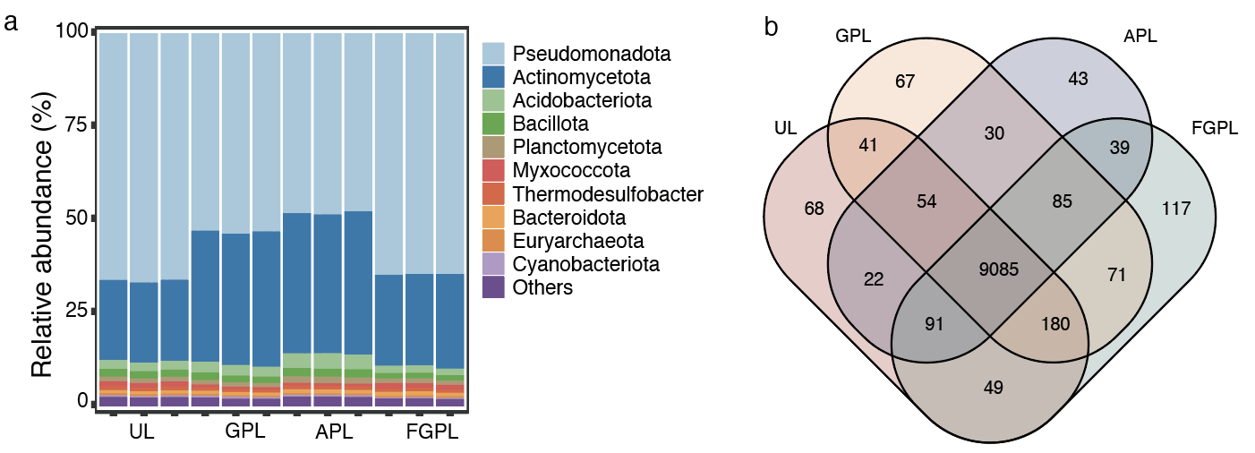
Figure S1 Compostion of bacterial community across the four land use patterns (UL: Unused land, GPL: Grazing pastureland, APL: Abandoned grazing pastureland, and FGPL: Fertilized grazing pastureland). a Relative abundance of bacterial populations in the four land use patterns at the phylum level. b Venn diagram showing the overlap of bacterial richness across the four land use patterns.

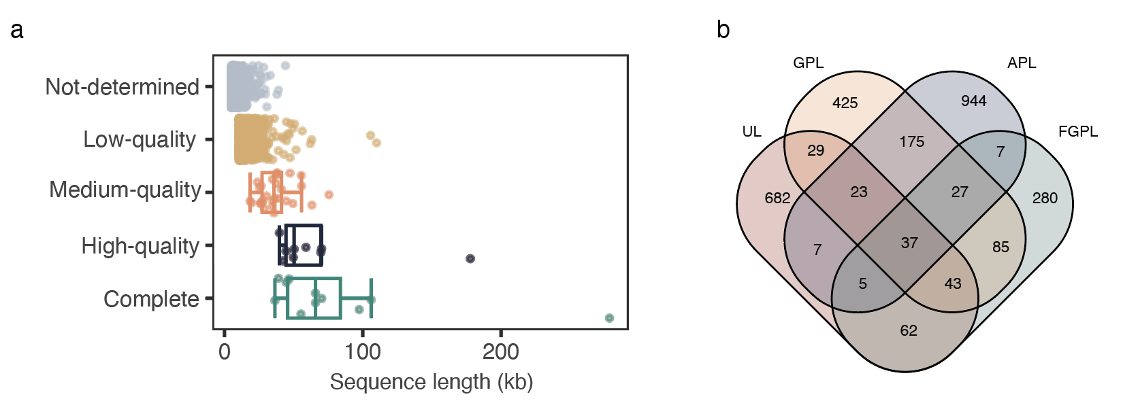
Figure S2 Viral community information. a Distribution of viral sequences quality and length. b Venn diagram showing the overlap of viral richness in the four land use patterns (UL: Unused land, GPL: Grazing pastureland, APL: Abandoned grazing pastureland, and FGPL: Fertilized grazing pastureland).

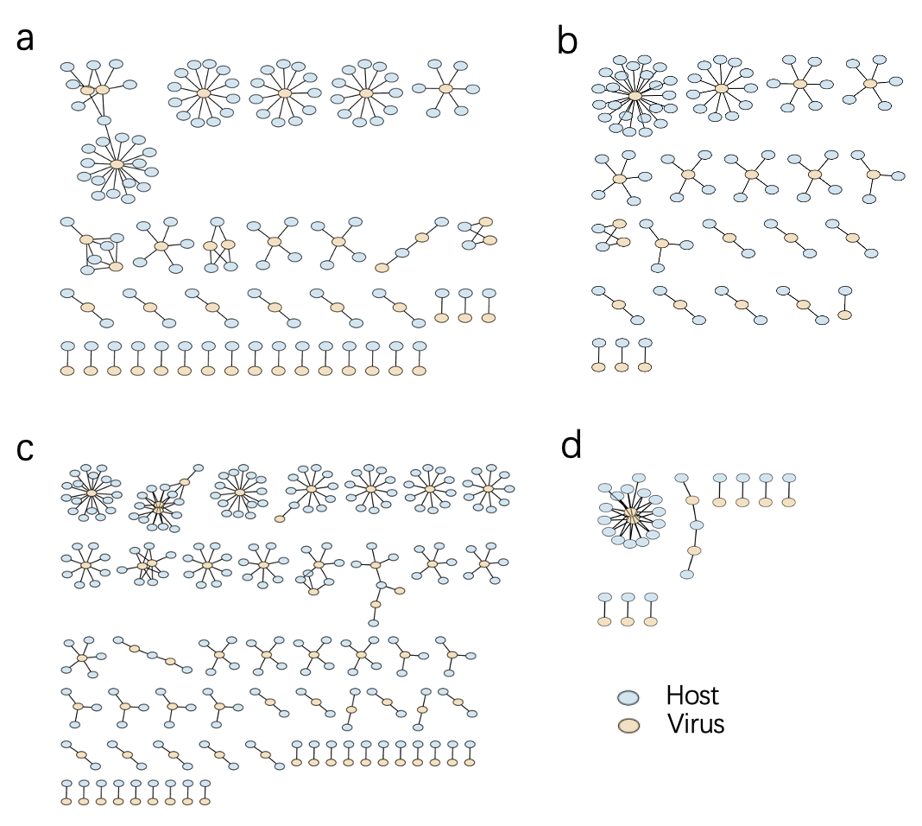
Figure S3 Virus-host linkages in the four land use patterns (a: Unused land, b: Grazing pastureland, c: Abandoned grazing pastureland, and d: Fertilized grazing pastureland). Nodes indicate species (hosts; blue) or vOTUs (viruses; yellow); edges indicate a host-virus relationship.

