Additional File 3: Figures S1 - S4.

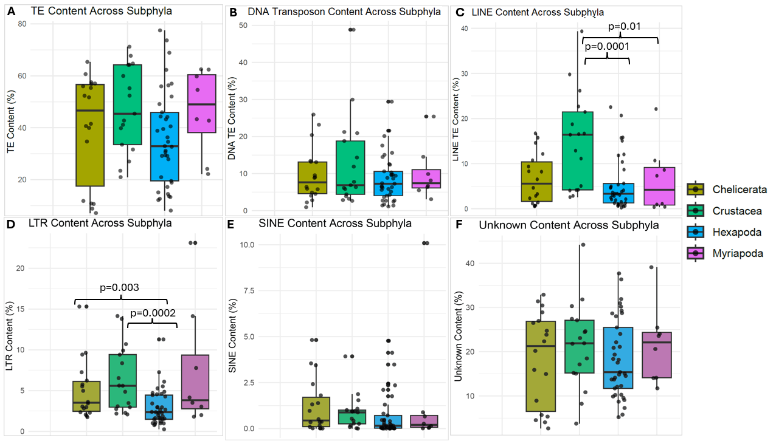Figure S1. TE content distribution across Arthropoda subphyla. (A) The boxplot illustrates the variation of the total transposable element (TE) content across four arthropod subphyla. Each box represents the interquartile range (IQR) of TE content within a subphylum, with the horizontal line inside the box indicating the median and the outlier showing the SD. The jittered dots show individual species data points, highlighting variability within subphyla. No statistically significant difference was observed among subphyla, as indicated by the one-way ANOVA test (p = 0.15). (B) Bar plot showing percent variation of DNA transposons among the four subphyla. No statistically significant difference was observed for DNA transposons among subphyla, as indicated by the one-way ANOVA test (p = 0.42). (C) Bar plot showing percent variation of LINEs within each subphylum and between the four subphyla. A statistically significant difference was observed among the subphyla (one-way ANOVA test, p = 0.0003) and between Crustacea-Myriapoda (Wilcoxon rank sum exact test, p = 0.01), and Crustacea-Hexapoda (Wilcoxon rank sum exact test, p = 0.0001). (D) Bar plot showing percent variation of LTRs within each subphylum and between the four subphyla. A statistically significant difference (one-way ANOVA test, p = 0.002) across the four subphyla, and between different phyla i.e., Crustacea-Hexapoda (Wilcoxon rank sum exact test, p = 0.0002) and Hexapoda-Chelicerata (Wilcoxon rank sum exact test, p = 0.003). (E) Bar plots showing distribution of SINE with no significant differences among the four subphyla indicated by one-way ANOVA test (p = 0.54). (F)Bar plots showing variation and distribution of Unknown TEs groups with no significant differences among the four subphyla indicated by one-way ANOVA test (p = 0.61). Note the non-statistical-significance values between-subphyla are not shown in (C) and (D).

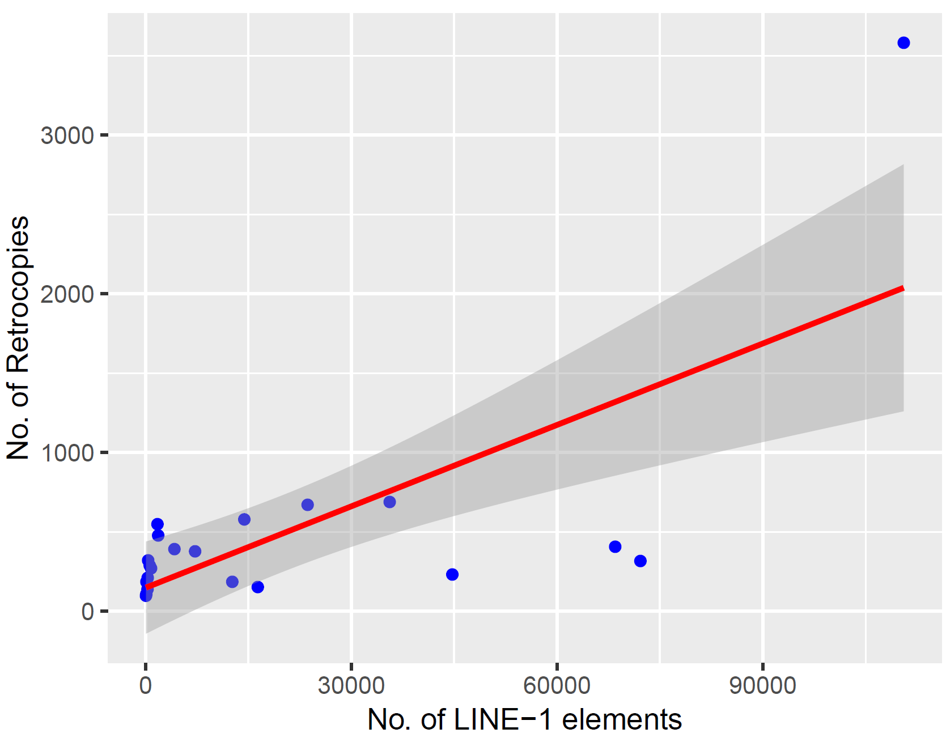
R²= 0.50, p = 0.0003
Figure S2. Correlation between the number of retrocopies and the number of LINE-1 elements. Each blue dot represents a species. The red line indicates the linear regression fit, and the shaded gray area represents the 95% confidence interval. A significant positive correlation (Pearson’s R = 0.71, p = 0.0003) suggests that the number of LINE-1 elements contributes to the number of retrocopies in the genome. The extreme outliner represents Schistocerca americana which has an exceptionally large genome and number of retrocopies compared to the other species.

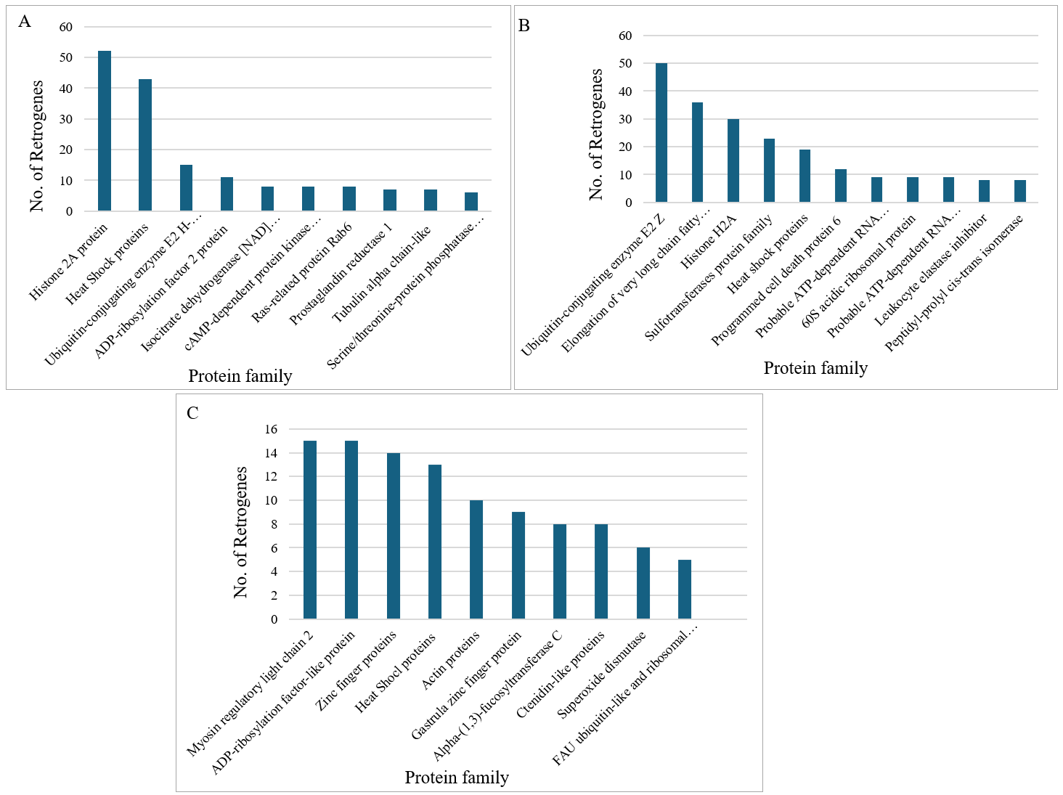
Crustacea
Hexapoda
Chelicerata
Figure S3. Top 10 gene families represented the highest number of retrogenes in the three subphyla. Panels (A) – (C) show the top 10 gene families’ expansion in Hexapoda, Chelicerata, and Crustacea, respectively.
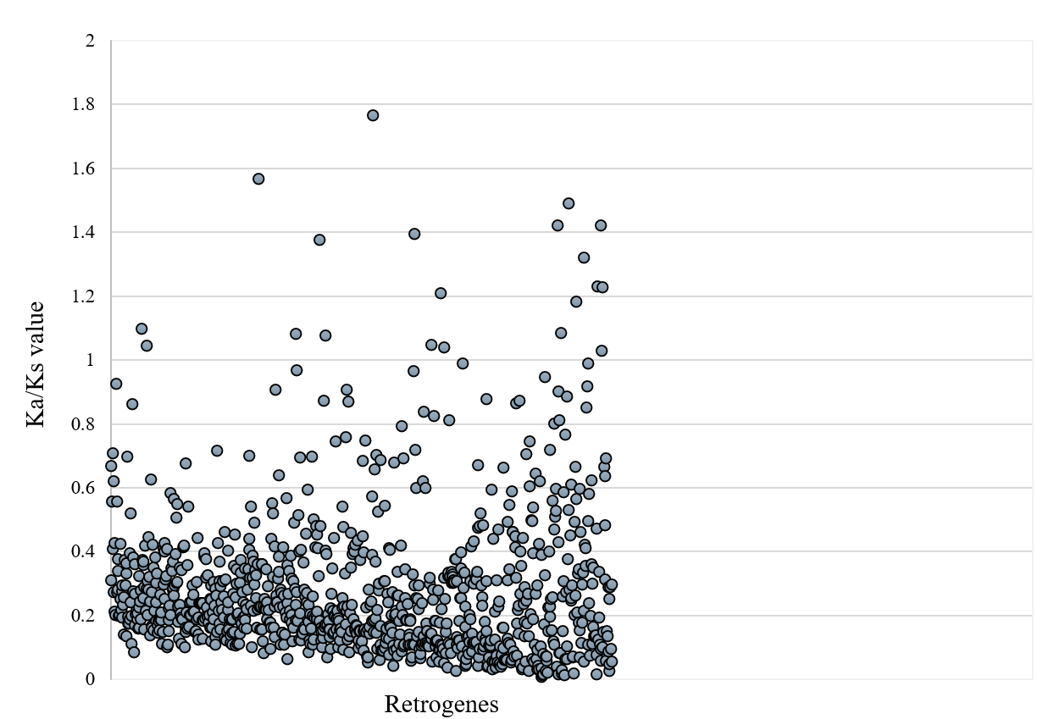
Figure S4. Scattered plot showing the Ka/Ks values of the Retrogenes. Each dot on x-axis represents retrogene, while Y-axis show values for Ka/Ks. A small number of retrogenes (20) have value >1 indicating they are under positive selection, while the rest of retrogenes show value <1 indicating purifying selection.

