Additional file 1 for “Hexadecanamide alleviates experimental colitis in mice and modifies the gut microbiome”
Lijuan Bao et al.
* Corresponding author: Wenchao Bian, bianwenchao@jlu.edu.cn or
Hongyang Jiang, jianghongy@jlu.edu.cn
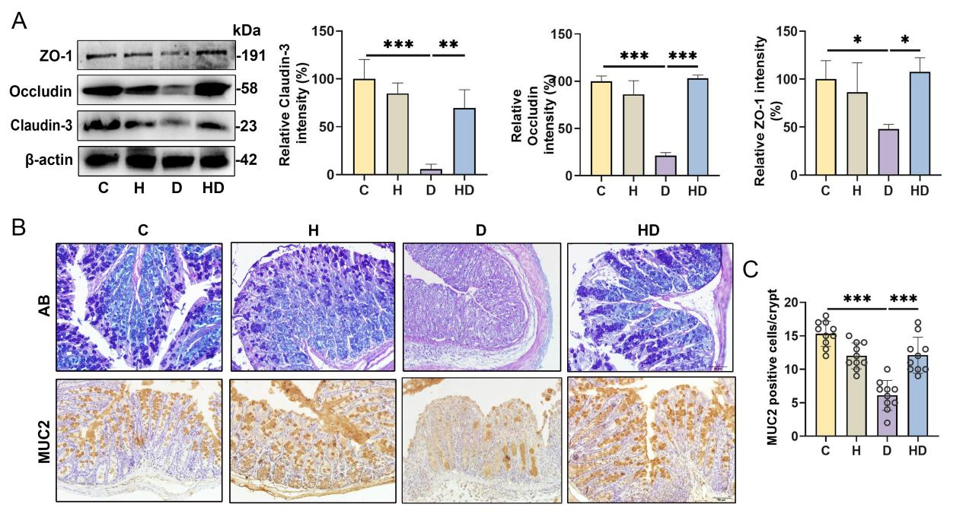
Figure. S1 HEX improves the integrity of the gut barrier. A. Representative western blot images of colon TJ proteins. B. Colonic mucus layer and goblet cells by AB and immunohistochemistry of MUC2 antibody staining (scale bar, 50 μm). C. MUC2-positive cells (n=5). Two crypts were randomly selected from colon section for counting, and five mice were used in each group. Data are presented as mean ± SD. *p < 0.05, **p < 0.01, and ***p < 0.001 indicate statistical significant based on one-way ANOVA. ns, no significance (A-C).

