Western blots for review
Control
HEX
Figure 2
HEX+DSS
DSS

Figure 2 F β-actin
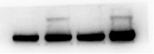
Figure 2 F PTGS2
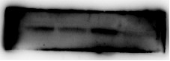
Figure 2 F GPX4
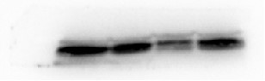
Figure 2 F ACSL4
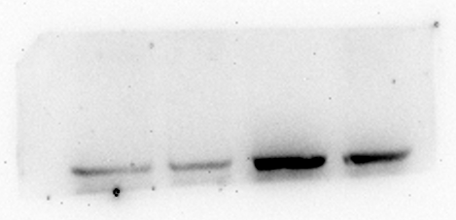
Figure 2 F SLC7A11
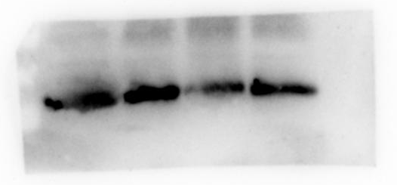
Figure 2 O β-actin
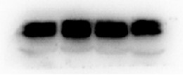
Figure 2 O LC3
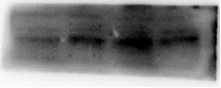
Figure 2 O SQSTM1
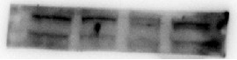
Figure 2 P β-actin
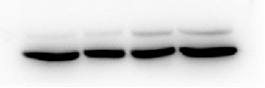
Figure 2 P NCOA4
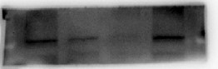
Figure 2 P FTH
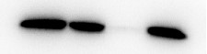
Figure S1 A β-actin
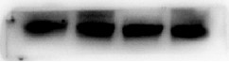
Figure S1 A Claudin-3
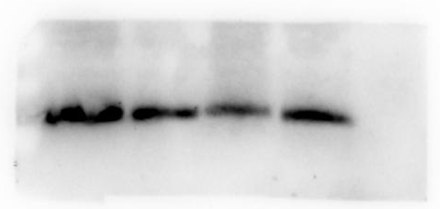
Figure S1 A Occludin
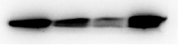
Figure S1 A ZO-1
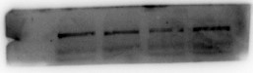

HR
C
R

Figure 2 N β-actin
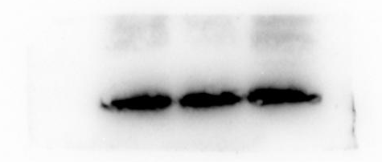

Figure 2 N PTGS2
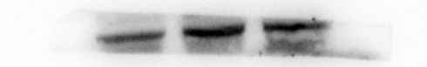
Figure 2 N GPX4
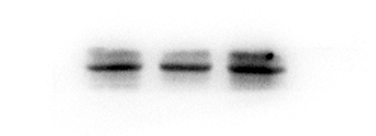
Figure 2 N ASCL4
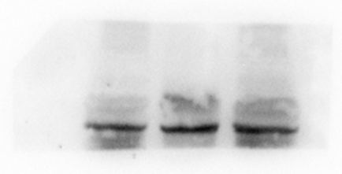
Figure 2 N SLC7A11
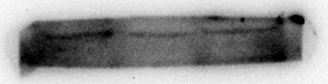

Figure 6
CF
HF

Figure 6 F β-actin
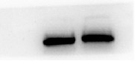
Figure 6 F PTGS2
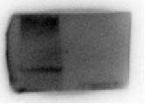
Figure 6 F GPX4
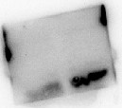

Figure 6 F ACSL4
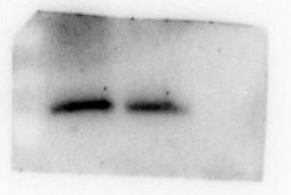
Figure 6 F SLC7A11
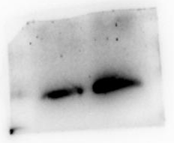

Figure 6 G β-actin
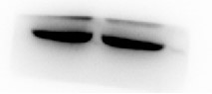
Figure 6 G LC3
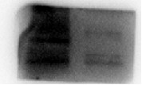
Figure 6 G SQSTM1
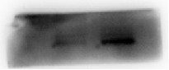
Figure 6 H β-actin
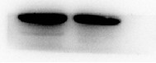
Figure 6 H NCOA4
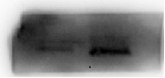
Figure 6 H FTH
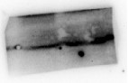

Figure 6 I β-actin
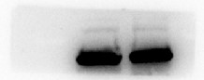
Figure 6 I Claudin-3
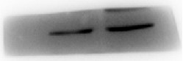
Figure 6 I Occludin
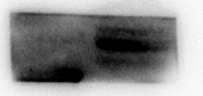
Figure 6 I ZO-1
