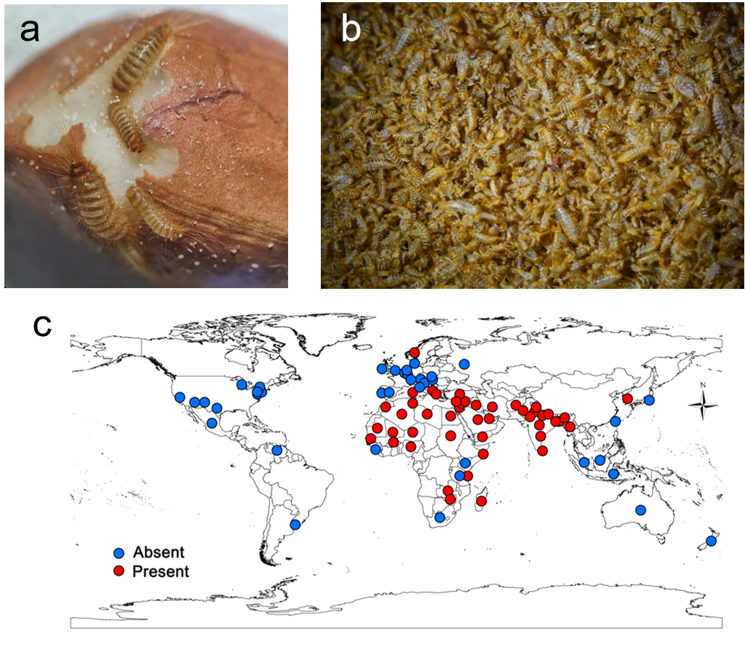
Additional file 1: Fig. S1 Damage and distribution of the khapra beetle. a Initial infestation of stored grains by larvae. b In bulk cargo, infestations often occur in the surface layers, covering numerous larval molting and excrement. c Current and historical distribution map (CABI, by September 2022).

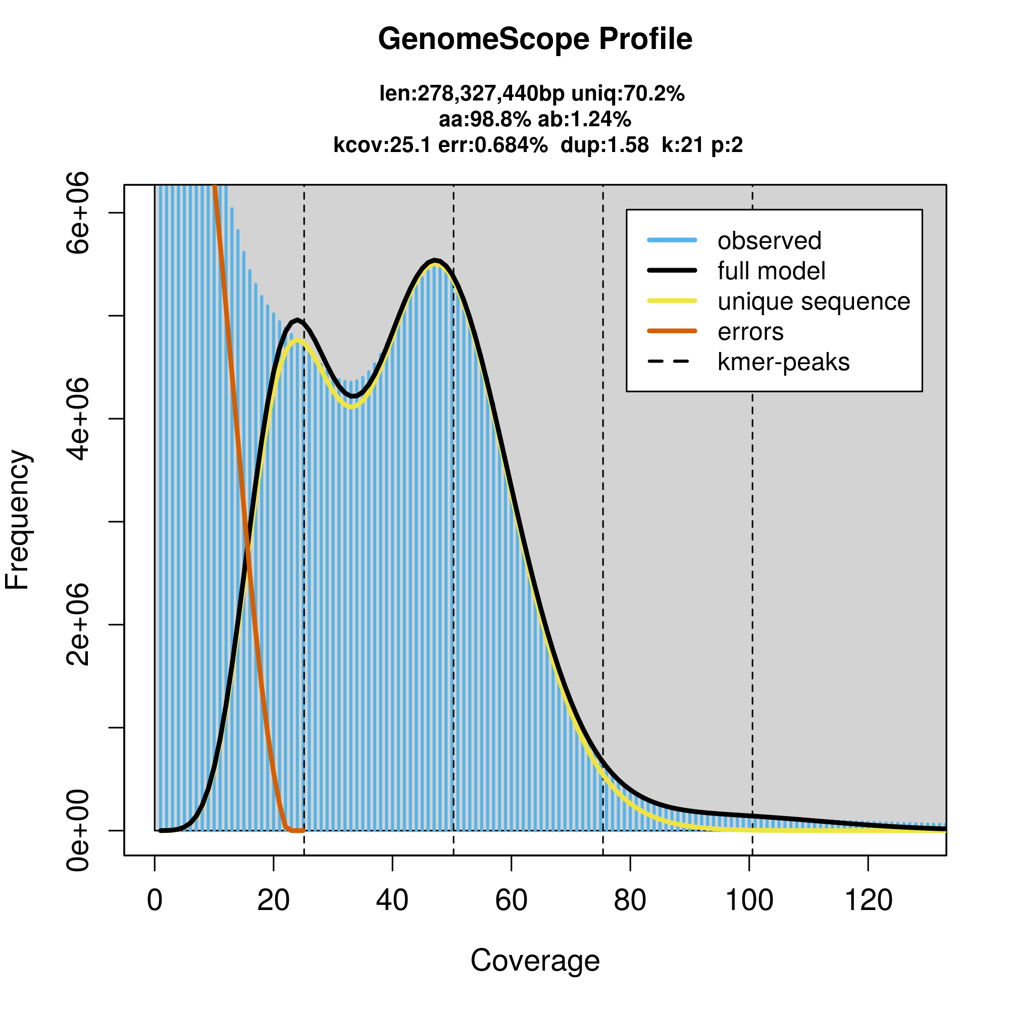
Additional file 1: Fig. S2 Genome survey of the khapra beetle. Genome size, heterozygosity and repeat sequence ratio were estimated based on Illumina sequencing data using jellyfish 2.2.10 and GenomeScope 2.0 (k=21).

Additional file 1: Fig. S3 Venn diagram for protein-coding genes' function annotation of the khapra beetle based on five databases. NCBI nucleotide sequences (NR), Swiss-Prot, and eggNOG databases were annotated using DIAMOND, while GO terms and KEGG pathway were estimated by Blast2GO26 and eggNOG-mapper v2.1.727 separately.
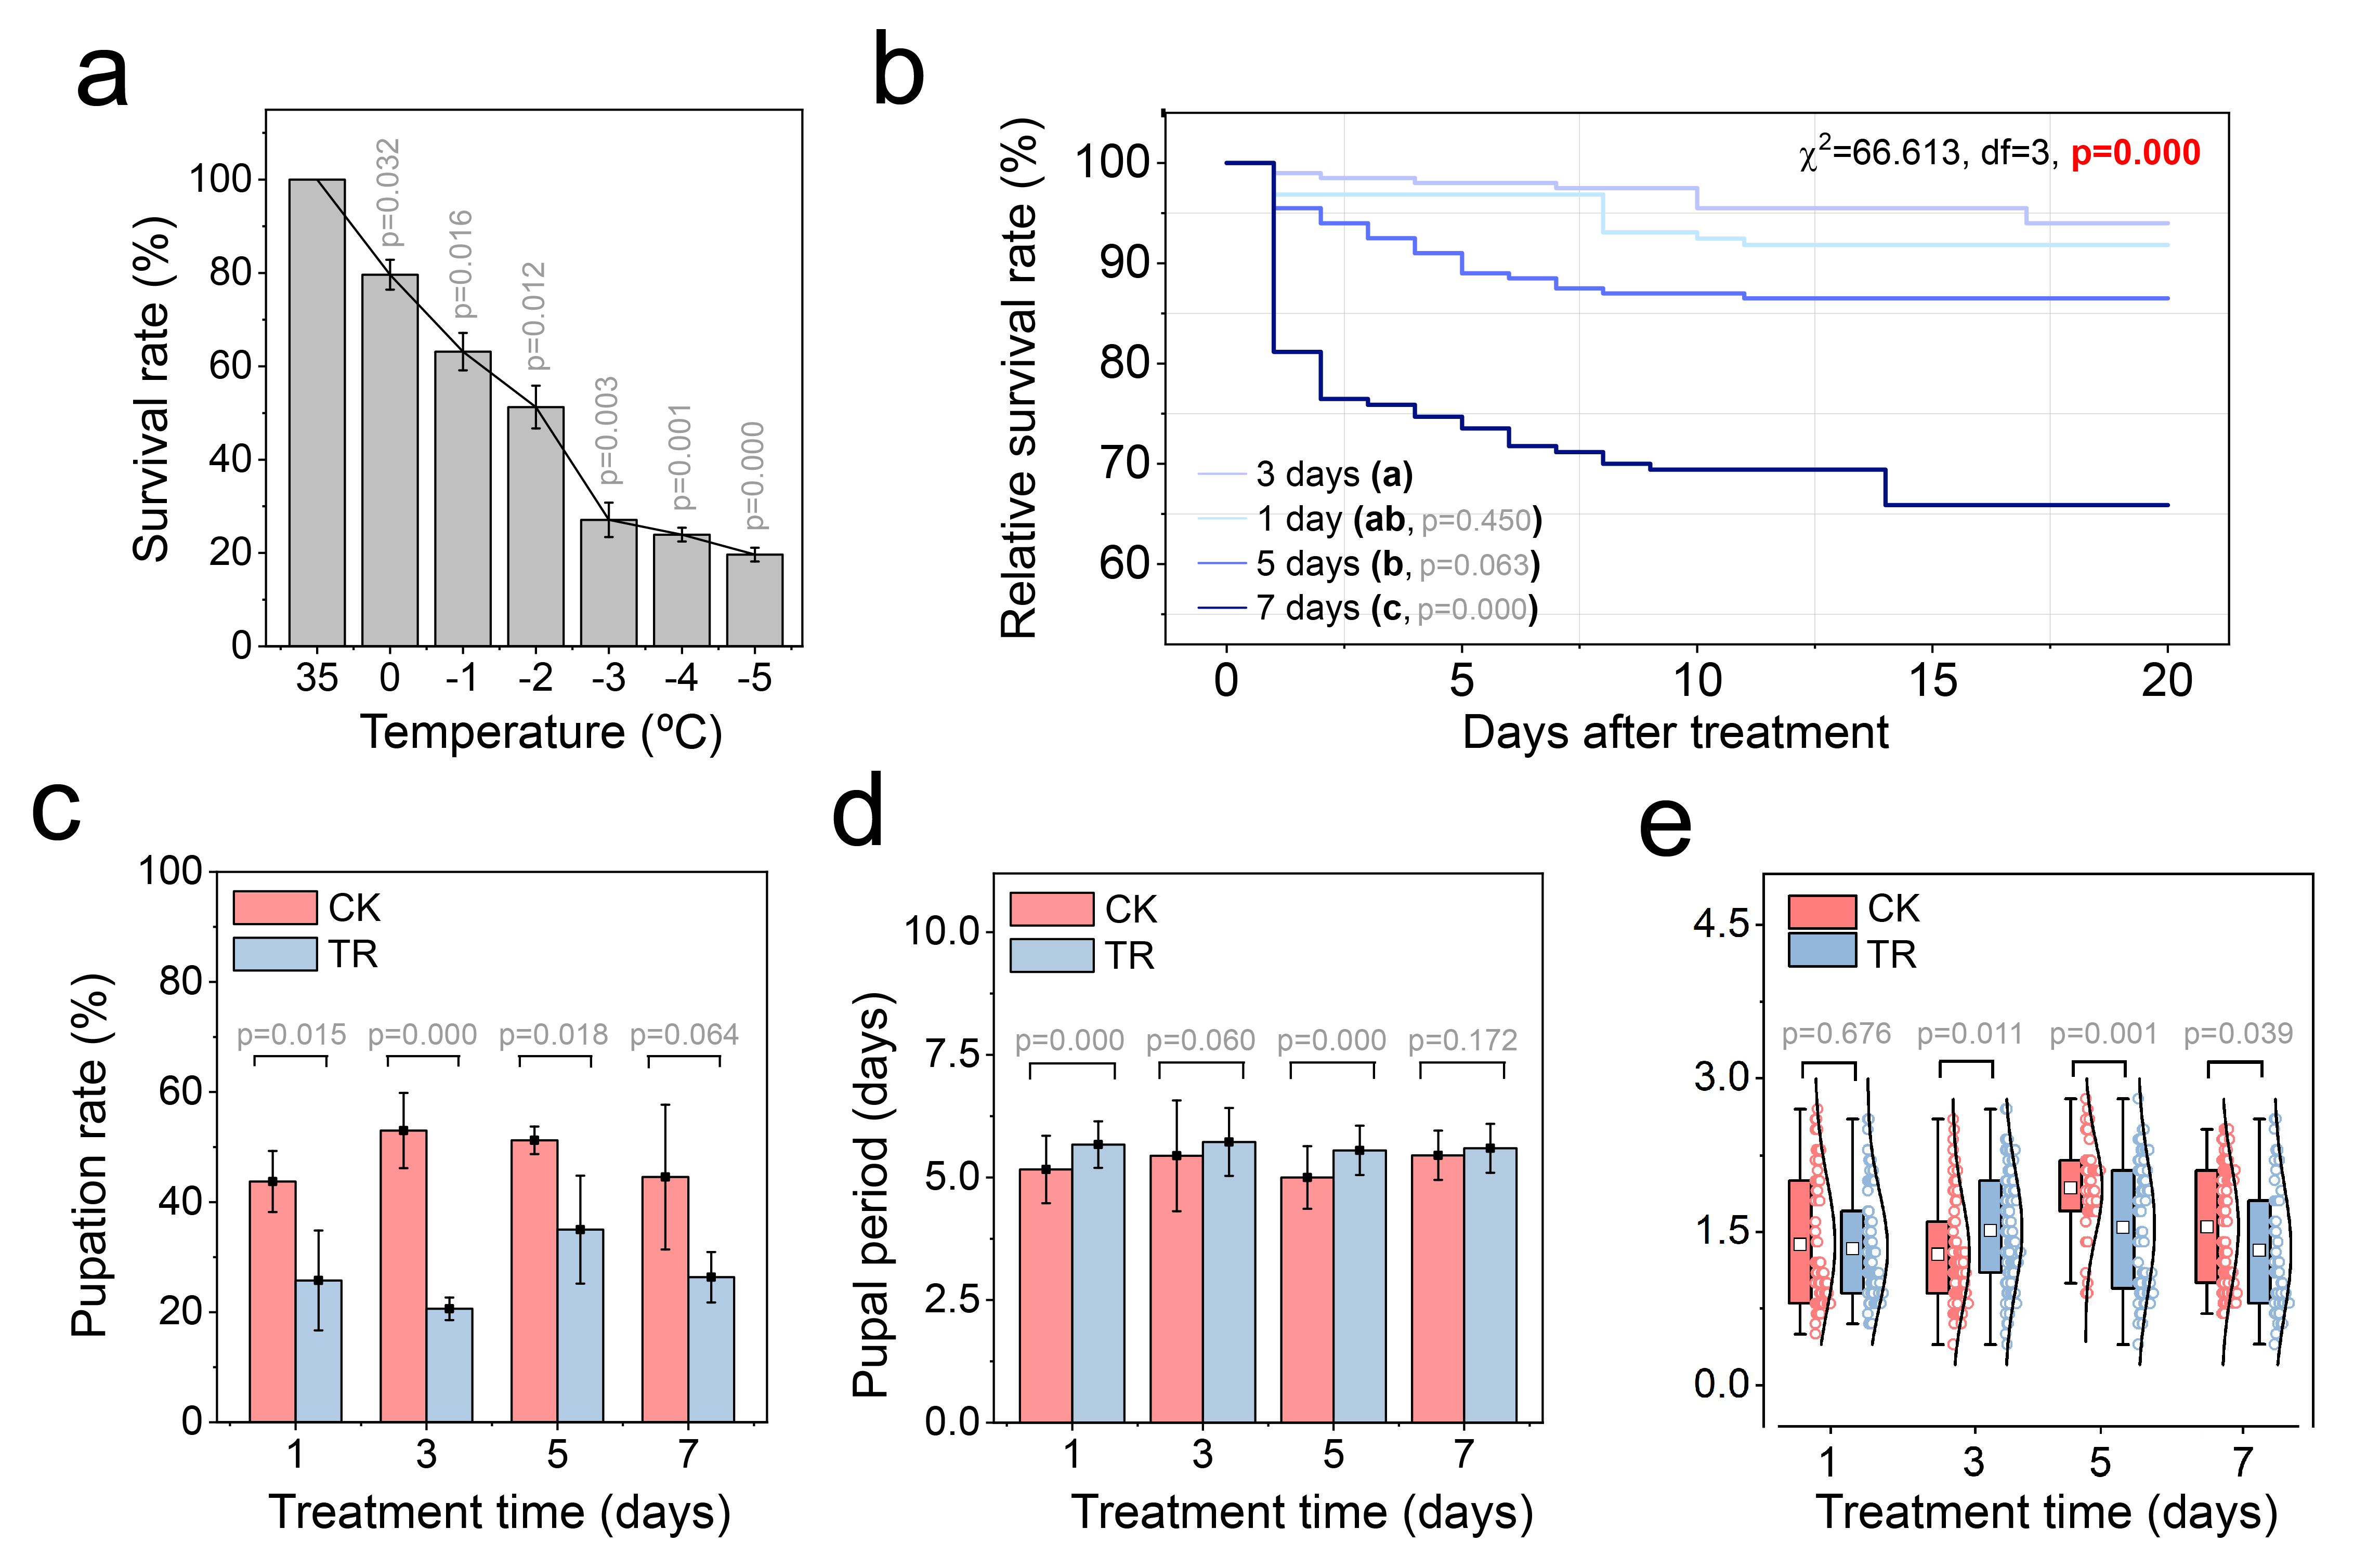
Additional file 1: Fig. S4 Impact of low temperature on survival and development in the khapra beetle. a Survival rate of old larvae under cold (0ºC, -1ºC, -2ºC, -3ºC, -4ºC, -5ºC) and the control temperatures after 7 d. Same letters after the labeling indicate no significant differences between treatments. Daily survival (b), pupation rate (c), pupal period (d) and pupal weight (e) of the khapra beetle from -1ºC relative to the control temperature (35ºC) when exposed to cold temperature for 1 d, 3 d, 5 d, or 7 d were also observed.
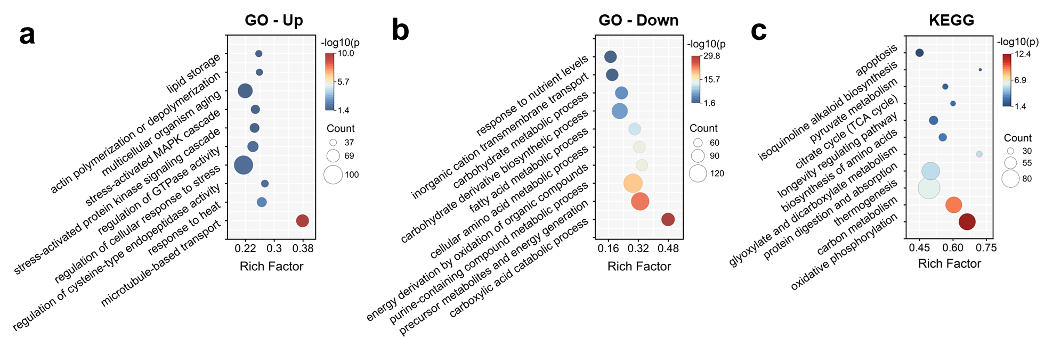
Additional file 1: Fig. S5 Dot plot of partial GO of the khapra beetle's differentially expressed genes (DEGs) under cold temperature (p_{adj}<0.05, qvalue< 0.05). a Dot plot of GO of up-regulated DEGs. b Dot plot of GO of down-regulated DEGs. c Dot plot of KEGG pathway enrichment of DEGs.
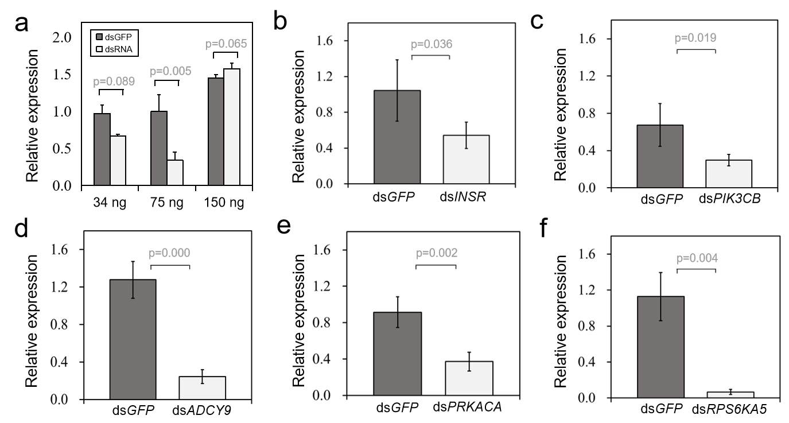
Additional file 1: Fig. S6 Detection of RNA interference (RNAi) efficiency after dsRNA injection in the khapra beetle. a Optimization of dsRNA injection dosage. b RNAi efficiency test for dsINSR. c RNAi efficiency test for dsPIK3CB. d RNAi efficiency test for dsADCY9. e RNAi efficiency test for dsPRKACA. f RNAi efficiency test for dsRPS6KA5. n=4 replicated experiments. Data were presented as mean values ± SD. Independent t-test (two-tailed) was used in a-f. Gene abbreviations: PRKACA, cAMP-dependent protein kinase catalytic subunit; INSR, insulin receptor; ADCY9, adenylate cyclase type 9; PIK3CB, phosphatidylinositol 4,5-bisphosphate 3-kinase catalytic subunit; RPS6KA5, ribosomal protein S6 kinase alpha-5.
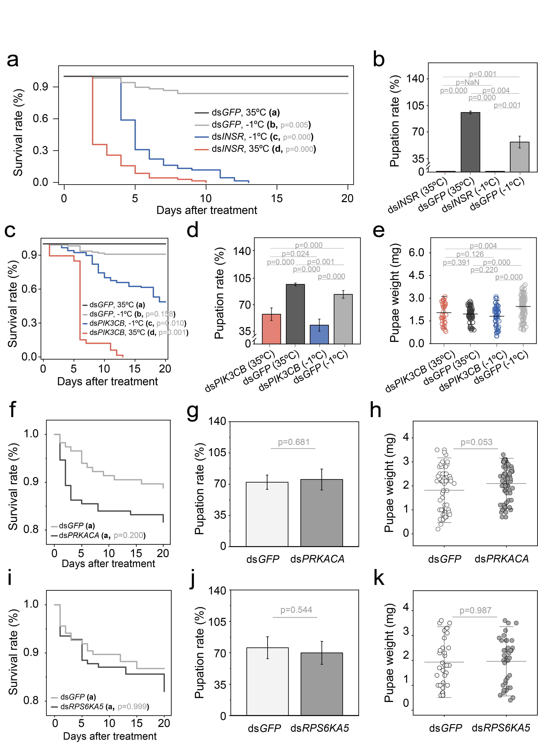
Additional file 1: Fig. S7 Influence on the khapra beetle after RNA interference (RNAi) of INSR, PIK3CB, PRKACA and RPS6KA5 genes. a, c, f, i Relative daily survival rate of old larvae after injecting dsINSR (a), dsPIK3CB (c), dsPRKACA (f), dsRPS6KA5 (i) and dsGFP. Survival analysis was performed using cox proportional hazards model. Same letters after the labeling indicate no significant differences between treatments. b, d, g, j Pupation rate of old larvae after injecting dsINSR (b), dsPIK3CB (d), dsPRKACA (g), dsRPS6KA5 (j) and dsGFP. e, h, k The weight of pupae after injecting dsPIK3CB (e), dsPRKACA (h), dsRPS6KA5 (k) and dsGFP. n=4 to 6 replicated experiments. ns=not significant, *p<0.05, **p<0.01, ***p<0.001. Data were presented as mean values ± SD (b, d, g, j, e, h, k). Independent t-test (two-tailed) was used in b, d-e, g-h, j-k. Gene abbreviations: GFP, green fluorescent protein; INSR, insulin receptor; PIK3CB, phosphatidylinositol 4,5-bisphosphate 3-kinase catalytic subunit; PRKACA, cAMP-dependent protein kinase catalytic subunit; RPS6KA5, ribosomal protein S6 kinase alpha-5.

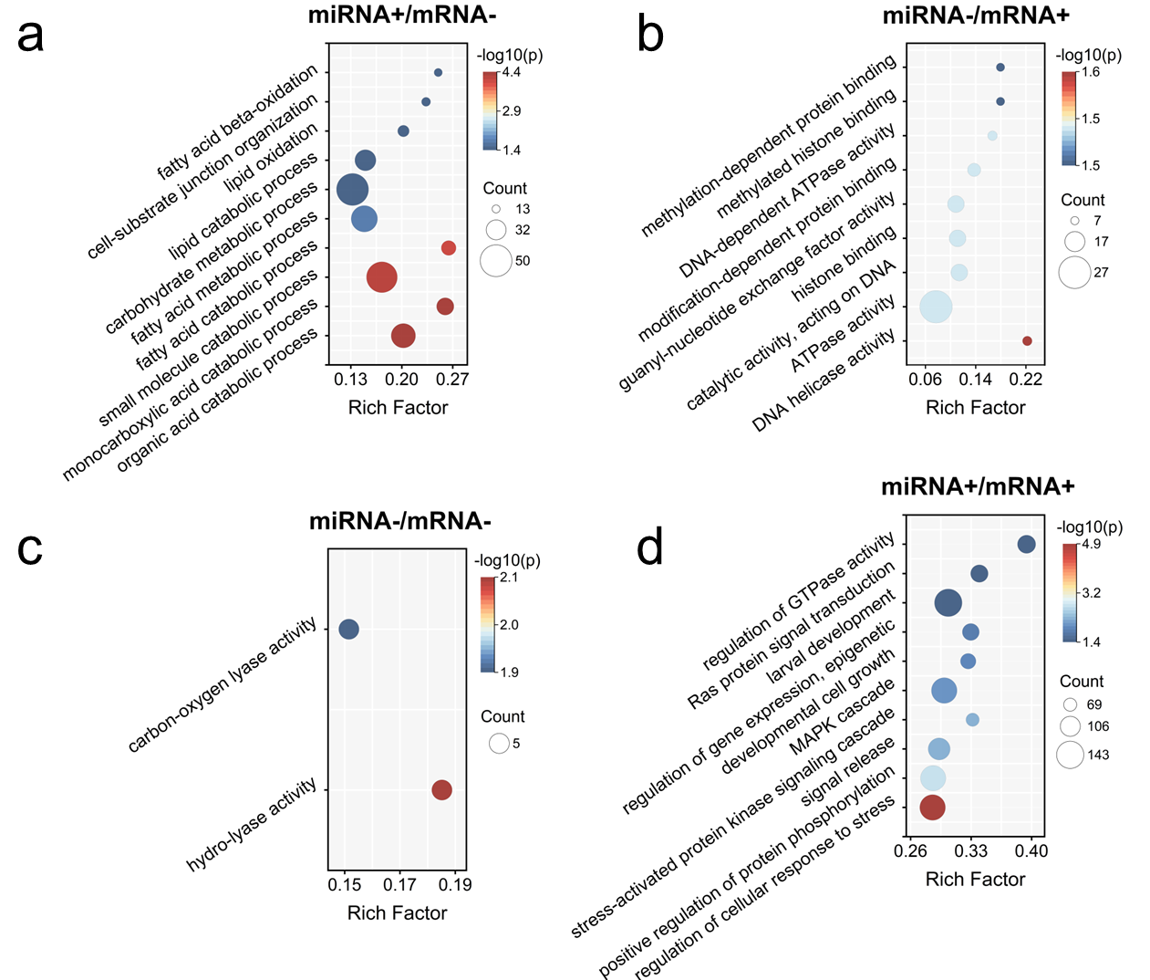
Additional file 1: Fig. S8 Dot plot of GO of khapra beetle's differentially expressed miRNAs (DEMs) under cold temperature (p_{adj}<0.05, qvalue< 0.05). a Dot plot of GO of up-regulated DEMs (miRNA+) concerning their significantly correlated down-regulated target genes (mRNA-). b Dot plot of GO of down-regulated DEMs (miRNA-) concerning their significantly correlated up-regulated target genes (mRNA+). c Dot plot of GO of miRNA- concerning their significantly correlated mRNA-. d Dot plot of GO of miRNA+ concerning their significantly correlated mRNA+.
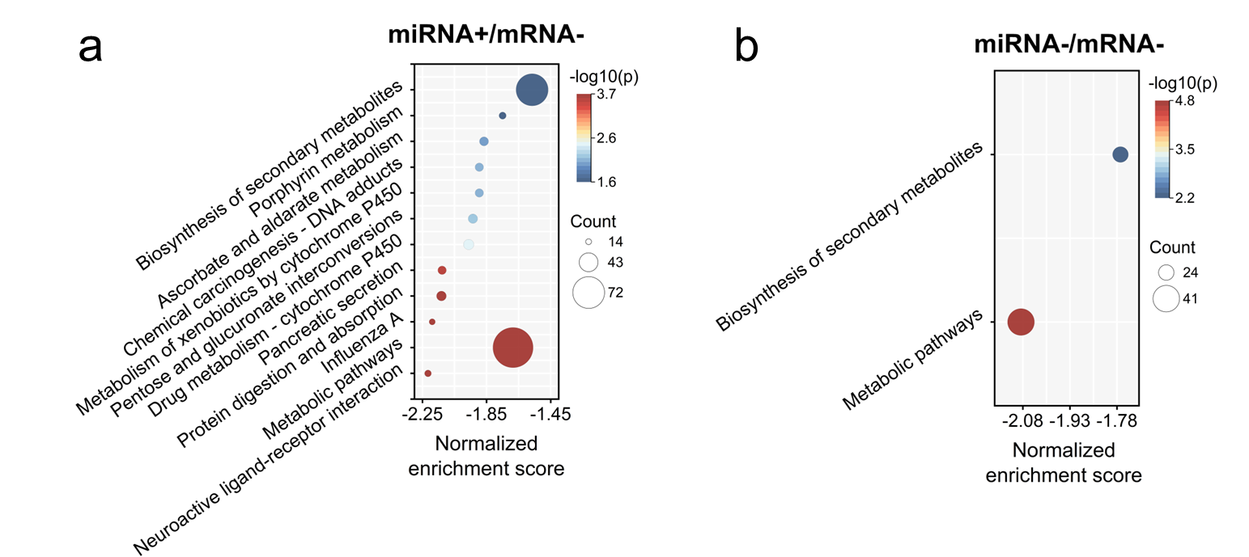
Additional file 1: Fig. S9 Dot plot of KEGG pathways of khapra beetle's differentially expressed miRNAs (DEMs) under cold temperature (p_{adj}<0.05, qvalue< 0.05). a Dot plot of enriched KEGG pathways of up-regulated DEMs (miRNA+) and their significantly correlated down-regulated target genes (mRNA-) under cold temperature. b Dot plot of enriched KEGG pathways of down-regulated DEMs (miRNA-) and their significantly correlated mRNA-.

Additional file 1: Table 1 Statistics of the khapra beetle genome assembly
Genome assembly | Feature | Value
Draft genome  (PacBio + Illumina) | Genome size (Mb) | 327
Draft genome  (PacBio + Illumina) | Contig number | 1,116
Draft genome  (PacBio + Illumina) | GC content (%) | 32.69
Draft genome  (PacBio + Illumina) | Contig N50 (kb) | 913
Draft genome  (PacBio + Illumina) | BUSCO evaluation | 99.1% (90.9% single, 8.2% duplicated, 0.5% missing)
Chromosome-level genome  (PacBio + Illumina + Hi-C) | Genome size (Mb) | 327
Chromosome-level genome  (PacBio + Illumina + Hi-C) | Scaffold number | 100
Chromosome-level genome  (PacBio + Illumina + Hi-C) | GC content (%) | 32.69
Chromosome-level genome  (PacBio + Illumina + Hi-C) | Contig N50 (kb) | 883
Chromosome-level genome  (PacBio + Illumina + Hi-C) | Scaffold N50 (Mb) | 38
Chromosome-level genome  (PacBio + Illumina + Hi-C) | Number of linkage groups | 9
Chromosome-level genome  (PacBio + Illumina + Hi-C) | BUSCO evaluation | 99.0% (96.3% single, 2.7% duplicated, 0.5% missing)

Additional file 1: Table 2 Statistics for repeat elements of the khapra beetle's genome
Repeat type | Number | Total length (bp) | Percentage of the genome (%)
Long interspersed nuclear elements (LINEs) | 24,189 | 11,155,442 | 3.41
Long terminal repeats (LTR) elements | 94,477 | 44,072,715 | 13.46
DNA transposons | 188,826 | 40,581,690 | 12.40
Rolling-circle eukaryotic transposons (RC) | 7,164 | 996,409 | 0.30
Satellite | 1,133 | 355,622 | 0.11
Simple repeat | 78 | 2,921 | 0.00
Unknown | 309,525 | 57,140,362 | 17.45
Total | 625,392 | 154,305,161 | 47.13

Additional file 1: Table 3 Statistics for non-coding RNAs (ncRNAs) of the khapra beetle's genome
ncRNA type | Number
ribozyme | 534
lncRNA | 2
Gene | 3
snRNA::splicing | 27
snRNA::snoRNA::CD-box | 13
rRNA | 442
Cis-reg | 234
snRNA::snoRNA::scaRNA | 1
snRNA::snoRNA::HACA-box | 9
tRNA | 357
miRNA | 56

Additional file 1: Table 4 Gene prediction results of the khapra beetle's genome by EVM integration
Feature | Value
Number of genes | 19,112
Total genic length (bp) | 160,615,181
Mean gene length (bp) | 8,403
Number of transcripts | 20,580
Transcripts per gene | 1.1
Total transcript length (bp) | 39,344,401
Mean transcript length (bp) | 1,911
Number of exons | 105,307
Exons per transcript | 5.1
Mean exon length (bp) | 373
Number of coding exons | 102,090
Number of introns | 84,727
Mean intron length (bp) | 1,725
Total coding sequence (CDS) length (bp) | 34,283,000
Mean CDS length (bp) | 1,665

Additional file 1: Table 5 Gene function annotation results of the khapra beetle's genome
Category | Number | Percentage
Protein-coding genes | 19,112 | 100%
Annotated genes | 16,969 | 88.79%
Annotated by NR | 16,943 | 88.65%
Annotated by SwissProt | 11,141 | 58.29%
Annotated by KEGG | 7,073 | 37.01%
Annotated by GO | 5,619 | 29.40%
Annotated by eggNOG | 16,150 | 84.50%
BUSCO evaluation of protein-coding sequences |  | 98.6% (90.9% single, 8.2% duplicated, 0.5% missing)

Additional file 1: Table 6 Datasets of other species used in comparative genomics analysis
Order | Species | InsectBase ID | GenBank accession no. | Size (Mb) | Genome level | CABI invasive | EPPO invasive | Reference in the Methods section
Diptera | Drosophila melanogaster | IBG_00296 | GCA_000001215.4 | 143.7 | Chromosome | No | No | [81]
 | Rhagoletis pomonella | IBG_00681 | GCA_013731165.1 | 1,223.0 | Scaffold | Yes | Yes | [82]
Lepidoptera | Bombyx mori | - | GCA_030269925.2 | 461.7 | Chromosome | No | No | [83]
 | Cydia pomonella | IBG_00224 | GCA_003425675.2 | 773.0 | Chromosome | No | Yes | [84]
Coleoptera | Agrilus planipennis | IBG_00017 | GCA_000699045.2 | 353.1 | Scaffold | Yes | Yes | [85]
 | Nicrophorus vespilloides | IBG_00571 | GCA_001412225.1 | 197.7 | Scaffold | No | No | [86]
 | Harmonia axyridis | IBG_00418 | GCA_011033045.2 | 422.8 | Chromosome | Yes | No | [87]
 | Aphidecta obliterata | IBG_01585 | GCA_963966015.1 | 349.58 | Chromosome | No | No | [88]
 | Tribolium madens | IBG_00769 | GCA_015345945.1 | 149.40 | Scaffold | No | Yes | [89]
 | Tribolium castaneum | IBG_00768 | GCA_000002335.3 | 168.0 | Chromosome | No | No | [90]
 | Oryzaephilus surinamensis | IBG_00599 | GCA_004796505.1 | 105.3 | Scaffold | Yes | No | [91]
 | Anoplophora glabripennis | IBG_00063 | GCA_000390285.2 | 715.8 | Scaffold | Yes | Yes | [92]
 | Exocentrus adspersus | IBG_01971 | GCA_029955175.1 | 257.54 | Contig | No | No | [93]
 | Leptinotarsa decemlineata | IBG_00487 | GCA_000500325.2 | 650.0 | Scaffold | Yes | Yes | [94]
 | Bruchidius siliquastri | IBG_01638 | GCA_949316355.1 | 375.58 | Chromosome | No | No | [95]
 | Platypus cylindrus | IBG_02288 | GCA_949748235.1 | 147.48 | Chromosome | No | No | [96]
 | Dendroctonus ponderosae | IBG_00234 | GCA_000355655.1 | 256.0 | Scaffold | Yes | Yes | [97]
(Our species) | Trogoderma granarium | - | JAWRCW000000000 | 327.0 | Chromosome | Yes | Yes | -

Additional file 1: Table 7 Overall statistics of OrthoFinder v2.5.1 orthogroup
Feature | Value
Number of species | 18
Number of genes | 313,785
Number of genes in orthogroups | 286,650
Number of unassigned genes | 27,135
Percentage of genes in orthogroups (%) | 91.4
Percentage of unassigned genes (%) | 8.6
Number of orthogroups | 21,943
Number of species-specific orthogroups | 5,711
Number of genes in species-specific orthogroups | 25,340
Percentage of genes in species-specific orthogroups (%) | 8.1
Mean orthogroup size | 13.1
Median orthogroup size | 8
G50 (assigned genes) | 20
G50 (all genes) | 19
O50 (assigned genes) | 4,006
O50 (all genes) | 4,703
Number of orthogroups with all species present | 2,639
Number of single-copy orthogroups | 319

Additional file 1: Table 8 Statistics of OrthoFinder v2.5.1 orthogroup per species
Species | Number of genes | Number of genes in orthogroups | Number of unassigned genes | Percentage of genes in orthogroups (%) | Percentage of unassigned genes (%) | Number of orthogroups containing species | Percentage of orthogroups containing species (%) | Number of species-specific orthogroups | Number of genes in species-specific orthogroups | Percentage of genes in species-specific orthogroups (%)
Anoplophora glabripennis | 14,510 | 14,172 | 338 | 97.7 | 2.3 | 9,436 | 43 | 82 | 509 | 3.5
Aphidecta obliterata | 25,857 | 23,043 | 2,814 | 89.1 | 10.9 | 10,883 | 49.6 | 508 | 2,416 | 9.3
Agrilus planipennis | 12,338 | 11,877 | 461 | 96.3 | 3.7 | 8,598 | 39.2 | 118 | 431 | 3.5
Bombyx mori | 15,265 | 13,488 | 1,777 | 88.4 | 11.6 | 8,389 | 38.2 | 299 | 1,926 | 12.6
Bruchidius siliquastri | 20,159 | 18,140 | 2,019 | 90 | 10 | 9,799 | 44.7 | 272 | 1,325 | 6.6
Cydia pomonella | 17,156 | 16,124 | 1,032 | 94 | 6 | 8,562 | 39 | 295 | 1,230 | 7.2
Drosophila melanogaster | 13,955 | 12,398 | 1,557 | 88.8 | 11.2 | 9,057 | 41.3 | 233 | 811 | 5.8
Dendroctonus ponderosae | 10,300 | 10,038 | 262 | 97.5 | 2.5 | 7,931 | 36.1 | 66 | 199 | 1.9
Exocentrus adspersus | 30,026 | 27,352 | 2,674 | 91.1 | 8.9 | 10,950 | 49.9 | 750 | 4,015 | 13.4
Harmonia axyridis | 25,685 | 19,567 | 6,118 | 76.2 | 23.8 | 10,426 | 47.5 | 1,054 | 3,883 | 15.1
Leptinotarsa decemlineata | 10,515 | 10,278 | 237 | 97.7 | 2.3 | 7,697 | 35.1 | 63 | 249 | 2.4
Nicrophorus vespilloides | 11,573 | 11,176 | 397 | 96.6 | 3.4 | 8,637 | 39.4 | 113 | 533 | 4.6
Oryzaephilus surinamensis | 18,581 | 16,996 | 1,585 | 91.5 | 8.5 | 10,393 | 47.4 | 404 | 1,441 | 7.8
Platypus cylindrus | 17,187 | 16,554 | 633 | 96.3 | 3.7 | 8,917 | 40.6 | 160 | 1,033 | 6
Rhagoletis pomonella | 21,503 | 20,476 | 1,027 | 95.2 | 4.8 | 9,850 | 44.9 | 753 | 3,049 | 14.2
Tribolium castaneum | 12,599 | 12,454 | 145 | 98.8 | 1.2 | 9,516 | 43.4 | 30 | 84 | 0.7
Trogoderma granarium | 19,112 | 17,869 | 1,243 | 93.5 | 6.5 | 10,058 | 45.8 | 413 | 1,919 | 10
Tribolium madens | 17,464 | 14,648 | 2,816 | 83.9 | 16.1 | 10,431 | 47.5 | 98 | 287 | 1.6

Additional file 1: Table 9 Gene counts of insecticide resistance, sensing, cold tolerance, growth and development in selected species based on BITACORA
 | ABCs | AFPs | CBDs | CSPs | Eclosion | ESTs | GSTs | HSPs | Insulin | JHBPs | OBPs | ORs | P450s | Trehalase | UGTs
Anoplophora glabripennis | 72 | 11 | 78 | 17 | 2 | 108 | 44 | 67 | 20 | 33 | 53 | 105 | 120 | 7 | 53
Aphidecta obliterata | 81 | 3 | 64 | 27 | 0 | 57 | 29 | 67 | 17 | 41 | 30 | 24 | 76 | 8 | 57
Agrilus planipennis | 60 | 1 | 59 | 14 | 0 | 47 | 28 | 57 | 14 | 27 | 12 | 20 | 71 | 4 | 37
Bombyx mori | 57 | 3 | 80 | 16 | 1 | 77 | 33 | 49 | 42 | 39 | 23 | 39 | 80 | 5 | 40
Bruchidius siliquastri | 76 | 5 | 65 | 9 | 0 | 77 | 32 | 54 | 15 | 33 | 22 | 83 | 89 | 5 | 21
Cydia pomonella | 81 | 2 | 53 | 25 | 1 | 93 | 39 | 70 | 27 | 28 | 20 | 113 | 139 | 3 | 29
Drosophila melanogaster | 56 | 5 | 147 | 4 | 1 | 39 | 55 | 62 | 17 | 30 | 50 | 70 | 87 | 2 | 35
Dendroctonus ponderosae | 51 | 3 | 52 | 9 | 0 | 39 | 33 | 47 | 14 | 27 | 28 | 46 | 69 | 4 | 18
Exocentrus adspersus | 97 | 7 | 109 | 15 | 1 | 77 | 38 | 77 | 24 | 38 | 39 | 52 | 143 | 7 | 53
Harmonia axyridis | 179 | 2 | 48 | 19 | 1 | 41 | 30 | 61 | 22 | 34 | 35 | 20 | 54 | 9 | 27
Leptinotarsa decemlineata | 66 | 7 | 39 | 11 | 2 | 60 | 34 | 50 | 14 | 36 | 41 | 45 | 69 | 2 | 32
Nicrophorus vespilloides | 47 | 2 | 43 | 11 | 2 | 39 | 35 | 43 | 17 | 57 | 70 | 52 | 124 | 2 | 35
Oryzaephilus surinamensis | 75 | 5 | 59 | 17 | 1 | 80 | 48 | 46 | 19 | 44 | 36 | 78 | 138 | 4 | 47
Platypus cylindrus | 64 | 5 | 61 | 11 | 0 | 52 | 28 | 58 | 13 | 25 | 25 | 77 | 120 | 5 | 27
Rhagoletis pomonella | 69 | 12 | 140 | 3 | 1 | 70 | 50 | 66 | 41 | 51 | 50 | 123 | 114 | 1 | 44
Tribolium castaneum | 76 | 5 | 75 | 18 | 1 | 53 | 47 | 52 | 16 | 46 | 44 | 180 | 124 | 6 | 42
Trogoderma granarium | 66 | 3 | 64 | 15 | 1 | 59 | 36 | 63 | 23 | 38 | 38 | 76 | 169 | 4 | 56
Tribolium madens | 69 | 6 | 81 | 17 | 2 | 64 | 48 | 58 | 19 | 46 | 40 | 129 | 128 | 5 | 37
# Abbreviations
ABCs: ATP-binding cassette transporters; AFPs: Insect antifreeze proteins; CBDs: Chitin-binding proteins; CSPs: Chemosensory proteins; Eclosion: Eclosion hormones; ESTs: Esterases; GSTs: Glutathione S-transferases; HSPs: Heat shock proteins; Insulin: Insulin/IGF/Relaxin family; JHBPs: Haemolymph juvenile hormone binding proteins; OBPs: Odorant-binding proteins; ORs: Olfactory receptors; P450s: Cytochrome P450 monooxygenases; UGTs: UDP-glucuronosyl transferases.
Additional file 1: Table 10 Pfam accession numbers of gene families and their HMM models used in predicting whole genome functions
Category | Gene family | Pfam accession no.
Insecticide resistance-related | ATP-binding cassette (ABC) transporter | PF00005
 | Esterase (ESTs) | PF02230, PF00135
 | Glutathione S-transferase (GSTs) | PF14497, PF17171, PF00043, PF13417, PF17172, PF02798
 | Cytochrome P450 monooxygenase (P450s) | PF00067
 | UDP-glucuronosyl transferase (UGTs) | PF00201
Sensing related | Chemosensory proteins (CSPs) | PF03392
 | Odorant-binding proteins (OBPs) | PF01395
 | Olfactory receptor (ORs) | PF13853
Cold tolerance related | Insect antifreeze protein repeat (AFPs) | PF02420
 | Heat shock proteins (HSPs) | PF00118, PF00011, PF00012, PF00183
Growth and development related | Chitin-binding proteins (CBDs) | PF01607, PF00379
 | Trehalase | PF01204
 | Haemolymph juvenile hormone binding proteins (JHBPs) | PF06585
 | Eclosion hormone (Eclosion) | PF04736
 | Insulin/IGF/Relaxin family | PF00049

Additional file 1: Table 16 Mapping rate of miRNA sequencing
Sample | Genome  (%) | Known miRNA  hairpin (%) | non-coding RNA (%) | Repeating  elements (%) | exons  (%) | introns  (%)
CK1 | 66.76 | 2.37 | 32.61 | 43.19 | 48.78 | 59.96
CK2 | 66.68 | 2.36 | 34.08 | 43.59 | 48.71 | 59.69
CK3 | 55.16 | 2.04 | 45.01 | 40.61 | 50.85 | 61.35
TR1 | 77.66 | 1.49 | 34.31 | 39.39 | 58.65 | 59.3
TR2 | 83.11 | 1.97 | 34.31 | 39.28 | 56.93 | 61.33
TR3 | 83.07 | 1.81 | 30.07 | 39.87 | 55.36 | 59.65

Additional file 1: Table 17 Small RNA classification of miRNA sequencing data
 | CK1 | CK2 | CK4 | TR1 | TR2 | TR3
miRNA (%) | 2.37 | 2.36 | 2.04 | 1.49 | 1.97 | 1.81
rRNA (%) | 26.54 | 27.23 | 36.25 | 23.55 | 25.30 | 22.41
tRNA (%) | 1.93 | 2.12 | 2.85 | 2.70 | 2.43 | 2.17
snRNA (%) | 0.57 | 0.62 | 0.71 | 1.00 | 0.96 | 0.83
snoRNA (%) | 0.70 | 0.78 | 0.97 | 1.21 | 0.97 | 0.82
other_ncRNA (%) | 2.72 | 3.18 | 4.09 | 5.71 | 4.50 | 3.70
repeat (%) | 34.47 | 33.97 | 27.71 | 28.72 | 30.29 | 32.34
exon_sense (%) | 4.60 | 4.67 | 4.31 | 14.87 | 11.04 | 11.61
exon_antisense (%) | 8.37 | 7.90 | 6.69 | 6.49 | 7.60 | 7.72
intron_sense (%) | 3.29 | 3.14 | 2.78 | 3.80 | 3.73 | 4.05
intron_antisense (%) | 3.61 | 3.39 | 2.88 | 2.67 | 2.90 | 3.22
unknown (%) | 10.83 | 10.65 | 8.72 | 7.79 | 8.31 | 9.31

Additional file 1: Table 18 Statistics on the first nucleotide position of miRNAs with different lengths
 | Adenine (A) | Uracil (U) | Cytosine (C) | Guanine (G)
18 bp | 3,022 | 7,654 | 2,352 | 1,669
19 bp | 9,536 | 32,461 | 4,086 | 1,551
20 bp | 59,390 | 318,292 | 25,056 | 12,741
21 bp | 347,414 | 1,070,483 | 194,434 | 46,274
22 bp | 951,761 | 4,418,463 | 483,961 | 971,309
23 bp | 512,999 | 2,178,871 | 570,126 | 62,073
24 bp | 176,517 | 873,882 | 28,093 | 5,223
25 bp | 38,808 | 125,702 | 3,696 | 304
26 bp | 1,774 | 12,497 | 261 | 71

Additional file 1: Table 19 Differentially expressed miRNAs of the khapra beetle potentially related to resistance to cold temperature
miRNA ID | log2FoldChange | pvalue | p_{adj} | direction | CK1 | CK2 | CK3 | TR1 | TR2 | TR3
novel0097 | 4.4348016 | 0.0018383 | 0.020361 | up | 1.06 | 0 | 0 | 15.13 | 4.53 | 11.75
novel0012 | 3.9380622 | 0.0001003 | 0.0020865 | up | 3.17 | 0 | 0 | 18.99 | 14.9 | 29.38
novel0117 | 3.8527008 | 3.72E-14 | 2.58E-12 | up | 9.5 | 1.51 | 5.71 | 109.05 | 66.08 | 124.04
novel0119 | 3.5378104 | 1.34E-17 | 2.79E-15 | up | 15.83 | 7.56 | 7.14 | 196.44 | 139.28 | 122.73
novel0126 | 3.2127715 | 0.0000383 | 0.0008843 | up | 4.22 | 0.76 | 1.43 | 22.25 | 31.1 | 21.54
novel0120 | 3.2108068 | 2.89E-06 | 0.0001002 | up | 127.67 | 39.3 | 25.7 | 857.7 | 827.91 | 603.88
novel0118 | 3.0319077 | 8.03E-11 | 4.18E-09 | up | 25.32 | 3.78 | 4.28 | 131.01 | 101.06 | 120.12
novel0099 | 2.8736226 | 0.0002091 | 0.0036251 | up | 6.33 | 0.76 | 0 | 21.81 | 19.43 | 28.07
tca-miR-305-3p | 2.5702577 | 6.57E-15 | 6.83E-13 | up | 20.05 | 18.14 | 37.12 | 172.4 | 143.81 | 259.83
novel0033 | 1.8673344 | 0.0001957 | 0.0036251 | up | 6.33 | 12.09 | 5.71 | 32.2 | 34.33 | 59.41
tca-miR-34-3p | 1.3690668 | 0.0003308 | 0.0045868 | up | 47.48 | 26.45 | 15.7 | 118.54 | 105.59 | 78.34
tca-miR-100-5p | -1.626802 | 0.0000041 | 0.0001217 | down | 184.65 | 73.31 | 145.62 | 43.47 | 36.93 | 94.01
novel0110 | -1.279232 | 0.0005667 | 0.0069341 | down | 42.2 | 42.33 | 31.41 | 20.33 | 19.43 | 24.16
tca-miR-8-5p | -1.070318 | 1.94E-07 | 8.08E-06 | down | 19942.88 | 18853.68 | 20338.24 | 12766.3 | 13087.14 | 10779.04

Additional file 1: Table 21 Primers used in this study
Purpose | Gene ID | Preferred name by eggnog-mapper's annotation (http://eggnog-mapper.embl.de/) | Primer name | Primer sequence (5'-3') | PCR product size (bp)
qRT-PCR test | Chr05_g11712 | Insulin-like peptide receptor (INSR) | INSR-F | TCATACTGTGCGGTGCTTGT | 150
qRT-PCR test | Chr05_g11712 | Insulin-like peptide receptor (INSR) | INSR-R | CTGTGTAAATGTGGCCGTCG | 150
qRT-PCR test | Chr06_g13868 | Phosphatidylinositol 4,5-bisphosphate 3-kinase catalytic subunit (PIK3CB) | PIK3CB-F | AAGGGCAGAAGAACACCCTG | 105
qRT-PCR test | Chr06_g13868 |  | PIK3CB-R | TCGCACACAGCGACAGTATT | 105
qRT-PCR test | Chr05_g10254 | Adenylate cyclase type 9 (ADCY9) | ADCY9-F | CAGCCAGTCGAGGAGTGATG | 103
qRT-PCR test | Chr05_g10254 | Adenylate cyclase type 9 (ADCY9) | ADCY9-R | GGGAGACCTACCGTATTGCG | 103
qRT-PCR test | Chr03_g06686 | cAMP-dependent protein kinase catalytic subunit (PRKACA) | PRKACA-F | TGCAAGTTGATTTGACGCGAA | 140
qRT-PCR test | Chr03_g06686 | cAMP-dependent protein kinase catalytic subunit (PRKACA) | PRKACA-R | CAGCACTTTCGGCTTGAAGG | 140
qRT-PCR test | Chr01_g02000 | Ribosomal protein S6 kinase alpha-5 (RPS6KA5) | RPS6KA5-F | ACCGCAGTCAGCCGATAAAA | 101
qRT-PCR test | Chr01_g02000 | Ribosomal protein S6 kinase alpha-5 (RPS6KA5) | RPS6KA5-R | TGTCCAGATTCAACGGGCTC | 101
qRT-PCR test | Chr07_g14199 | Superoxide dismutase (SOD2) | SOD2-F | ACAGCCCAGATTGCGTTACA | 106
qRT-PCR test | Chr07_g14199 | Superoxide dismutase (SOD2) | SOD2-R | GAGACGGTTCCGATTTGCAC | 106
qRT-PCR test | Chr02_g04085 | Catalase-rel domain containing protein (CAT) | CAT-F | GCACGGATACGGCTCACATA | 117
qRT-PCR test | Chr02_g04085 | Catalase-rel domain containing protein (CAT) | CAT-R | AGAGCCTTCTGAGGGTCCAA | 117
qRT-PCR test | Chr01_g00944 | β-actin (ACTB) | ACTB-F | CACCGCTGAAAGGGAAATCG | 132
qRT-PCR test | Chr01_g00944 | β-actin (ACTB) | ACTB-R | TGACCGTCGGGAAGTTCGTA | 132
dsRNA synthesis# | Chr05_g11712 | INSR | dsINSR-F | CCAGGGATTCTTCCCGTAGC | 521
dsRNA synthesis# | Chr05_g11712 | INSR | dsINSR-R | GTCCTGACCTACGTGCGATT | 521
dsRNA synthesis# | Chr06_g13868 | PIK3CB | dsPIK3CB-F | GCACGACCAGGATCGAAAGA | 425
dsRNA synthesis# | Chr06_g13868 | PIK3CB | dsPIK3CB-R | CAAAACGGACCGATACGCAC | 425
dsRNA synthesis# | Chr05_g10254 | ADCY9 | dsADCY9-F | CGTAGCCATAATCTTTGCCAGT | 439
dsRNA synthesis# | Chr05_g10254 | ADCY9 | dsADCY9-R | AACACCCGTCGAATCCATCC | 439
dsRNA synthesis# | Chr03_g06686 | PRKACA | dsPRKACA-F | AACTGAGGCAGATCGAGCAT | 439
dsRNA synthesis# | Chr03_g06686 | PRKACA | dsPRKACA-R | AACACTCCGAATGACCACCA | 439
dsRNA synthesis# | Chr01_g02000 | RPS6KA5 | dsRPS6KA5-F | CGGTGATGGTTCCTTTTCGG | 497
dsRNA synthesis# | Chr01_g02000 | RPS6KA5 | dsRPS6KA5-R | AACCCTCAGGATCACCGTTT | 497
dsRNA synthesis# | - | GFP | dsGFP-F | CACAAGTTCAGCGTGTCCG | 420
dsRNA synthesis# | - | GFP | dsGFP-R | GTTCACCTTGATGCCGTTC | 420

