Supplementary Materials for

Genomic Signatures of Speciation and Adaptation in the Ctenophore Mnemiopsis

Authors: Remi N. Ketchum^{1,2*}, Edward G. Smith³, Leandra M. Toledo¹, Whitney B. Leach⁴, Natalia E. Padillo-Anthemides¹, Andreas D. Baxevanis⁵, Adam M. Reitzel⁶, Joseph F. Ryan¹*

*Corresponding authors. Email: rketchum@ad.unc.edu, joseph.ryan@whitney.ufl.edu

Supplemental Table 1. Collection information for all samples collected along the US Atlantic coast including date of collection, number of samples collected, coordinates, and collection method.
 | Date of Collection (yyyy-mm-dd) | # of samples collected | Coordinates | Collection Method
Woods Hole, MA | 2021-08-16 | 15 | 41.524844, -70.674237 | Cteno-dipper (surface)
Little Egg Harbor Township, NJ | 2021-08-19 | 15 | 39.520152, -74.318928 | Plankton net (surface)
Berlin, MD | 2021-08-22 | 13 | 38.211082, -75.166615 | Cteno-dipper (surface)
Gloucester Point, VA | 2022-01-26 | 17 | 37.247772, -76.499840 | Cteno-dipper (surface)
Roanoke Island, NC | 2022-08-27 | 16 | 35.902007, -75.669288 | Cteno-dipper (surface)
Pivers Island, NC | 2022-11-15 | 16 | 34.717565, -76.670585 | Cteno-dipper (surface)
Wrightsville Beach, NC | 2022-08-31 | 15 | 34.208403, -77.796896 | Cteno-dipper (surface)
Charleston, SC | 2021-08-28 | 15 | 32.752802, -79.898984 | Cteno-dipper (surface)
Skidaway, GA | 2022-07-08 | 17 | 31.989390, -81.024077 | Cteno-dipper (surface)
Skidaway, GA (offshore) | 2022-09-19 | 9 | 31.924105, -80.966833 | <10m tow
Flagler Beach, FL | 2022-11-01 | 15 | 29.516855, -81.146889 | Cteno-dipper (surface)
Fort Pierce, FL | 2022-11-02 | 15 | 27.450034, -80.321657 | Cteno-dipper (surface)
Panacea, FL | 2022-03-29 | 10 | 30.023938, -84.385514 | Gulf Specimens

Supplemental Table 2: Comparison of genome assembly benchmarks between the two published Mnemiopsis leidyi genomes and the two new genome assemblies.
 | Mnemiopsis leidyi MA  Ryan et al 2013 | Mnemiopsis leidyi MA  This study | Mnemiopsis gardeni FL  This study | Mnemiopsis leidyi  Germany  Koutsouveli et al. 2025
Assembly size | 155.8 Mb | 215.8 Mb | 206.6 Mb | 224.5 Mb
No. of scaffolds | 5,100 | NA | NA | 13
No. of contigs | NA | 207 | 174 | NA
N50 | 187 Kb (scaff) | 2 Mb (contig) | 3.6 Mb (contig) | 17.3 Mb (scaff)
BUSCO Complete | 204 (80%) | 211 (83%) | 214 (84%) | 208 (82%)
BUSCO Complete + Partial | 233 (91%) | 231 (91 %) | 235 (92%) | 230 (90%)
BUSCO missing | 22 (8.6%) | 24 (9%) | 20 (8%) | 25 (10%)
% of detected core genes with > 1 ortholog | 1.47 | 1.9 | 3.74 | 4.33

Supplemental Table 3. Assembled gene/protein models that were annotated using three protein databases: UniProt Knowledgebase Swiss-Prot protein models v2021-03, RefSeq invertebrate protein models, and the M. leidyi protein models.

Supplemental Table 4. F_{ST} values across all populations of Mnemiopsis collected based on the LD-Filtered SNP dataset. These locations included: Woods Hole, MA (MAW), Little Egg Harbor Township, NJ (NJR), Berlin, MD (MDA), Gloucester Point, VA (VAV), Roanoke Island, NC (NCX), Pivers Island, NC (NCB), Wrightsville Beach, NC (NCW), Charleston, SC (SCC), Savannah, GA (GAS), Savannah offshore, GA (GAB), Flagler Beach, FL (FLM), Fort Pierce, FL (FLF), and Panacea, FL (FLP).
 | MAW | NJR | MDA | VAV | NCX | NCB | NCW | SCC | GAS | GAB | FLM | FLF | FLP
MAW
NJR | 0.039
MDA | 0.056 | -0.003
VAV | 0.215 | 0.097 | 0.075
NCX | 0.327 | 0.230 | 0.210 | 0.113
NCB | 0.400 | 0.328 | 0.314 | 0.262 | 0.230
NCW | 0.402 | 0.330 | 0.317 | 0.266 | 0.235 | 0.001
SCC | 0.402 | 0.331 | 0.318 | 0.266 | 0.236 | 0.0003 | 0.0002
GAS | 0.407 | 0.335 | 0.322 | 0.271 | 0.240 | 0.001 | 0.001 | 0.001
GAB | 0.402 | 0.330 | 0.317 | 0.265 | 0.235 | -0.0003 | 0.001 | 0.00004 | −0.00002
FLM | 0.391 | 0.318 | 0.305 | 0.253 | 0.223 | 0.029 | 0.028 | 0.027 | 0.032 | 0.027
FLF | 0.404 | 0.331 | 0.318 | 0.265 | 0.235 | 0.061 | 0.058 | 0.087 | 0.064 | 0.057 | 0.03
FLP | 0.422 | 0.349 | 0.336 | 0.283 | 0.254 | 0.089 | 0.086 | 0.087 | 0.092 | 0.086 | 0.059 | 0.039

Supplementary Table 5. f₃ results where each row represents a scenario where the FLP and MAW populations are the source for admixture and the third population is the target of hybridization. A f₃ statistic, the standard error (SE) and a Z-score value calculated with jackknife is provided for each scenario.

 | A | B | C | f₃ | stderr | Zscore | Nsnps
1 | FLP | MAW | NJR | -0.0737 | 0.00264 | -28.0 | 4353101
2 | FLP | MAW | MDA | -0.0842 | 0.00281 | -30.0 | 4366064
3 | FLP | MAW | VAV | -0.0424 | 0.00335 | -12.7 | 4420740
4 | FLP | MAW | NCX | -0.0233 | 0.00589 | -3.96 | 4457812
5 | FLP | MAW | NCB | 0.0406 | 0.00795 | 5.11 | 4711795
6 | FLP | MAW | NCW | 0.0464 | 0.00754 | 6.16 | 4710393
7 | FLP | MAW | SCC | 0.0460 | 0.00723 | 6.36 | 4709074
8 | FLP | MAW | GAS | 0.0542 | 0.00881 | 6.16 | 4720780
9 | FLP | MAW | GAB | 0.0455 | 0.00738 | 6.16 | 4710162
10 | FLP | MAW | FLM | 0.0142 | 0.00260 | 5.47 | 4676756
11 | FLP | MAW | FLF | 0.00534 | 0.00125 | 4.27 | 4584377

Supplemental Table 6. The top 1% of fixation index values (V_{ST}) for the copy number variation analyses with their associated annotations taken from Supplemental Table 3.

Supplemental Table 7. Gene Ontology (GO) analysis of genes in the top 1% regions of copy number variation outliers reveals enrichment in molecular functions (MF), cellular components (CC), and biological processes (BP).
Rank | GO ID | Category | Num in category | P-value | GO Description
1 | GO:0004819 | MF | 1 | 0.0023 | glutamine-tRNA ligase activity
2 | GO:0006425 | BP | 1 | 0.0023 | glutaminyl-tRNA aminoacylation
3 | GO:0015074 | BP | 3 | 0.0113 | DNA integration
4 | GO:0016876 | MF | 1 | 0.0241 | aminoacyl-tRNA ligase activity
5 | GO:0043039 | BP | 1 | 0.0345 | tRNA aminoacylation
6 | GO:0003676 | MF | 7 | 0.0357 | nucleic acid binding
7 | GO:0007155 | BP | 1 | 0.0600 | cell adhesion
8 | GO:0004523 | MF | 1 | 0.0670 | RNA-DNA hybrid ribonuclease activity
9 | GO:0016779 | MF | 1 | 0.0725 | nucleotidyltransferase activity
10 | GO:0006418 | BP | 1 | 0.1074 | tRNA aminoacylation for protein translation
11 | GO:0004812 | MF | 1 | 0.1170 | aminoacyl-tRNA ligase activity
12 | GO:0046983 | MF | 1 | 0.2033 | protein dimerization activity
13 | GO:0005509 | MF | 2 | 0.2112 | calcium ion binding
14 | GO:0000166 | MF | 1 | 0.2414 | nucleotide binding
15 | GO:0006412 | BP | 1 | 0.3122 | translation
16 | GO:0008270 | MF | 2 | 0.3299 | zinc ion binding
17 | GO:0004930 | MF | 3 | 0.4098 | G protein-coupled receptor activity
18 | GO:0007186 | BP | 3 | 0.4221 | G protein-coupled receptor signaling pathway
19 | GO:0005622 | CC | 1 | 0.4512 | intracellular anatomical structure
20 | GO:0005737 | CC | 1 | 0.4647 | cytoplasm
21 | GO:0046872 | MF | 1 | 0.4713 | metal ion binding
22 | GO:0016021 | CC | 5 | 0.5852 | membrane
23 | GO:0055085 | BP | 1 | 0.7341 | transmembrane transport
24 | GO:0016491 | MF | 1 | 0.8124 | oxidoreductase activity
25 | GO:0005515 | MF | 4 | 0.8238 | protein binding
26 | GO:0055114 | BP | 1 | 0.8908 | obsolete oxidation-reduction process
27 | GO:0005524 | MF | 1 | 0.9378 | ATP binding

Supplemental Table 8. Putative G protein-coupled receptors in the top 1% of copy number variation outliers.
ID | BEST UNIPROT HIT
jg9426 | BRS3_SHEEP
jg3742 | CLTR2_RAT
jg17847 | GPR19_MOUSE
jg14707 | QRFPR_BRAFL

Supplemental Table 9. The top 10% of XP-CLR values calculated between the two lineages using a sliding window approach, a step-size of 10 Kb and the maxSNPs flag set to 200. We have appended their associated annotations from Supplemental Table 3.

Supplemental Table 10. Putative G-coupled protein receptors in the top 10% of XP-CLR outliers with corresponding M. gardeni gene ID.
ID | BEST UNIPROT HIT
jg24766 | OPSD_SPHSP
jg17906 | OPSP_COLLI
jg18796 | MTR1B_RAT
jg22094 | ADA1A_ORYLA
jg9318 | CLTR2_MOUSE
jg8157 | NPR22_CAEEL
jg9346 | OPSD1_MIZYE
jg17110 | OPSD1_MIZYE
jg15114 | GR101_LYMST
jg4357 | CXCR1_RAT
jg3032 | GR101_LYMST
jg12031 | 5HT1A_MOUSE
jg16938 | GR101_LYMST
jg6892 | GR101_LYMST
jg21723 | CLTR1_RAT
jg9722 | C5AR1_CAVPO
jg10869 | GAL2B_DANRE
jg4732 | GPR17_HUMAN
jg11407 | QRFPR_BRAFL
jg5542 | TLR1_DROME
jg6417 | CLTR1_RAT
jg6367 | OPSD1_MIZYE
jg3602 | GR101_LYMST
jg24926 | OX2R_MOUSE
jg18531 | GR101_LYMST
jg7508 | ADRB1_MELGA
jg15516 | ADA2B_DANRE
jg15089 | FFAR3_RAT
jg6968 | CXCR2_RAT
jg13039 | OR7C2_HUMAN
jg9196 | HRH2_PONPY
jg3259 | PRLHR_MOUSE
jg21687 | OPN4_FELCA
jg20054 | GR101_LYMST
jg20383 | PAR2_MOUSE
jg12315 | AGRD1_BOVIN
jg11079 | GP83A_DANRE
jg20519 | GR101_LYMST
jg17168 | OPSD1_MIZYE
jg16790 | ADA1A_CAVPO
jg4268 | GPR17_RAT
jg8834 | GPR87_HUMAN
jg21572 | GPR25_HUMAN
jg21573 | P2RY4_HUMAN
jg14193 | CLTR1_CAVPO
jg15046 | ADA1B_RAT
jg8705 | ADB4C_MELGA
jg10820 | NPFR_DROME
jg21670 | CCH1R_DROME
jg23090 | GAL2B_DANRE
jg23091 | CLTR1_CAVPO
jg7663 | GPR21_HUMAN
jg23495 | GP183_HUMAN
jg20840 | GR101_LYMST
jg23465 | GRM7_PONAB
jg21077 | CXCR1_RABIT
jg10716 | CXR4A_XENLA
jg23083 | GP183_RAT
jg11802 | OPSD_ALLMI
jg21919 | OPSD_ASTFA
jg8302 | OPN4_HUMAN
jg4304 | P2RY1_CHICK
jg21417 | MTR1L_HUMAN
jg20841 | P2RY1_HUMAN
jg18789 | CCR4_MOUSE
jg23277 | OPRK_RAT
jg7942 | OPSD1_MIZYE
jg2813 | GR101_LYMST
jg24911 | OPSD1_MIZYE
jg9218 | SIFAR_DROME
jg23329 | CCKAR_MOUSE
jg19814 | GR101_LYMST
jg8431 | GALR2_HUMAN
jg11123 | GP161_BOVIN
jg2735 | GRIK2_MACFA
jg7993 | HRH2_MOUSE
jg7407 | AGRD1_BOVIN
jg4339 | GRM3_PONAB
jg7991 | S39AB_HUMAN
jg13104 | MTR1C_XENLA
jg15080 | GR101_LYMST
jg21725 | GPC6A_DANRE
jg5285 | GR101_LYMST
jg24843 | NPFF2_HUMAN
jg21456 | GPC6A_MOUSE
jg5225 | HRH2_MOUSE
jg20562 | GR101_LYMST
jg14575 | CCR4_HUMAN
jg23425 | LRP2_RAT
jg20230 | OPSD1_MIZYE
jg17099 | OPRK_CAVPO
jg3722 | EGG1_CAERE
jg12468 | ADA1D_HUMAN

Supplemental Table 11. Channels and receptors in the top 10% of XP-CLR outliers with corresponding M. gardeni gene ID.
ID | Type | Top UniProt hit
jg12907 | 2-pore calcium channel | TPC1_ARATH
jg9066 | Acid-sensing ion channels | ASIC4_RAT
jg9132 | Acid-sensing ion channels | ASI4A_DANRE
jg9383 | Acid-sensing ion channels | ASIC5_MOUSE
jg7342 | Calcium-activated K+ channel | KCMA1_BOVIN
jg9510 | Calcium-activated K+ channel | KCMB3_HUMAN
jg11518 | DEG/ENaC channel | DEL1_CAEEL
jg11565 | Glutamate receptor | GRIK2_HUMAN
jg2735 | Glutamate receptor | GRIK2_MACFA
jg3929 | Glutamate receptor | GRIK2_XENLA
jg6697 | Glutamate receptor | GRIK4_PANTR
jg8199 | Glutamate receptor | GRIK2_MOUSE
jg3342 | Synaptojanin | SYJ2B_RAT
jg7623 | Syntaxin | STX6_RAT
jg22067 | TRPC | TRPC4_HUMAN
jg22067 | TRPC | TRPC4_HUMAN
jg22066 | TRPL | TRPL_CAEEL
jg22457 | TRPM | TRPM2_HUMAN
jg18519 | TWiK potassium channel | TWK7_CAEEL
jg11558 | Voltage-gated chloride channel | CLCN2_CAVPO
jg5899 | Voltage-gated sodium channel | SC4AB_DANRE
jg23380 | Voltage-gated calcium channel | CAC1D_DROME
jg11179 | Voltage-gated potassium channel | KCNA1_MOUSE
jg11559 | Voltage-gated potassium channel | KCNA2_HUMAN
jg15226 | Voltage-gated potassium channel | KCNA1_MOUSE
jg19404 | Voltage-gated potassium channel | KCNA5_HUMAN
jg19411 | Voltage-gated potassium channel | KCNA1_HUMAN
jg20392 | Voltage-gated potassium channel | KCNA2_ONCMY
jg20686 | Voltage-gated potassium channel | KCNA3_HUMAN
jg20950 | Voltage-gated potassium channel | KCNA1_HUMAN
jg21641 | Voltage-gated potassium channel | KCNA2_ONCMY

Supplemental Table 12. Gene Ontology (GO) analysis of genes in the top 10% of XP-CLR outlier regions reveals enrichment in molecular functions, cellular components, and biological processes.
Rank | GO ID | Category | Num in category | P-value | GO Description
1 | GO:0005515 | MF | 291 | 0.0000 | protein binding
2 | GO:0003723 | MF | 43 | 0.0000 | RNA binding
3 | GO:0030117 | CC | 6 | 0.0005 | membrane coat
4 | GO:0004672 | MF | 51 | 0.0007 | protein kinase activity
5 | GO:0006468 | BP | 51 | 0.0012 | protein phosphorylation
6 | GO:0005488 | MF | 42 | 0.0019 | binding
7 | GO:0015035 | MF | 10 | 0.0029 | protein-disulfide reductase activity
8 | GO:0007018 | BP | 12 | 0.0048 | microtubule-based movement
9 | GO:0006662 | BP | 4 | 0.0054 | glycerol ether metabolic process
10 | GO:0008061 | MF | 9 | 0.0056 | chitin binding
11 | GO:0045454 | BP | 17 | 0.0066 | cell redox homeostasis
12 | GO:0003755 | MF | 6 | 0.0066 | peptidyl-prolyl cis-trans isomerase activity
13 | GO:0000413 | BP | 6 | 0.0066 | protein peptidyl-prolyl isomerization
14 | GO:0006379 | BP | 3 | 0.0069 | obsolete mRNA cleavage
15 | GO:0006452 | BP | 2 | 0.0069 | translational frameshifting
16 | GO:0045905 | BP | 2 | 0.0069 | positive regulation of translational termination
17 | GO:0045901 | BP | 2 | 0.0069 | positive regulation of translational elongation
18 | GO:0006030 | BP | 7 | 0.0073 | chitin metabolic process
19 | GO:0005216 | MF | 21 | 0.0080 | monoatomic ion channel activity
20 | GO:0005868 | CC | 2 | 0.0087 | cytoplasmic dynein complex
21 | GO:0044877 | MF | 2 | 0.0090 | protein-containing complex binding
22 | GO:0006811 | BP | 21 | 0.0095 | monoatomic ion transport
23 | GO:0042393 | MF | 2 | 0.0104 | histone binding
24 | GO:0006886 | BP | 13 | 0.0105 | intracellular protein transport
25 | GO:0006836 | BP | 5 | 0.0121 | neurotransmitter transport
26 | GO:0043022 | MF | 3 | 0.0135 | ribosome binding
27 | GO:0007186 | BP | 102 | 0.0136 | G protein-coupled receptor signaling pathway
28 | GO:0004930 | MF | 100 | 0.0152 | G protein-coupled receptor activity
29 | GO:0006820 | BP | 4 | 0.0152 | monoatomic anion transport
30 | GO:0030246 | MF | 11 | 0.0154 | carbohydrate binding
31 | GO:0006396 | BP | 10 | 0.0176 | RNA processing
32 | GO:0016021 | CC | 205 | 0.0178 | membrane
33 | GO:0003676 | MF | 132 | 0.0183 | nucleic acid binding
34 | GO:0031072 | MF | 2 | 0.0232 | heat shock protein binding
35 | GO:0008290 | CC | 2 | 0.0243 | F-actin capping protein complex
36 | GO:0051016 | BP | 2 | 0.0243 | barbed-end actin filament capping
37 | GO:0006270 | BP | 4 | 0.0248 | DNA replication initiation
38 | GO:0006383 | BP | 2 | 0.0250 | transcription by RNA polymerase III
39 | GO:0006813 | BP | 12 | 0.0278 | potassium ion transport
40 | GO:0042555 | CC | 3 | 0.0284 | MCM complex
41 | GO:0003777 | MF | 10 | 0.0308 | microtubule motor activity
42 | GO:0051056 | BP | 3 | 0.0322 | regulation of small GTPase mediated signal transduction
43 | GO:0008076 | CC | 10 | 0.0334 | voltage-gated potassium channel complex
44 | GO:0035556 | BP | 14 | 0.0355 | intracellular signal transduction
45 | GO:0005622 | CC | 29 | 0.0398 | intracellular anatomical structure
46 | GO:0048193 | BP | 2 | 0.0399 | Golgi vesicle transport
47 | GO:0004435 | MF | 2 | 0.0408 | phosphatidylinositol phospholipase C activity
48 | GO:0008081 | MF | 7 | 0.0420 | phosphoric diester hydrolase activity
49 | GO:0005328 | MF | 4 | 0.0424 | neurotransmitter:sodium symporter activity
50 | GO:0005249 | MF | 10 | 0.0443 | voltage-gated potassium channel activity
51 | GO:0007205 | BP | 2 | 0.0444 | protein kinase C-activating G protein-coupled receptor  signaling pathway
52 | GO:0004143 | MF | 2 | 0.0444 | ATP-dependent diacylglycerol kinase activity
53 | GO:0009055 | MF | 10 | 0.0454 | electron transfer activity
54 | GO:0006108 | BP | 2 | 0.0457 | malate metabolic process
55 | GO:0016615 | MF | 2 | 0.0457 | malate dehydrogenase activity
56 | GO:0031177 | MF | 2 | 0.0460 | phosphopantetheine binding
57 | GO:0008509 | MF | 2 | 0.0475 | monoatomic anion transmembrane transporter activity
58 | GO:0008017 | MF | 8 | 0.0486 | microtubule binding

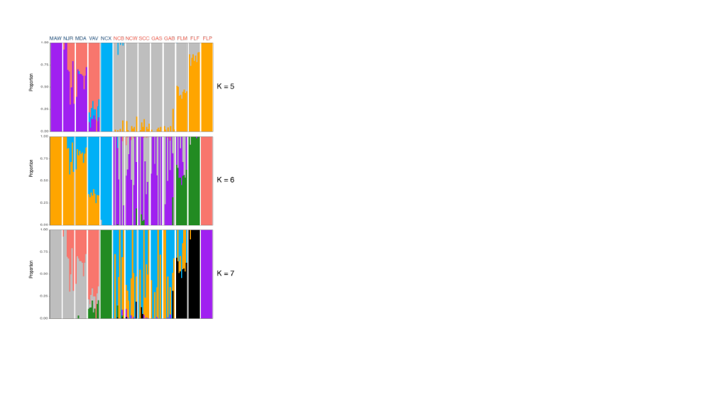

Supplemental Figure 1. Admixture plots for the 118 Mnemiopsis samples collected for K = 5 to K = 7 where each bar represents a single individual, and the colors represent each of the K components.

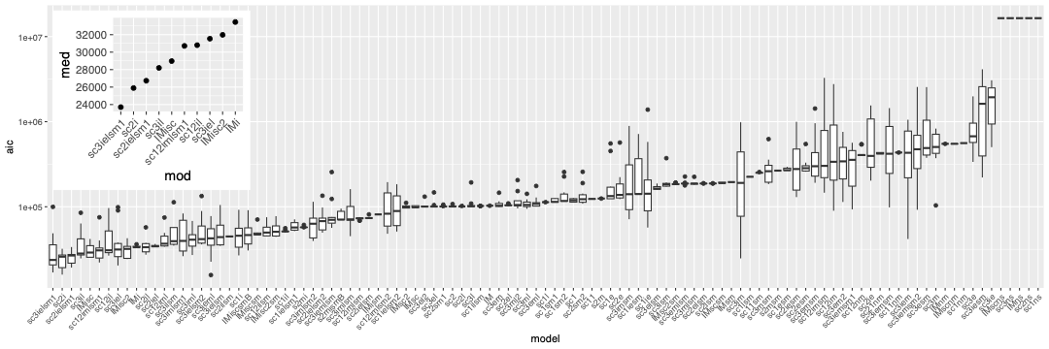
Supplemental Figure 2. Boxplots summarizing the best AIC scores for each model for all bootstrapped replicates for each of 102 demographic models tested. The inset plot shows the boxplot for the median AIC for the top ten best-fitting models in the set.

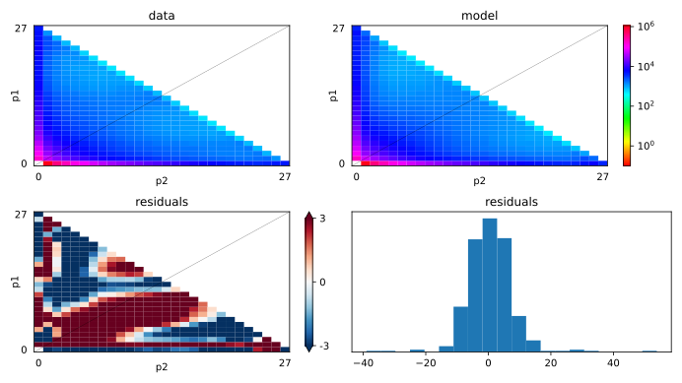
Supplemental Figure 3. Plots showing the goodness-of-fit of the best fitting model (sc3ielsm1). The top two panels show the observed AFS (top left) and the modeled AFS (top right). The lower two plots show model errors plotted as residuals between the best-fit model and the data (bottom left) and the frequency histogram of residuals (bottom right).

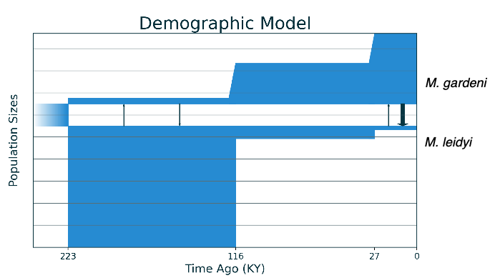

Supplemental Figure 4. The best-fit demographic model (sc3ielsm1) inferred using Moments for the demographic history between M. leidyi and M. gardeni. This best-fit model includes three epochs in each species with symmetric migration in the first and asymmetric migration in the last.

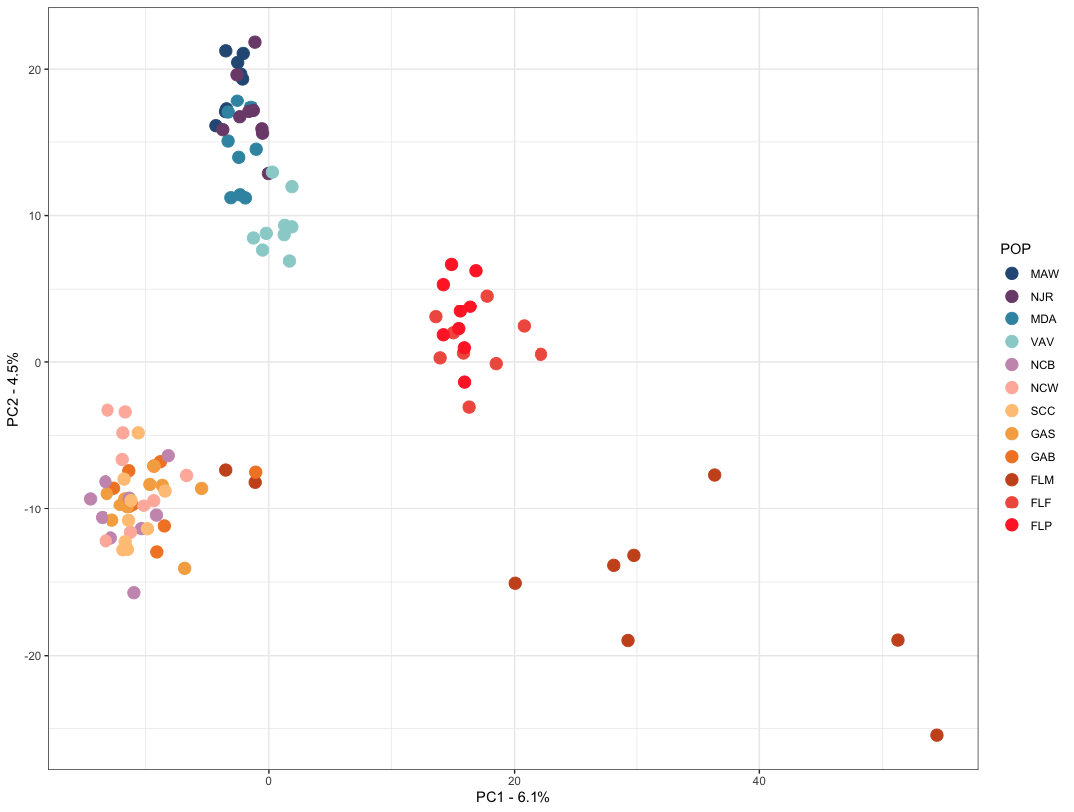
Supplemental Figure 5. PCA plot based on copy number variation among samples. Copy number estimates were generated as denoised copy number ratios in GATK. Individuals are colored by their sampling location.

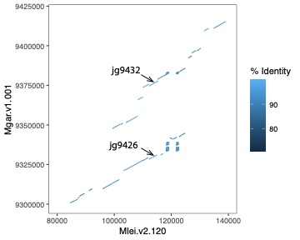

Supplemental Figure 6. The top V_{ST} outlier gene occurs in an M. gardeni-specific duplicated region. This dot plot shows BLAST hits (e-value < 1e-10; length >= 500bp) between corresponding regions in the M. leidyi and M. gardeni assemblies. The V_{ST} outlier gene (jg9426 – Mgar.v1.001:9329910-9331046) occurs as part of a larger duplicated region in M. gardeni. In M. leidyi, this region is single-copy. Arrows highlight the location of the M. gardeni duplicated genes.

