Original uncropped Western blot images
Corresponding to Figure 1C
Sample lanes (left to right): Marker, mcherry^{RNAi}, cp190^{RNAi}, su(Hw)^{RNAi}, mod(mdg4)67.2^{RNAi}, mcherry^{RNAi}, eff^{RNAi}, mcherry^{RNAi}, cul4^{RNAi}, WT1, WT2, Marker
Note that chemiluminescent signal is shown on left, and overlay of chemiluminescence and visual light is shown on right.
α-CP190
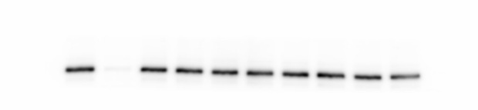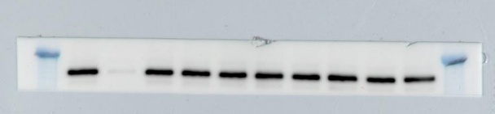
α-Su(Hw)
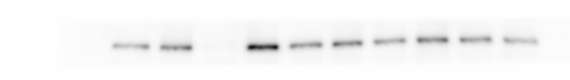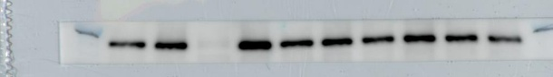
α-Mod(mdg4)67.2
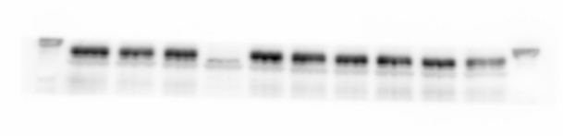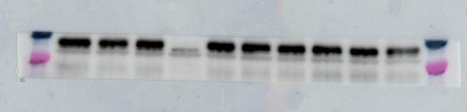
α-Eff (mouse)
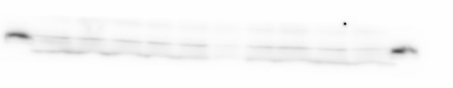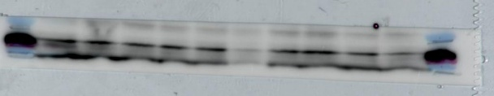
α-Tubulin
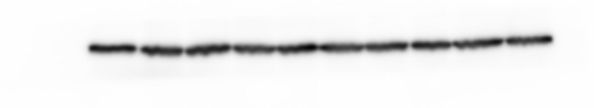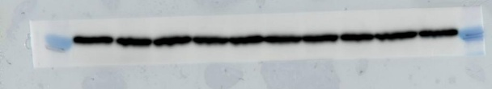
Sample lanes (left to right): Marker, mcherry^{RNAi}, cp190^{RNAi}, su(Hw)^{RNAi}, mod(mdg4)67.2^{RNAi}, WT1, WT2, mcherry^{RNAi}, eff^{RNAi}, mcherry^{RNAi}, cul4^{RNAi}, Marker. Note that these are the exact same samples as loaded in the top set.
α-Cul4 (mouse)
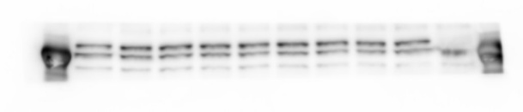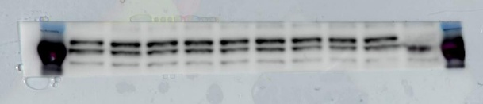
Corresponding to Figure 1D
Sample lanes correspond to labeling in main figure.
α-CP190
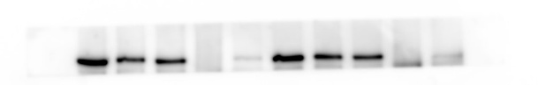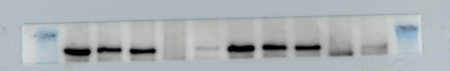
α-Su(Hw)
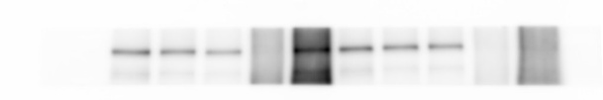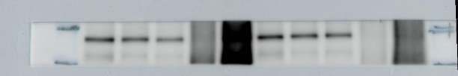
α-Cul4 (rabbit)
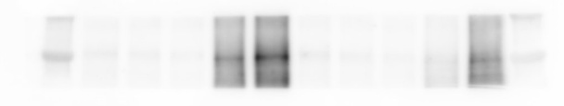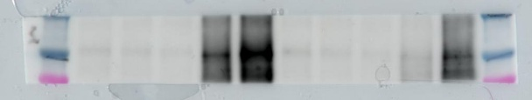
α-Mod(mdg4)67.2
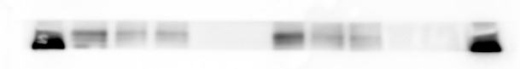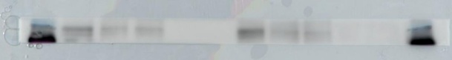
α-LaminB
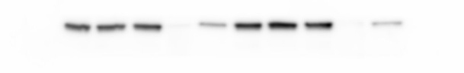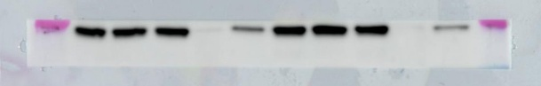
α-Polycomb
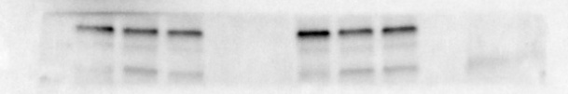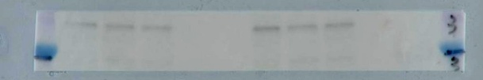
α-Eff (rabbit)
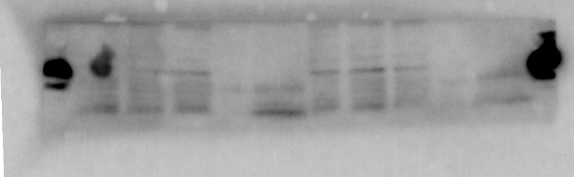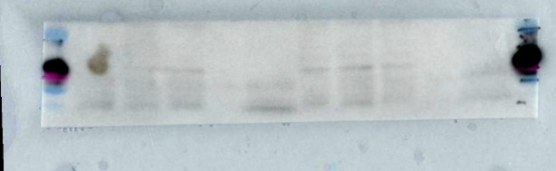

Corresponding to Figure 2A
Sample lanes (left to right): Marker, act5C-Gal4, act5C-Gal4, act5C::su(Hw)^{RNAi}, act5C::su(Hw)^{RNAi}, act5C::cul4^{RNAi}, act5C-Gal4, act5C::cul4^{RNAi}, act5C::eff^{RNAi}, act5C-Gal4, act5C::eff^{RNAi}, Marker
α-CP190
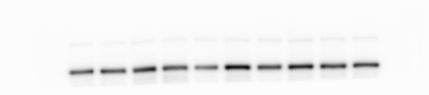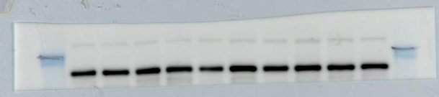
α-Cul4 (mouse)
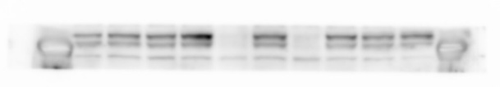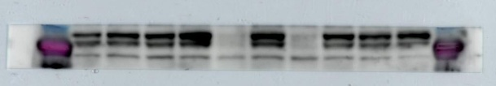
α-Tubulin
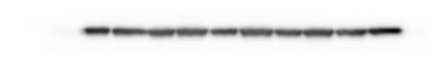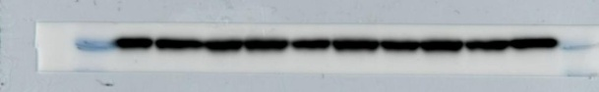
α-Eff (mouse)
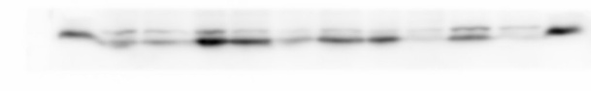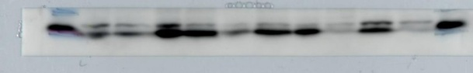

Corresponding to Figure 5A
Sample lanes correspond to labeling in main figure.
α-CP190
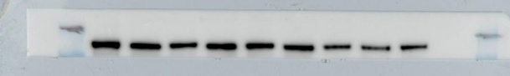
α-Su(Hw)
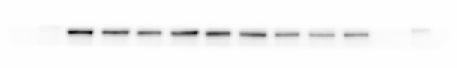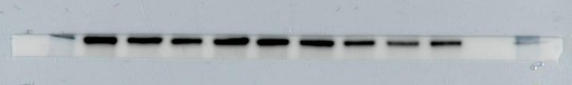
α-Cul4 (mouse)
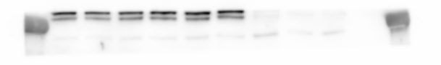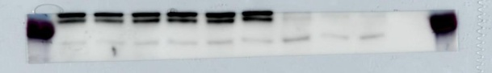
α-LaminB
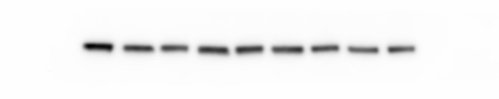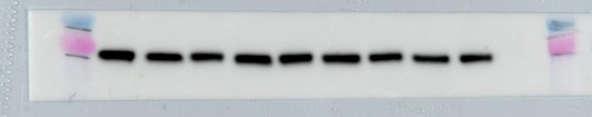
α-Tubulin
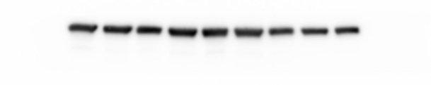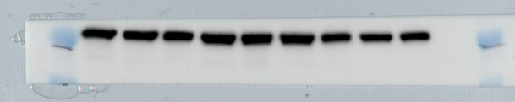
α-Eff (mouse)
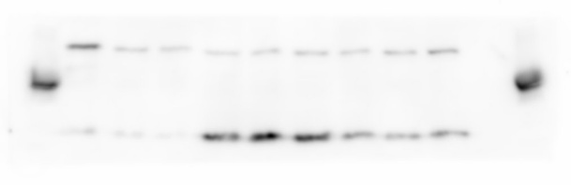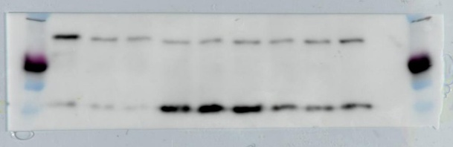

Corresponding to Additional file 1: Fig. S2B
α-Cul4 (rabbit)
Sample lanes (left to right): Marker, mcherry^{RNAi}, cul4^{RNAi}, mcherry^{RNAi}, cul4^{RNAi}
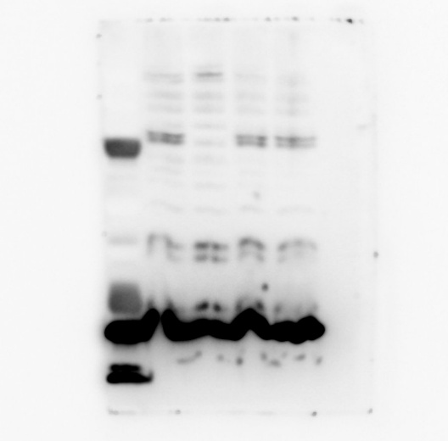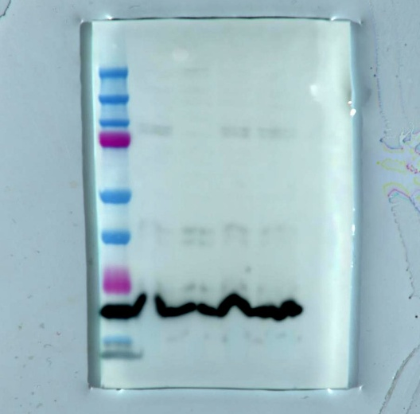
α-Cul4 (mouse)
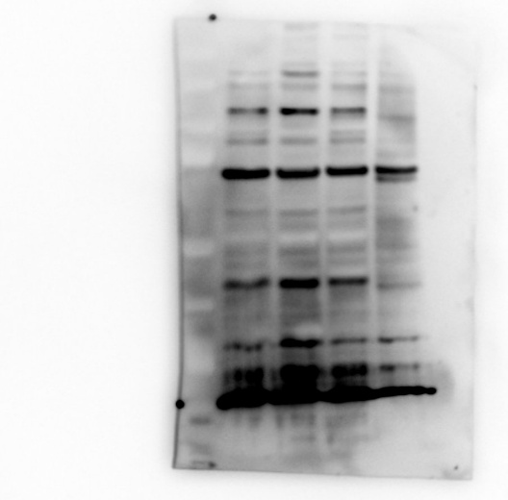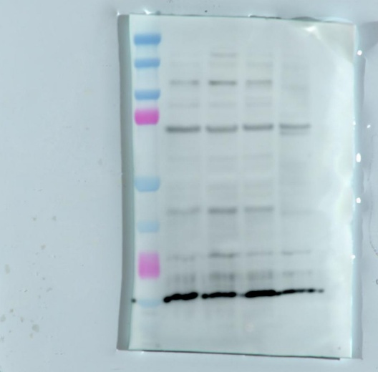
α-CP190
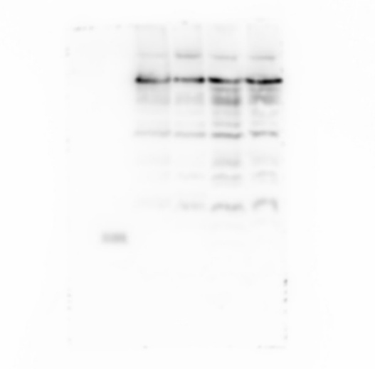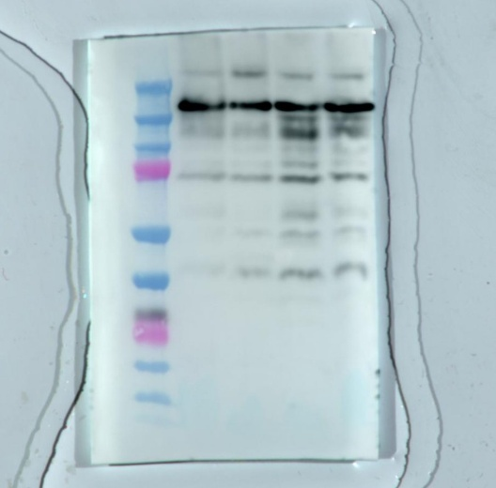

Corresponding to Additional file 1: Fig. S2E
Sample lanes (left to right): Marker, mcherry^{RNAi}, cp190^{RNAi}, su(Hw)^{RNAi}, mod(mdg4)67.2^{RNAi}, mcherry^{RNAi}, topors^{RNAi}, mcherry^{RNAi}, topors^{RNAi}, WT1, WT2, Marker
α-CP190
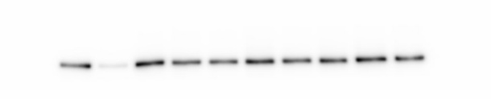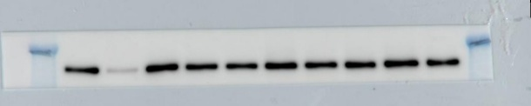
α-Topors
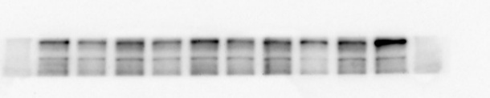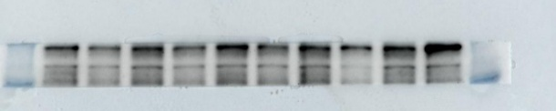
α-Su(Hw)
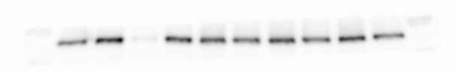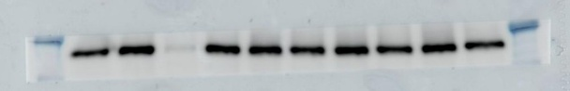
α-Cul4 (mouse)
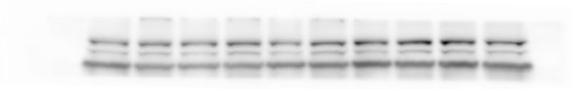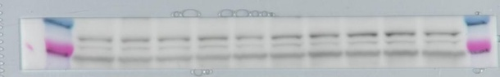
α-Mod(mdg4)67.2
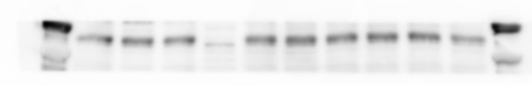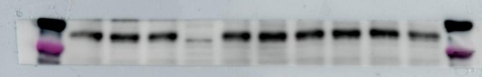
α-Tubulin
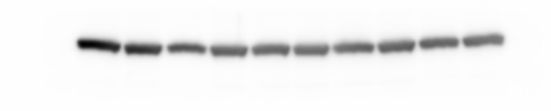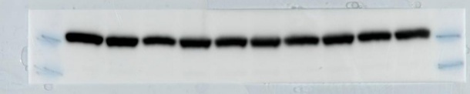
α-Eff (mouse)
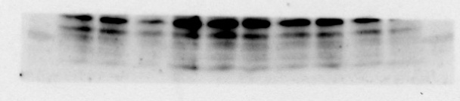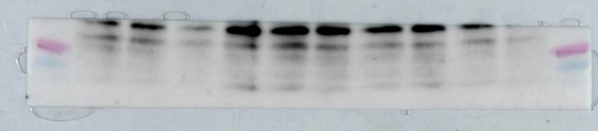

Corresponding to Additional file 1: Fig. S2G
Samples (left to right): anti-CP190 IP lanes as labeled in Fig. S2G and nuclear extract, supernatant of IgG IP, supernatant of anti-Eff IP, IgG IP, anti-Eff IP
α-CP190
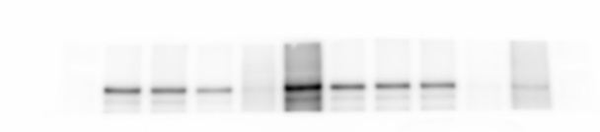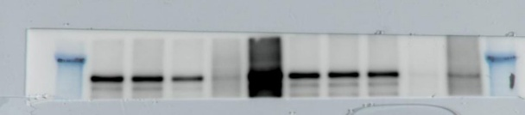
α-Cul4 (rabbit)
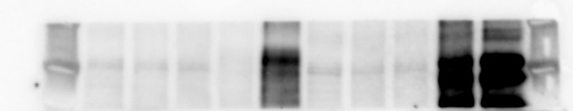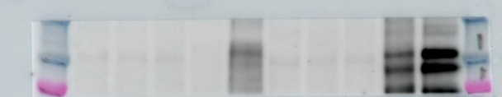
α-LaminB
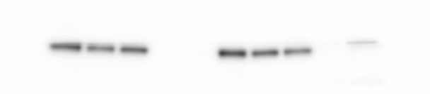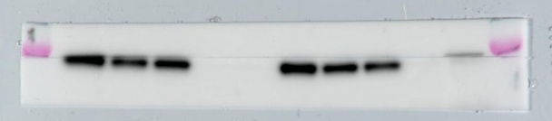
α-Polycomb
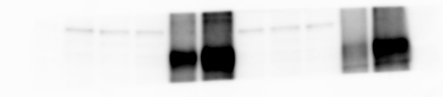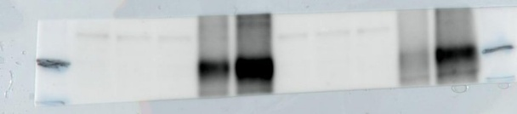
α-Eff (rabbit)
