Additional files

Elevated Retrocopy Burden and Sloth-Specific Expansions Illuminate Mammalian Genome Evolution
Marcela Uliano-Silva^{1,2,#,*}, Helena Beatriz da Conceição^{3#}, Rafael L. V. Mercuri^{3,4},Sylke Winkler⁵, Gabriela D. A. Guardia³, Eugene Myers⁵, Shane McCarthy¹, Alan Tracey¹, Alexander Suh^{6,7}, Mark Blaxter¹, Pedro A. F. Galante^{3,*}, Camila J. Mazzoni^{8,9, *}

¹ Tree of Life, Wellcome Sanger Institute, Cambridge, UK.
² Faculty of Biosciences and Aquaculture, Nord University, Bodø, Norway.
³ Molecular Oncology Center, Hospital Sírio Libanês, São Paulo, Brazil.
⁴ The Institute of Mathematics and Statistics of the University of São Paulo, São Paulo, Brazil.
⁵ Max-Planck Institute for Molecular Cell Biology & Genetics, Dresden, Germany
⁶ Centre for Molecular Biodiversity Research, Leibniz Institute for the Analysis of Biodiversity Change, Museum Koenig Bonn, Adenauerallee 160, D-53113 Bonn, Germany
⁷ Bonn Institute for Organismic Biology (BIOB) – Animal Biodiversity, University of Bonn, Bonn, Germany
⁸ Department of Evolutionary Genetics, Leibniz Institute for Zoo and Wildlife Research (IZW), Berlin, Germany.
⁹ Berlin Center for Genomics in Biodiversity Research (Begendiv), Berlin, Germany.

*Corresponding authors: Email: mu2@sanger.ac.uk (M.U.S), pgalante@mochsl.org.br (P.A.F.G.), mazzoni@izw-berlin.de (C.J.M.)
#Equal contributors

Supplementary Figures

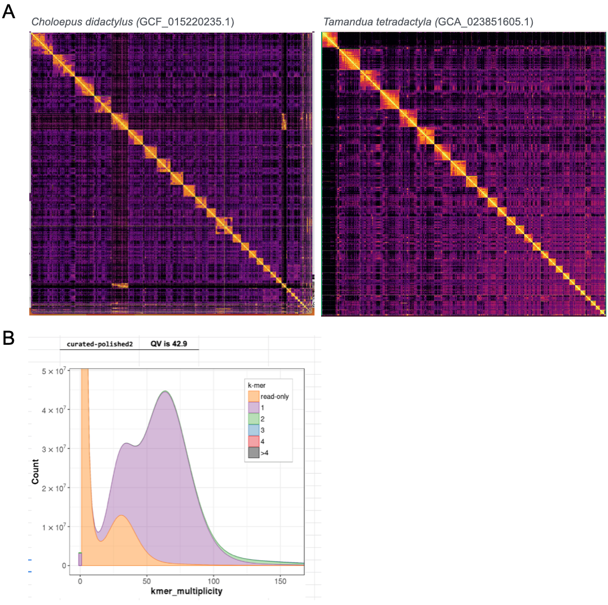
Figure S1. Genome assembly validation for Choloepus didactylus and Tamandua tetradactyla. A) Hi-C heatmaps for Choloepus didactylus and Tamandua tetradactyla. B) Merqury plot for C. didactylus final assembly: kmer counts show low levels of duplicated kmers in homozygous and heterozygous genome coverage peaks and distribution.

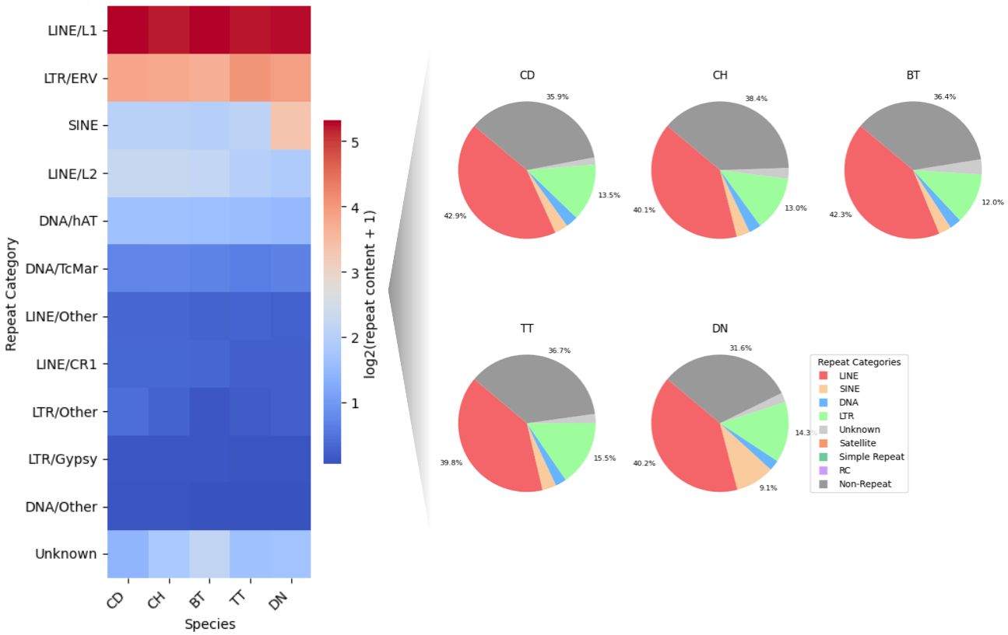
Figure S2: General repeat content of Xenarthra genomes. Species abbreviations: CD, C. didactylus; CH, C. hoffmanni; BT, B. torquatus; TT, T. tetradactyla; DN, D. novemcinctus.

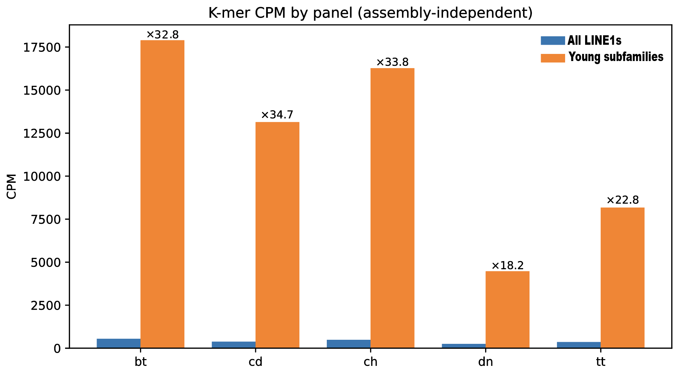
Figure S3: Assembly-independent quantification of young LINE1 sequence using k-mer analysis. Counts per million (CPM) of k-mers derived from young LINE1 subfamilies were quantified directly from raw sequencing reads for each species. Two reference sets were used: (i) all xenarthran LINE1 subfamilies present in the repeat library and (ii) a curated set of 65 LINE1 sequences (“young subfamilies”). Within each species, LINE1 subfamilies were ranked by genomic occupancy, and those cumulatively accounting for 80% of the total young LINE1 sequence were retained for the curated set. Bars represent normalized k-mer counts (CPM) detected in sequencing reads. Values above the bars indicate the enrichment ratio of the curated young set relative to the full set of xenarthran LINE1 subfamilies for each species. Species abbreviations: CD, Choloepus didactylus; CH, Choloepus hoffmanni; BT, Bradypus torquatus; TT, Tamandua tetradactyla; DN, Dasypus novemcinctus.

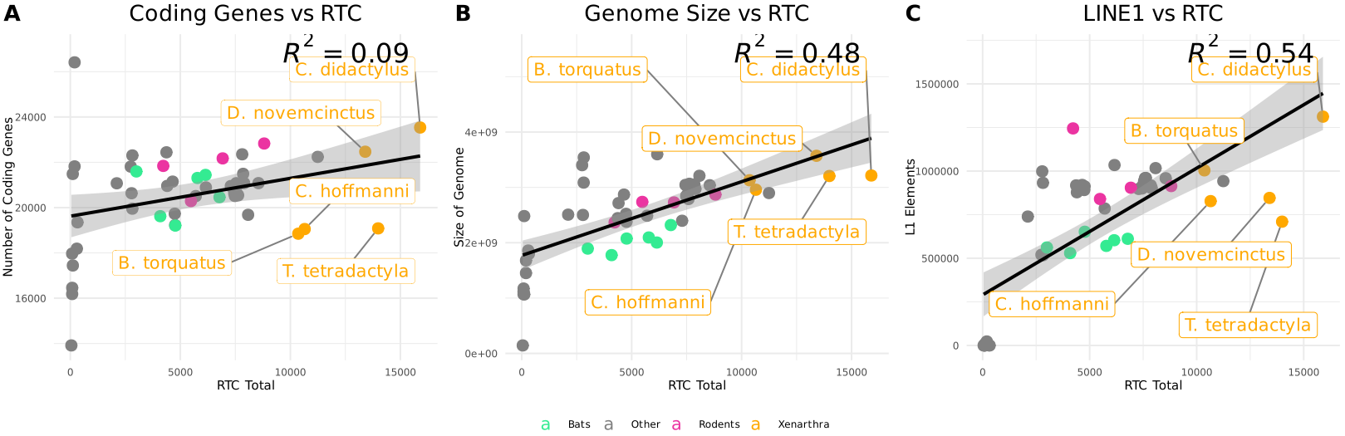
Figure S4: Correlations between retrocopy counts and genome size, number of protein-coding genes, and LINE-1 abundance across vertebrate species present in RCPedia. Xenarthra genomes are indicated in orange, rodents in pink and bats in green.
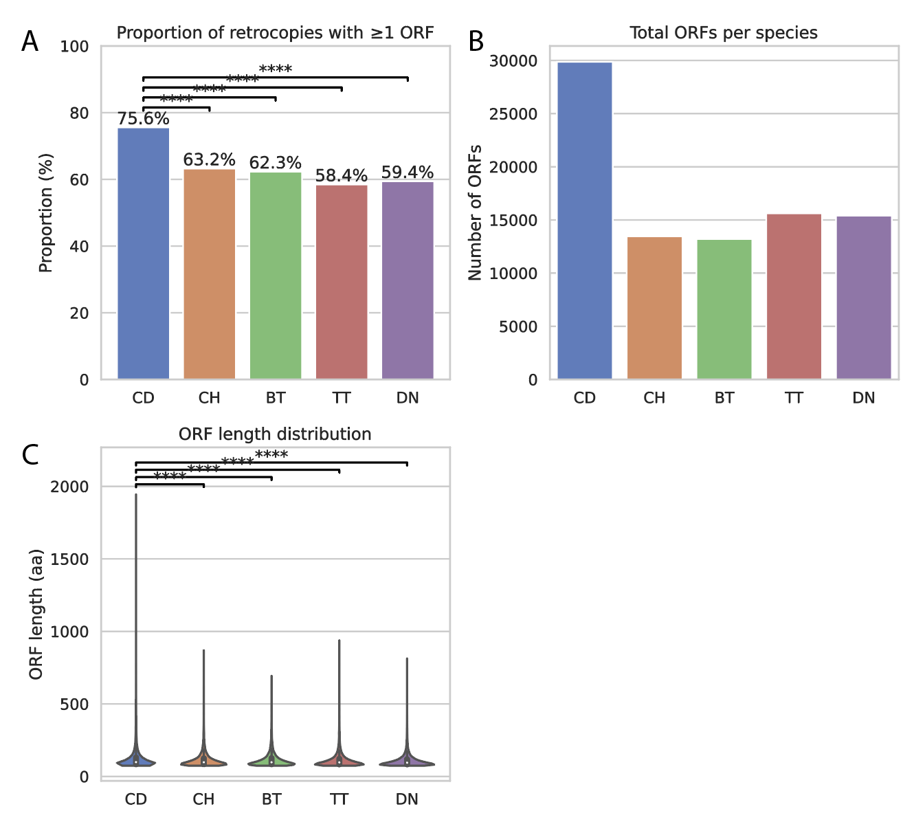
Figure S5: Retrocopy-predicted ORFs. A) Proportion of retrocopies yielding ORFs, Significance indicates pairwise comparisons between C. didactylus and the other species using two-proportion z-tests (, p < 0.0001). B) Total predicted ORFs per species, C) Length of retrocopy-predicted ORFs. Significance indicates pairwise Wilcoxon rank-sum tests comparing C. didactylus with other species (, p < 0.0001). Species abbreviations: CD, C. didactylus; CH, C. hoffmanni; BT, B. torquatus; TT, T. tetradactyla; DN, D. novemcinctus.

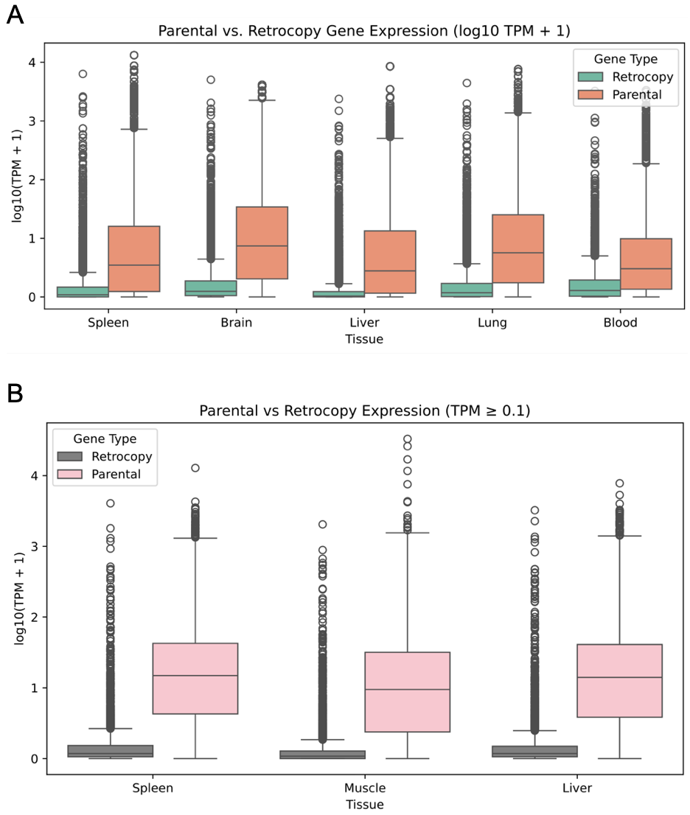
Figure S6. Parental genes and retrocopies expression in: A) C. didactylus; B) D. novemcinctus.

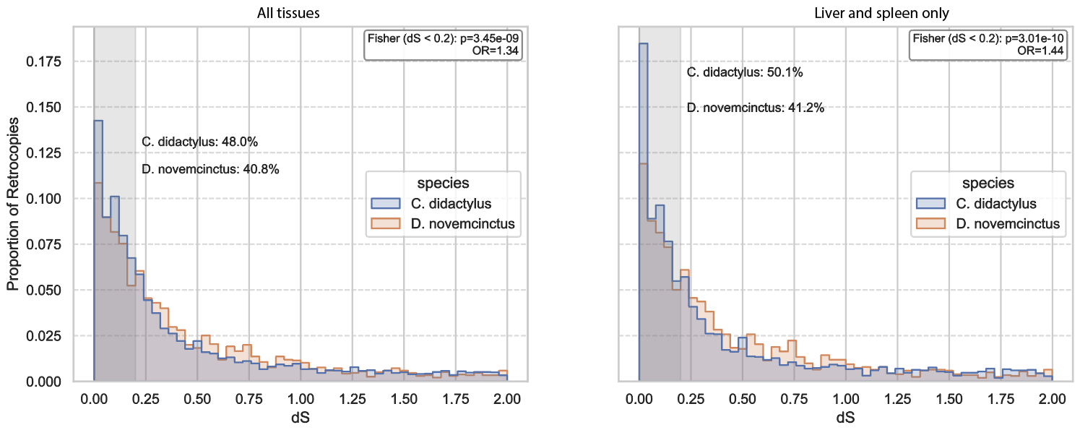
Figure S7. Distribution of synonymous substitution rates (dS) for expressed retrocopies in C. didactylus and D. novemcinctus. The overlay histogram shows the proportion of expressed retrocopies across dS bins, with the shaded region highlighting young retrocopies (dS < 0.2). The left panel shows the full dataset using all available tissues, while the right panel shows a controlled analysis restricted to shared tissues (liver and spleen). In both cases, a higher proportion of expressed retrocopies in C. didactylus fall within the low-dS range compared to D. novemcinctus (full dataset: Fisher’s exact test, p = 3.4 × 10⁻⁹, OR = 1.34; shared tissues: p = 3.0 × 10⁻¹⁰, OR = 1.44), indicating that the enrichment of young expressed retrocopies in C. didactylus is robust to differences in tissue sampling.

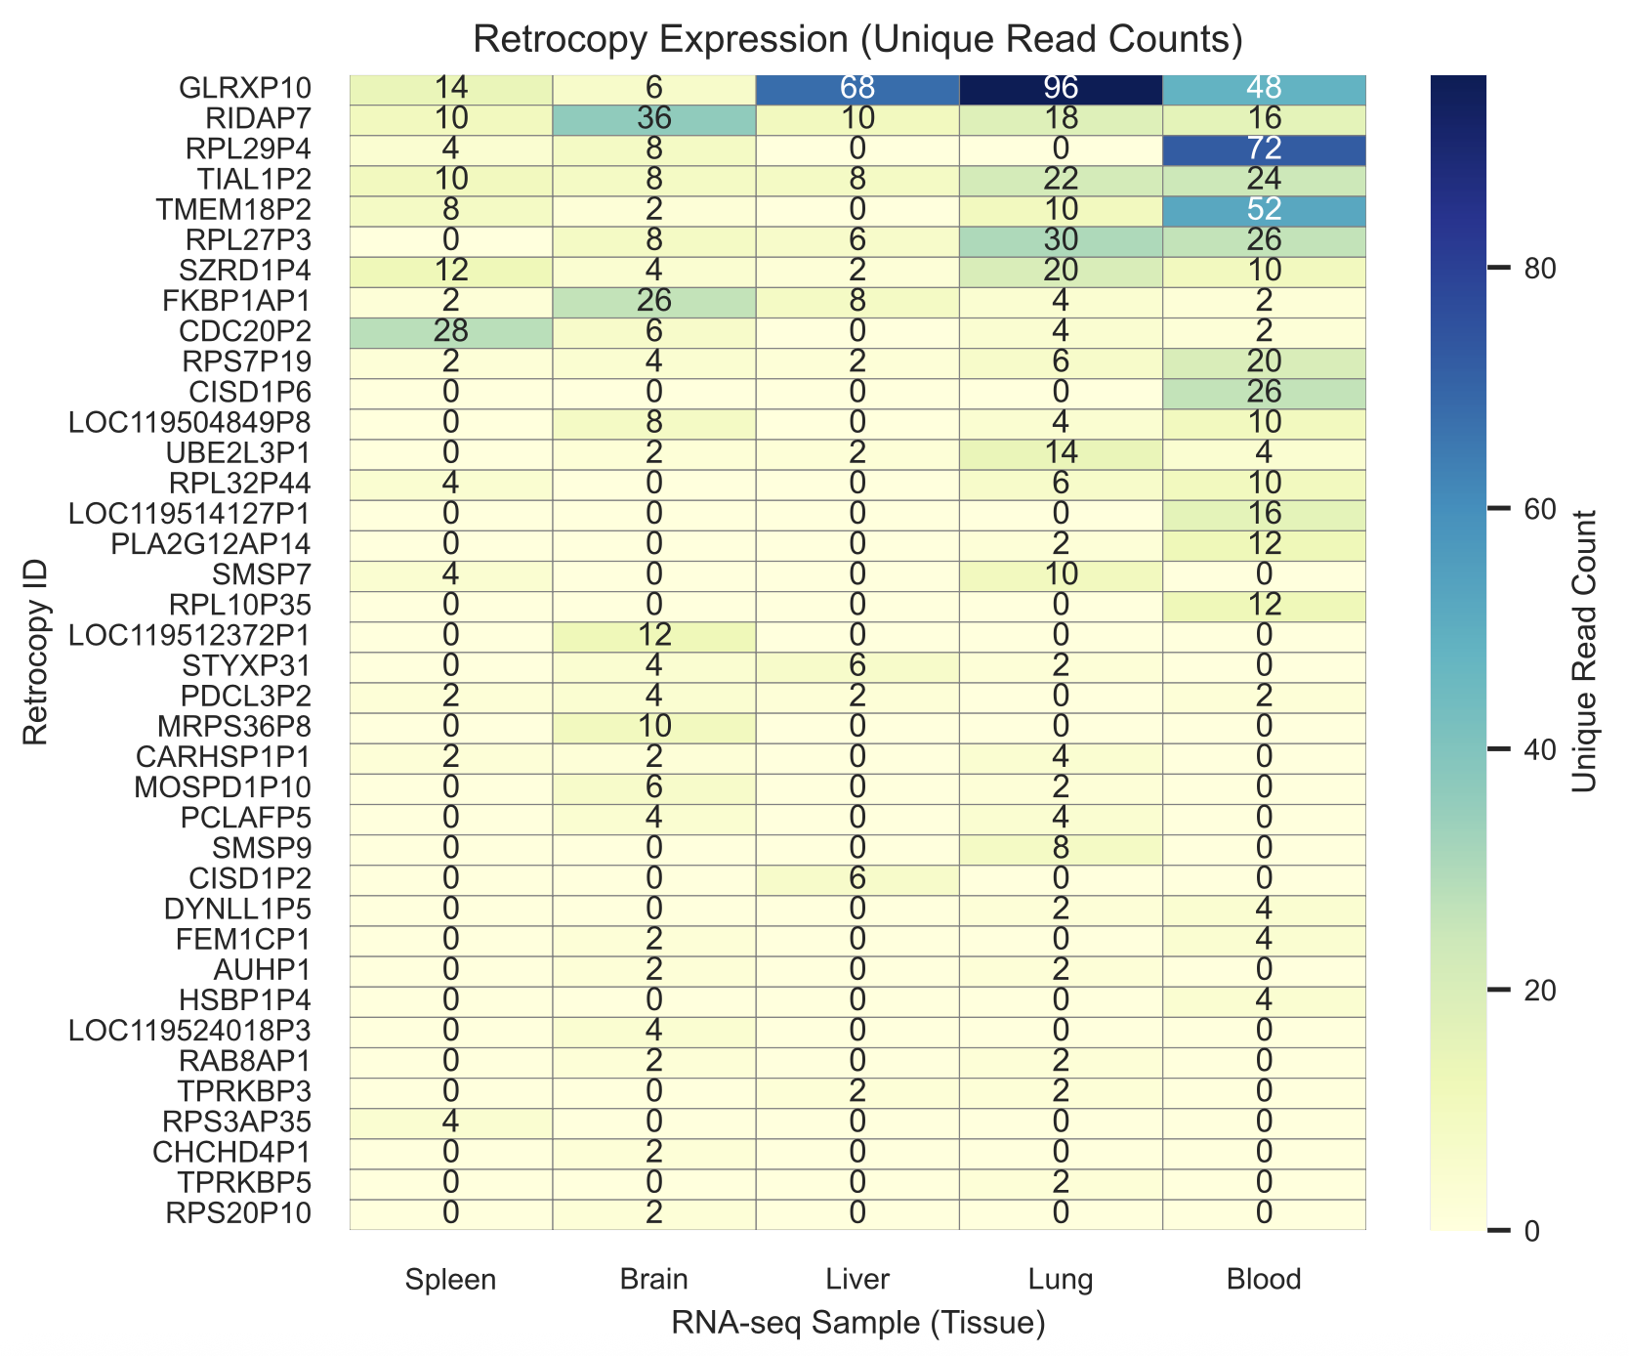
Figure S8. Expression of domesticated retrocopies in Choloepus didactylus. Expression levels were estimated using uniquely mapped RNA-seq reads.

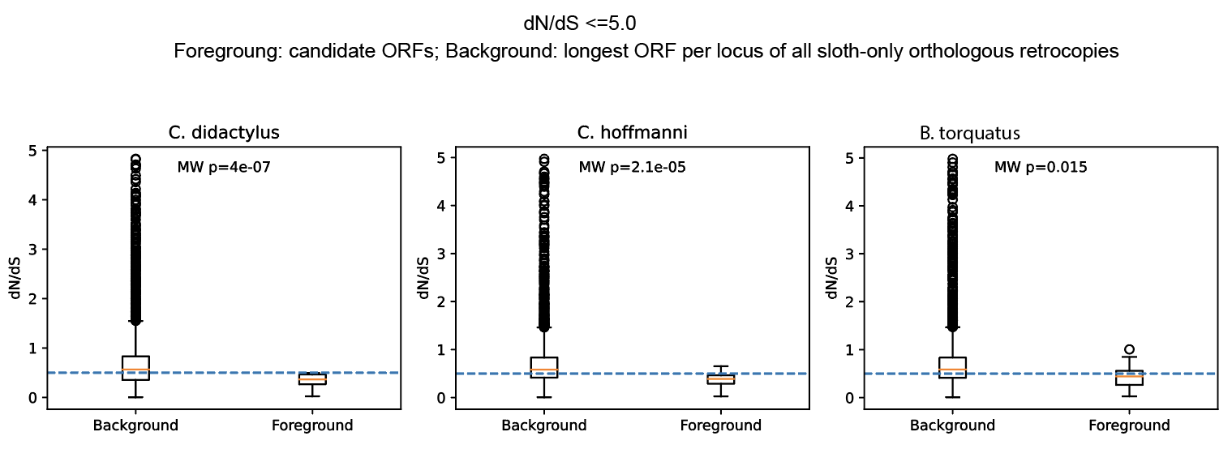
Figure S9. dN/dS distributions for candidate domesticated retrocopies across sloth lineages. Boxplots show dN/dS distributions for candidate retrocopies (foreground) and remaining sloth-only retrocopies (background) in C. didactylus, C. hoffmanni, and B. torquatus, after excluding extreme values (dN/dS > 5.0) to account for potential ratio instability. The background includes one representative ORF per locus (longest predicted ORF). Dashed horizontal lines indicate the purifying selection threshold (dN/dS = 0.5). P-values from two-sided Mann–Whitney U tests are shown above each panel. Candidate loci exhibit significantly lower dN/dS values than sloth-only background in all three species.
Supplementary Tables

Table S1. General metrics of publicly available Xenarthra genomes included in this study.
Species | Choloepus hoffmanni | Bradypus torquatus | Dasypus novemcinctus
Accession | DNAzoo  C_hoffmanni-2.0.1_HiC.fasta.gz | GCA_963992745.1 | GCF_030445035.2
Total length | 3,293,892,468 | 3,128,591,653 | 3,610,551,914
Scaffold N50 | 140,950,122 | 156,600,181 | 127,081,865
Contig N50 | 64,321 | 4,748,776 | 13,963,394
Scaffold count* | 253,016 | 2,915 | 546
BUSCO** mammalian_odb10 | C:94.2%[S:89.7%,D:4.5%],F:1.9%,M:3.9%,n:9226 | C:94.4%[S:90.1%,D:4.3%],F:1.1%,M:4.5%,n:9226 | C:93.8%[S:90.6%,D:3.2%],F:1.7%,M:4.5%,n:9226

*In cases where identified, Including the mitochondrial genome as a scaffold
**BUSCO: Benchmarking using single-copy orthologues

Table S2. Contiguity comparison (non-N contigs within scaffolds of Xenarthra assemblies)
Species | Number of contigs | Max contig length | % non-N bp ≥10 kb | % non-N bp ≥20 kb
Choloepus hoffmanni | 370998 | 0.71 Mb | 87.01% | 79.47%
Choloepus didactylus | 1386 | 67.7 Mb | 99.99% | 99.97%
Bradypus torquatus | 5022 | 30 Mb | 99.89% | 99.59%
Dasypus novemcinctus | 1339 | 82.5 Mb | 100% | 99.99%
Tamandua tetradactyla | 1162 | 46.6 Mb | 99.98% | 99.96%

Table S3 | Summary statistics from assembly-independent k-mer quantification of young LINE1 sequence.
Counts per million (CPM) of k-mers derived from LINE1 sequences were quantified directly from raw sequencing reads for each species. Two reference sets were used: (i) Young subfamilies, corresponding to the subset of LINE1 subfamilies with ≤5% Kimura divergence that cumulatively account for ~80% of young LINE1 genomic occupancy within each species, and (ii) All LINE1s, representing the full set of xenarthran LINE1 subfamilies identified in the repeat library. For each reference set, 50,000 representative k-mers were queried against raw sequencing reads. Columns report the number of query k-mers (num_kmers), the total number of matching k-mer counts in the reads (sum_counts), the number of k-mers detected at least once (num_present), the fraction of detected k-mers (hit_rate), the total number of k-mers in the sequencing dataset (total_kmers), the fraction of reads matching the query set (fraction), and normalized counts per million (CPM). Abbreviations: CD, Choloepus didactylus; CH, Choloepus hoffmanni; BT, Bradypus torquatus; TT, Tamandua tetradactyla; DN, Dasypus novemcinctus.
Species | LINE sequences | num_kmers | sum_counts | num_present | hit_rate | total_kmers | fraction | CPM
TT | Young subfamilies | 50000 | 217570456 | 19519 | 0.39038 | 26637966290 | 0.008168 | 8167.68
DN | Young subfamilies | 50000 | 78980822 | 13552 | 0.27104 | 17662279281 | 0.004472 | 4471.72
BT | Young subfamilies | 50000 | 612090161 | 35888 | 0.71776 | 34205970582 | 0.017894 | 17894.25
CD | Young subfamilies | 50000 | 453673836 | 36188 | 0.72376 | 34528976896 | 0.013139 | 13138.93
CH | Young subfamilies | 50000 | 58333292 | 34520 | 0.6904 | 3585115419 | 0.016271 | 16270.97
TT | All LINE1s | 50000 | 9536040 | 8236 | 0.16472 | 26637966290 | 0.000358 | 357.99
DN | All LINE1s | 50000 | 4337677 | 7203 | 0.14406 | 17662279281 | 0.000246 | 245.59
BT | All LINE1s | 50000 | 18689122 | 8914 | 0.17828 | 34205970582 | 0.000546 | 546.37
CD | All LINE1s | 50000 | 13077273 | 10103 | 0.20206 | 34528976896 | 0.000379 | 378.73
CH | All LINE1s | 50000 | 1726944 | 7981 | 0.15962 | 3585115419 | 0.000482 | 481.70

Table S4: Phylogenetically independent contrasts (PIC) analyses of correlations calculated in Figure S4. Phylogenetic tree recovered from https://timetree.org/ for the species used in this study.
dataset | predictor | slope | p_value | adj_r_squared | n_species | n_contrasts
all | coding | 0.3989 | 0.0001 | 0.2561 | 50 | 49
all | genome | 61443.1728 | 0.0002 | 0.2442 | 50 | 49
all | repeats | 42.8247 | 0.0001 | 0.2737 | 50 | 49
mammals_only | coding | 0.4051 | 0.0002 | 0.2801 | 41 | 40
mammals_only | genome | 58399.0253 | 0.0004 | 0.2579 | 41 | 40
mammals_only | repeats | 41.2432 | 0.0004 | 0.2593 | 41 | 40

Table S5: Statistical analysis of retrocopy burden per parental genes of C. didactylus versus other groups.
Specie 1 | Specie 2 | p | p-adj | p.format | p.sign | Method
C.didactylus | Primates | 1.03E-47 | 3.70E-47 | <2e-16 | **** | Wilcoxon
C.didactylus | Rodents | 4.95E-34 | 1.40E-33 | <2e-16 | **** | Wilcoxon
C.didactylus | Mammals | 2.07E-109 | 7.50E-108 | <2e-16 | **** | Wilcoxon
C.didactylus | Others | 1.55E-78 | 1.90E-77 | <2e-16 | **** | Wilcoxon
C.didactylus | T.tetradactyla | 6.40E-11 | 9.60E-11 | 6.40E-11 | **** | Wilcoxon
C.didactylus | D.novemcinctus | 0.1142628717 | 0.12 | 0.1143 | ns | Wilcoxon
C.didactylus | C.hoffmanni | 3.16E-18 | 5.70E-18 | <2e-16 | **** | Wilcoxon
C.didactylus | B.torquatus | 9.85E-22 | 2.00E-21 | <2e-16 | **** | Wilcoxon

Table S6: NCBI-assigned functions to parental genes given rise to domesticated retrocopies in C. didactylus
