Supplementary Figures
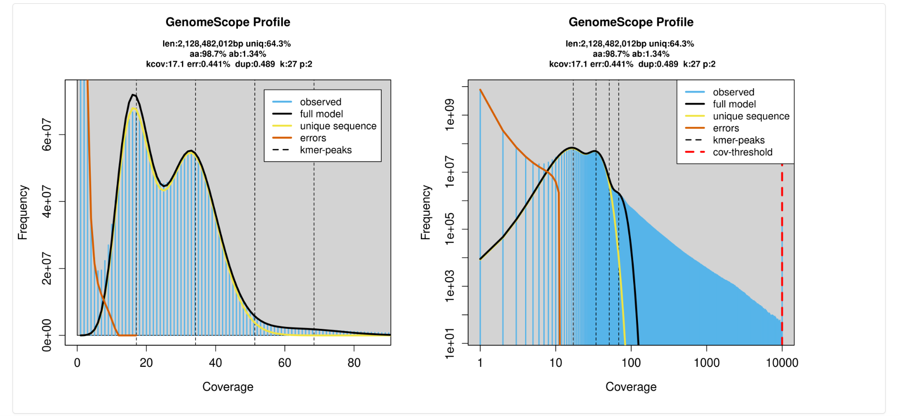
Supplementary Figure S1. GenomeScope 2.0 k-mer frequency profile of the tick genome. K-mer histogram generated from Jellyfish (k = 27) shown on a linear (left) and log (right) scale. Dashed vertical lines indicate k-mer coverage peaks. The model estimates a haploid genome size of ~2.13 Gb, heterozygosity of 1.34%, and sequencing error rate of 0.441%, accounting for 98.7% of the observed k-mer space.
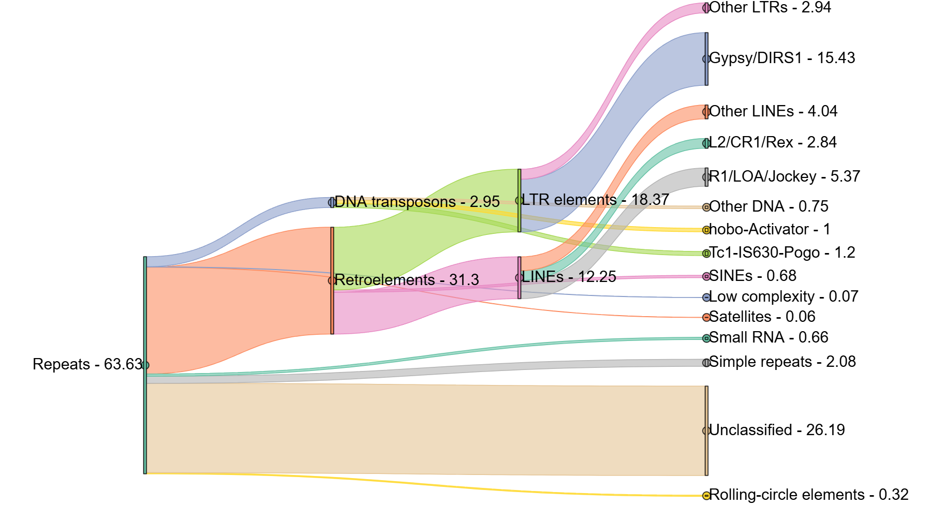

Supplementary Figure S2. Repeat content of the Dermacentor reticulatus genome visualised as a Sankey diagram.
The figure illustrates the hierarchical classification and relative abundance of repetitive elements identified in the D. reticulatus genome assembly. The diagram shows the flow from total repeat content (63.6% of the genome) through major repeat classes to their constituent subfamilies.
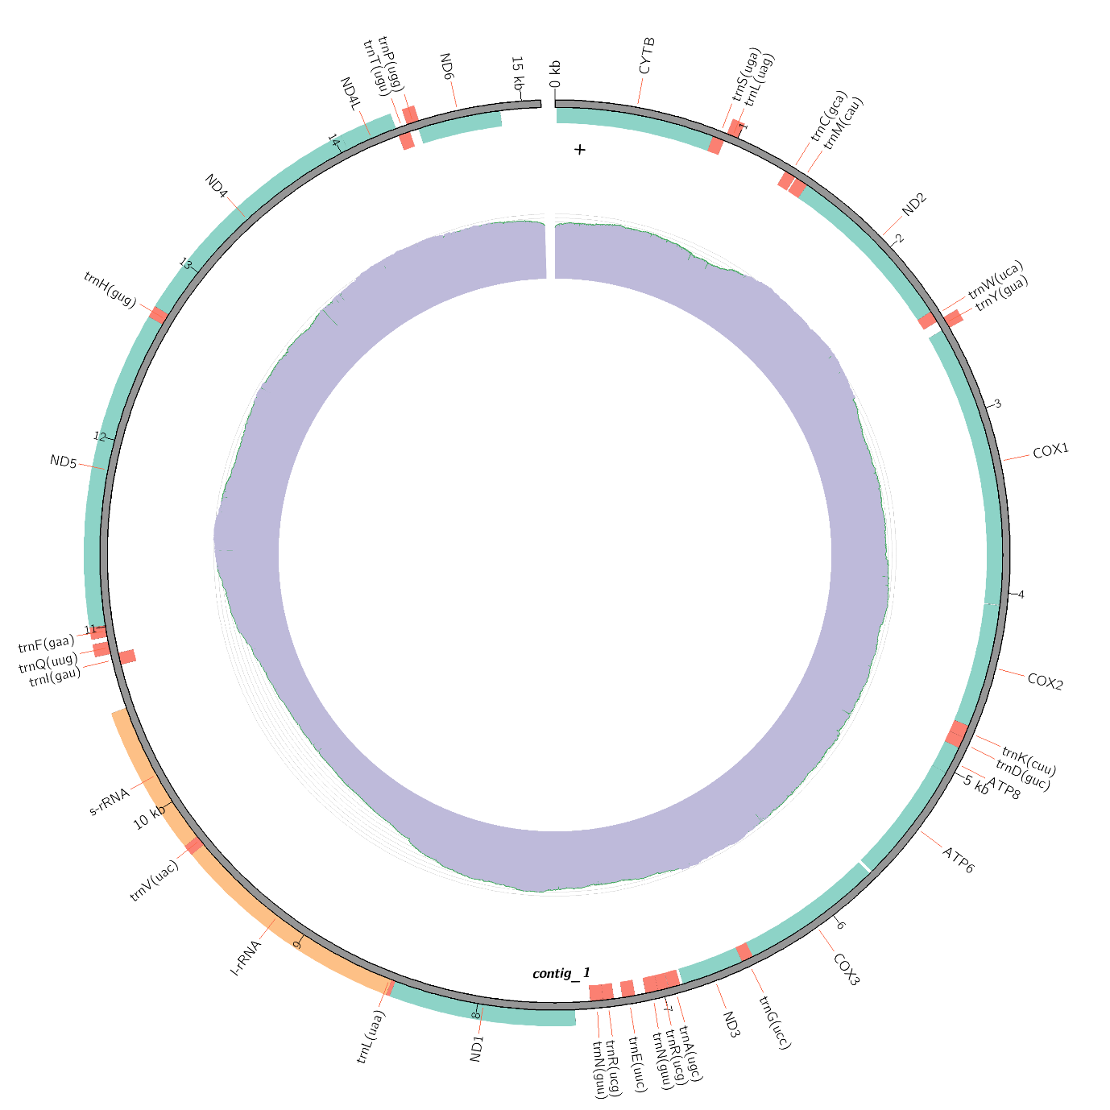

Supplementary Figure S3. Mitochondria Sequence and Annotation for D. reticulatus. The circular mitochondria sequence for D. reticulatus is shown alongside its annotation and genome coverage.

