Network-based machine learning to identify biomarkers for systemic lupus erythematosus

Minhyuk Park^{1,2}#, Donghyo Kim^{2,3,4}#, Juhun Lee^{1,2}#, Jaegyun Noh²#, Chan Johng Kim^{2,3,4}, Youngchul Oh², Chang-Hee Suh^{5,6}, Ji-Won Kim⁵, Sin-Hyeog Im^{1,2}*, Sanguk Kim^{2,7}* & Inhae Kim¹*

Fig. S1. Distribution of probability of association with SLE (P_{SLE}).
Fig. S2. Comparison of SLE biomarkers identified based on SLEDAI criterion for determining SLE active patients.
Fig. S3. Functional enrichment analysis of NetSLE biomarkers.
Fig. S4. Difference in P_{SLE} distribution of gene sets according to SLE association.
Fig. S5. Comparison of predictive performance for SLE disease activity.
Fig. S6. Comparison of predictive performance for SLE disease activity using up-regulated versus up- and down-regulated DEGs.
Fig. S7. Comparison of predictive performance for SLE disease activity across various model conditions.
Fig. S8. Network proximity between NetSLE biomarkers and target genes of drugs used in SLE treatment.
Fig. S9. Difference in z-score (proximity) distribution of drugs across clinical phase.
Fig. S10. Network relationships between NetSLE biomarkers and target genes of experimental drugs.
Fig. S11. Difference in SLEDAI distribution of SLE patients between subtypes.
Fig. S12. Ethnic composition of the SLE cohort.
Fig. S13. Identification of SLE subtypes by clustering analysis.
Fig. S14. Robustness of SLE subtype-specific cell proportions assessed via different inference tools.
Fig. S15. Comparison of immune cell proportions between SLE subtypes.
Fig. S16. Neutrophil and lymphocyte proportions of AS1 and AS2 identified by biclustering algorithms
Fig. S17. Comparison of clinical features between SLE active subtypes.
Fig. S18. Association of clinical features with SLE active subtypes.
Fig. S19. Distribution of SLEDAI for cohorts of SLE patients.
Fig. S20. SLE trait-related gene modules identified through WGCNA.

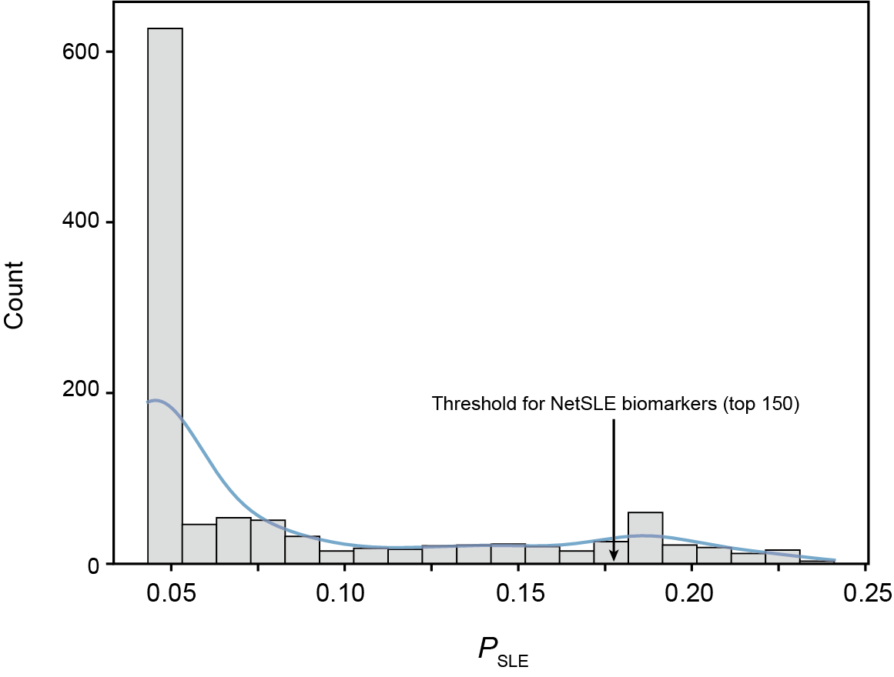
Fig. S1. Distribution of probability of association with SLE (P_{SLE}). Histograms illustrating the distribution of (P_{SLE}). The curved line visualizes the distribution of (P_{SLE}) in a smoothed manner to provide a less cluttered and more interpretable plot. Arrow indicates the threshold of (P_{SLE}) for determining NetSLE biomarkers.
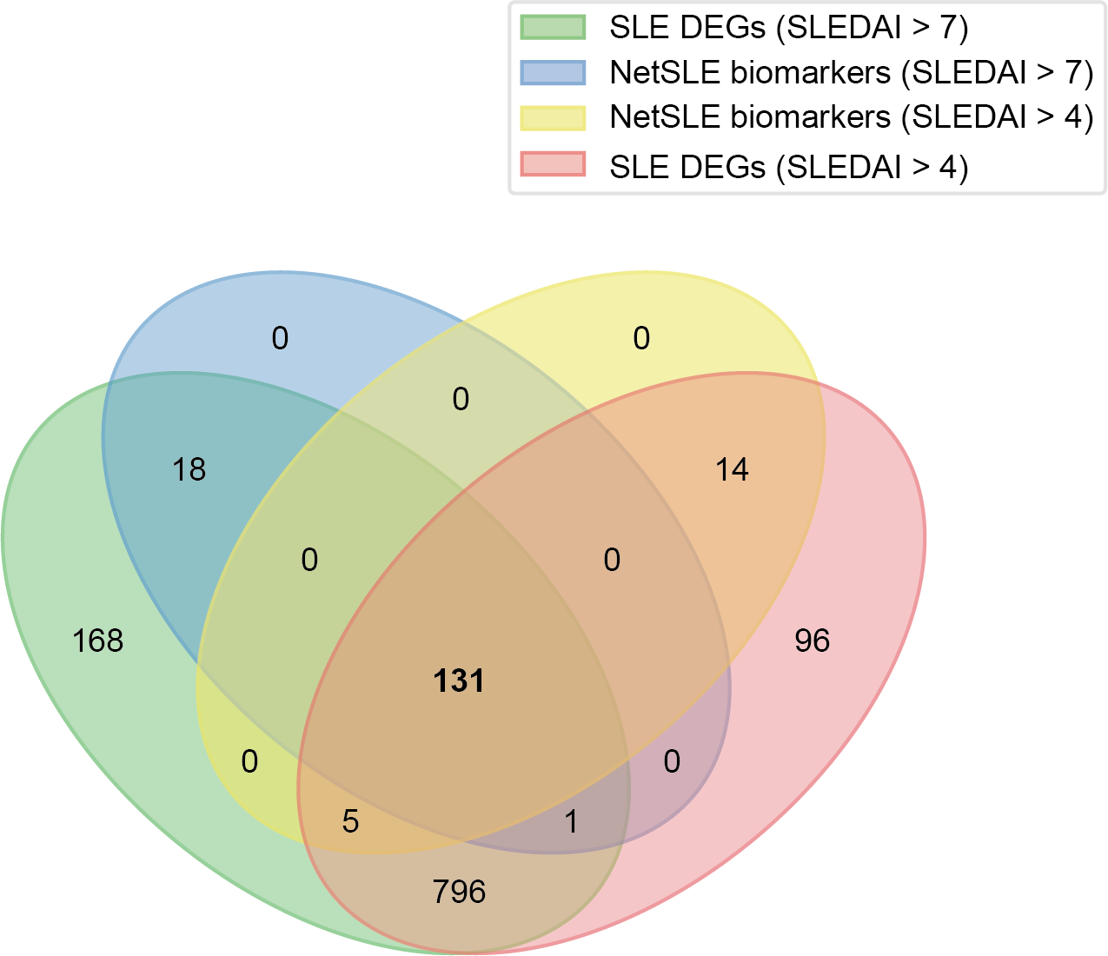
Fig. S2. Comparison of SLE biomarkers identified based on SLEDAI criterion for determining SLE active patients. Venn diagram illustrating the overlap across SLE DEGs and NetSLE biomarkers based on the SLEDAI criterion for classifying SLE active patients. The number of overlapping genes (n = 131) between the NetSLE biomarkers identified under SLEDAI thresholds of four and seven is highlighted in bold.
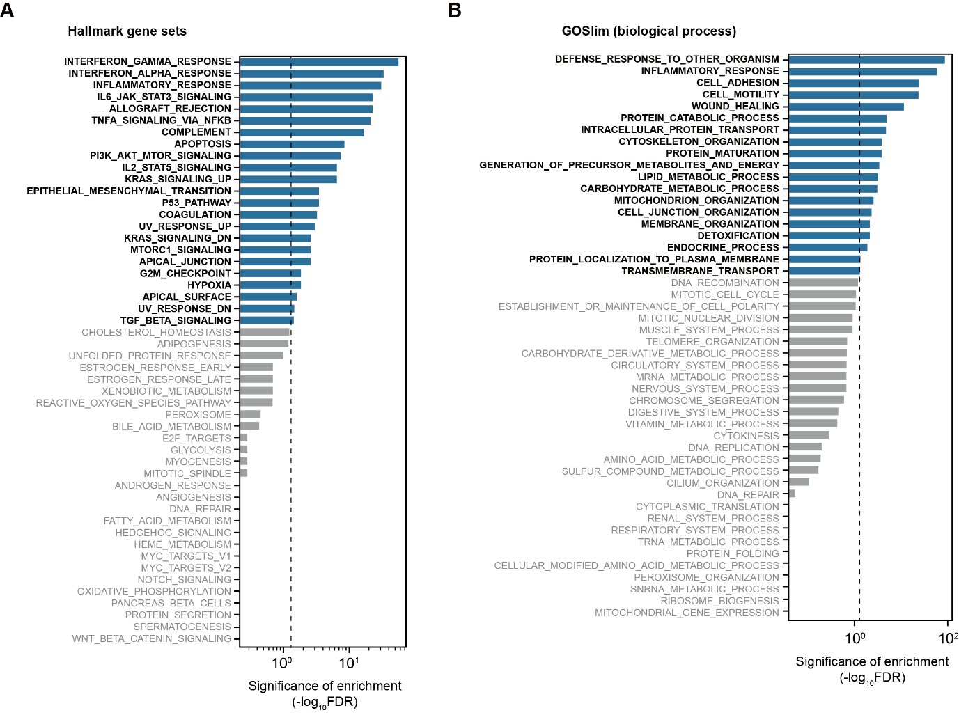
Fig. S3. Functional enrichment analysis of NetSLE biomarkers. (A–B) Bar plots displaying the enrichment significance of NetSLE biomarkers across various biological functions and pathway gene sets. The X-axis is presented on a logarithmic scale. Gene sets with significant enrichment are indicated by blue bars and bold black text, while those with insignificant enrichment are shown with gray bars and gray text. The dashed line marks the threshold for statistical significance, as determined by the hypergeometric test and corrected using the Benjamini-Hochberg method (False discovery rate, FDR).
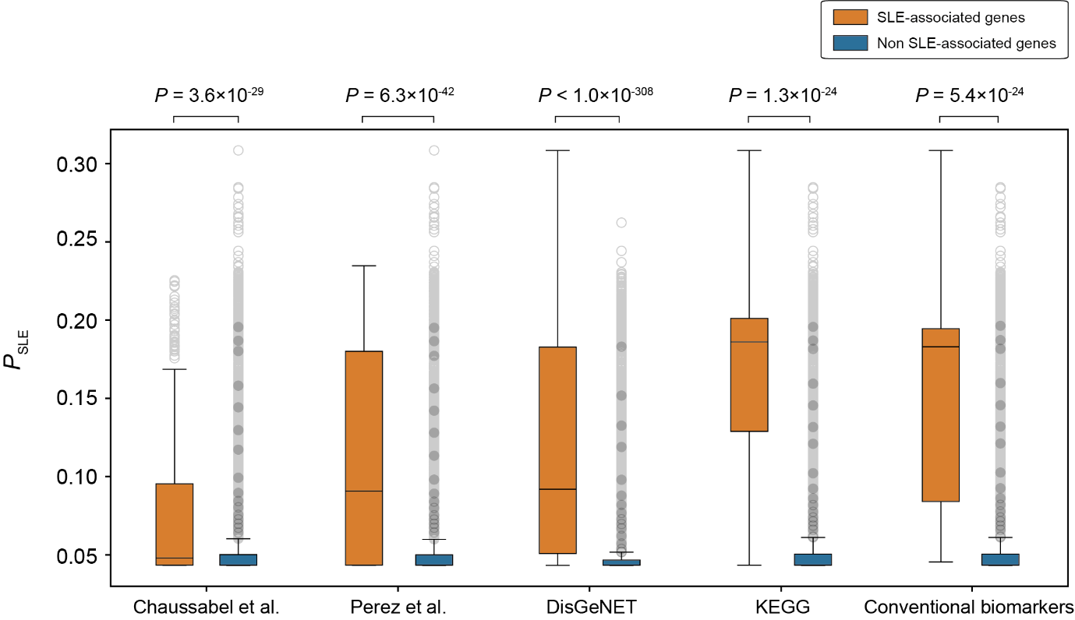
Fig. S4. Difference in P_{SLE} distribution of gene sets according to SLE association. Boxplots show the distribution of the P_{SLE} according to the SLE association of genes. The significance of the distribution difference was analyzed using the Mann–Whitney U test.
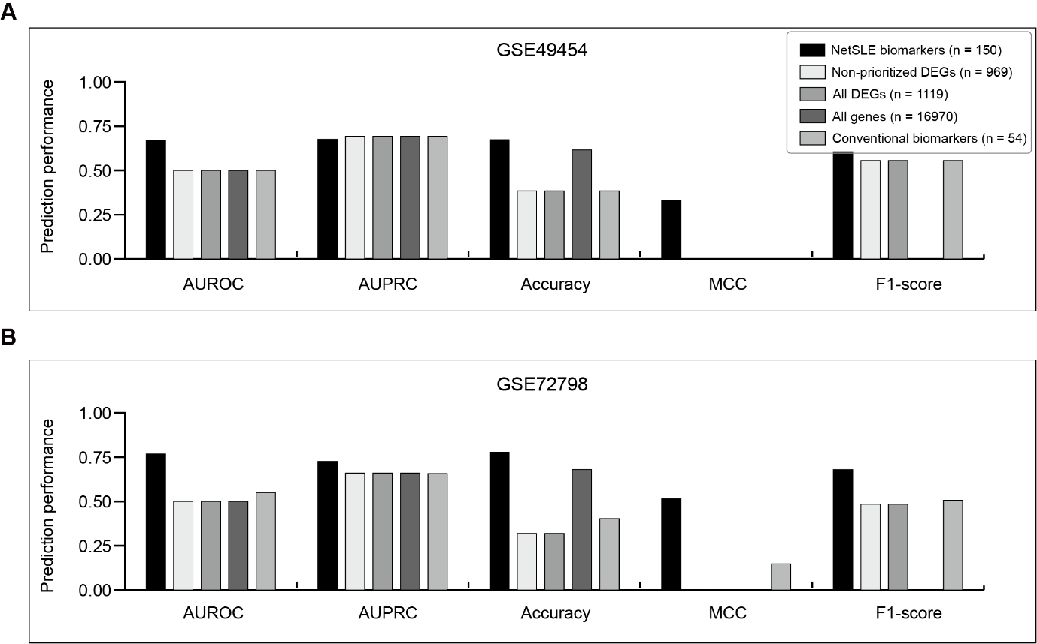 Fig. S5. Comparison of predictive performance for SLE disease activity. (A–B) Performance comparison of various gene sets in disease activity prediction. Bar plots show prediction performance values for various metrics. Area under the receiver operating characteristics (AUROC); Area under the precision-recall curve (AUPRC); Matthews correlation coefficient (MCC).

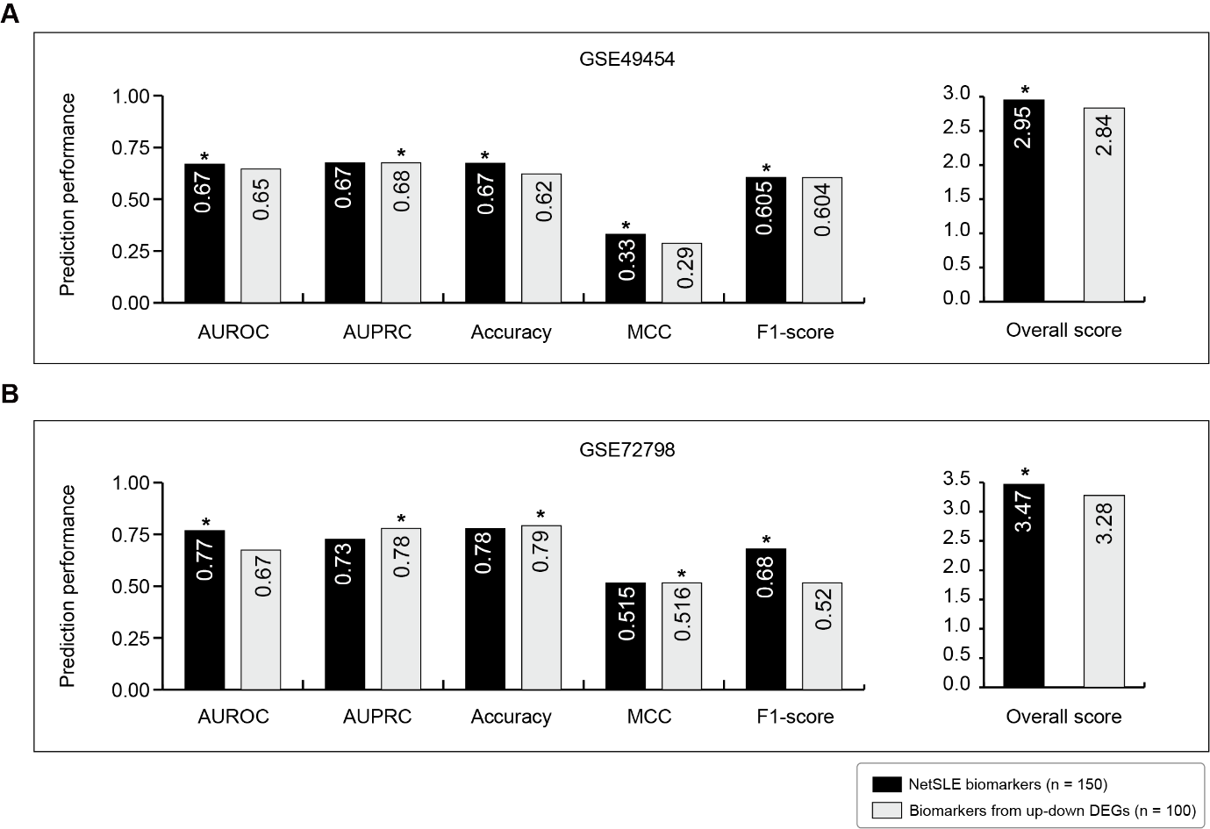Fig. S6. Comparison of predictive performance for SLE disease activity using up-regulated versus up- and down-regulated DEGs. (A–B) Performance comparison of various gene sets in disease activity prediction. Bar plots show prediction performance values for various metrics. An asterisk (*) above the bar indicates the higher performance between the two. The number of genes indicated in parentheses corresponds to the optimal number of genes that yielded the highest disease activity prediction performance. Area under the receiver operating characteristics (AUROC); Area under the precision-recall curve (AUPRC); Matthews correlation coefficient (MCC).

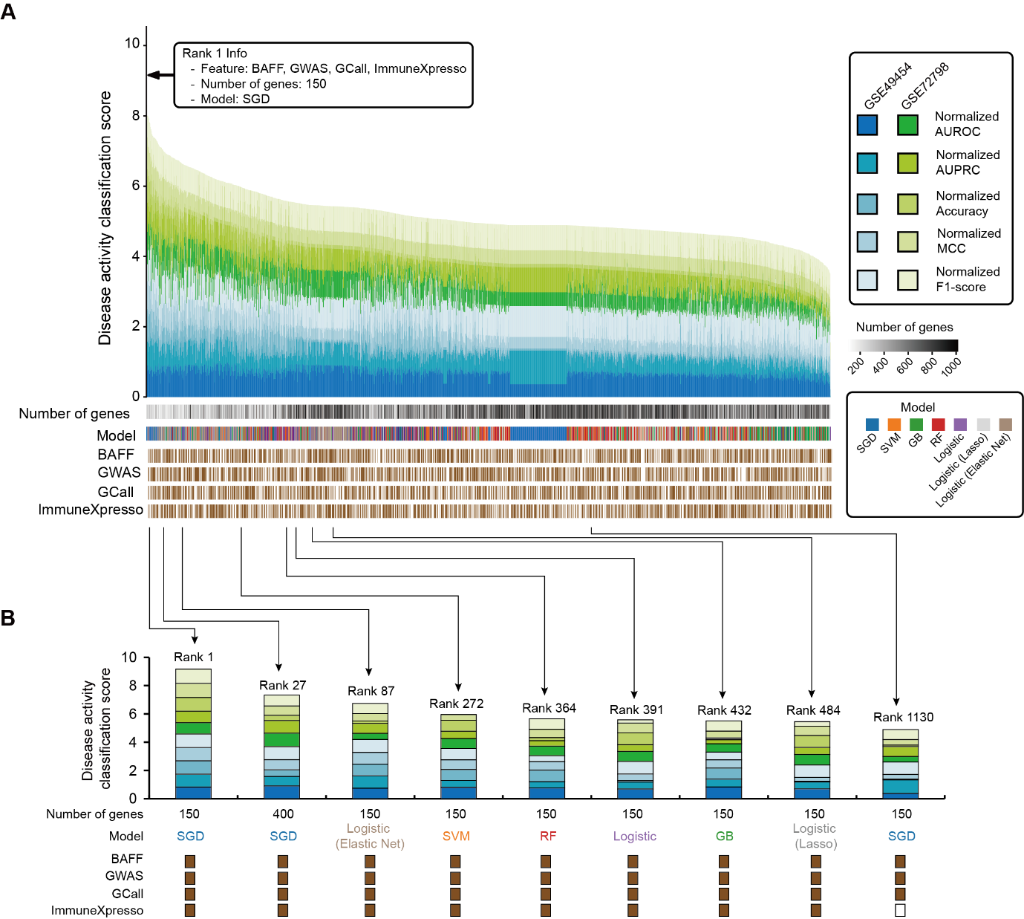
Fig. S7. Comparison of predictive performance for SLE disease activity across various model conditions. (A) Bar plot illustrating the predictive performance of models for SLE disease activity under different conditions. The number of biomarkers (prioritized DEGs) for building the model was explored from 100 to 500 (approximately half of the SLE DEGs). The heatmap represents the specific conditions used for model construction, including the type and number of gene sets, the model type, and prior knowledge related to SLE. Stacked bars show the cumulative classification scores of the predictions. (B) Bar plots depict the models’ predictive performance for each condition, with the cumulative classification scores, conditions, and rank indications marked. Area under the receiver operating characteristics (AUROC); Area under the precision-recall curve (AUPRC); Matthews correlation coefficient (MCC).

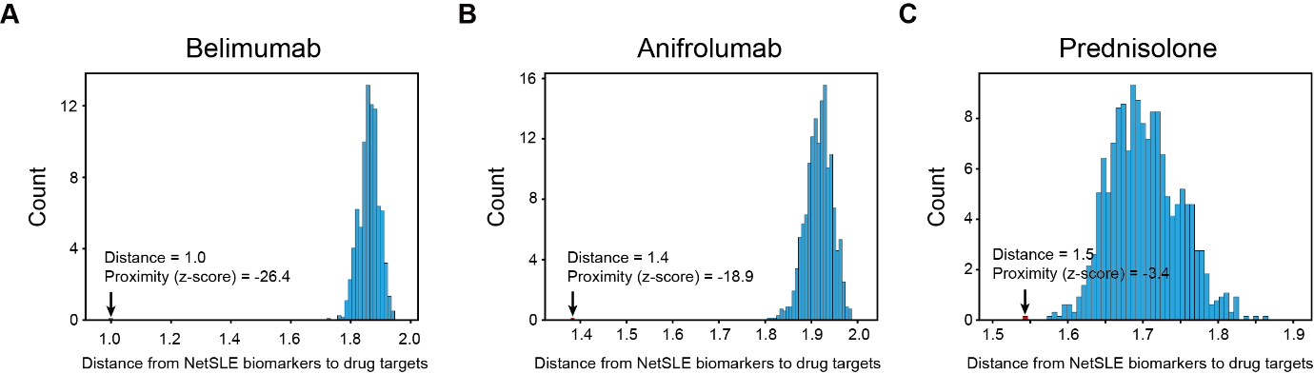
Fig. S8. Network proximity between NetSLE biomarkers and target genes of drugs used in SLE treatment. (A–C) Histogram showing the network distance from NetSLE biomarkers to drug target genes. The blue bars represent the distance distribution from 1,000 random samplings of gene sets, while the arrows and red bar indicate the distance from actual gene sets. The corresponding network distance values and network proximities (z-scores) based on the random distribution are displayed.
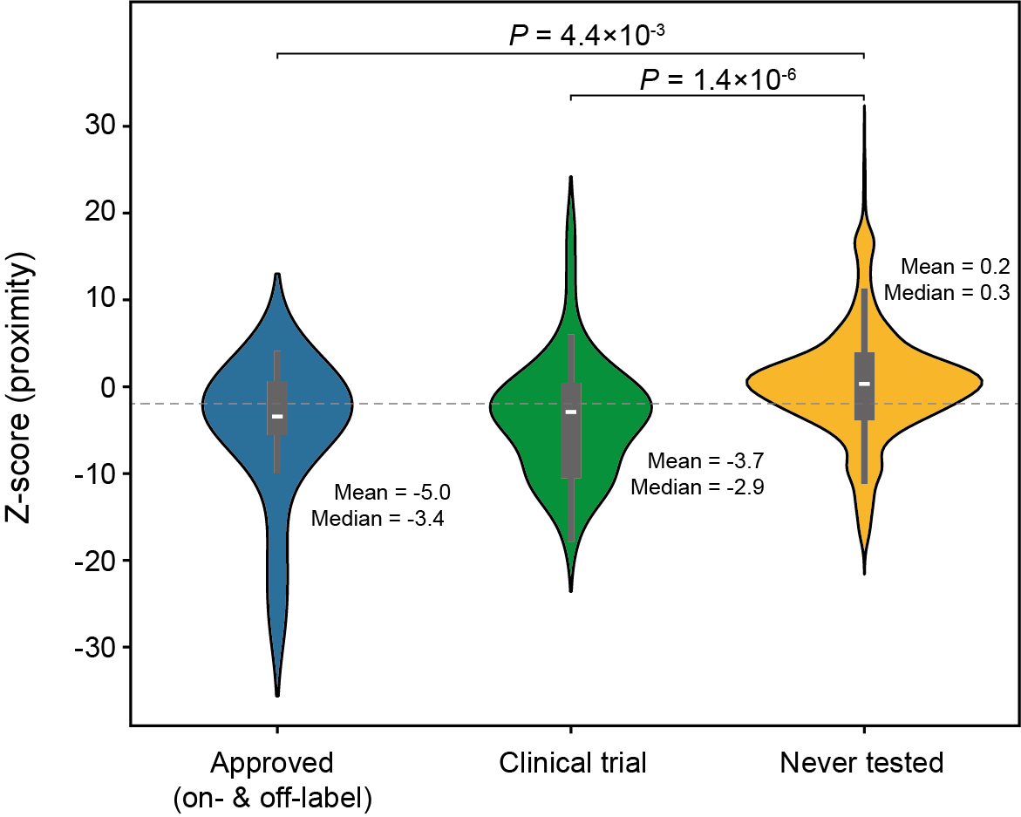
Fig. S9. Difference in Z-score (proximity) distribution of drugs across clinical phase. Violin plots showing distributions of proximity (z-score) between NetSLE biomarkers and target genes of drugs across clinical phase for SLE. The mean and median of each distribution are also displayed. The gray dotted line is the criterion for evaluating the therapeutic effect based on the proximity (z-score < –1.96). Difference between distributions was analyzed using the Mann-Whitney U test.
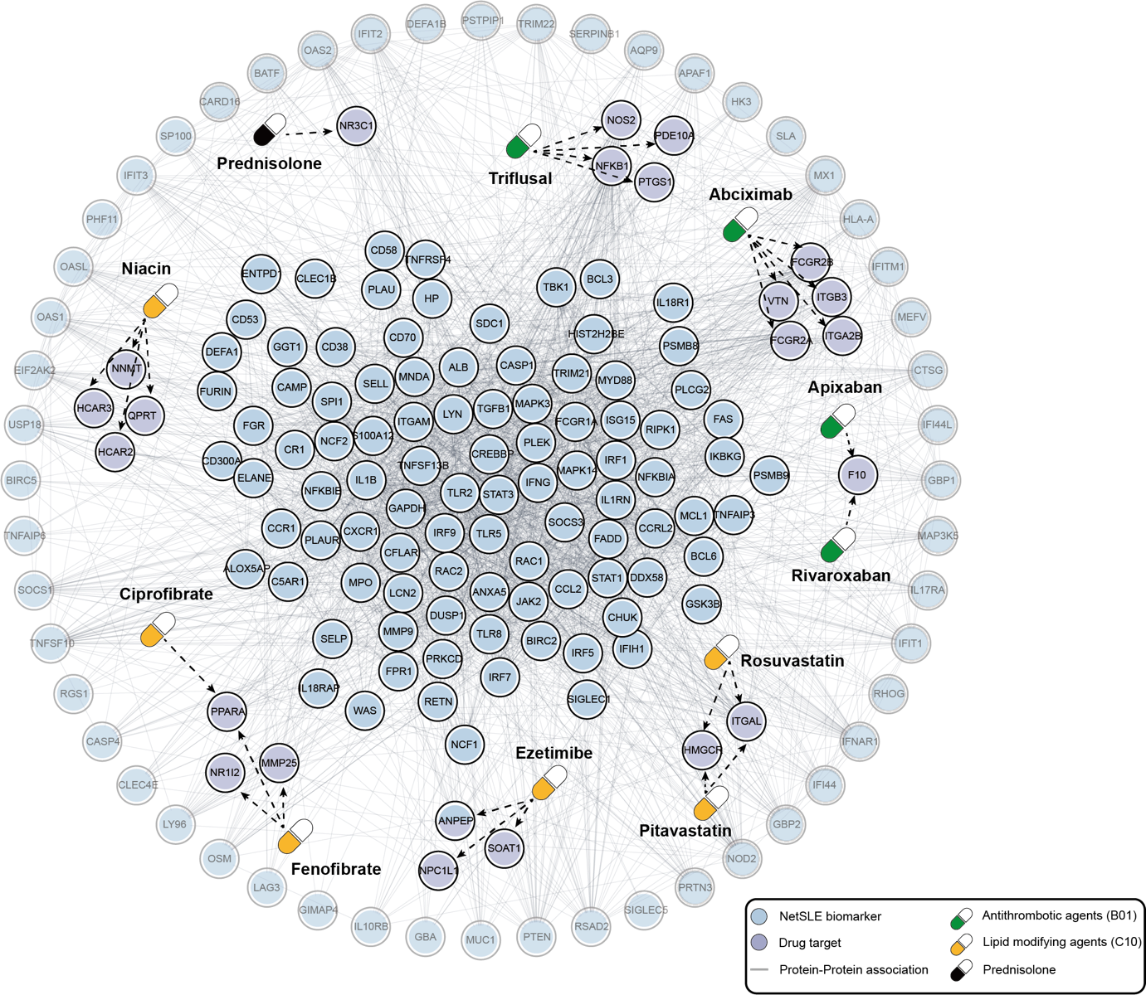
Fig. S10. Network relationships between NetSLE biomarkers and target genes of experimental drugs. Nodes in the protein-protein association network represent NetSLE biomarkers and the target genes of the experimental drugs, with arrows indicating the drug-targeted genes. NetSLE biomarkers that are first neighbors of the drug target genes are highlighted in rich color and positioned centrally, while other biomarkers are displayed in a transparent color on the periphery. For clarity, only associations with a combined score of 400 or higher in the STRING database are depicted.

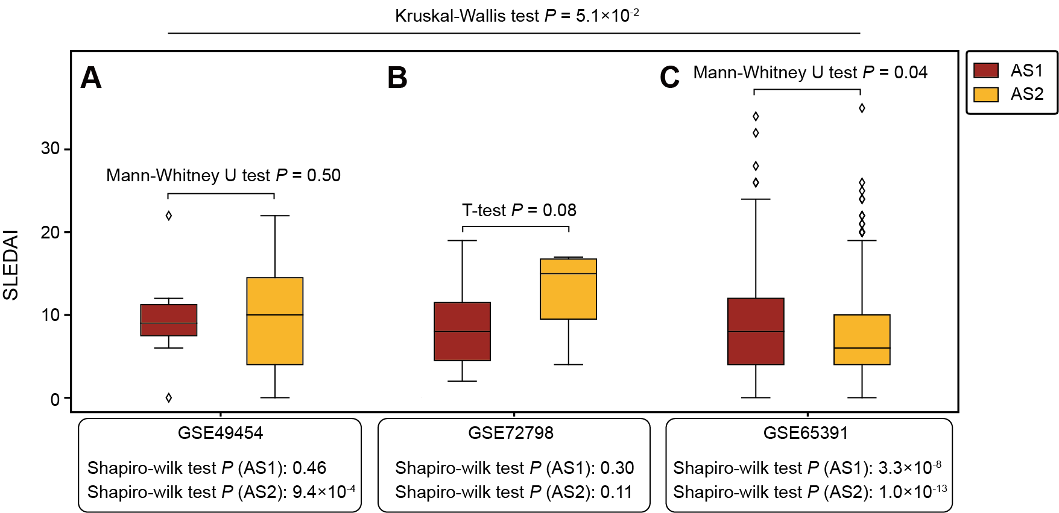
Fig. S11. Difference in SLEDAI distribution of SLE patients between subtypes. (A–C) Box plot illustrating the distributions of patients’ SLEDAI. Statistical significance of difference between AS1 and AS2 within the cohort was analyzed using the Mann-Whitney U- or T-test based on the Shapiro-Wilk test for normality of distribution. The Kruskal–Wallis test was used for assessing differences in SLEDAI distributions between subtypes across the three cohorts. P, p-value.

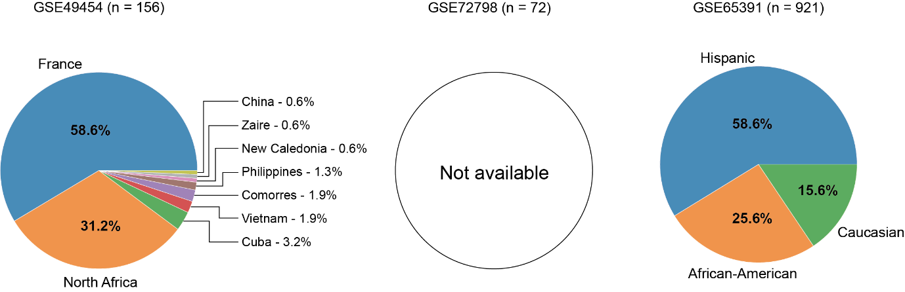
Fig. S12. Ethnic composition of the SLE cohort. Pie charts depicting racial composition for each cohort, with segments representing the proportion of samples of each race within the cohort. Note: Race information is not available for the GSE72798 data set.

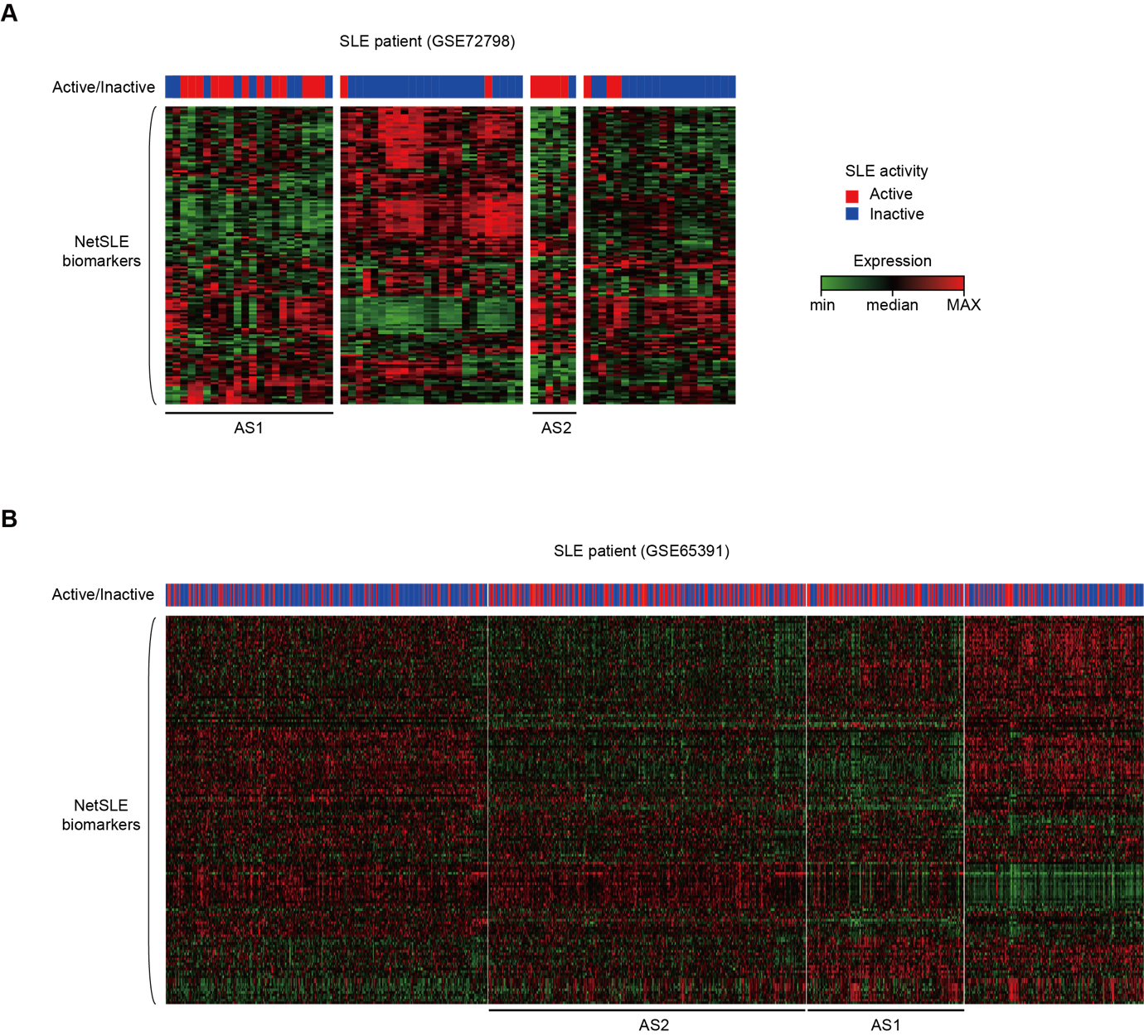Fig. S13. Identification of SLE subtypes by clustering analysis. (A–B) A heatmap shows the disease activity (red and blue representing active and inactive, respectively) and expression levels (represented in red, black, and green from high to low) of SLE patients from GSE72798 and GSE65391 cohorts, clustered based on the transcriptomic profiles of NetSLE biomarkers. Two distinct clusters, AS1 and AS2, enriched with SLE active patients, are underlined in black. In the heatmap, the expression values are log-transformed, median polished (row-wise and column-wise medians near zero), and normalized (row and column magnitudes near 1.0).

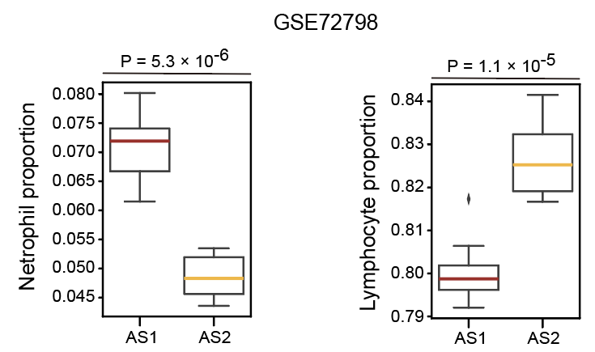
Fig. S14. Robustness of SLE subtype-specific cell proportions assessed via different inference tools. Neutrophil and lymphocyte proportions of SLE active subtypes (AS1 and AS2) in the GSE72798 cohort, estimated by InstaPrism (a computationally efficient implementation of BayesPrism). Statistical significance was assessed by two-sided Mann–Whitney U test.

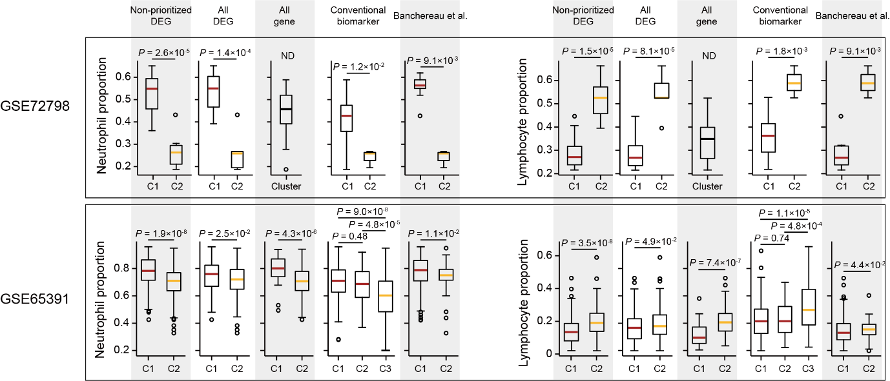 Fig. S15. Comparison of immune cell proportions between SLE subtypes. Box plots show the distribution of neutrophil and lymphocyte proportions across clusters identified by gene set. The red and yellow line represents the median of immune cell proportions for AS1 and AS2 patients, respectively. Difference in neutrophil and lymphocyte proportions between the clusters were statistically assessed using the Mann-Whitney U test. P, p-value; ND, not detected.

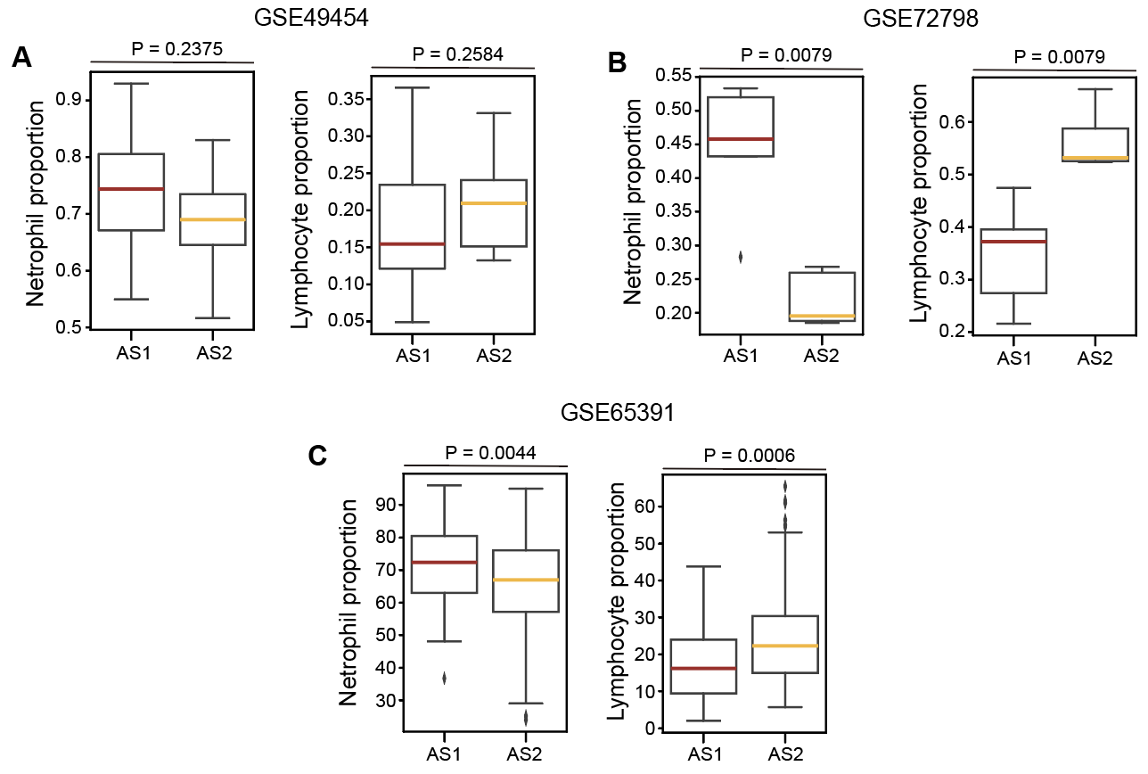
Fig. S16. Neutrophil and lymphocyte proportions of AS1 and AS2 identified by biclustering algorithms in GSE49454 cohort (A), GSE72798 cohort (B), and GSE65391 cohort (C). The proportions for GSE49454 and GSE65391 were derived from clinical data, whereas those for GSE72798 were inferred using CIBERSORTx. Statistical significance was measured by a two-sided Mann–Whitney U test.

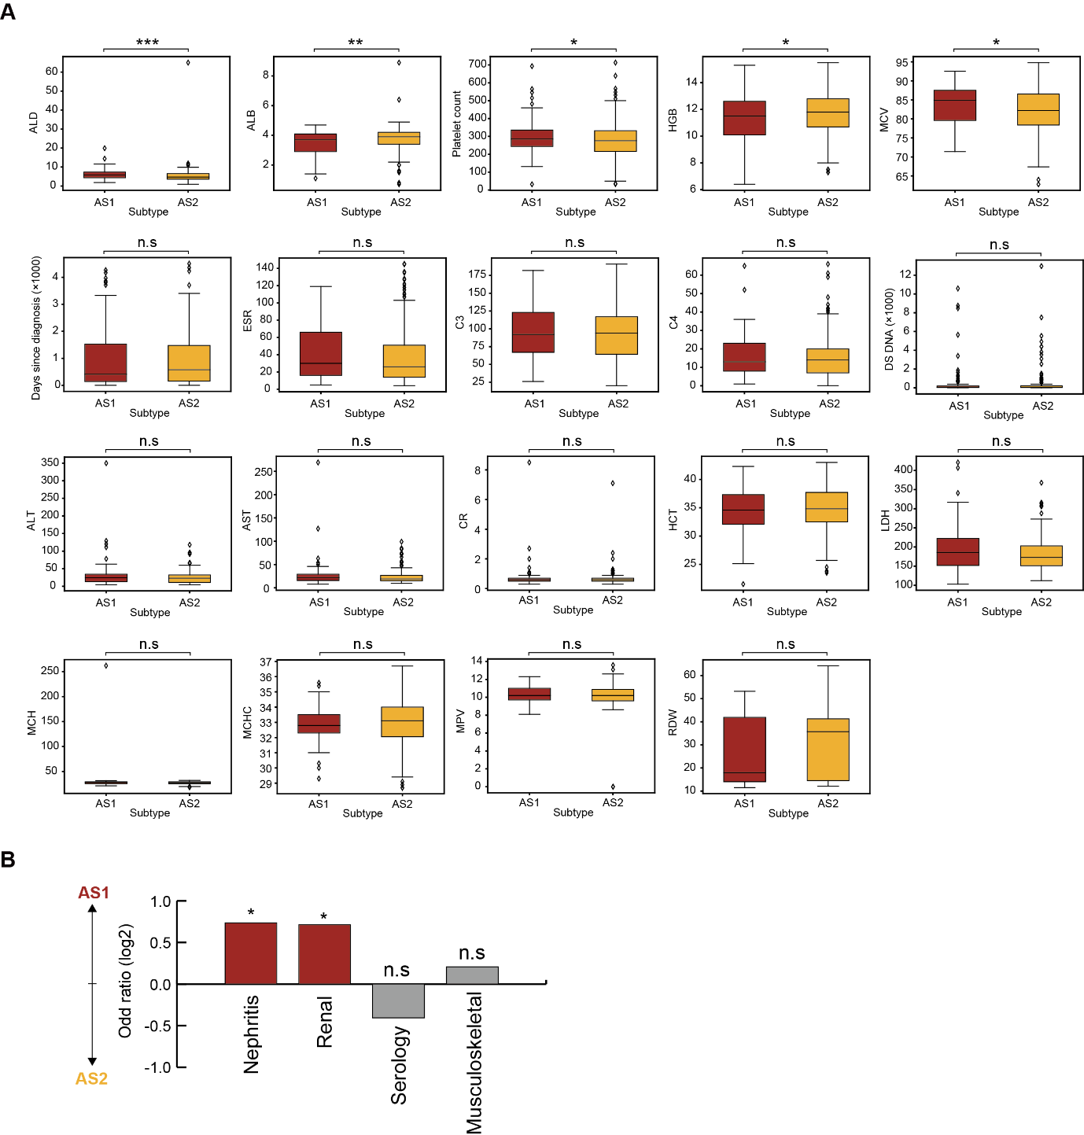
Fig. S17. Comparison of clinical features between SLE active subtypes. (A) Comparison of the distribution of complete blood count (CBC), biochemistry, and serological factors between AS1 and AS2. Differences of distribution were assessed using the Mann-Whitney U test. (B) Functional abnormality associations in AS1 and AS2 were analyzed, with overrepresentation and underrepresentation calculated using the odds ratio. Statistical significance was analyzed using Fisher’s exact test. * P < 5.0×10^{–2}, ** P < 1.0×10^{–2}, ***P < 5.0×10^{–3}, n.s (P ≥ 5.0×10^{–2}); P , p-value; Aldolase, ADL; Albumin, ABL; Hemoglobin, HGB; Mean corpuscular volume, MCV; Erythrocyte sedimentation rate, ESR; Alanine aminotransferase, ALT; Aspartate aminotransferase, AST; C-reactive protein, CR; Hematocrit, HCT; Lactate dehydrogenase, LDH; Mean corpuscular hemoglobin, MCH; Mean corpuscular hemoglobin concentration, MCHC; Mean platelet volume, MPV; Red cell distribution width, RDW.
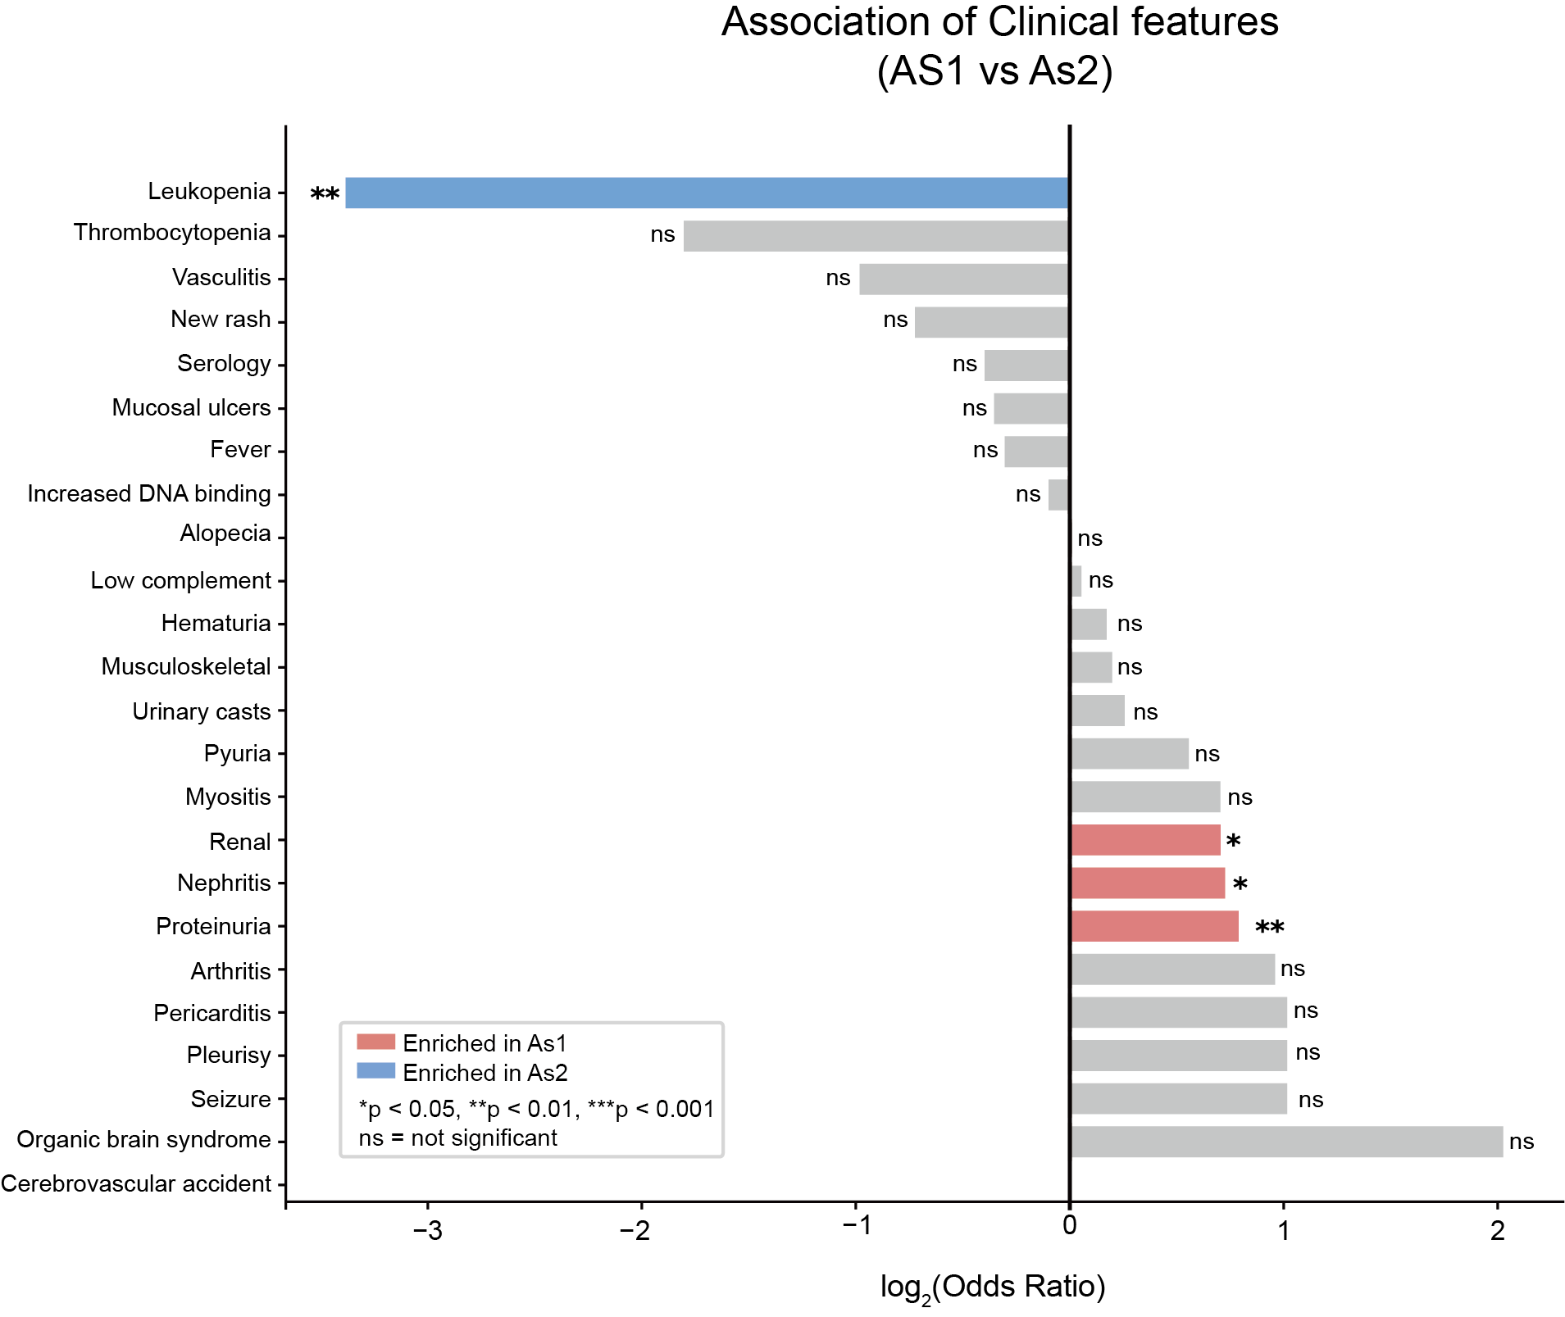
Fig. S18. Association of clinical features with SLE active subtypes (AS1 vs. AS2). The bar plot illustrates the results of an enrichment analysis conducted to identify clinical features significantly associated with two distinct active SLE patient subtypes, AS1 and AS2. Enrichment was evaluated using odds ratios and Fisher's exact test. The x-axis represents the log2(Odds Ratio), and the clinical features are sorted vertically by their odds ratios. Statistical significance of the p-values is denoted by asterisks (*p < 0.05, **p < 0.01; ns = not significant). Bars representing significantly enriched clinical features are highlighted in red for AS1 and in blue for AS2, while non-significant features are shown in gray.

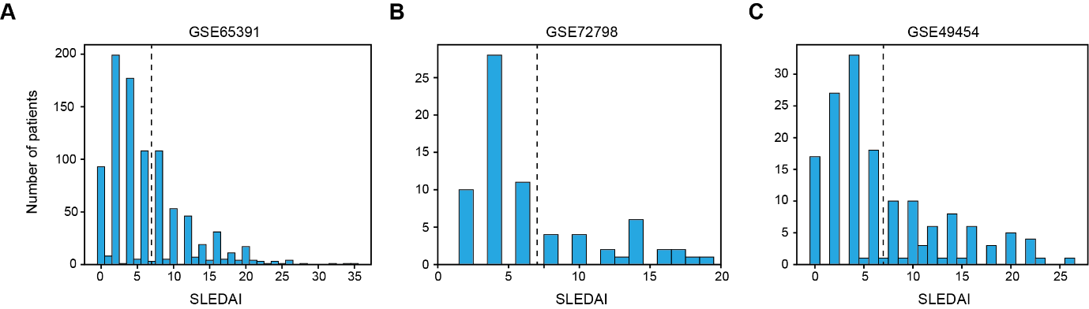
Fig. S19. Distribution of SLEDAI for cohorts of SLE patients. (A–C) Histograms illustrating the distribution of SLEDAI scores. The dashed lines indicate the mean SLEDAI for patients in the three datasets, rounded to the nearest integer (mean SLEDAI = 7), used as the threshold to distinguish between active and inactive patients.
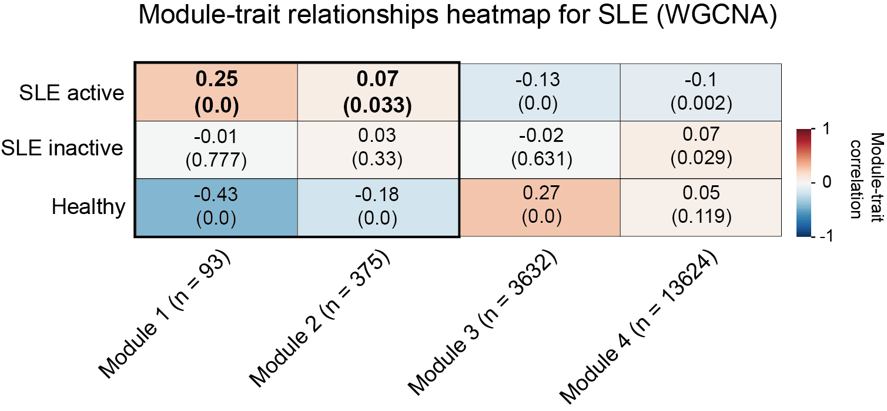
Fig. S20. SLE trait-related gene modules identified through WGCNA. Heatmap showing the correlation between SLE disease activity and gene expression profiles across modules. Correlations were computed using WGCNA. Correlation coefficient and statistical significance (in parentheses) displayed within the heatmap. Color gradients from red to blue represent the strength and direction of the correlation. The number of genes in each module is indicated in parentheses.

