Alternative life history strategies of a marine parasitic dinoflagellate

Xuqing Chen^{1,3*,} Kimberly S. Reece¹, Sebastian G. Gornik², Jeffrey D. Shields¹

Affiliations
¹ Virginia Institute of Marine Science, William & Mary, P.O. Box 1346, Gloucester Point, VA 23062-1346, USA
² Centre for Organismal Studies, University of Heidelberg, Im Neuenheimer Feld 230 69120 Heidelberg, Germany
³ Present address: Sorbonne Université, CNRS, UMR7144 Adaptation et Diversité en Milieu Marin, Station Biologique de Roscoff, 29680 Roscoff, France

*Corresponding author: Xuqing Chen, xuqing.chen@sb-roscoff.fr

Materials and Methods
SNP calling. RNA-seq reads from each sample were aligned to the reference transcriptome using bowtie2 [1] and processed as coordinate-sorted BAM files. For stage-level analyses, replicate BAMs belonging to the same life-history stage were merged and indexed using samtools [2]. SNP calling was performed from the transcriptome alignments using freebayes [3], in --pooled-continuous mode to avoid imposing a fixed ploidy model during variant calling, and biallelic SNPs were retained for downstream analyses. SNPs with total read depth ≥ 20, variant quality > 20, and minor allele count ≥ 2 were retained.
Allele frequency distribution plot. To visualize transcriptome-wide trends in allele balance, transcript coordinates were converted into a pseudo-scaffold by concatenating transcript positions using transcript length from estimated read counts using RSEM [4]. For each stage, per-SNP reference and alternate allele frequencies were plotted along this pseudo-scaffold, and local allele-frequency patterns were summarized in fixed genomic windows of 2Mb. Within each window, allele frequencies were grouped into histogram bins of width 0.05, and the most frequent bin was recorded as the dominant allele-frequency peak for that window. Peaks supported by fewer than 20 observations were discarded.
References
- Langmead B, Salzberg SL. Fast gapped-read alignment with Bowtie 2. Nat Methods. 2012 Apr;9(4):357–9. doi:10.1038/nmeth.1923
- Li H, Handsaker B, Wysoker A, Fennell T, Ruan J, Homer N, et al. The Sequence Alignment/Map format and SAMtools. Bioinformatics. 2009 Aug 15;25(16):2078–9. doi:10.1093/bioinformatics/btp352
- Garrison E, Marth G. Haplotype-based variant detection from short-read sequencing. arXiv preprint arXiv:1207.3907 [q-bio.GN] 2012
- Li B, Dewey CN. RSEM: Accurate transcript quantification from RNA-Seq data with or without a reference genome. BMC Bioinformatics. 2011 Aug 4;12. doi:10.1186/1471-2105-12-323

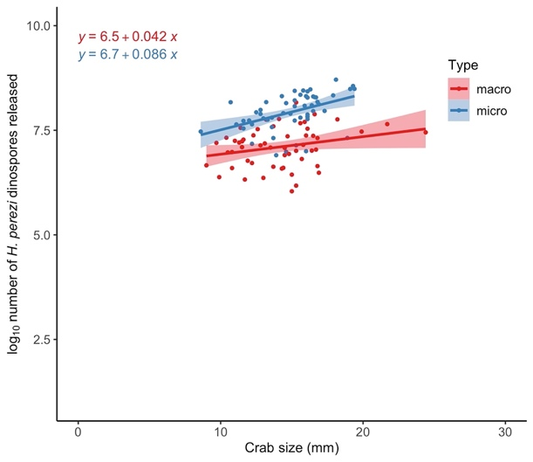
Figure S1. Crab size vs. number (log10) of the different dinospore types of Hematodinium perezi released by each crab. Crab size is measured as the long carapace width (distance between the two longest epibranchial spines). Cell count was estimated with a hemocytometer using at least two counts with a variation < 10%.

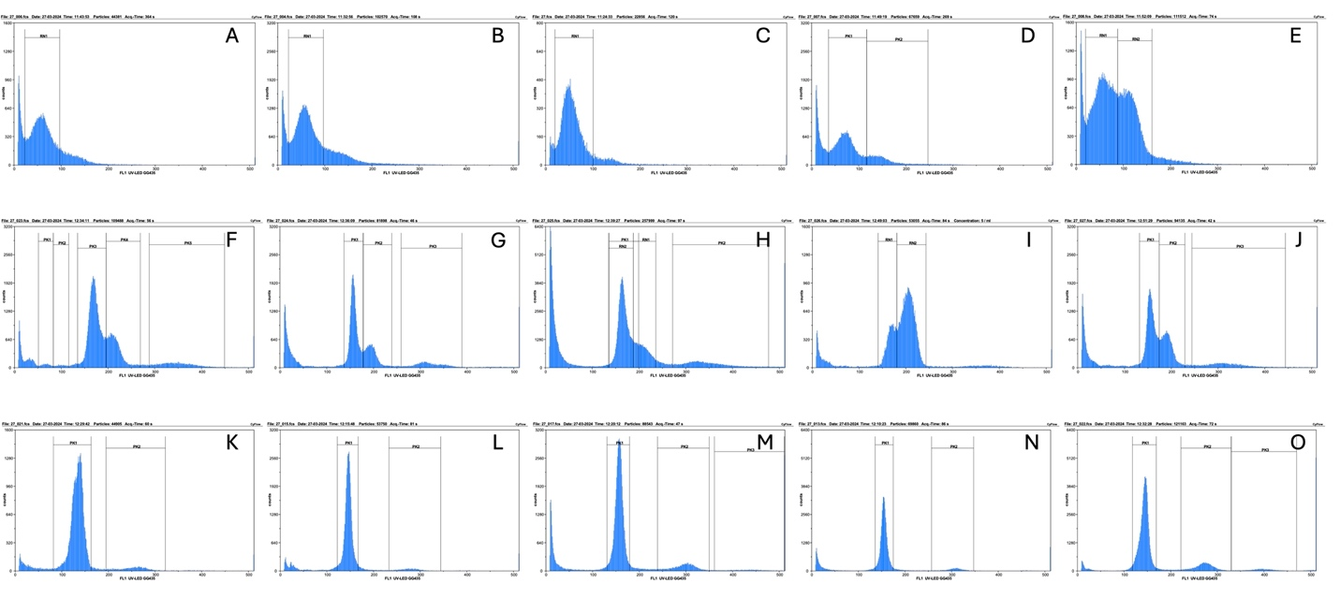
Figure S2. Relative fluorescence intensity of different life history stages of Hematodinium perezi stained with DAPI. Flow cytometric analysis was performed on a CyFlowTM Space equipped with a 365nm high power UV LED for DAPI excitation. A – E: ameboid trophont, F – J: macro-dinospore, K – O: micro-dinospore.

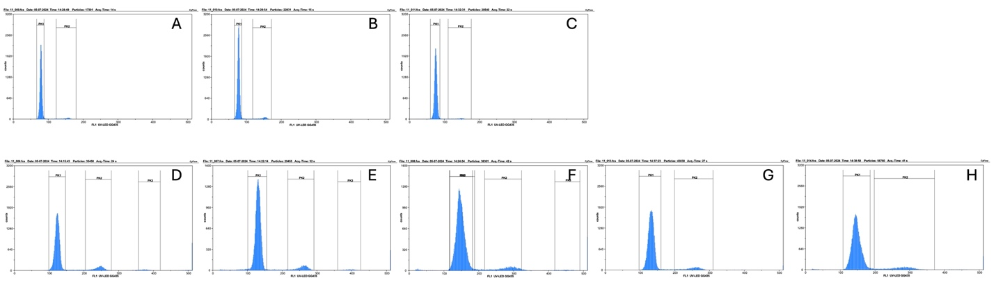
Figure S3. Relative fluorescence intensity of chicken red blood cells (A – C) and blue crab hemocytes (D – H) stained with DAPI. Flow cytometric analysis was performed on a CyFlowTM Space equipped with a 365nm high power UV LED for DAPI excitation.

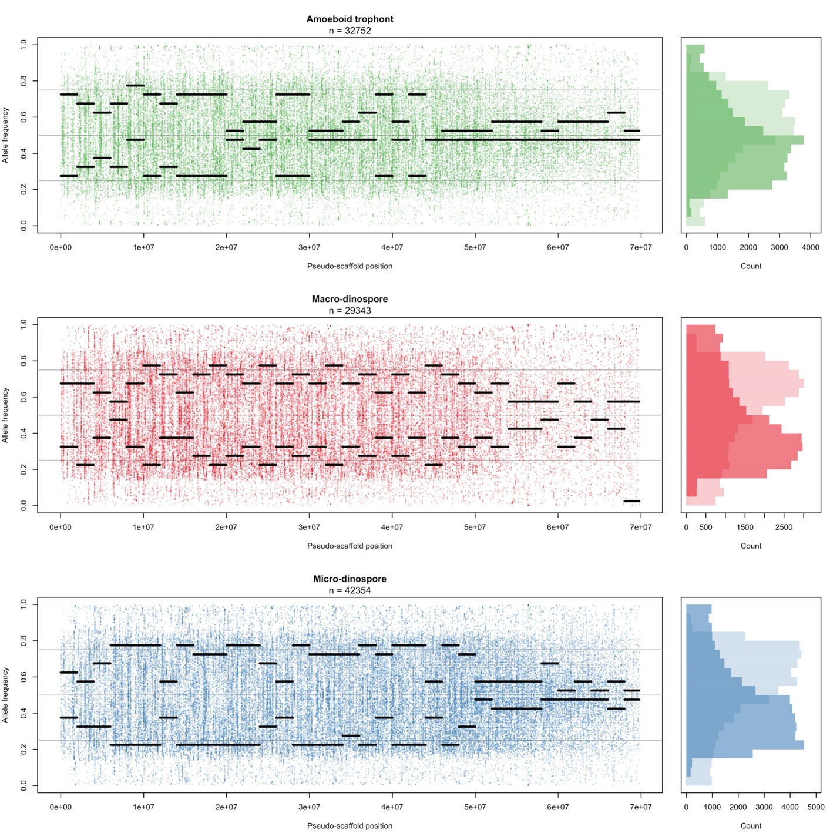Figure S4. Allele frequency distributions of ameboid trophonts, macro-dinospores, and micro-dinospores. SNP calling was performed on stage-specific reads. Left panels show per-SNP reference allele frequencies along a pseudo-scaffold generated from concatenated transcripts; black segments represent the dominant allele frequencies detected within 2Mb windows. Right panels show the overall distributions of reference allele frequencies (dark) and alternate allele frequencies (light). SNPs were filtered by read depth, variant quality, and minor allele count prior to analysis.

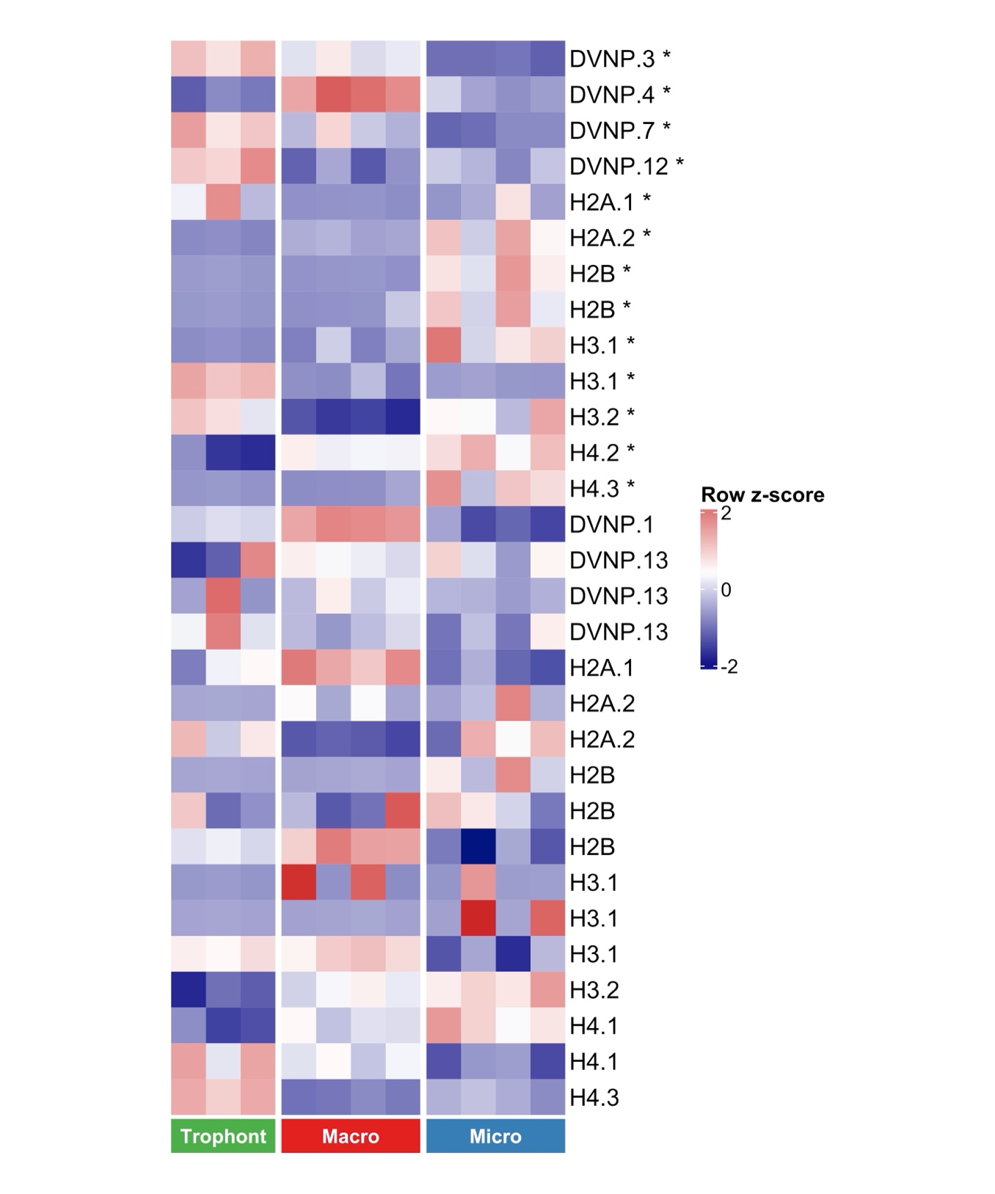Figure S5. Heatmap of expression of genes coding for Hematodinium dinoflagellate/viral nucleoproteins (DVNP) and histones in ameboid trophonts, macro- and micro- dinospores. Genes marked with asterisks are differentially expressed in at least one of the pairwise comparisons of macro-dinospore vs ameboid trophont or micro-dinospore vs ameboid trophont. Scale showing up-regulated (red) and down-regulated (blue) expression (|log₂(Fold change)| > 1.5, adjusted P-value ≤ 0.05).
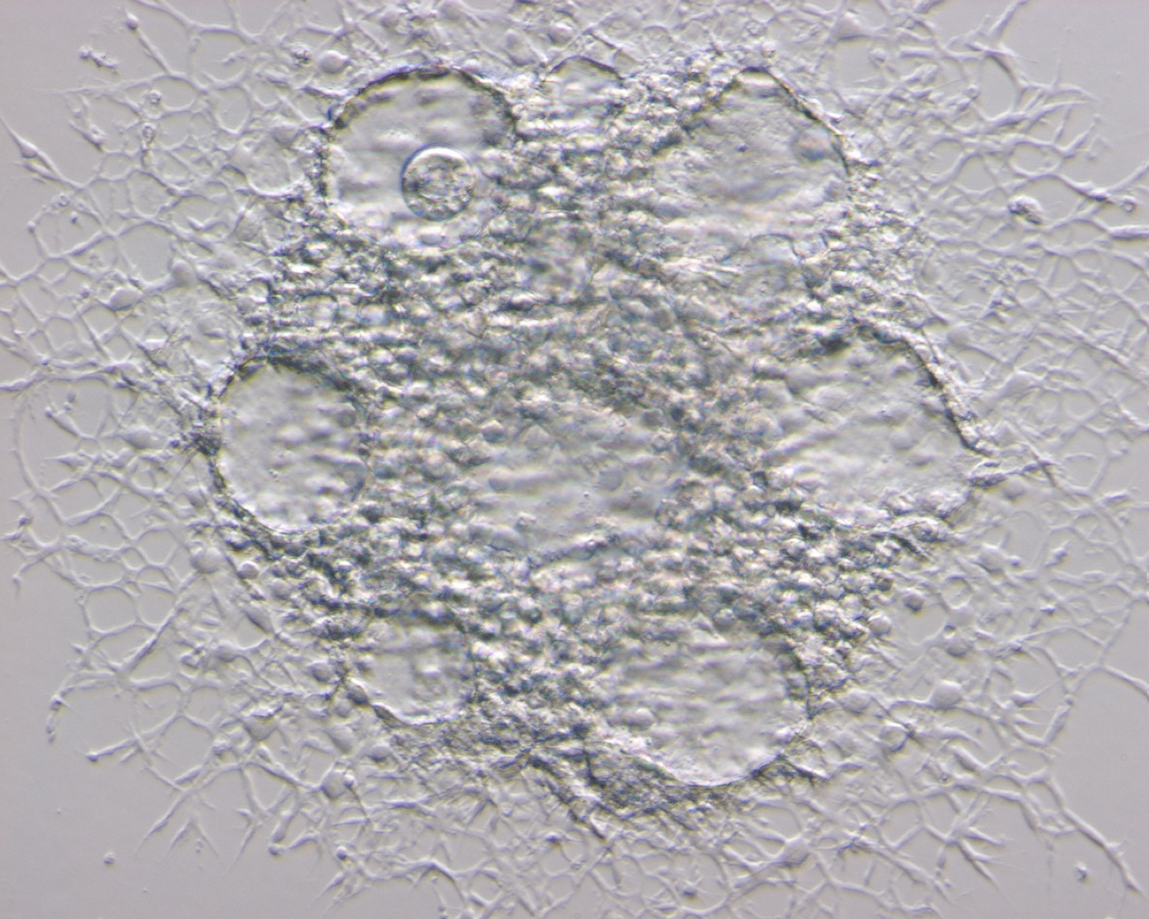
Figure S6. Arachnoid sporont of H. perezi showing presumptive germinative centers, likely locations for syngamy as proposed in this study. Photo credit: Jeffrey D. Shields.

Table S1. Sample information on different life history stages of Hematodinium perezi collected for transcriptomics (T) and flow cytometry (F). Subsets of each ameboid trophont sample were maintained in culture media for developmental changes and time to sporogenesis. Crab IDs starting with A are adult crabs. Crab IDs starting with J are juvenile crabs.
Collection date | Sample type | Use | Crab ID | Days to sporogenesis | Spore type
10/10/22 | Ameboid trophont | T, F | A1 | --- | ---
10/11/22 | Ameboid trophont | T, F | A56 | --- | ---
6/29/22 | Ameboid trophont | T | A19 | --- | ---
10/11/22 | Ameboid trophont | F | A57 | --- | ---
10/19/22 | Ameboid trophont | F | A14* | 30 | Micro-dinospore
6/16/23 | Ameboid trophont | F | A69 | 4 | Macro-dinospore
11/21/21 | Macro-dinospore | T, F | J69 | --- | ---
11/21/21 | Macro-dinospore | T | J43 | --- | ---
11/21/21 | Macro-dinospore | T | J72 | --- | ---
11/21/21 | Macro-dinospore | T | J76 | --- | ---
11/19/21 | Macro-dinospore | F | J101 | --- | ---
11/21/21 | Macro-dinospore | F | J117 | --- | ---
11/21/21 | Macro-dinospore | F | J28 | --- | ---
12/07/21 | Macro-dinospore | F | J114 | --- | ---
11/21/21 | Micro-dinospore | T, F | J34 | --- | ---
11/21/21 | Micro-dinospore | T, F | J16 | --- | ---
11/21/21 | Micro-dinospore | T | J86 | --- | ---
11/21/21 | Micro-dinospore | T | J33 | --- | ---
11/21/21 | Micro-dinospore | F | J15 | --- | ---
11/21/21 | Micro-dinospore | F | J27 | --- | ---
11/28/21 | Micro-dinospore | F | J58 | --- | ---
11/18/22 | Micro-dinospore | F | A14* | --- | ---
11/29/21 | Pre-spore | T | J87 | --- | ---
11/30/21 | Pre-spore | T | J74 | --- | ---
12/2/21 | Pre-spore | T | J22 | --- | ---
12/4/21 | Pre-spore | T | J2 | --- | ---

*Crab ID with asterisks indicate the samples are collected from the same crab.
--- not observed.

Table S2. RNA-seq and transcriptome assembly statistics of Hematodinium perezi.
 | Ameboid trophonts |  |  | Macro-dinospore |  |  |  | Micro-dinospore |  |  |  | Prespore
 | AT1 | AT2 | AT3 | MA1 | MA2 | MA3 | MA4 | MI1 | MI2 | MI3 | MI6 | PR1 | PR2 | PR3 | PR4
Raw reads | 28205272 | 33351207 | 28464230 | 21851943 | 31085612 | 24609871 | 29502488 | 23161926 | 21688133 | 22671614 | 32508330 | 27252978 | 27353526 | 26035396 | 28252471
Trimmed | 24335376 | 28572152 | 24329379 | 18550995 | 25997728 | 21044075 | 24894051 | 19593246 | 18524589 | 19435531 | 27712191 | 23747938 | 23918713 | 22680455 | 24843315
Host reads removed | 23911009 | 23039603 | 24081819 | 18487411 | 25952474 | 21010413 | 24854954 | 19447975 | 18495442 | 19362718 | 27622319 | 23695339 | 23867049 | 22643941 | 24804815
 | No. transcripts | Mean length (bp) | GC (%)
Assembly using Trinity | 347468 | 1399 | 45.4
CD-HIT-EST (-c 0.9) | 175307 | 1181 | 44.7
Unique transcripts | 94395 | 882 | 46.1

Table S3. List of genes related to pathways in relation to plastid loss in Hematodinium.
Transcript ID | Query annotation | Query ID | E-value | Annotation based on blastp against Nr
TRINITY_DN6253_c0_g1 | putative polyketide synthase | AKG25413.1 | 0 | AKG25413.1putative polyketide synthase
TRINITY_DN12236_c0_g2 | putative polyketide synthase | AKG25414.1 | 0 | AKG25414.1putative polyketide synthase
TRINITY_DN26762_c0_g1 | putative polyketide synthase | AKG25414.1 | 0 | AKG25414.1putative polyketide synthase
TRINITY_DN33002_c0_g1 | putative polyketide synthase | AKG25414.1 | 1.66E-63 | AKG25414.1putative polyketide synthase
TRINITY_DN3907_c0_g2 | putative polyketide synthase | AKG25414.1 | 0 | AKG25414.1putative polyketide synthase
TRINITY_DN6104_c0_g1 | putative polyketide synthase | AKG25415.1 | 0 | AKG25415.1putative polyketide synthase
TRINITY_DN13982_c0_g1 | putative polyketide synthase | AKG25417.1 | 1.1E-110 | AKG25417.1putative polyketide synthase, partial
TRINITY_DN3907_c5_g1 | putative polyketide synthase | AKG25417.1 | 1.48E-43 | AKG25417.1putative polyketide synthase, partial
TRINITY_DN1493_c2_g2 | 5-aminolevulinate synthase | AKG25418.1 | 0 | AKG25418.1ALAS
TRINITY_DN39884_c0_g1 | HemB | AKG25419.1 | 0 | AKG25419.1HemB
TRINITY_DN26925_c0_g1 | HemC | AKG25420.1 | 0 | AKG25420.1HemC
TRINITY_DN4384_c1_g1 | HemD | AKG25421.1 | 1.7E-144 | AKG25421.1HemD
TRINITY_DN7689_c0_g1 | HemE | AKG25422.1 | 0 | AKG25422.1HemE
TRINITY_DN2674_c0_g1 | HemY/G | AKG25423.1 | 0 | AKG25423.1HemY/G
TRINITY_DN844_c3_g1 | LysC | AKG25424.1 | 0 | AKG25424.1LysC
TRINITY_DN7963_c0_g1 | aspartate-semialdehyde dehydrogenase | AKG25425.1 | 0 | AKG25425.1aspartate-semialdehyde dehydrogenase
TRINITY_DN7886_c0_g1 | DapA | AKG25426.1 | 0 | AKG25426.1DapA
TRINITY_DN2234_c0_g1 | DapB | AKG25427.1 | 0 | AKG25427.1DapB
TRINITY_DN428_c1_g1 | LL-diaminopimelate aminotransferase DapL | AKG25428.1 | 0 | AKG25428.1LL-diaminopimelate aminotransferase DapL
TRINITY_DN3346_c1_g1 | LysA | AKG25429.1 | 0 | AKG25429.1LysA
TRINITY_DN157578_c0_g1 | farnesyl pyrophosphate synthetase | AKG25430.1 | 4.74E-06 | NP_001229754.1farnesyl pyrophosphate synthase isoform c
TRINITY_DN24488_c0_g1 | farnesyltransferase subunit alpha | AKG25431.1 | 0 | AKG25431.1farnesyltransferase subunit alpha
TRINITY_DN22183_c0_g1 | farnesyltransferase subunit beta | AKG25432.1 | 0 | AKG25432.1farnesyltransferase subunit beta
TRINITY_DN3383_c0_g1 | geranylgeranyltransferase subunit alpha | AKG25433.1 | 0 | AKG25433.1geranylgeranyltransferase subunit alpha
TRINITY_DN3665_c0_g1 | geranylgeranyltransferase subunit beta | AKG25434.1 | 2.7E-158 | AKG25434.1geranylgeranyltransferase subunit beta
TRINITY_DN13533_c0_g1 | ER elongases | PF3D7_0109300 | 6.58E-32 | XP_045136267.1elongation of very long chain fatty acids protein 6-like isoform X1
TRINITY_DN11301_c0_g1 | Cysteine desulfurase IscS | PF3D7_0727200 | 6.4E-164 | CAE8691104.1unnamed protein product
TRINITY_DN20510_c0_g1 | Cysteine desulfurase IscS | PF3D7_0727200 | 1.7E-161 | XP_044569016.1uncharacterized protein FDP41_007480
TRINITY_DN11940_c0_g1 | Iron-sulfur cluster assembly protein SufA | PF3D7_0522700 | 1.12E-07 | CAE7550930.1Isca2

