Additional File 1: Figures S1-S5.
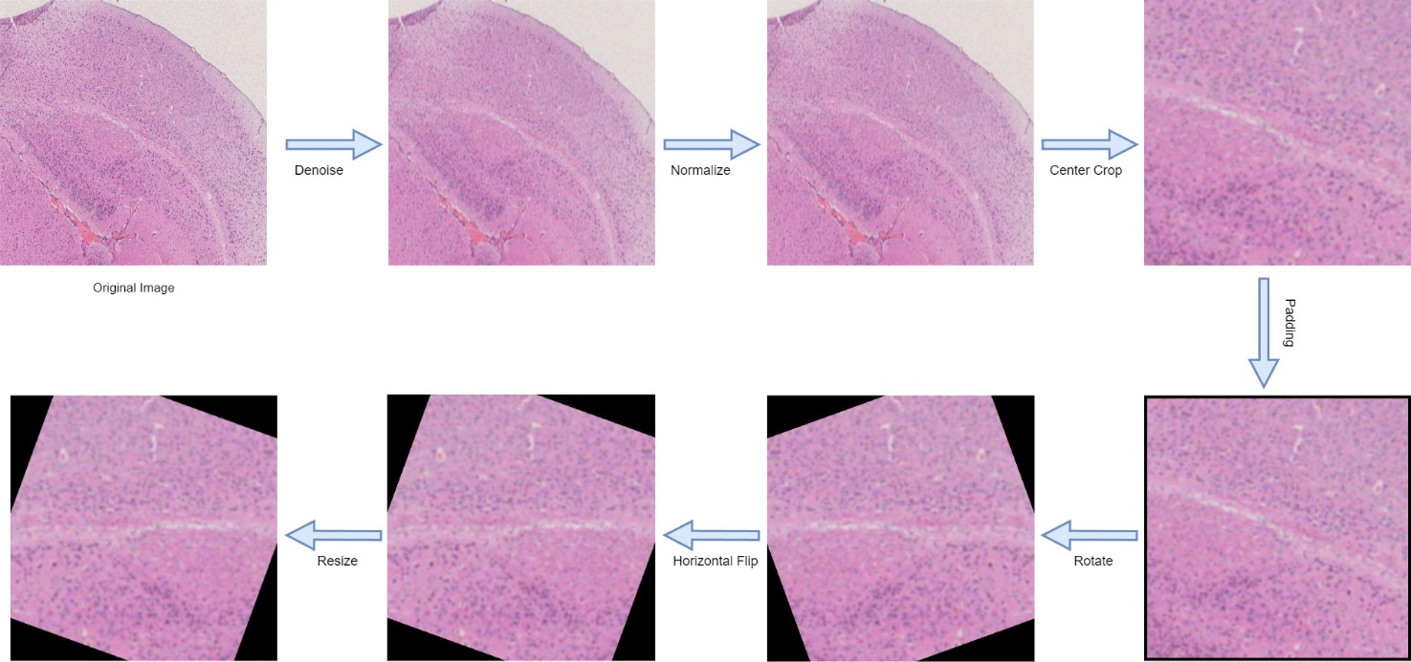
Fig. S1. Schematic of Microscopic Image Data Collection and Preprocessing Pipeline.
Note: This figure clearly illustrates the data preprocessing workflow from microscopic image acquisition to final model input, including specific steps for image format standardization, noise removal, contrast adjustment, histogram equalization, and data augmentation (random rotation, flipping, scaling, etc.).

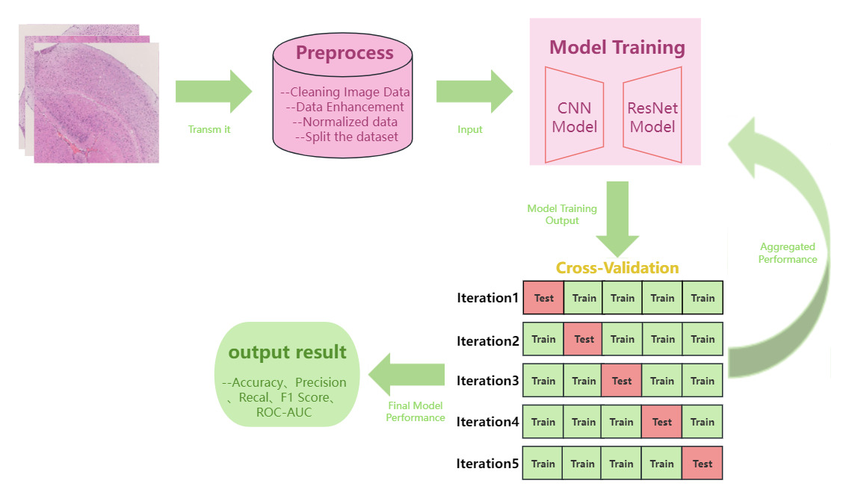
Fig. S2. Architecture and Training Process of the Deep Learning Model.
Note: This figure details the ResNet-based CNN structure, explicitly showing the network layout of convolutional layers, residual blocks, pooling layers, and fully connected layers. It also demonstrates the use of the Adam optimizer and cross-entropy loss function, along with the hyperparameter optimization and five-fold cross-validation processes during training.

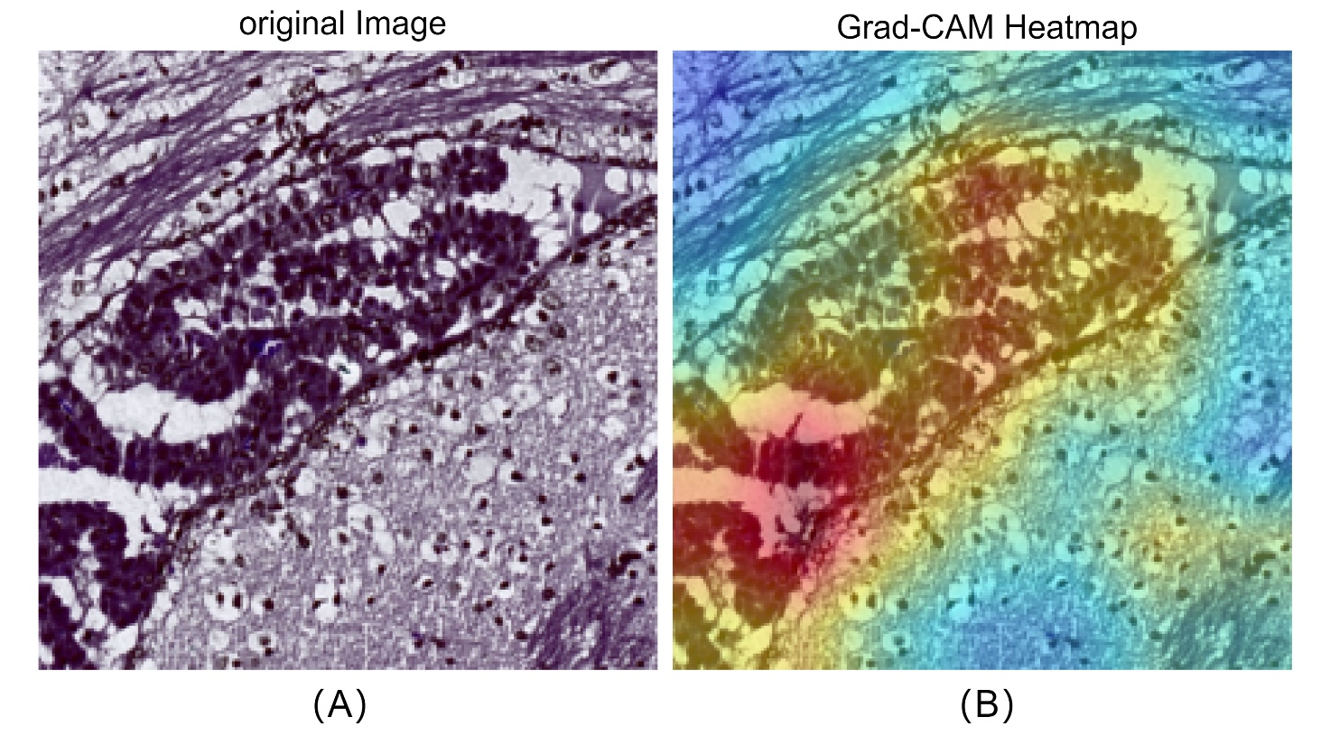
Fig. S3. Grad-CAM Model Interpretability Analysis Workflow.
Note: This schematic demonstrates how Grad-CAM technology generates heatmaps from CNN feature maps to visualize key regions of model attention during classification decisions, enabling researchers to intuitively understand critical areas influencing the classification process.

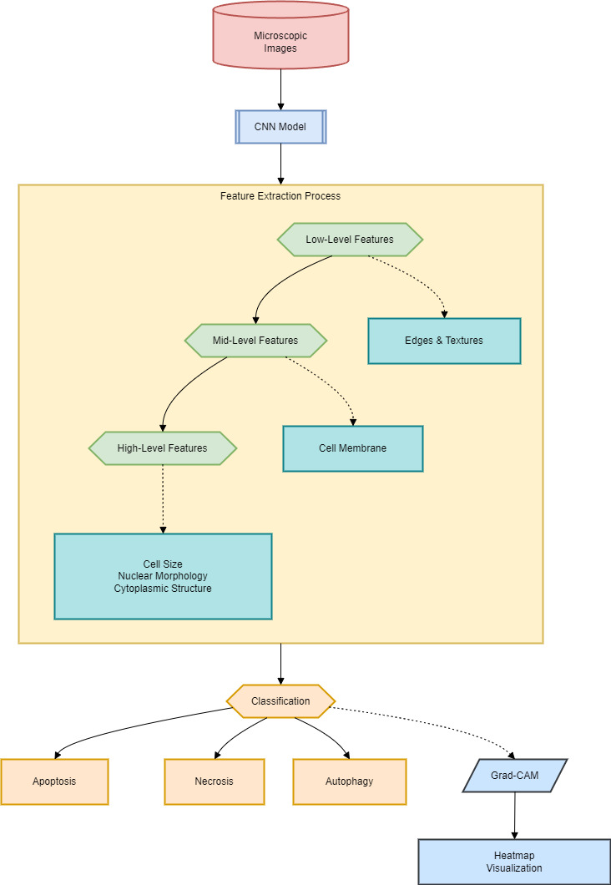
Fig. S4. Schematic of Image Data Analysis and Feature Extraction Pipeline
Note: This figure details how the CNN model automatically extracts multi-level cellular morphological features (e.g., cell size, nuclear morphology, cytoplasmic structure) from microscopic images through hierarchical processing, and demonstrates how these features enable precise classification of cell death types.

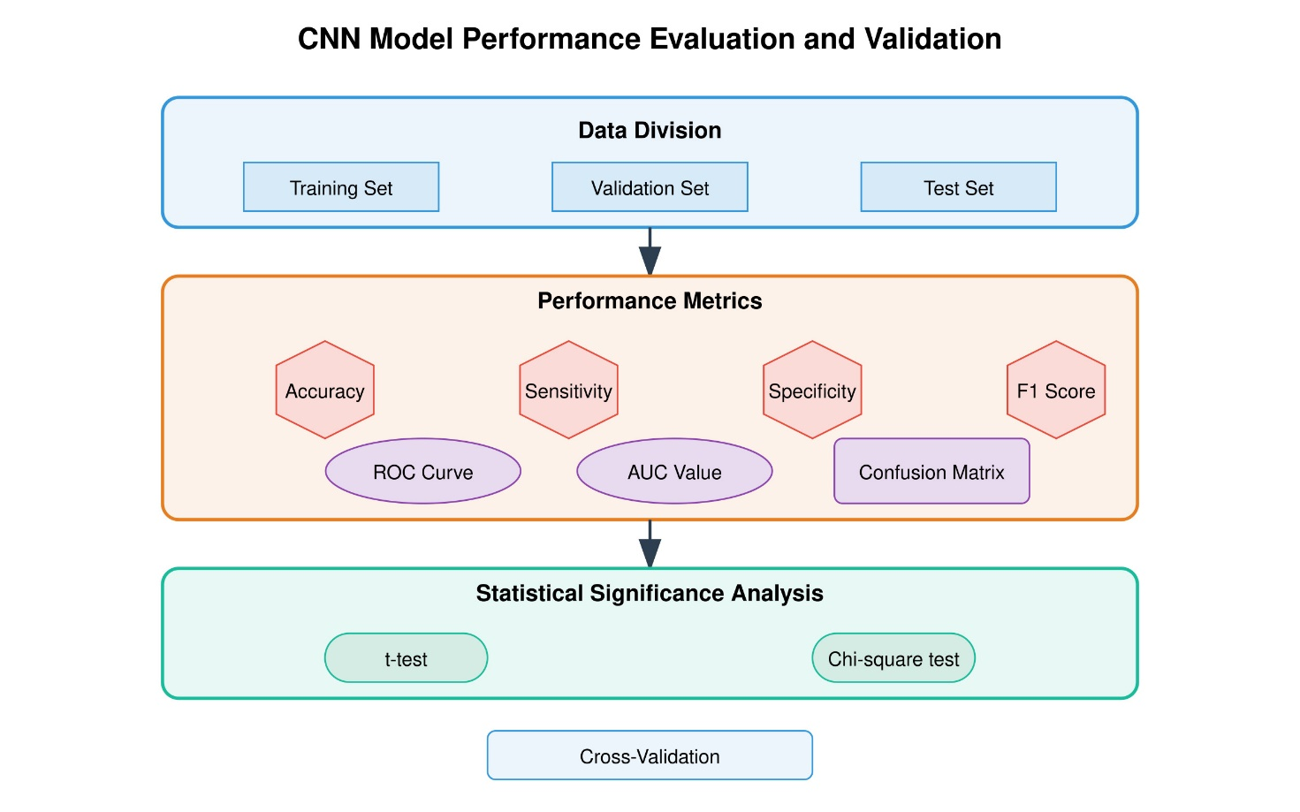
Fig. S5. Schematic of Model Performance Evaluation and Validation Workflow
Note: This figure illustrates the comprehensive model evaluation process, including the partitioning of training, validation, and independent test sets, detailed calculation procedures for classification metrics (accuracy, sensitivity, specificity, F1-score, ROC curves, and AUC values), along with the application of confusion matrix analysis and statistical significance testing methods.

