Supplementary Materials

Supplementary Notes 3
Supplementary Note 1. Genome assembly of FGSC2225 3
Supplementary Note 2. Gene prediction of FGSC2225 4
Supplementary Note 3. Functional annotation of FGSC2225 6
Supplementary Note 4. Simulation by artificially introducing RIP-like mutations into the genome of Sordaria macrospora 6
Supplementary Note 5. Phylogeny and structure of the N. crassa population 7
Supplementary Note 6. Identification and population distribution of HRAGs across N. crassa 8
Supplementary Figures 9
Fig. S1. FGSC2225 is a distantly related strain when compared to FGSC2489. 9
Fig. S2. Genome synteny of chromosome-level genome assembly. 10
Fig. S3. Gene annotation and distribution of N. crassa FGSC2225. 11
Fig. S4. Comparison of the RIP index and Ti/Tv method for HRAG identification. 12
Fig. S5. Distance between the nearest two CpA sites. 14
Fig. S6. Comparative analysis of Ti/Tv ratios and HRAG ratio across 27 Ascomycets. 15
Fig. S7. The characteristics of HRAGs. 16
Fig. S8. Diversity of coding genes in N. crassa. 17
Fig. S9. Distribution of shared and strain-specific HRAGs across the N. crassa population. 18
Fig. S10. Ten examples of high phylogenetic inconsistency between concatenated coding sequences (left tree) and specific genes (right tree). 19
Fig. S11. IGV analysis confirms that the genes (a) NCU02184 and (b) NCU05519 are single-copy genes in natural strains and offspring in sexual reproduction. 35
Fig. S12. Summary of SNP mutation sites (left) detected (a) across the N. crassa pangenome and (b) within all coding genes and (c) within all HRAGs relative to the FGSC2489 reference strain. 36
Fig. S13. Structure predictions of peptides using AlphaFold3. 37
Supplementary Tables 39
Table S1. N. crassa strains used in this study. 39
Table S2. Statistics of the FGSC2225 sequencing data. 40
Table S3. Assembly Statistics of FGSC2225 nuclear genome at each assembly stage. 41
Table S4. Telomeres of the FGSC2225 genome. 42
Table S5. Main features of N. crassa FGSC2225 genome assembly and gene annotation. 43
Table S6. Ratio of genes with high Ti/Tv ratios between RIPed Ascomycets and deRIP Ascomycets. 44
Table S7. Statistics of SNPs on genes and simulation. 45
Table S8. List of HRAGs with relatively elevated Ka/Ks ratios. 46

Supplementary Notes

Supplementary Note 1. Genome assembly of FGSC2225
A draft genome for N. crassa FGSC2225 was built using PacBio RSII subreads, which were extracted from the raw h5 file using bash5tools.py bundled with SMRT Analysis Software (v2.3.0, http://www.pacb.com/products-and-services/analyticalsoftware/smrt-analysis). Subreads less than 1 kb long or with a read score less than 0.8 were filtered out for further genome assembly using the Canu assembler (v1.4). Canu was run with parameters “genomeSize=41m ovsMemory=128g”, resulted in 19 assembled scaffolds that were 41.51 Mb in length (Table S3).

We performed three rounds of polishing: First, we used PBJelly (PBSuite v15.8.24) for gap filling and polishing with PacBio subreads. This step successfully connected the two contigs of Chr3 into a single, full-length chromosome and filled a large 15 kb padding gap (“Ns”). As a result, the scaffold number was reduced from 19 to 9, with 7 scaffolds corresponding to the 7 chromosomes in the FGSC2489 reference genome (version NC12). Second, we polished the assembly with Quiver (SMRT Link v6.0.0.47841), which used PacBio quality values (InsertionQV, DeletionQV, SubstitutionQV, and MergeQV) to identify and correct sequencing errors based on read consensus. Finally, we conducted a manual curation step. After alignment to the FGSC2489 genome, we identified and removed a mitochondrial scaffold. Additionally, we examined regions with unusually high coverage (e.g., first 30 kb of Chr6, 15 kb of Chr5, and a small scaffold), where reads were not uniquely mapped. To resolve these artifacts, we reassembled the subreads from these regions using Canu (v1.4). The reassembly produced a fragment of ~30 kb, which was integrated at the 5' terminus (head) of Chr5, with no linkage to Chr6.

Through these steps, we finalized the genome assembly of FGSC2225, which comprises 7 nuclear chromosomes and 1 mitochondrial genome, totaling 41.18 Mb in length.

We used the next-generation sequencing data to estimate the error rate in the assembled FGSC2225 genome. The short reads were first mapped to the genome sequence with BWA-MEM (v0.7.10-r789). Then the Samtools (v1.3.1) and Picard (v1.124) was used to index and sort bam and mark duplicates. The GATK software (v3.7) was used with the HaplotypeCaller function to identify SNPs and indels, utilizing the option '-stand_call_conf 30'. A total of 32 homozygous SNPs and 504 homozygous indel variants were identified, including 133 mono-base indel, 193 bi-base indel and 44 tri-base indel. The estimated error rate was around 8×10⁻⁷ for base errors and 1.26×10⁻⁵ for InDel errors.

Supplementary Note 2. Gene prediction of FGSC2225
Protein-coding genes were predicted by a complex combination of several ab initio gene prediction software as well as based known N. crassa gene models.

First, RNA evidence was collected from transcriptome data of hyphae samples and ascocarp samples which related to the FGSC2225 strain. The public available gene and protein models of 12 species and strains (N. crassa FGSC2489, FGSC4200, FGSC4830, FGSC73; G. tetrasperma; N. discrete; N. Hispaniola; N. tetrasperma FGSC2508, N. tetrasperma FGSC2509; S. brevicollis; S. humana; S. macrospora) were analyzed using miniport software and then intergraded into the evidence subset. The local RNA-seq data were used as evidence after being assembled using both Cufflinks (genome-guided assembly, first mapped to the genome using STAR aligner) and Trinity (genome-guided transcriptome do novo assembly). The RNA evidence was integrated for predicting and improving gene structure using PASA pipeline (https://github.com/PASApipeline/PASApipeline). The protein evidence of those annotated 12 strains was integrated using miniport software.

Second, an ab initio gene-finding program Augustus program (v3.2.3, https://bioinf.uni-greifswald.de/augustus/) was used with the well-trained model “Neurospora crassa” with transcriptome and protein evidence. A portable and easily configurable genome annotation pipeline MAKER (v2.31.9, https://www.yandell-lab.org/software/maker.html) was used in based on gene models and RNA evidence. The BRAKER3 software was used in de novo gene prediction with RNA and protein evidence.

Third, Liftoff and Blast program was used in the alignment between canonical FGSC2489 gene models and FGSC2225 genome sequence. The CDS and intron evidence provided vital information in FGSC2225 gene prediction when gene model was similar in these two strains. To the contrary, the candidate coding sequences that was highly differentiated with corresponding FGSC2489 gene sequence or gene model were not adopted. Gene prediction on these candidate sequences was mainly completed that based on previous mentioned ab initio gene prediction.

At last, the EVM program was employed for emerging and evaluation of gene models and assigned evidence-based quality values for gene models which produced by Augustus, BRAKER3, GeneMark, MAKER, PASA, miniprot and Liftoff with transcriptome and protein evidences. Candidate gene models were manually checked and subsequently used for further analysis.

The quality of FGSC2225 genome assembly was evaluated using the BUSCO method (v5.4.3, https://busco.ezlab.org/) with the parameters “-l busco/database/ascomycota_odb10 -i FGSC2225.genomic.fa -o FGSC2225 -m genome”. The lineage dataset of “ascomycota_odb10” contained 1,706 core BUSCO genes from 365 genomes. In FGSC2225 genome, a total of 1,676 complete BUSCOs (98.3%) were existence whereas 21 BUSCOs were absent, illustrating it was an accurate and excellent genome assembly. Besides, another 9 genes were identified as fragmented BUSCOs. The overall GC content of the FGSC2225 genome was 48.18%, which was almost equal to FGSC2489. A total of 9,726 genes were predicted, which shows almost same number of genes in FGSC2489.

Supplementary Note 3. Functional annotation of FGSC2225
Among 9,726 coding genes in FGSC2225, with 9,699 (99.72%) FGSC2225 proteins showing homology with proteins within the Neurospora genus. The total length of genes was ~16.79 Mb in FGSC2225, representing 40.7% of the total genome sequence. Gene lengths range from 75 bp to 33,595 bp, with an average length of 1,726 bp, which includes an average CDS length of 1,474 bp and an average intron length of 252 bp. The genes are arranged relatively compactly in the nuclear genome, with most located in non-repetitive regions and a median intergenic distance of 1,216 bp.

To determine how many predicted proteins in these closely related species are orthologs, the OrthoFinder software (v2.5.5) were employed for the identification of orthologs. In summary, 9,722 (99.96%) FGSC2225 proteins have at least one homolog within the Sordariaceae family, a ratio that is higher than that found in the N. crassa strains FGSC4200 and FGSC4830. As more genomes become available, the number of orphan genes has rapidly decreased. In this study, 114 novel genes were identified in N. crassa, contributing to the coding gene datasets. Additionally, 39 FGSC2225 genes were found to be absent in other Neurospora strains but present in close species in the genus Sordaria and Gelasinospora. Among the 9,726 coding genes in FGSC2225, 7,012 coding gene were assigned functional annotation (Table S5).

Supplementary Note 4. Simulation by artificially introducing RIP-like mutations into the genome of Sordaria macrospora
To evaluate this approach, we introduced RIP-like mutations into the genome of Sordaria macrospora, a close relative of N. crassa that lacks active RIP. We simulated a range of RIP-induced sequence divergences (0.1%, 0.5%, 1%, 2%, 5%, 10%, 15%, and 20%), as well as mixed models containing both RIP-like and non-RIP-like mutations (see Methods for details). Across all conditions, the Ti/Tv method consistently demonstrated higher sensitivity than the canonical RIP index in detecting RIP-affected genes (Fig. S4b & S4c). Importantly, the modest reduction in specificity relative to the RIP index was effectively mitigated by applying a Ti/Tv threshold of ≥ 10 (Fig. S4d).

Supplementary Note 5. Phylogeny and structure of the N. crassa population
There were 3,478,861 SNP variant sites detected across the N. crassa pangenome relative to the FGSC2489 reference, with RIP-like C:G↔T:A mutations comprising 74.5% of SNPs (Fig. S12a) This finding is consistent with the 78% prevalence observed in Parastagonospora nodorum. The SNPeffect analysis vs FGSC2489 annotations indicated that only 274,670 RIP-like (7.90%) and 151,840 (4.36%) non-RIP-like SNPs caused non-synonymous amino-acid changes, which is slightly lower than in P. nodorum (10.2% RIP-like and 5.8% non-RIP-like SNPs).

To better understand the effect of these mutations, we focused on the coding genes of the FGSC2225 strain. Our analysis showed that RIP-like SNPs produced a different mutational spectrum compared to other SNPs. Specifically, RIP-like SNPs were more likely to cause synonymous changes (56.8%) and less likely to cause nonsynonymous changes (29.2%) (Fig. S12b). In contrast, other SNPs in coding genes showed a higher proportion of nonsynonymous changes (47.7%).

Focusing on the HRAGs, a subset of coding genes, we observed lower nonsynonymous participation. Within these genes, RIP-like SNPs corresponded to nonsynonymous changes at a lower rate (24.8%) than in the overall coding gene set, while synonymous changes were more frequent (62.9%) (Fig. S12c). This is a higher percentage of synonymous changes than in the overall coding gene set. Other SNPs within these HRAGs also showed a higher proportion of nonsynonymous changes (43.1%) compared to RIP-like SNPs within HRAGs.
These results suggest that HRAGs containing RIP-like are predominantly subject to strong purifying selection.

Supplementary Note 6. Identification and population distribution of HRAGs across N. crassa
In these genetically diverse N. crassa strains, we detected 2,361 and 2,283 HRAGs across 134 re-sequenced genomes when using FGSC2489 and FGSC2225 as reference genomes, respectively. This yielded a total of 3,188 non-redundant HRAGs across the species (Supplementary Datasheet 2 & 3).

Shared HRAGs have been identified across various natural strains at the same gene locus. To clarify the extent of sharing across strains, we performed a frequency distribution analysis of HRAG occurrence across the population (Fig. S9). Among the 3,188 non-redundant HRAGs identified, the majority are strain-specific or restricted to a small number of strains: 881 (27.6%) occur in at most five strains, whereas only 191 (6.0%) are present in more than 50% of the population. This pattern indicates that most HRAGs likely represent recent or lineage-specific mutational events, while a smaller subset is more widely shared.

Supplementary Figures

Fig. S1. FGSC2225 is a distantly related strain when compared to FGSC2489.
(a) Maximum-likelihood phylogenetic tree illustrating the evolutionary relationships among N. crassa population. (b) Principal Component Analysis (PCA) of the N. crassa population, highlighting the clustering and genetic separation of diverse lineages.
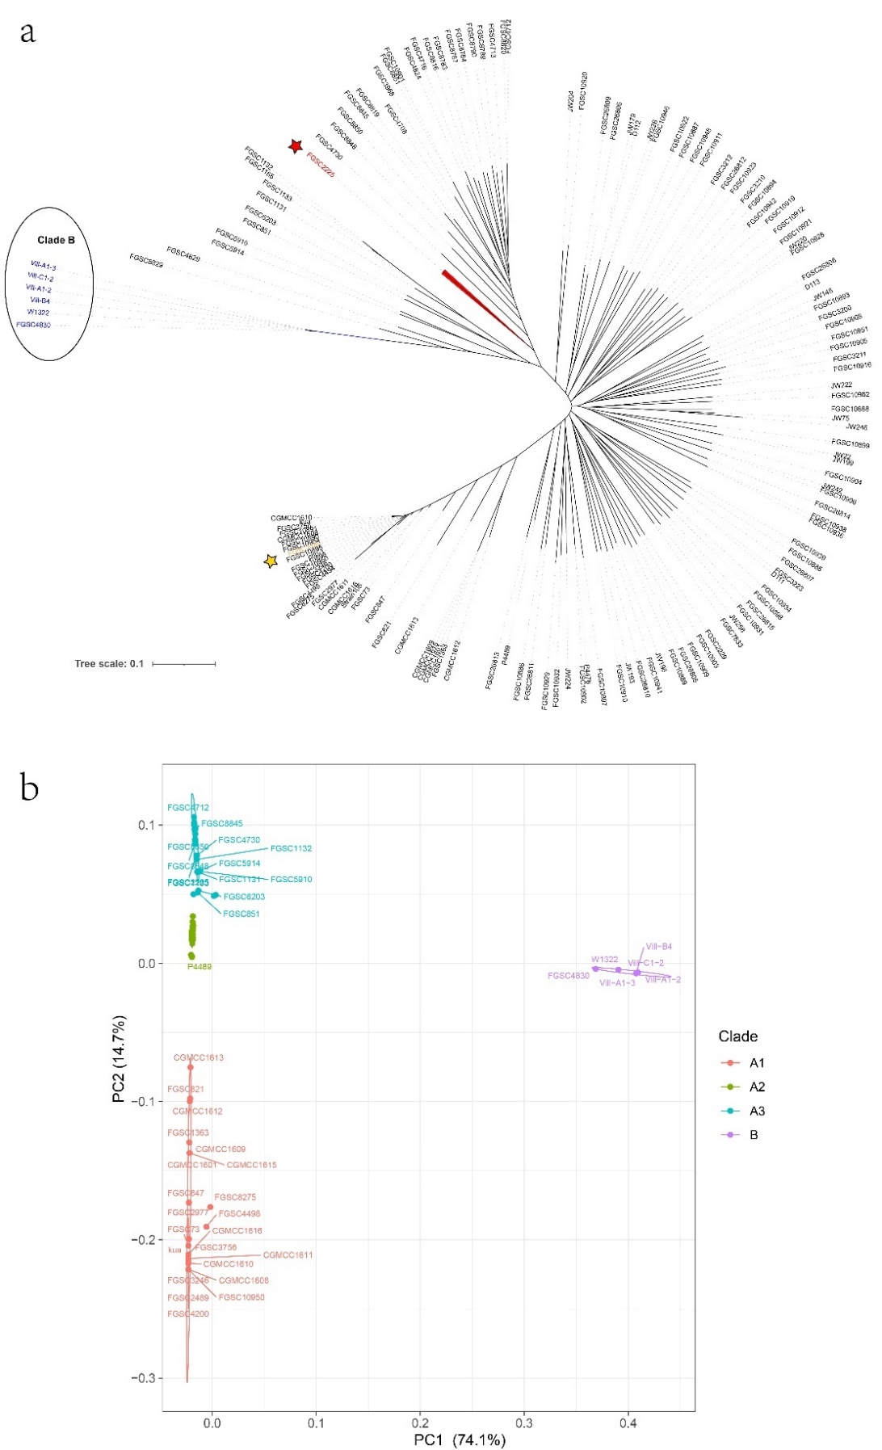

Fig. S2. Genome synteny of chromosome-level genome assembly.
(a) Synteny between the genomes of N. crassa FGSC2225 (x-axis) and FGSC2489 (y-axis). (b) Synteny between the genomes of N. crassa FGSC2225 (x-axis) and N. tetrasperma FGSC2509 (y-axis). The alignment was performed using MUMmer (v4.0) with default parameters. Only Blocks with an alignment length of ≥ 1000 bp and an identity ≥ 90% in chromosomes were shown.
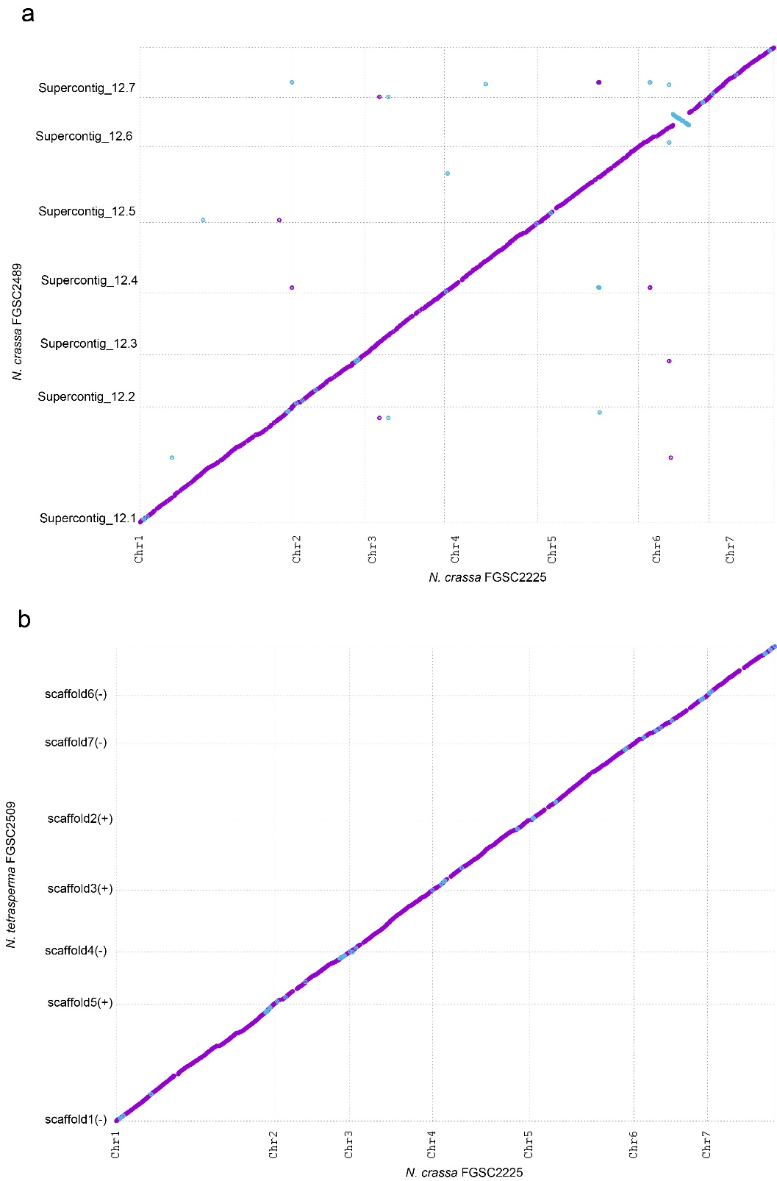

Fig. S3. Gene annotation and distribution of N. crassa FGSC2225.
(a) Gene density and the distribution of noncoding RNAs on the FGSC2225 genome. (b) BUSCO analysis confirming the high quality of gene prediction.
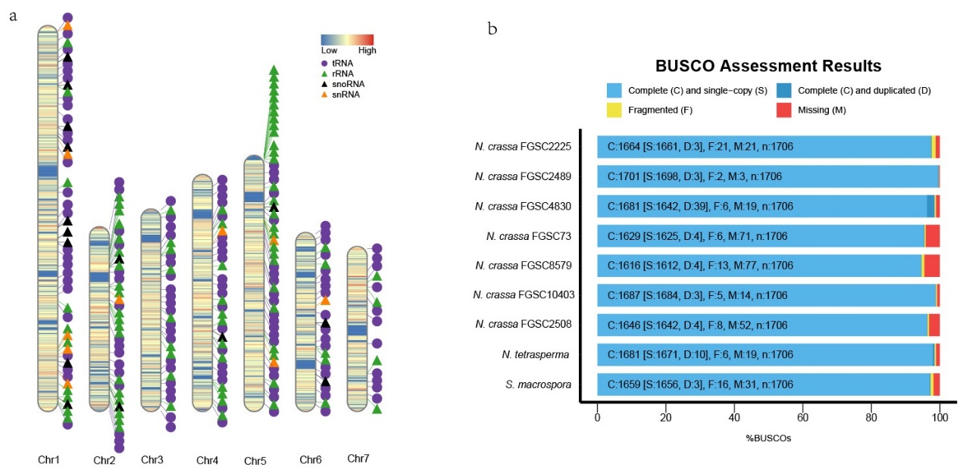

Fig. S4. Comparison of the RIP index and Ti/Tv method for HRAG identification.
(a) Comparison of RIP-related dinucleotide context in coding and repeat regions of N. crassa and S. macrospora. Due to high RIP activity, N. crassa strains exhibit elevated TpA content relative to ApT in repeat regions, resulting in a high TpA/ApT index (with red and blue dashed lines indicating index value = 2 and 1.2, respectively). Likewise, repeat regions in N. crassa show a marked depletion of (CpA+TpG) relative to (ApC+GpT), yielding a low (CpA+TpG)/(ApC+GpT) index (red line indicates value = 0.7). In contrast, coding regions in N. crassa and both coding and repeat regions in S. macrospora, which lacks strong RIP activity, shows no pronounced skew in dinucleotide frequencies. (b) Comparison of recovery rates of RIP-affected genes using Ti/Tv ratio and RIP index methods. A range of overall RIP-induced sequence divergences (0.1%, 0.5%, 1%, 2%, 5%, 10%, 15%, and 20%) was simulated to evaluate the performance of RIP index (TpA/TpT > 2; or [CpA+TpG]/[ApC+GpT] < 0.7) and Ti/Tv ratio (≥10) in both CDS and repeat regions. The recovery rate was calculated by “Number of correctly detected genes” / “Number of genes with simulated RIP-like mutations”. (c) Assessing the specificity of Ti/Tv method (threshold Ti/Tv ≥ 10) using a mixed model. The left panel shows the recovery rate of RIP-affected sequences in coding and repeat regions using the Ti/Tv method. The right panel show the false discovery rate (FDR) of the Ti/Tv method applied to both coding and repeat regions. FDR is defined as “Number of incorrectly detected genes” / “Number of genes without simulated RIP-like mutations”. (d) Evaluation of Ti/Tv thresholds for detecting simulated RIPed genes on coding sequences. A range of Ti/Tv thresholds (from ≥ 3 to ≥ 15) were evaluated on coding sequences with 1% simulated divergence. Simulations included varying proportions of RIP-like mutations: 0% RIP (a false positive control), 20-80% RIP (mixed mutation types), and 100% RIP (entirely RIP-like mutations). Correctly detected genes were further categorized based on the number of simulated RIP-like mutations within each gene. Results were derived from 100 simulation replicates.

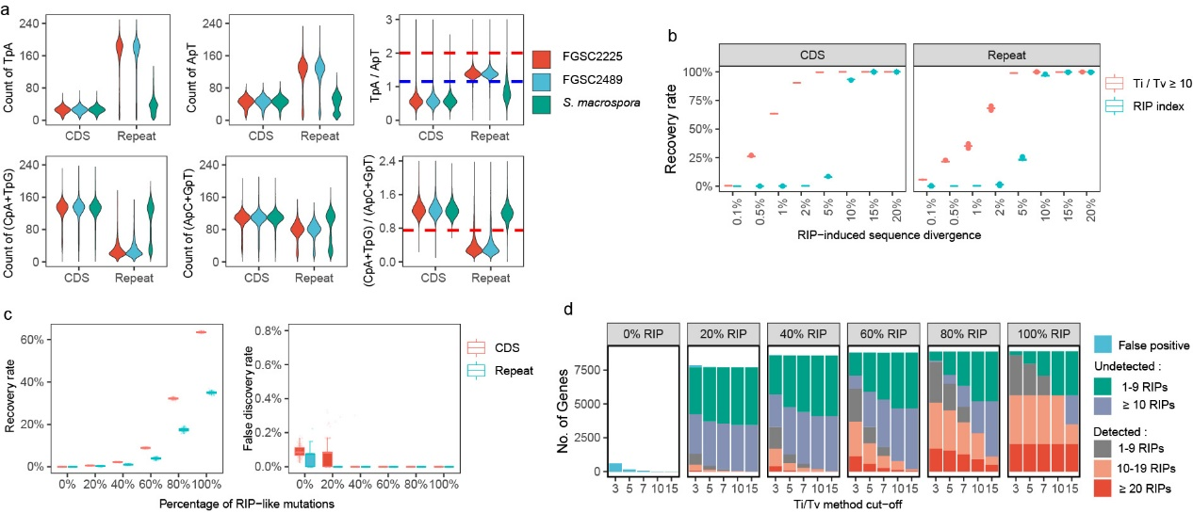

Fig. S5. Distance between the nearest two CpA sites.
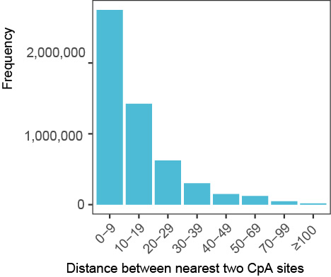

Fig. S6. Comparative analysis of Ti/Tv ratios and HRAG ratio across 27 Ascomycets.
The violin plot illustrates the percentage of genes with a Ti/Tv ratio ≥ 10 across different genomic backgrounds. Individual fungal species within each cohort are superimposed as jittered data points, with their corresponding scientific names highlighted in italicized text. Boxplots and data points are color-coded to distinguish between 11 RIPed Ascomycets (RIP index positive regions < 0.3%) and 16 deRIP Ascomycets (RIP index positive regions > 0.5%). Statistical significance between the two groups was determined using an independent sample T-test, with significance levels indicated above the boxes (ns, not significant; *, P < 0.05). Data across the 27 Ascomycete species (comprising 207 strains) were obtained from the Ensembl Fungi database and published population structure datasets.
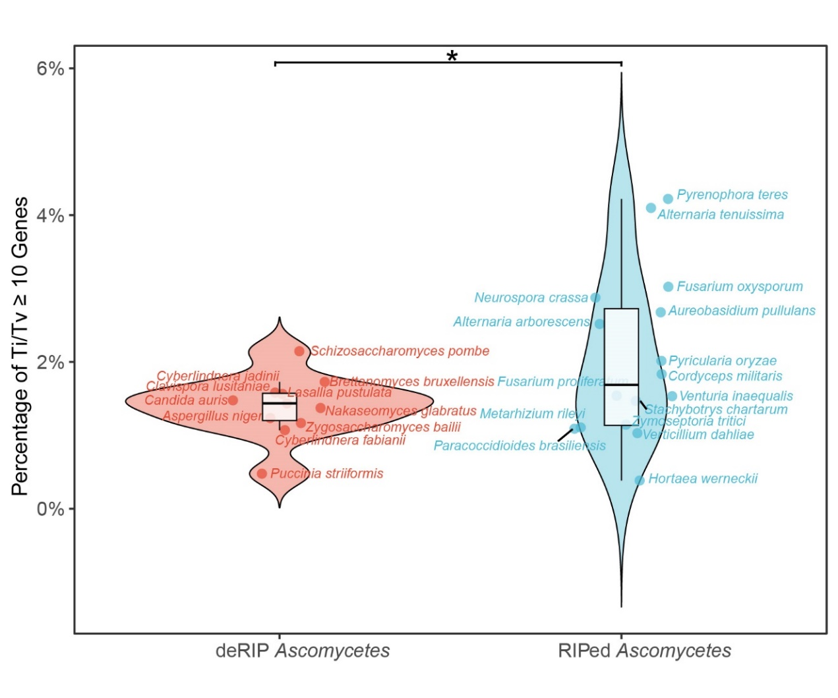

Fig. S7. The characteristics of HRAGs.
(a) HRAGs are significantly longer than other coding genes. (b) The majority of HRAGs exhibit distances to repeats exceeding 1 kb. (c) In 100 kb windows, the length of HRAGs is significantly negative corelated with the length of TEs. (d) The RNA-seq data reveals the distribution of gene expression levels in the hyphae of FGSC2489. The expression level of HRAGs (FPKM median=15.46) is notably higher than that of other genes (FPKM median=10.99, Wilcoxon p-value < 2.2e-16).
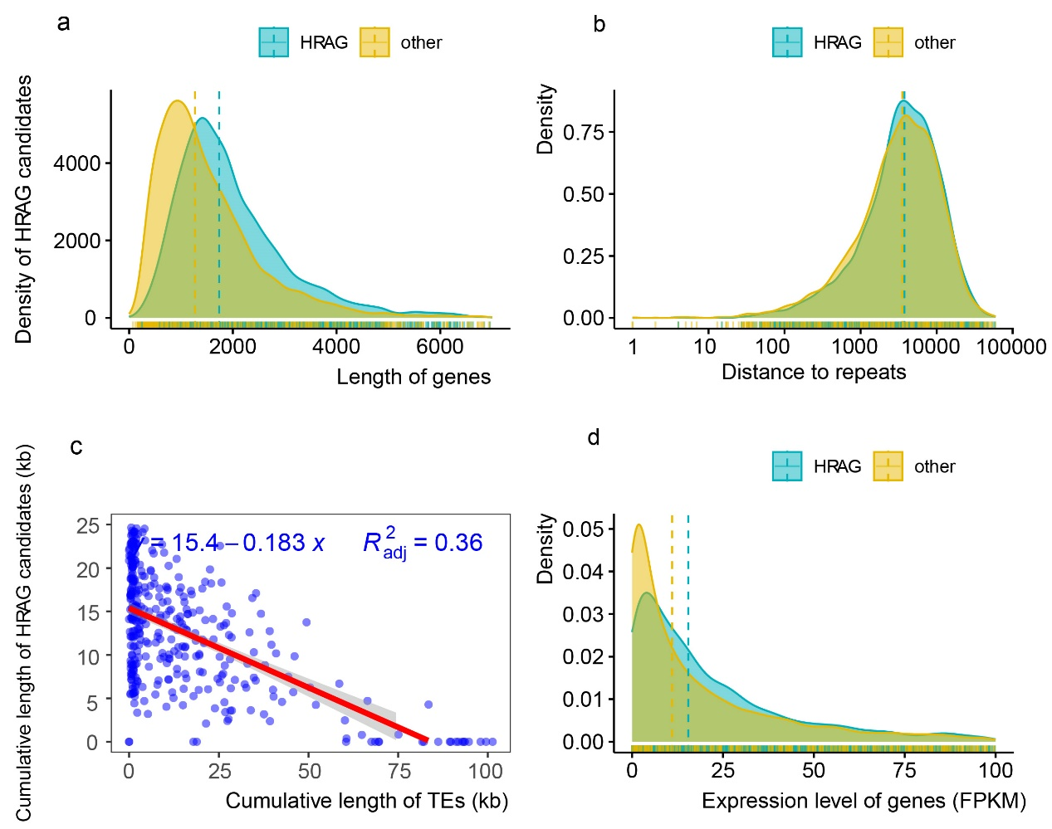

Fig. S8. Diversity of coding genes in N. crassa.
Nucleotide diversity (Pi), haplotype diversity (Hd), branch diversity (Bd), and haplotype network branch diversity (HBd) were calculated using HapNetComplexity.R based on SNPs identified among 134 N. crassa strains. The HBd of HRAGs is significantly higher than that of non-HRAGs (Wilcoxon rank-sum test, P < 2.2 × 10⁻¹⁶), indicating elevated sequence complexity within RIP-affected regions.
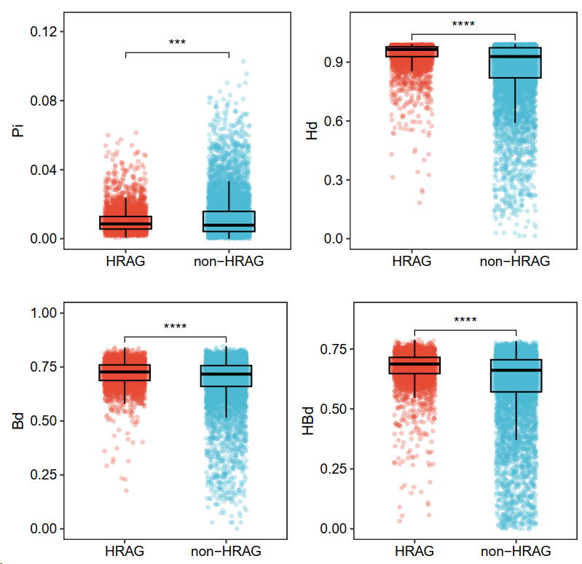

Fig. S9. Distribution of shared and strain-specific HRAGs across the N. crassa population.
The histogram illustrates the frequency of each HRAG identified across the population, categorizing them by the number of strains in which they occur. This highlights the distinction between strain-specific HRAGs, which appear in only a few specific lineages, and those shared across multiple strains or the entire population.

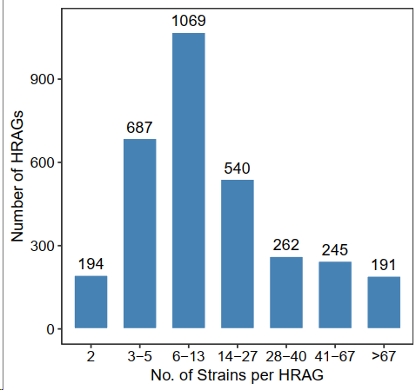

Fig. S10. Ten examples of high phylogenetic inconsistency between concatenated coding sequences (left tree) and specific genes (right tree).
NCU02337

NCU02683

NCU02899

NCU03071

NCU03188
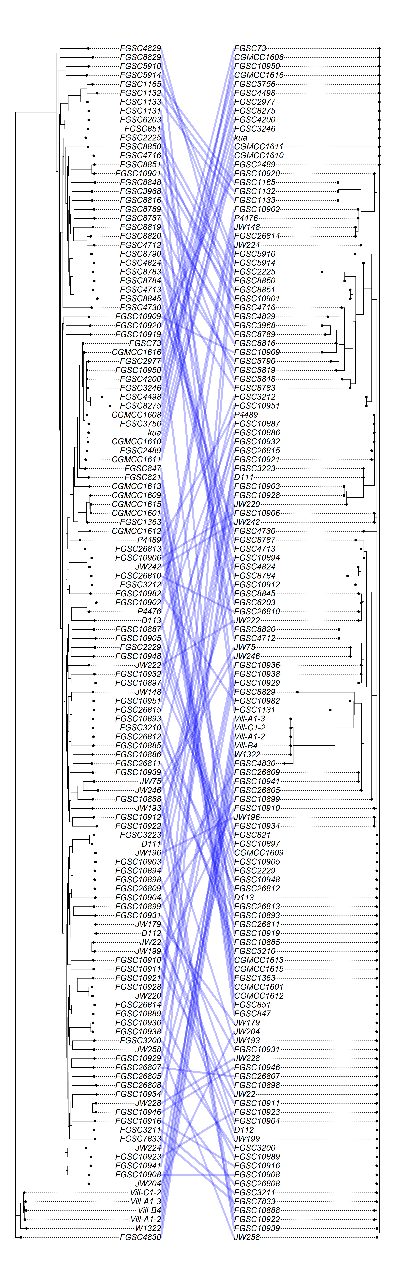

NCU03500
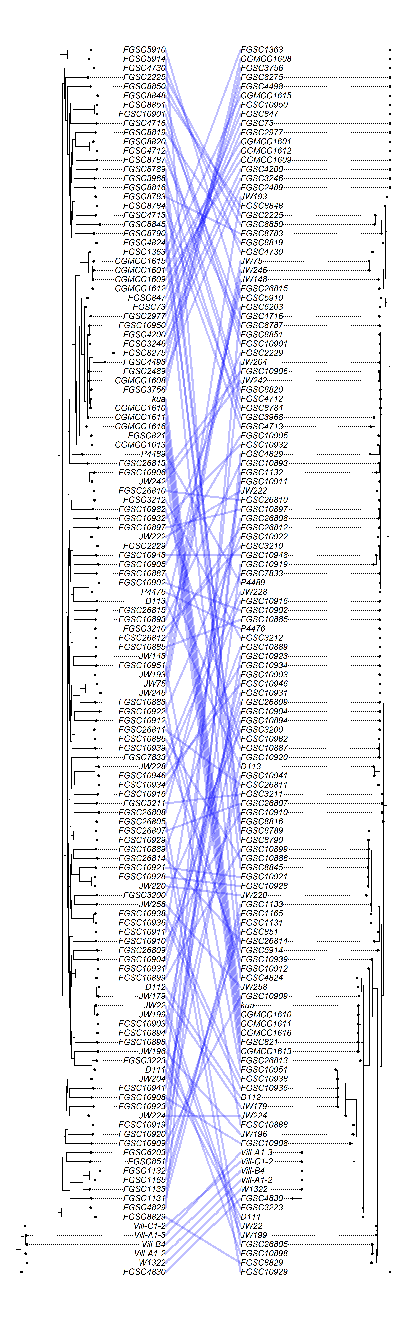

NCU03944
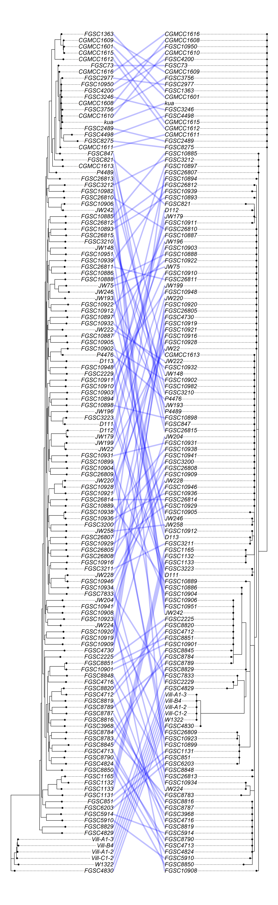

NCU04069
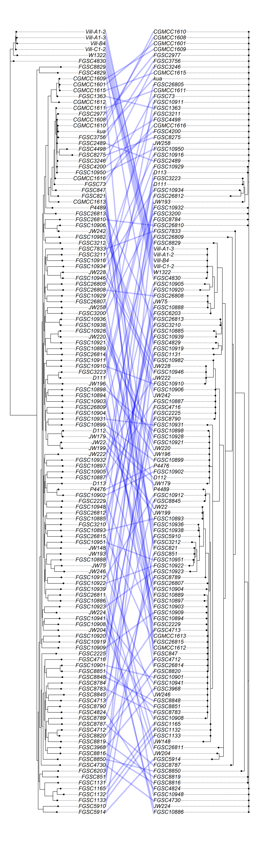
NCU04292
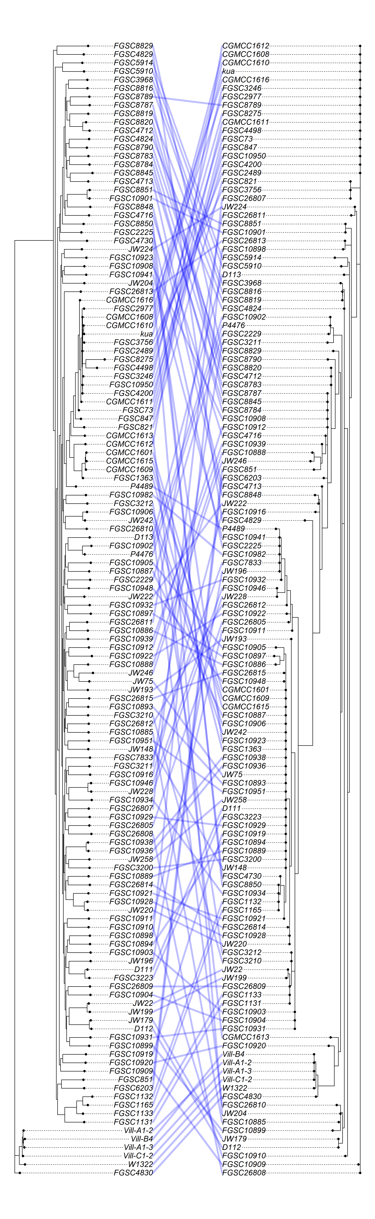
NCU04856
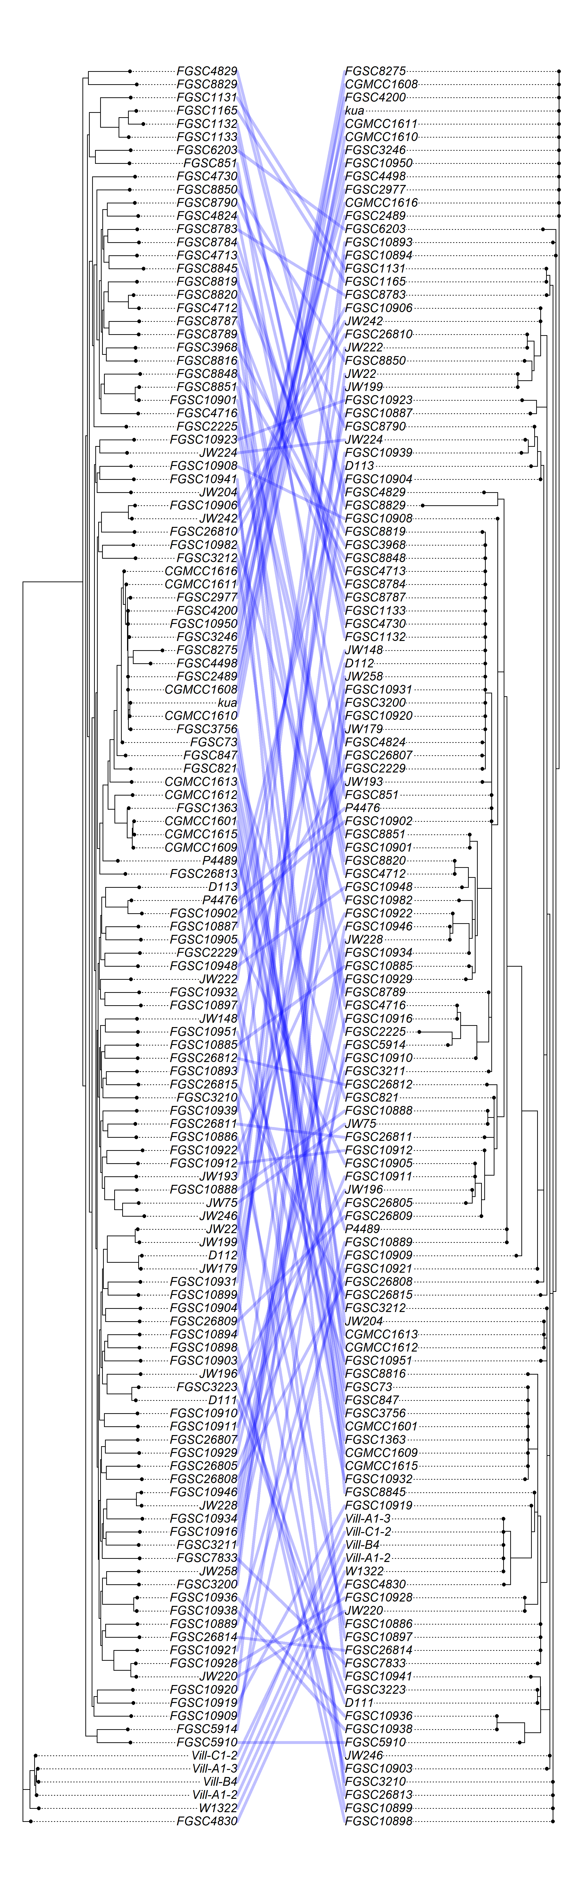
NCU05006
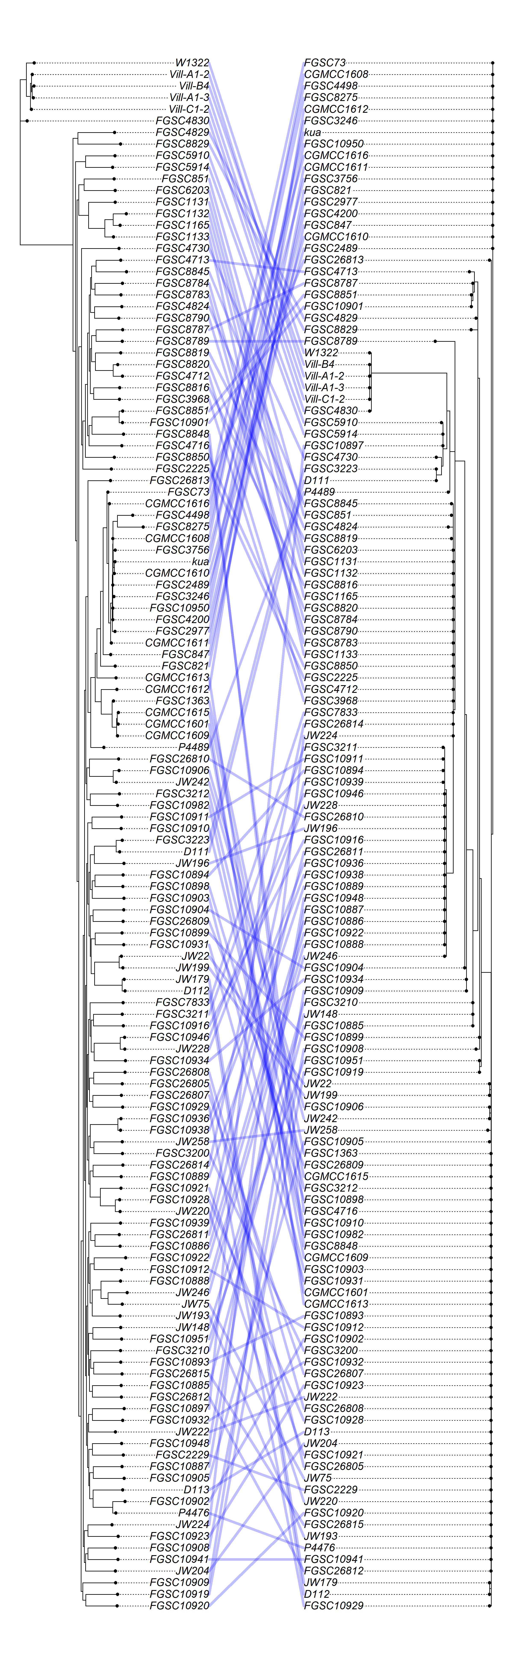
NCU07567
NCU07710
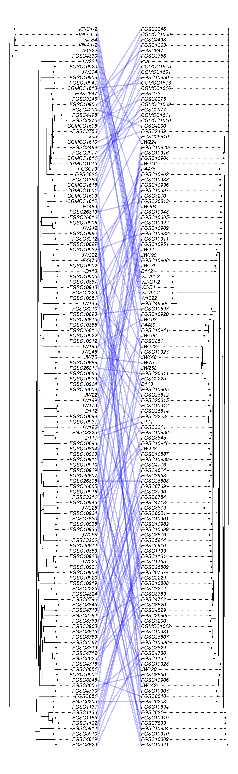

NCU08402
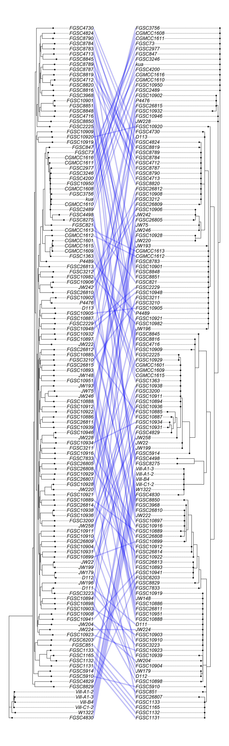
NCU09142
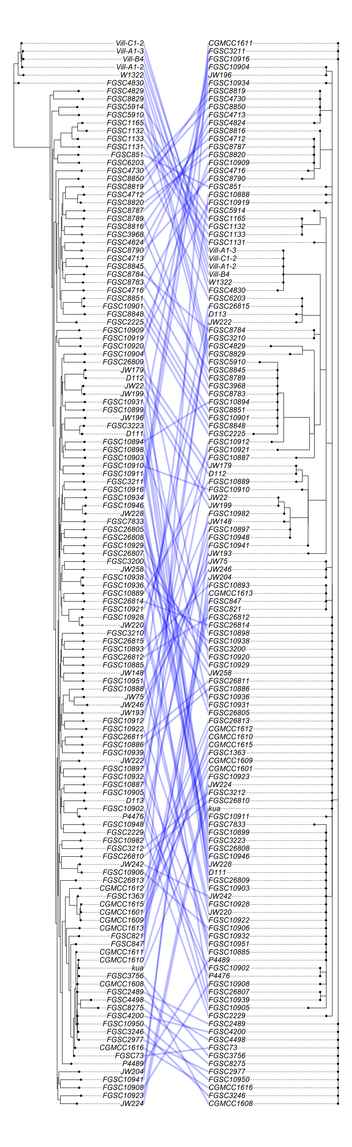
NCU09709
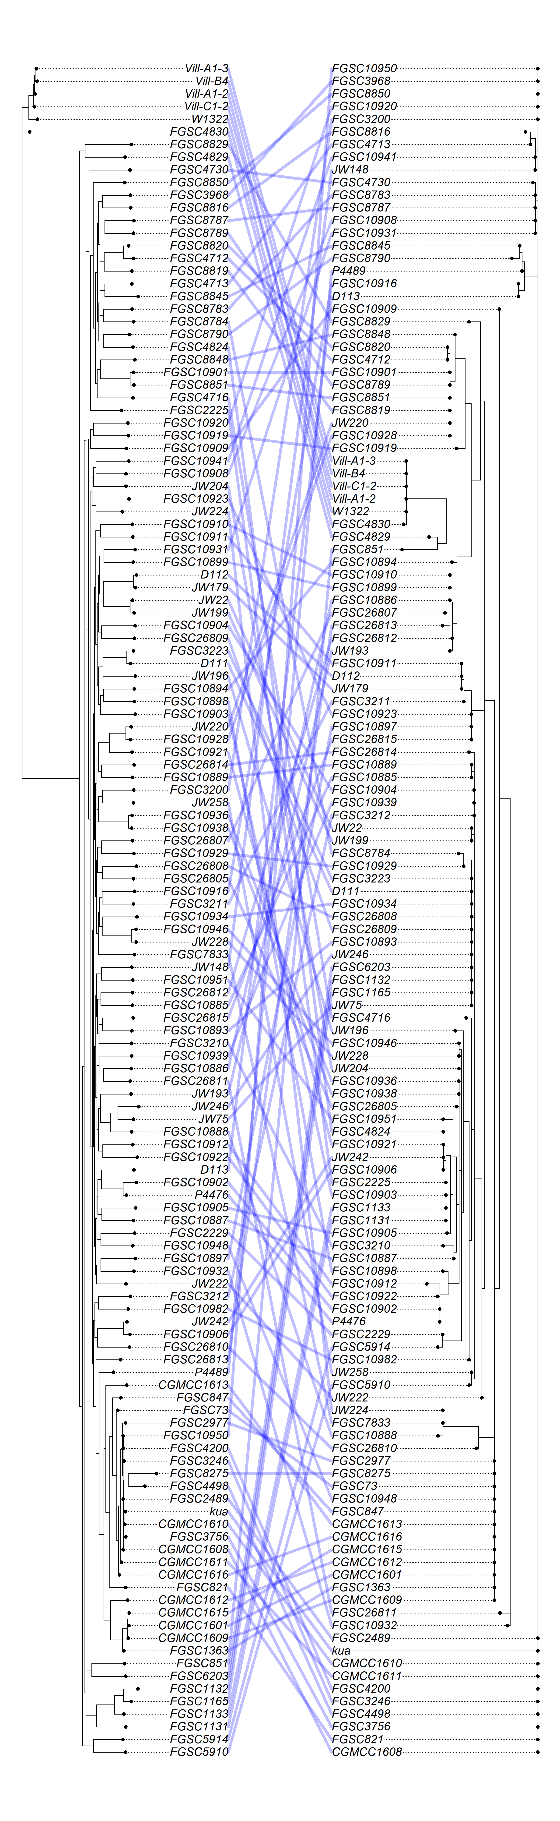

Fig. S11. IGV analysis confirms that the genes (a) NCU02184 and (b) NCU05519 are single-copy genes in natural strains and offspring in sexual reproduction.

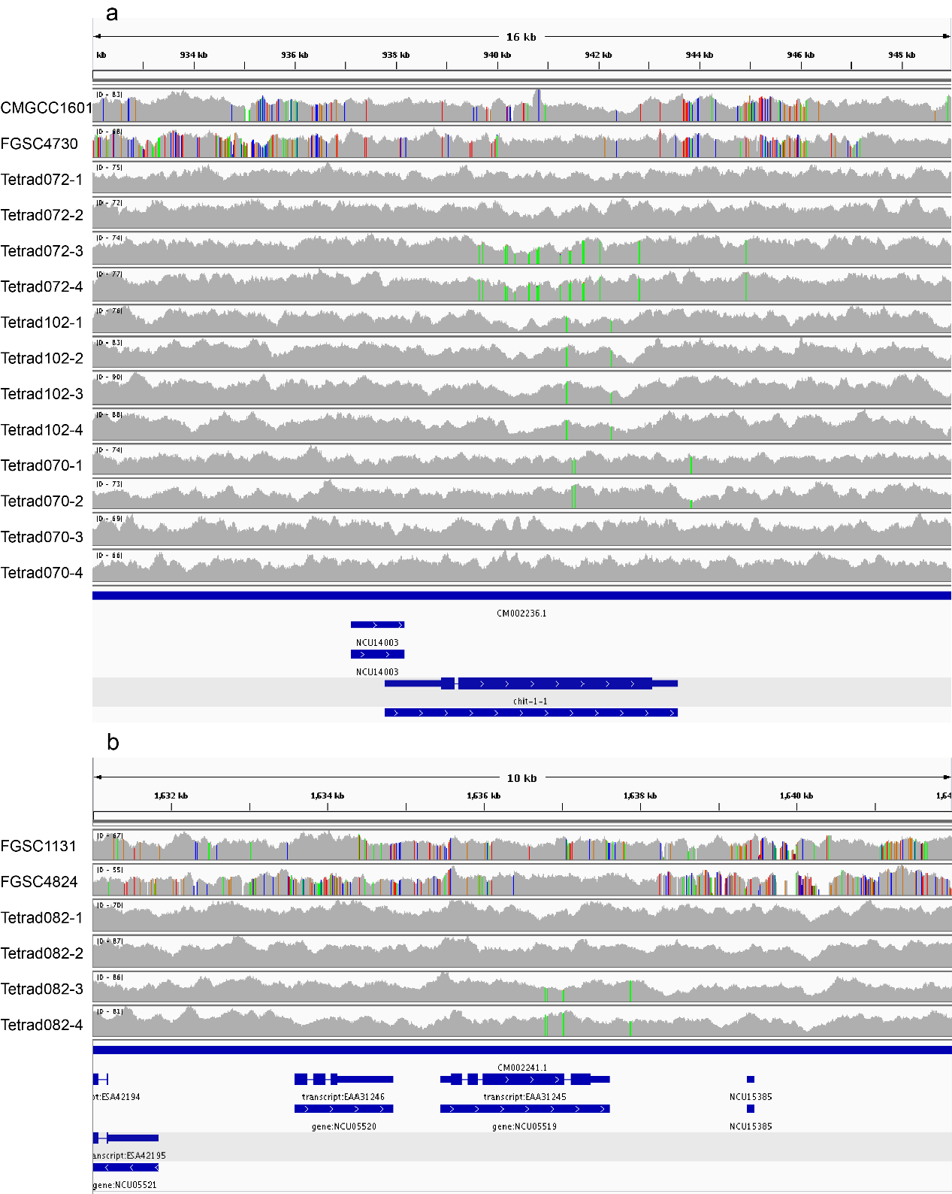

Fig. S12. Summary of SNP mutation sites (left) detected (a) across the N. crassa pangenome and (b) within all coding genes and (c) within all HRAGs relative to the FGSC2489 reference strain.
SNP mutation sites were categorized (middle) into RIP-like (C↔T or A↔G SNPs) and Other/non-RIP-like (not C↔T or A↔G SNPs) and by their predicted effects on protein-coding genes (right).
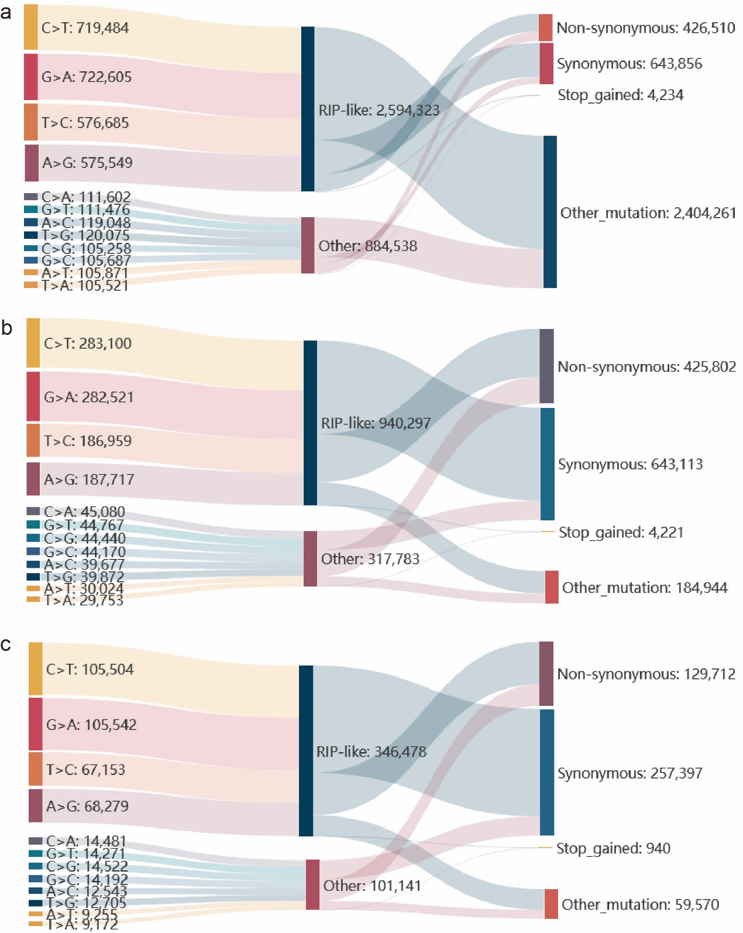

Fig. S13. Structure predictions of peptides using AlphaFold3.
(a) Spo76 (NCU01154) protein in strain FGSC2489. (b) Spo76 protein in strain FGSC4730. (c) Brr2 (NCU07411) protein in strain FGSC2489. (d) Brr2 protein in strain FGSC10919.
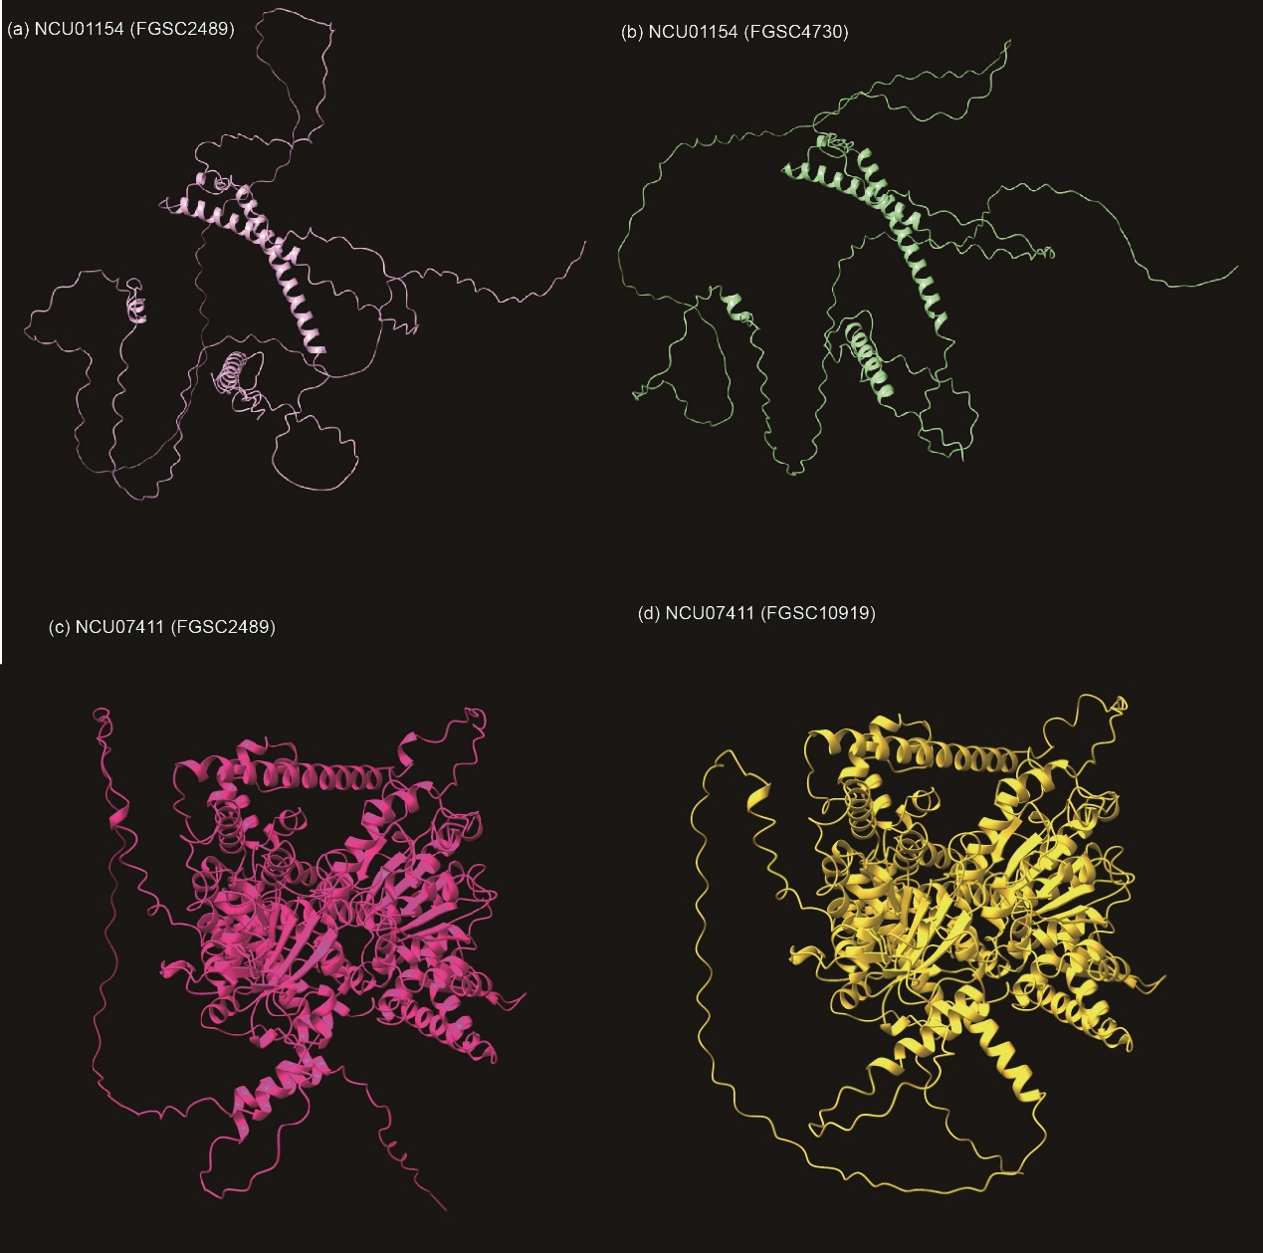

Supplementary Tables

Table S1. N. crassa strains used in this study.
Strain | Relevant genotype | Collection Site | NCBI accession | Source
FGSC2225 | Mauriceville-1cA; mat A | Mauriceville, Texas, USA | SRR31100579 | Wild-type, FGSC ª catalog no. 2225
FGSC2489 | 74-OR23-1VA; mat A | Oak Ridge, Tennessee, USA | SRR31100578 | Wild-type, widely-used in the lab, FGSC catalog no. 2489
CGMCC1601 | mat A | USA | SRR31100567 | CGMCC ^{b} catalog no. 3.1601
CGMCC1608 | mat A | USA | SRR31100566 | CGMCC catalog no. 3.1608
CGMCC1609 | mat A | USA | SRR31100565 | CGMCC catalog no. 3.1609
CGMCC1610 | mat A | USA | SRR31100564 | CGMCC catalog no. 3.1610
CGMCC1611 | mat a | USA | SRR31100563 | CGMCC catalog no. 3.1611
CGMCC1612 | mat a | USA | SRR31100562 | CGMCC catalog no. 3.1612
CGMCC1613 | mat A | USA | SRR31100561 | CGMCC catalog no. 3.1613
CGMCC1615 | mat A | USA | SRR31100577 | CGMCC catalog no. 3.1615
CGMCC1616 | mat A | USA | SRR31100576 | CGMCC catalog no. 3.1616
ku70^{RIP} | Δmus-51; mat a | Mutant | SRR31100568 | ku-70, deficient of KU70
Δorc3 | Δmus-51;Δorc3::hph^{r}; mat a | Mutant | SRR31100575 | Knockout NCU02683 in the strain ku-70
Δgln-2 | Δmus-51;Δgln-2::hph^{r}; mat a | Mutant | SRR31100574 | Knockout NCU04856 in the strain ku-70
Δcct6 | Δmus-51;Δcct6::hph^{r}; mat a | Mutant | SRR31100573 | Knockout NCU09709 in the strain ku-70
Tetrad102-1^{c} | mat A | Tetrad offspring | SRR31100572 | Spore progeny of Tetrad102
Tetrad102-2 | mat A | Tetrad offspring | SRR31100571 | Spore progeny of Tetrad102
Tetrad102-3 | mat A | Tetrad offspring | SRR31100570 | Spore progeny of Tetrad102
Tetrad102-4 | mat A | Tetrad offspring | SRR31100569 | Spore progeny of Tetrad102

hph^{r}: hygromycin resistant.
ª FGSC: Fungal Genetic Stock Center (http://www.fgsc.net/).
^{b} CGMCC: China General Microbiological Culture Collection Center (https://cgmcc.net/). The 9 strains entitled ‘CGMCC16’ were collected in USA around the 1950s and then transferred to China in ~1960s. These strains belong to linkage group IV (group D).
^{c} Only 4 out of 8 spore progenies in the Tetrad102 were sampled and sequenced.

Table S2. Statistics of the FGSC2225 sequencing data.

Platform | Insert size (bp) | No. of reads ª | Average read length (bp) | Total Data (Gb) | Average depth ^{b}
Pacbio (RS II) | ~20,000 | 1,137,501 | 9,962 | 11.33 | 274.8 ×
NGS (MGISEQ-2000 PE) | ~ 330 | 30,443,680 | 150 × 2 | 4.11 | 99.7 ×

ª For genomic PacBio data, “reads” here stand for subreads, i.e. reads partitioned from polymerase read after removing adapters; ^{b} Depth was calculated based on the 41.24 Mb genome size.

Table S3. Assembly Statistics of FGSC2225 nuclear genome at each assembly stage.

Assembly stage | No. of contigs | Contig Mean length | Contig N50 | Genome total size
Canu unitigs | 19 | 2,184,761 | 6,054,487 | 41,510,471
Canu assembly scaffolds | 12 | 3,444,908 | 6,054,486 | 41,333,898
1st round polishing (Gap filling) | 9 | 4,590,132 | 6,054,486 | 41,311,190
2nd round polishing (Quiver) | 9 | 4,598,470 | 6,079,302 | 41,386,238
3rd round polishing (Manual) | 7 | 5,882,909 | 6,060,753 | 41,180,365

For genomic PacBio data, “reads” here stand for subreads, partitioned from polymerase read after removing adapters. Only sequences from the nuclear genome are included in the statistics

Table S4. Telomeres of the FGSC2225 genome.

Chr ID | Chr Length | Telomere status | No. of monomer in top | Monomer direction in top | No. of monomer in bottom | Monomer direction in bottom
Chr1 | 9,868,134 | both | 79 | + | 57 | -
Chr2 | 4,726,971 | both | 61 | + | 46 | -
Chr3 | 5,178,936 | both | 72 | + | 62 | -
Chr4 | 6,060,753 | both | 70 | + | 70 | -
Chr5 | 6,548,468 | both | 80 | - | 45 | -
Chr6 | 4,578,415 | both | 65 | + | 63 | -
Chr7 | 4,218,688 | both | 62 | + | 63 | -
* Telomere repeat monomer: AACCCT

Table S5. Main features of N. crassa FGSC2225 genome assembly and gene annotation.
Feature | FGSC2225 | FGSC2489
No. of Scaffolds | 8 | 21ª
Anchored to chromosome | 100% | 35% ª
Size of Assembled genome (bp) | 41,244,053 | 41,102,378 ª
Size of Repeat Masked sequence (bp) | 5,314,547 | 4,974,628 ª
GC content (%) | 48.18% | 48.19% ª
Transposon/TE (bp) | 9,830,214 | NA ^{b}
Predicted protein-coding genes | 9,726 | 9,758 ª
Total Length of genes (bp) | 16,785,571 | 16,635,786 ª
Average gene size (bp) | 1,726 | 1,705 ª
Average CDS size in each gene (bp) | 1,474 | 1,525 ª
Median intergenic distance (bp) | 1,216 | 1,304 ª
Annotated genes | 7,012 | 4,682 ª
Conserved hypothetical proteins in Neurospora genus | 9,699 | 9,733 ^{b}
Predicted novel proteins (novel in Neurospora genus) | 27 | 25 ^{b}
tRNA genes | 456 | 455 ^{b}

ª These data were calculated by the genome assembly of N. crassa strain FGSC2489 (version NC12) in the Ensembl Fungi website (http://fungi.ensembl.org/index.html). ^{b} These data were assessed using same software and parameters with FGSC2225 genome assembly.

Table S6. Ratio of genes with high Ti/Tv ratios between RIPed Ascomycets and deRIP Ascomycets.

Species | RIP Class | RIP index positive regions % | Global Ti/Tv in CDS | Divergence in CDS % | Ratio of Ti/Tv ≥10 genes
Candida auris | deRIP | 0.038% | 2.400 | 0.643% | 1.48%
Clavispora lusitaniae | deRIP | 0.066% | 2.253 | 0.994% | 1.56%
Puccinia striiformis | deRIP | 0.074% | 2.299 | 0.395% | 0.48%
Cyberlindnera jadinii | deRIP | 0.076% | 2.601 | 0.616% | 1.58%
Cyberlindnera fabianii | deRIP | 0.119% | 2.404 | 0.464% | 1.07%
Brettanomyces bruxellensis | deRIP | 0.136% | 3.293 | 0.484% | 1.73%
Zygosaccharomyces bailii | deRIP | 0.147% | 3.152 | 1.022% | 1.17%
Aspergillus niger | deRIP | 0.161% | 2.546 | 0.588% | 1.24%
Lasallia pustulata | deRIP | 0.163% | 2.174 | 0.577% | 1.44%
Schizosaccharomyces pombe | deRIP | 0.178% | 3.404 | 0.390% | 2.15%
Nakaseomyces glabratus | deRIP | 0.353% | 2.474 | 0.440% | 1.37%
Alternaria tenuissima | RIPed | 0.549% | 3.540 | 1.046% | 4.10%
Stachybotrys chartarum | RIPed | 0.572% | 2.870 | 0.397% | 1.47%
Fusarium oxysporum | RIPed | 0.587% | 2.925 | 0.837% | 3.02%
Paracoccidioides brasiliensis | RIPed | 0.745% | 2.164 | 0.447% | 1.09%
Pyrenophora teres | RIPed | 1.007% | 3.211 | 0.654% | 4.22%
Pyricularia oryzae | RIPed | 1.142% | 2.421 | 0.466% | 2.01%
Fusarium proliferatum | RIPed | 1.266% | 2.490 | 0.921% | 1.54%
Hortaea werneckii | RIPed | 1.338% | 2.320 | 0.394% | 0.38%
Alternaria arborescens | RIPed | 1.413% | 3.542 | 0.388% | 2.52%
Metarhizium rileyi | RIPed | 1.417% | 2.461 | 0.353% | 1.11%
Verticillium dahliae | RIPed | 1.800% | 2.253 | 0.394% | 1.03%
Aureobasidium pullulans | RIPed | 4.136% | 3.222 | 0.919% | 2.68%
Cordyceps militaris | RIPed | 9.218% | 2.112 | 0.912% | 1.83%
Neurospora crassa | RIPed | 15.372% | 2.596 | 0.936% | 2.88%
Zymoseptoria tritici | RIPed | 16.972% | 2.142 | 1.066% | 1.14%
Venturia inaequalis | RIPed | 49.011% | 2.635 | 0.614% | 1.53%

Data across the 27 Ascomycete species (comprising 207 strains) were obtained from the Ensembl Fungi database and published population structure datasets.

Table S7. Statistics of SNPs on genes and simulation.

Mutation type | Real gene dataset |  |  | Simulation dataset
Mutation type | All genes | Ti/Tv ≥10 genes |  | Mock1ª on all genes | Mock2^{b} on all genes | Mock1ª on each Ti/Tv≥10 gene | Mock2^{b} on all Ti/Tv≥10 genes
Synonymous Ti | 38,692 | 2,575 |  | 17,611 | 17,632 | 1,105 | 1,091
Nonsynonymous Ti | 12,777 | 514 |  | 33,858 | 33,852 | 1,984 | 1,998
Synonymous Tv | 9,031 | 117 |  | 3,288 | 3,184 | 27 | 33
Nonsynonymous Tv | 8,267 | 57 |  | 14,010 | 14,099 | 147 | 141
All Ti | 51,469 | 3,089 |  | 51,469 | 51,484 | 3,089 | 3,089
All Tv | 17,298 | 174 |  | 17,298 | 17,283 | 174 | 174
Ti/Tv | 2.98 | 17.75 |  | 2.98 | 2.98 | 17.75 | 17.75
Synonymous SNP | 47,723 | 2,692 |  | 20,899 | 20,816 | 1,132 | 1,124
Nonsynonymous SNP | 21,044 | 571 |  | 47,868 | 47,951 | 2,131 | 2,139
Nonsynonymous/Synonymous | 0.44 | 0.21 |  | 2.29 | 2.30 | 1.88 | 1,90
ª Mock1 method introduces random corresponding SNPs in specific genes. ^{b} Mock2 method introduces random SNPs across all simulated genes.

Table S8. List of HRAGs with relatively elevated Ka/Ks ratios.
Gene ID | Gene | Ka/Ks | Information | Reference
NCU00424 | Spo76 | 2.54 (FGSC2489 vs. FGSC4824) | A conserved chromosome morphogenesis protein that links the mitotic and meiotic programs | (i) Building bridges to move recombination complexes. Proceedings of the National Academy of Sciences  (ii) Canonical and noncanonical roles of Hop1 are crucial for meiotic prophase in the fungus Sordaria macrospora  (iii) Spo76p Is a Conserved Chromosome Morphogenesis Protein that Links the Mitotic and Meiotic Programs
NCU06352 | OPT4 | 2.20 (FGSC2489 vs. FGSC10923) | Oligopeptide transporter 4, associate with MCC/eisosomes | The Composition and the Structure of MCC/Eisosomes in Neurospora crassa
NCU01154 | sub-1 | 1.87 (FGSC2489 vs. FGSC4730) | Submerged protoperithecia-1 | Neurospora illuminates fungal photoreception
NCU07411 | Brr2 | 1.82 (FGSC2489 vs. FGSC10919) | Bad Response to Refrigeration 2 (Brr2) (Q7S0U4), RNA helicase involved in the spliceosome (however, some studies suggest that absent in fungi) | Functions and regulation of the Brr2 RNA helicase during splicing
NCU01917 | sad-7 | 1.49 (FGSC2489 vs. FGSC10893) | Required for a fully efficient MSUD response to unpaired genes | An RNA Recognition Motif-Containing Protein Functions in Meiotic Silencing by Unpaired DNA
NCU04773 | MAC1 | 1.34 (FGSC2489 vs. FGSC3200) | Copper ion-binding domain | A global search for novel transcription factors impacting the Neurospora crassa circadian clock
NCU01967 | ELP6 | 1.15 (FGSC2489 vs. FGSC4712) | Elongator complex protein 6, Potentially play roles in azole/Terb resistance in the evolved drug-resistant strain 26thV1 | Experimental Evolution of Multidrug Resistance in Neurospora crassa under Antifungal Azole Stress
NCU06971 | xlr-1 | 0.85 (FGSC2489 vs. FGSC3211) | Transcriptional activator xlnR, Utilization of xylan | Network reconstruction and systems analysis of plant cell wall deconstruction by Neurospora crassa
NCU00850 |  | 0.85 (FGSC2489 vs. FGSC3200) | Q7SD89 | Intron evolution in Neurospora: the role of mutational bias and selection
NCU00628 | MED17 | 0.63 (FGSC2489 vs. FGSC10920) | Mediator of RNA polymerase II transcription subunit 17 | Alternative Oxidase Transcription Factors AOD2 and AOD5 of Neurospora crassa Control the Expression of Genes Involved in Energy Production and Metabolism

