Additional file 1
Enlarged hind femora as active defense weapons in Cretaceous stick insects

Xinran Zhao, Dong Ren, Hongru Yang* and Taiping Gao*

*Correspondence
Taiping Gao tpgao@cnu.edu.cn; Hongru Yang hryang@cnu.edu.cn
College of Life Sciences, Capital Normal University, Beijing 100048, China

Contents
Dataset S1. The detailed description and measurements of two species.
Figure S1. Counterpart of holotype, Coniphasma inflatum.
Figure S2. Counterpart of holotype, Coniphasma breve.
Figure S3. Paratype of Coniphasma breve.
Table S1. Checklist of all known fossil species of Susumaniidae.
Table S2. Measurements (length and width, in mm) and ratios of profemur (Pf), protibia (Pt), mesofemur (Mf), mesotibia (Mt), metafemur (Mtf), and metatibia (Mtt) for known fossil specimens of Susumaniidae.

Dataset S1. The detailed description and measurements of two species
Coniphasma inflatum sp. nov.
Description.
Holotype (No. CNU-PHA-LB2009005P/C, adult male): head globular; prognathous, mandible with incisive; antenna filiform, incompletely; scape and pedicel cylindrical, slightly longer than width; pedicel shorter and narrower than scape (Fig. 1A–C, and Fig. S1).
Pronotum nearly square, shorter and narrower than mesothorax; mesothorax slightly longer than width, shorter and narrower than metathorax; metathorax approximately equal to prothorax plus mesothorax in height; metasternum distinctly separated from abdominal sternum I (Fig. 1A and B).
Forewings nearly complete, color brown, with wing spot in posteromedial area; longitudinal veins straight and nearly parallel, with many cross-veins; without ‘procostal’ area; ScP terminating at anterior margin beyond forewing midpoint; R and Sc extremely close in proximal part; R branching at one-third of forewing; RP with two branches, forked at forewing mid-length; M with two branches, branching point between RP origin and RP branching point; CuA with two branches, forked in forewing proximal part; CuP, 1A and 2A simple; area between 1A and 2A wide (Fig. 1A, B, and Fig. S1).
Hind wings partially preserved, hyaline; R with two branches, forked in proximal part; M with two branches, branching point distal to R origin; Cu simple, fused with 1A proximally; 2A–7A with common origin near wing base; other anal veins indistinct (Fig. 1A, B, and Fig. S1).
Fore-, mid-, and hind legs incompletely preserved, all robust; fore- and middle femora and tibiae possessing dorsal carinae; all femora covered with symmetrically arranged maculae and dark bands; forefemur straight; metafemur greatly inflated, maximum width approximately one-third of its length, three times wide as that of tibia; metafemur shorter than mesothorax plus metathorax in height; tibiae with V-shaped area (Fig. 1D, F–I).
Abdomen slightly narrower than thorax, with ten segments preserved; abdominal segment I shorter than each of remaining segments; gradually narrows from segment I to VII, gradually broadening from VII to IX; alimentary canal straight; cerci cylindrical, undivided; epiproct present (Fig. 1A, B and E).
Paratype (No. CNU-PHA-LL2009006, gender unknown): antenna filiform, with more than 20 segments, first flagellomere shorter than scape plus pedicel; flagellomere II shorter than flagellomere I; remaining flagellomeres gradually longer (Fig. 2A).
Profemur and protibia subequal; tarsi pentamerous, basitarsus long, shorter than remaining tarsomeres combined; tarsomere IV shortest (Fig. 2A).
Metafemur with rows of small denticulate notches on the inner side (Fig. 2B and C).
Remaining preserved features are consistent with the holotype.
Measurements (in mm).
Holotype: body 35.5 in height (excluding antenna); head 2.5; scape 0.5; pedicel 0.4; prothorax 2.5; mesothorax 4.1; metathorax 5.5; forewing 27.2; abdomen 20.2; profemur length 4.7, width 1.3; mesofemur length 5.8, width 1.2; mesotibia length 5.3, width 0.5; metafemur length 6.5, width 2.1; metatibia length 6.6, width 0.8.
Paratype: head 3.0 in height; the preserved left antenna 47.4; the preserved right antenna 48.2; scape 0.5; pedicel 0.7; flagellomeres I 0.6; prothorax 3.6; mesothorax 5.2; metathorax 7.5; forewing 38.1; hindwing 37.5; profemur length 6.3, width 1.4; protibia length 6.2, width 0.5; mesofemur length 7.2, width 1.6; mesotibia length 6.5, width 0.7; mesotarsus length 4.6; metafemur length 9.0, width 2.8; metatibia length 7.8, width 0.9.

Coniphasma breve sp. nov.
Description.
Holotype (No. CNU-PHA-LB2009007P/C, gender unknown): head globular; prognathous, mandible with incisive; antenna filiform, with more than 20 segments; scape and pedicel cylindrical, slightly longer than width, pedicel shorter and narrower than scape; first flagellomere shorter than scape plus pedicel; flagellomere II shorter than flagellomere I, remaining flagellomeres gradually longer (Fig. 3A, C, and Fig. S2).
Pronotum nearly square, shorter and narrower than the mesothorax, with a distinctly transverse furrow on the anterior part of the pronotum; mesothorax slightly longer than width, shorter and narrower than metathorax; metathorax approximately equal to prothorax plus mesothorax, longer than width (Fig. 3A, and Fig. S2).
Forewings complete, uniformly brown, opaque, wing spot distributed in posteromedial area; left forewing fully expanded, right forewing folded against body, pressed under hind wing; longitudinal veins straight, nearly parallel, with many cross-veins, without ‘procostal’ area; ScP terminating at anterior margin beyond forewing midpoint; R and Sc extremely close in proximal part; R branching at one-third of forewing; RP with two branches, forked at forewing mid-length; M with two branches, branching point between RP origin and RP branching point; CuA with two branches, forked in forewing proximal part; CuP, 1A and 2A simple; area between 1A and 2A width (Fig. 3A and D, and Fig. S2A, B).
Hind wings folded against body, opaque, wing spot distributed in posteromedial area; cross-veins present; longitudinal veins indistinguishable (Fig. 3A and Fig. S2A, B).
Legs incompletely preserved, robust, femora with dorsal carinae, symmetrically arranged maculae and dark bands; profemur and protibia subequal; metafemur longer than profemur; metafemur shorter than mesothorax plus metathorax; profemur straight; tarsi possibly pentamerous (Fig. 3A, E–J).
Abdomen concealed by wings, narrower than thorax, poorly preserved, segmentation not visible; alimentary canal trace faint (Fig. 3A and Fig. S2A, B).
Paratype (No. CNU-PHA-LB2009008): mid- and hind femora subequal to respective tibiae, tarsi pentamerous, basitarsus long, shorter than other tarsomeres combined, tarsomere IV shortest; unguis present (Fig. S3A and B).
Remaining preserved features are consistent with the holotype.
Measurements (in mm).
Holotype: body 35.0 in height (excluding antenna); head 2.8; the preserved left antenna 32.7; the preserved right antenna 10.8; scape 0.7; pedicel 0.5; flagellomeres I 0.4; prothorax 2.4; mesothorax 3.7; metathorax 4.6; forewing 27.3; hindwing 27.2; profemur length 4.4, width 1.1; protibia length 4.3, width 0.6; mesofemur length 4.3, width 1.1; metafemur length 5.8, width 1.4.
Paratype: body 31.5 in height (excluding antenna); head 3.1; prothorax 2.3; mesothorax 2.7; metathorax 4.6; forewing 28.6; hindwing 23.7; profemur length 6.7, width 1.6; mesofemur length 4.9, width 1.4; mesotibia length 4.7, width 0.5; mesotarsus 6.8; metafemur length 5.9, width 1.9; metatibia length 6.0, width 0.9; metatarsus 5.9.

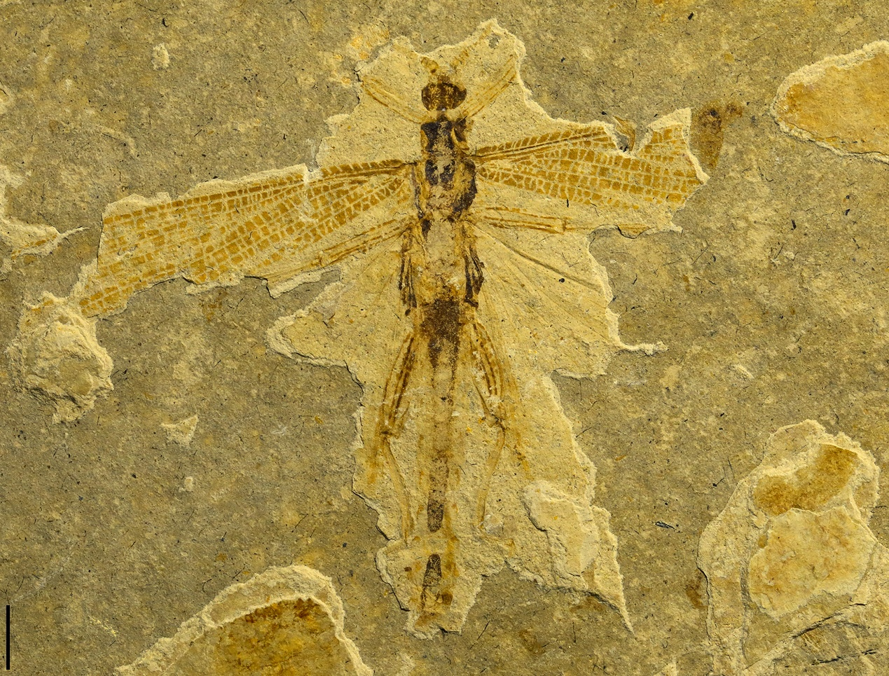
Fig. S1 Counterpart of holotype (Coniphasma inflatum sp. nov., No. CNU-PHA-LB2009005C, adult male). Scale bar: 4 mm.

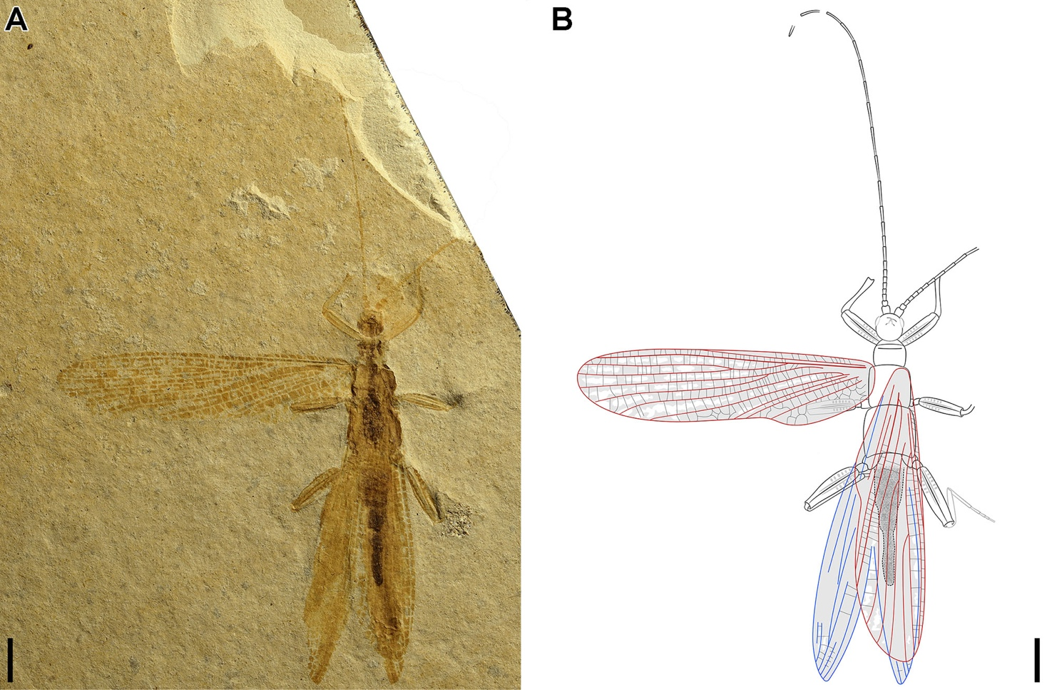
Fig. S2 Counterpart of holotype (Coniphasma breve sp. nov., No. CNU-PHA-LB2009007C, gender unknown). A, B Photo and line drawing. Scale bars: 4 mm.

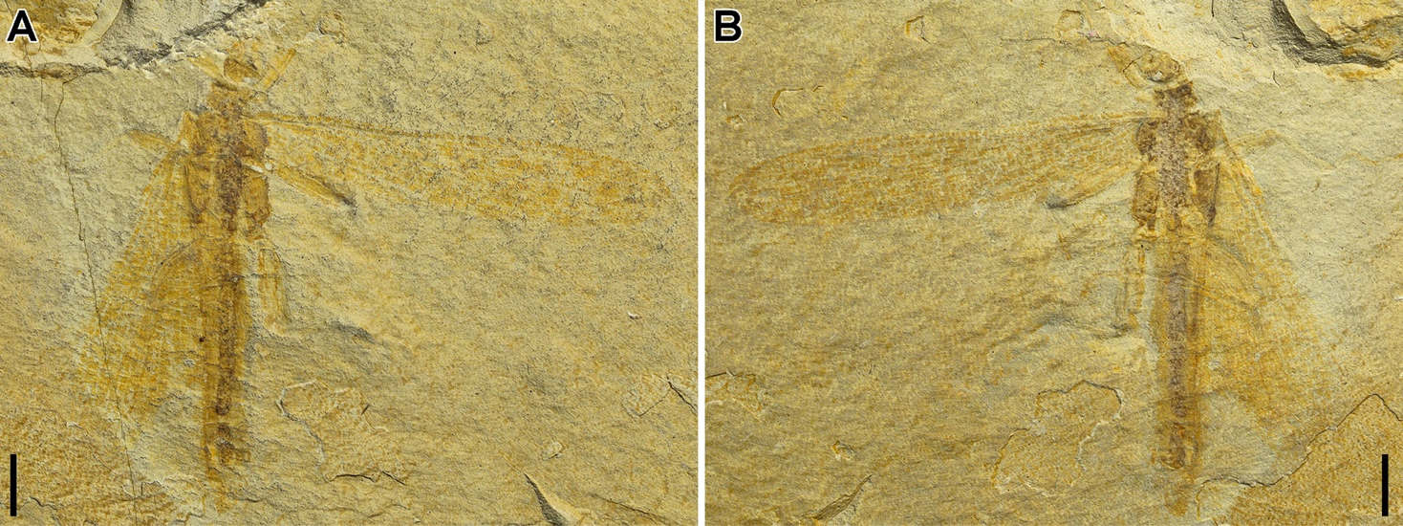
Fig. S3 Paratype of Coniphasma breve sp. nov., No. CNU-PHA-LB2009008P/C, gender unknown. A, B Part and counterpart. Scale bars: 4 mm.

Table. S1 Checklist of all known fossil Susumaniidae
Family | Subfamily | Genus | Species | Geological Age | Geographic Distribution
Susumaniidae | Susumaniinae | Aethephasma | A. megista Ren, 1997 | ~125 Ma (Early Cretaceous) | China (Pingquan, Hebei)
Susumaniidae | Susumaniinae | Hagiphasma | H. paradoxa Ren, 1997 | ~125 Ma (Early Cretaceous) | China (Beipiao, Liaoning)
Susumaniidae | Susumaniinae | Orephasma | O. eumorpha Ren, 1997 | ~125 Ma (Early Cretaceous) | China (Pingquan, Hebei)
Susumaniidae | Susumaniinae | Renphasma | R. sinica Nel & Delfosse, 2011 | ~125 Ma (Early Cretaceous) | China (Beipiao, Liaoning)
Susumaniidae | Susumaniinae | Coniphasma | C. rosenkrantzi Birket-Smith, 1981 | 89.8–86.3 Ma (Late Cretaceous) | Greenland
Susumaniidae | Susumaniinae | Coniphasma | C. inflatum sp. nov. | ~125 Ma (Early Cretaceous) | China (Beipiao and Lingyuan, Liaoning)
Susumaniidae | Susumaniinae | Coniphasma | C. breve sp. nov. | ~125 Ma (Early Cretaceous) | China (Beipiao, Liaoning)
Susumaniidae | Susumaniinae | Cretophasmomima | C. melanogramma Wang, Béthoux & Ren, 2014 | ~125 Ma (Early Cretaceous) | China (Ningcheng, Inner Mongolia)
Susumaniidae | Susumaniinae | Cretophasmomima | C. vitimica Kuzmina, 1985 | 125–113 Ma (Early Cretaceous) | Russian Federation (Transbaikalia)
Susumaniidae | Susumaniinae | Cretophasmomima | C. burjatica Gorochov, 1988 | 125–113 Ma (Early Cretaceous) | Russian Federation (Transbaikalia)
Susumaniidae | Susumaniinae | Cretophasmomima | C. clara Gorochov, 1988 | 83.5–70.6 Ma (Late Cretaceous) | Russian Federation (Magadan)
Susumaniidae | Susumaniinae | Cretophasmomima | C. arkagalica Gorochov, 1988 | 83.5–70.6 Ma (Late Cretaceous) | Russian Federation (Magadan)
Susumaniidae | Susumaniinae | Cretophasmomima | C. traceyae Xu, Jarzembowski & Fang, 2020 | 145–125 Ma (Early Cretaceous) | UK (England, Ockley village, Surrey County)
Susumaniidae | Susumaniinae | Cretophasmomimoides | C. reductus Gorochov, 1988 | 125–113 Ma (Early Cretaceous) | Mongolia (Uverkhangai Aymag)
Susumaniidae | Susumaniinae | Liutiaogoucuna | L. arachnoidea Xu et al., 2020 | ~125 Ma (Early Cretaceous) | China (Ningcheng, Inner Mongolia)
Susumaniidae | Susumaniinae | Eosusumania | E. fusca Gorochov, 1988 | 93.9–89.8 Ma (Late Cretaceous) | Russian Federation (Khabarovski)
Susumaniidae | Susumaniinae | Palaeopteron | P. complexus Rice, 1969 | 101–94 Ma (Late Cretaceous) | Canada (Labrador)
Susumaniidae | Susumaniinae | Paraphasmomimella | P. longa Kuzmina, 1985 | 125–113 Ma (Early Cretaceous) | Russian Federation (Transbaikalia)
Susumaniidae | Susumaniinae | Paraphasmomimella | P. chetanica Gorochov, 1988 | 93.9–89.8 Ma (Late Cretaceous) | Russian Federation (Khabarovski)
Susumaniidae | Susumaniinae | Phasmomimella | P. araripensis Martins-Neto, 1991 | 115–110 Ma (Early Cretaceous) | Brazil (Ceará)
Susumaniidae | Susumaniinae | Phasmomimella | P. antiqua Kuzmina, 1985 | 125–113 Ma (Early Cretaceous) | Russian Federation (Transbaikalia)
Susumaniidae | Susumaniinae | Phasmomimella | P. paskapoensis Kevan & Wighton, 1981 | 61.7–56.8 Ma (Paleocene) | Canada (Alberta)
Susumaniidae | Susumaniinae | Phasmomimula | P. enigma Kevan & Wighton, 1981 | 61.7–56.8 Ma (Paleocene) | Canada (Alberta)
Susumaniidae | Susumaniinae | Promastacoides | P. albertae Kevan & Wighton, 1981 | 61.7–56.8 Ma (Paleocene) | Canada (Alberta)
Susumaniidae | Susumaniinae | Prosusumania | P. semenica Gorochov, 1988 | 125–122 Ma (Early Cretaceous) | Russian Federation (Pad Semen)
Susumaniidae | Susumaniinae | Susumania | S. flexuosa Gorochov, 1988 | 83.5–70.6 Ma (Late Cretaceous) | Russian Federation (Magadan)
Susumaniidae | Susumaniinae | Eoprephasma | E. hichensi Archibald & Bradler, 2015 | ~49 Ma (Eocene) | Canada (British Columbia)
Susumaniidae | Phasmomimoidinae | Phasmomimoides | P. lineatus Sharov, 1968 | 166–157 Ma (Middle Jurassic) | Kazakhstan (Chimkent Oblast)
Susumaniidae | Phasmomimoidinae | Phasmomimoides | P. baissiense Sharov, 1968 | 125–113 Ma (Early Cretaceous) | Russian Federation (Transbaikalia)
Susumaniidae | Phasmomimoidinae | Phasmomimoides | P. reticulatus Kuzmina, 1985 | 125–113 Ma (Early Cretaceous) | Russian Federation (Transbaikalia)
Susumaniidae | Phasmomimoidinae | Phasmomimoides | P. latus Kuzmina, 1985 | 125–113 Ma (Early Cretaceous) | Russian Federation (Transbaikalia)
Susumaniidae | Phasmomimoidinae | Phasmomimoides | P. ornatus Kuzmina, 1985 | 125–113 Ma (Early Cretaceous) | Russian Federation (Transbaikalia)
Susumaniidae | Phasmomimoidinae | Phasmomimoides | P. maculatus Kuzmina, 1985 | 125–113 Ma (Early Cretaceous) | Russian Federation (Transbaikalia)
Susumaniidae | Phasmomimoidinae | Phasmomimoides | P. minutus Gorochov, 2000 | 166–157 Ma (Middle Jurassic) | Kazakhstan (Chimkent Oblast)
Susumaniidae | Aclistophasmatinae | Adjacivena | A. rasnitsyni Shang, Béthoux & Ren, 2011 | ~165 Ma(Middle Jurassic) | China (Ningcheng, Inner Mongolia)
Susumaniidae | Aclistophasmatinae | Adjacivena | A. grossa Yang, Engel, Ren & Gao, 2022 | ~165 Ma (Middle Jurassic) | China (Ningcheng, Inner Mongolia)
Susumaniidae | Aclistophasmatinae | Aclistophasma | A. echinulatum Yang, Engel & Gao, 2020 | ~165 Ma (Middle Jurassic) | China (Ningcheng, Inner Mongolia)
Susumaniidae | Incertae sedis | Yananphasma | Y. chresmodoides Guo et al., 2025 | 174–172Ma (Middle Jurassic) | China (Yulin, Shaanxi)

Table. S2 Measurements (length and width, in mm) and ratios of profemur (Pf), protibia (Pt), mesofemur (Mf), mesotibia (Mt), metafemur (Mtf), and metatibia (Mtt) for known well-preserved fossil specimens of Susumaniidae.
Specific name | Specimen no. | Pf  L | Pf  W | Pt  W | Mf  L | Mf  W | Mt  W | Mtf  L | Mtf  W | Mtt  W | Pf W/L | Mf W/L | Mtf W/L | Pf/Pt W | Mf/Mt W | Mtf/Mtt W
Orephasma eumorpha | Holotype, HP96001 | 5.85 | 0.7 |  | 7.07 | 0.62 |  |  |  |  | 0.12 | 0.09
Hagiphasma paradoxa | Holotype, LB96001 | 10.41 | 1.95 | 0.99 | 10.8 | 1.35 | 0.71 | 19.3 | 1.07 | 0.84 | 0.19 | 0.13 | 0.06 | 1.97 | 1.90 | 1.27
Aethephasma megista | Holotype, HP96002 | 9.81 | 1.85 | 0.97 | 12.35 | 1.41 |  |  |  |  | 0.19 | 0.11 |  | 1.91
Cretophasmomima melanogramma | Holotype, CNU-PHA-NN2012002 | 8.38 | 1.32 | 0.93 | 8.54 | 1.36 | 0.97 | 10.92 | 1.58 | 1.01 | 0.16 | 0.16 | 0.14 | 1.42 | 1.40 | 1.56
Aclistophasma echinulatum | Holotype, CNU-PHA-NN2019006 | 5.57 | 1.02 |  | 6.93 | 1.35 |  | 11.15 | 1.64 |  | 0.18 | 0.19 | 0.15
Adjacivena grossa | Holotype, CNU-PHA-NN2008007 | 6.84 | 1.04 | 0.78 | 7.06 | 1.19 | 0.68 |  |  |  | 0.15 | 0.17 |  | 1.33 | 1.75
Coniphasma inflatum（Holotype） | Holotype, CNU-PHA-LB2009005 | 4.69 | 1.28 |  | 5.77 | 1.18 | 0.46 | 6.43 | 2.06 | 0.77 | 0.27 | 0.20 | 0.32 |  | 2.57 | 2.68
Coniphasma inflatum （Paratype） | Paratype, CNU-PHA-LL2009006 | 6.28 | 1.37 | 0.49 | 7.17 | 1.55 | 0.73 | 8.95 | 2.76 | 0.85 | 0.22 | 0.22 | 0.31 | 2.80 | 2.12 | 3.25
Coniphasma breve  （Holotype） | Holotype, CNU-PHA-LB2009007 | 4.39 | 1.12 | 0.61 | 4.31 | 1.09 |  | 5.79 | 1.42 |  | 0.26 | 0.25 | 0.25 | 1.84

