Additional file 1

Mesenchymal stem cell-derived exosomes alleviate renal interstitial fibrosis via pVHL-mediated HIF-1α ubiquitination and degradation
Chen Qi^{1#}, Bei Li^{2#},Wei Wu³, Linru Shi⁴, Xianbin Xia^{5*}, Cheng Ji^{4,5*}
¹ Department of Clinical Laboratory, Suzhou Hospital of Anhui Medical University, 221300, Suzhou, China.
² Jiangsu Key Laboratory of Laboratory Medicine, Department of laboratory Medicine, School of Medicine, Jiangsu University, 212013, Zhenjiang, China.
³ Emergency Department National Regional Medical Center for Qinghai, Qinghai Hospital, 810000, Xining, China.
⁴ Jiangsu Key Laboratory of Laboratory Medicine, Department of laboratory Medicine, School of Medicine, Jiangsu University, 212013, Zhenjiang, China.
⁵ Department of Respiratory and Critical Medicine, Xinyu Renmin Hospital Xinyu, 338099, Jiangxi, China.

* Correspondences should be addressed to:
Cheng Ji, Jiangsu University, 212013, Zhenjiang, China. E-mail: chengji@ujs.edu.cn

# These authors contributed equally to this work.

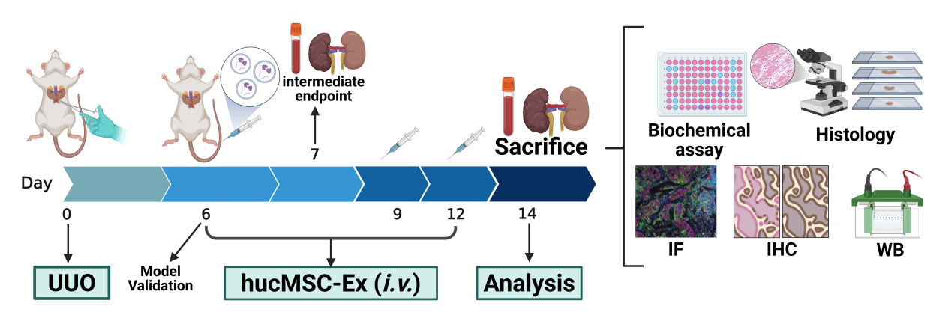
Additional file 1: Fig. S1. A schematic illustration of the hucMSC-Ex treatment experimental design.

Additional file 1: Fig. S2. Quantitative analysis of Western blot for α-SMA and HIF-1α expression.

Additional file 1: Fig. S3. Western blot quantitative analysis to detect HIF-1α expression in cytoplasm and nucleus

Additional file 1: Fig. S4. Western blot quantitative analysis was performed to detect the expression of α-SMA, collagen I and vimentin protein in renal lysate.

Additional file 1: Fig. S5. Western blot quantitative analysis of α-SMA and HIF-1α expression in the kidneys.

Additional file 1: Fig. S6. Western blot quantitative analysis was performed to detect the expression of HIF-1α in NRK-52E cells.

Additional file 1: Fig. S7. Western blot quantitative analysis of PHD2 and pVHL expression in the kidneys of UUO rats.

Additional file 1: Fig. S8. Western blot quantitative analysis of HIF-1α protein levels in NRK-52E cells treated with MG132 (25 μM).

Additional file 1: Fig. S9. Western blot quantitative analysis was performed to detect the expression of collagen Ⅰ, vimentin and α-SMA.

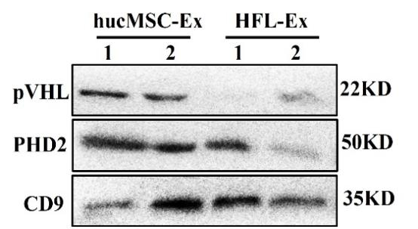
Additional file 1: Fig. S10. Western blot quantitative analysis was performed to detect the pVHL and PHD2 expression in hucMSC-Ex and HFL-Ex.

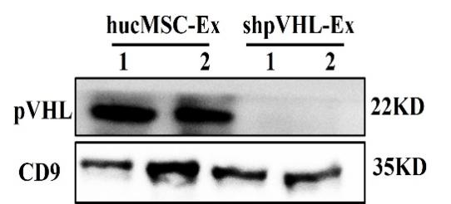
Additional file 1: Fig. S11. Western blot analysis was performed to detect the pVHL expression in hucMSC-Ex and shpVHL-Ex.

