Additional file 2
Testing period effects
Using the best fitting age terms from the pooled fractional polynomial models of alcohol intake across the life course (presented in Figure 3 of the main manuscript) we explored possible period effects by including an interaction term between age and period (broadly defined by the decade that each measurement occasion occurred in) to examine potential differences in alcohol intake across the life course at different time periods for men and women separately.

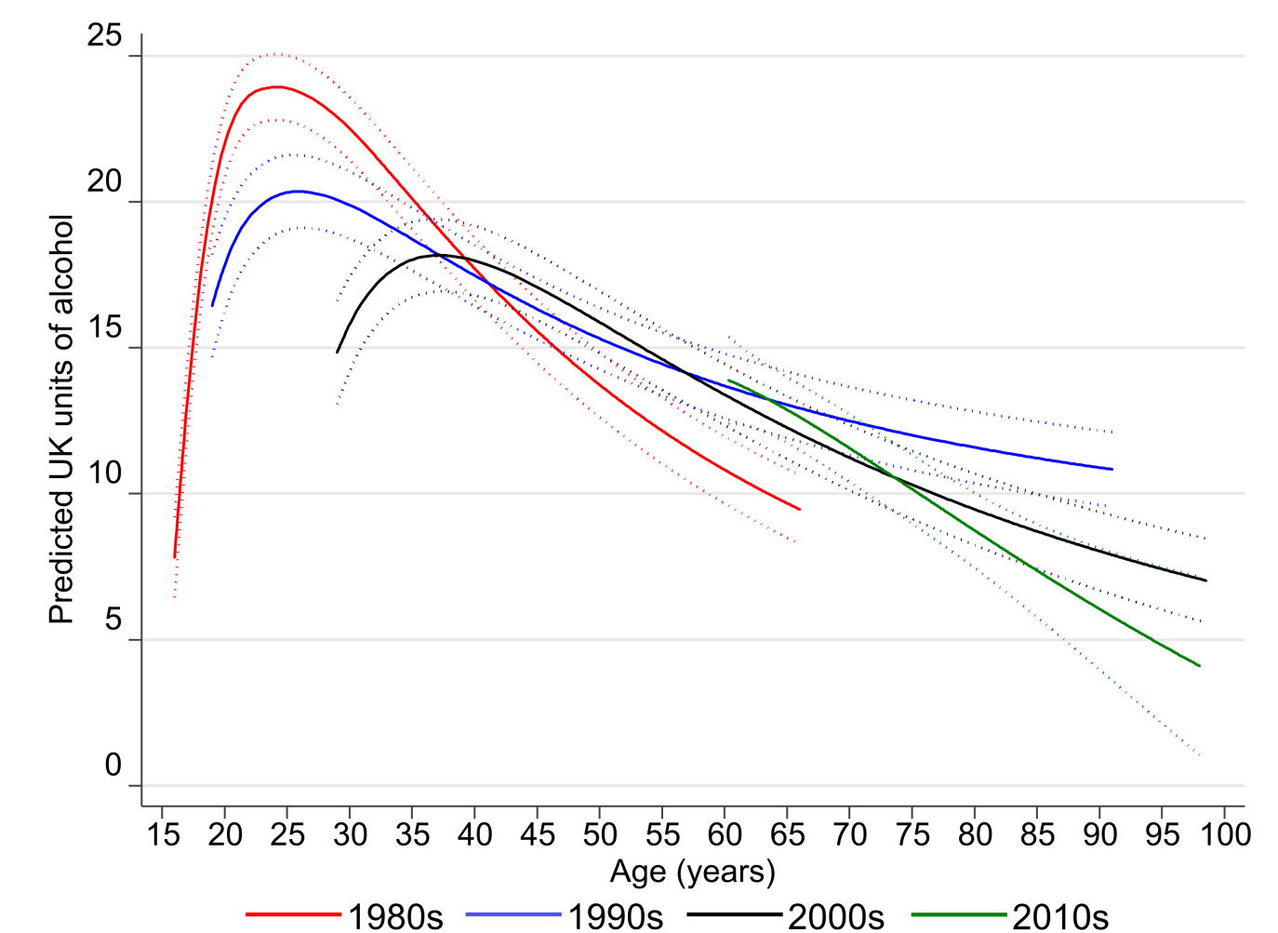
Figure 1 - Period effects of alcohol intake across the life course in men

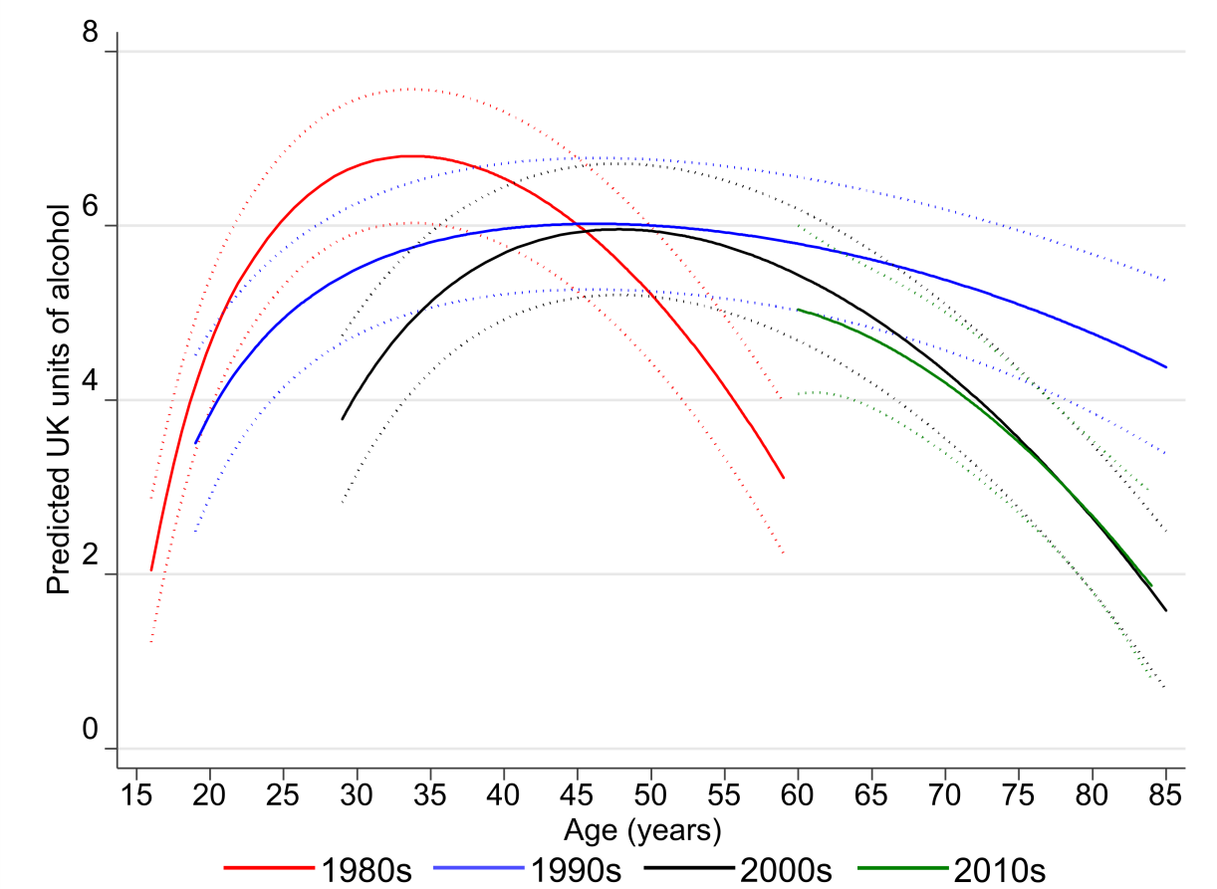
Figure 2 - Period effects of alcohol intake across the life course in women

