Additional file 10a: Results of automatic textual analysis for answers to open ended questions in French (n=690).
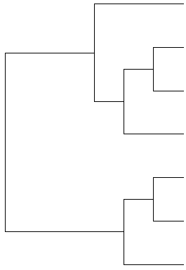 | Visits, tests and refills
 | Secondary effects
 | Medication management (mainly strategies not to forget)
 | Self monitoring
 | Accept condition and relationships with family
 | Lifestyle changes
 | Paperwork and reimbursments

Additional file 10b: Results of automatic textual analysis for answers to open ended questions in Spanish (n=42).
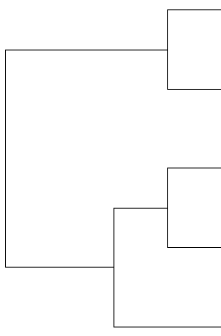 | Paperwork and reimbursements
 | Family support, professional impact
 | Doctor visits, planning organization
 | Tests and self monitoring
 | Medication management

