Results
Meta-analysis

- All immune related adverse events

  - Ipilimumab

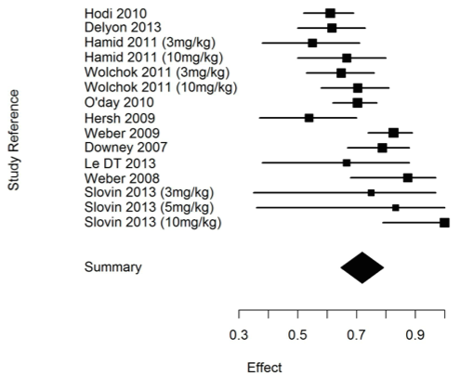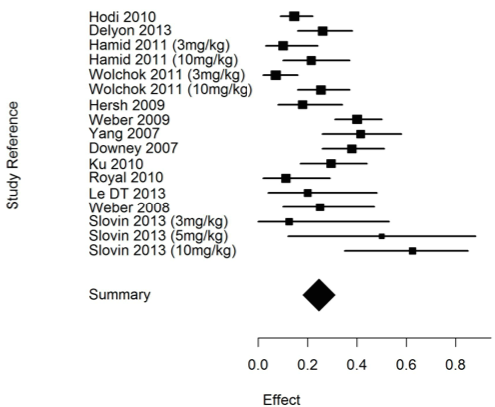
A
B

Figure 5 - Incidence of global irAEs with ipilimumab all dosage (3mg/kg, 10mg/kg, 5mg/kg), all-grade (A) and severe grade (B).

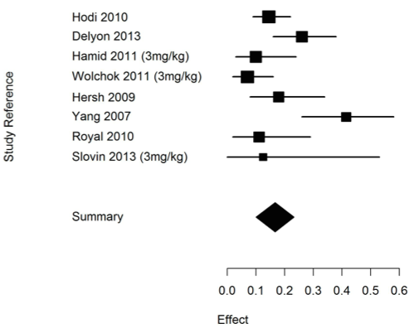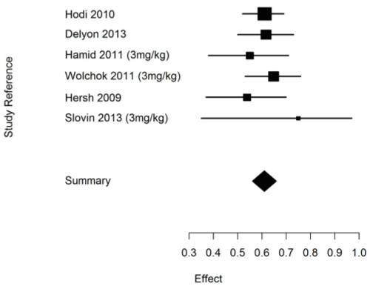
A
B

Figure 6 - Incidence of global irAEs with ipilimumab 3mg/kg, all-grade (A) and severe grade (B).
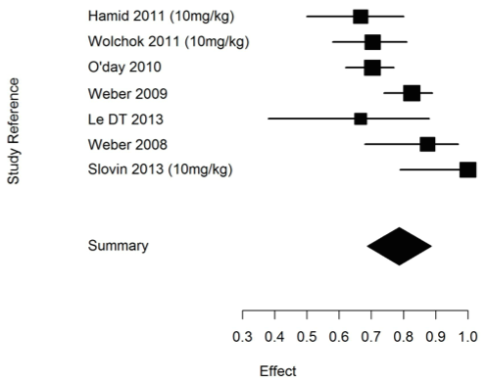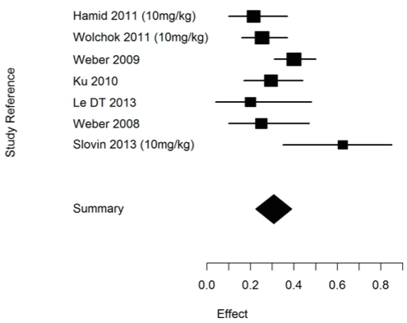
A
B

Figure 7 - Incidence of global irAEs with ipilimumab 10mg/kg, all-grade (A) and severe grade (B).

  - Tremelimumab

Only one study (Calabrò et al. 2013) reported global irAEs with tremelimumab treatment, at 15mg/kg dosage. A meta analysis was not possible in this group.

- Endocrinologic immune related adverse events

  - Anti-CTLA-4

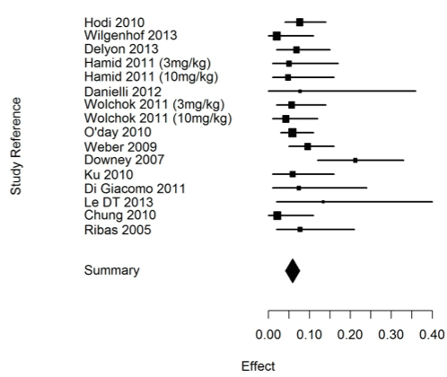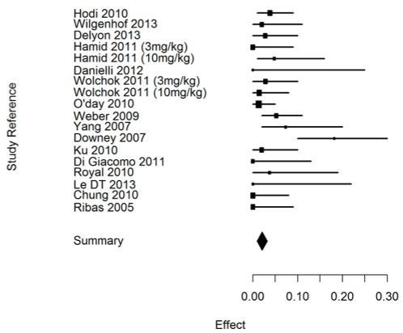
A
B

Figure 8 - Incidence of endocrinologic irAEs with anti-CTLA-4, all-grade (A) and severe grade (B).

  - Ipilimumab
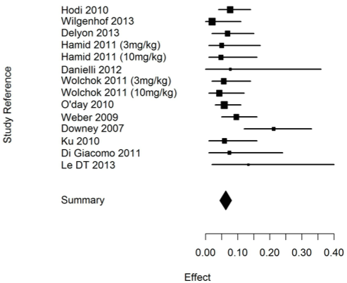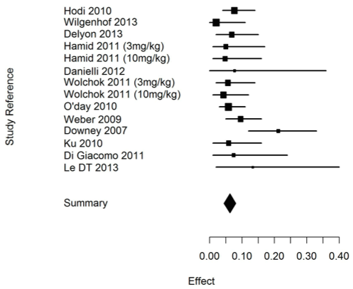
A
B

Figure 9 - Incidence of endocrinologic irAEs with ipilimumab all dosage, all-grade (A) and severe grade (B).

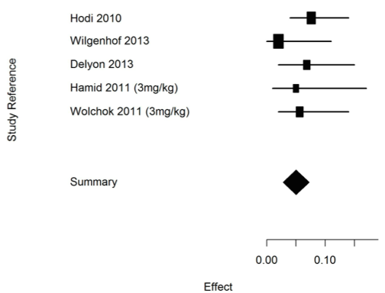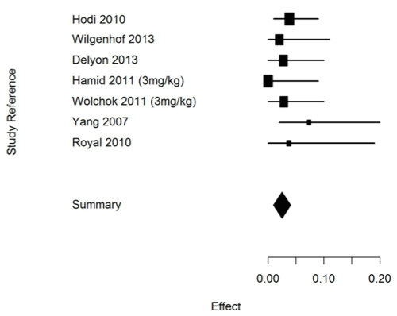
A
B

Figure 10 - Incidence of endocrinologic irAEs with ipilimumab 3mg/kg, all-grade (A) and severe grade (B).

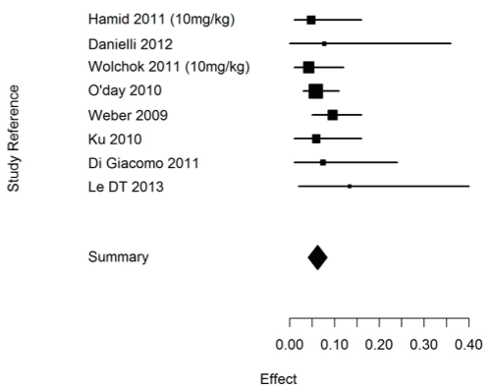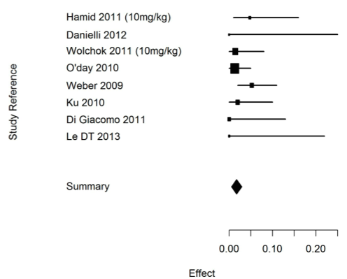
A
B
Figure 11 - Incidence of endocrinologic irAEs with ipilimumab 10mg/kg, all-grade (A) and severe grade (B).

  - Tremelimumab

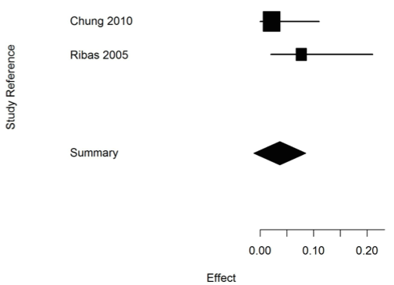

Figure 12 - Incidence of endocrinologic irAEs with tremelimumab, all-grade. Meta analysis was not possible for severe grade.

- Cutaneous immune related adverse events

  - Anti CTLA4

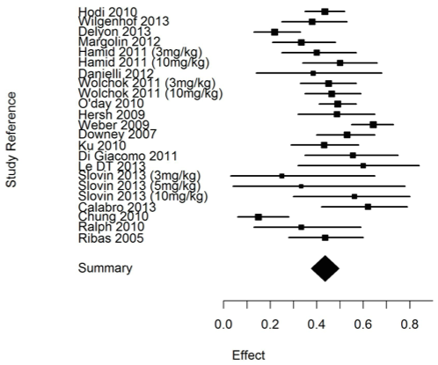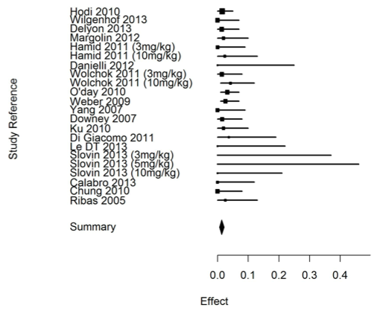
A
B

Figure 13 - Incidence of cutaneous irAEs with anti-CTLA-4, all-grade (A) and severe grade (B).

  - Ipilimumab
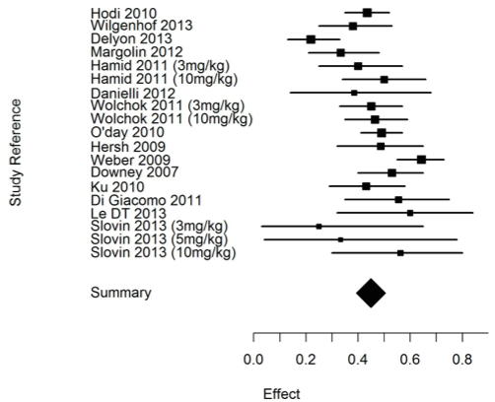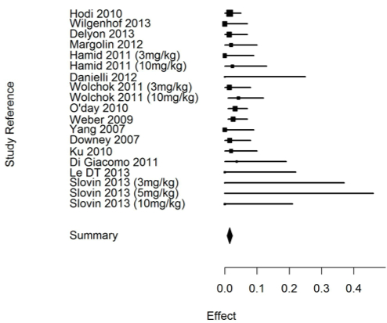
A
B

Figure 14 - Incidence of cutaneous irAEs with ipilimumab all dosage, all-grade (A) and severe grade (B).

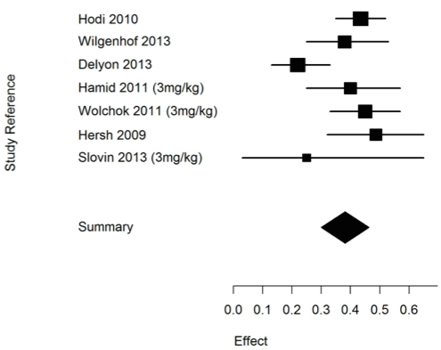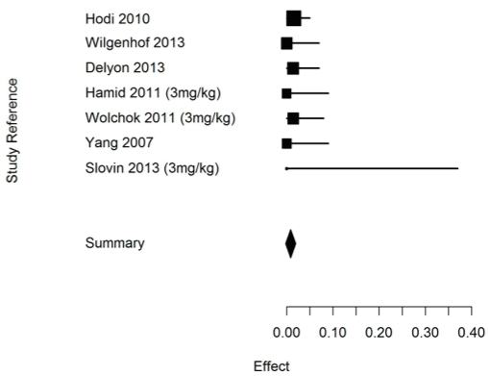
A
B

Figure 15 - Incidence of cutaneous irAEs with ipilimumab 3mg/kg, all-grade (A) and severe grade (B).

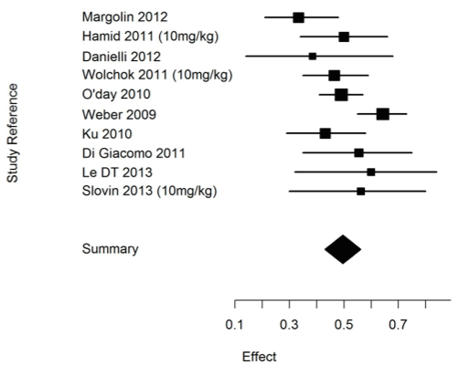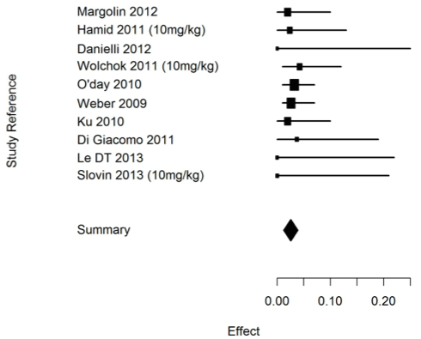
A
B

Figure 16 - Incidence of cutaneous irAEs with ipilimumab 10mg/kg, all-grade (A) and severe grade (B).

  - Tremelimumab

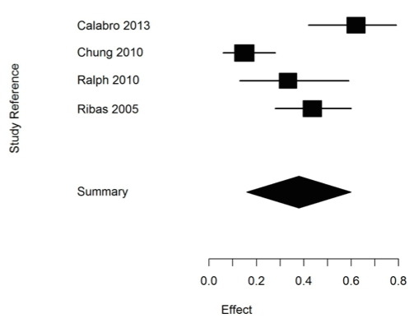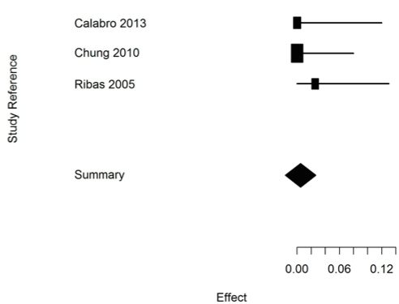
A
B

Figure 17 - Incidence of cutaneous irAEs with tremelimumab, all-grade (A) and severe grade (B).

- Gastro intestinal immune related adverse events

  - Anti CTLA4

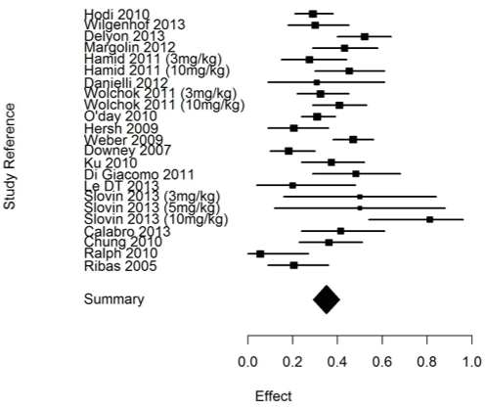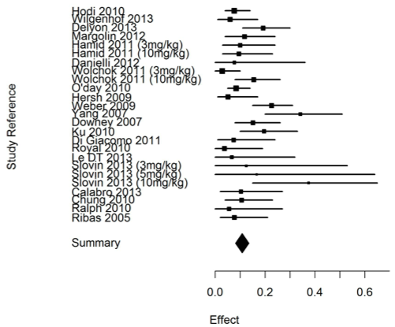
A
B

Figure 18 - Incidence of gastro intestinal irAEs with anti CTLA4, all-grade (A) and severe grade (B).

  - Ipilimumab

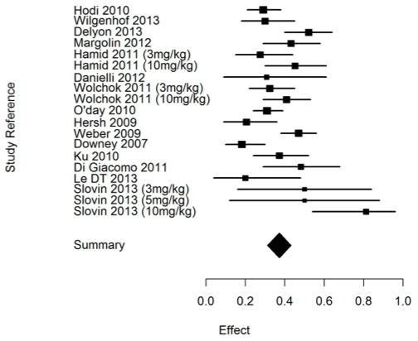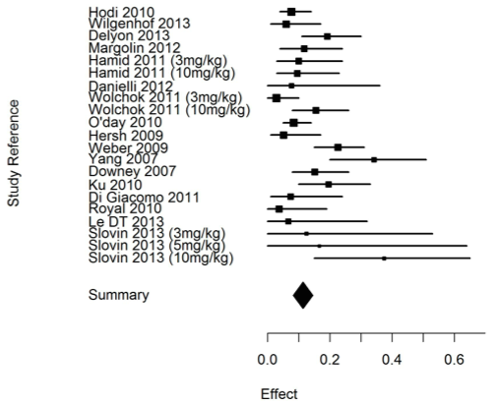
A
B

Figure 19 - Incidence of gastro intestinal irAEs with ipilimumab all dosage, all-grade (A) and severe grade (B).

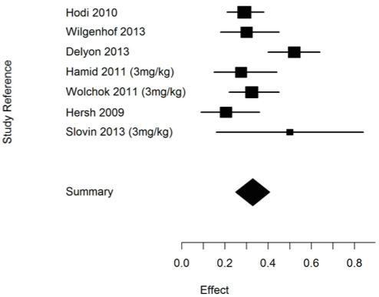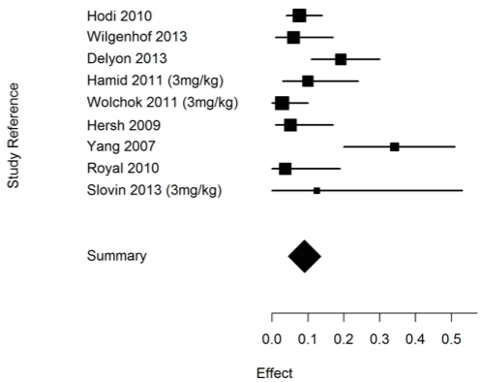
A
B

Figure 20 - Incidence of gastro intestinal irAEs with ipilimumab 3mg/kg, all-grade (A) and severe grade (B).

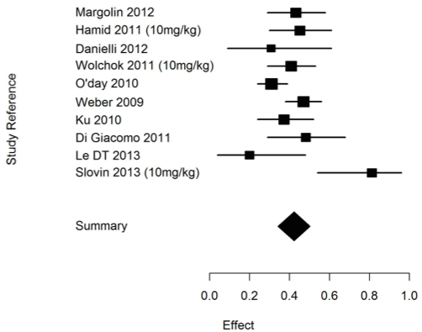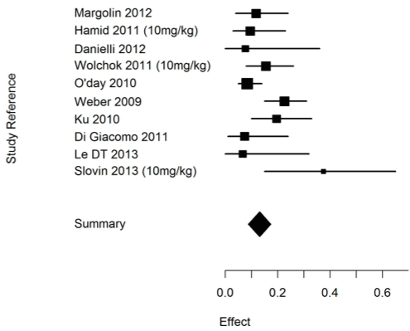
A
B

Figure 21 - Incidence of gastro intestinal irAEs with ipilimumab 10mg/kg, all-grade (A) and severe grade (B).

  - Tremelimumab

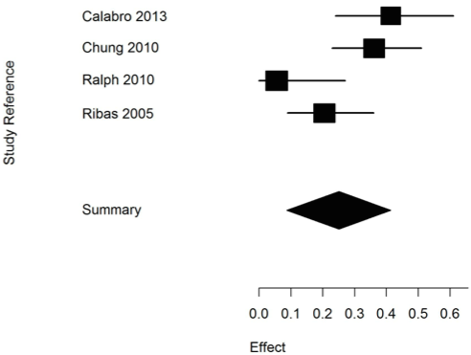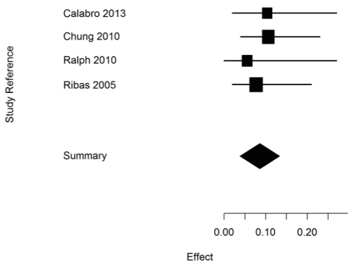
A
B

Figure 22 - Incidence of gastro intestinal irAEs with tremelimumab, all-grade (A) and severe grade (B).

- Hepatic immune related adverse events

  - Anti-CTLA-4

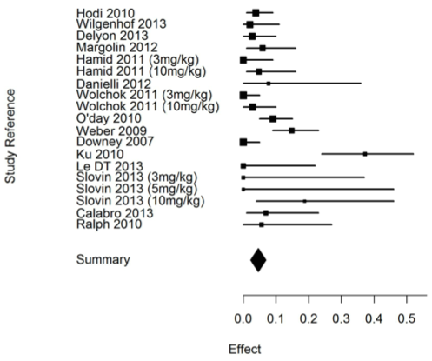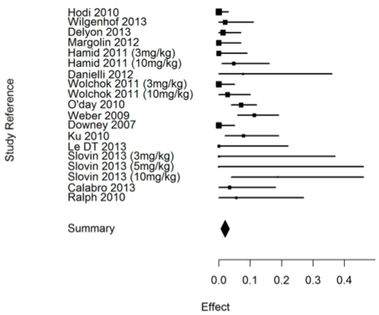
A
B

Figure 23 - Incidence of gastro intestinal irAEs with anti-CTLA-4, all-grade (A) and severe grade (B).

  - Ipilimumab
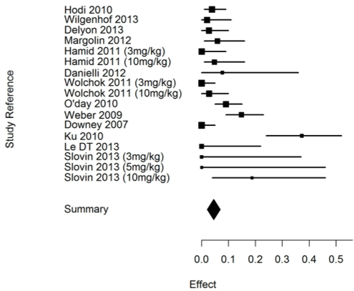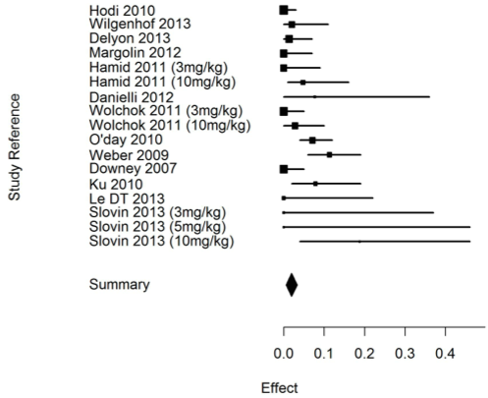
A
B

Figure 24 - Incidence of hepatic irAEs with ipilimumab all dosage, all-grade (A) and severe grade (B).

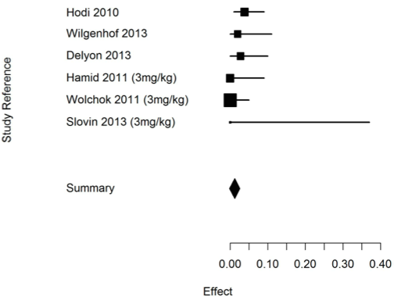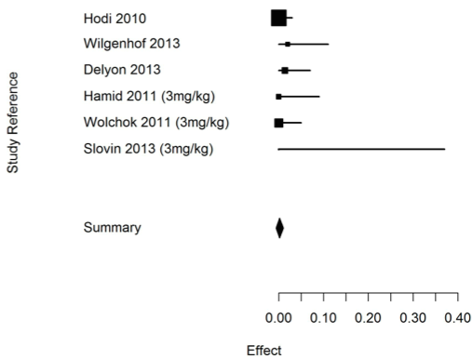
A
B

Figure 25 - Incidence of hepatic irAEs with ipilimumab 3mg/kg, all-grade (A) and severe grade (B).

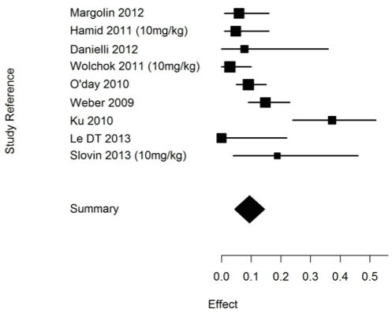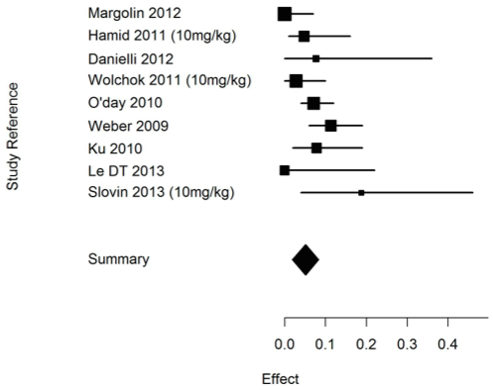
A
B

Figure 26 - Incidence of hepatic irAEs with ipilimumab 10mg/kg, all-grade (A) and severe grade (B).

  - Tremelimumab

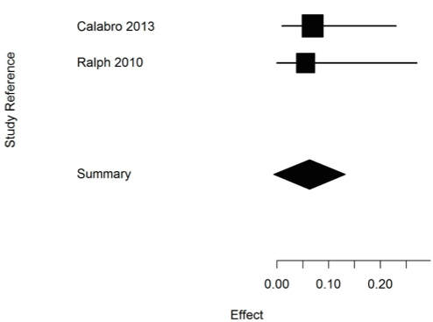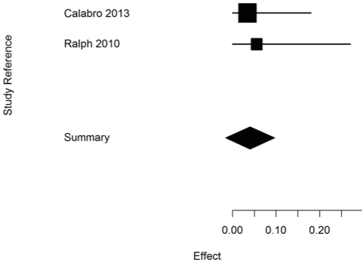
A
B

Figure 27 - Incidence of hepatic irAEs with tremelimumab, all-grade (A) and severe grade (B).

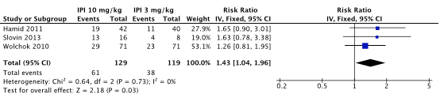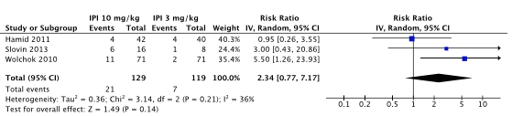
B
A

Figure 28 –Risk ratio of developing a gastro intestinal irAE with ipilimumab at 10mg/kg comparing with 3mg/kg for gastro intestinal irAEs all grade (A) and high grade (B).

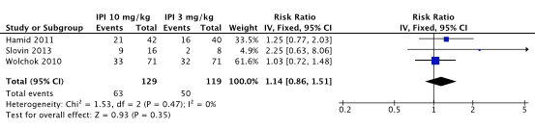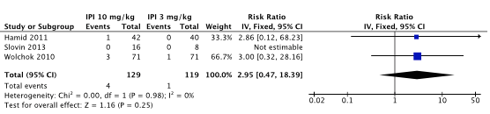
A
B

Figure 29 - Risk ratio of developing a cutaneous irAE with ipilimumab at 10mg/kg comparing with 3mg/kg for cutaneous irAEs all grade (A) and high grade (B).

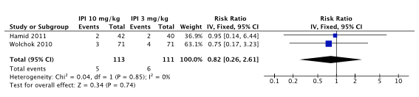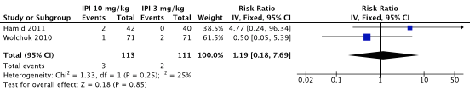
A
B

Figure 30 – Risk ratio of developing an endocrine irAE with ipilimumab at 10mg/kg comparing with 3mg/kg for endocrine irAEs all grade (A) and high grade (B).

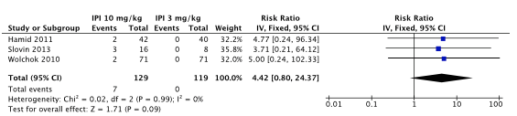

Figure 31 - Risk ratio of developing a hepatic irAE with ipilimumab at 10mg/kg comparing with 3mg/kg for hepatic irAEs all grade (which are all high grade).

Systematic review

Table 2 - General characteristics of patients receiving anti-CTLA-4 antibodies described in case reports
Table 3 - Organ specific irAEs.

Quality assessment

Table 4 - Quality assessment - + low risk of bias, - high risk of bias, ? uncertain risk of bias, n/a not applicable.

