Online Only Tables and Figure Legends
Response and Survival of the Breast Cancer Intrinsic Subtypes following Multi-Agent Neoadjuvant Chemotherapy

Tables
Table S1. Cox model DRFS analyses including intrinsic subtype in all patients from the MDACC-based cohort (GSE25066).
Table S2. Cox model DRFS analyses including ROR-P in all patients from the MDACC-based cohort (GSE25066).
Table S3. Cox model DRFS analyses including intrinsic subtype in patients that achieved a pCR from the MDACC-based cohort (GSE25066).
Table S4. Cox model DRFS analyses including ROR-P in patients that achieved a pCR from the MDACC-based cohort (GSE25066).
Table S5. Cox model DRFS analyses including ROR-P in patients with residual disease from the MDACC-based cohort (GSE25066).
Table S6. Distribution of the PAM50 subtypes within the TNBCtype groups and viceversa.
Table S7. Association of the TNBCtype subtypes with chemotherapy response in triple-negative breast cancer.

Figures
Figure S1. CONSORT diagram of the various cohorts evaluated in this study.
Figure S2. Kaplan-Meier distant relapse-free survival analysis in MDACC-based (GSE25066¹³) dataset set. (A) Survival outcomes of the ROR-P groups in all patients. (B) Survival outcomes of the ROR-P groups in patients with clinically node-negative disease.
Figure S3. Levels of ESR1 across TNBCtype ESR1-low group, TNBCtype ESR1-high group and ER-positive group. Median expression of ESR1 in the PAM50 training dataset reported in Parker et al. has been set to zero.
Figure S4. Distribution of the TNBCtype subtypes and ESR1-high group within the PAM50 subtypes in TNBC.
Figure S5. Distribution of the TNBCtype subtypes and ESR1-high group within the PAM50+Claudin-low subtypes in TNBC.
Figure S6. Training and testing gene expression-based models predictive of pCR in all patients.
Figure S7. Training and testing gene expression-based models predictive of pCR in patients with Basal-like disease.
Figure S8. Training and testing gene expression-based models predictive of pCR in patients with luminal (A+B) disease.

Table S1. Cox model DRFS analyses including intrinsic subtype in all patients from the MDACC-based cohort (GSE25066).

 |  |  |  |  | Univariate Analysis |  |  |  |  | Multivariable Analysis
Variables | N | % | 5-yr DRFS |  | HR | Lower 95% | Upper 95% | p-value |  | HR | Lower 95% | Upper 95% | p-value
Age (cont. variable) | - | - | - |  | 1.0 | 0.98 | 1.02 | 0.860 |  | 0.98 | 0.97 | 1.00 | 0.120
Tumor size
T0-T2 | 288 | 57% | 76% |  | 1.0 | - | - | - |  | 1.0 | - | - | -
T3-T4 | 220 | 43% | 68% |  | 1.8 | 1.23 | 2.60 | 0.002 |  | 1.4 | 1.12 | 1.84 | 0.004
Node status
N0 | 157 | 31% | 86% |  | 1.0 | - | - | - |  | 1.0 | - | - | -
N1-3 | 351 | 69% | 66% |  | 2.9 | 1.74 | 4.91 | <0.001 |  | 3.1 | 1.70 | 5.59 | <0.001
ER IHC
Positive | 297 | 59% | 80% |  | 1.0 | - | - | - |  | 1.0 | - | - | -
Negative | 205 | 41% | 61% |  | 2.9 | 1.97 | 4.27 | <0.001 |  | 1.7 | 0.87 | 3.46 | 0.110
PR IHC
Positive | 243 | 49% | 81% |  | 1.0 | - | - | - |  | 1.0 | - | - | -
Negative | 258 | 51% | 64% |  | 2.6 | 1.75 | 3.96 | <0.001 |  | 1.2 | 0.68 | 2.25 | 0.490
HER2 STATUS
Negative | 485 | 99% | 72% |  | 1.0 | - | - | - |  | 1.0 | - | - | -
Positive | 6 | 1% | 67% |  | 1.8 | 0.43 | 7.13 | 0.430 |  | 0.5 | 0.06 | 3.40 | 0.440
Histological Grade
1 | 32 | 7% | 97% |  | 1.0 | - | - | - |  | 1.0 | - | - | -
2 | 180 | 38% | 74% |  | 7.0 | 0.96 | 51.23 | 0.055 |  | 2.79 | 0.37 | 21.22 | 0.32
3 | 259 | 55% | 69% |  | 9.5 | 1.31 | 68.25 | 0.026 |  | 2.58 | 0.33 | 20.01 | 0.36
PAM50
Luminal A | 155 | 33% | 81% |  | 1.0 | - | - | - |  | 1.0 | - | - | -
Luminal B | 109 | 23% | 78% |  | 1.4 | 0.71 | 2.64 | 0.344 |  | 1.4 | 0.67 | 2.76 | 0.390
HER2-E | 40 | 8% | 58% |  | 3.4 | 1.69 | 6.75 | 0.001 |  | 2.7 | 1.15 | 6.24 | 0.022
Basal-like | 171 | 36% | 63% |  | 3.5 | 2.09 | 5.94 | <0.001 |  | 2.6 | 1.11 | 5.98 | 0.027
pCR
No | 389 | 80% | 92% |  | 1.0 | - | - | - |  | 1.0 | - | - | -
Yes | 99 | 20% | 68% |  | 0.3 | 0.12 | 0.55 | 0.001 |  | 0.11 | 0.04 | 0.27 | <0.001

Table S2. Cox model DRFS analyses including ROR-P in all patients from the MDACC-based cohort (GSE25066).
 |  |  |  |  | Univariable Analysis |  |  |  |  | Multivariable Analysis
Variables | N | % | 5-yr DRFS |  | HR | Lower 95% | Upper 95% | p-value |  | HR | Lower 95% | Upper 95% | p-value
Age (cont. variable) | - | - | - |  | 1.0 | 0.98 | 1.02 | 0.860 |  | 1.00 | 0.97 | 1.01 | 0.170
Tumor size
T0-T2 | 288 | 57% | 76% |  | 1.0 | - | - | - |  | 1.0 | - | - | -
T3-T4 | 220 | 43% | 68% |  | 1.8 | 1.23 | 2.60 | 0.002 |  | 1.3 | 1.03 | 1.65 | 0.030
Node status
N0 | 157 | 31% | 86% |  | 1.0 | - | - | - |  | 1.0 | - | - | -
N1-3 | 351 | 69% | 66% |  | 2.9 | 1.74 | 4.91 | <0.001 |  | 2.9 | 1.62 | 5.11 | <0.001
ER IHC
Positive | 297 | 59% | 80% |  | 1.0 | - | - | - |  | 1.0 | - | - | -
Negative | 205 | 41% | 61% |  | 2.9 | 1.97 | 4.27 | <0.001 |  | 2.6 | 1.47 | 4.49 | 0.001
PR IHC
Positive | 243 | 49% | 81% |  | 1.0 | - | - | - |  | 1.0 | - | - | -
Negative | 258 | 51% | 64% |  | 2.6 | 1.75 | 3.96 | <0.001 |  | 1.3 | 0.73 | 2.28 | 0.372
HER2 STATUS
Negative | 485 | 99% | 72% |  | 1.0 | - | - | - |  | 1.0 | - | - | -
Positive | 6 | 1% | 67% |  | 1.8 | 0.43 | 7.13 | 0.430 |  | 0.4 | 0.06 | 3.18 | 0.406
Histological Grade
1 | 32 | 7% | 97% |  | 1.0 | - | - | - |  | 1.0 | - | - | -
2 | 180 | 38% | 74% |  | 7.0 | 0.96 | 51.23 | 0.055 |  | 3.27 | 0.44 | 24.45 | 0.25
3 | 259 | 55% | 69% |  | 9.5 | 1.31 | 68.25 | 0.026 |  | 2.74 | 0.37 | 20.55 | 0.33
ROR-P
Low | 80 | 21% | 92% |  | 1.0 | - | - | - |  | 1.0 | - | - | -
Med | 206 | 53% | 68% |  | 4.8 | 1.92 | 12.06 | <0.001 |  | 2.8 | 1.07 | 7.15 | 0.037
High | 103 | 26% | 48% |  | 10.0 | 3.95 | 25.15 | <0.001 |  | 4.4 | 1.65 | 11.66 | 0.003
pCR
No | 389 | 80% | 92% |  | 1.0 | - | - | - |  | 1.0 | - | - | -
Yes | 99 | 20% | 68% |  | 0.3 | 0.12 | 0.55 | 0.001 |  | 0.1 | 0.05 | 0.28 | <0.001

Table S3. Cox model DRFS analyses including intrinsic subtype in patients that achieved a pCR from the MDACC-based cohort (GSE25066).

 |  |  |  |  | Univariable Analysis
Variables | N | % | 5-yr DRFS |  | HR | Lower 95% | Upper 95% | p-value
Age (cont. variable) | - | - | - |  | 1.0 | 0.91 | 1.08 | 0.880
Tumor size
T0-T2 | 58 | 59% | 90% |  | 1.0 | - | - | -
T3-T4 | 41 | 41% | 95% |  | 0.6 | 0.11 | 2.88 | 0.486
Node status
N0 | 28 | 28% | 96% |  | 1.0 | - | - | -
N1-3 | 71 | 72% | 91% |  | 2.5 | 0.30 | 20.49 | 0.403
ER IHC
Positive | 30 | 31% | 100% |  | 1.0 | - | - | -
Negative | 68 | 69% | 90% |  | - | 0.00 | Inf | 0.999
PR IHC
Positive | 26 | 27% | 100% |  | 1.0 | - | - | -
Negative | 72 | 73% | 90% |  | - | 0.00 | Inf | 0.999
HER2 STATUS
Negative | 93 | 98% | 93% |  | 1.0 | - | - | -
Positive | 2 | 2% | 100% |  | - | 0.00 | Inf | 0.999
Histological Grade
1 | 1 | 1% | 100% |  | 1.0 | - | - | -
2 | 12 | 13% | 100% |  | - | 0.00 | Inf | 0.999
3 | 77 | 86% | 92% |  | - | 0.00 | Inf | 0.999
PAM50
Luminal A | 4 | 4% | 100% |  | 1.0 | - | - | -
Luminal B | 16 | 17% | 100% |  | - | 0.00 | Inf | 0.999
HER2-E | 9 | 10% | 100% |  | - | 0.00 | Inf | 0.999
Basal-like | 64 | 69% | 88% |  | - | 0.00 | Inf | 0.999

Table S4. Cox model DRFS analyses including ROR-P in patients that achieved a pCR from the MDACC-based cohort (GSE25066).

 |  |  |  |  | Univariable Analysis
Variables | N | % | 5-yr DRFS |  | HR | Lower 95% | Upper 95% | p-value
Age (cont. variable) | - | - | - |  | 1.0 | 0.91 | 1.08 | 0.880
Tumor size
T0-T2 | 58 | 59% | 90% |  | 1.0 | - | - | -
T3-T4 | 41 | 41% | 95% |  | 0.6 | 0.11 | 2.88 | 0.486
Node status
N0 | 28 | 28% | 96% |  | 1.0 | - | - | -
N1-3 | 71 | 72% | 91% |  | 2.5 | 0.30 | 20.49 | 0.403
ER IHC
Positive | 30 | 31% | 100% |  | 1.0 | - | - | -
Negative | 68 | 69% | 90% |  | - | 0.00 | Inf | 0.999
PR IHC
Positive | 26 | 27% | 100% |  | 1.0 | - | - | -
Negative | 72 | 73% | 90% |  | - | 0.00 | Inf | 0.999
HER2 STATUS
Negative | 93 | 98% | 93% |  | 1.0 | - | - | -
Positive | 2 | 2% | 100% |  | - | 0.00 | Inf | 0.999
Histological Grade
1 | 1 | 1% | 100% |  | 1.0 | - | - | -
2 | 12 | 13% | 100% |  | - | 0.00 | Inf | 0.999
3 | 77 | 86% | 92% |  | - | 0.00 | Inf | 0.999
ROR-P
Low | 6 | 6% | - |  | 1.0 | - | - | -
Med | 50 | 51% | 91% |  | - | 0.00 | Inf | 0.999
High | 43 | 43% | 92% |  | - | 0.00 | Inf | 0.999

Table S5. Cox model DRFS analyses including ROR-P in patients with residual disease from the MDACC-based cohort (GSE25066).

 |  |  |  |  | Univariable Analysis |  |  |  |  | Multivariable Analysis
Variables | N | % | 5-yr DRFS |  | HR | Lower 95% | Upper 95% | p-value |  | HR | Lower 95% | Upper 95% | p-value
Age (cont. variable) | - | - | - |  | 1.0 | 0.98 | 1.01 | 0.590 |  | 0.99 | 0.97 | 1.01 | 0.186
Tumor size
T0-T2 | 216 | 56% | 74% |  | 1.0 | - | - | - |  | 1.0 | - | - | -
T3-T4 | 173 | 44% | 61% |  | 2.1 | 1.38 | 3.07 | <0.001 |  | 1.3 | 1.05 | 1.71 | 0.018
Node status
N0 | 126 | 32% | 85% |  | 1.0 | - | - | - |  | 1.0 | - | - | -
N1-3 | 263 | 68% | 66% |  | 3.3 | 1.90 | 5.71 | <0.001 |  | 2.7 | 1.54 | 4.90 | <0.001
ER IHC
Positive | 129 | 34% | 78% |  | 1.0 | - | - | - |  | 1.0 | - | - | -
Negative | 255 | 66% | 47% |  | 4.0 | 2.69 | 6.02 | <0.001 |  | 2.6 | 1.47 | 4.61 | 0.001
PR IHC
Positive | 175 | 46% | 79% |  | 1.0 | - | - | - |  | 1.0 | - | - | -
Negative | 208 | 54% | 54% |  | 3.3 | 2.15 | 5.05 | <0.001 |  | 1.2 | 0.67 | 2.15 | 0.539
HER2 STATUS
Negative | 373 | 99% | 68% |  | 1.0 | - | - | - |  | 1.0 | - | - | -
Positive | 3 | 1% | NA |  | 1.1 | 0.16 | 8.16 | 0.900 |  | 0.4 | 0.06 | 3.26 | 0.419
Histological Grade
1 | 28 | 8% | 96% |  | 1.0 | - | - | - |  | 1.0 | - | - | -
2 | 160 | 44% | 73% |  | 6.1 | 0.83 | 44.43 | 0.076 |  | 3.26 | 0.43 | 24.43 | 0.25
3 | 175 | 48% | 60% |  | 10.9 | 1.51 | 78.73 | 0.018 |  | 2.70 | 0.36 | 20.29 | 0.33
ROR-P
Low | 80 | 21% | 92% |  | 1.0 | - | - | - |  | 1.0 | - | - | -
Med | 206 | 53% | 68% |  | 4.8 | 1.92 | 12.06 | <0.001 |  | 2.7 | 1.05 | 7.10 | 0.039
High | 103 | 26% | 48% |  | 10.0 | 3.95 | 25.15 | <0.001 |  | 4.6 | 1.71 | 12.22 | 0.003

Table S6. Logistic regression model analyses of chemotherapy response in the combined cohort (except Horak et al.).
 |  |  |  | Univariate Analysis |  |  |  |  |  | Multivariate Analysis
Signatures | N | pCR rate |  | OR | Lower 95% | Upper 95% | p-value | aROC |  | OR | Lower 95% | Upper 95% | p-value | aROC
Age (cont. variable) | - | - |  | 1.0 | 0.97 | 1.01 | 0.375 | 0.521 |  | 1.00 | 0.97 | 1.02 | 0.749 | 0.786
Tumor size |  |  |  |  |  |  |  |  |  |  |  |  |  | 0.786
T0-T2 | 392 | 23% |  | 1.0 | - | - | - | 0.529 |  | 1.0 | - | - | - | 0.786
T3-T4 | 264 | 19% |  | 0.8 | 0.53 | 1.15 | 0.207 | 0.529 |  | 0.6 | 0.50 | 0.30 | 0.807 | 0.786
ER IHC |  |  |  |  |  |  |  |  |  |  |  |  |  | 0.786
Positive | 386 | 12% |  | 1.0 | - | - | - | 0.678 |  | 1.0 | - | - | - | 0.786
Negative | 263 | 37% |  | 4.4 | 2.97 | 6.60 | <0.001 | 0.678 |  | 1.3 | 0.61 | 2.58 | 0.533 | 0.786
PR IHC |  |  |  |  |  |  |  |  |  |  |  |  |  | 0.786
Positive | 299 | 12% |  | 1.0 | - | - | - | 0.638 |  | 1.0 | - | - | - | 0.786
Negative | 349 | 31% |  | 3.3 | 2.19 | 5.07 | <0.001 | 0.638 |  | 0.8 | 0.40 | 1.51 | 0.463 | 0.786
HER2 STATUS |  |  |  |  |  |  |  |  |  |  |  |  |  | 0.786
Negative | 570 | 20% |  | 1.0 | - | - | - | 0.551 |  | 1.0 | - | - | - | 0.786
Positive | 64 | 39% |  | 2.6 | 1.51 | 4.46 | 0.001 | 0.551 |  | 2.1 | 0.90 | 4.88 | 0.087 | 0.786
GRADE |  |  |  |  |  |  |  |  |  |  |  |  |  | 0.786
Grade 1 | 46 | 7% |  | 1.0 | - | - | - | 0.656 |  | 1.0 | - | - | - | 0.786
Grade 2 | 277 | 13% |  | 2.1 | 0.61 | 7.04 | 0.243 | 0.656 |  | 0.7 | 0.17 | 2.85 | 0.617 | 0.786
Grade 3 | 299 | 32% |  | 6.8 | 2.05 | 22.40 | 0.002 | 0.656 |  | 1.5 | 0.35 | 6.50 | 0.578 | 0.786
PAM50 |  |  |  |  |  |  |  |  |  |  |  |  |  | 0.786
Luminal A | 195 | 4% |  | 1.0 | - | - | - | 0.736 |  | 1.0 | - | - | - | 0.786
Luminal B | 138 | 16% |  | 5.1 | 2.11 | 12.30 | <0.001 | 0.736 |  | 4.5 | 1.71 | 11.75 | 0.002 | 0.786
HER2-E | 74 | 34% |  | 13.7 | 5.60 | 33.54 | <0.001 | 0.736 |  | 8.3 | 2.74 | 24.85 | <0.001 | 0.786
Basal-like | 198 | 39% |  | 17.1 | 7.63 | 38.29 | <0.001 | 0.736 |  | 13.2 | 4.50 | 38.50 | <0.001 | 0.786
Normal-like | 52 | 23% |  | 8.1 | 2.99 | 21.74 | <0.001 | 0.736 |  | - | - | - | - | 0.786
STUDY |  |  |  |  |  |  |  |  |  |  |  |  |  | 0.786
MDACC508 | 488 | 20% |  | 1.0 | - | - | - | 0.536 |  | 1.0 | - | - | - | 0.786
ISPY | 54 | 31% |  | 1.8 | 0.98 | 3.34 | 0.060 | 0.536 |  | 1.7 | 0.63 | 4.37 | 0.301 | 0.786
MIYAKE | 115 | 23% |  | 1.2 | 0.74 | 1.96 | 0.449 | 0.536 |  | 1.5 | 0.75 | 3.12 | 0.238 | 0.786

*OR, odds ratio; aROC, area under the receiver operating curve.

Table S7. Pathological complete response (pCR) rates of the PAM50+Claudin-low subtype classification*. (A) Within patients with triple-negative disease and (B) within all patients.

A
 | RD | % | pCR | % | Total
Luminal A | 9 | 75.0% | 3 | 25.0% | 12
Luminal B | 7 | 100.0% | 0 | 0.0% | 7
Basal-like | 119 | 64.3% | 66 | 35.7% | 185
HER2-E | 16 | 57.1% | 12 | 42.9% | 28
Normal-like | 12 | 60.0% | 8 | 40.0% | 20
Claudin-low | 43 | 57.3% | 32 | 42.7% | 75

B
 | RD | % | pCR | % | Total
Luminal A | 248 | 94.7% | 14 | 5.3% | 262
Luminal B | 140 | 84.3% | 26 | 15.7% | 166
Basal-like | 148 | 62.4% | 89 | 37.6% | 237
HER2-E | 56 | 65.1% | 30 | 34.9% | 86
Normal-like | 35 | 71.4% | 14 | 28.6% | 49
Claudin-low | 71 | 64.5% | 39 | 35.5% | 110

*RD, residual disease.

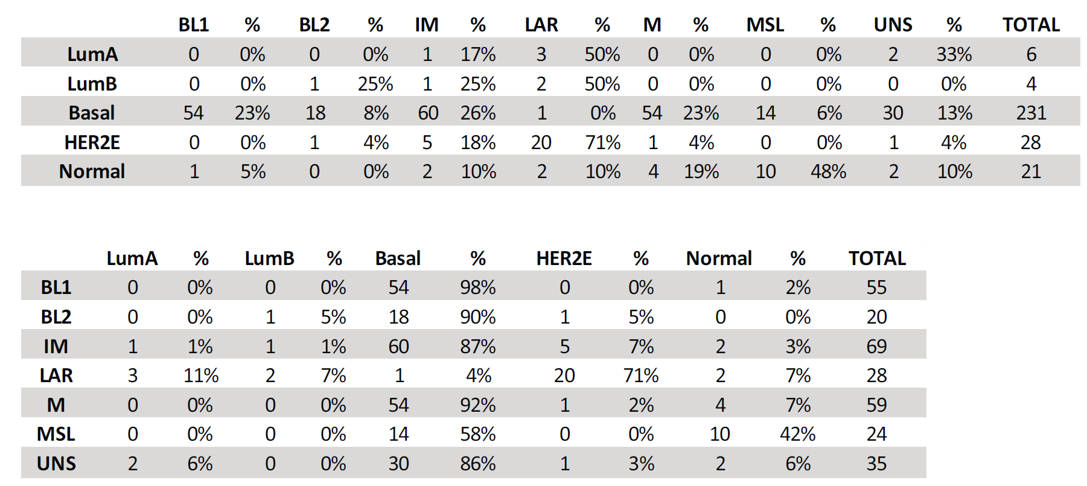
Table S8. Distribution of the PAM50 subtypes within the TNBCtype groups and vice versa*.

*HER2E, HER2-enriched; BL1, Basal 1; BL2, Basal 2; IM, immunomodulatory; LAR, luminal androgen receptor; M, mesenchymal; MSL, mesenchymal stem cell; UNS, unstable.

Table S9. Association of the TNBCtype subtypes with chemotherapy response in triple-negative breast cancer.
 | HR-/HER2- (TN)
 | N | % |  | pCR | % | RD | % |  | Adjusted P-value*
BL1 | 54 | 20% |  | 25 | 46% | 29 | 54% |  | 0.140
BL2 | 18 | 7% |  | 5 | 28% | 13 | 72% |  | 0.140
IM | 67 | 25% |  | 25 | 37% | 42 | 63% |  | 0.140
M | 50 | 18% |  | 18 | 36% | 32 | 64% |  | 0.140
LAR | 27 | 10% |  | 10 | 37% | 17 | 63% |  | 0.140
MSL | 22 | 8% |  | 10 | 45% | 12 | 55% |  | 0.140
UNS | 33 | 12% |  | 15 | 45% | 18 | 55% |  | 0.140

*, Likelihood ratio test: adjusting clinical features: age, clinical stage, clinical nodal status and study cohort. In the model, TNBCtype subtype was used as categorical variable.

Figure S1
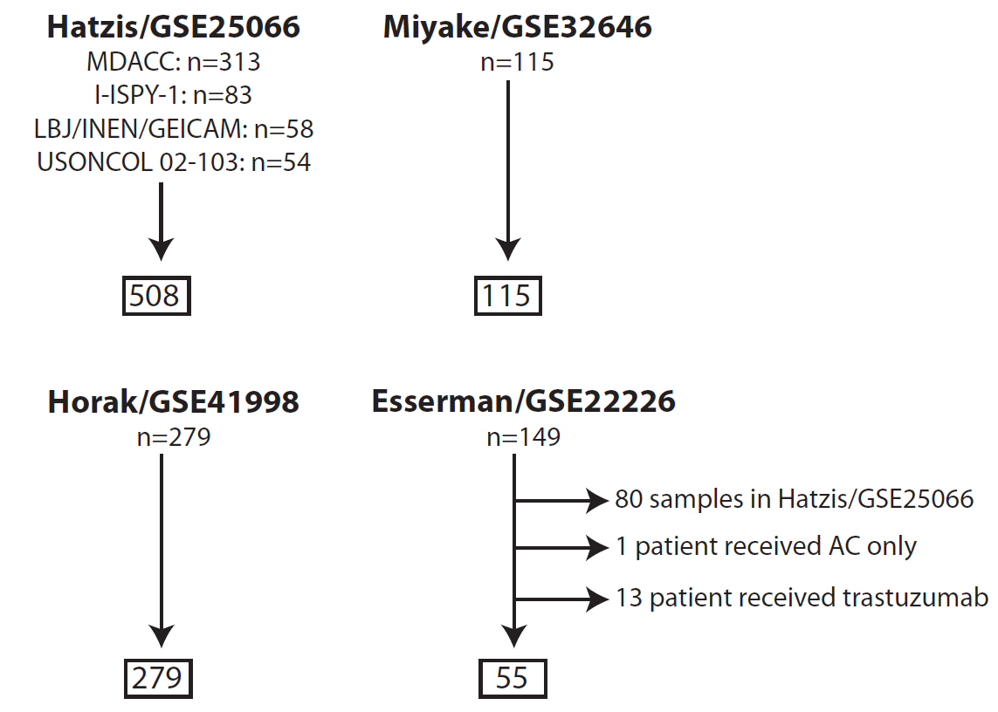

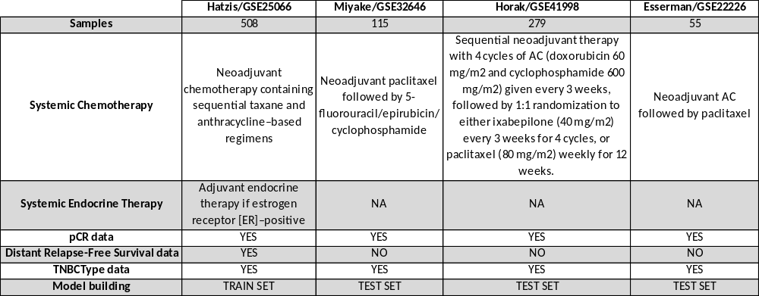

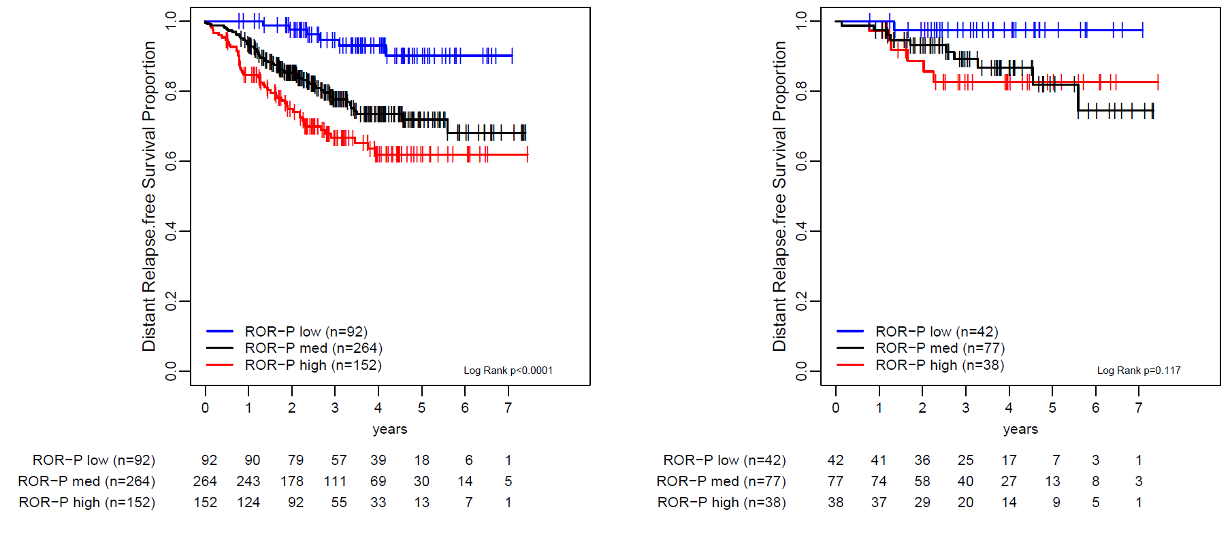
Figure S2

Figure S3
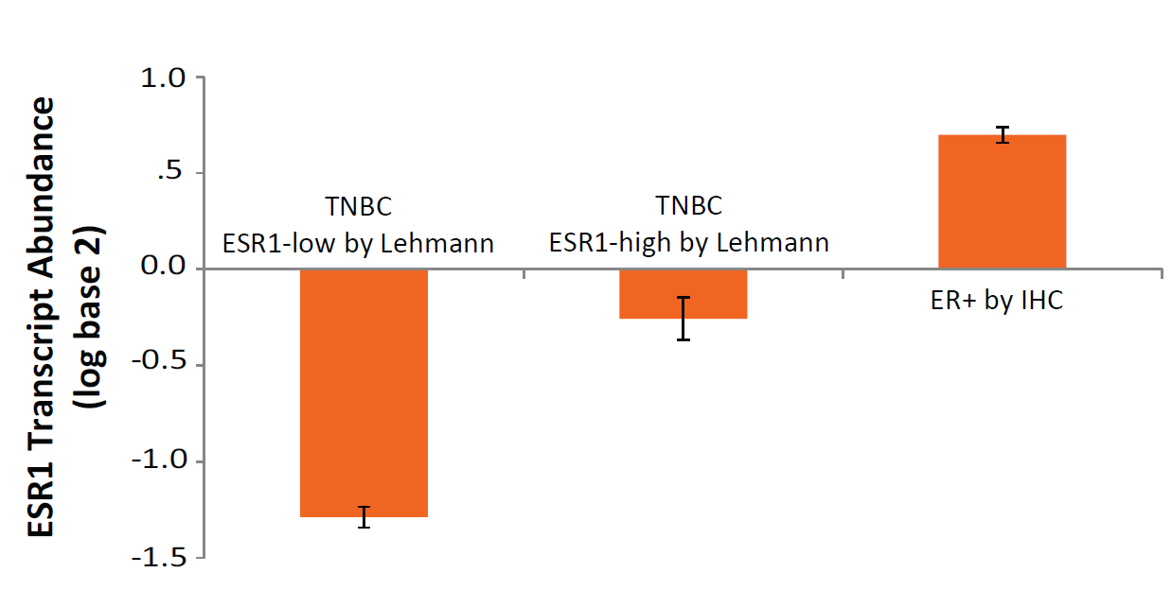

Figure S4
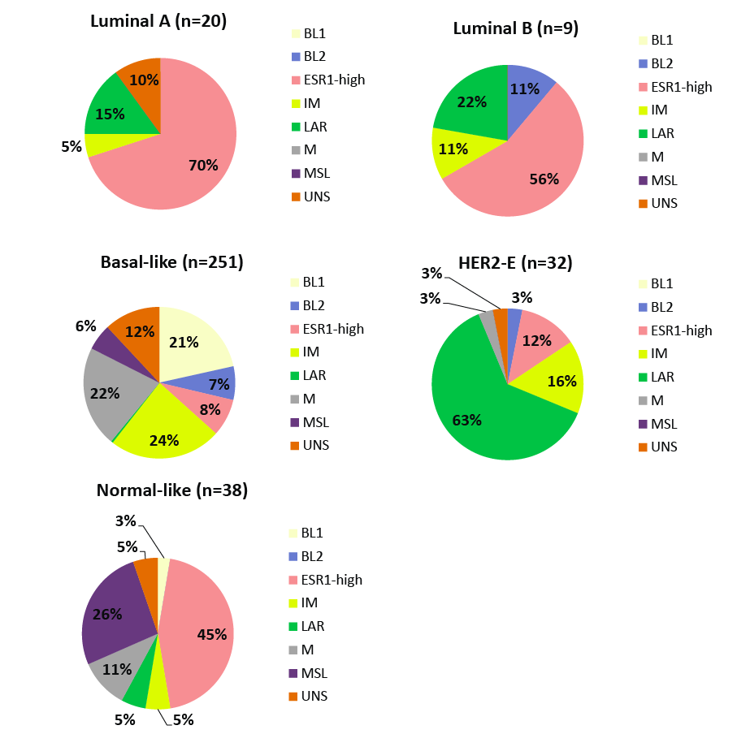

Figure S5
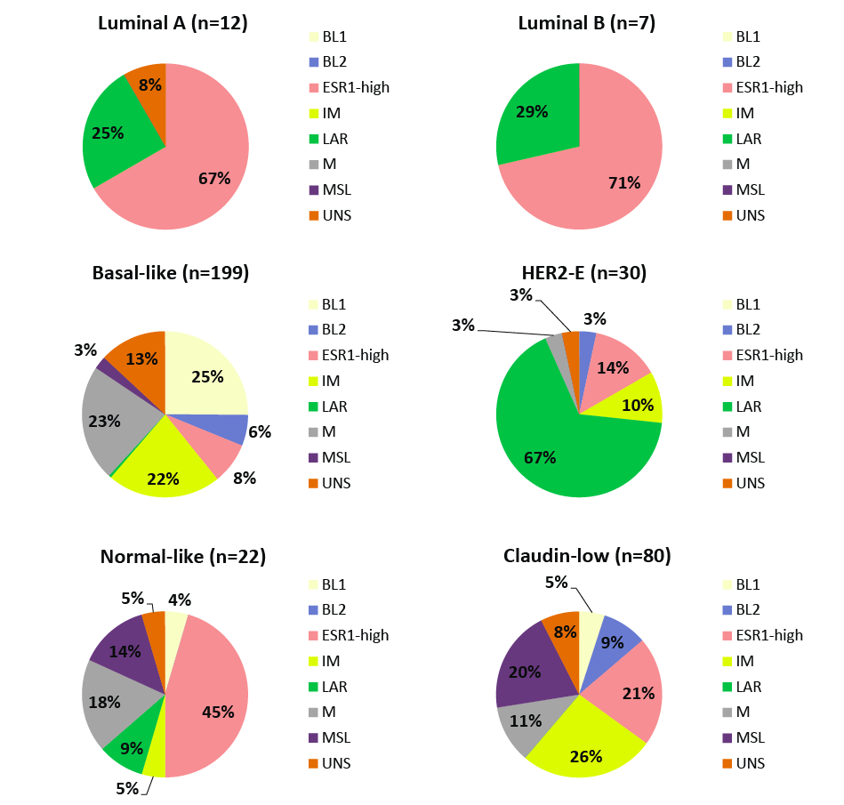

Figure S6
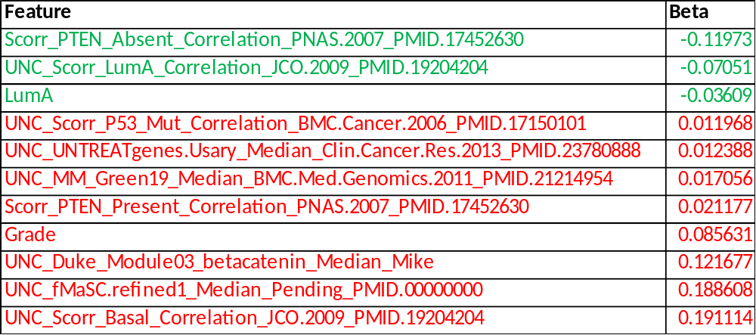
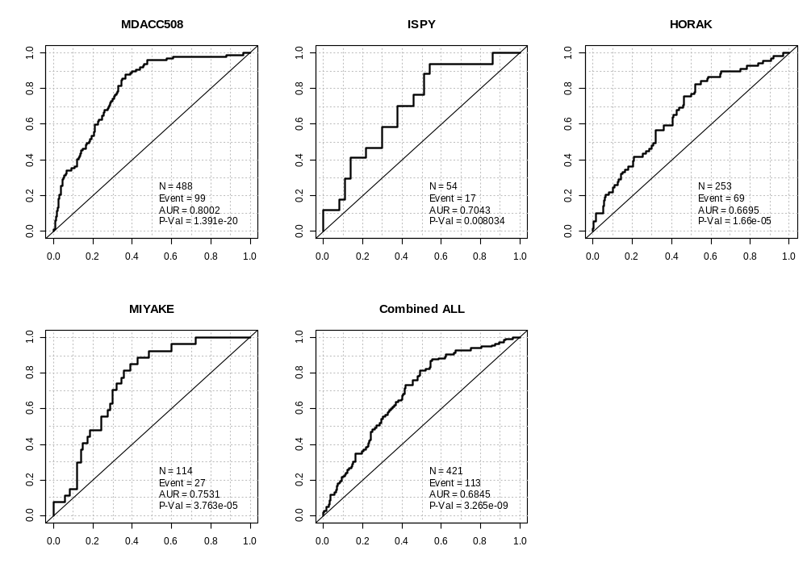

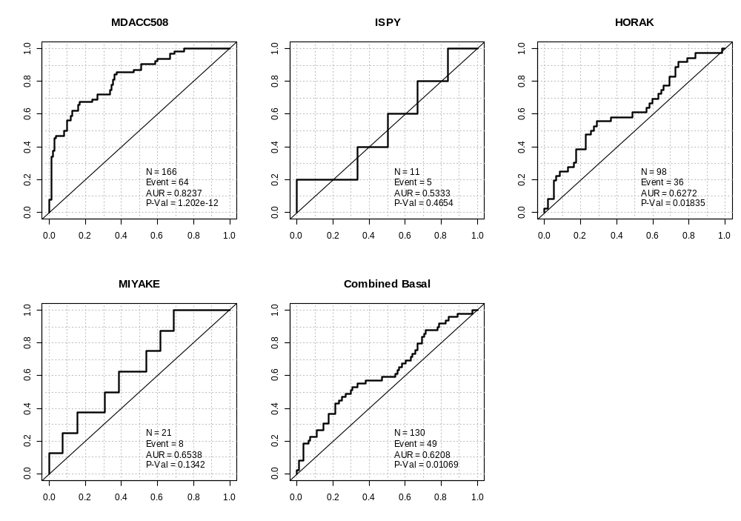
Figure S7

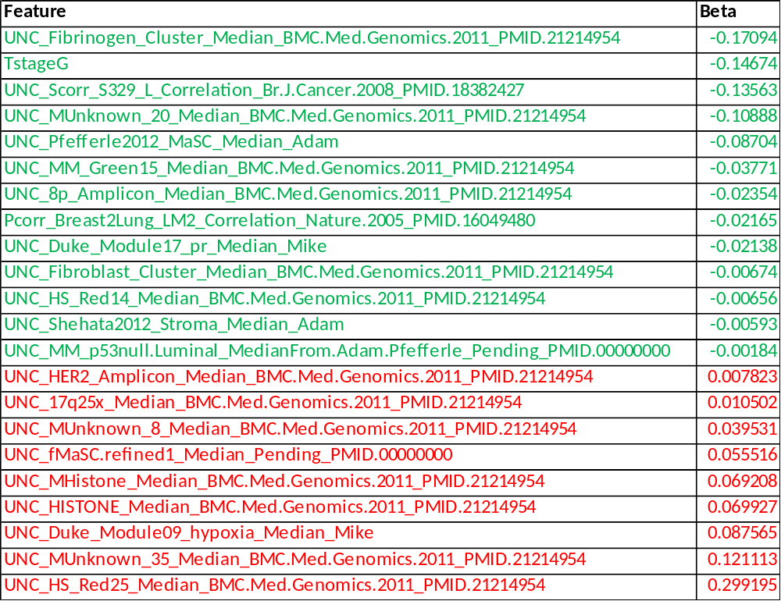

Figure S8

