Supplemental Material

Supplemental Table 1. Linearity tests for each formula using restricted cubic splines with 3 knots.
Populations | Univariable model | Adjusted model*
Population-Based
MDRD4 | 0.0007 | 0.006
CKD-EPI | 0.66 | 0.75
CG-BSA | 0.53 | 0.58
Cardiovascular Risk
MDRD4 | <0.0001 | <0.0001
CKD-EPI | <0.0001 | <0.0001
CG-BSA | <0.0001 | <0.0001
Heart Failure
MDRD4 | 0.049 | 0.017
CKD-EPI | 0.57 | 0.32
CG-BSA | 0.23 | 0.095
Post-Myocardial Infarction
MDRD4 | <0.0001 | <0.0001
CKD-EPI | <0.0001 | <0.0001
CG-BSA | <0.0001 | <0.0001
Legend: CG-BSA, Cockcroft-Gault formula adjusted for body surface area; MDRD4, modification of diet in renal disease-4 formula; CKD-EPI, Chronic Kidney Disease Epidemiology Collaboration equation.
*Adjusted for gender, smoking status, hypertension history, diagnosis of diabetes, heart rate and systolic blood pressure.

Supplemental Table 2. Cox-regression models according to the different formulas (categorized for “renal function” stages) and age subgroups
Variables |  | HR (95%CI) | P-value | P for interaction
Community
MDRD4
 | Categorical |  |  | 0.739
 | Stage 1: >=90 | Reference |  | 0.739
Age ≤68 | Stage 2: 60 – 89 | 0.778 (0.358 - 1.691) | 0.527 | 0.739
 | Stage 3a: 45 – 59 | 1.771 (0.593 - 5.290) | 0.306 | 0.739
 | Stage 3b/4/5: <45 | Error (insufficient data) | - | 0.739
 | Categorical |  |  | 0.739
 | Stage 1: >=90 | Reference |  | 0.739
Age >68 | Stage 2: 60 – 89 | 0.732 (0.455 - 1.177) | 0.198 | 0.739
 | Stage 3a: 45 – 59 | 0.908 (0.515 - 1.603) | 0.740 | 0.739
 | Stage 3b/4/5: <45 | 1.961 (0.992 - 3.874) | 0.053 | 0.739
CKD-EPI
 | Categorical |  |  | 0.494
 | Stage 1: >=90 | Reference |  | 0.494
Age ≤68 | Stage 2: 60 – 89 | 1.511 (0.603 - 3.783) | 0.378 | 0.494
 | Stage 3a: 45 – 59 | 3.501 (0.986 – 12.429) | 0.053 | 0.494
 | Stage 3b/4/5: <45 | Error (insufficient data) | - | 0.494
 | Categorical |  |  | 0.494
 | Stage 1: >=90 | Reference |  | 0.494
Age >68 | Stage 2: 60 – 89 | 0.873 (0.403 - 1.893) | 0.731 | 0.494
 | Stage 3a: 45 – 59 | 1.145 (0.506 – 2.591) | 0.745 | 0.494
 | Stage 3b/4/5: <45 | 2.094 (0.874 – 5.017) | 0.097 | 0.494
CG-BSA
 | Categorical |  |  | 0.147
 | Stage 1: >=90 | Reference |  | 0.147
Age ≤68 | Stage 2: 60 – 89 | 2.919 (1.002 – 8.507) | 0.050 | 0.147
 | Stage 3a: 45 – 59 | 4.664 (1.159 – 18.762) | 0.030 | 0.147
 | Stage 3b/4/5: <45 | Error (insufficient data) | - | 0.147
 | Categorical |  |  | 0.147
 | Stage 1: >=90 | Reference |  | 0.147
Age >68 | Stage 2: 60 – 89 | 0.662 (0.300 - 1.459) | 0.306 | 0.147
 | Stage 3a: 45 – 59 | 0.925 (0.419 – 2.045) | 0.848 | 0.147
 | Stage 3b/4/5: <45 | 1.546 (0.674 – 3.543) | 0.303 | 0.147
Cardiovascular Risk
MDRD4
 | Categorical |  |  | <0.001
 | Stage 1: >=90 | Reference |  | <0.001
Age ≤70 | Stage 2: 60 – 89 | 0.764 (0.549 - 1.063) | 0.110 | <0.001
 | Stage 3a: 45 – 59 | 0.828 (0.565 – 1.214) | 0.334 | <0.001
 | Stage 3b/4/5: <45 | 2.518 (1.504 – 4.216) | <0.001 | <0.001
 | Categorical |  |  | <0.001
 | Stage 1: >=90 | Reference |  | <0.001
Age >70 | Stage 2: 60 – 89 | 0.720 (0.516 - 1.004) | 0.052 | <0.001
 | Stage 3a: 45 – 59 | 0.792 (0.567 - 1.108) | 0.174 | <0.001
 | Stage 3b/4/5: <45 | 1.551 (1.096 – 2.196) | 0.013 | <0.001
CKD-EPI
 | Categorical |  |  | <0.001
 | Stage 1: >=90 | Reference |  | <0.001
Age ≤70 | Stage 2: 60 – 89 | 0.815 (0.599 - 1.108) | 0.191 | <0.001
 | Stage 3a: 45 – 59 | 0.965 (0.675 – 1.378) | 0.843 | <0.001
 | Stage 3b/4/5: <45 | 2.920 (1.835 – 4.649) | <0.001 | <0.001
 | Categorical |  |  | <0.001
 | Stage 1: >=90 | Reference |  | <0.001
Age >70 | Stage 2: 60 – 89 | 0.664 (0.330 - 1.336) | 0.251 | <0.001
 | Stage 3a: 45 – 59 | 0.699 (0.347 – 1.406) | 0.315 | <0.001
 | Stage 3b/4/5: <45 | 1.260 (0.624 – 2.543) | 0.520 | <0.001
CG-BSA
 | Categorical |  |  | <0.001
 | Stage 1: >=90 | Reference |  | <0.001
Age ≤70 | Stage 2: 60 – 89 | 0.985 (0.760 – 1.277) | 0.907 | <0.001
 | Stage 3a: 45 – 59 | 1.489 (1.086 – 2.042) | 0.013 | <0.001
 | Stage 3b/4/5: <45 | 3.656 (2.149 – 6.221) | <0.001 | <0.001
 | Categorical |  |  | <0.001
 | Stage 1: >=90 | Reference |  | <0.001
Age >70 | Stage 2: 60 – 89 | 0.627 (0.279 - 1.408) | 0.258 | <0.001
 | Stage 3a: 45 – 59 | 0.816 (0.365 – 1.824) | 0.620 | <0.001
 | Stage 3b/4/5: <45 | 1.442 (0.644 – 3.230) | 0.373 | <0.001
Heart Failure
MDRD4
 | Categorical |  |  | 0.040
 | Stage 1: >=90 | Reference |  | 0.040
Age ≤75 | Stage 2: 60 – 89 | 1.525 (0.818 - 2.843) | 0.184 | 0.040
 | Stage 3a: 45 – 59 | 2.039 (1.046 – 3.974) | 0.036 | 0.040
 | Stage 3b/4/5: <45 | 3.727 (1.952 – 7.114) | <0.001 | 0.040
 | Categorical |  |  | 0.040
 | Stage 1: >=90 | Reference |  | 0.040
Age >75 | Stage 2: 60 – 89 | 0.584 (0.358 – 0.954) | 0.032 | 0.040
 | Stage 3a: 45 – 59 | 0.695 (0.425 - 1.136) | 0.147 | 0.040
 | Stage 3b/4/5: <45 | 1.112 (0.694 – 1.782) | 0.659 | 0.040
CKD-EPI
 | Categorical |  |  | 0.061
 | Stage 1: >=90 | Reference |  | 0.061
Age ≤75 | Stage 2: 60 – 89 | 1.362 (0.726 - 2.554) | 0.336 | 0.061
 | Stage 3a: 45 – 59 | 2.265 (1.170 – 4.386) | 0.015 | 0.061
 | Stage 3b/4/5: <45 | 3.369 (1.780 – 6.373) | <0.001 | 0.061
 | Categorical |  |  | 0.061
 | Stage 1: >=90 | Reference |  | 0.061
Age >75 | Stage 2: 60 – 89 | 1.715 (0.238 – 12.341) | 0.592 | 0.061
 | Stage 3a: 45 – 59 | 1.301 (0.180 – 9.376) | 0.794 | 0.061
 | Stage 3b/4/5: <45 | 2.706 (0.379 – 19.344) | 0.321 | 0.061
CG-BSA
 | Categorical |  |  | 0.003
 | Stage 1: >=90 | Reference |  | 0.003
Age ≤75 | Stage 2: 60 – 89 | 1.303 (0.668 – 2.543) | 0.437 | 0.003
 | Stage 3a: 45 – 59 | 2.967 (1.527 – 5.766) | 0.001 | 0.003
 | Stage 3b/4/5: <45 | 5.026 (2.608 – 9.687) | <0.001 | 0.003
 | Categorical |  |  | 0.003
 | Stage 1: >=90 | Reference |  | 0.003
Age >75 | Stage 2: 60 – 89 | 1.499 (0.205 – 10.958) | 0.690 | 0.003
 | Stage 3a: 45 – 59 | 1.199 (0.166 – 8.648) | 0.857 | 0.003
 | Stage 3b/4/5: <45 | 2.373 (0.332 – 26.943) | 0.389 | 0.003
Myocardial Infarction
MDRD4
 | Categorical |  |  | 0.008
 | Stage 1: >=90 | Reference |  | 0.008
Age ≤65 | Stage 2: 60 – 89 | 1.030 (0.895 - 1.185) | 0.681 | 0.008
 | Stage 3a: 45 – 59 | 1.863 (1.570 – 2.211) | <0.001 | 0.008
 | Stage 3b: 30 - 45 | 2.977 (2.366 – 3.746) | <0.001 | 0.008
 | Stage 4/5: <30 | 5.391 (3.256 – 8,926) | <0.001 | 0.008
 | Categorical |  |  | 0.008
 | Stage 1: >=90 | Reference |  | 0.008
Age >65 | Stage 2: 60 – 89 | 1.041 (0.896 – 1.211) | 0.599 | 0.008
 | Stage 3a: 45 – 59 | 1.477 (1.269 - 1.720) | <0.001 | 0.008
 | Stage 3b: 30 - 45 | 2.314 (1.978 – 2.707) | <0.001 | 0.008
 | Stage 4/5: <30 | 3.450 (2.806 – 4.242) | <0.001 | 0.008
CKD-EPI
 | Categorical |  |  | 0.020
 | Stage 1: >=90 | Reference |  | 0.020
Age ≤65 | Stage 2: 60 – 89 | 1.097 (0.956 - 1.258) | 0.336 | 0.020
 | Stage 3a: 45 – 59 | 1.924 (1.624 – 2.279) | <0.001 | 0.020
 | Stage 3b: 30 - 45 | 3.173 (2.532 – 3.977) | <0.001 | 0.020
 | Stage 4/5: <30 | 4.629 (2.799 – 7.655) | <0.001 | 0.020
 | Categorical |  |  | 0.020
 | Stage 1: >=90 | Reference |  | 0.020
Age >65 | Stage 2: 60 – 89 | 1.103 (0.896 – 1.358) | 0.356 | 0.020
 | Stage 3a: 45 – 59 | 1.538 (1.250 – 1.894) | <0.001 | 0.020
 | Stage 3b: 30 - 45 | 2.404 (1.949 – 2.966) | <0.001 | 0.020
 | Stage 4/5: <30 | 3.671 (2.911 – 4.629) | <0.001 | 0.020
CG-BSA
 | Categorical |  |  | <0.001
 | Stage 1: >=90 | Reference |  | <0.001
Age ≤65 | Stage 2: 60 – 89 | 1.209 (1.056 – 1.385) | 0.006 | <0.001
 | Stage 3a: 45 – 59 | 2.436 (2.052 – 2.893) | <0.001 | <0.001
 | Stage 3b: 30 - 45 | 3.549 (2.719 – 4.632) | <0.001 | <0.001
 | Stage 4/5: <30 | 11.311 (5.346 – 23.933) | <0.001 | <0.001
 | Categorical |  |  | <0.001
 | Stage 1: >=90 | Reference |  | <0.001
Age >65 | Stage 2: 60 – 89 | 0.989 (0.773 – 1.266) | 0.930 | <0.001
 | Stage 3a: 45 – 59 | 1.396 (1.095 – 1.779) | 0.007 | <0.001
 | Stage 3b/4/5: <45 | 2.404 (1.886 – 3.064) | <0.001 | <0.001
 | Stage 4/5: <30 | 3.685 (2.841 – 4.780) | <0.001 | <0.001
Legend: all analyses are univariable.
CG-BSA, Cockcroft-Gault formula adjusted for body surface area; MDRD4, modification of diet in renal disease-4 formula; CKD-EPI, Chronic Kidney Disease Epidemiology Collaboration equation.

Supplemental Table 3. Improvement indices for glomerular filtration rate estimation formulas in comparison to body surface area.
Improvement indices  and populations | MDRD4 on top of BSA | P-value | CKD-EPI on top of BSA | P-value | CG-BSA on top of BSA | P-value
Community
NRI continuous  2 yr (95%CI) | 0.096 (-0.019 to 0.257) | 0.132 | 0.195 (0.030 to 0.299) | 0.013 | 0.240 (0.097 to 0.361) | <0.001
IDI continuous  2 yr (_{95%}CI) | 0.002 (0.000 to 0.008) | 0.006 | 0.006 (0.002 to 0.013) | <0.001 | 0.010 (0.004 to 0.019) | <0.001
Cardiovascular Risk
NRI continuous  2 yr (95%CI) | 0.079 (0.040 to 0.118) | <0.001 | 0.111 (0.080 to 0.147) | <0.001 | 0.208 (0.171 to 0.238) | <0.001
IDI continuous  2 yr (_{95%}CI) | 0.003 (0.002 to 0.006) | <0.001 | 0.006 (0.004 to 0.010) | <0.001 | 0.012 (0.009 to 0.017) | <0.001
Heart Failure
NRI continuous  2 yr (95%CI) | 0.192 (0.112 to 0.260) | <0.001 | 0.205 (0.120 to 0.275) | <0.001 | 0.256 (0.188 to 0.315) | <0.001
IDI continuous  2 yr (_{95%}CI) | 0.027 (0.014 to 0.044) | <0.001 | 0.034 (0.019 to 0.047) | <0.001 | 0.042 (0.027 to 0.058) | <0.001
Improvement indices  and populations | BSA on top of MDRD4 | P-value | BSA on top of CKD-EPI | P-value | BSA on top of CG-BSA | P-value
Community
NRI continuous  2 yr (95%CI) | -0.017 (-0.133 to 0.176) | 1.000 | -0.001 (-0.138 to 0.129) | 0.977 | 0.075 (-0.055 to 0.197) | 0.266
IDI continuous  2 yr (_{95%}CI) | -0.000 (-0.000 to 0.000) | 1.000 | 0.000 (0.000 to 0.000) | 1.000 | 0.001 (-0.000 to 0.000) | 0.285
Cardiovascular Risk
NRI continuous  2 yr (95%CI) | 0.101 (0.058 to 0.118) | <0.001 | 0.093 (0.051 to 0.131) | <0.001 | -0.006 (-0.041 to 0.051) | 1.000
IDI continuous  2 yr (_{95%}CI) | 0.002 (0.001 to 0.006) | <0.001 | 0.002 (0.001 to 0.003) | <0.001 | 0.000 (0.000 to 0.000) | 1.000
Heart Failure
NRI continuous  2 yr (95%CI) | 0.132 (0.041 to 0.201) | <0.001 | 0.124 (0.034 to 0.201) | <0.001 | 0.065 (-0.037 to 0.043) | 0.229
IDI continuous  2 yr (_{95%}CI) | 0.013 (0.004 to 0.024) | <0.001 | 0.012 (0.004 to 0.021) | <0.001 | 0.003 (0.000 to 0.009) | 0.053
Legend: CG-BSA, Cockcroft-Gault formula adjusted for body surface area; MDRD4, modification of diet in renal disease-4 formula; CKD-EPI, Chronic Kidney Disease Epidemiology Collaboration equation; BSA, body surface area.
Supplemental Figure 1. Association between “renal function” formulas and cardiovascular mortality in each population setting using restricted cubic splines with y-axis in log scale.
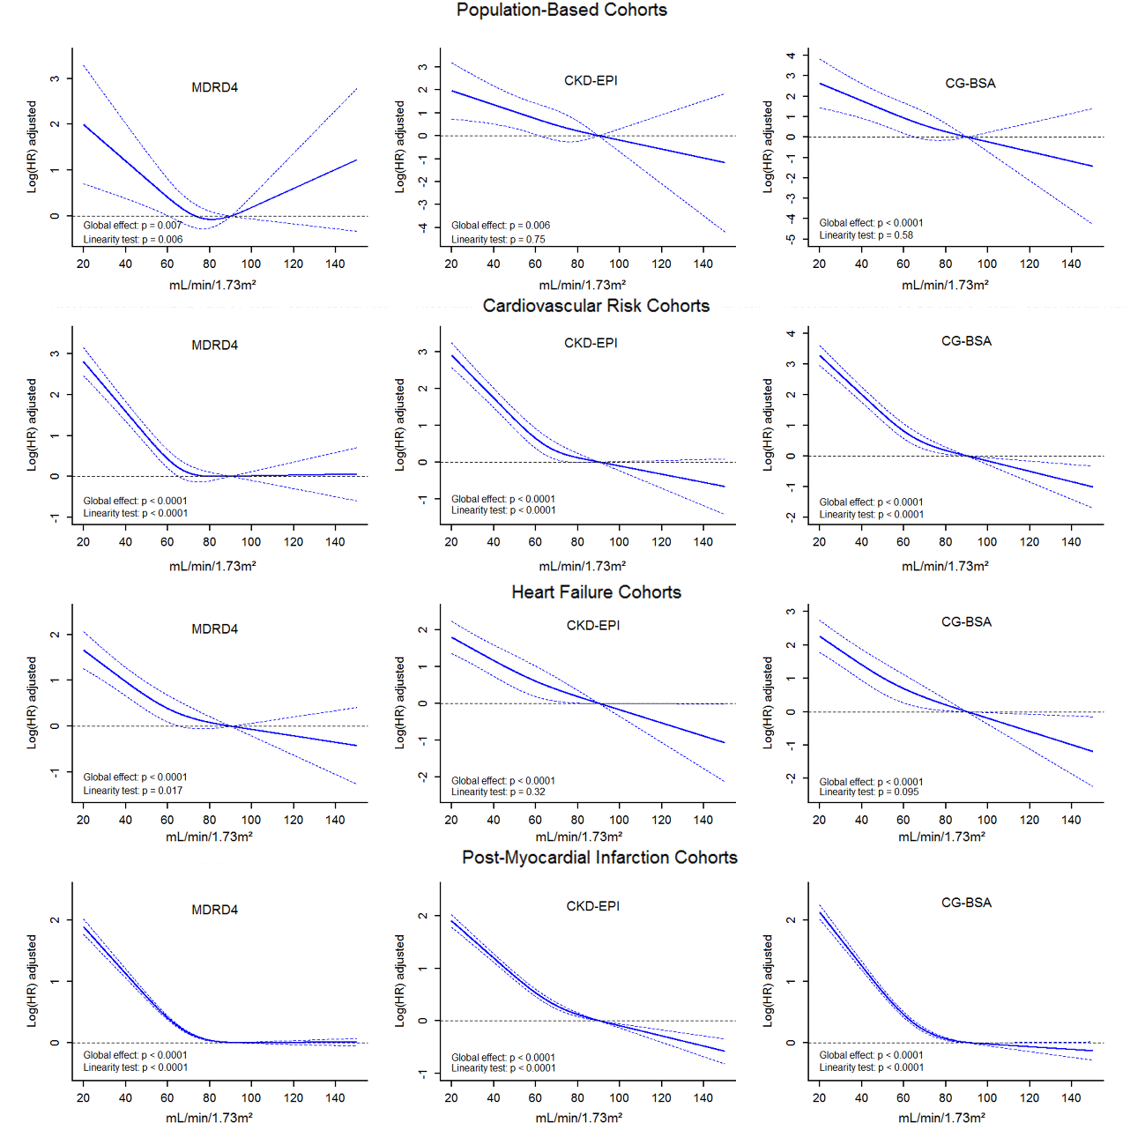
Legend: CG-BSA, Cockcroft-Gault formula adjusted for body surface area; MDRD4, modification of diet in renal disease-4 formula; CKD-EPI, Chronic Kidney Disease Epidemiology Collaboration equation.
Models adjusted for gender, smoking status, hypertension history, diagnosis of diabetes, heart rate and systolic blood pressure.

Supplemental Figure 2. Calibration assessment for “renal function” formulas within each population
Legend: CG-BSA, Cockcroft-Gault formula adjusted for body surface area; MDRD4, modification of diet in renal disease-4 formula; CKD-EPI, Chronic Kidney Disease Epidemiology Collaboration equation.
The outcome is cardiovascular mortality.
Dots represent the observed survival among deciles of predicted risks whereas the thin line represents the predicted risk values derived from Cox models.

