Habitual coffee consumption and genetic predisposition to obesity: gene-diet interaction analyses in three US prospective studies

Supplementary Material

Contents

Table S1 | Characteristics of 77 SNPs for BMI in the HPFS, NHS and WHI | 2
Table S2 | Baseline characteristics of non-coffee consumers in the HPFS, NHS and WHI | 4
Table S3 | Genetic associations with differences in BMI and prevalent obesity, according to coffee consumption in the HPFS, NHS and WHI (excluding non-coffee consumers) | 5
Table S4 | Genetic associations with differences in BMI and prevalent obesity, according to coffee consumption in the HPFS, NHS and WHI (only in non-smokers) | 6
Table S5 | Baseline characteristics of decaffeinated coffee consumers and caffeinated coffee consumers in the HPFS and NHS | 7
Table S6 | Differences in BMI per increment of 10 risk alleles, according to consumptions of decaffeinated coffee and caffeinated coffee in the HPFS and NHS | 8
Table S7 | Comparison of baseline characteristics for study participants and the other participants in the HPFS and NHS | 9
Figure S1 | Distribution of the genetic risk score in the HPFS, NHS and WHI | 10
Figure S2 | Differences in BMI per increment of 1 cup/d decaffeinated coffee and caffeinated coffee consumption, according to tertiles of the genetic risk score in the HPFS and NHS | 11

Table S1. Characteristics of 77 SNPs for BMI in the HPFS, NHS and WHI
SNPs | Nearest gene | Chr. | Alleles |  | Frequency of Effect allele, %
SNPs | Nearest gene | Chr. | Effect/other |  | HPFS | NHS | WHI
rs657452 | AGBL4 | 1 | A/G |  | 0.37 | 0.38 | 0.40
rs2820292 | NAV1 | 1 | C/A |  | 0.52 | 0.53 | 0.55
rs11583200 | ELAVL4 | 1 | C/T |  | 0.37 | 0.39 | 0.39
rs543874 | SEC16B | 1 | G/A |  | 0.19 | 0.19 | 0.19
rs3101336 | NEGR1 | 1 | C/T |  | 0.64 | 0.63 | 0.62
rs12566985 | FPGT-TNNI3K | 1 | G/A |  | 0.43 | 0.43 | 0.44
rs17024393 | GNAT2 | 1 | C/T |  | 0.03 | 0.03 | 0.03
rs11165643 | PTBP2 | 1 | T/C |  | 0.58 | 0.59 | 0.58
rs12401738 | FUBP1 | 1 | A/G |  | 0.32 | 0.34 | 0.35
rs7599312 | ERBB4 | 2 | G/A |  | 0.74 | 0.73 | 0.74
rs11126666 | KCNK3 | 2 | A/G |  | 0.26 | 0.27 | 0.27
rs1528435 | UBE2E3 | 2 | T/C |  | 0.62 | 0.63 | 0.62
rs11688816 | EHBP1 | 2 | G/A |  | 0.48 | 0.51 | 0.52
rs13021737 | TMEM18 | 2 | G/A |  | 0.81 | 0.82 | 0.82
rs10182181 | ADCY3 | 2 | G/A |  | 0.47 | 0.47 | 0.47
rs1016287 | FLJ30838 | 2 | T/C |  | 0.30 | 0.29 | 0.30
rs2121279 | LRP1B | 2 | T/C |  | 0.14 | 0.13 | 0.13
rs2365389 | FHIT | 3 | C/T |  | 0.60 | 0.59 | 0.59
rs16851483 | RASA2 | 3 | T/G |  | 0.07 | 0.06 | 0.06
rs6804842 | RARB | 3 | G/A |  | 0.59 | 0.57 | 0.58
rs3849570 | GBE1 | 3 | A/C |  | 0.32 | 0.34 | 0.33
rs1516725 | ETV5 | 3 | C/T |  | 0.86 | 0.87 | 0.86
rs13078960 | CADM2 | 3 | G/T |  | 0.22 | 0.20 | 0.21
rs17001654 | SCARB2 | 4 | G/C |  | 0.17 | 0.16 | 0.16
rs11727676 | HHIP | 4 | T/C |  | 0.91 | 0.92 | 0.90
rs10938397 | GNPDA2 | 4 | G/A |  | 0.44 | 0.44 | 0.43
rs13107325 | SLC39A8 | 4 | T/C |  | 0.08 | 0.07 | 0.07
rs2112347 | POC5 | 5 | T/G |  | 0.63 | 0.64 | 0.64
rs13191362 | PARK2 | 6 | A/G |  | 0.88 | 0.88 | 0.88
rs2033529 | TDRG1 | 6 | G/A |  | 0.29 | 0.28 | 0.29
rs9400239 | FOXO3 | 6 | C/T |  | 0.70 | 0.70 | 0.70
rs2207139 | TFAP2B | 6 | G/A |  | 0.17 | 0.17 | 0.17
rs205262 | C6orf106 | 6 | G/A |  | 0.28 | 0.27 | 0.28
rs1167827 | HIP1 | 7 | G/A |  | 0.57 | 0.57 | 0.58
rs2245368 | PMS2L11 | 7 | C/T |  | 0.16 | 0.16 | 0.18
rs2033732 | RALYL | 8 | C/T |  | 0.75 | 0.75 | 0.75
rs17405819 | HNF4G | 8 | T/C |  | 0.70 | 0.70 | 0.69
rs1928295 | TLR4 | 9 | T/C |  | 0.54 | 0.56 | 0.55
rs4740619 | C9orf93 | 9 | T/C |  | 0.46 | 0.44 | 0.45
rs10733682 | LMX1B | 9 | A/G |  | 0.49 | 0.49 | 0.48
rs6477694 | EPB41L4B | 9 | C/T |  | 0.33 | 0.34 | 0.34
rs10968576 | LINGO2 | 9 | G/A |  | 0.31 | 0.31 | 0.31
rs7903146 | TCF7L2 | 10 | C/T |  | 0.70 | 0.70 | 0.71
rs17094222 | HIF1AN | 10 | C/T |  | 0.22 | 0.21 | 0.22
rs11191560 | NT5C2 | 10 | C/T |  | 0.09 | 0.09 | 0.09
rs7899106 | GRID1 | 10 | G/A |  | 0.05 | 0.05 | 0.05
rs12286929 | CADM1 | 11 | G/A |  | 0.47 | 0.47 | 0.46
rs2176598 | HSD17B12 | 11 | T/C |  | 0.25 | 0.25 | 0.25
rs11030104 | BDNF | 11 | A/G |  | 0.78 | 0.79 | 0.79
rs3817334 | MTCH2 | 11 | T/C |  | 0.41 | 0.41 | 0.41
rs4256980 | TRIM66 | 11 | G/C |  | 0.63 | 0.64 | 0.64
rs11057405 | CLIP1 | 12 | G/A |  | 0.92 | 0.90 | 0.91
rs7138803 | BCDIN3D | 12 | A/G |  | 0.40 | 0.38 | 0.38
rs12429545 | OLFM4 | 13 | A/G |  | 0.13 | 0.13 | 0.12
rs12016871 | MTIF3 | 13 | T/C |  | 0.18 | 0.19 | 0.09
rs10132280 | STXBP6 | 14 | C/A |  | 0.67 | 0.69 | 0.69
rs12885454 | PRKD1 | 14 | C/A |  | 0.59 | 0.66 | 0.66
rs7141420 | NRXN3 | 14 | T/C |  | 0.48 | 0.53 | 0.53
rs11847697 | PRKD1 | 14 | T/C |  | 0.04 | 0.05 | 0.05
rs3736485 | DMXL2 | 15 | A/G |  | 0.45 | 0.46 | 0.46
rs16951275 | MAP2K5 | 15 | T/C |  | 0.75 | 0.77 | 0.76
rs758747 | NLRC3 | 16 | T/C |  | 0.29 | 0.27 | 0.29
rs9925964 | KAT8 | 16 | A/G |  | 0.61 | 0.63 | 0.63
rs2650492 | SBK1 | 16 | A/G |  | 0.32 | 0.32 | 0.25
rs1558902 | FTO | 16 | A/T |  | 0.43 | 0.42 | 0.41
rs3888190 | ATP2A1 | 16 | A/C |  | 0.37 | 0.39 | 0.39
rs12446632 | GPRC5B | 16 | G/A |  | 0.86 | 0.86 | 0.86
rs1000940 | RABEP1 | 17 | G/A |  | 0.28 | 0.28 | 0.31
rs12940622 | RPTOR | 17 | G/A |  | 0.58 | 0.57 | 0.57
rs7243357 | GRP | 18 | T/G |  | 0.83 | 0.83 | 0.82
rs6567160 | MC4R | 18 | C/T |  | 0.23 | 0.24 | 0.23
rs1808579 | C18orf8 | 18 | C/T |  | 0.44 | 0.46 | 0.48
rs17724992 | PGPEP1 | 19 | A/G |  | 0.73 | 0.74 | 0.73
rs2287019 | QPCTL | 19 | C/T |  | 0.82 | 0.82 | 0.80
rs3810291 | ZC3H4 | 19 | A/G |  | 0.33 | 0.32 | 0.32
rs2075650 | TOMM40 | 19 | A/G |  | 0.90 | 0.88 | 0.87
rs29941 | KCTD15 | 19 | G/A |  | 0.68 | 0.68 | 0.67
Chr., chromosome.
Allele coding based on the forward strand. Effect allele is the one associated with high BMI; and other is the reference allele.

Table S2. Baseline characteristics of non-coffee consumers in the HPFS, NHS and WHI
Characteristic | Non-coffee consumers
HPFS
Participants, n | 794
Age, year | 53.1 ± 9.0
BMI, kg/m² | 25.0 ± 4.4
Coffee, cups/d | 0
Physical activity, MET-h/wk | 19.9 ± 25.1
AHEI score | 51.8 ± 11.8
Total energy intake, kcal/d | 2003 ± 622
Alcohol, g/d | 6.5 ± 12.7
Current smokers, % | 3.8
Sugar-sweetened beverages, serving/d | 1.41 ± 1.38
Genetic risk score | 68.8 ± 5.5
NHS
Participants, n | 907
Age, year | 53.2 ± 7.1
BMI, kg/m² | 26.8 ± 5.7
Coffee, cups/d | 0
Physical activity, MET-h/wk | 13.8 ± 17.2
AHEI score | 47.4 ± 11.2
Total energy intake, kcal/d | 1736 ± 537
Alcohol, g/d | 3.1 ± 8.4
Current smokers, % | 10.3
Sugar-sweetened beverages, serving/d | 1.14 ± 1.09
Genetic risk score | 69.3 ± 5.6
WHI
Participants, n | 240
Age, year | 68.0 ± 6.2
BMI, kg/m² | 29.1 ± 5.4
Coffee, cups/d | 0
Physical activity, MET-h/wk | 11.0 ± 13.4
AHEI score | 54.7 ± 10.3
Total energy intake, kcal/d | 1509 ± 709
Alcohol, g/d | 3.7 ± 14.4
Current smokers, % | 4.2
Sugar-sweetened beverages, serving/d | 0.92 ± 1.05
Genetic risk score | 70.7 ± 5.7
Plus-minus values are means ± SD.

Table S3. Genetic associations with differences in BMI and prevalent obesity, according to coffee consumption in the HPFS, NHS and WHI (excluding non-coffee consumers)
Cohort | Study participants number | Coffee consumption |  |  | P for interaction
Cohort | Study participants number | <1 cup/d | 1-3 cups/d | >3 cups/d | P for interaction
BMI, kg/m²
HPFS | 4322 | 0.81 ± 0.32 | 0.81 ± 0.25 | 0.32 ± 0.30 | 0.017
NHS | 8934 | 1.75 ± 0.22 | 1.07 ± 0.13 | 1.13 ± 0.16 | 0.041
WHI | 5408 | 1.80 ± 0.35 | 1.02 ± 0.17 | 0.96 ± 0.25 | 0.035
Pooled* | 18664 | 1.52 ± 0.16 | 1.02 ± 0.10 | 0.95 ± 0.12 | <0.001
Obesity
HPFS | 4322 | 2.17 (1.61-2.93) | 1.47 (1.16-1.85) | 1.31 (1.03-1.66) | 0.012
NHS | 8934 | 1.98 (1.63-2.42) | 1.52 (1.34-1.73) | 1.50 (1.29-1.75) | 0.050
WHI | 5408 | 1.56 (1.21-2.00) | 1.46 (1.28-1.66) | 1.40 (1.15-1.70) | 0.286
Pooled* | 18664 | 1.88 (1.64-2.16) | 1.49 (1.37-1.62) | 1.43 (1.28-1.59) | 0.003
Data are β coefficients ± SE for differences in BMI (kg/m²) per increment of 10 risk alleles, or ORs (95% CIs) for prevalent obesity per increment of 10 risk alleles.
In the HPFS and NHS, data were derived from the repeated-measures analysis in men (3 measures from 1986 to 1998) and women (3 measures from 1986 to 1998); in the WHI, data were derived from the repeated-measures in women (2 measures from 1993 to 2003).
Data were adjusted for age, genotyping source, physical activity (<3, 3-8.9, 9-17.9, 18-26.9, ≥27 MET-h/wk), AHEI score (quintiles), total energy intake (quintiles), smoking status (never, former, current), sugar-sweetened beverages consumption (quintiles), and alcohol consumption (0, 0.1-4.9, 5-9.9, 10-14.9, ≥15 g/d).
*Results for the three cohorts were pooled by means of inverse-variance-weighted random effects meta-analysis (if P <0.05 for heterogeneity) or fixed effects meta-analysis (if P ≥0.05 for heterogeneity).
Table S4. Genetic associations with differences in BMI and prevalent obesity, according to coffee consumption in the HPFS, NHS and WHI (only in non-smokers)
Cohort | Study participants number | Coffee consumption |  |  | P for interaction
Cohort | Study participants number | <1 cup/d | 1-3 cups/d | >3 cups/d | P for interaction
BMI, kg/m²
HPFS | 2376 | 0.72 ± 0.31 | 1.15 ± 0.39 | 0.67 ± 0.60 | 0.800
NHS | 4427 | 1.48 ± 0.24 | 1.09 ± 0.20 | 0.94 ± 0.25 | 0.110
WHI | 2883 | 1.54 ± 0.36 | 1.33 ± 0.23 | 0.53 ± 0.40 | 0.052
Pooled* | 9686 | 1.27 ± 0.17 | 1.19 ± 0.14 | 0.81 ± 0.20 | 0.032
Obesity
HPFS | 2376 | 1.91 (1.33-2.74) | 1.53 (1.03-2.28) | 1.31 (0.79-2.17) | 0.199
NHS | 4427 | 1.74 (1.40-2.15) | 1.46 (1.20-1.78) | 1.51 (1.16-1.97) | 0.268
WHI | 2883 | 1.70 (1.30-2.23) | 1.62 (1.35-1.94) | 1.30 (0.96-1.76) | 0.117
Pooled* | 9686 | 1.75 (1.51-2.04) | 1.54 (1.36-1.75) | 1.40 (1.16-1.69) | 0.023
Data are β coefficients ± SE for differences in BMI (kg/m²) per increment of 10 risk alleles, or ORs (95% CIs) for prevalent obesity per increment of 10 risk alleles.
In the HPFS and NHS, data were derived from the repeated-measures analysis in men (3 measures from 1986 to 1998) and women (3 measures from 1986 to 1998); in the WHI, data were derived from the repeated-measures in women (2 measures from 1993 to 2003).
Data were adjusted for age, genotyping source, physical activity (<3, 3-8.9, 9-17.9, 18-26.9, ≥27 MET-h/wk), AHEI score (quintiles), total energy intake (quintiles), sugar-sweetened beverages consumption (quintiles), and alcohol consumption (0, 0.1-4.9, 5-9.9, 10-14.9, ≥15 g/d).
*Results for the three cohorts were pooled by means of inverse-variance-weighted random effects meta-analysis (if P <0.05 for heterogeneity) or fixed effects meta-analysis (if P ≥0.05 for heterogeneity).

Table S5. Baseline characteristics of decaffeinated coffee consumers and caffeinated coffee consumers in the HPFS and NHS
Characteristic | Decaffeinated coffee consumer | Caffeinated coffee consumer
HPFS
Participants, n | 2699 | 3615
Age, year | 55.0 ± 8.6 | 54.4 ± 8.6
BMI, kg/m² | 25.4 ± 4.6 | 25.4 ± 4.7
Coffee, cups/d | 2.46 ± 1.86 | 2.64 ± 1.79
Physical activity, MET-h/wk | 20.2 ± 23.6 | 19.1 ± 24.4
AHEI score | 54.3 ± 11.7 | 52.3 ± 11.7
Total energy intake, kcal/d | 2028 ± 597 | 2054 ± 619
Alcohol, g/d | 12.7 ± 15.5 | 14.0 ± 16.6
Current smoker, % | 7.6 | 10.0
Sugar-sweetened beverages, serving/d | 1.11 ± 0.96 | 1.14 ± 1.00
NHS
Participants, n | 5938 | 7709
Age, year | 54.1 ± 6.6 | 54.1 ± 6.5
BMI, kg/m² | 25.4 ± 4.8 | 25.7 ± 4.9
Coffee, cups/d | 2.65 ± 1.67 | 2.84 ± 1.61
Physical activity, MET-h/wk | 14.7 ± 19.6 | 13.7 ± 18.4
AHEI score | 50.4 ± 10.4 | 49.4 ± 10.3
Total energy intake, kcal/d | 1783 ± 488 | 1782 ± 493
Alcohol, g/d | 6.6 ± 9.9 | 7.4 ± 10.9
Current smoker, % | 15.4 | 19.2
Sugar-sweetened beverages, serving/d | 0.99 ± 0.55 | 0.98 ± 0.83
Plus-minus values are means ± SD.
Baseline data were from 41,213 men in the HPFS (1986) and 79,328 women in the NHS (1986). Participants were initially healthy men and women for whom baseline coffee consumption data were available. Decaffeinated coffee consumers and caffeinated coffee consumers overlapped.

Table S6. Differences in BMI per increment of 10 risk alleles, according to consumptions of decaffeinated coffee and caffeinated coffee in the HPFS and NHS
Analysis | Coffee consumption |  |  | P for interaction
Analysis | <1 cup/d | 1-3 cups/d | >3 cups/d | P for interaction
Decaffeinated coffee
HPFS | 0.70 ± 0.17 | 0.68 ± 0.37 | -0.11 ± 0.86 | 0.280
NHS | 1.34 ± 0.10 | 0.85 ± 0.20 | 0.83 ± 0.38 | 0.018
Pooled* | 1.17 ± 0.09 | 0.82 ± 0.18 | 0.68 ± 0.35 | 0.010
Caffeinated coffee
HPFS | 0.77 ± 0.21 | 0.93 ± 0.27 | -0.11 ± 0.37 | 0.058
NHS | 1.32 ± 0.13 | 1.04 ± 0.14 | 1.32 ± 0.22 | 0.760
Pooled* | 1.16 ± 0.11 | 1.02 ± 0.13 | 0.94 ± 0.19 | 0.212
Plus-minus values are β coefficients ± SE. In the HPFS and NHS, data were derived from the repeated-measures analysis in men (3 measures from 1986 to 1998) and women (3 measures from 1986 to 1998).
Data were adjusted for age, genotyping source, physical activity (<3, 3-8.9, 9-17.9, 18-26.9, ≥27 MET-h/wk), AHEI score (quintiles), total energy intake (quintiles), smoking status (never, former, current), sugar-sweetened beverages consumption (quintiles), and alcohol consumption (0, 0.1-4.9, 5.0-9.9, 10.0-14.9, ≥15 g/d); decaffeinated and caffeinated coffee were adjusted for each other.
*Results for the two studies were pooled by means of inverse-variance-weighted random effects meta-analysis (if P <0.05 for heterogeneity) or fixed effects meta-analysis (if P ≥0.05 for heterogeneity).

Table S7. Comparison of baseline characteristics for study participants and the other participants in the HPFS and NHS
Characteristic | Study participants | Other participants | P
HPFS
Participants, n | 5116 | 36097 | -
Age, year | 54.4 ± 8.7 | 52.7 ± 9.6 | <0.001
BMI, kg/m² | 25.4 ± 4.7 | 24.9 ± 5.0 | <0.001
Whites, % | 100.0 | 94.5 | <0.001
Coffee, cups/d | 2.09 ± 1.87 | 1.92 ± 1.80 | <0.001
Physical activity, MET-h/wk | 19.5 ± 24.8 | 21.7 ± 30.7 | <0.001
AHEI score | 52.6 ± 11.8 | 52.5 ± 11.5 | 0.42
Total energy intake, kcal/d | 2037 ± 617 | 1991 ± 622 | <0.001
Alcohol, g/d | 12.5 ± 16.3 | 11.2 ± 15.3 | <0.001
Current smoker, % | 8.6 | 9.9 | <0.001
Sugar-sweetened beverages, serving/d | 1.17 ± 1.07 | 1.24 ± 1.19 | <0.001
NHS
Participants, n | 9841 | 69487 | -
Age, year | 54.1 ± 6.6 | 51.9 ± 7.2 | <0.001
BMI, kg/m² | 25.8 ± 5.0 | 25.2 ± 4.8 | <0.001
Whites, % | 100.0 | 97.4 | <0.001
Coffee, cups/d | 2.43 ± 1.73 | 2.43 ± 1.76 | 0.91
Physical activity, MET-h/wk | 14.0 ± 18.3 | 14.2 ± 21.2 | 0.35
AHEI score | 49.5 ± 10.5 | 48.4 ± 10.4 | <0.001
Total energy intake, kcal/d | 1770 ± 499 | 1753 ± 510 | 0.002
Alcohol, g/d | 6.8 ± 10.7 | 6.6 ± 10.7 | 0.060
Current smoker, % | 17.4 | 22.3 | <0.001
Sugar-sweetened beverages, serving/d | 1.00 ± 0.87 | 0.98 ± 0.90 | 0.19
Plus-minus values are means ± SD.
Baseline data were from 41,213 men in the HPFS (1986) and 79,328 women in the NHS (1986). Participants were initially healthy men and women for whom baseline coffee consumption data were available.

Figure S1. Distribution of the genetic risk score in the HPFS, NHS and WHI
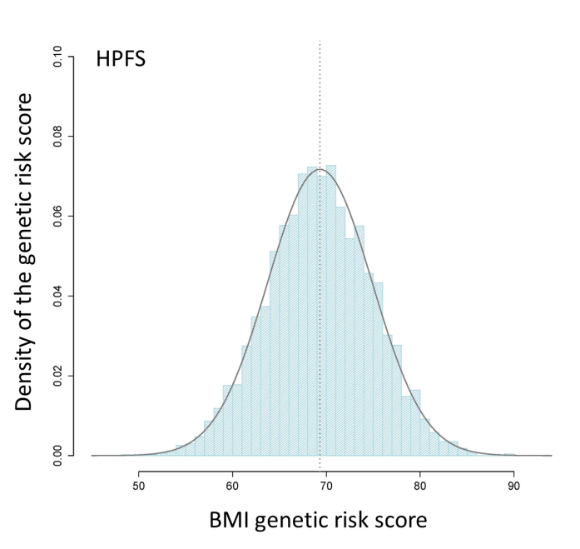
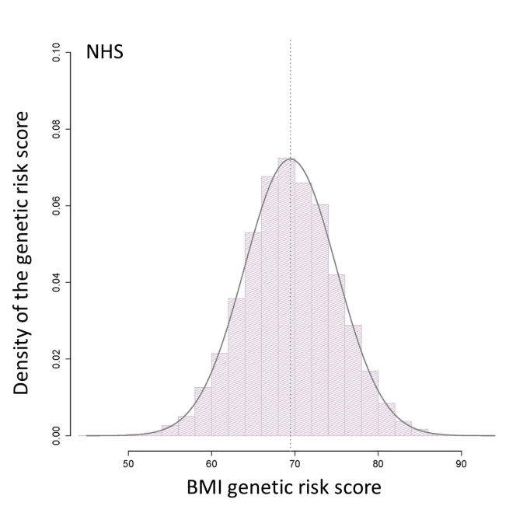
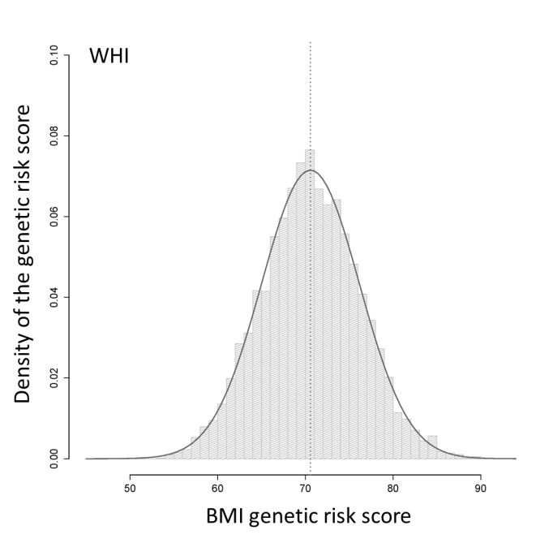

Figure S2. Differences in BMI per increment of 1 cup/d decaffeinated coffee and caffeinated coffee consumption, according to tertiles of the genetic risk score in the HPFS and NHS
Data are β coefficients ± SE.
Data description and adjustment are the same as shown in Supplementary Table 2.

