Additional Files
Additional Figures

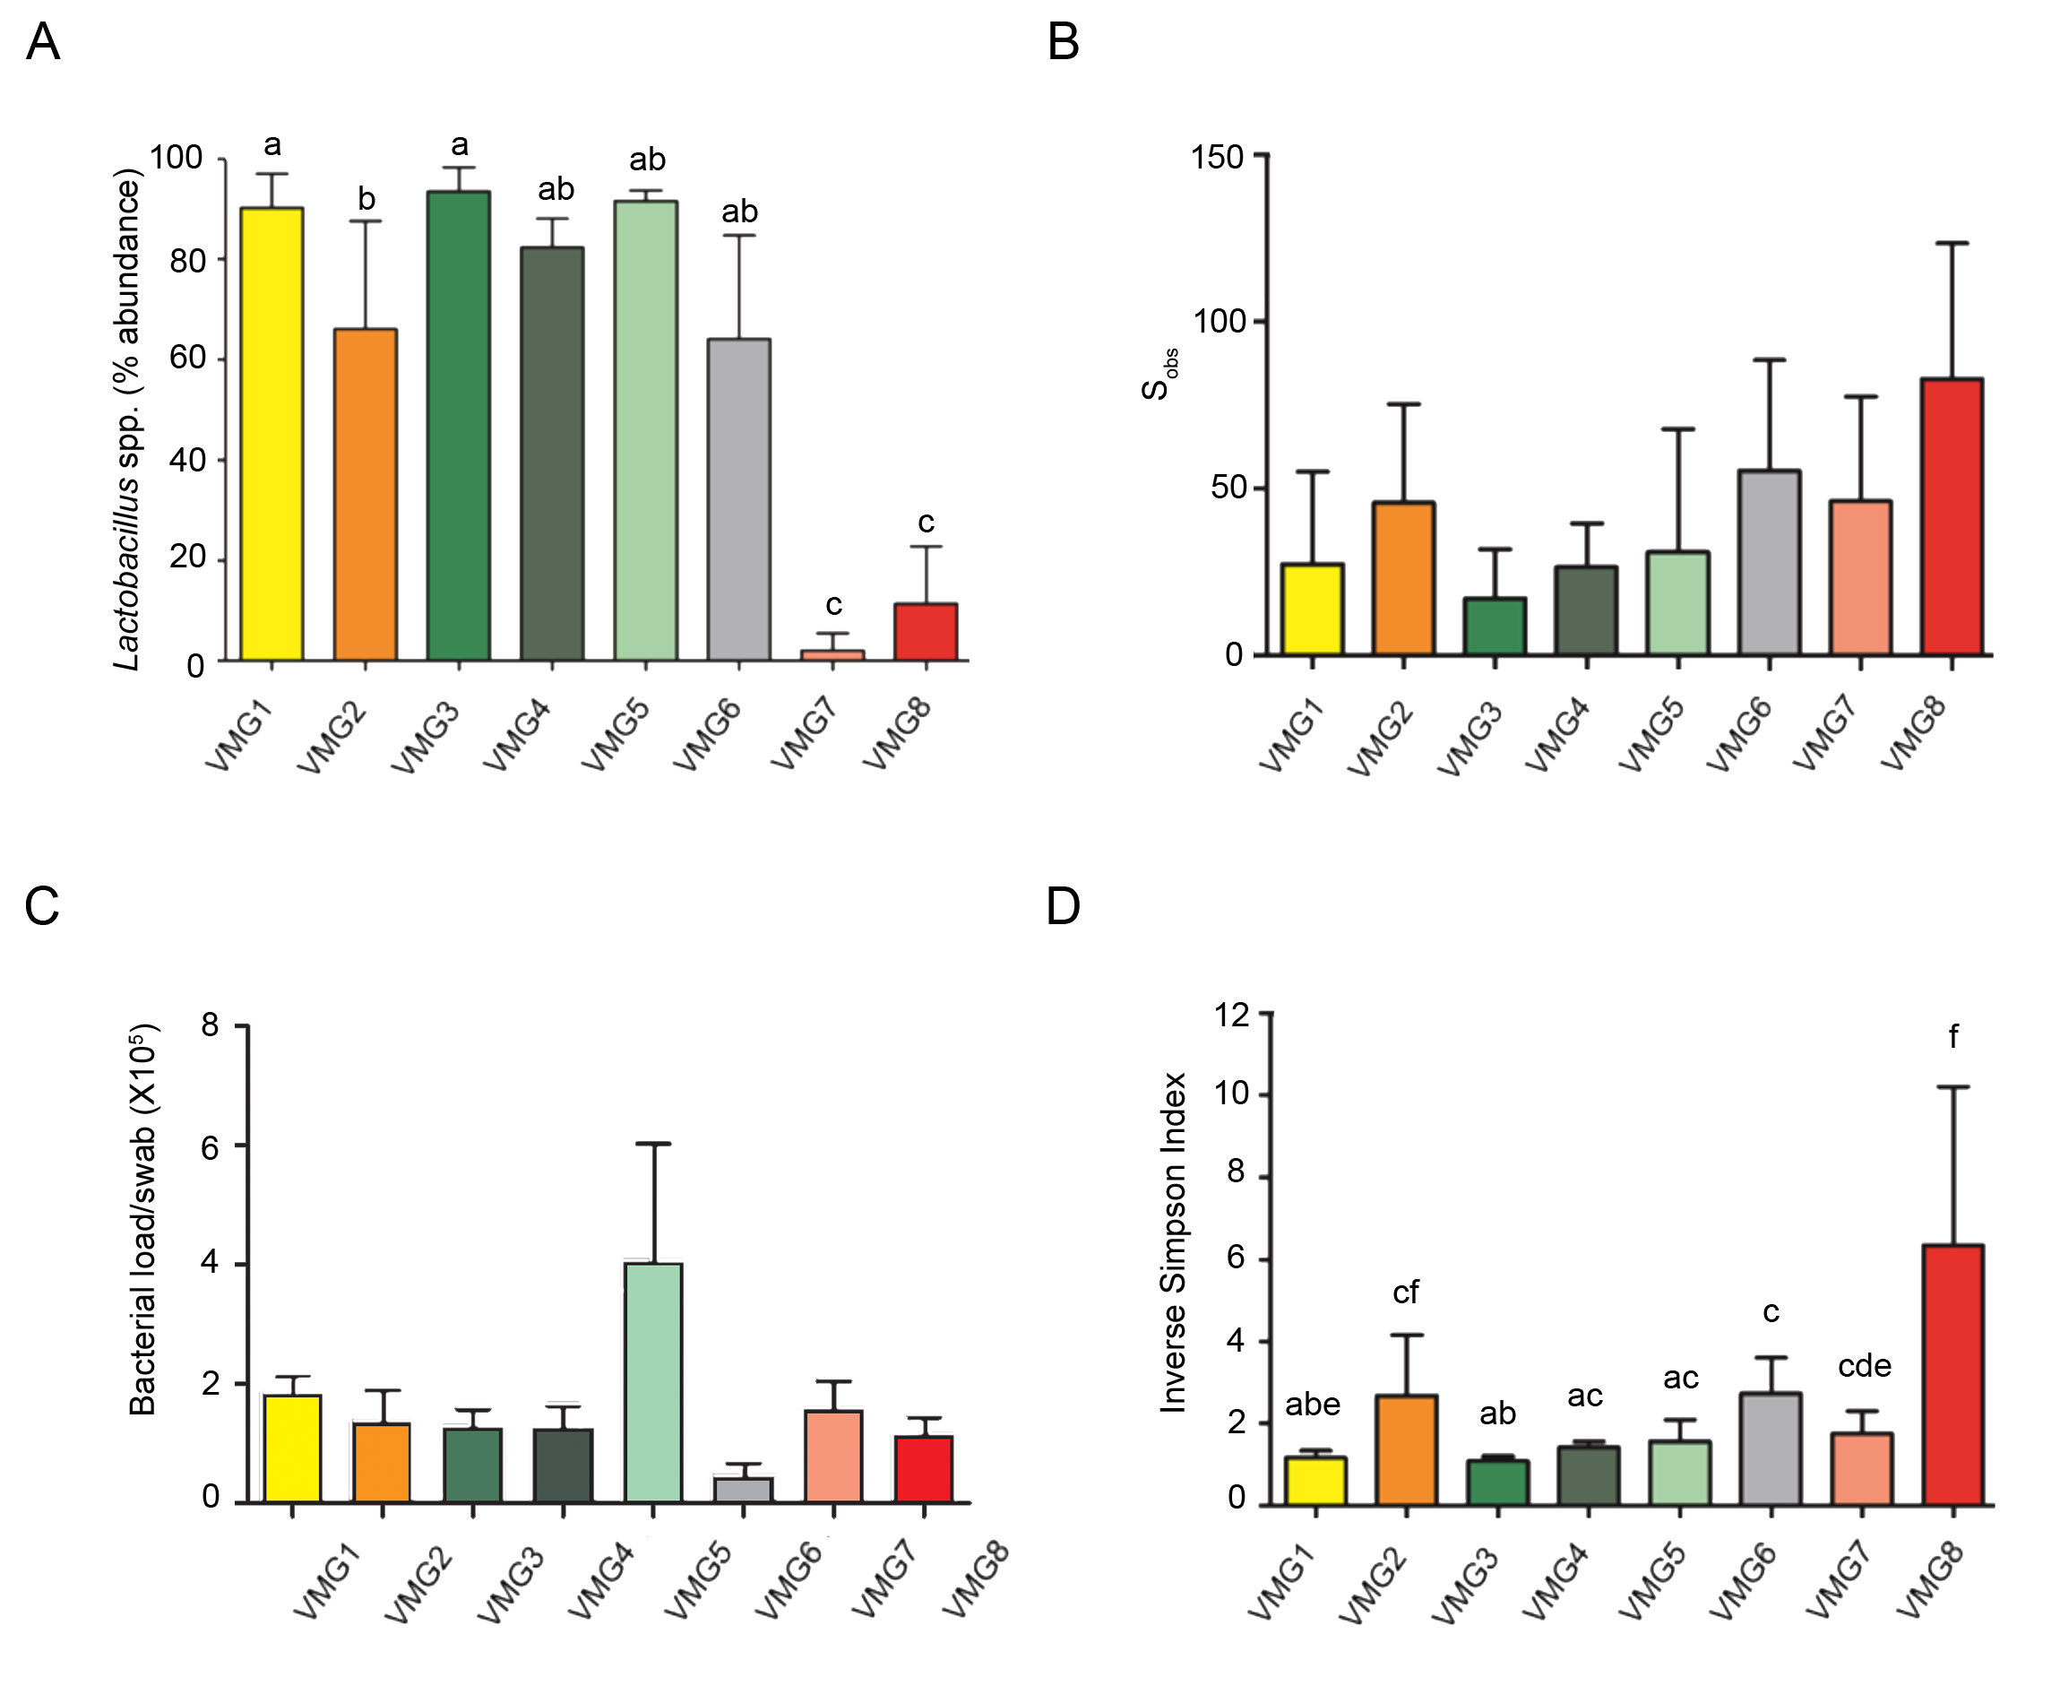
Figure S1. Characteristics of Vaginal Microbiota Groups defined using Ward clustering. A total of 8 vaginal microbiota groups (VMG) were identified. (A) VMG 1,3,4 and 5 are dominated by Lactobacillus, VMG 2 and 6 have intermediate Lactobacillus abundance and VMG 7 and 8 have significantly lower Lactobacillus abundance (P < 0.0001, Kruskal Wallis) (B) Species observed were lowest in the Lactobacillus dominant groups (VMG 1,3,4 and 5) and highest in groups 2,6 and 8. (C) Bacterial load was comparable across all groups (D) Inverse simpson scores were significantly higher in VMG 2,6 and 8. These differential characteristics were used to sub-group the Vaginal Microbiota Groups into Lactobacillus dominant (1,3,4,5) Intermediate (2,6) and deplete (7,8) communities. Letters indicate significant differences detected following post-hoc, pair-wise comparison (Dunn’s multiple comparison, P < 0.05). Shared letters indicate no difference; a lack of shared letters indicates a significant difference in medians between the groups.

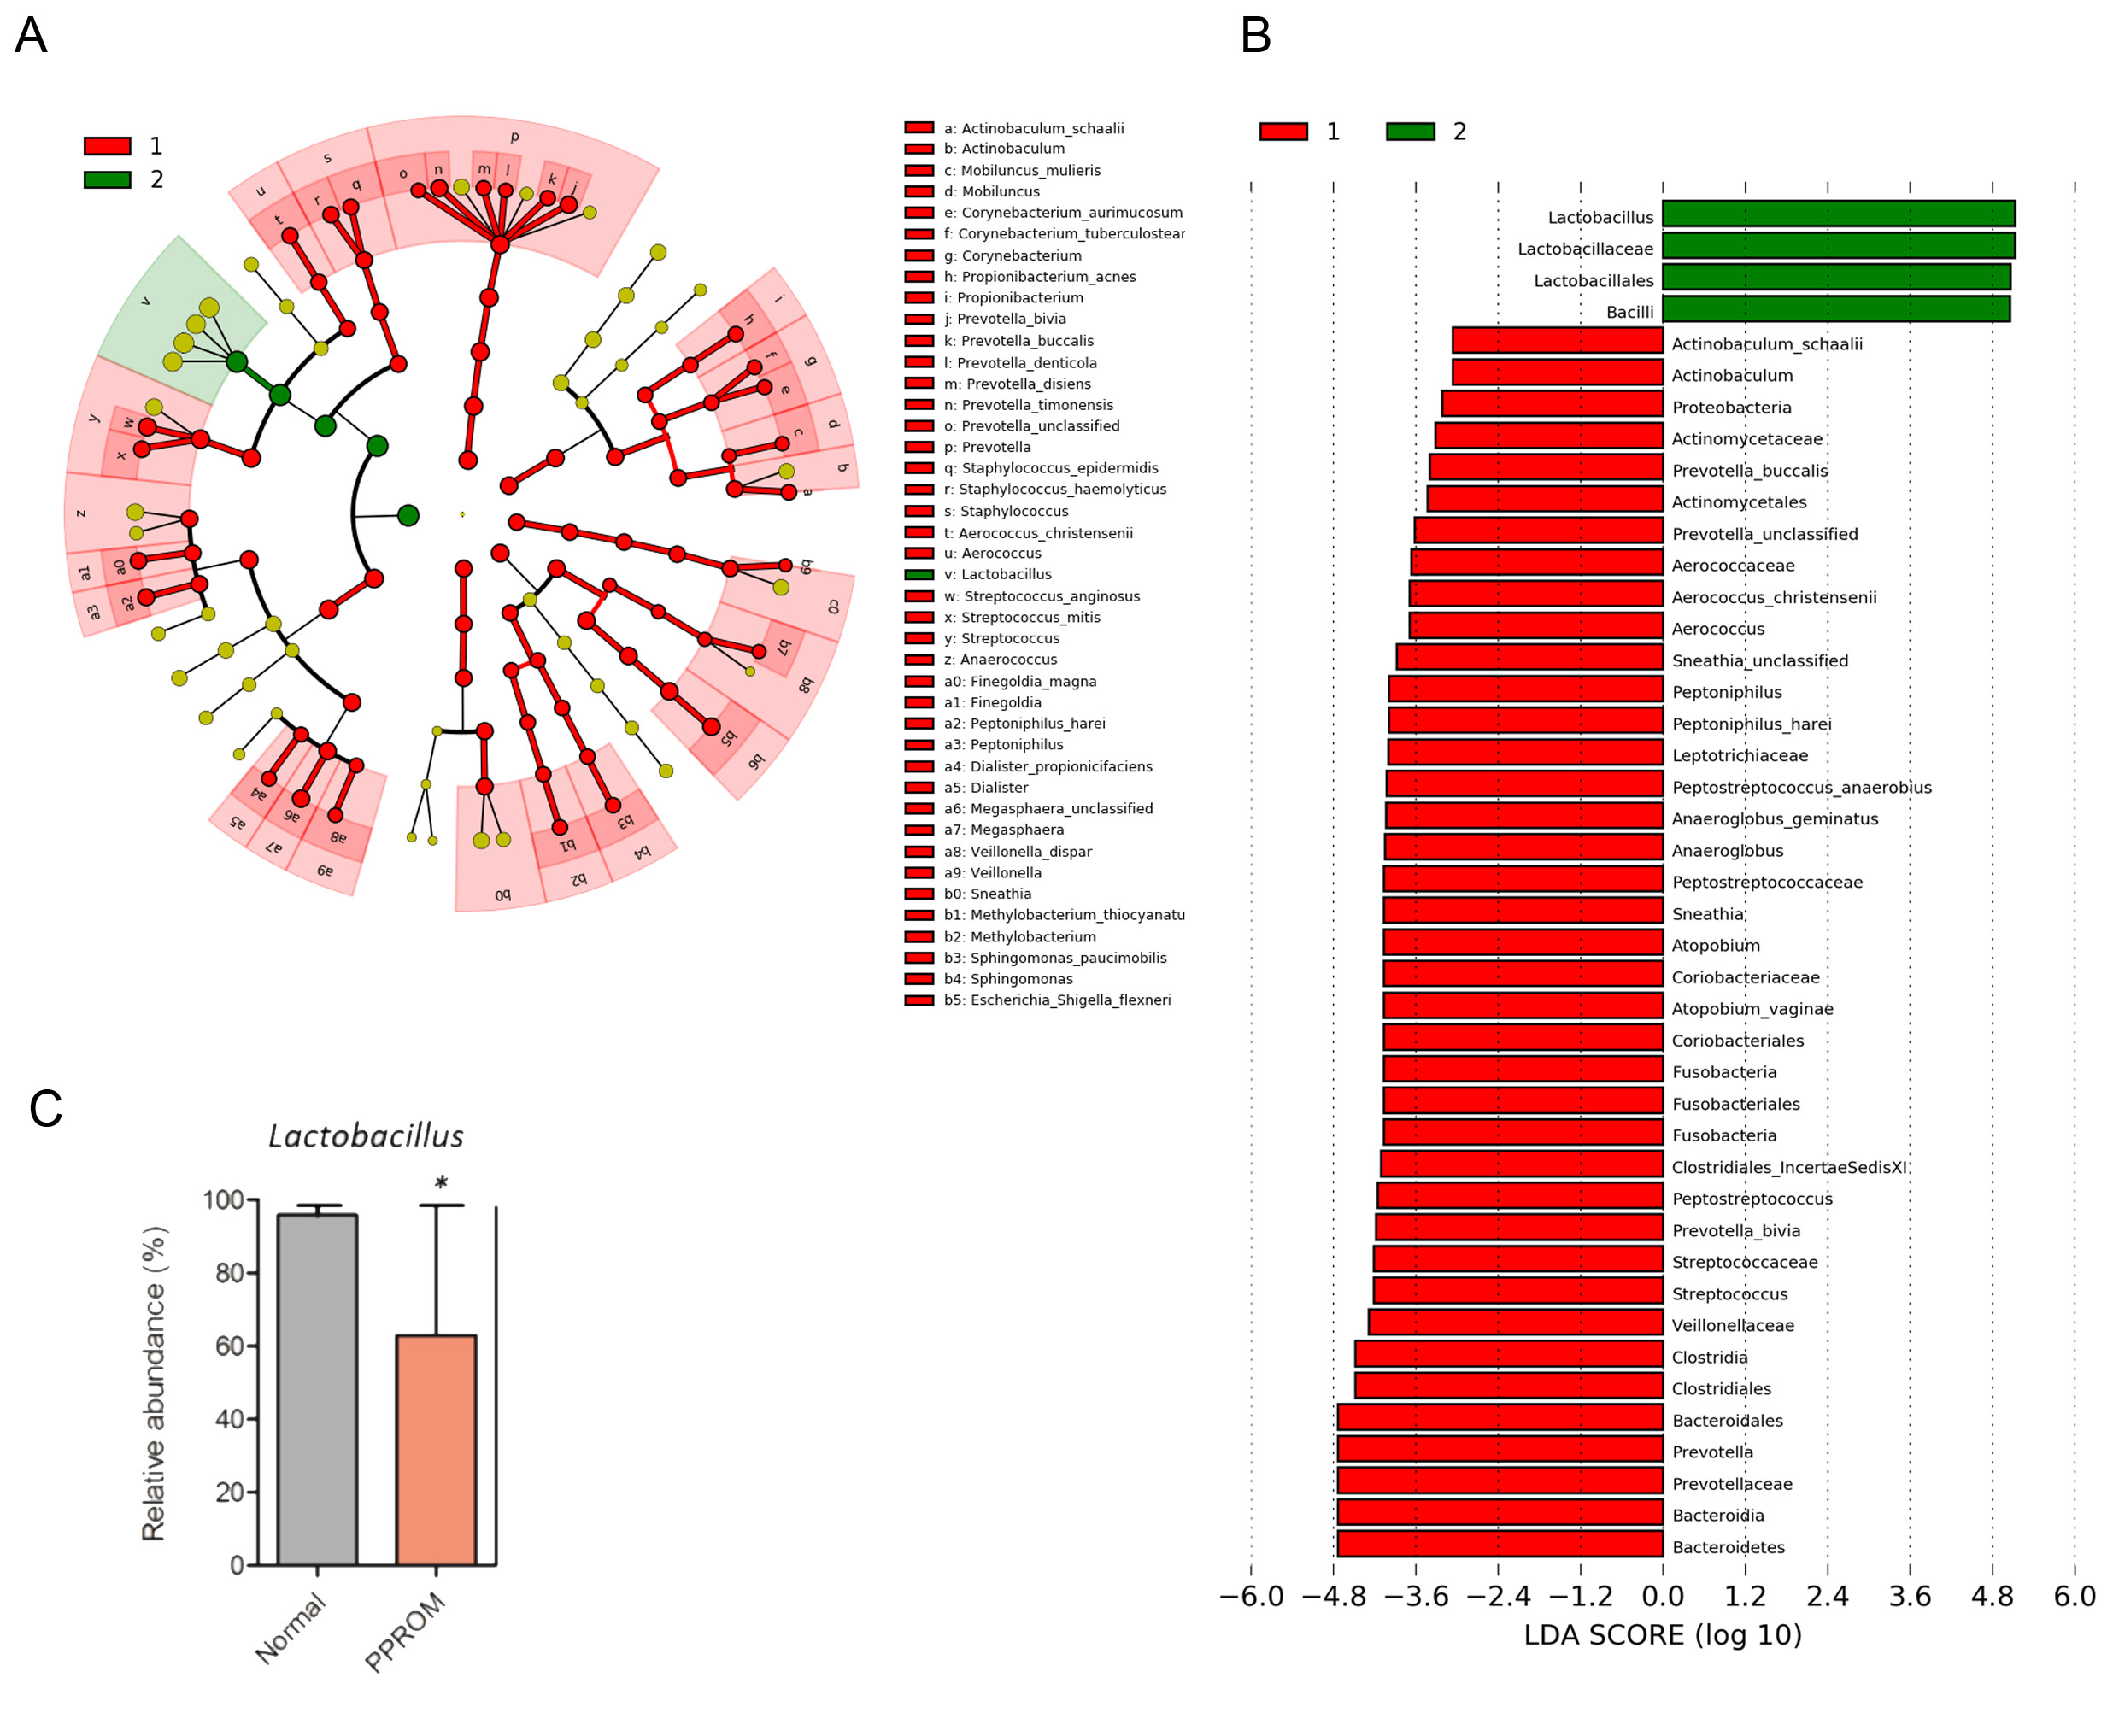
Figure S2. Bacterial taxonomic groups discriminate between normal term delivery and samples taken following membrane rupture. (A) Differentially abundant microbial clades and nodes identified between gestational age matched samples from normal pregnancies delivering at term and samples taken following PPROM prior to erythromycin treatment identified by LEfSe and presented as a cladogram. (B) LDA with effect size for each differentially abundant species, normal pregnancy is characterised by Lactobacillus spp. An expansion in diversity following membrane rupture including increased levels of Streptococcus spp., Sneathia spp. and Prevotella spp. (C) There is a reduction in Lactobacillus abundance following membrane rupture (P = 0.039, Mann Whitney).

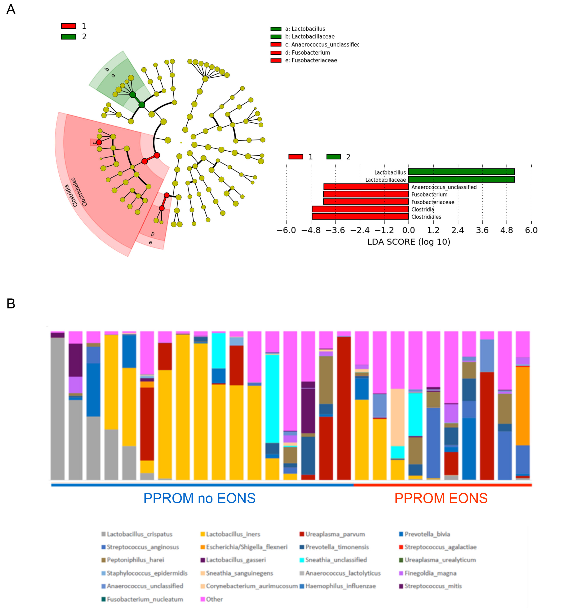
Figure S3. Bacterial taxonomic groups associated with Early Onset Neonatal Sepsis (EONS) following PPROM, for neonates delivered at or before 28 weeks gestation (n=27). (A) Differentially abundant microbial clades and nodes identified from the last vaginal sample taken prior to delivery according to the presence of neonatal sepsis identified using LefSe analysis and presented as a cladogram (B) LDA to estimate the effect size for each differentially abundant taxa. Lactobacillus spp. were differentially expressed amongst women whose babies did not develop EONS whilst vaginal Fusobacterium was associated with EONS.

Additional Tables

Table S1. Bacterial diversity, richness and Lactobacillus spp. relative abundance of Vaginal Microbiota Groups 1-8
VMG | Sobs | Inv. Simpson Index | Shannon Index | Dominant Lactobacillus spp. | Average Abundance Lactobacillus spp. (%)
1 | 15 (9-42) | 1.10 (1.01-1.26) | 0.29 (0.03-0.48) | L.iners | 92.3 (84.9-04.9)
2 | 36 (26-54) | 2.08 (1.83-3.10) | 1.13 (0.90-1.56) | L.iners | 68.3 (49.8-81.1)
3 | 11 (6.-26) | 1.03 (1.01- 1.10) | 0.11 (0.03-0.25) | L.crispatus | 93.3 (92.2-98.0)
4 | 26 (14-40) | 1.42 (1.29-1.54) | 0.63 (0.5-0.65) | L.gasseri | 80.3 (78.1-87.7)
5 | 10 (7-77) | 1.56 (1.00-2.04) | 0.71 (0.02-0.92) | L.jensenii | 92.6 (89.5-93.1)
6 | 38 (32-87) | 2.85 (1.82-3.45) | 1.4 (0.81-1.90) | L.crispatus | 62.3 (44.6-87.9)
7 | 42 (18-69) | 1.74 (1.20-2.30) | 0.91 (0.53-1.27) | NA | 0.41 (0.13-2.76)
8 | 85 (46-117) | 5.00 (3.70-7.40) | 2.28 (1.73-2.74) | NA | 9.3 (0.8-16.1)

Table S2. Linear regression analysis comparing proportion of Lactobacillus spp dominance across all patient groups corrected for potential confounders as described in Methods.
Patient  Groups | Lactobacillus Spp. dominance | estimate | se | t | p | q | n | paired
1vs2 | 1 | 0.569 | 0.204 | 2.789 | 5.3E-03 | 2.2E-02 | 35 | 0
1vs2 | 2 | -0.214 | 0.142 | -1.505 | 1.3E-01 | 2.8E-01 | 35 | 0
1vs2 | 3 | -0.355 | 0.162 | -2.190 | 2.9E-02 | 8.6E-02 | 35 | 0
1vs3 | 1 | 0.484 | 0.131 | 3.686 | 2.3E-04 | 2.4E-03 | 59 | 0
1vs3 | 2 | -0.142 | 0.090 | -1.565 | 1.2E-01 | 2.7E-01 | 59 | 0
1vs3 | 3 | -0.342 | 0.111 | -3.081 | 2.1E-03 | 1.4E-02 | 59 | 0
2vs3 | 1 | 0.000 | 0.000 | 0.000 | 1.0E+00 | 1.0E+00 | 54 | 1
2vs3 | 2 | 0.000 | 0.000 | 0.000 | 1.0E+00 | 1.0E+00 | 54 | 1
2vs3 | 3 | 0.000 | 0.000 | 0.000 | 1.0E+00 | 1.0E+00 | 54 | 1
3vs4 | 1 | 0.361 | 0.084 | 4.291 | 1.8E-05 | 3.7E-04 | 82 | 1
3vs4 | 2 | -0.229 | 0.091 | -2.507 | 1.2E-02 | 4.3E-02 | 82 | 1
3vs4 | 3 | -0.129 | 0.100 | -1.285 | 2.0E-01 | 3.8E-01 | 82 | 1
4vs5 | 1 | 0.000 | 0.000 | 0.000 | 1.0E+00 | 1.0E+00 | 65 | 1
4vs5 | 2 | 0.000 | 0.000 | 0.000 | 1.0E+00 | 1.0E+00 | 65 | 1
4vs5 | 3 | 0.000 | 0.000 | 0.000 | 1.0E+00 | 1.0E+00 | 65 | 1
4vs6 | 1 | -0.237 | 0.085 | -2.803 | 5.1E-03 | 2.2E-02 | 69 | 1
4vs6 | 2 | 0.000 | 0.000 | 0.000 | 1.0E+00 | 1.0E+00 | 69 | 1
4vs6 | 3 | 0.086 | 0.094 | 0.920 | 3.6E-01 | 6.3E-01 | 69 | 1
5vs6 | 1 | 0.000 | 0.000 | 0.000 | 1.0E+00 | 1.0E+00 | 48 | 1
5vs6 | 2 | 0.211 | 0.114 | 1.846 | 6.5E-02 | 1.7E-01 | 48 | 1
5vs6 | 3 | 0.059 | 0.119 | 0.498 | 6.2E-01 | 1.0E+00 | 48 | 1
Lactobacillus spp. dominance
1. Lactobacillus spp. Dominated
2. Intermediate dominance
3. Devoid of Lactobacillus spp.

Patient Groups
1=Controls (Term Delivery)
2= Before PPROM
3= After PPROM before erythromycin
4= After PPORM after 48h erythromycin
5= After PPROM after <1 week erythromycin
6= After PPROM after >1 week erythromycin

Table S3. Linear regression analysis comparing proportion of Lactobacillus spp. dominance in paired samples before and after 48h erythromycin treatment.

Lactobacillus spp. Dominance | estimate | se | t | p | q | n
1 | -0.438 | 0.161 | -2.725 | 6.4E-03 | 1.9E-02 | 32
2 | 0.313 | 0.154 | 2.030 | 4.2E-02 | 6.4E-02 | 32
3 | 0.125 | 0.168 | 0.745 | 4.6E-01 | NA | 32
continuous | -0.563 | 0.290 | -1.939 | 5.2E-02 | NA | 32

Table S4. Maternal and Neonatal factors in the presence and absence of Chorioamnionitis +/- Funisitis.
 | Normal | Chorioamnionitis +/- Funisitis | P value
Number | 15 | Chorioamnionitis -4  Chorioamnionitis + Funisitis- 34  Chorioamnionitis+/-Funisitis- 38
Sex  F  M | 7 (47%)  8 (53%) | 18 (47%)  20 (53%)
Mode of Del  Vaginal  Instrumental  LSCS | 7 (47%)  1 (6%)  7 (47%) | 18 (47%)  3 (8%)  17 (45%)
Gestation PPROM  (weeks) | 27⁺¹ (25⁺³ – 28⁺⁶) | 26⁺³ (25⁺³- 27⁺²) | 0.43
Gestation Del | 31⁺⁵ (29⁺⁴ – 33⁺⁶) | (27⁺³ (26⁺³- 28⁺²) | 0.009
Latency- PPROM to Del  (days) | 24.7 (6.2-43.2) | 6.8 (5-8.7) | 0.88
Birthweight  (g) | 1827 (1555-2088) | 935 (727-1226) | 0.001
Apgar (min)  1  5  10 | 6.9 (4.7-9.0)  8.8 (7.8-9.8)  9.3 (8.7-9.9) | 5.4 (4.6-6.2)  7.7 (7.0-8.3)  8.7 (8.0-9.4) | 0.049  0.042  0.47
Umbilical Cord  Arterial pH  Venous pH | 7.28 (7.21-7.31)  7.31 (7.29-7.34) | 7.23 (7.21-7.32)  7.33 (7.28-7.44) | 0.39  0.53
Maternal CRP  (mg/dL) | 2.7 (1.4-4.2) | 33.2 (12.9-57.4) | 0.000016
Maternal WCC  (10⁹/L) | 12.2 (9.0-13.8 | 17.0 (12.7-21.1) | 0.0016
Neonatal CRP  (mg/dL) | 0.3 (0.2-3.92) | 17.7 (7.0-28.3) | 0.0076
Only data from cases where placenta and fetal membranes were sent for histology is included. Placental tissue was not sent for histology in 34 cases. Data presented as median (interquartile range) or number (%) . P-values calculated by Mann Whitney U unless stated otherwise

Table S5. Linear regression analysis comparing proportion of Lactobacillus spp. dominance in cases with and without choriomanionitis +/- funisitis.
Dysbiosis Group | estimate | se | t | p | q | n | paired
1 | 0.483 | 0.146 | 3.298 | 9.7E-04 | 2.9E-03 | 52 | 0
2 | -0.162 | 0.158 | -1.028 | 3.0E-01 | 3.0E-01 | 52 | 0
3 | -0.321 | 0.170 | -1.884 | 6.0E-02 | 8.9E-02 | 52 | 0
continuous | 0.804 | 0.276 | 2.917 | 3.5E-03 |  | 52 | 0

 | Early Onset Neonatal Sepsis | No Early Onset Neonatal Sepsis | P value
Number | 16 | 56
Sex  F  M | 9 (56%)  7 (44%) | 26 (46%)  30 (54%) | 0.46
Mode of Del  Vaginal  Instrumental  LSCS | 7 (44%)  4 (25%)  5 (31%) | 24 (43%)  6 (11%)  26 (46%) | 0.24
Gestation PPROM  (weeks) | 27⁺¹ (25⁺³ – 28⁺⁶) | 29⁺³ (28⁺¹- 30⁺⁴) | 0.07
Gestation Del  (weeks) | 27⁺⁶ (26⁺¹ – 29⁺³) | 31⁺² (30⁺¹- 32⁺²) | 0.0046
Latency (days)  (PPROM-Del) | 5 (2.7-7.4) | 10.5 (2.3-18.7) | 0.59
Birthweight  (g) | 1100 (790-1411) | 1707 (1519-1896) | 0.0037
Apgar (min)  1  5  10 | 5.7 (4.5-6.8)  7.8 (7.3-8.3)  8.8 (8.1-9.4) | 6.8 (6.1-7.5)  8.5 (8.0-9.0)  9.2 (8.8-9.7) | 0.046  0.01  0.03
Umbilical Cord  Arterial pH  Venous pH | 7.26 (7.21-7.30)  7.33 (7.30-7.37) | 7.25 (7.22-7.28)  7.30 (7.28-7.33) | 0.93  0.29
Placental Histology  Normal  Chorioamnionitis +/- Funisitis  Not sent | 0 (0%)  14 (88%)  2 (12%) | 14 (25%)  21 (37.5%)  21 (37.5%) | 0.0045*
Maternal CRP  (mg/dL) | 42.84 (26.8-58.8) | 20.6 (13-28) | 0.0008
Neonatal CRP  (mg/dL) | 40.87 (21.6-58.4) | 1.72 (0.79-2.6) | 1.79 x 10⁻⁸
Neonatal Duration of Antibiotics (h) | 120 (112-128) | 49 (41-57) | 3.12 x 10⁻⁸
Table S6. Maternal and Neonatal Factors associated with Early Onset Neonatal Sepsis

Cases of intrauterine death and cases with insufficient neonatal metadata were removed from the analysis (n=15). Data presented as median (interquartile range) or number (%). P values represent comparison between cases of EONS and No EONS, categorical data analysed by Fisher’s Exact and continuous non-parametric data by Mann Whitney unless stated otherwise. *Significance calculated comparing cases where placental histology was sent.

