Figure S1
Proportions of <5 and ≥ 5 years of age reporting having slept under a bed net the night before and proportion of households reporting having been sprayed the year before the respective surveys between 2003 to 2015 in a) Micheweni district and b) North A district.
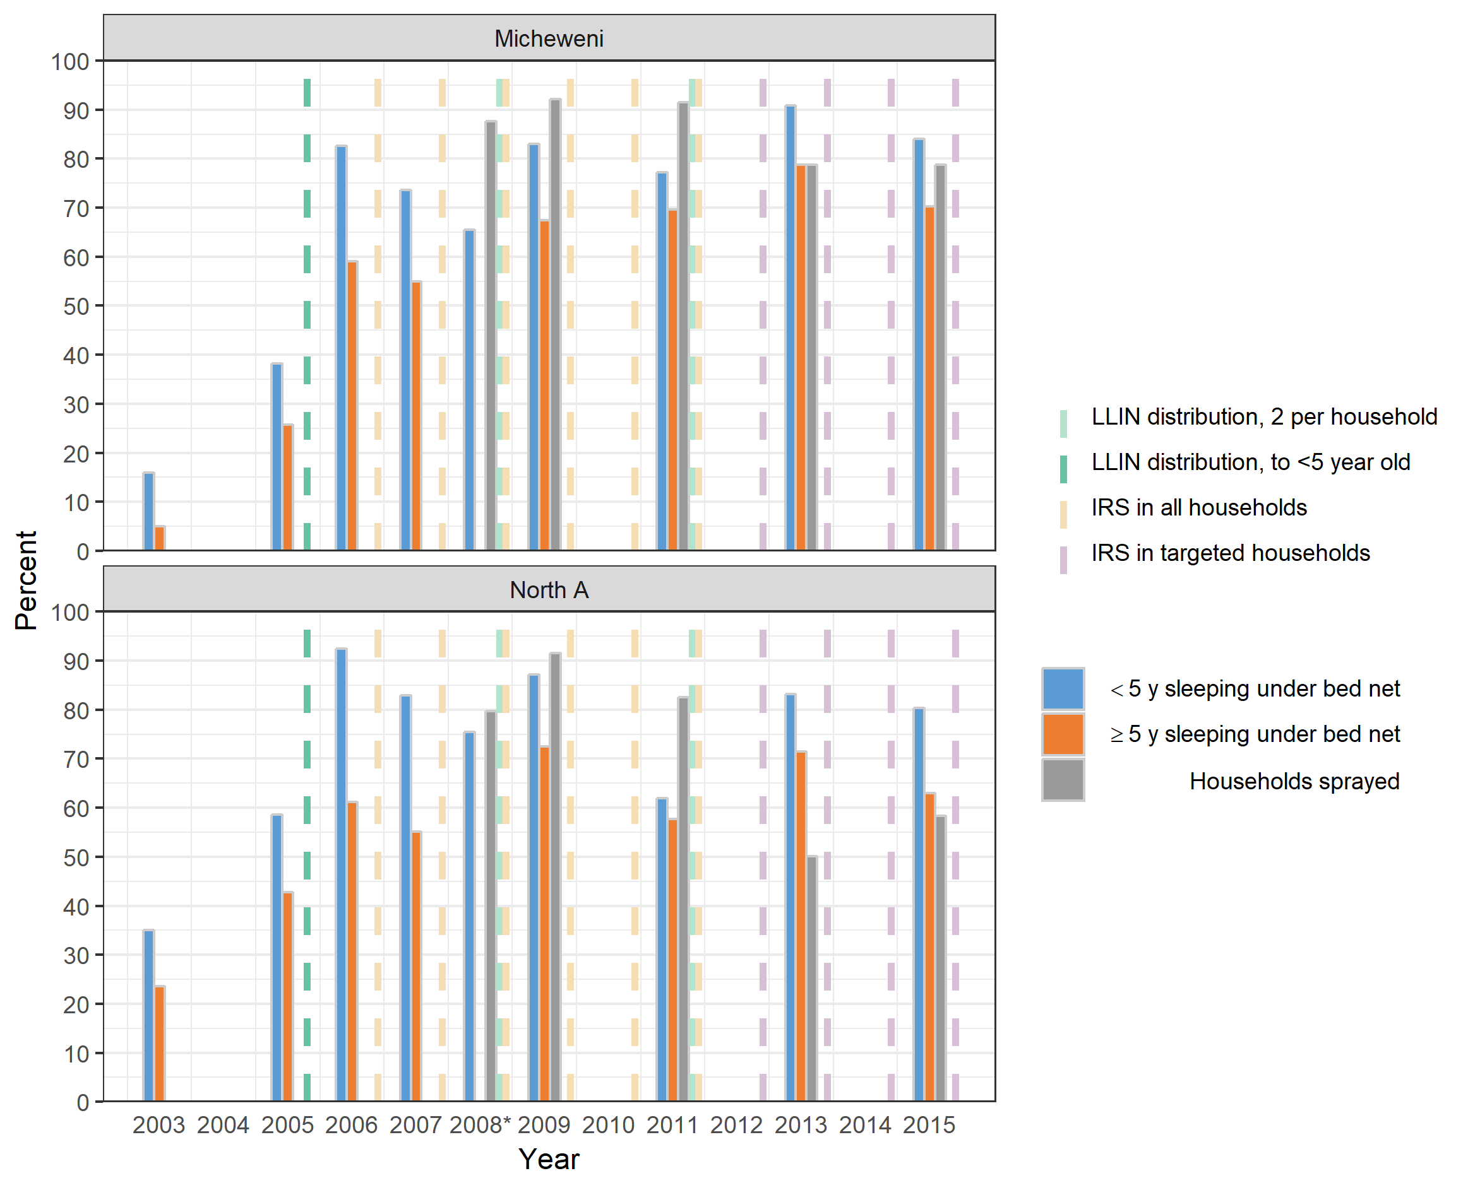

* Data for people >5 years were not available

Figure S2
Proportions of An. arabiensis among An. gambiae s.l mosquito samples collected in surveys on Unguja island, Zanzibar between 2005 and 2014.

