Additional file 1
Entire population (n= 120)
 | Correlation coefficient | p-value
Age | -0.05 | 0.62
Sex (M/F) | -0.01 | 0.86
BMI | 0.52 | <0.001
Waist circumference | 0.66 | <0.001
SBP | 0.18 | 0.11
DBP | 0.22 | 0.05
Copeptin | 0.25 | 0.01
FBG | 0.26 | 0.02
Total Cholesterol | -0.09 | 0.40
HDL | -0.27 | 0.02
LDL | -0.06 | 0.59
Triglycerides | 0.34 | 0.02
AST | 0.23 | 0.04
ALT | 0.39 | <0.001
FBI | 0.04 | 0.78
HOMA- β% | -0.08 | 0.59
HOMA-IR | 0.13 | 0.37
T2DM yes/no | 0.31 | 0.002
MS yes/no | 0.64 | <0.001
Number of MS’ components | 0.68 | <0.001

Table S1. Presence of NAFLD - Bivariate correlation analyses. Spearman’s coefficient, NAFLD is considered as a dichotomous variable (Yes/No)

Abbreviations: BMI – Body Mass Index, SBP – Systolic Blood Pressure, DBP – Diastolic Blood Pressure, FBG - fasting blood glucose, HDL-C - High-Density Lipoprotein Cholesterol, LDL-C - Low-Density Lipoprotein, AST - aspartate aminotransferase, ALT - alanine aminotransferase, GGT - gamma-glutamyl transpeptidase, FBI - Fasting blood insulin, HOMA-IR - HOmeostasis Model Assessment of insulin resistance, HOMA-β% - HOmeostasis Model Assessment of insulin secretion, MS – Metabolic Syndrome, T2DM – Type 2 Diabetes Mellitus.
Entire population (n= 120)
 | Correlation coefficient | p-value
Age | 0.089 | 0.38
Sex (M/F) | -0.34 | 0.001*
BMI | 0.06 | 0.53
Waist circumference | 0.26 | 0.034
SBP | 0.09 | 0.39
DBP | 0.02 | 0.86
FBG | -0.02 | 0.80
Total Cholesterol | -0.008 | 0.94
HDL-c | -0.14 | 0.18
LDL-c | -0.08 | 0.48
Triglycerides | -0.07 | 0.50
AST | 0.10 | 0.32
ALT | 0.18 | 0.08
GGT | 0.20 | 0.15
Serum creatinine | 0.26 | 0.012
Serum uric acid | 0.37 | 0.015
NAFLD (yes/no) | 0.25 | 0.01
T2DM (yes/no) | -0.13 | 0.17*
MS (yes/no) | 0.23 | 0.014*

Table S2. Copeptin- Bivariate correlation analyses (Pearson’s coefficient, *Spearman’s coefficient, copeptin is considered as a continue variable)
Abbreviations: BMI – Body Mass Index, SBP – Systolic Blood Pressure, DBP – Diastolic Blood Pressure, HDL-C - High-Density Lipoprotein Cholesterol, LDL-C - Low-Density Lipoprotein, , FBG - fasting blood glucose, AST - aspartate aminotransferase, ALT - alanine aminotransferase, GGT - gamma-glutamyl transpeptidase, FBG - fasting blood glucose, NAFLD – non-alcoholic fatty liver disease, NASH – non-alcoholic steatohepatitis, MS – Metabolic Syndrome, T2DM – Type 2 Diabetes Mellitus.

 |  | β | S.E. | Wald | β standardized | P value | Odd Ratio | 95% C.I.  Lower Upper
Model 1ª | Sex | 2.724 | 2.216 | 1.510 | 0.27 | 0.219 | 15.239 | 0.198 | 1173.787
Model 1ª | Age | 0.144 | 0.087 | 2.773 | 0.30 | 0.096 | 1.155 | 0.975 | 1.370
Model 1ª | BMI | 0.003 | 0.162 | 0.000 | 0.004 | 0.986 | 1.003 | 0.731 | 1.376
Model 1ª | Copeptin | 0.677 | 0.321 | 4.450 | 0.64 | 0.035 | 1.968 | 1.049 | 3.691
Model 1ª | HDL-c | -0.201 | 0.109 | 3.377 | -0.45 | 0.066 | 0.818 | 0.661 | 1.013
Model 1ª | Triglycerides | 0.036 | 0.019 | 3.592 | 0.75 | 0.058 | 1.037 | 0.999 | 1.076
Model 1ª | FBG | -0.047 | 0.053 | 0.785 | 0.39 | 0.375 | 0.954 | 0.860 | 1.058
Model 1ª | Constant | -6.475 | 8.969 | 0.521 |  | 0.470 | 0.002
Model 2ª | Sex | 2.729 | 2.198 | 1.542 | 0.27 | 0.214 | 15.317 | 0.206 | 1137.337
Model 2ª | Age | 0.145 | 0.087 | 2.781 | 0.31 | 0.095 | 1.155 | 0.975 | 1.369
Model 2ª | Copeptin | 0.676 | 0.320 | 4.471 | 0.64 | 0.034 | 1.967 | 1.051 | 3.682
Model 2ª | HDL-c | -0.200 | 0.107 | 3.530 | -0.45 | 0.060 | 0.819 | 0.664 | 1.009
Model 2ª | Triglycerides | 0.036 | 0.018 | 3.933 | 0.75 | 0.047 | 1.037 | 1.000 | 1.074
Model 2ª | FBG | -0.047 | 0.053 | 0.797 | 0.39 | 0.372 | 0.954 | 0.861 | 1.058
Model 2ª | Constant | -6.352 | 5.733 | 1.228 |  | 0.268 | 0.002
Model 3ª | Sex | 2.819 | 2.202 | 1.639 | 0.27 | 0.200 | 16.767 | 0.224 | 1256.396
Model 3ª | Age | 0.104 | 0.071 | 2.132 | 0.22 | 0.144 | 1.110 | 0.965 | 1.276
Model 3ª | Copeptin | 0.634 | 0.295 | 4.627 | 0.60 | 0.031 | 1.884 | 1.058 | 3.357
Model 3ª | HDL-c | -0.192 | 0.102 | 3.501 | -0.43 | 0.061 | 0.826 | 0.676 | 1.009
Model 3ª | Triglycerides | 0.032 | 0.017 | 3.626 | 0.67 | 0.057 | 1.033 | 0.999 | 1.067
Model 3ª | Constant | -8.612 | 5.429 | 2.516 |  | 0.113 | 0.000
Model 4ª | Age | 0.093 | 0.069 | 1.809 | 0.20 | 0.179 | 1.098 | 0.958 | 1.258
Model 4ª | Copeptin | 0.353 | 0.146 | 5.852 | 0.37 | 0.016 | 1.423 | 1.069 | 1.894
Model 4ª | HDL-c | -0.130 | 0.082 | 2.473 | -0.30 | 0.116 | 0.878 | 0.747 | 1.032
Model 4ª | Triglycerides | 0.025 | 0.014 | 3.248 | 0.58 | 0.071 | 1.026 | 0.998 | 1.054
Model 4ª | Constant | -5.432 | 4.224 | 1.654 |  | 0.198 | 0.004
Model 5ª | Copeptin | 0.323 | 0.140 | 5.375 | 0.32 | 0.020 | 1.382 | 1.051 | 1.817
Model 5ª | HDL-c | -0.084 | 0.054 | 2.489 | -0.18 | 0.115 | 0.919 | 0.827 | 1.021
Model 5ª | Triglycerides | 0.028 | 0.014 | 4.172 | 0.61 | 0.041 | 1.028 | 1.001 | 1.056
Model 5ª | Constant | -3.477 | 3.288 | 1.118 |  | 0.290 | 0.031

ª Variables entered on Model 1: Sex, Age, BMI, Copeptin, HDL-c, Triglycerides, FBG.

Cox & Snell R² = 0.56

Table S3. Multivariate logistic regression analysis. The presence of NASH is the dependent variable. Copeptin is considered as a continuous variable.
Abbreviations: S.E. - Standard Error, C.I. - Confidence Interval, BMI – Body Mass Index, HDL-c - High-Density Lipoprotein Cholesterol, FBG - fasting blood glucose

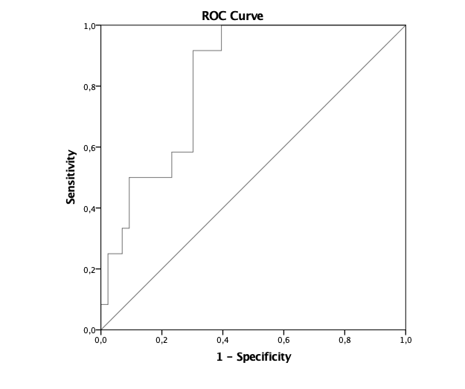

Area | Std. Errorª | Asymptotic Sig.^{b} | Asymptotic 95% Confidence Interval
Area | Std. Errorª | Asymptotic Sig.^{b} | Lower Bound | Upper Bound
0.822 | 0.057 | 0.001 | 0.709 | 0.934
a. Under the nonparametric assumption
b. Null hypothesis: true area = 0.5

Sensitivity: 92% - Specificity: 70% per plasma copeptin values > 8.06 pmol/L

Figure S1. Copeptin area under the receiver operating characteristic (ROC) curve for NASH.

