S2 Appendix – Density and convergence plots for imputed variables
Alex Pate
12/04/2018
The following document details the imputation process for imputing the dataset used to derive models A – F.

Contents
Methods 2
Results - Female Cohort 3
BMI 3
SBP 4
SBP standard deviation 5
Cholesterol 6
HDL 7
Smoking 8
Ethnicity 10
Results - Male Cohort 11
BMI 11
SBP 12
SBP standard deviation 13
Cholesterol 14
HDL 15
Smoking 16
Ethnicity 17

Methods
Imputation methods
We used multiple imputation by chained equations to impute missing data for body mass index (BMI), systolic blood pressure (SBP) and SBP variability, cholesterol, HDL, smoking status and ethnicity. The program used to impute the data was the R package MICE[1]. We imputed 20 datasets and carried out 20 iterations for each dataset. Variables included in the imputation models were all predictor variables from the final model (including interaction terms and fractional polynomials), Nelson Aalen estimate of the cumulative hazard at the time of event/censored and the censoring indicator. All continuous variables were imputed using predictive mean matching, and polytomous regression for categorical variables[1].

Imputation assessment methods
The density plots show assess whether there are any systematic differences in covariates for those with missing data and those without, i.e. supports the missing at random assumption. The convergence plots show the imputation had reached a steady state when we drew the values.

Results - Female Cohort

BMI
BMI convergence plot
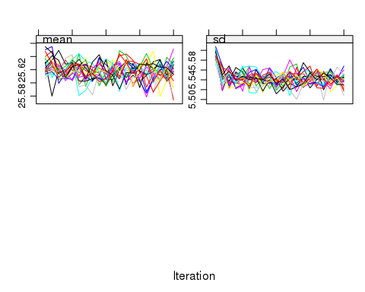
BMI density plot
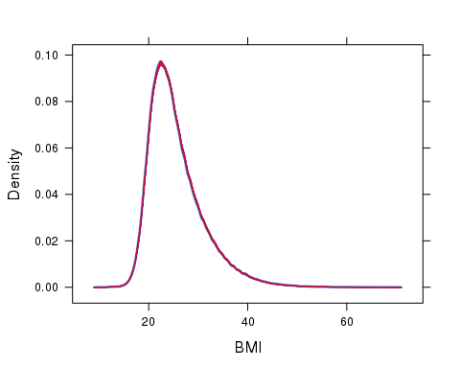

SBP

SBP convergence plot

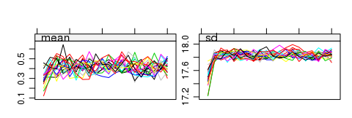
SBP density plot
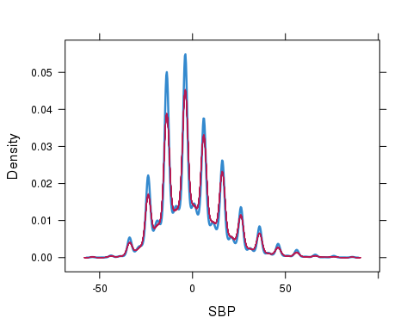

SBP standard deviation
SBP standard deviation convergence plot

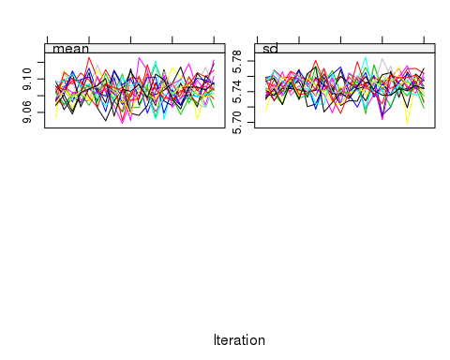
SBP standard deviation density plot
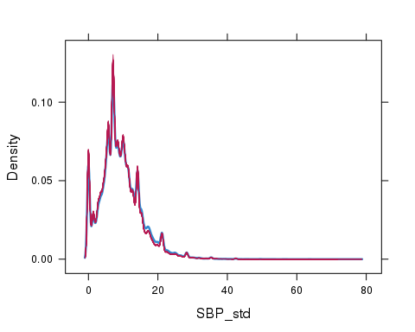

Cholesterol
Cholesterol convergence plot
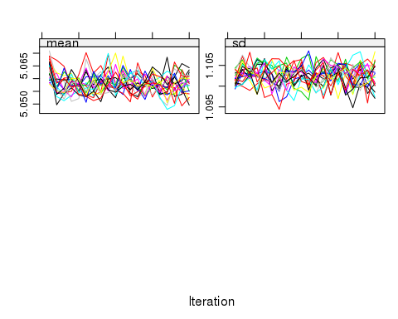
Cholesterol density plot
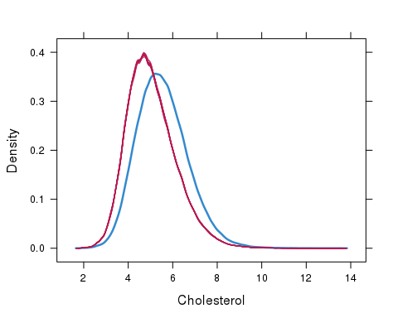

HDL
HDL convergence plot
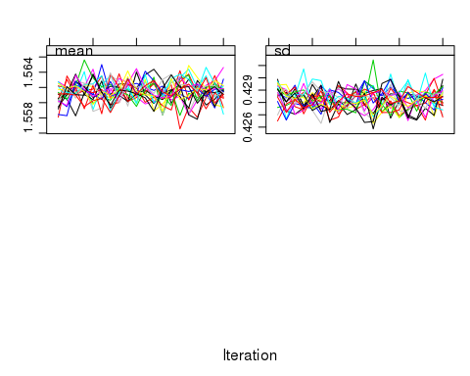
HDL density plot
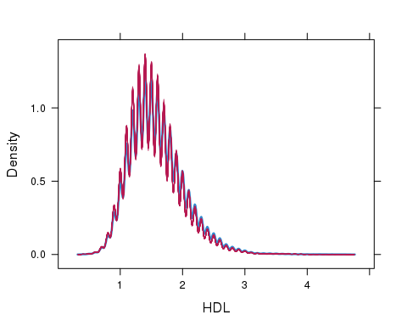

Smoking
Distribution of non missing data

Var1 | Freq
Never | 56.03
Ex | 16.98
Current | 27.00
Distribution of imputed data (by imputation)

 | Never | Ex | Current
1 | 57.92 | 16.15 | 25.93
2 | 58.33 | 16.27 | 25.40
3 | 58.78 | 15.76 | 25.47
4 | 57.50 | 15.96 | 26.55
5 | 59.48 | 15.92 | 24.61
6 | 58.98 | 16.12 | 24.90
7 | 57.65 | 15.90 | 26.45
8 | 57.94 | 15.77 | 26.29
9 | 58.33 | 15.71 | 25.96
10 | 59.18 | 15.70 | 25.12
11 | 58.90 | 16.05 | 25.05
12 | 59.06 | 15.45 | 25.49
13 | 58.35 | 15.77 | 25.88
14 | 57.90 | 16.19 | 25.91
15 | 58.62 | 15.78 | 25.60
16 | 58.56 | 16.00 | 25.44
17 | 58.84 | 15.69 | 25.46
18 | 59.23 | 15.11 | 25.66
19 | 58.50 | 15.65 | 25.85
20 | 59.45 | 15.56 | 25.00

Ethnicity

Imp | asianother | bangladesh | black | chinese | indian | mixed | oth_asian | other | pakistani | white
Real data | 1.55 | 0.33 | 4.13 | 0.77 | 2.70 | 1.06 | 0.42 | 1.94 | 1.07 | 86.02
1 | 1.30 | 1.00 | 3.67 | 1.06 | 3.20 | 1.12 | 1.03 | 2.19 | 1.88 | 83.56
2 | 1.30 | 2.11 | 3.92 | 1.79 | 3.91 | 2.67 | 0.28 | 2.09 | 1.74 | 80.19
3 | 1.33 | 0.93 | 5.07 | 1.57 | 4.49 | 1.87 | 0.44 | 2.76 | 2.00 | 79.54
4 | 1.80 | 1.58 | 5.58 | 0.69 | 2.56 | 1.45 | 0.86 | 2.81 | 1.85 | 80.82
5 | 1.26 | 1.06 | 4.70 | 3.32 | 2.01 | 0.86 | 1.52 | 0.94 | 1.18 | 83.16
6 | 1.98 | 0.66 | 5.78 | 2.78 | 2.50 | 1.48 | 0.82 | 1.68 | 2.67 | 79.66
7 | 1.45 | 0.62 | 6.16 | 0.36 | 2.28 | 1.86 | 0.54 | 1.02 | 2.53 | 83.18
8 | 0.89 | 1.41 | 4.20 | 1.58 | 5.21 | 1.60 | 0.47 | 2.76 | 2.45 | 79.43
9 | 0.96 | 0.95 | 8.73 | 0.45 | 2.68 | 1.25 | 0.71 | 1.29 | 1.35 | 81.64
10 | 0.94 | 1.59 | 6.07 | 0.84 | 3.33 | 1.77 | 0.95 | 4.29 | 0.99 | 79.23
11 | 0.55 | 0.59 | 5.31 | 0.69 | 1.66 | 0.96 | 1.34 | 1.16 | 1.19 | 86.56
12 | 1.01 | 1.03 | 4.60 | 0.49 | 2.62 | 0.45 | 1.54 | 0.90 | 1.19 | 86.17
13 | 1.04 | 1.28 | 4.40 | 0.86 | 3.04 | 1.29 | 1.24 | 1.13 | 1.64 | 84.07
14 | 1.33 | 0.57 | 4.69 | 0.40 | 2.16 | 0.48 | 0.73 | 1.65 | 1.32 | 86.68
15 | 1.99 | 1.03 | 4.15 | 1.01 | 2.98 | 0.51 | 1.52 | 1.56 | 1.39 | 83.85
16 | 1.32 | 1.05 | 5.78 | 0.91 | 3.61 | 1.28 | 1.33 | 1.99 | 2.78 | 79.94
17 | 1.46 | 0.79 | 5.01 | 0.73 | 3.04 | 1.03 | 1.26 | 3.00 | 2.43 | 81.24
18 | 0.81 | 1.51 | 5.93 | 0.72 | 3.11 | 2.07 | 1.13 | 1.53 | 1.56 | 81.63
19 | 1.76 | 0.47 | 3.74 | 0.74 | 3.38 | 1.14 | 0.76 | 1.44 | 0.99 | 85.59
20 | 2.00 | 0.50 | 4.01 | 1.36 | 2.24 | 1.82 | 1.49 | 2.32 | 7.29 | 76.97

Results - Male Cohort

BMI
BMI convergence plot
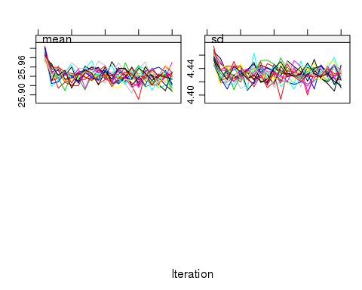
BMI density plot
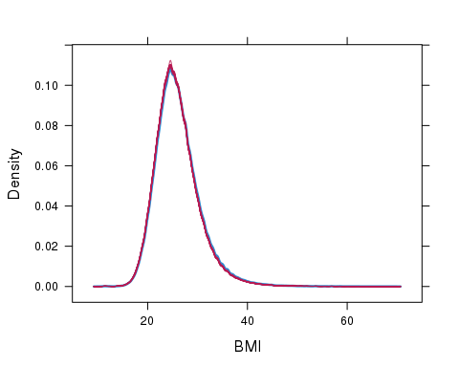

SBP
SBP convergence plot
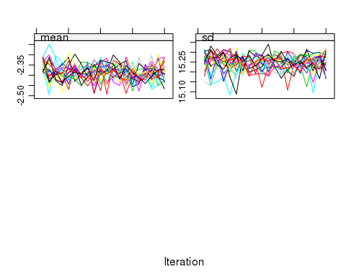
SBP density plot
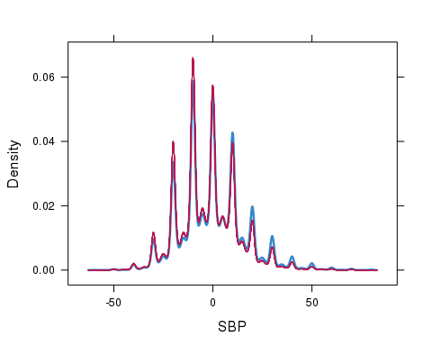

SBP standard deviation
SBP standard deviation convergence plot
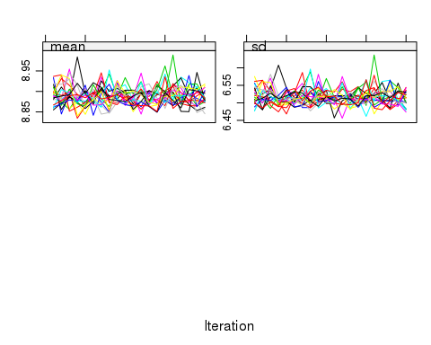
SBP standard deviation density plot
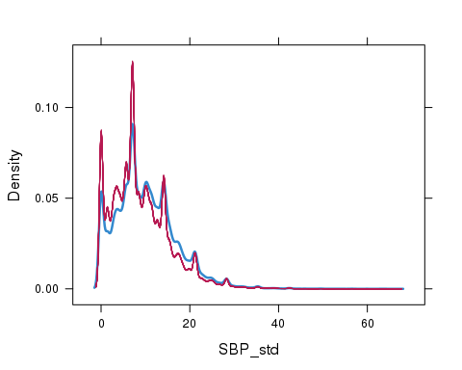

Cholesterol
Cholesterol convergence plot
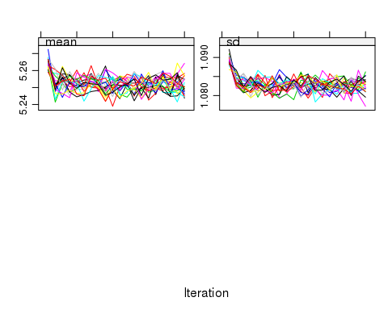
Cholesterol density plot
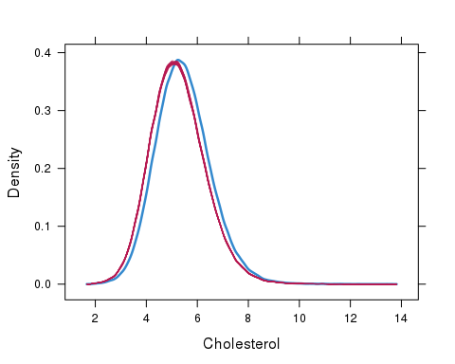

HDL
HDL convergence plot
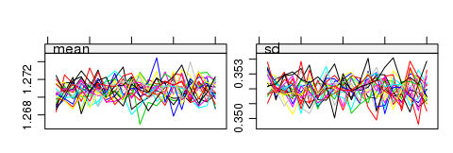
HDL density plot
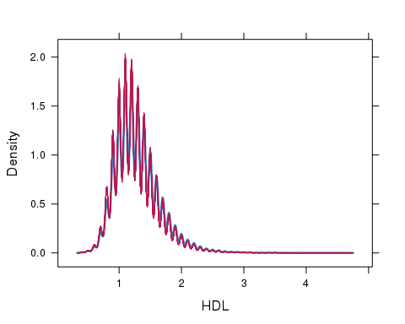

Smoking
Distribution of non missing data

Var1 | Freq
Never | 46.68
Ex | 17.39
Current | 35.93
Distribution of imputed data (by imputation)
Imp | Never | Ex | Current
1 | 48.44 | 17.29 | 34.27
2 | 48.65 | 17.20 | 34.15
3 | 48.83 | 17.05 | 34.12
4 | 48.20 | 17.51 | 34.29
5 | 48.35 | 17.24 | 34.40
6 | 48.31 | 17.34 | 34.35
7 | 48.23 | 17.27 | 34.50
8 | 48.28 | 17.34 | 34.39
9 | 48.20 | 17.36 | 34.44
10 | 48.76 | 17.03 | 34.22
11 | 48.43 | 17.18 | 34.39
12 | 48.18 | 17.30 | 34.51
13 | 47.90 | 17.35 | 34.75
14 | 48.32 | 17.45 | 34.23
15 | 48.37 | 17.36 | 34.27
16 | 48.62 | 17.21 | 34.18
17 | 48.43 | 17.21 | 34.35
18 | 48.21 | 17.42 | 34.37
19 | 48.16 | 17.24 | 34.60
20 | 49.21 | 17.06 | 33.70

Ethnicity

Imp | asianother | bangladesh | black | chinese | indian | mixed | oth_asian | other | pakistani | white
Real data | 1.55 | 0.5 | 4.00 | 0.61 | 3.11 | 0.99 | 0.49 | 1.95 | 1.26 | 85.54
1 | 2.62 | 1.24 | 3.97 | 1.64 | 4.49 | 2.44 | 2.39 | 2.63 | 3.48 | 75.11
2 | 2.36 | 1.86 | 3.58 | 1.75 | 1.88 | 1.68 | 2.27 | 1.53 | 3.39 | 79.70
3 | 2.16 | 1.20 | 4.93 | 0.86 | 3.54 | 1.53 | 1.52 | 2.69 | 2.72 | 78.84
4 | 1.17 | 0.61 | 6.83 | 0.17 | 2.30 | 1.41 | 1.12 | 1.61 | 1.74 | 83.04
5 | 2.53 | 2.19 | 2.39 | 2.12 | 2.81 | 2.59 | 2.11 | 1.99 | 4.74 | 76.52
6 | 2.88 | 1.35 | 2.94 | 2.26 | 4.70 | 1.55 | 1.89 | 1.81 | 3.40 | 77.23
7 | 0.82 | 0.57 | 2.44 | 1.35 | 1.72 | 1.27 | 0.79 | 0.73 | 2.13 | 88.19
8 | 1.99 | 1.09 | 2.02 | 1.01 | 1.85 | 1.45 | 0.92 | 1.63 | 2.72 | 85.35
9 | 1.67 | 1.10 | 3.44 | 0.75 | 2.56 | 1.10 | 1.18 | 1.02 | 2.54 | 84.65
10 | 2.69 | 2.31 | 3.05 | 1.06 | 2.82 | 2.50 | 2.00 | 2.41 | 4.49 | 76.66
11 | 1.44 | 0.99 | 2.19 | 0.80 | 1.40 | 1.50 | 1.59 | 0.59 | 2.07 | 87.44
12 | 1.84 | 0.91 | 2.06 | 1.15 | 1.74 | 1.36 | 0.89 | 1.94 | 2.35 | 85.75
13 | 1.42 | 0.97 | 1.95 | 1.31 | 1.03 | 1.10 | 1.65 | 1.08 | 1.98 | 87.51
14 | 0.97 | 0.82 | 1.87 | 0.67 | 3.07 | 0.83 | 0.97 | 1.97 | 1.66 | 87.16
15 | 1.16 | 1.17 | 1.67 | 1.52 | 1.14 | 1.33 | 1.68 | 1.38 | 3.00 | 85.96
16 | 1.54 | 1.33 | 2.88 | 0.93 | 1.36 | 1.18 | 1.68 | 0.88 | 2.42 | 85.81
17 | 1.27 | 0.65 | 3.94 | 0.70 | 3.75 | 2.64 | 0.60 | 1.72 | 1.56 | 83.17
18 | 1.33 | 1.08 | 2.16 | 0.97 | 2.72 | 0.77 | 0.86 | 1.51 | 1.96 | 86.65
19 | 1.59 | 0.73 | 2.42 | 0.71 | 2.68 | 0.74 | 0.68 | 0.45 | 1.33 | 88.66
20 | 4.76 | 1.87 | 15.10 | 1.64 | 4.89 | 2.42 | 1.66 | 7.36 | 4.60 | 55.71

