Additional File 1 for “Travel time to health facilities in areas of viral hemorrhagic fever outbreak potential: maps for guiding local preparedness and response”

Table of Contents
Additional Figures 2
Additional Tables 3
1.0 GATHER compliance 4
2.0 Methodology 6
3.0 Additional Results 9

Additional Figures
Figure S1 Data flow for travel time to most accessible hospital for areas with VHF spillover potential 6
Figure S2 Data flow for travel time to any grid-cell at risk for VHF spillover from any other location 7
Figure S3 Data flow for reductions in travel time via new resource allocation 8
Figure S4 Absolute travel times to health facilities from areas with potential for VHF spillover, sub-Saharan Africa 9
Figure S5 Travel times to the most accessible health facility by foot for Central African Republic 10
Figure S6 Maps of the uncertainty around the Ebola environmental suitability niche maps for Cote d’Ivoire 11
Figure S7 Maps of the uncertainty around the Marburg environmental suitability niche maps for Cote d’Ivoire 12
Figure S8 Maps of the uncertainty around the CCHF environmental suitability niche maps for Cote d’Ivoire 13
Figure S9 Maps of the uncertainty around the CCHF environmental suitability niche maps for Cote d’Ivoire 14
Figure S10 Violin plots of the distribution of travel times (in hours) from areas with VHF spillover event potential, by country 15

Additional Tables
Table S1 Guidelines for Accurate and Transparent Health Estimates Reporting (GATHER) checklist 4
Table S2 Travel time to most accessible hospital from locations with VHF spillover event potential, Angola 16
Table S3 Travel time to most accessible hospital from locations with Ebola cases (2018-2019), Democratic Republic of the Congo 17
Table S4 Travel time to most accessible hospital from locations with Ebola cases (2018-2019), Uganda 18
Table S5 Travel time to most accessible hospital from locations with Ebola cases (2018-2019), Rwanda 19
Table S6 Travel time to most accessible hospital from locations with Ebola cases (2018-2019), South Sudan 20
Table S7 Terms used for facility stratification by country 21

- GATHER Compliance
Table S1. Guidelines for Accurate and Transparent Health Estimates Reporting (GATHER) checklist.
Item # | Checklist item | Reported on page #
Objectives and Funding
1 | Define the indicator(s), populations (including age, sex, and geographic entities), and time period(s) for which estimates were made. | Main text: Introduction
2 | List the funding sources for the work. | Main text: Acknowledgements
Data Inputs
For all data inputs from multiple sources that are synthesized as part of the study:
3 | Describe how the data were identified and how the data were accessed. | Main text: Methods (data sources) pages 9-11  Additional File: Additional Figure S1 page 6
4 | Specify the inclusion and exclusion criteria. Identify all ad-hoc exclusions. | Main text: Methods (data sources) pages 9-11  Additional File: Additional Figure S1 page 6
5 | Provide information on all included data sources and their main characteristics. For each data source used, report reference information or contact name/institution, population represented, data collection method, year(s) of data collection, sex and age range, diagnostic criteria or measurement method, and sample size, as relevant. | Main text: Methods (data sources) pages 9-11  Additional File: Additional Figure S1 page 6
6 | Identify and describe any categories of input data that have potentially important biases (e.g., based on characteristics listed in item 5). | Main text: Discussion pages 19-25
For data inputs that contribute to the analysis but were not synthesized as part of the study:
7 | Describe and give sources for any other data inputs. | NA
For all data inputs:
8 | Provide all data inputs in a file format from which data can be efficiently extracted (e.g., a spreadsheet rather than a PDF), including all relevant meta-data listed in item 5. For any data inputs that cannot be shared because of ethical or legal reasons, such as third-party ownership, provide a contact name or the name of the institution that retains the right to the data. | http://ghdx.healthdata.org/record/ihme-data/travel-time-health-facilities-vhf-outbreak-preparedness-africa
9 | Provide a conceptual overview of the data analysis method. A diagram may be helpful. | Main text: Methods (data sources) pages 9-11  Additional File: Additional Figure S1 page 6
10 | Provide a detailed description of all steps of the analysis, including mathematical formulae. This description should cover, as relevant, data cleaning, data pre-processing, data adjustments and weighting of data sources, and mathematical or statistical model(s). | Main text: Methods (data sources) pages 9-11
11 | Describe how candidate models were evaluated and how the final model(s) were selected. | NA
12 | Provide the results of an evaluation of model performance, if done, as well as the results of any relevant sensitivity analysis. | Additional File: Additional Figure S1 page 6
13 | Describe methods for calculating uncertainty of the estimates. State which sources of uncertainty were, and were not, accounted for in the uncertainty analysis. | Main text: Methods (data sources) pages 9-11  Additional File: Additional Figure S1 page 6
14 | State how analytic or statistical source code used to generate estimates can be accessed. | http://ghdx.healthdata.org/record/ihme-data/travel-time-health-facilities-vhf-outbreak-preparedness-africa
Results and Discussion
15 | Provide published estimates in a file format from which data can be efficiently extracted. | http://ghdx.healthdata.org/record/ihme-data/travel-time-health-facilities-vhf-outbreak-preparedness-africa
16 | Report a quantitative measure of the uncertainty of the estimates (e.g. uncertainty intervals). | Additional Information:  Additional Figures S6-S9 pages 11-14  http://ghdx.healthdata.org/record/ihme-data/travel-time-health-facilities-vhf-outbreak-preparedness-africa
17 | Interpret results in light of existing evidence. If updating a previous set of estimates, describe the reasons for changes in estimates. | Main text: Results pages 14-18
18 | Discuss limitations of the estimates. Include a discussion of any modelling assumptions or data limitations that affect interpretation of the estimates. | Main text: Results pages 17-18

- Methodology
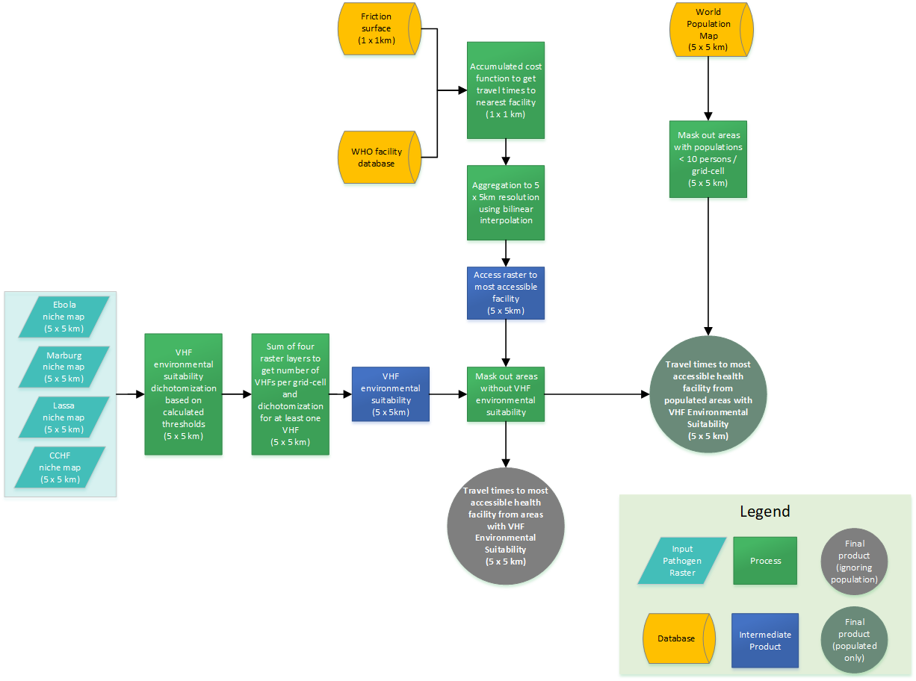
Figure S1. Data flow for travel time to most accessible hospital for areas with VHF spillover potential. This data flow visualization demonstrates the flow of data from ecological niche maps for the four viral hemorrhagic fevers (light blue parallelograms) through the incorporation of the other three data sources (WHO health facilities, WorldPop raster layer, and the Malaria Atlas Project’s friction surface, in yellow) and through raster manipulation to the final product of a raster of travel times to the nearest health facility from locations with VHF spillover potential, both overall (grey circle) and masking out un-populated areas (green circle).

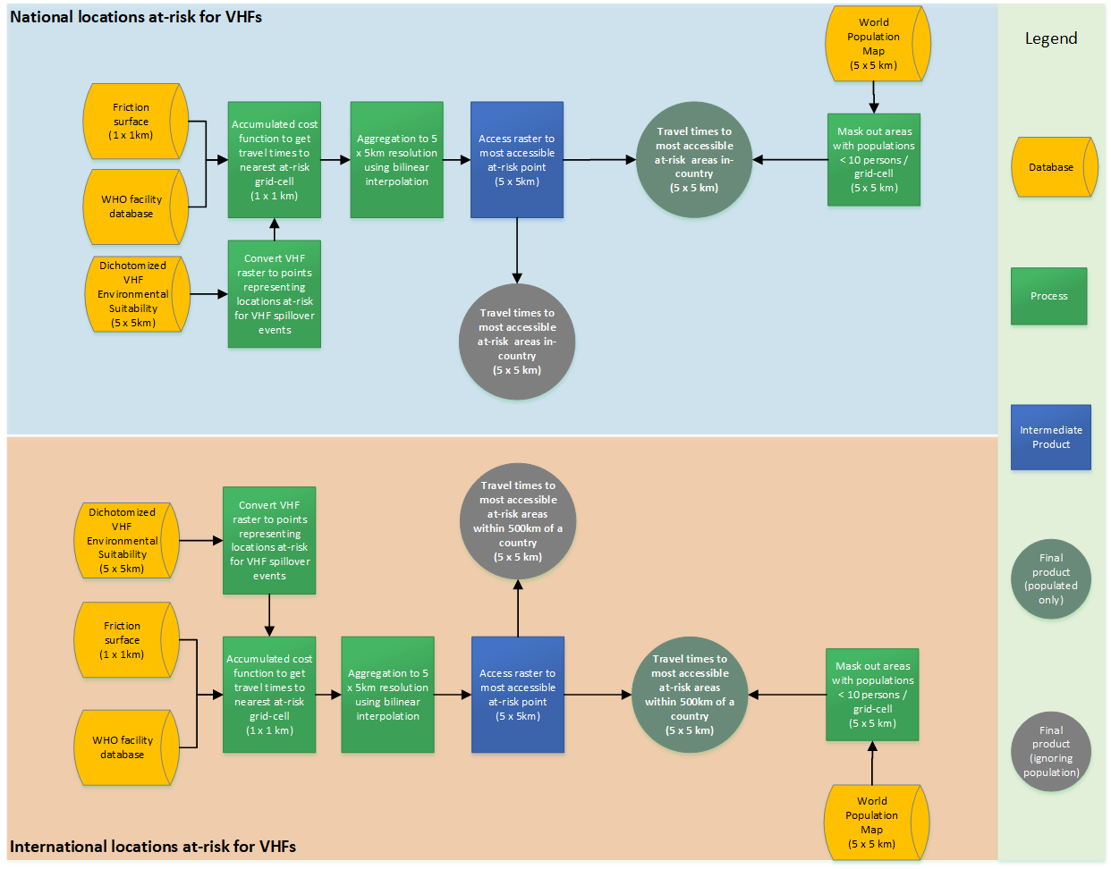
Figure S2. Data flow for travel time to any grid-cell at risk for VHF spillover from any other location. This data flow visualization demonstrates the flow of data from three data sources (dichotomized ecological niche maps for four VHFs, WorldPop raster layer, and the Malaria Atlas Project’s friction surface, in yellow) and through raster manipulation to the final product of a raster of travel times to the nearest at-risk grid-cell from locations not at-risk both overall (grey circle) and masking out un-populated areas (green circle). The top half of the figure (shaded blue) demonstrates times to at-risk grids in-country, while the bottom half (shaded orange) represents times to at-risk grids within 500km of a country’s borders.

Figure S3. Data flow for reductions in travel time via new resource allocation. This data flow visualization demonstrates the flow of data to produce the travel time reduction maps. The Malaria Atlas Project’s friction surface and WHO facility database (yellow databases) are combined to produce the accumulated cost surface, which is then aggregated to 5 x 5 km resolution, and converted to a surface of points. We sequentially place new infrastructure in each of these grid-cells, and recalculate travel times to the most accessible facility for each new point. For the unweighted map, we then subtract this assessment, with areas without VHF spillover event potential masked out, from the contemporary assessment to get the mean reduction in travel time to new infrastructure. For the weighted map, we multiply the travel times by the population in that grid-cell to get a map of the mean population-weighted reduction in travel times.
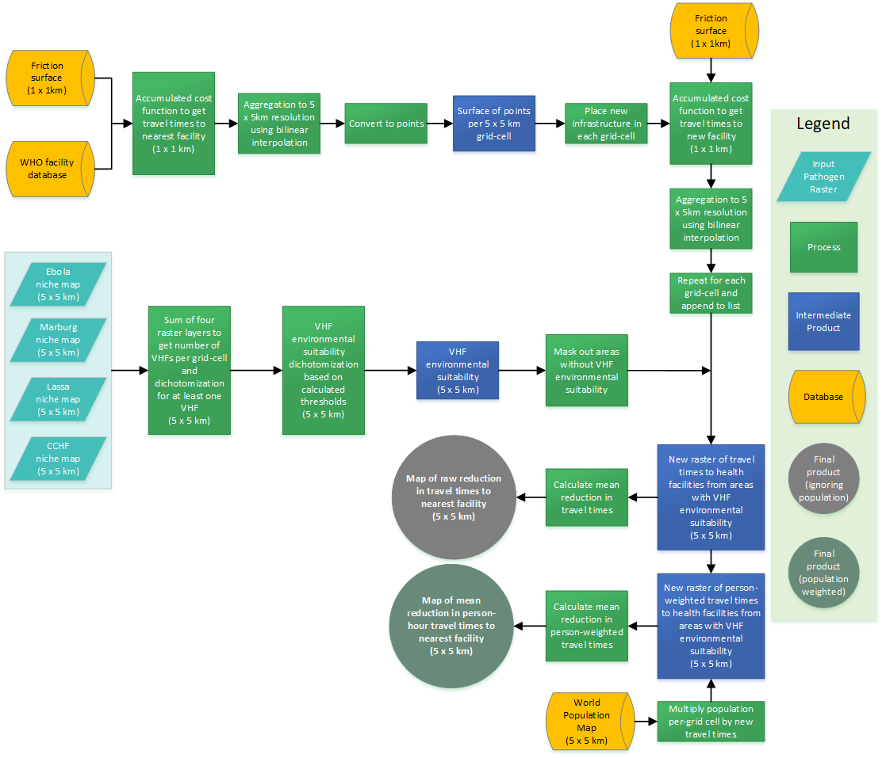

- Supplementary Material
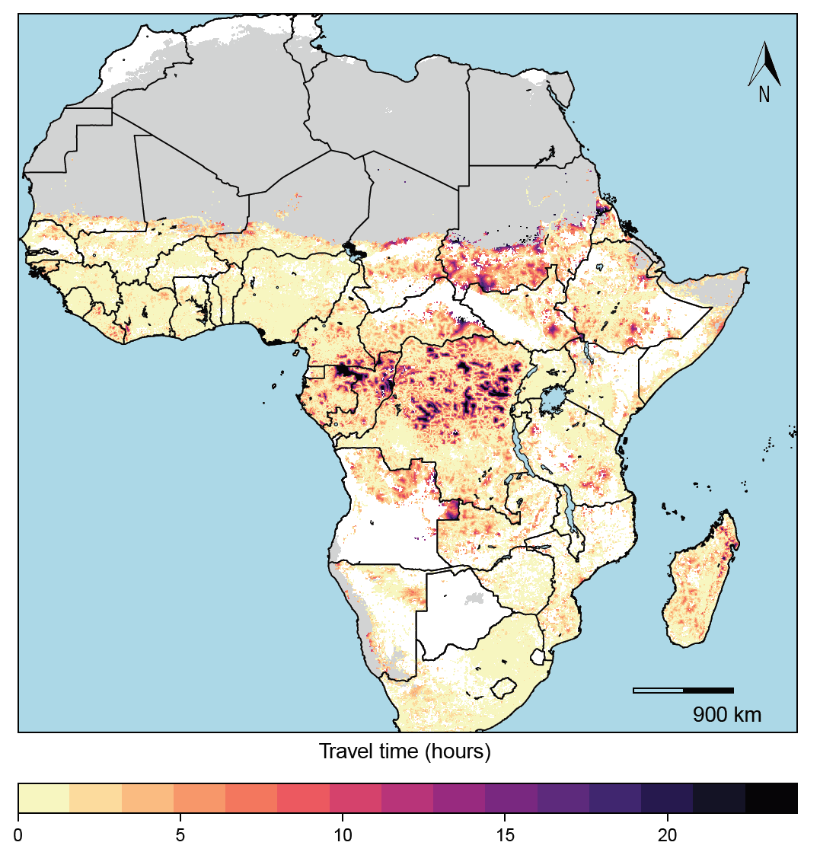
Figure S4. Absolute travel times to health facilities from areas with potential for VHF spillover, sub-Saharan Africa. This figure portrays absolute travel times with the longest travel times presented in dark purple and the shortest travel times in light yellow. Those areas in grey are unpopulated regions while those areas in white do not have potential for VHF spillover events.
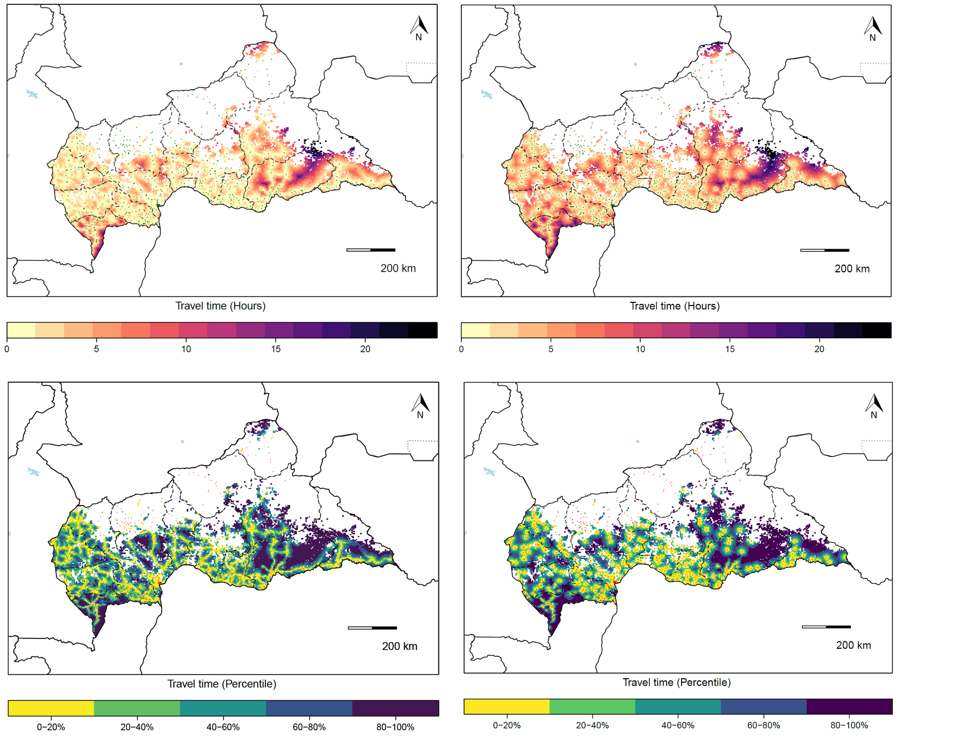
Figure S5. Travel times to the most accessible health facility by foot for Central African Republic. Panel a) presents the results of the assessment of the travel time to health facilities using the original friction layer which presents the absolute travel times using the fastest available means of travel while panel b) presents the absolute travel times using the foot-travel only layer. Panel c) presents the results of the assessment of percentile-ranked travel times using the original friction layer, while panel d) presents the percentile-ranked travel times using the foot-travel only layer.
d
c
b
a

Figure S6. Maps of the uncertainty around the Ebola environmental suitability niche maps for Cote d’Ivoire. The first panel (a) demonstrates the travel times to health facilities from areas with spillover event potential using the most conservative 95th percentile (0.468) as a threshold for classifying whether a grid-cell has spillover event potential, panel (b) uses the median (0.349) as the threshold, and panel (c) uses the least conservative 5th percentile (0.210) as the threshold.
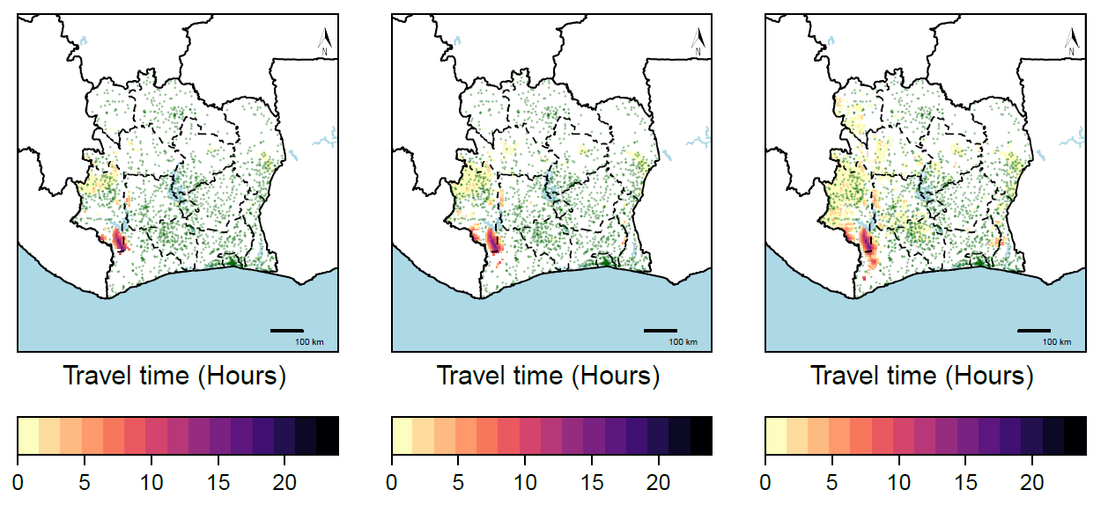
c
b
a

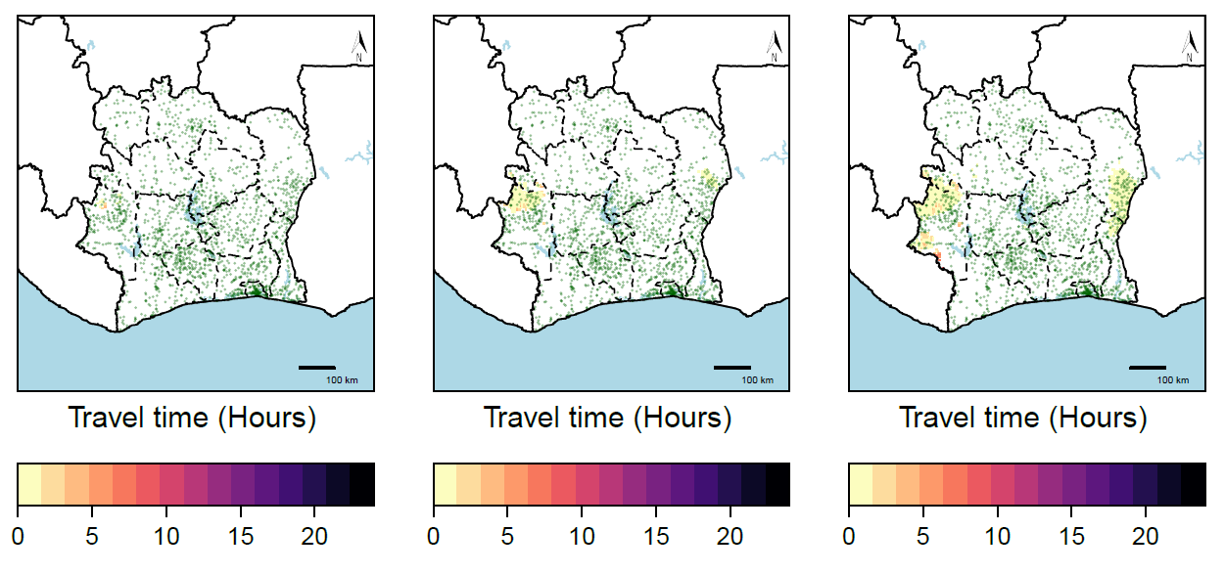
Figure S7. Maps of the uncertainty around the Marburg environmental suitability niche maps for Cote d’Ivoire. The first panel (a) demonstrates the travel times to health facilities from areas with spillover event potential using the most conservative 95th percentile (0.608) as a threshold for classifying whether a grid-cell has spillover event potential, panel (b) uses the median (0.399) as the threshold, and panel (c) uses the least conservative 5th percentile (0.300) as the threshold.
c
b
a

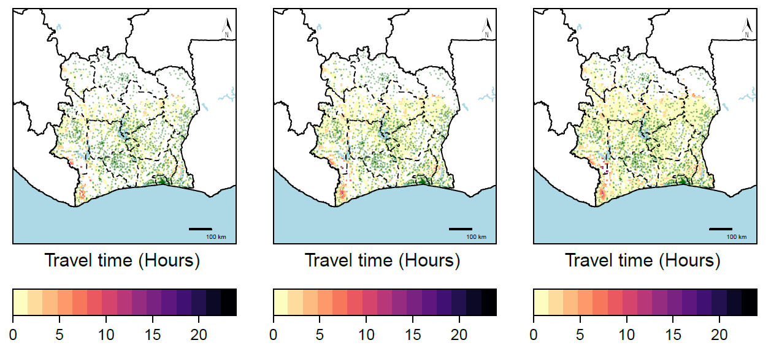
Figure S8. Maps of the uncertainty around the CCHF environmental suitability niche maps for Cote d’Ivoire. The first panel (a) demonstrates the travel times to health facilities from areas with spillover event potential using the most conservative 95th percentile (0.025) as a threshold for classifying whether a grid-cell has spillover event potential, panel (b) uses the median (0.019) as the threshold, and panel (c) uses the least conservative 5th percentile (0.014) as the threshold.
c
b
a

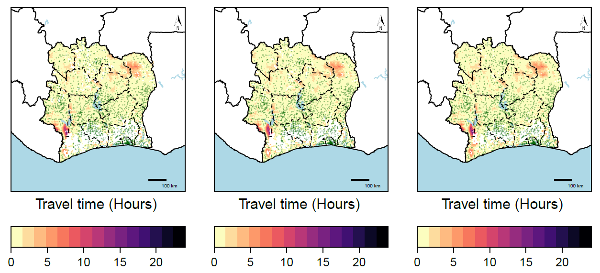
Figure S9. Maps of the uncertainty around the Lassa environmental suitability niche maps for Cote d’Ivoire. The first panel (a) demonstrates the travel times to health facilities from areas with spillover event potential using the most conservative 95th percentile (0.443) as a threshold for classifying whether a grid-cell has spillover event potential, panel (b) uses the median (0.396) as the threshold, and panel (c) uses the least conservative 5th percentile (0.339) as the threshold.
c
b
a

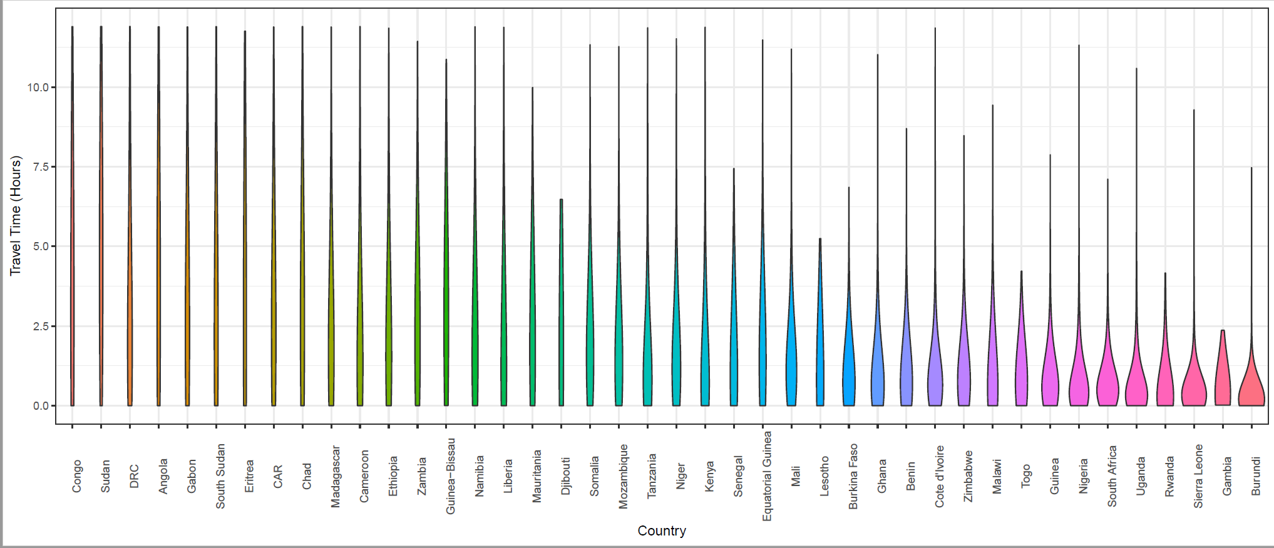
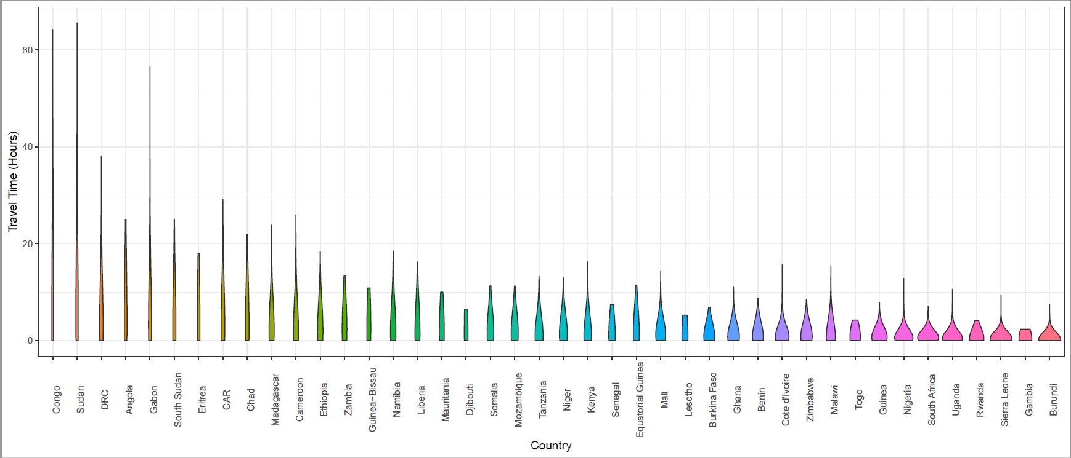
Figure S10. Violin plots of the distribution of travel times (in hours) from areas with VHF spillover event potential, by country. Panel a) presents the un-trimmed travel times by country while panel b) restricts the maximum travel time to 12+ hours to more closely evaluate the distributions in under one half-day of travel.
B
A

Table S2 Travel time to nearest locations with VHF spillover event potential from all hospitals in Angola. This table presents the travel times to a location with VHF spillover event potential from hospitals (with their first administrative unit in parentheses) in rank order, colored by hours of travel. 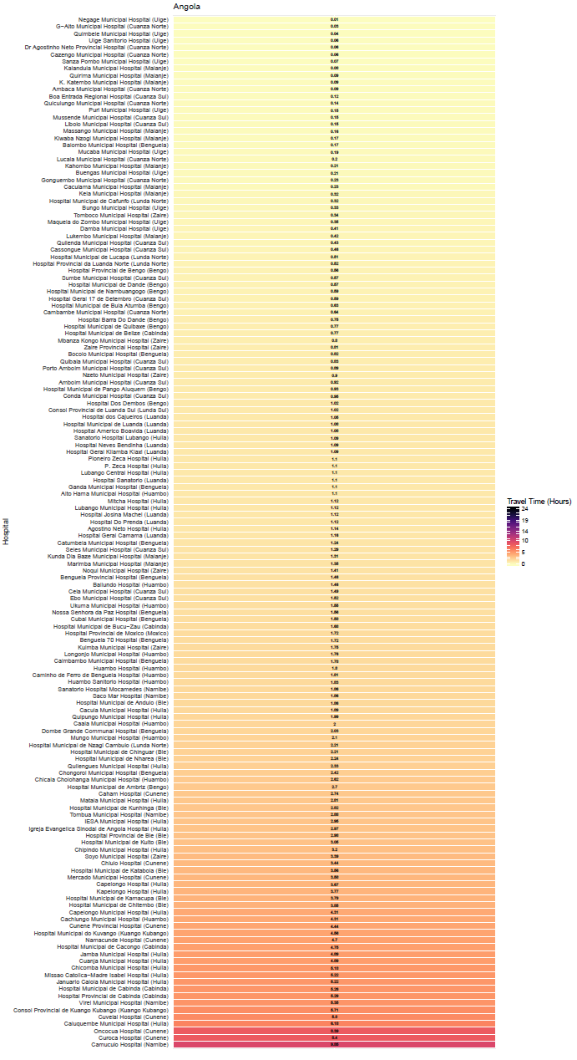
Table S3 Travel time to most accessible hospital from locations with Ebola cases (2018-2019), Democratic Republic of the Congo. This table presents the travel times from the twenty closest hospitals in the Democratic Republic of the Congo to a location with Ebola cases based on case data from the WHO’s Situation Report 50, published July 16, 2019. The hospitals are presented in rank-order from closest (shortest travel times) to furthest (longest travel time) among the twenty.
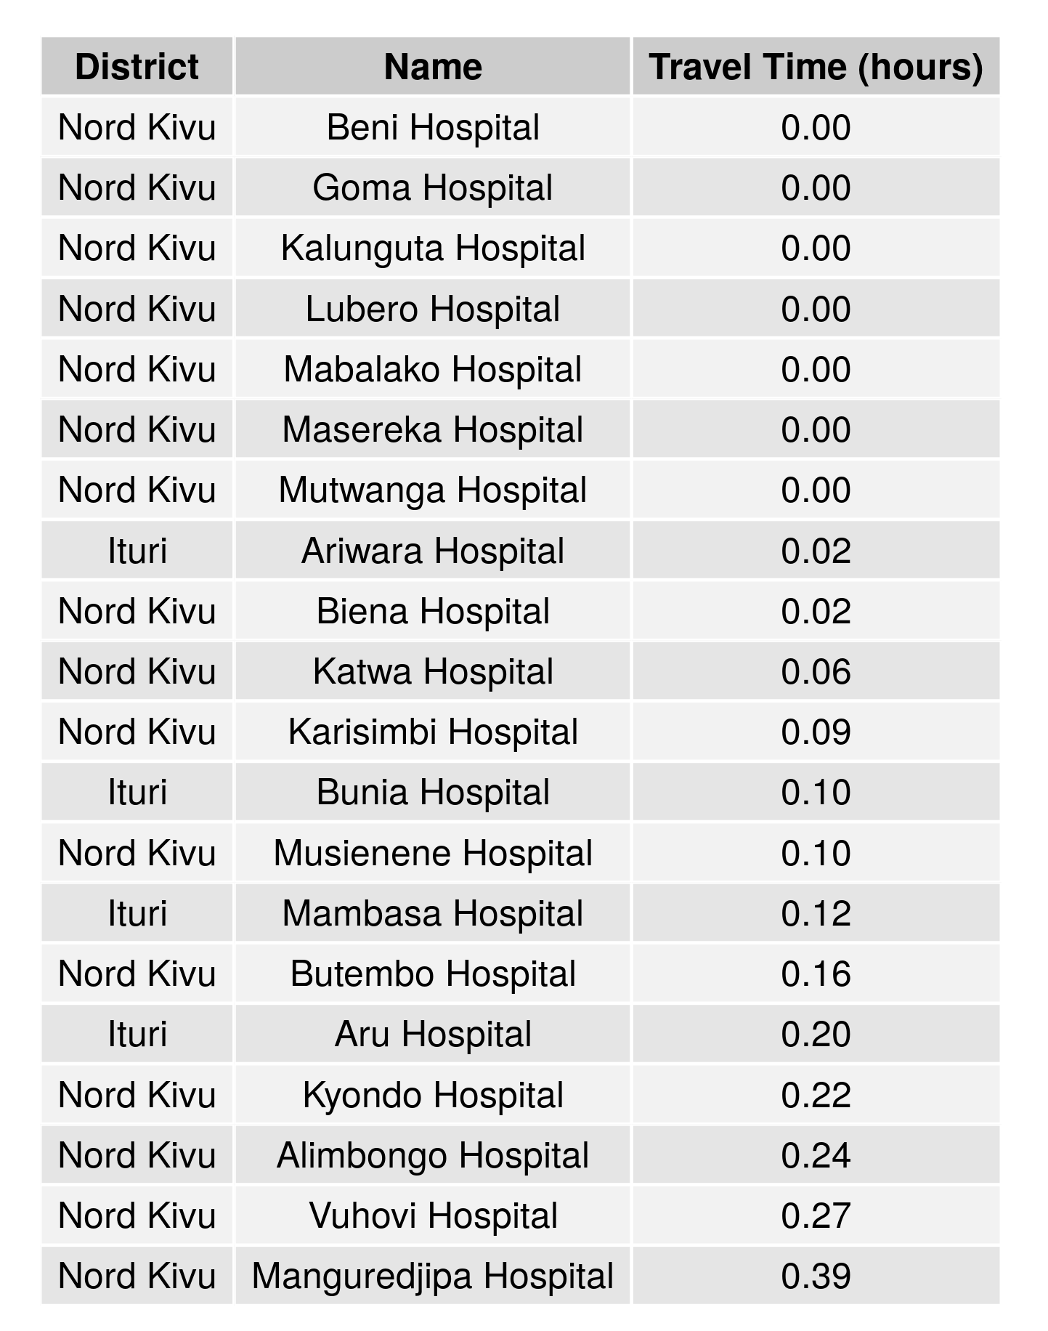
Table S4. Travel time to most accessible hospital from locations with Ebola cases (2018-2019), Uganda. This table presents the travel times from the twenty closest hospitals in Uganda to a location with Ebola cases based on case data from the WHO’s Situation Report 50, published July 16, 2019. The hospitals are presented in rank-order from closest (shortest travel times) to furthest (longest travel time) among the twenty.
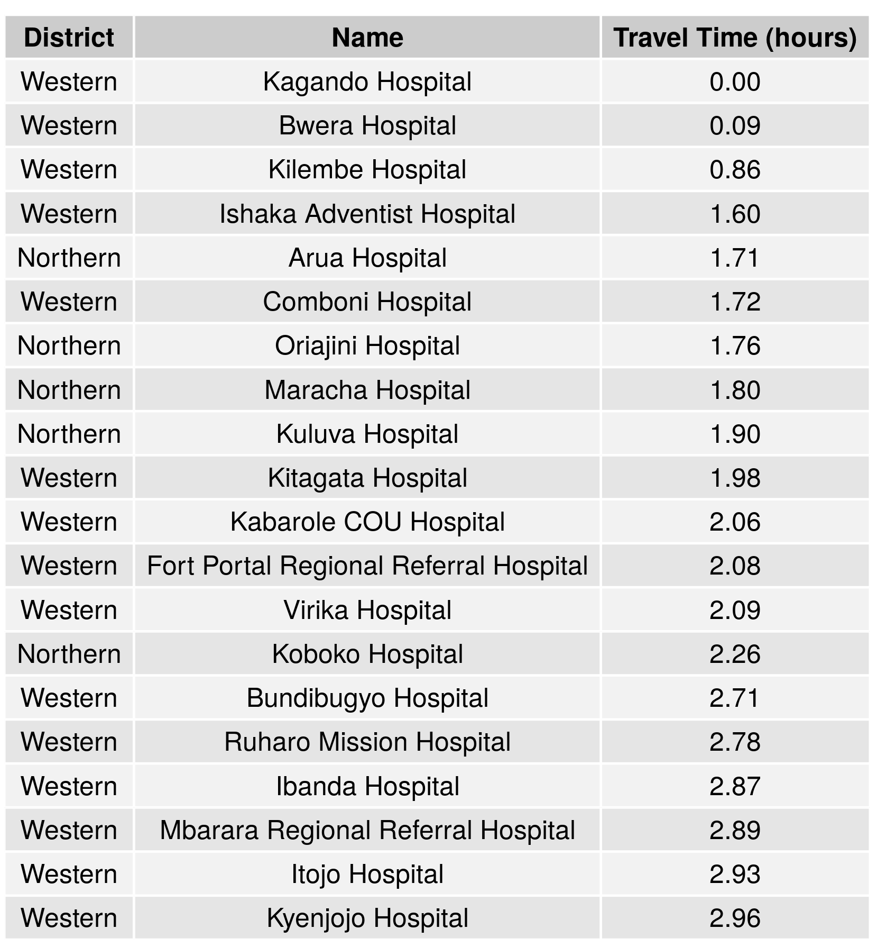

Table S5. Travel time to most accessible hospital from locations with Ebola cases (2018-2019), Rwanda. This table presents the travel times from the twenty closest hospitals in Rwanda to a location with Ebola cases based on case data from the WHO’s Situation Report 50, published July 16, 2019. The hospitals are presented in rank-order from closest (shortest travel times) to furthest (longest travel time) among the twenty.
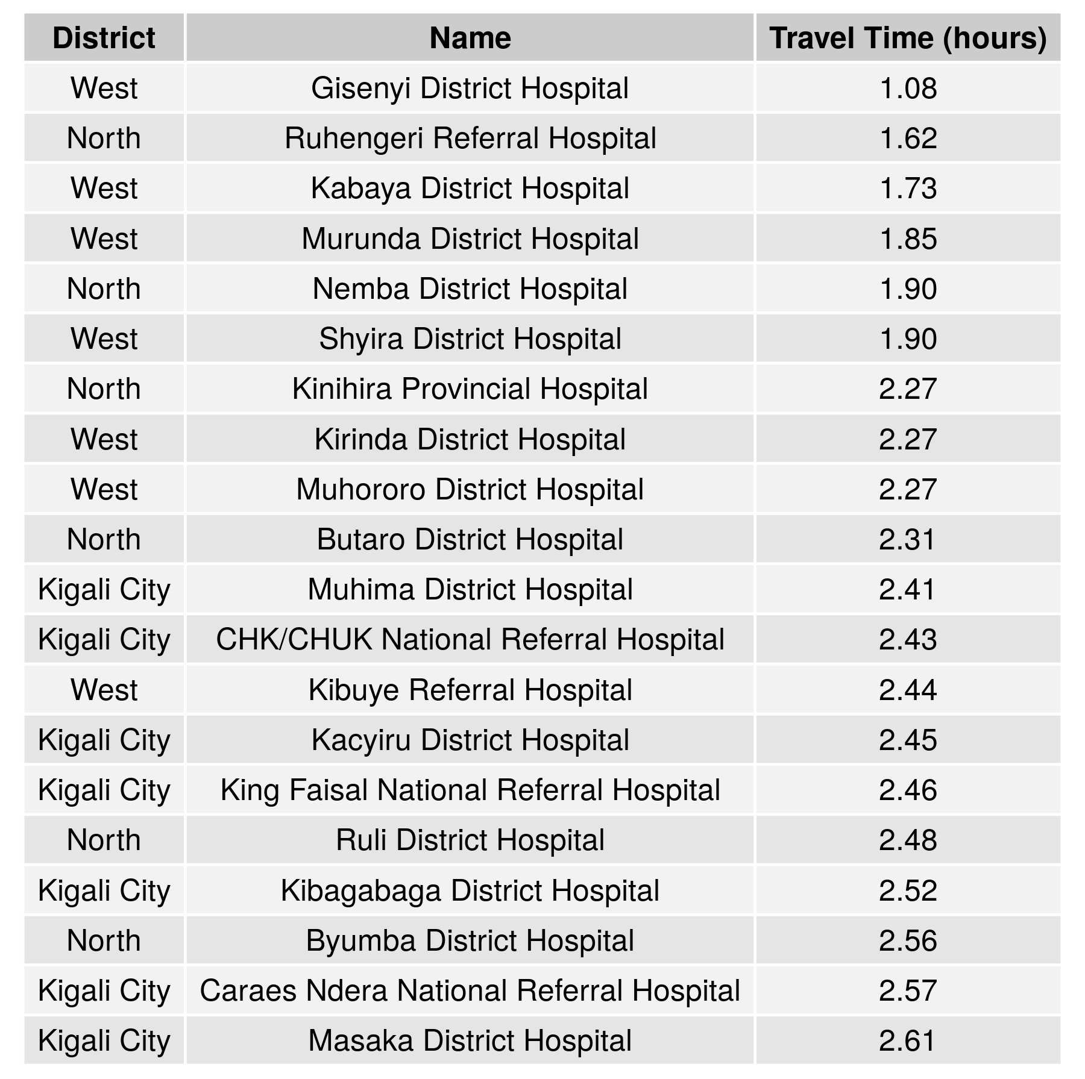
Table S6 Travel time to most accessible hospital from locations with Ebola cases (2018-2019), South Sudan. This table presents the travel times from the twenty closest hospitals in South Sudan to a location with Ebola cases based on case data from the WHO’s Situation Report 49, published July 9, 2019. The hospitals are presented in rank-order from closest (shortest travel times) to furthest (longest travel time) among the twenty.
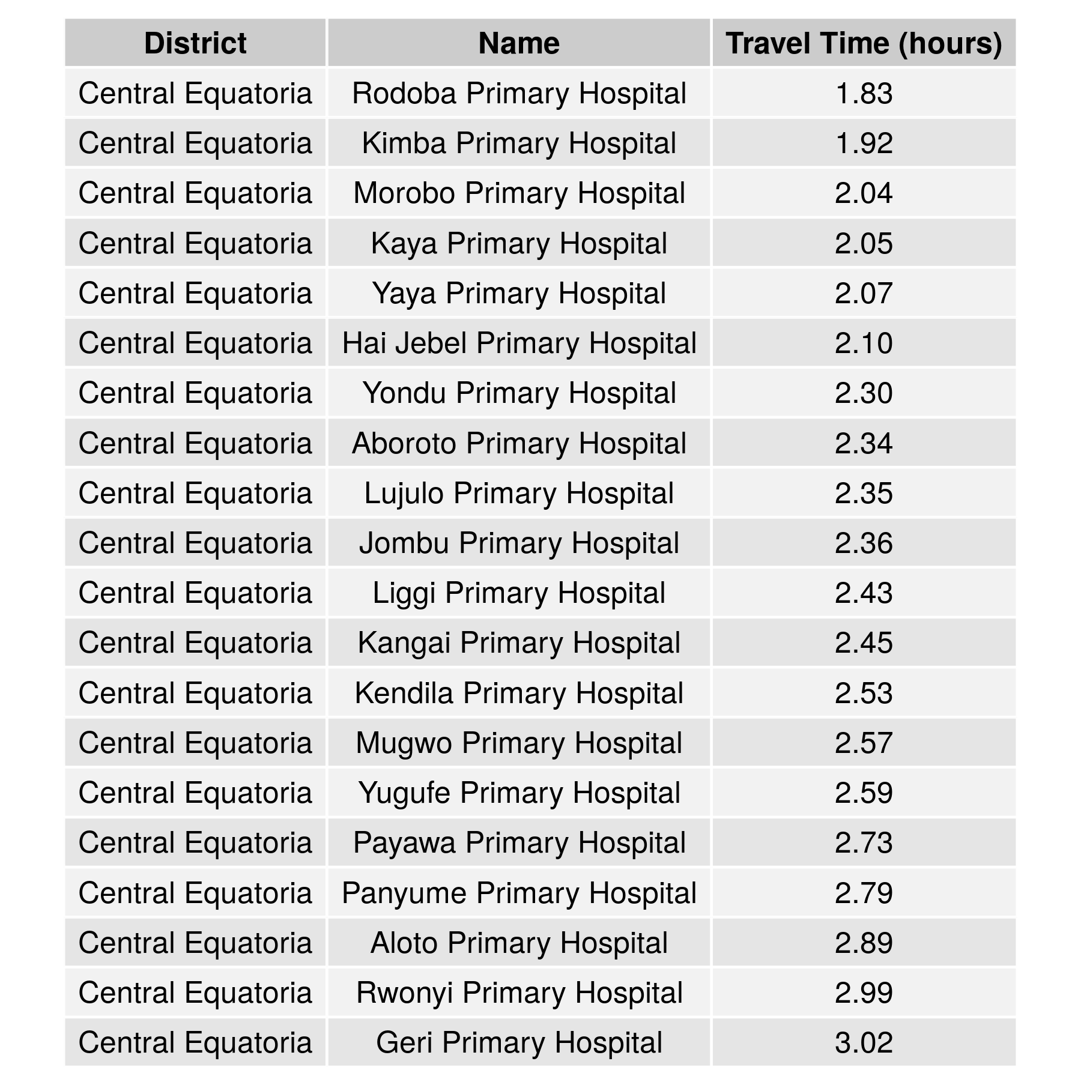

Table S7 Terms used for facility stratification by country. This table presents the terms used for facility type stratification and the original terminology recoded.
Country | Facility Type (Original) | Facility Type (Recoded)
Angola | Hospital | Hospital
Angola | Municipal Hospital | Hospital
Angola | Provincial Hospital | Hospital
Angola | Posto de Saúde | Health Post
Angola | Centro de Saúde | Health Centre
Angola | Centro Materno Infantil | Maternity
Angola | Central Hospital | Hospital
Angola | Centro Sanatorio Materno Infantil | Maternity
Angola | Regional Hospital | Hospital
Angola | General Hospital | Hospital
Benin | Health Centre | Health Centre
Benin | Community Health Centre | Community Health Unit
Benin | Hôpital de Zone | Hospital
Benin | Centre de Santé d’Arrondissement | Health Centre
Benin | Dispensaire | Dispensary
Benin | Centre de Santé de Sous-Prefecture | Health Centre
Benin | Centre Médical | Medical Center
Benin | Unites de Santé de Village | Community Health Unit
Benin | Centre Hospitalier Départemental | Hospital
Benin | Centro de Santé de Circonscription Urbaine | Health Centre
Benin | Hôpital | Hospital
Benin | Clinic | Health Clinic
Benin | Centre de Santé Central | Health Centre
Benin | Centre National Hospitalier Universitaire | Hospital
Benin | Centre Médico-social | Medical Center
Botswana | Clinic | Health Clinic
Botswana | Primary Hospital | Health Clinic
Botswana | Health Post | Health Post
Botswana | District Hospital | Hospital
Botswana | Referral Hospital | Hospital
Burkina Faso | Centre de Santé et de Promotion Sociale | Health Centre
Burkina Faso | Centre Médical Avec Antenne Chirurgicale | Medical Center
Burkina Faso | Centre Hospitalier Régional | Hospital
Burkina Faso | Centre Médical | Medical Center
Burkina Faso | Dispensaire | Dispensary
Burkina Faso | Centre Hospitalier National | Hospital
Burkina Faso | Centre Hospitalier Universitaire National | Hospital
Burundi | Hôpital de District | Hospital
Burundi | Health Centre | Health Centre
Burundi | Hôpital Tertiaire | Hospital
Cameroon | Health Centre | Health Centre
Cameroon | Centre de Santé Intégré | Health Centre
Cameroon | Hôpital de District | Hospital
Cameroon | Centre Medical d’Arrondissement | Medical Center
Cameroon | Hôpital Régional | Hospital
Cameroon | Dispensaire | Dispensary
Cameroon | Hôpital Centraux | Hospital
Cameroon | Hôpital Général | Hospital
Cameroon | Clinic | Health Clinic
Central African Republic | Centre de Santé ""C"" | Health Centre
Central African Republic | Hôpital Centraux | Hospital
Central African Republic | Centre de Santé ""E"" | Health Centre
Central African Republic | Centre de Santé ""B"" | Health Centre
Central African Republic | Centre de Santé ""A"" | Health Centre
Central African Republic | Poste de santé | Health Post
Central African Republic | Centre de Sante | Health Centre
Central African Republic | Hôpital Régional Universitaire | Hospital
Central African Republic | Hôpital Préfectoraux | Hospital
Central African Republic | Centre de Santé ""D"" | Health Centre
Chad | Health Centre | Health Centre
Chad | Hôpital de District | Hospital
Chad | Hôpital de Regional | Hospital
Chad | Hôpital de Nationaux | Hospital
Chad | Regional hospital | Hospital
Congo | Centre de Santé Intégré | Health Centre
Congo | Hôpital Comboutique | Hospital
Congo | l’Hôpital de Base | Hospital
Congo | University Hospital | Hospital
Congo | Hôpital Général | Hospital
Congo | Hôpital | Hospital
Cote d'Ivoire | Centre de Santé Rural | Health Centre
Cote d'Ivoire | Centre de Santé Urbain | Health Centre
Cote d'Ivoire | Centre Médico-social | Medical Center
Cote d'Ivoire | Hôpital Général | Hospital
Cote d'Ivoire | Hospitalier Universitaire | Hospital
Cote d'Ivoire | Hospitalier Régional | Hospital
Democratic Republic of the Congo | Poste de Santé | Health Post
Democratic Republic of the Congo | Centre de Santé | Health Centre
Democratic Republic of the Congo | Hôpital Général de Référence | Hospital
Democratic Republic of the Congo | Dispensaire | Dispensary
Democratic Republic of the Congo | Centre Médical | Medical Center
Democratic Republic of the Congo | Centre Hôpital | Hospital
Democratic Republic of the Congo | Centre de Santé de Référence | Health Centre
Democratic Republic of the Congo | Polyclinique | Polyclinic
Democratic Republic of the Congo | Clinique | Health Clinic
Democratic Republic of the Congo | Centre de Santé Municipal | Health Centre
Democratic Republic of the Congo | Hôpital | Hospital
Democratic Republic of the Congo | Centre Medico-Chirurgical | Medical Center
Djibouti | Health Post | Health Post
Djibouti | Hospital Medical Center | Hospital
Djibouti | Hospital Medical Centre | Hospital
Djibouti | Tertiary Hospital | Hospital
Djibouti | Community Health Centre | Community Health Unit
Equatorial Guinea | Regional Hospital | Hospital
Equatorial Guinea | Health Centre | Health Centre
Equatorial Guinea | District Hospital | Hospital
Eritrea | Health Centre | Health Centre
Eritrea | Health Station | Health Station
Eritrea | Clinic | Health Clinic
Eritrea | Hospital | Hospital
Eritrea | Mini Hospital | Hospital
Eritrea | Mini Clinic | Health Clinic
Eritrea | National Referral Hospital | Hospital
Ethiopia | Clinic | Health Clinic
Ethiopia | Health Centre | Health Centre
Ethiopia | Health Post | Health Post
Ethiopia | Hospital | Hospital
Ethiopia | Health Station | Health Station
Ethiopia | Nucleas Health Centre | Health Centre
Ethiopia | National Hospital | Hospital
Ethiopia | General Hospital | Hospital
Ethiopia | District Hospital | Hospital
Ethiopia | Zonal Hospital | Hospital
Ethiopia | Referral Hospital | Hospital
Gabon | Dispensaire | Dispensary
Gabon | Centre de Santé Urbain | Health Centre
Gabon | Health Centre | Health Centre
Gabon | Regional Hospital | Hospital
Gabon | Medical Centre | Medical Center
Gabon | Centre Hospitalier Urbain | Hospital
Gabon | University Hospital | Hospital
Gabon | Hôpital Coopération | Hospital
Gambia | Hospital | Hospital
Gambia | Health Centre (minor) | Health Centre
Gambia | Clinic | Health Clinic
Gambia | Health Centre (major) | Health Centre
Gambia | Teaching Hospital | Hospital
Gambia | General Hospital Hospital | Hospital
Ghana | Clinic | Health Clinic
Ghana | Health Centre | Health Centre
Ghana | Community-based Health Planning and Services | Community Health Unit
Ghana | Hospital | Hospital
Ghana | District Hospital | Hospital
Ghana | General Hospital | Hospital
Ghana | Teaching Hospital | Hospital
Ghana | Regional Hospital | Hospital
Ghana | Municipal Hospital | Hospital
Ghana | Polyclinic | Polyclinic
Guinea | Poste de Santé | Health Post
Guinea | Health Centre | Health Centre
Guinea | Hôpital Régional | Hospital
Guinea | Hôpital Prefectoral | Hospital
Guinea | National Hospital | Hospital
Guinea Bissau | Regional Hospital | Hospital
Guinea Bissau | Hospital | Hospital
Guinea Bissau | National Hospital | Hospital
Kenya | Dispensary | Dispensary
Kenya | Health Centre | Health Centre
Kenya | District Hospital | Hospital
Kenya | Sub-District Hospital | Hospital
Kenya | Mission Hospital | Hospital
Kenya | Clinic | Health Clinic
Kenya | Hospital | Hospital
Kenya | County Referral Hospital | Hospital
Kenya | Provincial General Hospital | Hospital
Kenya | National Referral Hospital | Hospital
Lesotho | District Hospital | Hospital
Lesotho | Health Centre | Health Centre
Lesotho | Filter Clinic | Health Clinic
Lesotho | Mission Hospital | Hospital
Lesotho | National Referral Centre | Hospital
Liberia | Clinic | Health Clinic
Liberia | Hospital | Hospital
Liberia | Health Centre | Health Centre
Liberia | Mission Hospital | Hospital
Liberia | National Referral Hospital | Hospital
Madagascar | Hospital | Hospital
Madagascar | Health Centre | Health Centre
Madagascar | Health Post | Health Post
Malawi | Clinic | Health Clinic
Malawi | Health Centre | Health Centre
Malawi | Community Hospital | Community Health Unit
Malawi | Health Post/Dispensary | Health Post
Malawi | District Hospital | Hospital
Malawi | Mission Hospital | Hospital
Malawi | Rural Hospital | Hospital
Malawi | Central Hospital | Hospital
Mali | Clinic | Health Clinic
Mali | Community Health Centre | Community Health Unit
Mali | Polyclinic | Polyclinic
Mali | Hospital | Hospital
Mali | University Hospital | Hospital
Mali | Referral Health Centre | Hospital
Mali | Regional Hospital | Hospital
Mauritania | Health Centre | Health Centre
Mauritania | Hospital | Hospital
Mauritania | Health Post | Health Post
Mauritania | General Hospital | Hospital
Mozambique | Centro de Saúde Rural I | Health Centre
Mozambique | Posto de Saúde | Health Post
Mozambique | Centro de Saúde Rural II | Health Centre
Mozambique | Centro de Saúde Urbano C | Health Centre
Mozambique | Hospital Rural | Hospital
Mozambique | Centro de Saúde Urbano B | Health Centre
Mozambique | Hospital Provincial | Hospital
Mozambique | Hospital Distrital | Hospital
Mozambique | Centro de Saúde Urbano A | Health Centre
Mozambique | Hospital Geral | Hospital
Mozambique | Hospital Central | Hospital
Namibia | Clinic | Health Clinic
Namibia | Health Centre | Health Centre
Namibia | District Hospital | Hospital
Namibia | Mission Hospital | Hospital
Namibia | Intermediate Hospital | Hospital
Namibia | Central Hospital | Hospital
Niger | Integrated Health Centre | Health Centre
Niger | Health Hut | Health Hut
Niger | Hospital | Hospital
Niger | Centre Hospitalier Universitaire | Hospital
Nigeria | Primary Health Centre | Health Clinic
Nigeria | Health Centre | Health Centre
Nigeria | Clinic | Health Clinic
Nigeria | Health Post | Health Post
Nigeria | Model Health Centre | Health Centre
Nigeria | General Hospital | Hospital
Nigeria | Dispensary | Dispensary
Nigeria | Basic Health Centre | Health Centre
Nigeria | Comprehensive Health Centre | Health Centre
Nigeria | Federal Medical Centre | Medical Center
Nigeria | Cottage Hospital | Hospital
Nigeria | Polyclinic | Polyclinic
Nigeria | Medical Centre | Medical Center
Nigeria | Hospital | Hospital
Nigeria | University Teaching Hospital | Hospital
Nigeria | Model Primary Health Centre | Health Clinic
Nigeria | Rural Hospital | Hospital
Nigeria | District Hospital | Hospital
Nigeria | Natonal Hospital | Hospital
Nigeria | State Hospital | Hospital
Nigeria | DISPENSARY | Dispensary
Rwanda | Health Centre | Health Centre
Rwanda | Health Post | Health Post
Rwanda | District Hospital | Hospital
Rwanda | Referral Hospital | Hospital
Rwanda | Provincial Hospital | Hospital
Rwanda | National Referral Hospital | Hospital
Rwanda | Secondary Health Post | Health Post
Senegal | Centre Hospitalier Universitaire | Hospital
Senegal | Poste de Santé | Health Post
Senegal | Centre Hospitalier National | Hospital
Senegal | Health Centre | Health Centre
Senegal | Hôpital | Hospital
Senegal | Hôpital Général | Hospital
Senegal | Hôpital Régional | Hospital
Sierra Leone | Mission Hospital | Hospital
Sierra Leone | Community Health Centre | Community Health Unit
Sierra Leone | Community Health Post | Community Health Unit
Sierra Leone | Maternal & Child Health Post | Health Post
Sierra Leone | Hospital | Hospital
Sierra Leone | Clinic | Health Clinic
Sierra Leone | Health Centre | Health Centre
Sierra Leone | Health Post | Health Post
Sierra Leone | Refferal Hospital | Hospital
Somalia | Health Post | Health Post
Somalia | Maternal & Child Health Centre | Health Centre
Somalia | Regional Hospital | Hospital
Somalia | Hospital | Hospital
Somalia | Health Centre | Health Centre
Somalia | District Hospital | Hospital
Somalia | Referral Hospital | Hospital
South Africa | District Hospital | Hospital
South Africa | Satellite Clinic | Health Clinic
South Africa | Clinic | Health Clinic
South Africa | Community Health Centre | Community Health Unit
South Africa | Regional Hospital | Hospital
South Africa | Health Post | Health Post
South Africa | Provincial Tertiary Hospital | Hospital
South Africa | National Central Hospital | Hospital
South Africa | Medical Centre | Medical Center
South Africa | Community Health Centre/Clinic | Community Health Unit
South Africa | Community Health Centre (After hours) | Community Health Unit
South Sudan | Primary Health Care Unit | Health Clinic
South Sudan | Primary Health Care Centre | Health Clinic
South Sudan | State Hospital | Hospital
South Sudan | Teaching Hospital | Hospital
South Sudan | County Hospital | Hospital
Sudan | Type D Hospital | Hospital
Sudan | Hospital | Hospital
Sudan | Type C Hospital | Hospital
Sudan | Type B Hospital | Hospital
Sudan | Type A Hospital | Hospital
Sudan | Teaching Hospital | Hospital
Sudan | Referral Hospital | Hospital
Sudan | National Hospital | Hospital
Tanzania | Health Centre | Health Centre
Tanzania | Dispensary | Dispensary
Tanzania | Hospital | Hospital
Tanzania | Referral Hospital | Hospital
Tanzania | Designated District Hospital | Hospital
Tanzania | District Hospital | Hospital
Tanzania | Regional Referral Hospital | Hospital
Tanzania | National Hospital | Hospital
Togo | Centre Médico-social | Medical Center
Togo | Unité de Soins Périphérique | Community Health Unit
Togo | Centre Hospitalier Préfectoral | Hospital
Togo | Centre Hospitalier Régional | Hospital
Togo | Centre Hospitalier Universitaire | Hospital
Uganda | Health Centre III | Health Centre
Uganda | Clinic | Health Clinic
Uganda | Health Centre II | Health Centre
Uganda | Health Centre IV | Health Centre
Uganda | Hospital | Hospital
Uganda | National Referral Hospital | Hospital
Uganda | Regional Referral Hospital | Hospital
Zambia | Health Centre | Health Centre
Zambia | Health Post | Health Post
Zambia | Level 1 Hospital | Hospital
Zambia | Level 2 Hospital | Hospital
Zambia | Rural Health Centre | Health Centre
Zambia | Clinic | Health Clinic
Zambia | Level 3 Hospital | Hospital
Zimbabwe | Clinic | Health Clinic
Zimbabwe | Central Hospital | Hospital
Zimbabwe | Rural Hospital | Hospital
Zimbabwe | Rural Health Clinic | Health Clinic
Zimbabwe | District Hospital | Hospital
Zimbabwe | Provincial Hospital | Hospital
Zimbabwe | District/Provincial Hospital | Hospital

