Demographic and clinical characteristics at diagnosis in FEP patients with and without missing data on smoking, alcohol drinking and BMI.
 |  |  | FEP patients with missing data (n=1,356) | FEP patients without missing data (n=1,689)
Type of psychosis, n (%)
 | Non-affective |  | 935 (69.0) | 1,101 (65.2)
 | Drug-induced |  | 303 (22.4) | 375 (22.2)
 | Affective |  | 114 (8.4) | 195 (11.6)
 | Pregnancy-related* |  | / | 18 (1.1)
Year of index date, median (IQR) |  |  | 2010 (2007, 2013) | 2010 (2007, 2013)
Age, median (IQR) |  |  | 24 (20, 32) | 35 (28, 41)
Male, n (%) |  |  | 1,001 (73.8) | 913 (54.1)
Geographical region, n (%)
 | London |  | 119 (8.8) | 152 (9.0)
 | South, England |  | 405 (29.9) | 393 (23.3)
 | Midlands and East, England |  | 256 (18.9) | 343 (20.3)
 | North, England |  | 204 (15.0) | 328 (19.4)
 | Northern Ireland |  | 66 (4.9) | 102 (6.0)
 | Scotland |  | 161 (11.9) | 195 (11.6)
 | Wales |  | 145 (10.7) | 176 (10.4)
Smoking, n (%)
 | Non smoker |  | 421 (31.1) | 590 (34.9)
 | Ever smoker |  | 665 (49.0) | 1,099 (65.1)
 | Unknown |  | 270 (19.9) | /
Alcohol consumption, n (%)
 | Non drinker |  | 74 (5.5) | 224 (13.3)
 | Ever drinker |  | 277 (20.4) | 1,465 (86.7)
 | Unknown |  | 1,005 (74.1) | /
Body mass index, median (IQR) |  |  | 22.8 (20.1, 26.8) | 24.0 (21.2, 28.2)
 | < 18.5 kg/m² (underweight), n (%) |  | 52 (3.8) | 98 (5.8)
 | ≥ 18.5 kg/m² & < 25 kg/m² (normal), n (%) |  | 215 (15.9) | 870 (51.5)
 | ≥ 25 kg/m² & < 30 kg/m² (overweight), n (%) |  | 79 (5.8) | 422 (25.0)
 | ≥ 30 kg/m² (obese), n (%) |  | 56 (4.1) | 299 (17.7)
 | Unknown |  | 954 (70.4) | /
Number of different prescriptions in 5 years before index date, median (IQR) |  |  | 4 (2, 5) | 5 (3, 7)
Number of GP consultations in 5 years before index date, median (IQR) |  |  | 40 (21, 69) | 69 (39, 116)
 |  | 4-5 year prior to index date | 4 (1, 10)† | 9 (3, 19)†
 |  | 3-4 year prior to index date | 4 (1, 11)† | 10 (3, 21)†
 |  | 2-3 year prior to index date | 5 (1, 12)† | 11 (4, 22)†
 |  | 1-2 year prior to index date | 7 (2, 15)† | 12 (5, 24)†
 |  | 0-1 year prior to index date | 13 (6, 24)† | 20 (10, 36)†
Number of symptom records in 5 years before index date, median (IQR)‡ |  |  | 1 (0, 4) | 3 (1, 6)
FEP, first episode psychosis; BMI, body mass index; IQR, interquartile range. †One-way ANOVA trend analysis within patients with FEP, p < 0.0001. ‡Total number of coded records based on 55 studied individual symptoms. *Data were not reported for certain cells due to CPRD reporting policy that no cell should contain fewer than 5 events.

Cumulative proportion of patients having a prodrome symptom recorded in primary care from 5 years before until the time of FEP diagnosis in patients with missing data (smoking, alcohol drinking or BMI).
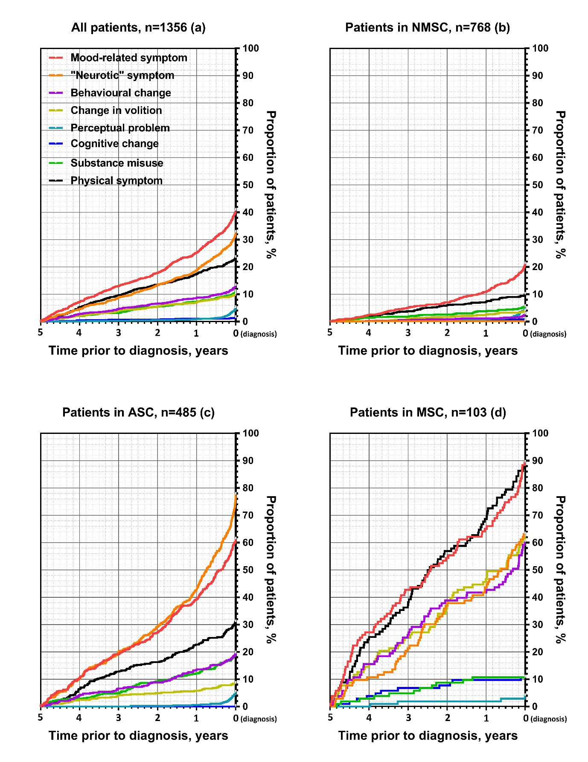

Cumulative proportion of patients having a prodrome symptom recorded in primary care from 5 years before until the time of FEP diagnosis in patients without missing data (smoking, alcohol drinking and BMI).
