Additional file 4: Risk of bias assessment
Risk of bias was assessed for each study using the Risk of Bias in Non-randomized Studies – of Interventions (ROBINS-I) assessment tool. The ROBINS-I tool enables assessment of bias with seven domains: 1) confounding; 2) selection of participants; 3) classification of ‘interventions’ (i.e. exposures); 4) deviations from intended ‘interventions’; 5) missing data; 6) measurement of outcomes; 7) and selection of reported results. Our risk of bias assessment pertains to the association between pregnancy specific P. falciparum antibody responses and pregnancy and birth outcomes derived from the study, rather than the study itself. Many studies were classified as having a ‘moderate’ or ‘serious’ risk of bias due to confounding for reasons that were usually not related to the quality of the study, including:
- Inclusion of studies in which the primary research question was not the association between P. falciparum antibodies and pregnancy associated malaria
- Inclusion of studies in which very few women had pregnancy associated malaria
- Authors responding to our request for cross-tabulated (i.e. unadjusted) data for antibody responses and malaria in pregnancy
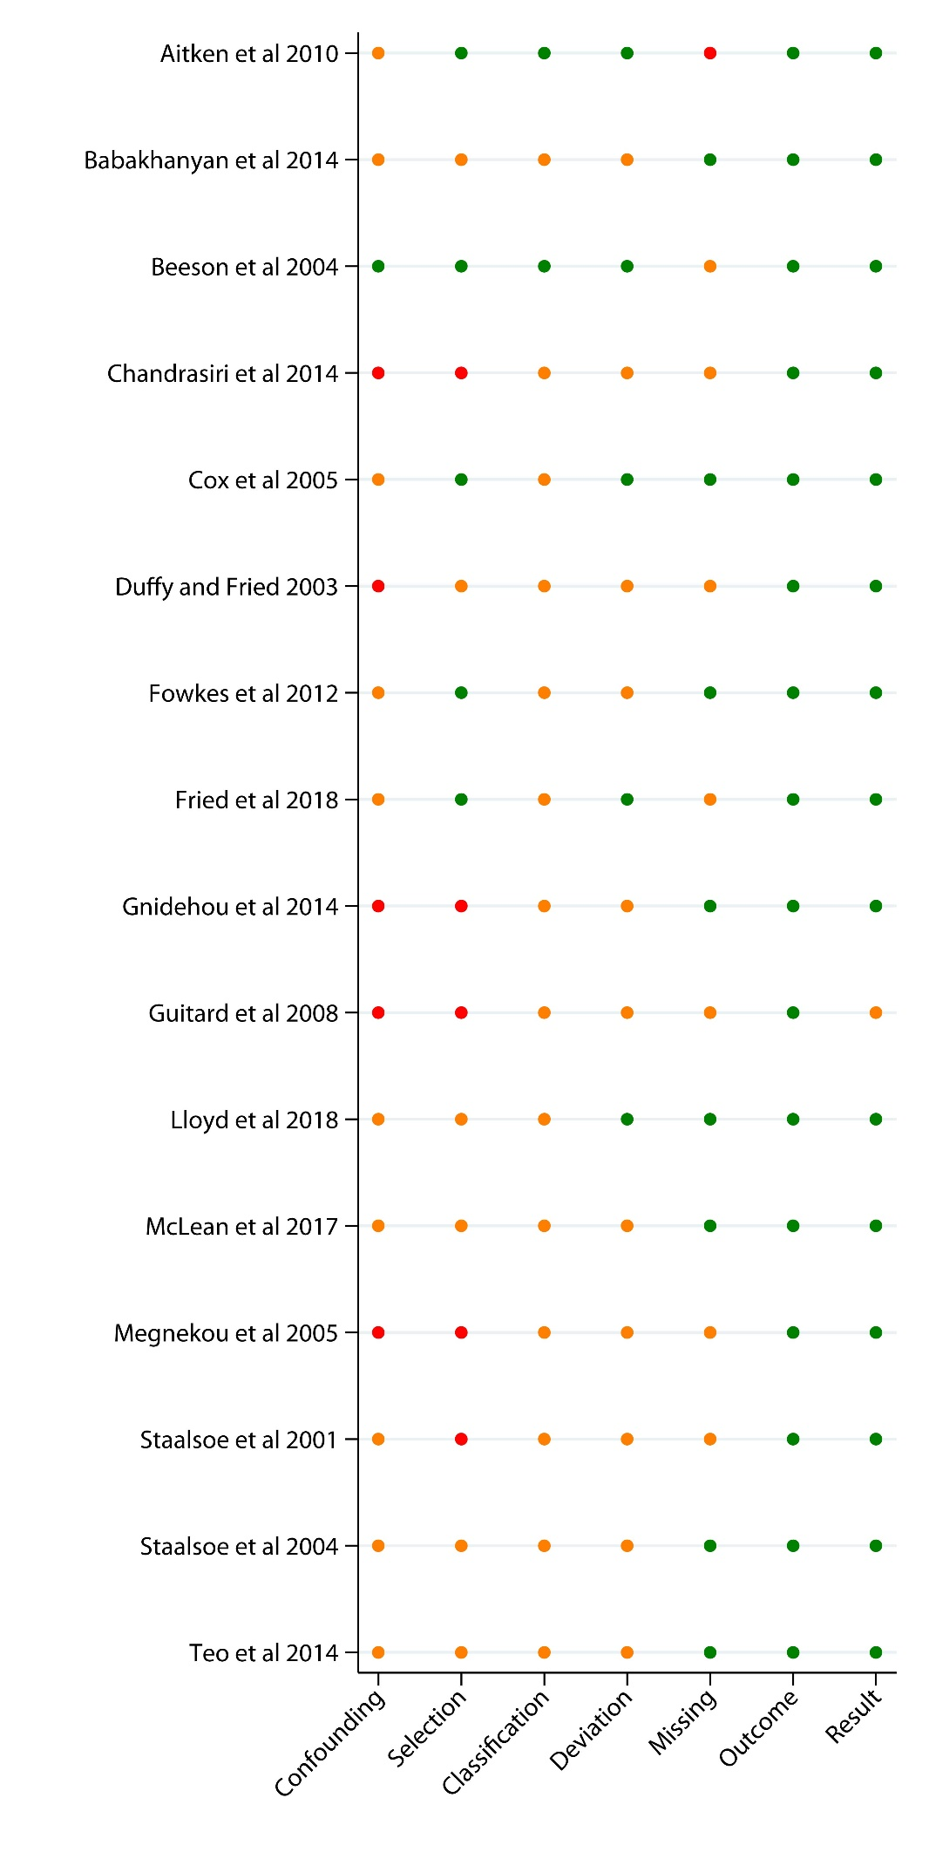
Figure S1. Risk of bias assessment. (Black – critical risk); red – serious risk; orange – moderate risk; green – low risk; (hollow circle – no information).

