Additional File 3: Figure S1
Title: Forest Plots showing results of network meta-analysis of monotherapy for (a) systolic and (b) diastolic blood pressure lowering effect.

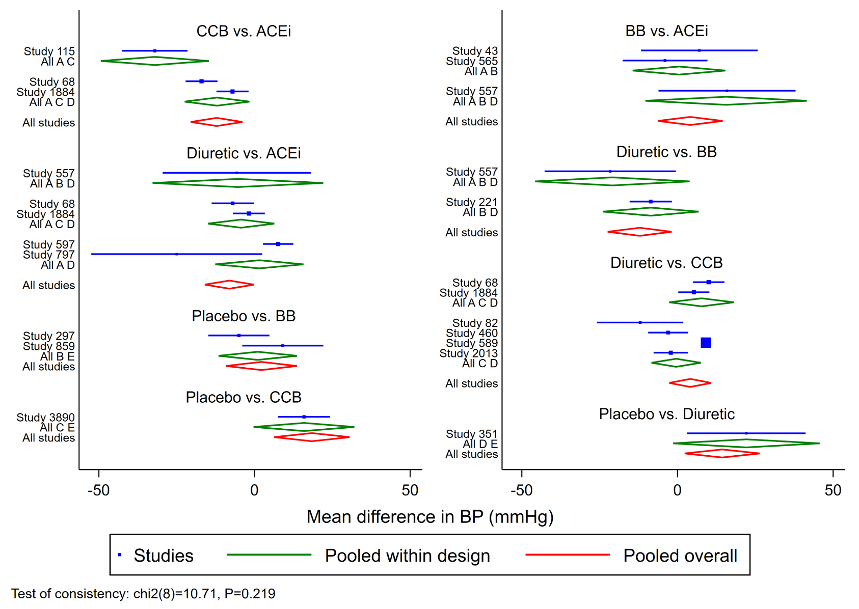
a

b
Additional File 3: Figure S2
Title: Trends in blood pressure lowering efficacy of treatment with (a) age, (b) gender and (c) number of participants as well as (d) year of publication
a

b
c

d
Additional File 3: Figure S3
Title; Rankograms for Network Meta-analysis with exclusion of imputed missing values (a) SBP (b) DBP and exclusion of studies rates as high risk of bias (c) SBP and (d) DBP. For each plot tests of consistency given for overall network meta-analysis as well as surface under cumulative ranking curve area (SUCRA) and relative mean rank (1 best 5 worst) compared to other treatments.
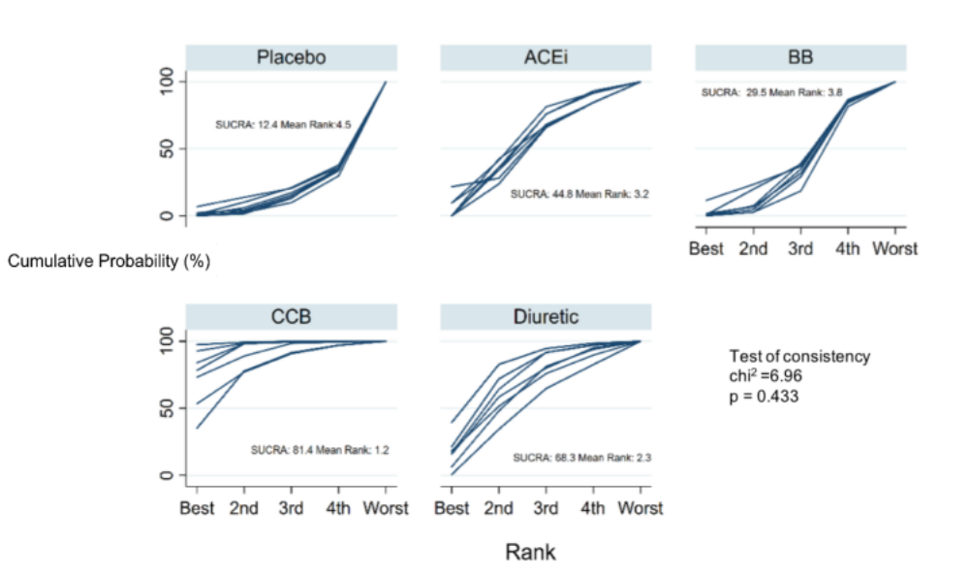
a
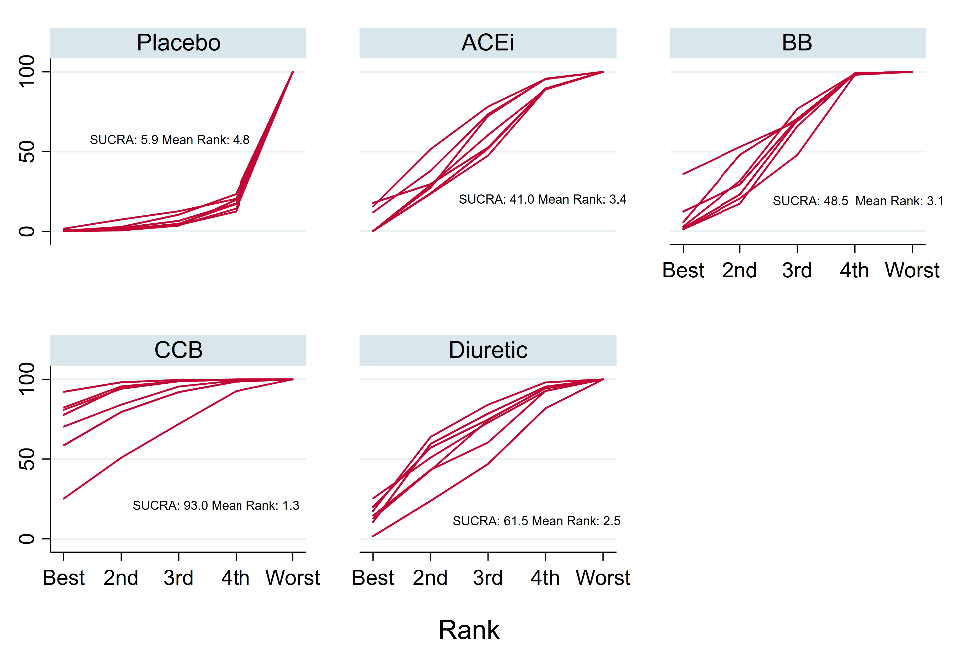
Test of consistency
chi² =7.22
p = 0.407
b
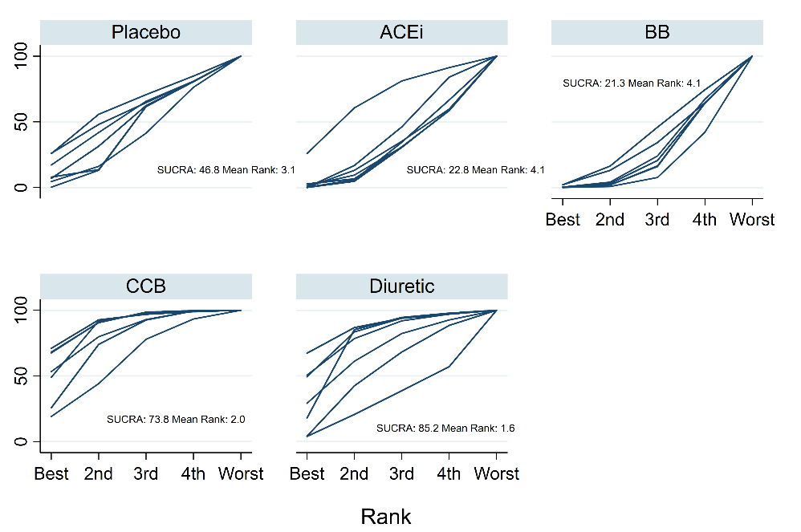
c
Test of consistency
chi² =2.74
p = 0.84

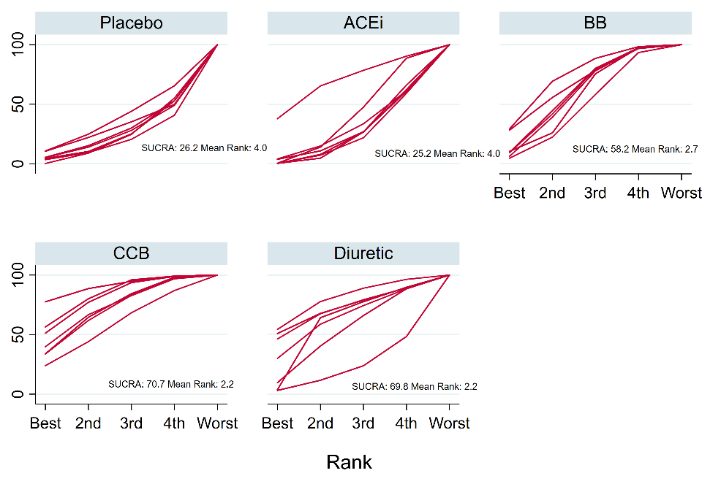
d
Test of consistency
chi² =2.55
p = 0.86

Additional File 3: Figure S4
Funnel plot for global meta-analysis of 31 studies, grouped by blood pressure agent class. Effect size refers to reported change in mean systolic blood pressure (mmHg). Pseudo 95% confidence intervals plotted. Egger’s test for publication bias across all studies: slope = 0.524 (-2.32 to 3.36), intercept or bias = -0.200, p=0.713.

