Index supplemental material
Page
2 | Table S1 | Fetal and placental characteristics (N = 7670)
3 | Table S2 | Characteristics of mothers and their children with and without placenta measures available
4 | Table S3 | Statistical significance level of comparison of screening models with and without placenta measures for screening for preterm birth, small-size and large-size for gestational age
4 | Table S4 | Estimated sensitivity at different levels of specificity for models screening for preterm birth, small-size and large-size for gestational age
5 | Figure S1 | Flowchart population for analysis
6 | Figure S2 | Receiver operating characteristic curves for models screening for spontaneous preterm birth
7 | Figure S3 | Receiver operating characteristic curves for models screening for preterm birth, small-size and large-size for gestational age, with screen positive defined as estimated fetal weight <5th percentile, or >95th percentile
8 | Figure S4 | Receiver operating characteristic curves for models screening for preterm birth, small-size and large-size for gestational age using abdominal circumference instead of estimated fetal weight
9 | Figure S5 | Receiver operating characteristic curves for screening for preterm birth, small-size and large-size for gestational age, with separate umbilical and uterine artery indices
10 | Figure S6 | Receiver operating characteristic curves for models screening for preterm birth, small-size and large-size for gestational age based on estimated fetal weight, without maternal characteristics
11 | Figure S7 | Defining screen positive separately for small- and large-size for gestational age
13 | Figure S8 | Receiver operating characteristic curves for models screening for small-size and large-size for gestational age according to size at birth <5th percentile, or >95th percentile
15 | Figure S9 | Receiver operating characteristic curves for models screening for small-size and large-size for gestational age at birth defined as birth weight <3rd and >97th percentile, respectively
17 | Figure S10 | Receiver operating characteristic curves for models screening for small-size and large-size for gestational age at birth with adverse outcomes

Table S1. Fetal and placental characteristics (N = 7670)
Second trimester fetal and placental characteristics
Gestational age in weeks, median (IQR) | 20.5(19.9 to 21.3)
Head circumference, mean (SD) (mm) | 179.5(14.7)
Abdominal circumference, mean (SD) (mm) | 157(15)
Femur length, mean (SD) (mm) | 33.5(3.6)
Estimated fetal weight, mean (SD) (g) | 382.3(95.5)
Estimated fetal weight < 10th percentile (<-1.32SDS) No. (%) | 767(10)
Estimated fetal weight > 90th percentile (>1.19SDS) No. (%) | 767(10)
Uterine artery resistance index, mean (SD) | 0.54(0.09)
Umbilical artery pulsatility index, mean (SD) | 1.2(0.19)
Third trimester fetal and placental characteristics
Gestational age in weeks, median (IQR) | 30.4(29.8 to 30.9)
Head circumference, mean (SD) (mm) | 284.9(12.4)
Abdominal circumference, mean (SD) (mm) | 263.8(16.5)
Femur length, mean (SD) (mm) | 57.5(3)
Estimated fetal weight, mean (SD) (g) | 1615.9(256.2)
Estimated fetal weight < 10th percentile (<-1.20SDS), No. (%) | 767(10)
Estimated fetal weight > 90th percentile (>1.35SDS) No. (%) | 767(10)
Uterine artery resistance index | 0.48(0.08)
Umbilical artery pulsatility index | 0.98(0.17)
Second to third trimester estimated fetal weight change <10th percentile (<1.10SDS) No (%) | 767(10)
Second to third trimester estimated fetal weight change >90th percentile (>1.35SDS) No (%) | 767(10)
Abbreviations: IQR: inter quartile range; SD: Standard deviation;
Values are observed data and represent means (SD), medians (IQR) or number of subjects (valid %).
Table S2. Characteristics of mothers and their children with and without placenta measures availableª
 | Placenta measures available N=7014^{b} | No placenta measures available N=656^{c} | P-value^{d}
Maternal characteristics
Age |  |  | 0.13
< 25, No (%) | 1419(20.5) | 154(23.5)
25-35, No (%) | 4559(65) | 413(63)
> 35, No (%) | 1036(14.8) | 89(13.6)
Height, mean (SD) (cm) | 167.3(7.36) | 166.6(7.4) | 0.013
Weight, mean (SD) (kg) | 69(13) | 721(14.4) | <0.01
Body Mass Index, mean (SD) (kg/m²) |  |  | <0.01
Normal, No (%) | 4359(62.5) | 350(54.2)
Overweight, No (%) | 1809(25.9) | 170(26.3)
Obese, No (%) | 806(11.6) | 126(19.5)
Education, No. higher education (%) | 2837(43.6) | 218(36.2) | <0.01
Race / Ethnicity, No. (%) |  |  | 0.11
Dutch or European, No (%) | 3949(58.5) | 340(55)
Surinamese , No (%) | 587(8.7) | 68(11)
Turkish, No (%) | 622(9.2) | 51(8.3)
Moroccan , No (%) | 428(6.3) | 45(7.3)
Cape Verdian or Dutch Antilles, No (%) | 506(7.5) | 54(8.8)
Parity, No. nulliparous (%) | 3951(56.8) | 357(54.7) | 0.06
Smoking, No. (%) |  |  | 0.19
None, No (%) | 4532(72.6) | 435(75)
Early-pregnancy only, No (%) | 556(8.9) | 39(6.7)
Continued, No (%) | 1155(18.5) | 106(18.3)
Birth characteristics
Males, No. (%) | 3549(50.6) | 312(47.6) | 0.14
Gestational age, median (IQR), weeks | 40.1(39.1 to 41.0) | 40(39.0 to 41.0) | 0.07
Birth weight, mean (SD) grams | 3424(542) | 3419(567) | 0.83
Preterm birth^{e}, No. (%) | 307(4.4) | 38(5.8) | 0.09
Small for gestational age^{e}, No. (%) | 693(9.9) | 75(11.4) | 0.08
Large for gestational age^{e}, No. (%) | 689(9.8) | 78(11.9) | 0.08
Caesarean delivery, No. (%) | 740(11.6) | 82(13.6) | 0.67
Assisted vaginal delivery, No. (%) | 889(13.9) | 75(12.5) | 0.67
Apgar score below 7 at 5 minutes, No. (%) | 73(0.8) | 5(0.8) | 0.75
Abbreviations: IQR: inter quartile range; SD: Standard deviation.
ª Because these measurements were only performed in one of two research centers, second and third trimester uterine artery resistance indices were available in subgroups of n=4,361 and n=4,193 women, respectively. Second and third trimester UA-PI were available in n=5,831 and n=6,224 women, respectively.
^{b} Participants with any of the following placenta measures available: 2nd or 3rd trimester umbilical artery pulsatility index or 2nd or 3rd trimester uterine artery resistance index. Values are observed data and represent means (SD), medians (IQR) or number of subjects (valid %).
^{c} Participants without any of the following placenta measures available: 2nd or 3rd trimester umbilical artery pulsatility index or 2nd or 3rd trimester uterine artery resistance index. Values are observed data and represent means (SD), medians (IQR) or number of subjects (valid %).
^{d} P-value for difference between groups.
^{e} Preterm birth is defined as birth before 37 weeks; Small-size for gestational age is defined as < 10th percentile (<-1.4 SDS) of gestational age-and sex-adjusted birth weight; Large-size for gestational age is defined as > 90th percentile (>1.18 SDS) of gestational age-and sex-adjusted birth weight.

Table S3. Statistical significance level of comparison of screening models with and without placenta measures, for screening for preterm birth, small-size and large-size for gestational age
 | Preterm birth | Small-size for gestational age | Large-size for gestational age
Maternal characteristics vs. third trimester model | P<0.01 | P<0.01 | P<0.01
Second trimester model vs. third trimester model | P<0.01 | P<0.01 | P<0.01
Third trimester model vs. Third trimester model and placenta measures* | P<0.01 | P<0.01 | NA
Models are based on maternal characteristics, estimated fetal weight, and placenta measures. NA: Not applicable as no comparison was made. Values are p-values for comparison of models, using the method of DeLong et.al for comparison of two correlated AUCs. *Analyses performed in a subsample with all placenta measures available.

Table S4. Estimated sensitivity at different levels of specificity for models screening for preterm birth, small-size and large-size for gestational age
 |  | Estimated sensitivities
 | Specificity | Maternal characteristics model | Second trimester modelª
Preterm birth | 70% | 44% | 44%
 | 80% | 33% | 32%
 | 90% | 18% | 19%
Small-size for gestational age | 70% | 56% | 65%
 | 80% | 43% | 51%
 | 90% | 25% | 33%
Large-size for gestational age | 70% | 53% | 58%
 | 80% | 43% | 44%
 | 90% | 25% | 28%
Values are estimated sensitivity at different levels of specificity. Derived from receiver operating characteristic curve. ªSecond trimester model: Maternal characteristics and 2nd trimester estimated fetal weight.

Figure S1. Flowchart population for analysis
n = 8879
Participants enrolled during pregnancy

n = 1130 excluded due to no second and third trimester fetal growth measurements

n = 7749
Participants eligible for present study

n = 33 excluded due to fetal deaths (n = 15), twin births (n = 2) and loss to follow-up (n = 16)

n = 7716
Participants with singleton live births eligible for present study

n = 46 excluded due to no information of birth outcomes available (weight and / or gestational age at birth)

Total population for analysis n = 7670
Second trimester
Head circumference n = 7613
Abdominal Circumference n = 7670
Femur length n = 7670
Estimated fetal weight n = 7670
Uterine artery resistance index n = 4361
Umbilical artery pulsatility index n = 5831
Third trimester
Head circumference n = 7596
Abdominal Circumference n = 7670
Femur length n = 7670
Estimated fetal weight n = 7670
Uterine artery resistance index n = 4193
Umbilical artery pulsatility index n = 6224
Birth
Gestational age at birth n = 7670
Weight n = 7670

Figure S2. Receiver operating characteristic curves for models screening for spontaneous preterm birthª
Screening performance for spontaneous preterm birth based  on maternal and fetal characteristics^{b} |  |  | Screening performance for spontaneous preterm birth based  on maternal, fetal and placental characteristics^{c}
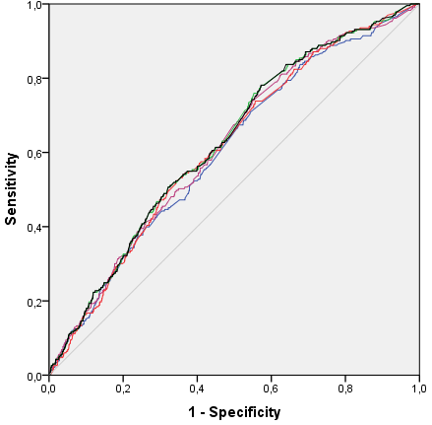 | Models | AUC  (95% Confidence Interval) | 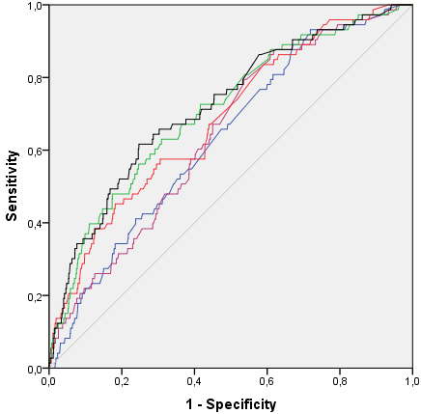 | Models | AUC  (95% Confidence Interval)
 | Maternal characteristics:  (Blue line) | 0.60 (0.57 to 0.64) |  | Maternal characteristics:  (Blue line) | 0.63 (0.57 to 0.69)
 | Second trimester:  (Purple line) | 0.62 (0.58 to 0.65) |  | Second trimester:  (Purple line) | 0.64 (0.59 to 0.70)
 | Third trimester:  (Red line) | 0.61 (0.58 to 0.65) |  | Third trimester:  (Red line) | 0.68 (0.62 to 0.74)
 | Second and third trimester:  (Green line) | 0.63 (0.59 to 0.66) |  | Second and third trimester:  (Green line) | 0.71 (0.65 to 0.77)
 | Growth:  (Black line) | 0.63 (0.59 to 0.66) |  | Growth:  (Black line) | 0.72 (0.66 to 0.78)
ª Receiver operating characteristic curves and corresponding area under the curve (95% confidence interval) of models based on predicted values from the five models for screening for spontaneous preterm birth. Spontaneous preterm birth was defined as birth before 37th week of gestation, after non-medically induced labor.
^{b} Model characteristics: Maternal characteristics; Second trimester model: Maternal characteristics and 2nd trimester EFW; Third trimester model: Maternal characteristics and 3rd trimester EFW; Second and third trimester model: Maternal characteristics, 2nd and 3rd trimester EFW; Growth model: Maternal characteristics, 2nd and 3rd trimester EFW and 2nd to 3rd trimester EFW change.
^{c} AUCs based on a sample of 2705 participants with all placenta measures available. EFW models as described under ^{b} with additional placenta measures. Second trimester model: 2nd trimester uterine artery resistance index and 2nd trimester umbilical artery pulsatility index. Third trimester model; 3rd trimester uterine artery resistance index and 3rd trimester umbilical artery pulsatility index; Second and third trimester model: 2nd and 3rd trimester uterine artery resistance index, and 2nd and 3rd trimester umbilical artery pulsatility index; Growth model: 2nd and 3rd trimester uterine artery resistance index and 2nd and 3rd trimester umbilical artery pulsatility index, 2nd to 3rd trimester change of uterine artery resistance index and umbilical artery pulsatility index.

Figure S3. Receiver operating characteristic curves for models screening for preterm birth, small-size and large-size for gestational age, with screen positive defined as estimated fetal weight <5th percentile, or >95th percentileª
Preterm birth
Estimated fetal weight^{b} |  |  |  | Estimated fetal weight and placenta measures^{c}
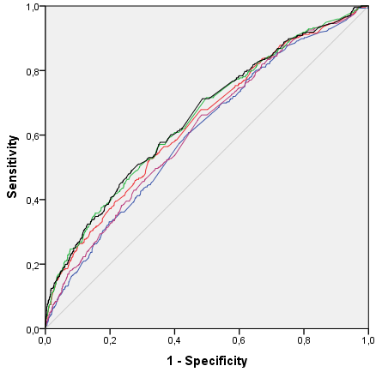 |  | Model 1: 0.61 (0.58 to 0.64)  Model 2: 0.62 (0.58 to 0.65)  Model 3: 0.64 (0.61 to 0.67)  Model 4: 0.65 (0.62 to 0.69)  Model 5: 0.66 (0.62 to 0.69) |  | 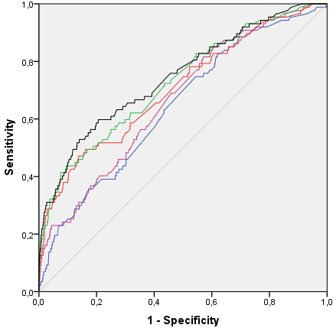 | Model 1: 0.64 (0.58 to 0.70)  Model 2: 0.67 (0.61 to 0.72)  Model 3: 0.71 (0.64 to 0.77)  Model 4: 0.73 (0.67 to 0.78)  Model 5: 0.75 (0.69 to 0.80)
Small-size for gestational age
Estimated fetal weight^{b} |  |  |  | Estimated fetal weight and placenta measures^{c}
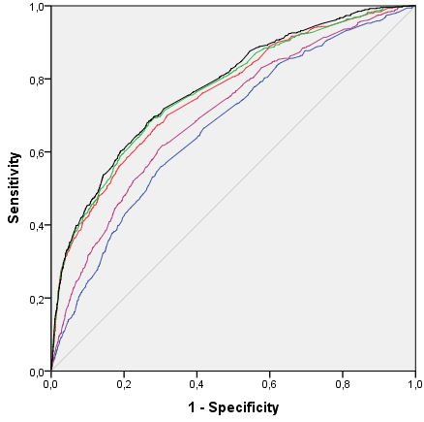 |  |  | Model 1: 0.67 (0.65 to 0.69)  Model 2: 0.70 (0.68 to 0.72)  Model 3: 0.76 (0.74 to 0.78)  Model 4: 0.77 (0.75 to 0.79)  Model 5: 0.78 (0.76 to 0.80) | 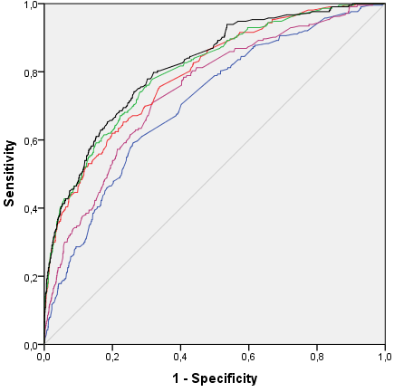 | Model 1: 0.71 (0.67 to 0.74)  Model 2: 0.74 (0.71 to 0.78)  Model 3: 0.79 (0.76 to 0.82)  Model 4: 0.81 (0.77 to 0.84)  Model 5: 0.82 (0.79 to 0.85)
Large-size for gestational age
Estimated fetal weight^{b} |  |  |  | Estimated fetal weight and placenta measures^{c}
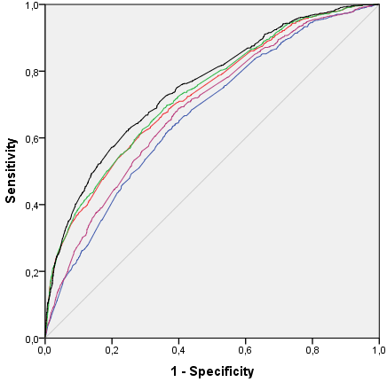 | Model 1: 0.67 (0.65 to 0.69)  Model 2: 0.69 (0.67 to 0.71)  Model 3: 0.73 (0.71 to 0.75)  Model 4: 0.73 (0.71 to 0.75)  Model 5: 0.75 (0.73 to 0.77) |  |  | 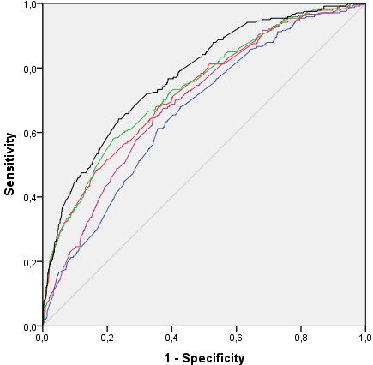 | Model 1: 0.66 (0.63 to 0.70)  Model 2: 0.70 (0.66 to 0.73)  Model 3: 0.73 (0.69 to 0.76)  Model 4: 0.74 (0.70 to 0.77)  Model 5: 0.77 (0.74 to 0.81)
ª Receiver operating characteristic curves and corresponding area under the curve (95% CI) based on predicted values from five models for screening for preterm birth, small- and large-size for gestational age. Models are based on maternal characteristics, second and third trimester fetal and placental ultrasound.
^{b} Model 1: Maternal characteristics; Model 2: Maternal characteristics and 2nd trimester EFW; Model 3: Maternal characteristics and 3rd trimester EFW; Model 4: Maternal characteristics, 2nd +3rd trimester EFW; Model 5: Maternal characteristics, 2nd + 3rd trimester EFW and 2nd to 3rd trimester EFW change.
^{c} AUCs based on a sample of 2705 participants with all placenta measures available. Models as EFW models under ^{b}, adding the following placenta measures. Model 2: 2nd trimester uterine artery resistance index, and 2nd trimester umbilical artery pulsatility index. Model 3: 3rd trimester uterine artery resistance index, and 3rd trimester umbilical artery pulsatility index; Model 4: 2nd and 3rd trimester uterine artery resistance index, and 2nd and 3rd trimester umbilical artery pulsatility index; Model 5: 2nd and 3rd trimester uterine artery resistance index, and 2nd and 3rd trimester umbilical artery pulsatility index, 2nd to 3rd trimester change of uterine artery resistance index and umbilical artery pulsatility index.
Grey line: Reference line;
Blue line: Model 1: Maternal characteristics model;
Purple line: Model 2: Second trimester model;
Red line: Model 3: Third trimester model;
Green line: Model 4: Second and third trimester model;
Black line: Model 5: Growth model.
Figure S4. Receiver operating characteristic curves for models screening for preterm birth, small-size and large-size for gestational age using abdominal circumference instead of estimated fetal weightª
Preterm birth
Abdominal circumference^{b} |  |  | Abdominal circumference and placenta measures^{c}
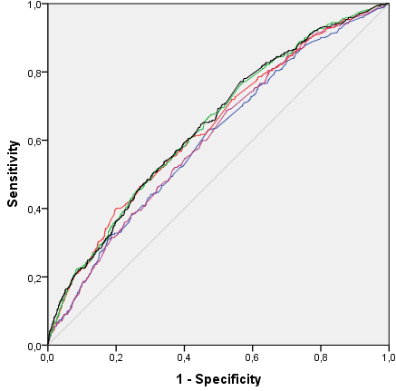 | Model 1: 0.60 (0.57 to 0.63)  Model 2: 0.61 (0.58 to 0.64)  Model 3: 0.64 (0.61 to 0.67)  Model 4: 0.64 (0.61 to 0.67)  Model 5: 0.64 (0.61 to 0.67) |  | 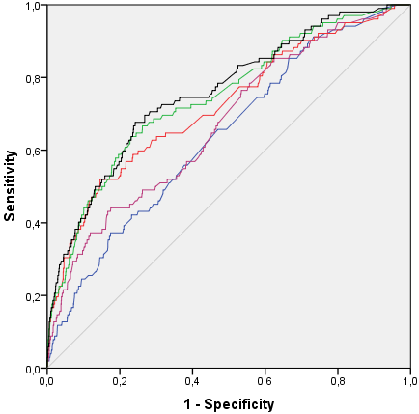 | Model 1: 0.64 (0.59 to 0.69)  Model 2: 0.67 (0.62 to 0.73)  Model 3: 0.72 (0.66 to 0.78)  Model 4: 0.75 (0.69 to 0.80)  Model 5: 0.76 (0.71 to 0.81)
Small-size for gestational age
Abdominal circumference^{b} |  |  | Abdominal circumference and placenta measures^{c}
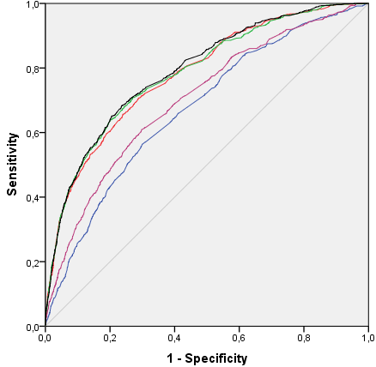 | Model 1: 0 67 (0.65 to 0.69)  Model 2: 0.70 (0.68 to 0.72)  Model 3: 0.78 (0.76 to 0.80)  Model 4: 0.79 (0.77 to 0.80)  Model 5: 0.79 (0.77 to 0.81) |  | 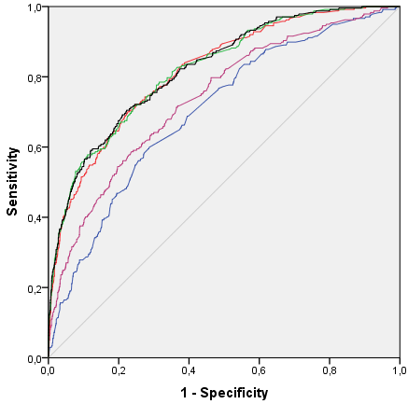 | Model 1: 0.70 (0.67 to 0.74)  Model 2: 0.74 (0.71 to 0.77)  Model 3: 0.82 (0.79 to 0.85)  Model 4: 0.82 (0.79 to 0.85)  Model 5: 0.82 (0.80 to 0.85)
Large-size for gestational age
Abdominal circumference^{b} |  |  | Abdominal circumference and placenta measures^{c}
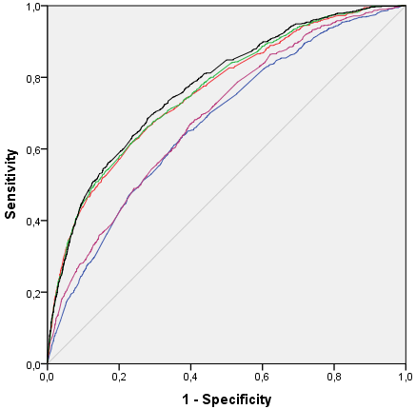 |  | Model 1: 0.68 (0.66 to 0.70)  Model 2: 0.69 (0.67 to 0.71)  Model 3: 0.76 (0.74 to 0.78)  Model 4: 0.77 (0.75 to 0.78)  Model 5: 0.78 (0.76 to 0.79) | 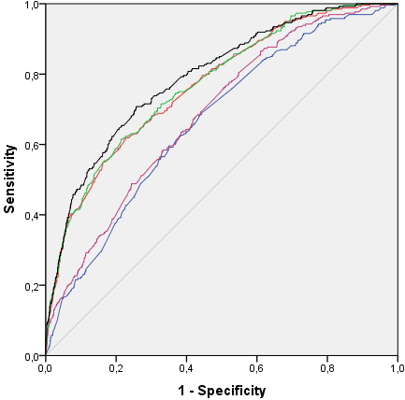 |  | Model 1: 0.67 (0.63 to 0.70)  Model 2: 0.69 (0.65 to 0.72)  Model 3: 0.77 (0.74 to 0.80)  Model 4: 0.77 (0.74 to 0.80)  Model 5: 0.79 (0.76 to 0.82)
ª Receiver operating characteristic curves of models based on predicted values from five models for preterm birth, small- and large-size for gestational age. Models based on fetal abdominal circumference, and placenta measures.
^{b} Model 1: Maternal characteristics; Model 2: Maternal characteristics and 2nd trimester AC; Model 3: Maternal characteristics and 3rd trimester AC; Model 4: Maternal characteristics, 2nd +3rd trimester AC; Model 5: Maternal characteristics, 2nd + 3rd trimester AC and 2nd to 3rd trimester AC change.
^{c} AUCs based on a sample of 2705 participants with all placenta measures available. Models as AC models under ^{b}, adding the following placenta measures: Model 2: 2nd trimester uterine artery resistance index and 2nd trimester umbilical artery pulsatility index. Model 3: 3rd trimester uterine artery resistance index and 3rd trimester umbilical artery pulsatility index; Model 4: 2nd and 3rd trimester uterine artery resistance index, and 2nd and 3rd trimester umbilical artery pulsatility index; Model 5: 2nd and 3rd trimester uterine artery resistance index and 2nd and 3rd trimester umbilical artery pulsatility index, 2nd to 3rd trimester change of uterine artery resistance index and umbilical artery pulsatility index.
Grey line: Reference line;
Blue line: Model 1: Maternal characteristics model;
Purple line: Model 2: Second trimester model;
Red line: Model 3: Third trimester model;
Green line: Model 4: Second and third trimester model;
Black line: Model 5: Growth model

Figure S5. Receiver operating characteristic curves for screening for preterm birth, small-size and large-size for gestational age, with separate umbilical and uterine artery indicesª
Estimated fetal weight and only umbilical artery pulsatility index^{bc}
Preterm birth  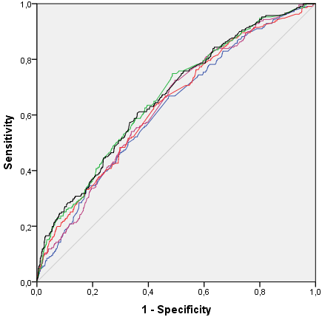  Model 1: 0.62 (0.59 to 0.66)  Model 2: 0.64 (0.60 to 0.67)  Model 3: 0.64 (0.60 to 0.67)  Model 4: 0.66 (0.63 to 0.70)  Model 5: 0.66 (0.63 to 0.70) | Small-size for gestational age  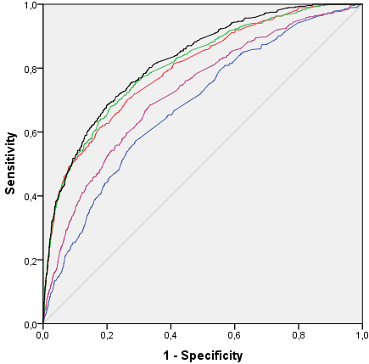  Model 1: 0.68 (0.66 to 0.71)  Model 2: 0.73 (0.70 to 0.75)  Model 3: 0.80 (0.78 to 0.75)  Model 4: 0.81 (0.79 to 0.83)  Model 5: 0.82 (0.80 to 0.84) | Large-size for gestational age  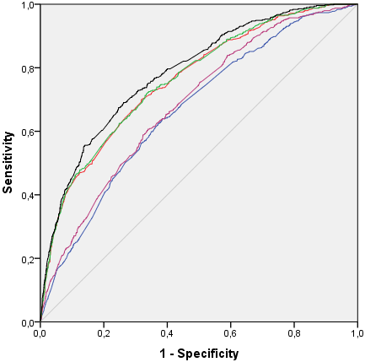  Model 1: 0.67 (0.64 to 0.69)  Model 2: 0.69 (0.66 to 0.71)  Model 3: 0.76 (0.74 to 0.78)  Model 4: 0.76 (0.74 to 0.79)  Model 5: 0.79 (0.76 to 0.81)
Estimated fetal weight and only uterine artery resistance index^{bd}
Preterm birth  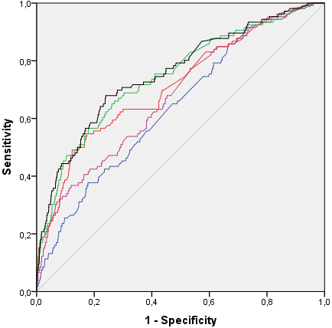  Model 1: 0.64 (0.59 to 0.69)  Model 2: 0.68 (0.63 to 0.73)  Model 3: 0.71 (0.66 to 0.77)  Model 4: 0.75 (0.69 to 0.80)  Model 5: 0.76 (0.71 to 0.81) | Small-size for gestational age  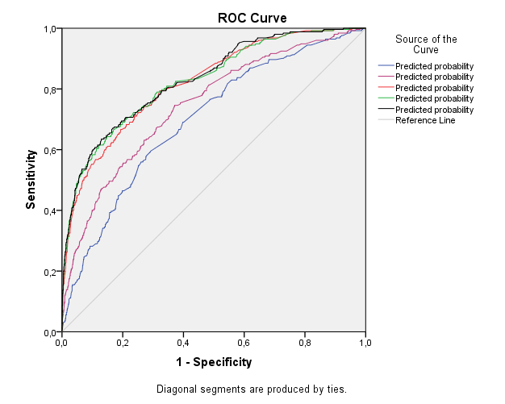  Model 1: 0.70 (0.66 to 0.73)  Model 2: 0.75 (0.71 to 0.78)  Model 3: 0.82 (0.79 to 0.85)  Model 4: 0.83 (0.80 to 0.85)  Model 5: 0.83 (0.80 to 0.86) | Large-size for gestational age  Model 1: 0.70 (0.66 to 0.73)  Model 2: 0.75 (0.71 to 0.78)  Model 3: 0.82 (0.79 to 0.85)  Model 4: 0.83 (0.80 to 0.85)  Model 5: 0.83 (0.80 to 0.86)
ª Receiver operating characteristic curves of models based on EFW combined with umbilical artery pulsatility index or uterine artery pulsatility index. Values are area under the curve (95% confidence interval).
^{b} Model 1: Maternal characteristics; Model 2: Maternal characteristics and 2nd trimester EFW; Model 3: Maternal characteristics and 3rd trimester EFW; Model 4: Maternal characteristics, 2nd +3rd trimester EFW; Model 5: Maternal characteristics, 2nd + 3rd trimester EFW and 2nd to 3rd trimester EFW change.
^{c} EFW models as described under ^{b} with additional placenta measures. Second trimester model: 2nd trimester umbilical artery pulsatility index. Third trimester model; 3rd trimester umbilical artery pulsatility index; Second and third trimester model: 2nd and 3rd trimester umbilical artery pulsatility index; 2nd and 3rd trimester umbilical artery pulsatility index, 2nd to 3rd trimester change of umbilical artery pulsatility index.
^{d} EFW models as described under ^{b} with additional placenta measures. Second trimester model: 2nd trimester uterine artery resistance index; Third trimester model; 3rd trimester uterine artery resistance index; Second and third trimester model: 2nd and 3rd trimester uterine artery resistance index; Growth model: 2nd and 3rd trimester uterine artery resistance index and 2nd to 3rd trimester change of uterine artery resistance index.
Grey line: Reference line;
Blue line: Model 1: Maternal characteristics model;
Purple line: Model 2: Second trimester model;
Red line: Model 3: Third trimester model;
Green line: Model 4: Second and third trimester model;
Black line: Model 5: Growth model.

Figure S6. Receiver operating characteristic curves for models screening for preterm birth, small-size and large-size for gestational age based on estimated fetal weight, without maternal characteristics^{ab}
Preterm birth | Small-size for gestational age | Large-size for gestational age
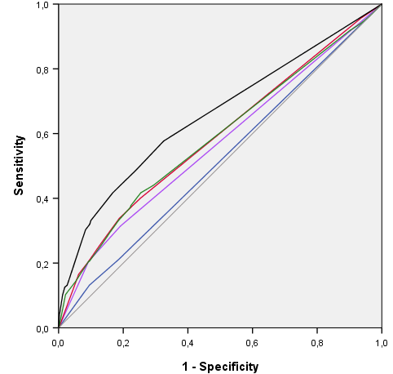  Model 2: 0.54 (0.50 to 0.57)  (blue)  Model 3: 0.57 (0.54 to 0.60)  (purple)  Model 3^{c}: 0.66 (0.61 to 0.70)  (black)  Model 4: 0.59 (0.56 to 0.63)  (red)  Model 5: 0.60 (0.57 to 0.63)  (green) | 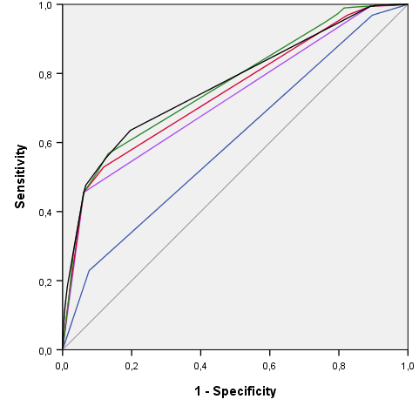  Model 2: 0.61 (0.59 to 0.63)  (blue)  Model 3: 0.71 (0.69 to 0.73)  (purple)  Model 3 ^{c}: 0.77 (0.74 to 0.80)  (black)  Model 4: 0.74 (0.72 to 0.76)  (red)  Model 5: 0.76 (0.74 to 0.78)  (green) | 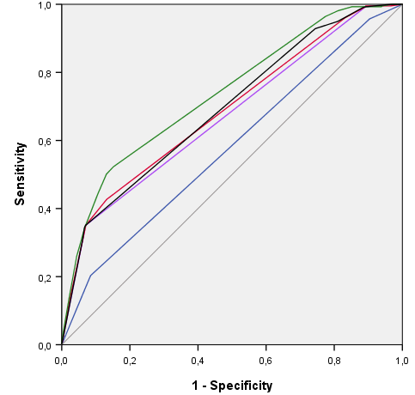Model 2: 0.58 (0.56 to 0.60)  (blue)  Model 3: 0.68 (0.65 to 0.70)  (purple)  Model 3 ^{c}: 0.69 (0.67 to 0.72)  (black)  Model 4: 0.69 (0.67 to 0.71)  (red)  Model 5: 0.73 (0.71 to 0.75)  (green)
ª Receiver operating characteristic curves and corresponding area under the curve (95% CI) based on predicted values from four models for preterm birth, small- and large-size for gestational age. Models are based on second and third trimester fetal ultrasound.
^{b} Model 2: 2nd trimester EFW; Model 3: 3rd trimester EFW; Model 4: 2nd +3rd trimester EFW; Model 5: 2nd + 3rd trimester EFW and 2nd to 3rd trimester EFW change.
^{c} AUCs based on a sample of 2705 participants with all placenta measures available. Models 3^{c} 3rd trimester EFW + 3rd trimester uterine artery resistance index and 3rd trimester umbilical artery pulsatility index;

Figure S7. Defining screen positive separately for small- and large-size for gestational ageª.
Screening performance for small-size for gestational age based  on maternal and fetal characteristics^{b,c} |  |  | Screening performance for small-size for gestational age based  on maternal, fetal and placental characteristics^{c,d}
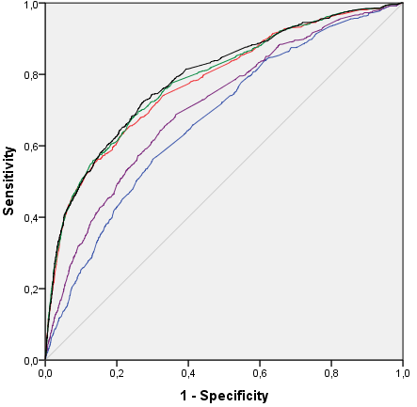 | Models | AUC (95% Confidence Interval) | 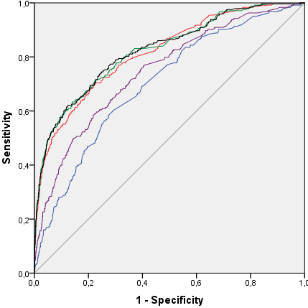 | Models | AUC (95% Confidence Interval)
 | Maternal characteristics:  (Blue line) | 0.67 (0.65 to 0.69) |  | Maternal characteristics:  (Blue line) | 0.70 (0.67 to 0.74)
 | Second trimester:  (Purple line) | 0.71 (0.69 to 0.73) |  | Second trimester:  (Purple line) | 0.75 (0.71 to 0.78)
 | Third trimester:  (Red line) | 0.78 (0.76 to 0.80) |  | Third trimester:  (Red line) | 0.82 (0.79 to 0.85)
 | Second and third trimester:  (Green line) | 0.89 (0.77 to 0.80) |  | Second and third trimester:  (Green line) | 0.82 (0.79 to 0.85)
 | Growth:  (Black line) | 0.79 (0.77 to 0.81) |  | Growth:  (Black line) | 0.82 (0.80 to 0.85)
Sensitivity of the third-trimester-models based on estimated fetal weight |  |  | Sensitivity of the third trimester models based on EFW and placenta measures
Specificity |  |  | Specificity
70% | 71% |  | 70% | 75%
80% | 61% |  | 80% | 66%
90% | 49% |  | 90% | 54%
Screening performance for large-size for gestational age based  on maternal and fetal characteristics^{b,e} |  |  | Screening performance for large-size for gestational age based  on maternal, fetal and placental characteristics^{d,e}
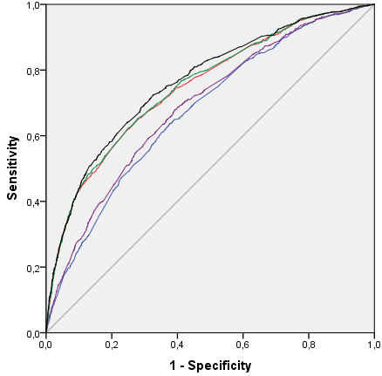 | Models | AUC (95% Confidence Interval) | 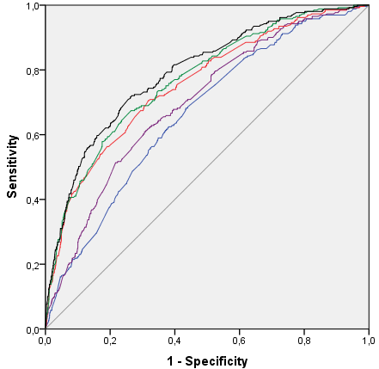 | Models | AUC (95% Confidence Interval)
 | Maternal characteristics:  (Blue line) | 0.68 (0.66 to 0.70) |  | Maternal characteristics:  (Blue line) | 0.67 (0.63 to 0.70)
 | Second trimester:  (Purple line) | 0.69 (0.67 to 0.71) |  | Second trimester:  (Purple line) | 0.70 (0.67 to 0.79)
 | Third trimester:  (Red line) | 0.75 (0.73 to 0.77) |  | Third trimester:  (Red line) | 0.76 (0.72 to 0.79)
 | Second and third trimester:  (Green line) | 0.75 (0.73 to 0.77) |  | Second and third trimester:  (Green line) | 0.77 (0.74 to 0.80)
 | Growth:  (Black line) | 0.76 (0.74 to 0.78) |  | Growth:  (Black line) | 0.79 (0.76 to 0.82)
Sensitivity of the third-trimester-models based on estimated fetal weight |  |  | Sensitivity of the third trimester models based on EFW and placenta measures
Specificity |  |  | Specificity
70% | 67% |  | 70% | 67%
80% | 57% |  | 80% | 57%
90% | 43% |  | 90% | 45%
AUC: area under the curve; CI: Confidence interval; EFW: Estimated fetal weight;
ª Receiver operating characteristic curve for the detection of fetuses at risk for small-size and large-size for gestational age based on second and third trimester fetal ultrasound and placenta measures, and derived sensitivity and specificity of the third trimester model.
^{b} Model characteristics: Maternal characteristics; Second trimester model: Maternal characteristics and 2nd trimester EFW; Third trimester model: Maternal characteristics and 3rd trimester EFW; Combined model: Maternal characteristics, 2nd and 3rd trimester EFW; Growth model: Maternal characteristics, 2nd and 3rd trimester EFW and 2nd to 3rd trimester EFW change.
^{c} Screen positive is defined as EFW <10th percentile.
^{d} AUCs based on a sample of 2705 participants with all placenta measures available. Models are EFW models as described under ^{b} with additional placenta measures. Second trimester model: 2nd trimester uterine artery resistance index and 2nd trimester umbilical artery pulsatility index. Third trimester model; 3rd trimester uterine artery resistance index and 3rd trimester umbilical artery pulsatility index; Second and third trimester model: 2nd and 3rd trimester uterine artery resistance index, and 2nd and 3rd trimester umbilical artery pulsatility index; Growth model: 2nd and 3rd trimester uterine artery resistance index and 2nd and 3rd trimester umbilical artery pulsatility index, 2nd to 3rd trimester change of uterine artery resistance index and umbilical artery pulsatility index.
^{e} Screen positive is defined as EFW >90th percentile.

Figure S8. Receiver operating characteristic curves for models screening for small-size and large-size for gestational age according to size at birth <5th percentile, or >95th percentileª
Screening performance for small-size for gestational age based  on maternal and fetal characteristics^{b} |  |  | Screening performance for small-size for gestational age based  on maternal, fetal and placental characteristics^{c}
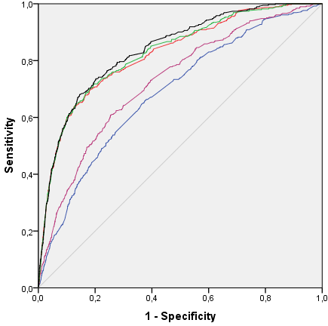 | Models | AUC (95% Confidence Interval) | 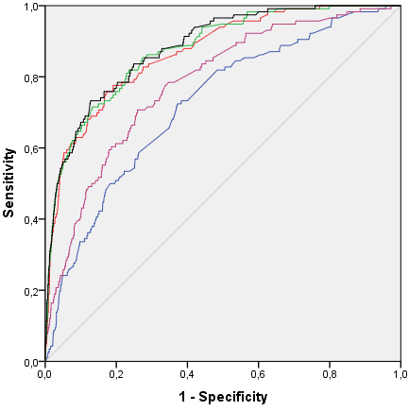 | Models | AUC (95% Confidence Interval)
 | Maternal characteristics:  (Blue line) | 0.69 (0.66 to 0.71) |  | Maternal characteristics:  (Blue line) | 0.72 (0.68 to 0.77)
 | Second trimester:  (Purple line) | 0.73 (0.70 to 0.75) |  | Second trimester:  (Purple line) | 0.78 (0.74 to 0.82)
 | Third trimester:  (Red line) | 0.82 (0.80 to 0.85) |  | Third trimester:  (Red line) | 0.87 (0.84 to 0.90)
 | Second and third trimester:  (Green line) | 0.83 (0.81 to 0.85) |  | Second and third trimester:  (Green line) | 0.88 (0.85 to 0.91)
 | Growth:  (Black line) | 0.84 (0.82 to 0.86) |  | Growth:  (Black line) | 0.88 (0.85 to 0.91)
Sensitivity of the third trimester models based on EFW ^{d} |  |  | Sensitivity of the third trimester models based on EFW and placenta measures ^{d}
Specificity | SGA if gestational age adjusted birthweight <p5 |  | Specificity | SGA if gestational age adjusted birthweight <p5
70% | 77% |  | 70% | 84%
80% | 71% |  | 80% | 78%
90% | 59% |  | 90% | 63%
Screening performance for large-size for gestational age based  on maternal and fetal characteristics^{b} |  |  | Screening performance for large-size for gestational age based  on maternal, fetal and placental characteristics^{c}
 | Models | AUC (95% Confidence Interval) |  | Models | AUC (95% Confidence Interval)
 | Maternal characteristics:  (Blue line) | 0.69 (0.67 to 0.72) |  | Maternal characteristics:  (Blue line) | 0.67 (0.62 to 0.72)
 | Second trimester:  (Purple line) | 0.72 (0.69 to 0.74) |  | Second trimester:  (Purple line) | 0.72 (0.68 to 0.77)
 | Third trimester:  (Red line) | 0.79 (0.76 to 0.81) |  | Third trimester:  (Red line) | 0.78 (0.74 to 0.82)
 | Second and third trimester:  (Green line) | 0.79 (0.77 to 0.81) |  | Second and third trimester:  (Green line) | 0.80 (0.76 to 0.84)
 | Growth:  (Black line) | 0.81 (0.79 to 0.83) |  | Growth:  (Black line) | 0.82 (0.79 to 0.86)
Sensitivity of the third trimester models based on EFW ^{d} |  |  | Sensitivity of the third trimester models based on EFW and placenta measures ^{d}
Specificity | LGA if gestational age adjusted birthweight >p95 |  | Specificity | LGA if gestational age adjusted birthweight >p95
70% | 72% |  | 70% | 67%
80% | 63% |  | 80% | 61%
90% | 48% |  | 90% | 43%

ª Receiver operating characteristic curves and corresponding area under the curve (95% confidence interval) of models based on predicted values from the five models for small- and large-size for gestational age. Small-size for gestational age defined as gestational age adjusted birth weight <5th percentile. Large-size for gestational age defined as gestational age adjusted birth weight >95th percentile.
^{b} Model 1: Maternal characteristics; Model 2: Maternal characteristics and 2nd trimester EFW; Model 3: Maternal characteristics and 3rd trimester EFW; Model 4: Maternal characteristics, 2nd +3rd trimester EFW; Model 5: Maternal characteristics, 2nd + 3rd trimester EFW and 2nd to 3rd trimester EFW change.
^{c} AUCs based on a sample of 2705 participants with all placenta measures available. Models as EFW models under ^{b}, adding the following placenta measures. Model 2: 2nd trimester uterine artery resistance index, and 2nd trimester umbilical artery pulsatility index. Model 3; 3rd trimester uterine artery resistance index, and 3rd trimester umbilical artery pulsatility index; Model 4: 2nd and 3rd trimester uterine artery resistance index, and 2nd and 3rd trimester umbilical artery pulsatility index; Model 5: 2nd and 3rd trimester uterine artery resistance index, and 2nd and 3rd trimester umbilical artery pulsatility index, 2nd to 3rd trimester change of uterine artery resistance index and umbilical artery pulsatility index.
^{d} Effects of changing the outcome threshold on the sensitivity of the third trimester model used for screening of fetuses at risk for small-size and large-size for gestational age.

Figure S9. Receiver operating characteristic curves for models screening for small-size and large-size for gestational age at birth defined as birth weight <3rd and >97th percentile, respectivelyª
Small-size for gestational age as gestational age adjusted birthweight <3rd percentile
Estimated fetal weight^{b} |  | Estimated fetal weight and placenta measures^{c}
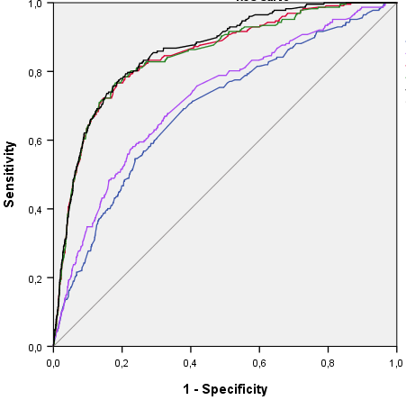 | Model 1: 0.69 (0.66 to 0.73)  (blue)  Model 2: 0.72 (0.69 to 0.76)  (purple)  Model 3: 0.85 (0.82 to 0.87)  (red)  Model 4: 0.85 (0.82 to 0.87)  (green)  Model 5: 0.86 (0.84 to 0.88)  (black) | 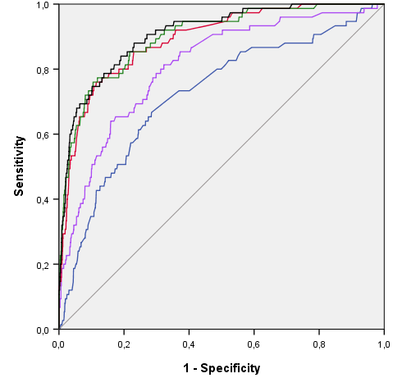 | Model 1: 0.72 (0.66 to 0.79)  (blue)  Model 2: 0.81 (0.76 to 0.86  (purple)  Model 3: 0.89 (0.76 to 0.93)  (red)  Model 4: 0.90 (0.86 to 0.94)  (green)  Model 5: 0.91 (0.88 to 0.94)  (black)
Sensitivity of the third trimester models based on EFW |  | Sensitivity of the third trimester models based on EFW and placenta measures
Specificity |  | Specificity
70% | 83% | 70% | 86%
80% | 77% | 80% | 80%
90% | 64% | 90% | 68%
Large-size for gestational age gestational age adjusted >97th percentile
Estimated fetal weight^{b} |  | Estimated fetal weight and placenta measures^{c}
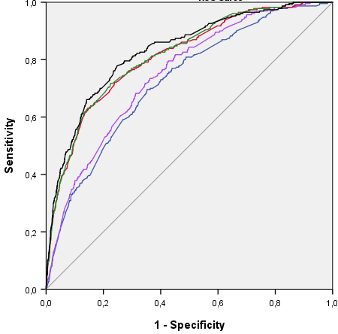 | Model 1: 0.72 (0.69 to 0.76)  (blue)  Model 2: 0.75 (0.72 to 0.78)  (purple)  Model 3: 0.81 (0.78 to 0.84)  (red)  Model 4: 0.82 (0.79 to 0.84)  (green)  Model 5: 0.83 (0.80 to 0.86)  (black) | 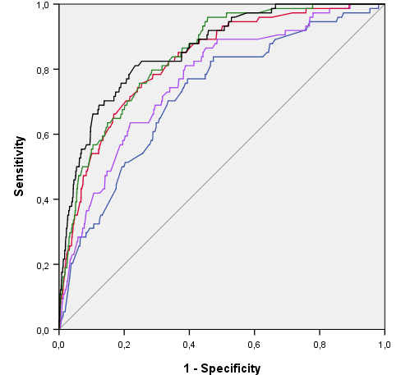 | Model 1: 0.72 (0.66 to 0.78)  (blue)  Model 2: 0.77 (0.71 to 0.82)  (purple)  Model 3: 0.83 (0.78 to 0.87)  (red)  Model 4: 0.84 (0.80 to 0.88)  (green)  Model 5: 0.86 (0.82 to 0.90)  (black)
Sensitivity of the third trimester models based on EFW |  | Sensitivity of the third trimester models based on EFW and placenta measures
Specificity |  | Specificity
70% | 77% | 70% | 77%
80% | 66% | 80% | 66%
90% | 51% | 90% | 47%
ª Receiver operating characteristic curves and corresponding area under the curve (95% CI) based on predicted values from five models for small- and large-size for gestational age. Models are based on maternal characteristics, second and third trimester fetal and placental ultrasound.
^{b} Model 1: Maternal characteristics; Model 2: Maternal characteristics and 2nd trimester EFW; Model 3: Maternal characteristics and 3rd trimester EFW; Model 4: Maternal characteristics, 2nd +3rd trimester EFW; Model 5: Maternal characteristics, 2nd + 3rd trimester EFW and 2nd to 3rd trimester EFW change.
^{c} AUCs based on a sample of 2705 participants with all placenta measures available. Models as EFW models under ^{b}, adding the following placenta measures. Model 2: 2nd trimester uterine artery resistance index, and 2nd trimester umbilical artery pulsatility index. Model 3; 3rd trimester uterine artery resistance index, and 3rd trimester umbilical artery pulsatility index; Model 4: 2nd and 3rd trimester uterine artery resistance index, and 2nd and 3rd trimester umbilical artery pulsatility index; Model 5: 2nd and 3rd trimester uterine artery resistance index, and 2nd and 3rd trimester umbilical artery pulsatility index, 2nd to 3rd trimester change of uterine artery resistance index and umbilical artery pulsatility index.
Figure S10. Receiver operating characteristic curves for models screening for small-size and large-size for gestational age at birth with adverse outcomesª
Small-size for gestational age and gestational hypertensive disorders
Estimated fetal weight^{b} |  | Estimated fetal weight and placenta measures^{c}
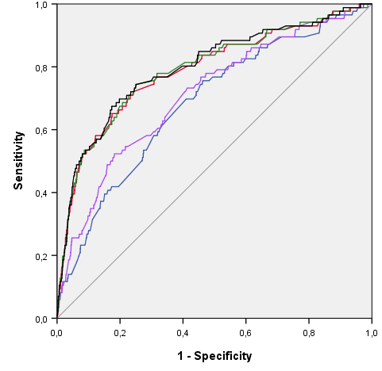 | Model 1: 0.68 (0.63 to 0.74)  (blue)  Model 2: 0.71 (0.66 to 0.77)  (purple)  Model 3: 0.79 (0.73 to 0.84)  (red)  Model 4: 0.79 (0.74 to 0.85)  (green)  Model 5: 0.80 (0.74 to 0.85) | 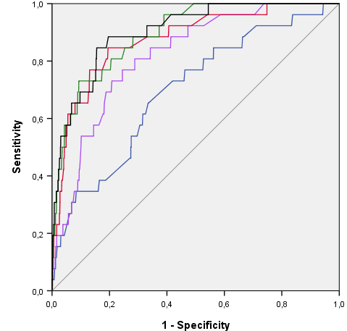 | Model 1: 0.70 (0.60 to 0.80)  (blue)  Model 2: 0.82 (0.75 to 0.89)  (purple)  Model 3: 0.88 (0.81 to 0.94)  (red)  Model 4: 0.90 (0.84 to 0.95)  (green)  Model 5: 0.90 (0.85 to 0.96)  (black)
Large-size for gestational age and assisted vaginal delivery or cesarean section
Estimated fetal weight^{b} |  | Estimated fetal weight and placenta measures^{c}
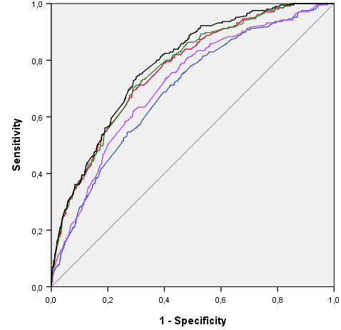 | Model 1: 0.69 (0.86 to 0.73)  (blue)  Model 2: 0.72 (0.68 to 0.75)  (purple)  Model 3: 0.77 (0.73 to 0.80)  (red)  Model 4: 0.77 (0.74 to 0.80)  (green)  Model 5:0.78 (0.76 to 0.81)  (black) | 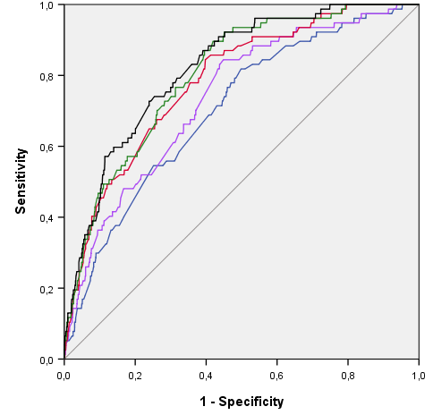 | Model 1: 0.70 (0.65 to 0.76)  (blue)  Model 2: 0.74 (0.68 to 0.79  (purple)  Model 3: 0.79 (0.74 to 0.83)  (red)  Model 4: 0.80 (0.76 to 0.85)  (green)  Model 5: 0.82 (0.78 to 0.86)  (black)
ª Receiver operating characteristic curves and corresponding area under the curve (95% CI) based on predicted values from five models for small- and large-size for gestational age. Models are based on maternal characteristics, second and third trimester fetal and placental ultrasound.
^{b} Model 1: Maternal characteristics; Model 2: Maternal characteristics and 2nd trimester EFW; Model 3: Maternal characteristics and 3rd trimester EFW; Model 4: Maternal characteristics, 2nd +3rd trimester EFW; Model 5: Maternal characteristics, 2nd + 3rd trimester EFW and 2nd to 3rd trimester EFW change.
^{c} AUCs based on a sample of 2705 participants with all placenta measures available. Models as EFW models under ^{b}, adding the following placenta measures. Model 2: 2nd trimester uterine artery resistance index, and 2nd trimester umbilical artery pulsatility index. Model 3; 3rd trimester uterine artery resistance index, and 3rd trimester umbilical artery pulsatility index; Model 4: 2nd and 3rd trimester uterine artery resistance index, and 2nd and 3rd trimester umbilical artery pulsatility index; Model 5: 2nd and 3rd trimester uterine artery resistance index, and 2nd and 3rd trimester umbilical artery pulsatility index, 2nd to 3rd trimester change of uterine artery resistance index and umbilical artery pulsatility index.

