Risk prediction models for dementia: role of age and cardiometabolic risk factors
Additional file 1: Methodological details and complimentary results.
Contents
Table S1. Scoring of the Cardiovascular Risk Factors, Aging, and Incidence of Dementia (CAIDE) risk score. 2
Table S2. Scoring of the Framingham cardiovascular Risk Score (FRS). 3
Table S3. Scoring of the Finnish Diabetes Risk Score (FINDRISC). 4
Table S4. TRIPOD checklist 5
Figure S1. Association of standardized predictors (CAIDE, FRS, and FINDRISC) assessed at age 55 with incidence of dementiaª (Panel A) and their distribution (Panel B). 6
Figure S2. Schematic representation of role of risk scores in transitions examined using multistate models. 7
Figure S3. Flowchart of sample selection for analysis on dementia with assessment of risk scores in 1991-1993. 8
Figure S4. Trajectory of global cognitive score ª in dementia cases in the years leading to dementia diagnosis and dementia free participants until end of follow-up. 9
Table S5. Association of age and standardized risk scores (CAIDE, FRS, and FINDRISC) assessed in 1991-1993, with and without age, with incidence of dementia; mean follow-up 23.5 years; 318 cases of dementia in 7,553 participants. 10
Table S6. Association of standardized risk scores (CAIDE, FRS, and FINDRISC) assessed at age 55, 60, and 65 with incidence of dementia without history of cardiovascular disease. 11
Table S7. Association of standardized risk scores (CAIDE, FRS, and FINDRISC) with incidence of dementia using cause-specific and subdistribution hazard to account for competing risk of death. 12

Table S1. Scoring of the Cardiovascular Risk Factors, Aging, and Incidence of Dementia (CAIDE) risk score.
Points | Age (years) | Education (years) | Sex | Physical activity† | SBP (mmHg) | BMI (kg/m²) | Total cholesterol (mmol/L)
0 | <47 | ≥10 | Women | Active | ≤140 | ≤30 | ≤6.5
1 |  |  | Men | Inactive
2 |  | 7-9 |  |  | >140 | >30 | >6.5
3 | 47-53 | 0-6
4 | >53
SBP=systolic blood pressure, BMI=body-mass index
†Physical activity causing sweating ≥ 2/week for a total weekly duration of one hour or more.

Table S2. Scoring of the Framingham cardiovascular Risk Score (FRS).
Points | Age (years) | Smoker | Diabetic | SBP not treated (mmHg) | SBP treated (mmHg) | HDL (mg/dL) | Total cholesterol (mg/dL)
Women
-3 |  |  |  | <120
-2 |  |  |  |  |  | ≥60
-1 |  |  |  |  | <120 | 50-59
0 | 30-34 | No | No | 120-129 |  | 45-49 | <160
1 |  |  |  | 130-139 |  | 35-44 | 160-199
2 | 35-39 |  |  | 140-149 | 120-129 | <35
3 |  | Yes |  |  | 130-139 |  | 200-239
4 | 40-44 |  | Yes | 150-159 |  |  | 240-279
5 | 45-49 |  |  | ≥160 | 140-149 |  | ≥280
6 |  |  |  |  | 150-159
7 | 50-54 |  |  |  | ≥160
8 | 55-59
9 | 60-64
10 | 65-69
11 | 70-74
12 | ≥75
Men
-2 |  |  |  | <120 |  | ≥60
-1 |  |  |  |  |  | 50-59
0 | 30-34 | No | No | 120-129 | <120 | 45-49 | <160
1 |  |  |  | 130-139 |  | 35-44 | 160-199
2 | 35-39 |  |  | 140-159 | 120-129 | <35 | 200-239
3 |  |  | Yes | ≥160 | 130-139 |  | 240-279
4 |  | Yes |  |  | 140-159 |  | ≥280
5 | 40-44 |  |  |  | ≥160
6 | 45-49
8 | 50-54
10 | 55-59
11 | 60-64
12 | 65-69
14 | 70-74
15 | ≥75
SBP=systolic blood pressure, HDL=high-density lipoprotein

Table S3. Scoring of the Finnish Diabetes Risk Score (FINDRISC).
Points | Age (years) | Family diabetes | Daily fruit/veg. | Physical activity† | HBP medication | History of HBG | BMI (kg/m²) | Waist circumference (cm)
 |  |  |  |  |  |  |  | Women | Men
0 | <45 | No | Yes | Yes | Never | No | ≤25 | <80 | <94
1 |  |  | No |  |  |  | 25-30
2 | 45-54 |  |  | No | At least once
3 | 55-64 | 2nd deg. |  |  |  |  | >30 | 80-88 | 94-102
4 | ≥65 |  |  |  |  |  |  | ≥88 | ≥102
5 |  | 1st deg. |  |  |  | Yes
HBP=High blood pressure, HBG=high blood glucose, BMI=body-mass index
†Moderate to vigorous physical activity ≥30min/day, as defined by the 2011 Compendium of Physical Activities

Table S4. TRIPOD checklist
Section/Topic | Item | Checklist Item | Page
Title and abstract
Title | 1 | Identify the study as developing and/or validating a multivariable prediction model, the target population, and the outcome to be predicted. | 1
Abstract | 2 | Provide a summary of objectives, study design, setting, participants, sample size, predictors, outcome, statistical analysis, results, and conclusions. | 2
Introduction
Background and objectives | 3a | Explain the medical context (including whether diagnostic or prognostic) and rationale for developing or validating the multivariable prediction model, including references to existing models. | 4
Background and objectives | 3b | Specify the objectives, including whether the study describes the development or validation of the model or both. | 4,5
Methods
Source of data | 4a | Describe the study design or source of data (e.g., randomized trial, cohort, or registry data), separately for the development and validation data sets, if applicable. | 5
Source of data | 4b | Specify the key study dates, including start of accrual; end of accrual; and, if applicable, end of follow-up. | 5
Participants | 5a | Specify key elements of the study setting (e.g., primary care, secondary care, general population) including number and location of centres. | 5
Participants | 5b | Describe eligibility criteria for participants. | 5
Participants | 5c | Give details of treatments received, if relevant. | 5-7
Outcome | 6a | Clearly define the outcome that is predicted by the prediction model, including how and when assessed. | 7
Outcome | 6b | Report any actions to blind assessment of the outcome to be predicted. | NA
Predictors | 7a | Clearly define all predictors used in developing or validating the multivariable prediction model, including how and when they were measured. | 5-7
Predictors | 7b | Report any actions to blind assessment of predictors for the outcome and other predictors. | NA
Sample size | 8 | Explain how the study size was arrived at. | Fig. S3
Missing data | 9 | Describe how missing data were handled (e.g., complete-case analysis, single imputation, multiple imputation) with details of any imputation method. | Fig. S3
Statistical analysis methods | 10c | For validation, describe how the predictions were calculated. | 7-9
Statistical analysis methods | 10d | Specify all measures used to assess model performance and, if relevant, to compare multiple models. | 7-9
Statistical analysis methods | 10e | Describe any model updating (e.g., recalibration) arising from the validation, if done. | NA
Risk groups | 11 | Provide details on how risk groups were created, if done. | 7-9
Development vs. validation | 12 | For validation, identify any differences from the development data in setting, eligibility criteria, outcome, and predictors. | 10
Results
Participants | 13a | Describe the flow of participants through the study, including the number of participants with and without the outcome and, if applicable, a summary of the follow-up time. A diagram may be helpful. | Fig. S3
Participants | 13b | Describe the characteristics of the participants (basic demographics, clinical features, available predictors), including the number of participants with missing data for predictors and outcome. | Table 1
Participants | 13c | For validation, show a comparison with the development data of the distribution of important variables (demographics, predictors and outcome). | Table 1
Model performance | 16 | Report performance measures (with CIs) for the prediction model. | Tables 2, 3
Model-updating | 17 | If done, report the results from any model updating (i.e., model specification, model performance). | NA
Discussion
Limitations | 18 | Discuss any limitations of the study (such as nonrepresentative sample, few events per predictor, missing data). | 13-14
Interpretation | 19a | For validation, discuss the results with reference to performance in the development data, and any other validation data. | 12
Interpretation | 19b | Give an overall interpretation of the results, considering objectives, limitations, results from similar studies, and other relevant evidence. | 11-12
Implications | 20 | Discuss the potential clinical use of the model and implications for future research. | 14-15
Other information
Supplementary information | 21 | Provide information about the availability of supplementary resources, such as study protocol, Web calculator, and data sets. | Additional file 1
Funding | 22 | Give the source of funding and the role of the funders for the present study. | 16

Figure S1. Association of standardized predictors (CAIDE, FRS, and FINDRISC) assessed at age 55 with incidence of dementiaª (Panel A) and their distribution (Panel B).
Panel A Panel B
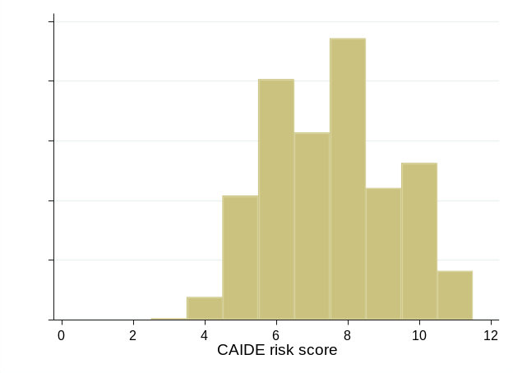
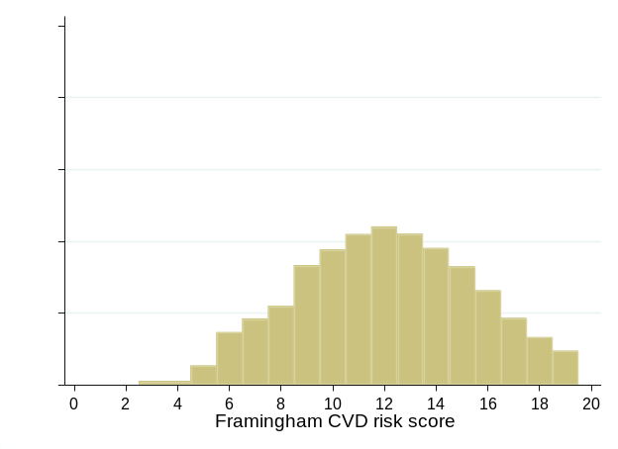
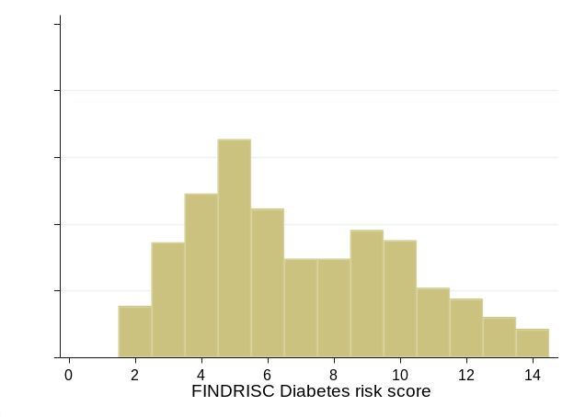
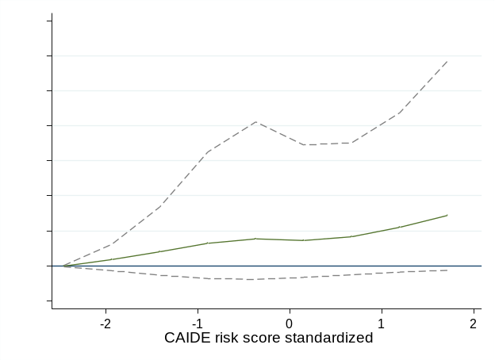
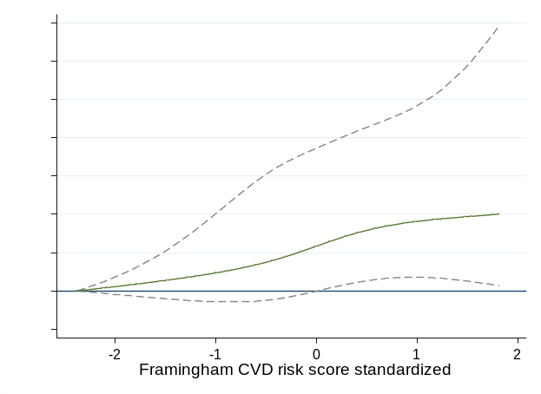
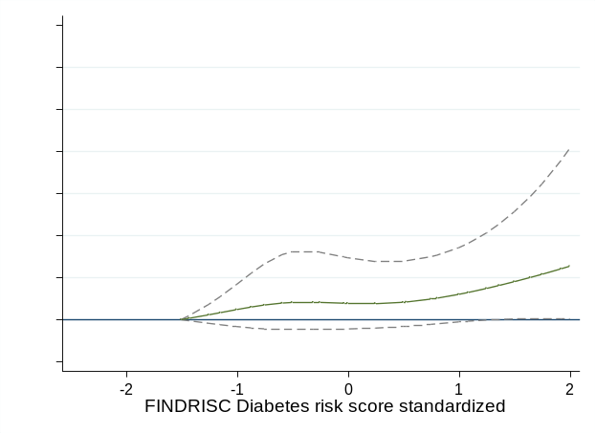

CAIDE=Cardiovascular Risk Factors, Aging, and Incidence of Dementia; FRS: Framingham cardiovascular Risk Score; FINDRISC: Finnish Diabetes Risk Score.
ªHazard ratio estimated from restricted cubic spline (4 knots) and their 95% confidence interval 95%, scale for the predictors was reduced to 2 standard deviation over the mean.

Figure S2. Schematic representation of role of risk scores in transitions examined using multistate models.
Transition 1: Healthy to Incident Cardiometabolic Disease
Incident cardiometabolic disease
Start of follow-up

Transition 2 : Cardiometabolic disease to Dementia
Transition 3: Healthy to Dementia
Dementia

1985-1988, N=10,308 Baseline of the Whitehall II study
1991-1993, N=8,814 free of dementia
1,494 excluded participants
No response/withdrawal before 1991-1993 (n=1,369)
Died before 1991-1993 (n=125)
Analysis: Dementia
Follow-up form 1991-1993 to
31st March 2017
N Dementia/Total=318/7553

N Dementia/Total=318/7553

1,261 missing data on at least one score
CAIDE (n=947)
Framingham CVD (n=1,008)
FINDRISC (n=1,151)

Figure S3. Flowchart of sample selection for analysis on dementia with assessment of risk scores in 1991-1993.

Figure S4. Trajectory of global cognitive score ª in dementia cases in the years leading to dementia diagnosis and dementia free participants until end of follow-up.
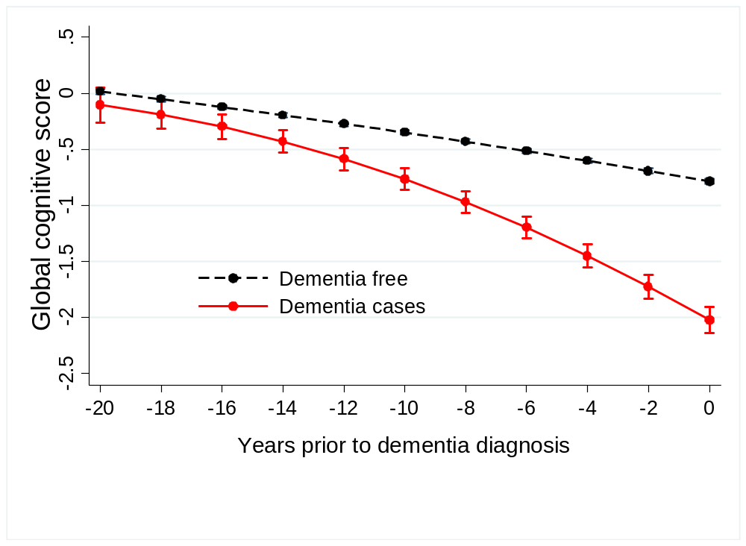

 | Number of observations in the analysis
Years |  | -20 to -16 | -16 to -12 | -12 to-8 | -8 to-4 | -4 to 0
Dementia free (N=7237) |  | 5136 | 5693 | 5130 | 5788 | 5768
Dementia cases (N=291) |  | 88 | 125 | 167 | 177 | 145
ª Composed of tests of memory, reasoning, phonemic and semantic fluency administered to the participants in 1997, 2003, 2007, 2012, and 2015.

Table S5. Association of age and standardized risk scores (CAIDE, FRS, and FINDRISC) assessed in 1991-1993, with and without age, with incidence of dementia; mean follow-up 23.5 years; 318 cases of dementia in 7,553 participants.
 | HR (95% CI) |  | R² (95% CI) |  | C-statistic (95% CI) | p | p^{d} |  | AIC
Age (39-63 years)ª | 3.09 (2.70, 3.55) |  | 52.7 (45.6, 59.9) |  | 0.781 (0.758, 0.804) | Ref. |  |  | 5257.0
Risk scores
CAIDE^{b} | 2.24 (1.98, 2.52) |  | 32.5 (25.5, 39.4) |  | 0.714 (0.690, 0.739) | 0.001 | Ref. |  | 5403.2
CAIDE (without age)^{c} | 1.44 (1.30, 1.61) |  | 8.49 (4.21, 14.4) |  | 0.604 (0.573, 0.635) | 0.001 | 0.001 |  | 5543.4
FRS^{b} | 2.08 (1.87, 2.31) |  | 32.0 (24.9, 39.5) |  | 0.719 (0.693, 0.745) | 0.001 | Ref. |  | 5406.5
FRS (without age) ^{c} | 1.43 (1.29, 1.59) |  | 8.11 (3.96, 14.1) |  | 0.600 (0.567, 0.632) | 0.001 | 0.001 |  | 5545.4
FINDRISC^{b} | 1.52 (1.38, 1.67) |  | 12.5 (7.47, 19.3) |  | 0.630 (0.602, 0.659) | 0.001 | Ref. |  | 5521.2
FINDRISC (without age) ^{c} | 1.25 (1.14, 1.39) |  | 3.47 (0.83, 7.95) |  | 0.549 (0.516, 0.582) | 0.001 | 0.001 |  | 5570.3
CAIDE=Cardiovascular Risk Factors, Aging, and Incidence of Dementia; FRS: Framingham cardiovascular Risk Score; FINDRISC: Finnish Diabetes Risk Score.
HR: Hazard Ratio, CI: Confidence Interval, R²=Royston’s R², C-index=Harrell’s C-index, AIC=Akaike Information Criterion
ª1 SD corresponds to 6.0 years.
^{b}1 SD corresponds to 2.9 points in CAIDE, 3.7 points for men & 4.2 points for women in FRS, and 3.3 points for men & 3.9 points for women in FINDRISC.
^{c}1 SD corresponds to 1.9 points in CAIDE without age, 2.8 points for men & 3.2 points for women in FRS without age, and 3.0 points for men & 3.5 points for women in FINDRISC without age.
^{d}p-values for difference in C-statistic when risk score without the age component was compared to that with the age component.

Table S6. Association of standardized risk scores (CAIDE, FRS, and FINDRISC) assessed at age 55, 60, and 65 with incidence of dementia without history of cardiovascular disease.
 | HR (95% CI) | R² (95% CI) | C-index (95% CI) |  | p-value^{e} | AIC | ∆_{AIC}
Risk scores assessed in 1991-1993,ª age 39 to 63 years (Mean follow-up 23.5 years; 249 cases of dementia in 7,484 participants)
CAIDE | 2.16 (1.88, 2.47) | 30.1 (22.5, 38.2) |  | 0.706 (0.678, 0.734) | Ref. | 4243.0 | Ref.
FRS | 1.90 (1.69, 2.14) | 24.9 (17.7, 32.6) |  | 0.698 (0.668, 0.728) | 0.556 | 4268.1 | 25.1
FINDRISC | 1.49 (1.34, 1.66) | 11.4 (5.69, 18.5) |  | 0.625 (0.593, 0.657) | <0.001 | 4329.0 | 86
Analysis stratified by baseline age
Risk scores assessed at 55 years^{b} (Mean follow-up 17.8 years; 213 cases of dementia in 6,719 participants)
CAIDE | 1.21 (1.06, 1.38) | 2.17 (0.16, 6.66) |  | 0.543 (0.502, 0.585) | Ref. | 3407.4 | Ref.
FRS | 1.29 (1.12, 1.49) | 3.57 (0.78, 8.82) |  | 0.568 (0.526, 0.610) | 0.309 | 3402.5 | -4.9
FINDRISC | 1.23 (1.07, 1.41) | 2.33 (0.21, 6.85) |  | 0.557 (0.513, 0.600) | 0.584 | 3406.9 | -0.5
Risk scores assessed at 60 years^{c} (Mean follow-up 14.0 years; 237 cases of dementia in 6,944 participants)
CAIDE | 1.04 (0.91, 1.18) | 0.08 (0.00, 1.95) |  | 0.500 (0.454, 0.546) | Ref. | 3657.9 | Ref.
FRS | 1.16 (1.02, 1.32) | 1.32 (0.04, 4.34) |  | 0.558 (0.516, 0.599) | 0.024 | 3653.0 | -4.9
FINDRISC | 1.21 (1.06, 1.39) | 1.90 (0.07, 6.21) |  | 0.543 (0.497, 0.589) | 0.098 | 3650.7 | -7.2
Risk scores assessed at 65 years^{d} (Mean follow-up 9.5 years; 210 cases of dementia in 6,398 participants)
CAIDE | 1.04 (0.91, 1.19) | 0.11 (0.00, 1.95) |  | 0.502 (0.455, 0.549) | Ref. | 3139.9 | Ref.
FRS | 1.12 (0.98, 1.27) | 0.82 (0.00, 3.97) |  | 0.536 (0.492, 0.580) | 0.215 | 3137.4 | -2.5
FINDRISC | 1.10 (0.96, 1.27) | 0.54 (0.00, 3.66) |  | 0.507 (0.462, 0.553) | 0.851 | 3138.4 | -1.5
CAIDE=Cardiovascular Risk Factors, Aging, and Incidence of Dementia; FRS: Framingham cardiovascular Risk Score; FINDRISC: Finnish Diabetes Risk Score.
HR: Hazard Ratio, CI: Confidence Interval, R²=Royston’s R², C-index=Harrell’s C-index, AIC=Akaike Information Criterion
ª1991-1993: 1 SD corresponds to 2.9 points in CAIDE, 3.7 points for men & 4.2 points for women in FRS, and 3.3 points for men & 3.9 points for women in FINDRISC.
^{b}Age 55: 1 SD corresponds to 1.9 points in CAIDE, 3.4 points for men & 3.6 points for women in FRS, and 3.6 points for men & 4.0 points for women in FINDRISC.
^{c} Age 60: 1 SD corresponds to 1.9 points in the CAIDE, 3.1 points for men & 3.6 points for women in FRS, and 3.8 points for men & 4.1 points for women in FINDRISC.
^{d}Age 65: 1 SD corresponds to 1.9 points in the CAIDE, 2.9 points for men & 3.6 points for women in FRS, and 4.0 points for men & 4.4 points for women in FINDRISC.
^{e}p-value for difference in C-statistic.

Table S7. Association of standardized risk scores (CAIDE, FRS, and FINDRISC) with incidence of dementia using cause-specific and subdistribution hazard to account for competing risk of death.
 | Cause specific  HR (95% CI) | Subdistribution  HR (95% CI)
Risk scores assessed in 1991-1993,ª age 39 to 63 years (Mean follow-up 23.5 years; 249 cases of dementia & 1014 deaths in 7,484 participants)
CAIDE | 2.24 (1.98, 2.52) | 2.10 (1.89, 2.33)
FRS | 2.08 (1.87, 2.31) | 1.90 (1.73, 2.08)
FINDRISC | 1.52 (1.38, 1.67) | 1.45 (1.33, 1.59)
Analysis stratified by baseline age
Risk scores assessed at 55 years^{b} (Mean follow-up 17.8 years; 213 cases of dementia & 1014 deaths & 821 deaths in 6,719 participants)
CAIDE | 1.22 (1.09, 1.38) | 1.20 (1.07, 1.36)
FRS | 1.43 (1.26, 1.61) | 1.32 (1.17, 1.50)
FINDRISC | 1.25 (1.10, 1.41) | 1.18 (1.05, 1.34)
Risk scores assessed at 60 years^{c} (Mean follow-up 14.0 years; 237 cases of dementia & 823 deaths in 6,944 participants)
CAIDE | 1.03 (0.92, 1.16) | 1.04 (0.92, 1.18)
FRS | 1.23 (1.10, 1.38) | 1.16 (1.03, 1.30)
FINDRISC | 1.20 (1.07, 1.36) | 1.14 (0.99, 1.30)
Risk scores assessed at 65 years^{d} (Mean follow-up 9.5 years; 210 cases of dementia & 587 deaths in 6,398 participants)
CAIDE | 1.05 (0.93, 1.18) | 1.07 (0.94, 1.20)
FRS | 1.13 (1.01, 1.27) | 1.08 (0.96, 1.22)
FINDRISC | 1.13 (1.00, 1.28) | 1.08 (0.94, 1.23)
CAIDE=Cardiovascular Risk Factors, Aging, and Incidence of Dementia; FRS: Framingham cardiovascular Risk Score; FINDRISC: Finnish Diabetes Risk Score.
HR: Hazard Ratio, CI: Confidence Interval
ª1991-1993: 1 SD corresponds to 2.9 points in CAIDE, 3.7 points for men & 4.2 points for women in FRS, and 3.3 points for men & 3.9 points for women in FINDRISC.
^{b}Age 55: 1 SD corresponds to 1.9 points in CAIDE, 3.4 points for men & 3.6 points for women in FRS, and 3.6 points for men & 4.0 points for women in FINDRISC.
^{c} Age 60: 1 SD corresponds to 1.9 points in the CAIDE, 3.1 points for men & 3.6 points for women in FRS, and 3.8 points for men & 4.1 points for women in FINDRISC.
^{d}Age 65: 1 SD corresponds to 1.9 points in the CAIDE, 2.9 points for men & 3.6 points for women in FRS, and 4.0 points for men & 4.4 points for women in FINDRISC.

