Additional file 1
Figures

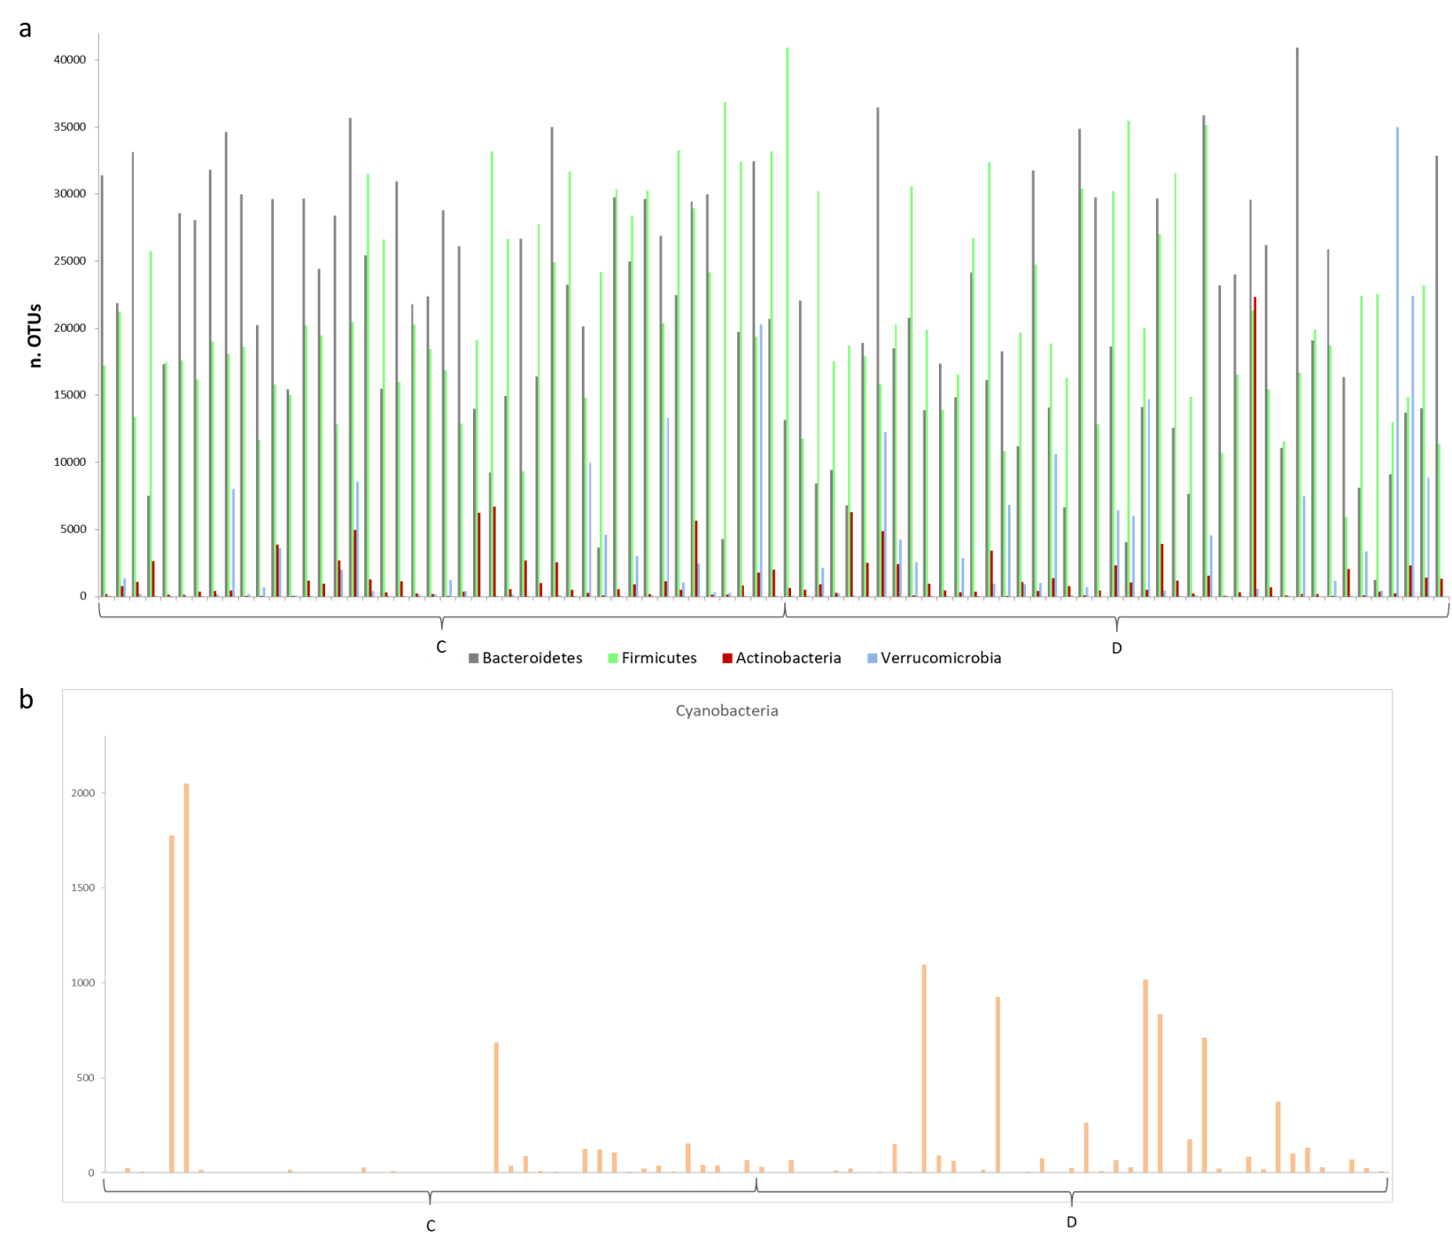

Figure S1. OTUs distribution in the control-diseased dataset for the most representative phyla. a) OTUs distribution for Bacteroidetes, Firmicutes, Actinobacteria and Verrucomicrobia. b) OTUs distribution for Cyanobacteria.

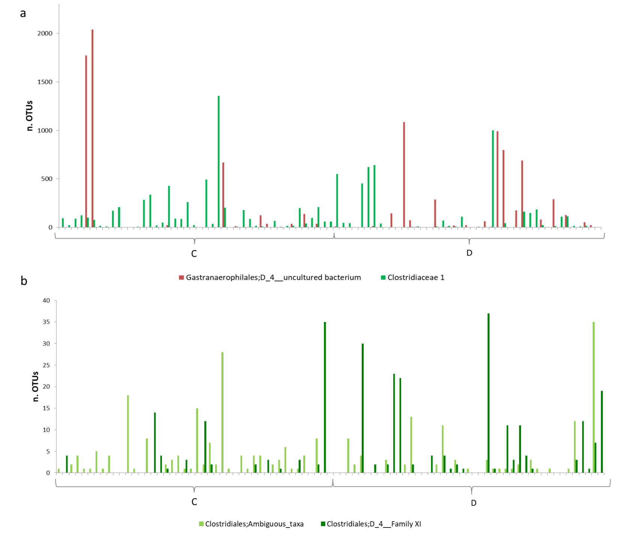

Figure S2. OTUs distribution in the control-diseased dataset for the significant families. a) OTUs distribution for Gastranaerophilales;D_4__uncultured bacterium and Clostridiaceae 1. b) OTUs distribution for Clostridiales;Ambiguous_taxa and Clostridiales;D_4__Family XI.

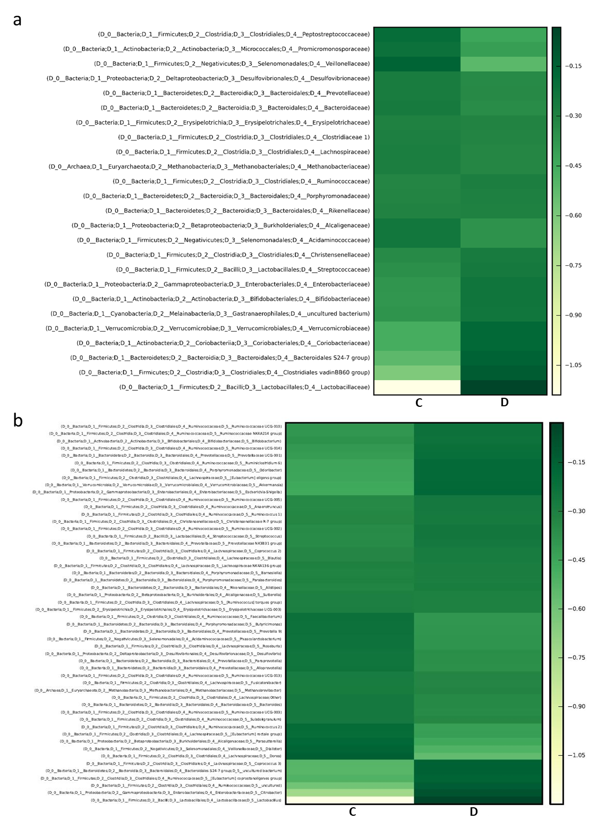

Figure S3. Gut bacterial families and genera characteristics at baseline. a) Relative abundance of microbial groups at family level in the control group (C) and diseased group (D); families with a relative abundance less than 0.002 are omitted for the sake of clarity. b) Relative abundance of microbial groups at genus level in the control group (C) and diseased group (D); genera with a relative abundance less than 0.003 are omitted for the sake of clarity.

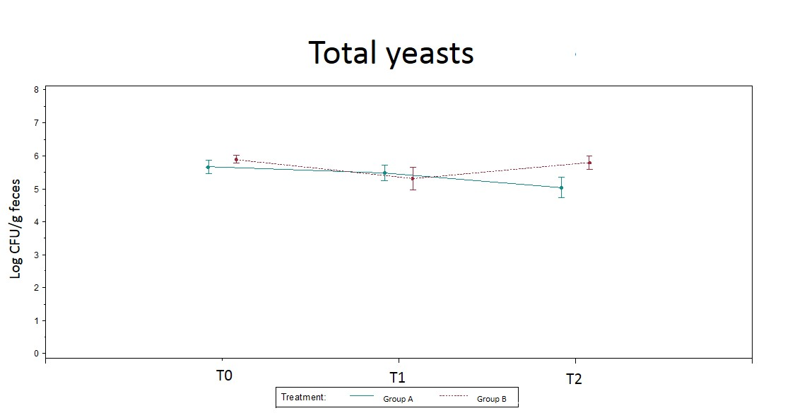

Figure S4. Fecal yeast qPCR counts during the intervention. The graphic was conceived as mean plot reporting also the standard errors.

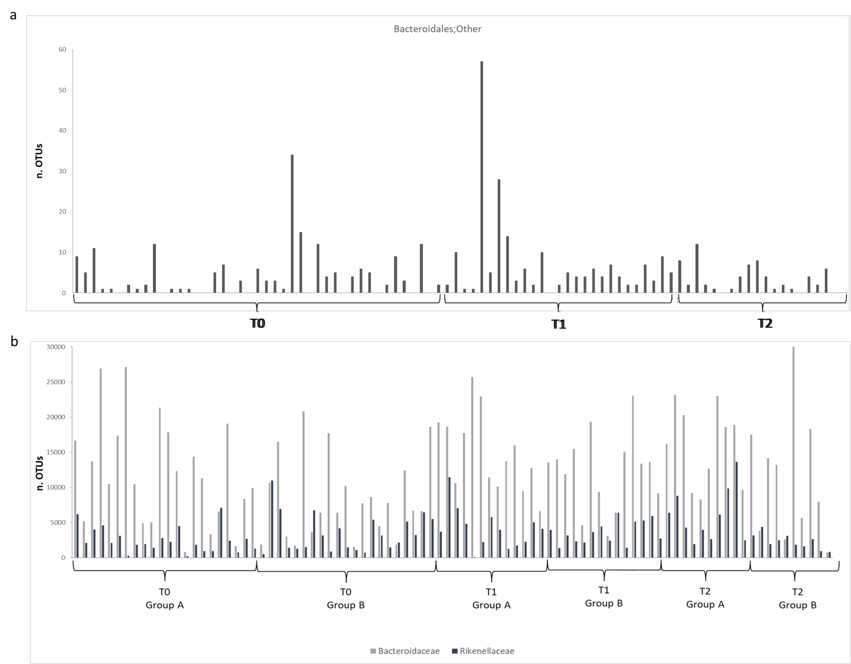

Figure S5. OTUs distribution in ALS patient dataset for significant familes. a) OTUs distribution for Bacteroidales;other among the ALS patients grouped for different timepoints and not considering the type of treatment. b) OTUs distribution for Baceroidaceae and Rikenellaceae among ALS patients considering the time and the different treatments (Group A and Group B).

Tables

Table S1. Absolute abundance expressed as means of the number of OTUs for phyla and families that were significantly different between controls (C) and diseased subjects (D) at the baseline.

OTUs | C | D | P-value
Phyla
Cyanobacteria | 125.16±409.83 | 152.79±293.54 | 0.031
Families
Gastranaerophilalaes; D_4__uncultured bacterium | 111.02±410.01 | 115.81±265.07 | 0.015
Clostridiales; Ambiguous taxa | 3.41±5.33 | 2.58±6.00 | 0.025
Clostridiaceae 1 | 128.73±222.39 | 104.35±216.81 | 0.005
Clostridiales; D_4__Familiy XI | 1.95±5.85 | 4.72±8.74 | 0.024

Table S2. Absolute abundance expressed as means of the number of OTUs for phyla and familes that were significantly different among ALS patients during the study. “P_{corr}” corresponds to the adjusted P-value for the comparisons performed.

OTUs | T0 |  | T1 |  | T2 |  | P-value | P_{corr}
Phyla
Tenericutes | 114.84±275.52 ª |  | 13.37±29.13 ^{b} |  | 38.80±98.63 ^{ab} |  | 0.004 | 0.012
Bacteroidetes | 40598.51±21545.38 ª |  | 51729.74±19843.78 ^{b} |  | 60875.10±28458.40 ^{ab} |  | 0.011 | 0.034
Families
Bacteroidaceae | 10243.51±6944.05 ª |  | 13687.18±5523.66 ^{b} |  | 13584.89±7939.45 ^{ab} |  | 0.013 | 0.039
Bacteroidales; other | 4.37±6.14 ª |  | 7.53±11.11 ^{b} |  | 3±3.25 ª |  | 0.009  0.010 | 0.029  0.029
OTU | Group A | Group B | Group A | Group B | Group A | Group B
Rikenellaceae | 2529.41±  1803.73 ª | 3504.38±2749.63 ^{ab} | 4287.64±  2890.45 ^{ab} | 3611.64±  1650.76 ^{ab} | 5981.78±  4008.07 ^{b} | 2303.10±  1093.47 ª | 0.001  0.004 | 0.011  0.039

Table S3. DNA concentration and mean counts of the analyzed microbial groups by qPCR in stool samples of ALS patients during the intervention.

 | Time | Group A | Group B |  | P-value
 | Time | Mean (SD) |  | Mean (SD)
DNA | T0 | 153.58 (120.16) |  | 157.27 (119.65) |  | 0.91
 | T1 | 132.44 (70.37) |  | 120.61 (56.88) |  | 0.63
 | T2 | 90.99 (54.9) |  | 116.5 (52.42) |  | 0.25
Total bacteria | T0 | 10.33 (0.86) |  | 10.38 (0.87) |  | 0.91
Total bacteria | T1 | 10.46 (0.71) |  | 10.15 (1.13) |  | 0.38
Total bacteria | T2 | 10.45 (0.48) |  | 10.67 (0.64) |  | 0.34
Lactobacillus spp. | T0 | 5.4 (1.54) |  | 5.48 (0.96) |  | 0.54
 | T1 | 5.61 (1.34) |  | 5.21 (1.27) |  | 0.36
 | T2 | 5.33 (1.28) |  | 5.47 (0.78) |  | 0.94
Bifidobacterium spp. | T0 | 7.07 (1.82) |  | 7.52 (1.43) |  | 0.42
Bifidobacterium spp. | T1 | 7.73 (0.95) |  | 7.47 (1.85) |  | 0.98
Bifidobacterium spp. | T2 | 6.78 (1.91) |  | 7.79 (0.89) |  | 0.24
E. coli | T0 | 6.64 (1.17) |  | 6.55 (1.11) |  | 0.78
E. coli | T1 | 6.04 (1.9) |  | 6.23 (1.65) |  | 0.77
E. coli | T2 | 5.66 (1.95) |  | 6.93 (0.92) |  | 0.05
Clostridium cluster I | T0 | 5.53 (1.3) |  | 5.88 (1.76) |  | 0.27
Clostridium cluster I | T1 | 5.48 (1.41) |  | 5.72 (1.36) |  | 0.63
Clostridium cluster I | T2 | 4.97 (1.16) |  | 5.61 (0.81) |  | 0.12
Enterobacteriaceae | T0 | 8.55 (0.78) |  | 8.48 (0.82) |  | 0.76
Enterobacteriaceae | T1 | 8.13 (1.83) |  | 8.08 (1.97) |  | 0.95
Enterobacteriaceae | T2 | 7.71 (2.07) |  | 8.75 (0.56) |  | 0.11
Total Yeasts | T0 | 5.66 (1) |  | 5.89 (0.6) |  | 0.32
Total Yeasts | T1 | 5.48 (0.97) |  | 5.32 (1.24) |  | 0.84
Total Yeasts | T2 | 5.04 (1.09) |  | 5.8 (0.7) |  | 0.03

DNA concentrations are expressed as ng DNA/200 mg of faeces and the mean counts as Log CFU/g of feces, the related P- value is reported. Bolded values indicate P < 0.05.

Table S4. Relative abundance of the main families for each group of subjects.

Families | Controls | T0  Group A | T1  Group A | T2  Group A | T0  Group B | T1  Group B | T2  Group B
Methanobacteriaceae | 0.637 | 0.394 | 0.184 | 0.804 | 0.782 | 1.572 | 0.517
Actinomycetaceae | 0.009 | 0.009 | 0.006 | 0.015 | 0.011 | 0.010 | 0.009
Bifidobacteriaceae | 2.073 | 1.191 | 2.191 | 1.257 | 4.486 | 4.147 | 5.817
Promicromonosporaceae | 0.287 | 0.169 | 0.152 | 0.452 | 0.208 | 0.2583 | 0.175
Coriobacteriaceae | 0.223 | 0.378 | 0.439 | 0.989 | 0.476 | 0.498 | 0.722
Bacteroidaceae | 24.109 | 24.114 | 29.404 | 32.328 | 16.085 | 25.195 | 25.240
Bacteroidales S24-7 group | 1.038 | 1.328 | 0.590 | 0.246 | 3.451 | 1.742 | 2.498
Porphyromonadaceae | 5.318 | 5.262 | 8.682 | 8.685 | 5.820 | 7.763 | 4.580
Prevotellaceae | 8.086 | 5.896 | 3.682 | 1.910 | 8.310 | 9.881 | 6.514
Rikenellaceae | 5.965 | 4.851 | 8.732 | 12.249 | 7.22 | 7.144 | 4.823
Bacteroidales; uncultured bacterium | 0.080 | 0.094 | 0.074 | 0.048 | 0.164 | 0.388 | 0.177
Bacteroidales;Other | 0.007 | 0.007 | 0.021 | 0.007 | 0.009 | 0.010 | 0.004
Gastranaerophilales;uncultured bacterium | 0.173 | 0.351 | 0.019 | 0.102 | 0.114 | 0.088 | 0.013
Lactobacillaceae | 0.048 | 0.142 | 0.068 | 0.034 | 1.091 | 0.036 | 0.045
Streptococcaceae | 0.362 | 0.609 | 0.266 | 0.212 | 0.286 | 0.213 | 0.217
Christensenellaceae | 2.462 | 2.816 | 2.016 | 1.225 | 2.908 | 3.118 | 2.393
Clostridiaceae 1 | 0.248 | 0.163 | 0.108 | 0.025 | 0.307 | 0.200 | 0.070
Clostridiales vadinBB60 group | 0.104 | 0.265 | 0.198 | 0.061 | 0.365 | 0.130 | 0.270
Defluviitaleaceae | 0.015 | 0.012 | 0.024 | 0.012 | 0.032 | 0.019 | 0.011
Clostridiales;Family XIII | 0.146 | 0.225 | 0.533 | 0.212 | 0.156 | 0.195 | 0.104
Lachnospiraceae | 11.484 | 10.518 | 9.020 | 7.588 | 10.443 | 7.980 | 9.167
Peptococcaceae | 0.114 | 0.111 | 0.105 | 0.105 | 0.139 | 0.256 | 0.108
Peptostreptococcaceae | 0.443 | 0.250 | 0.109 | 0.104 | 0.266 | 0.153 | 0.092
Ruminococcaceae | 20.908 | 23.617 | 18.248 | 22.755 | 21.137 | 17.813 | 21.021
Clostridiales;Other | 0.018 | 0.012 | 0.015 | 0.008 | 0.019 | 0.019 | 0.012
Thermoanaerobacteraceae | 0.050 | 0.039 | 0.065 | 0.040 | 0.031 | 0.017 | 0.022
Erysipelotrichaceae | 0.887 | 1.102 | 0.310 | 0.558 | 0.637 | 0.515 | 0.402
Acidaminococcaceae | 2.265 | 1.643 | 1.666 | 1.230 | 1.836 | 2.237 | 2.085
Veillonellaceae | 4.250 | 1.347 | 2.837 | 1.448 | 2.390 | 0.886 | 1.206
Fusobacteriaceae | 0.002 | 0.007 | 0.011 | 0.016 | 0.005 | 0.007 | 0.029
Victivallaceae | 0.005 | 0.015 | 0.002 | 0.011 | 0.014 | 0.007 | 0.025
Rhodospirillaceae | 0.129 | 0.304 | 0.474 | 0.506 | 0.056 | 0.227 | 0.202
Oxalobacteraceae | 0.020 | 0.044 | 0.016 | 0.023 | 0.021 | 0.047 | 0.058
Desulfovibrionaceae | 0.680 | 0.817 | 0.543 | 0.525 | 0.368 | 0.445 | 0.526
Enterobacteriaceae | 1.717 | 1.656 | 2.463 | 0.752 | 3.025 | 1.243 | 3.190
Pasteurellaceae | 0.345 | 0.029 | 0.026 | 0.008 | 0.036 | 0.027 | 0.032
Synergistaceae | 0.128 | 0.327 | 0.304 | 0.159 | 0.071 | 0.118 | 0.398
Mollicutes RF9; uncultured bacterium | 0.016 | 0.035 | 0.002 | 0.022 | 0.075 | 0.004 | 0.029
Mollicutes; NB1-n;Ambiguous taxa | 0.012 | 0.012 | 0.002 | 0.004 | 0.049 | 0.008 | 0.005
Opitutae vadinHA64; uncultured bacterium | 0.022 | 0.042 | 0.006 | 0.001 | 0.051 | 0.039 | 0.055
Verrucomicrobiaceae | 3.557 | 7.937 | 4.409 | 1.067 | 5.562 | 3.643 | 5.994
Data are expressed as percentage of relative abundance; families with a relative abundance less than 0.001% are omitted for the sake of clarity

