Additional file 7

Sum-Score Meta-analyses

Figure S1: Funnel plot of HAM-D sum-score meta-analysis
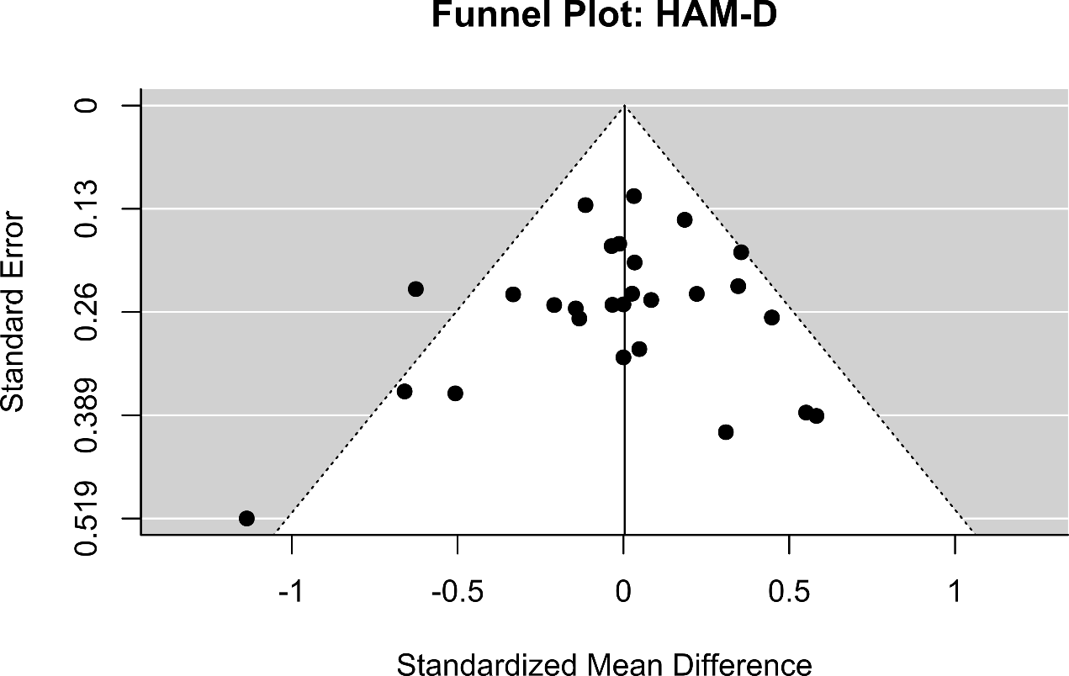

Figure S2: Funnel plot of BDI sum-score meta-analysis
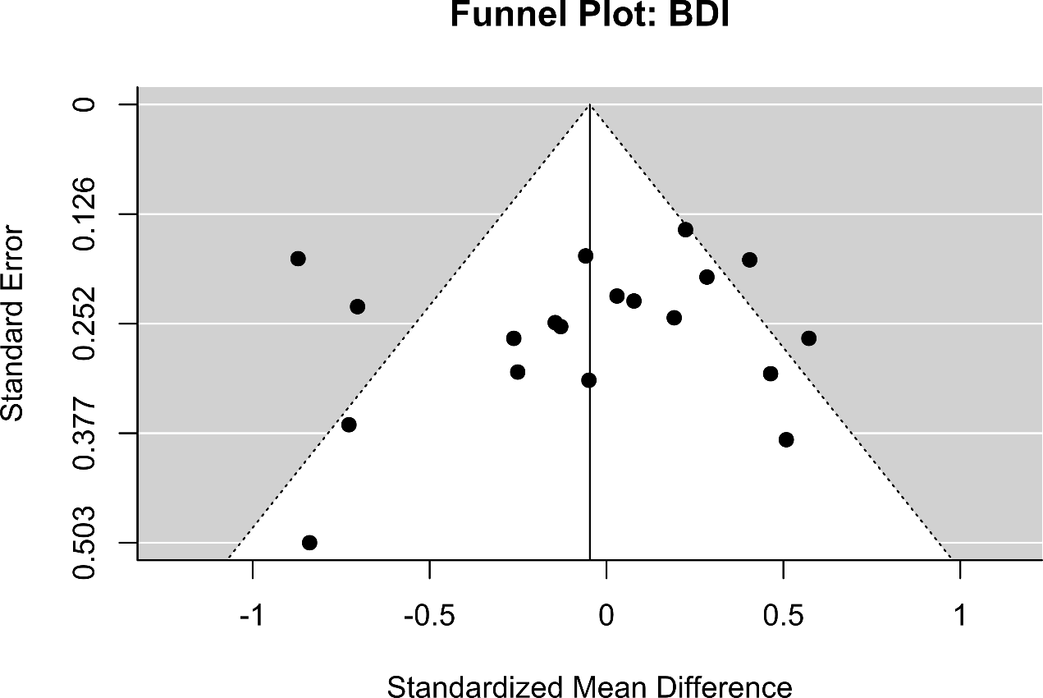

Table S7: Meta-regression of HAM-D and BDI sum-score meta-analyses on differential dropout
 | HAM-D |  | BDI
 | Beta (SE) | P | Beta (SE) | P
Intercept | 0.060 (0.052) | 0.254 | 0.030 (0.107) | 0.782
Moderator† | -0.011 (0.004) | 0.018 | -0.012 (0.007) | 0.124
Note: †Moderator is differential dropout as percentage of greater dropout in ADM arm(s) versus psychotherapy arm(s).

Figure S3: Meta-Regression of HAM-D sum-score meta-analysis on differential dropout
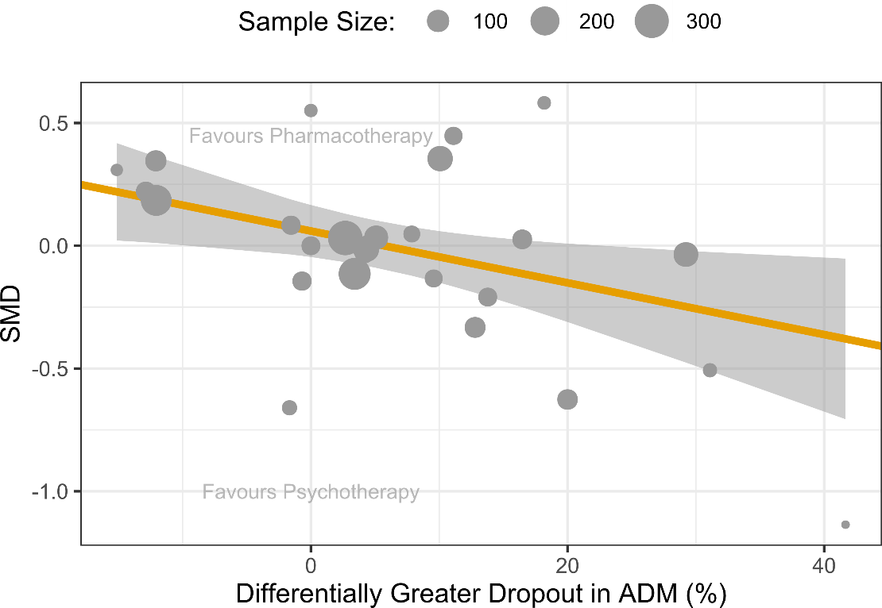
Note: Shaded area highlights 95% CI as predicted from meta-regression model.

Figure S4: Meta-Regression of BDI sum-score meta-analysis on differential dropout
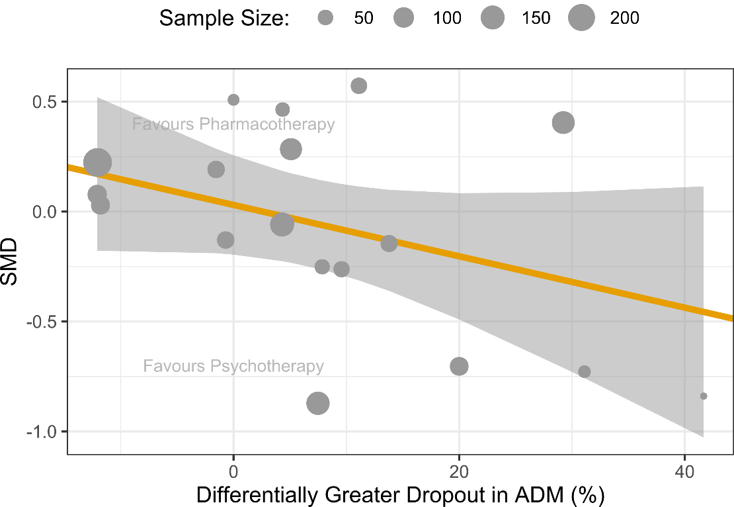
Note: Shaded area highlights 95% CI as predicted from meta-regression model.

Figure S5: Forest plot of dropout meta-analysis
