Additional file 8

Individual Symptom Meta-analyses

Table S8: Individual symptom forest plots for the HAM-D
HAM-D symptom | Forest Plot
1 | 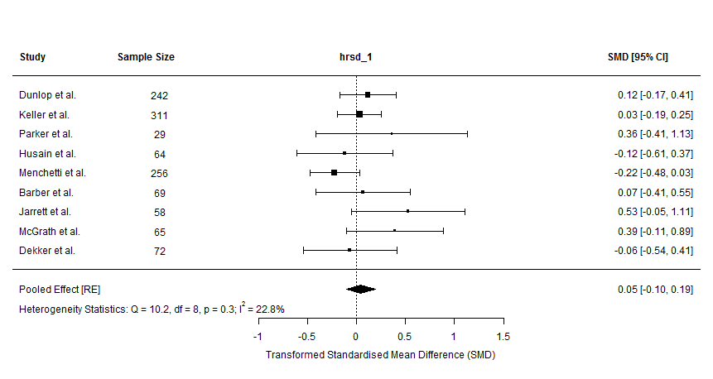
2 | 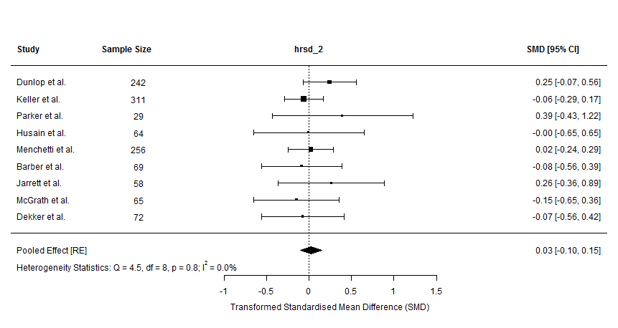
3 | 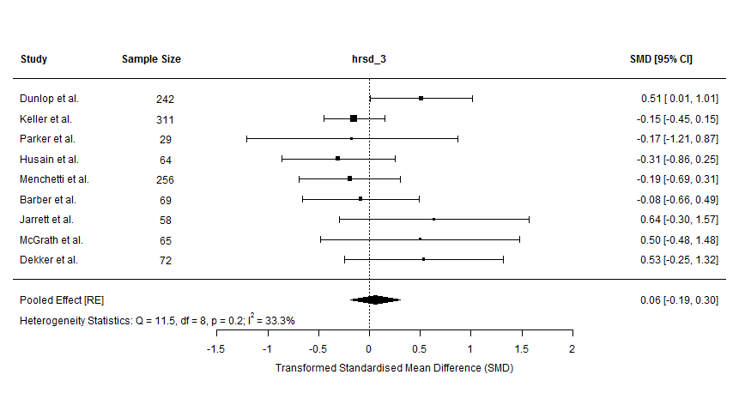
4 | 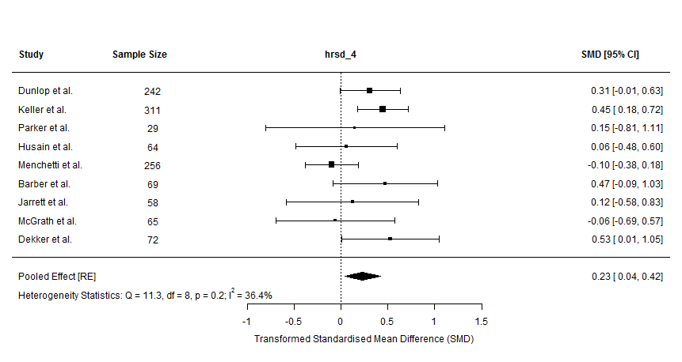
5 | 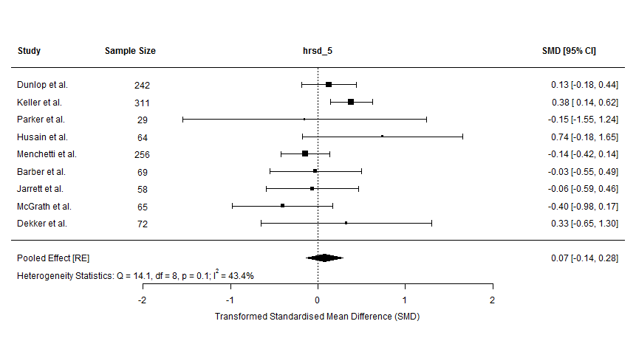
6 | 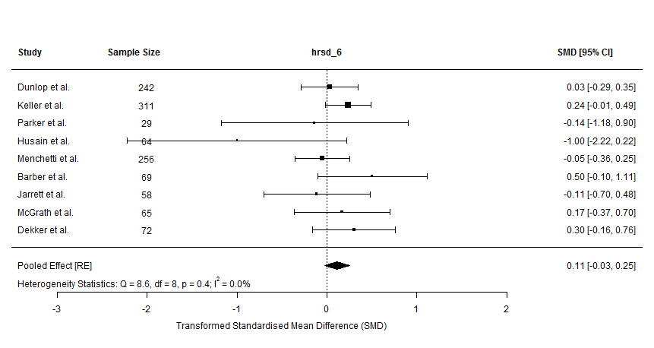
7 | 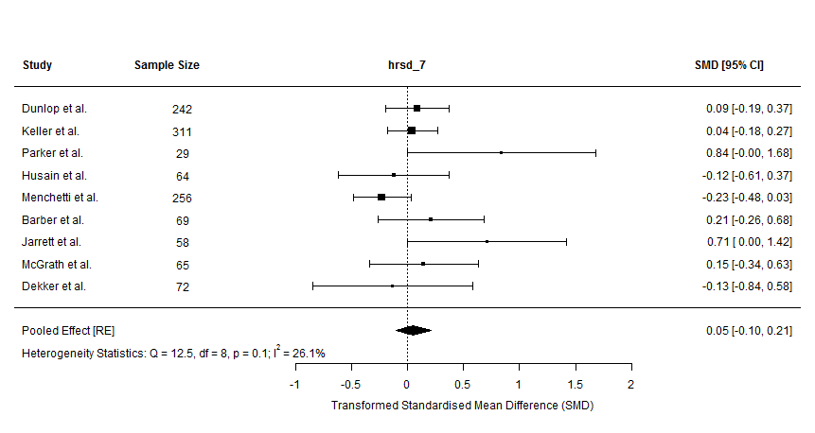
8 | 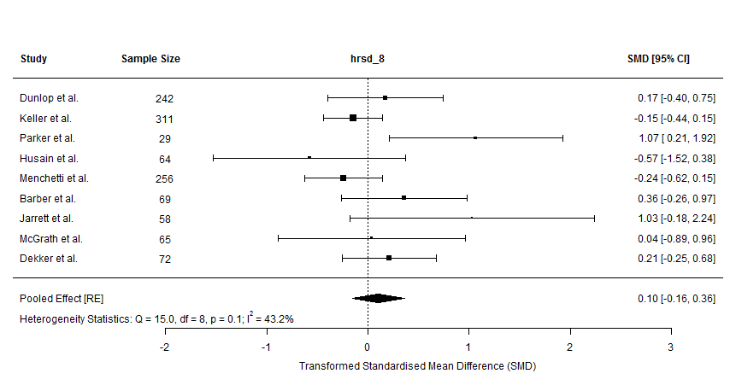
9 | 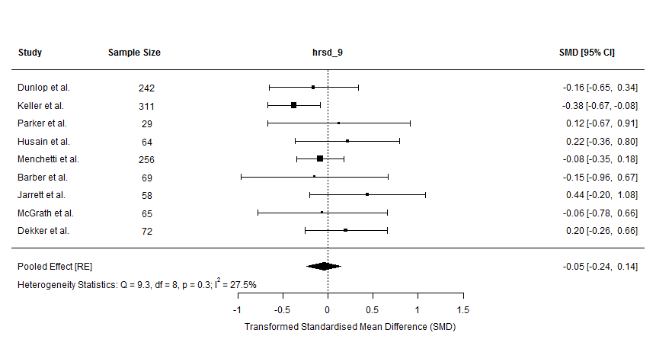
10 | 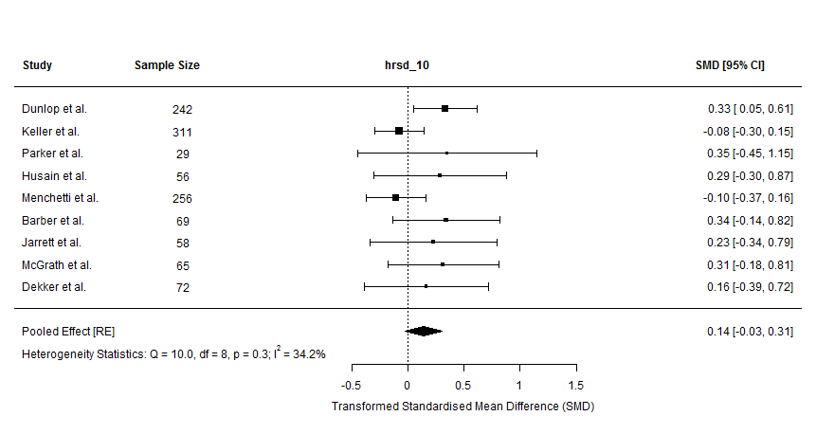
11 | 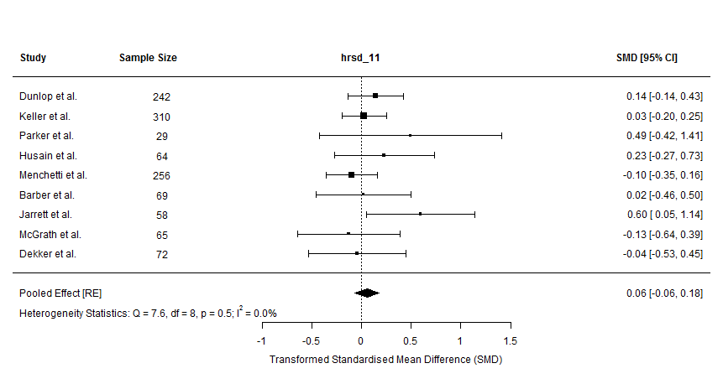
12 | 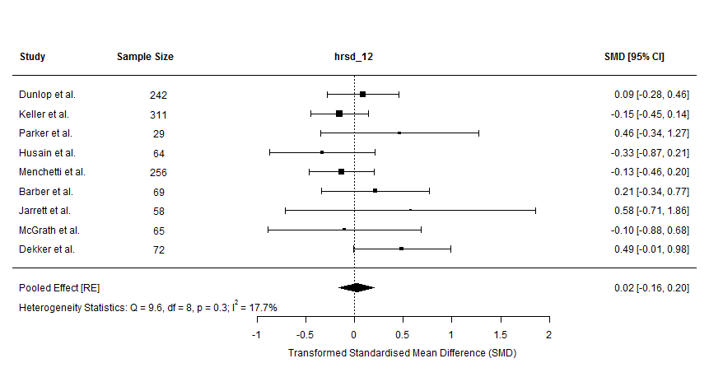
13 | 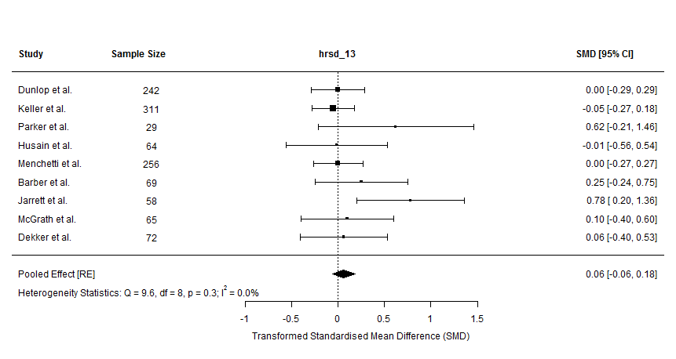
14 | 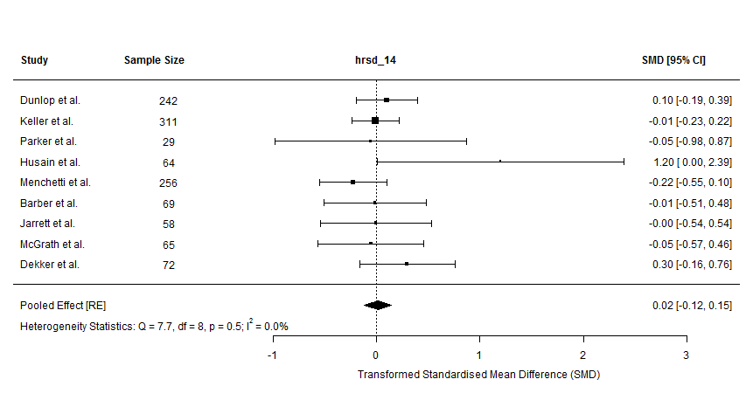
15 | 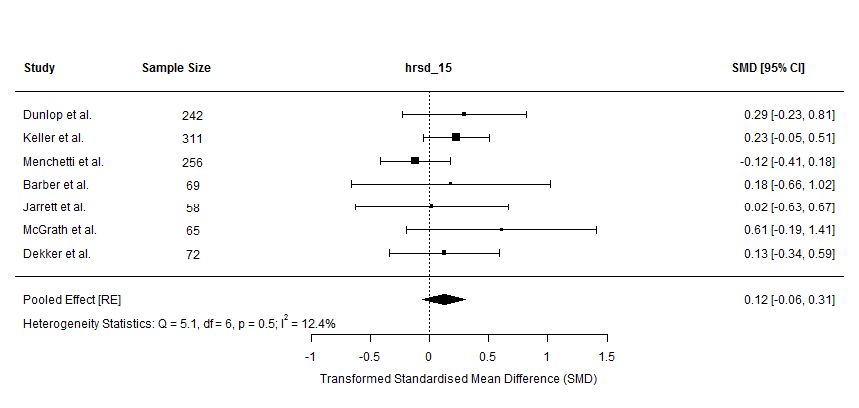
16 | 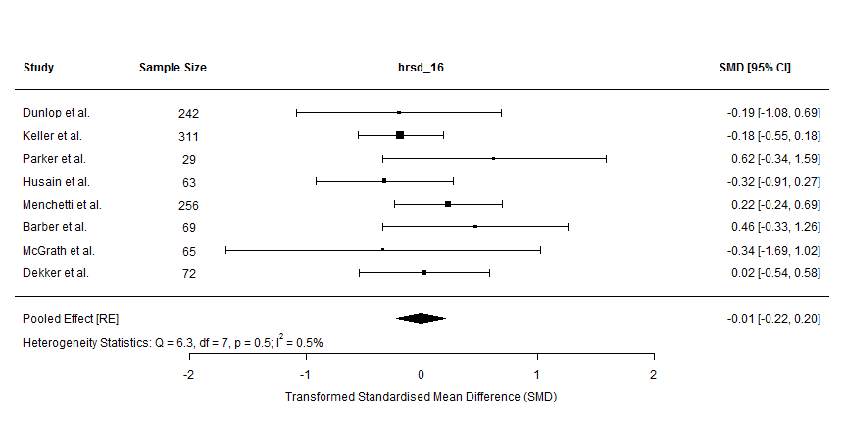
17 | 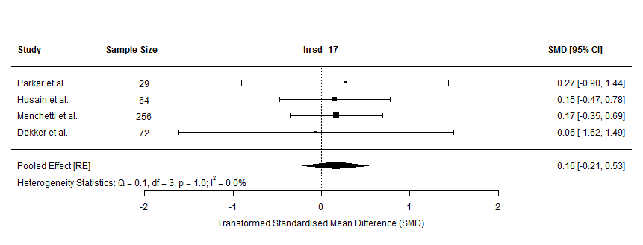
18 | 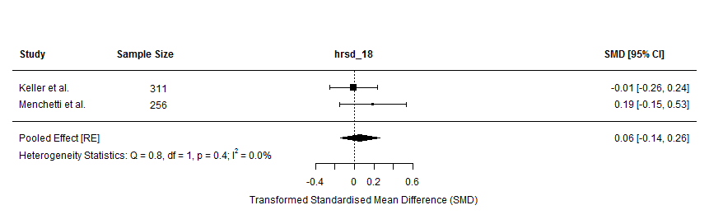
19 | 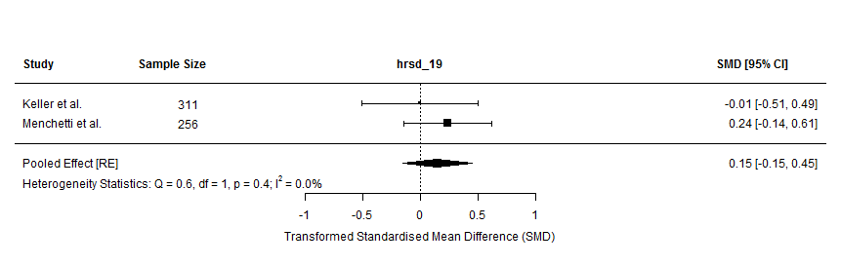
20 | 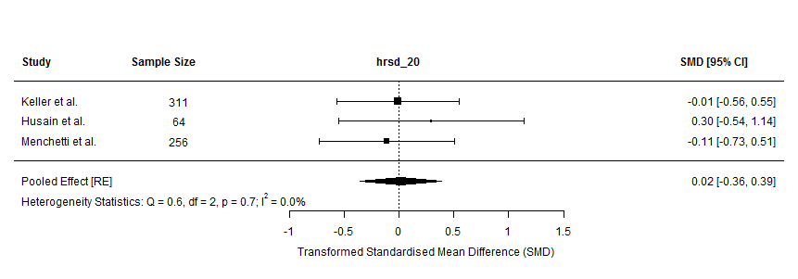
21 | 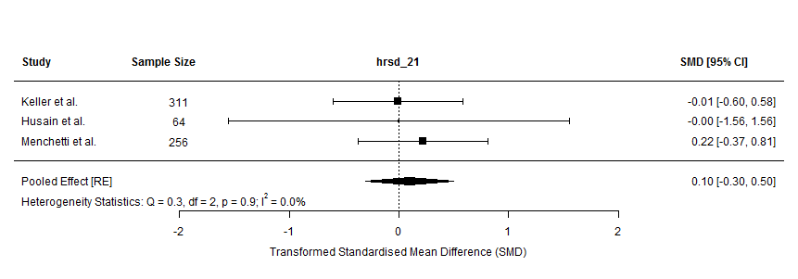

Table S9: Individual symptom forest plots for the BDI
BDI symptom | Forest Plot
1 | 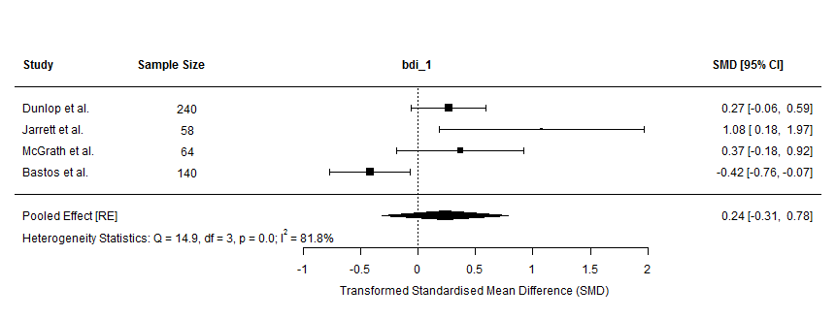
2 | 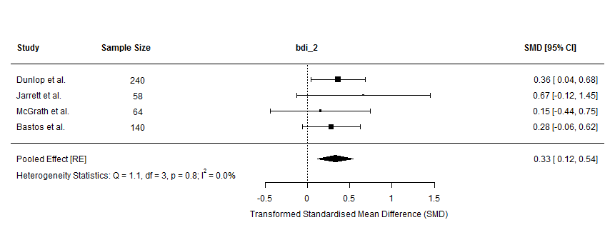
3 | 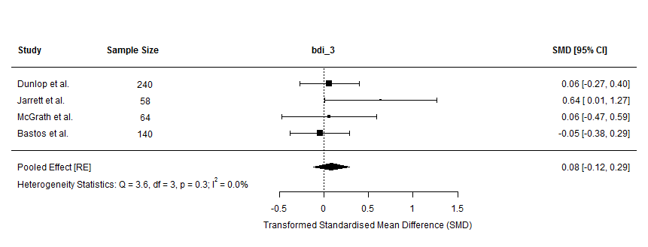
4 | 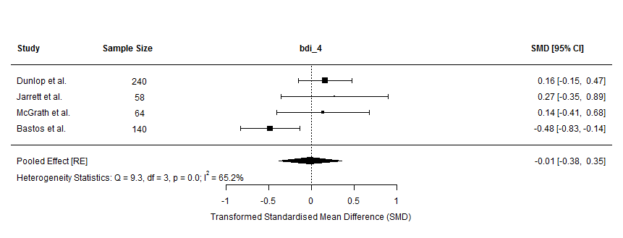
5 | 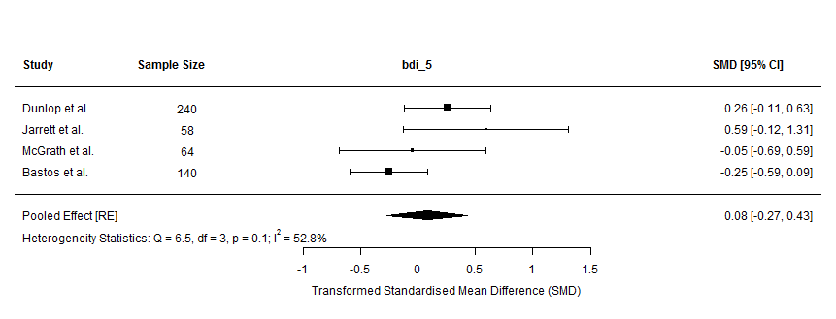
6 | 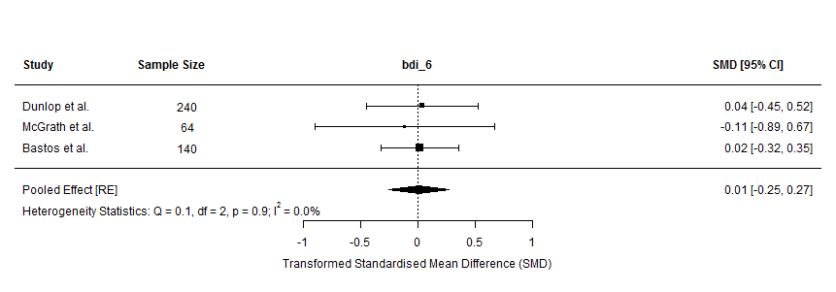
7 | 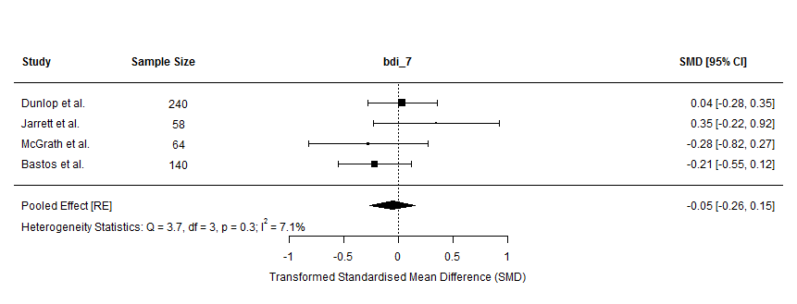
8 | 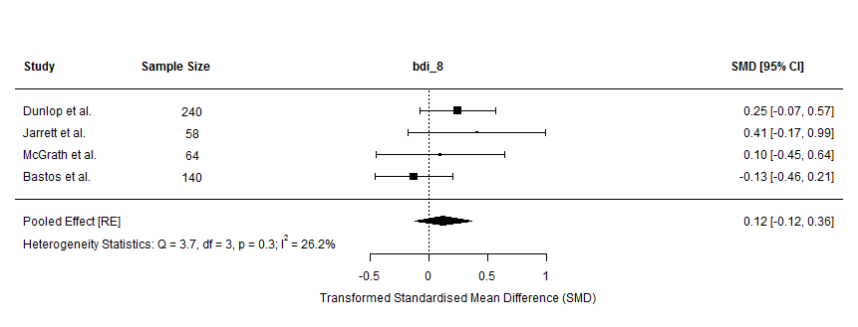
9 | 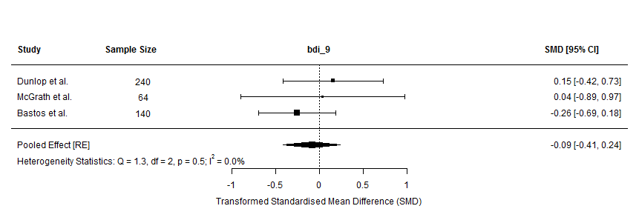
10 | 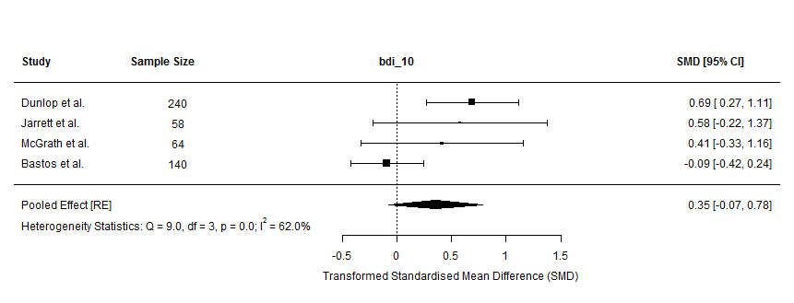
11 | 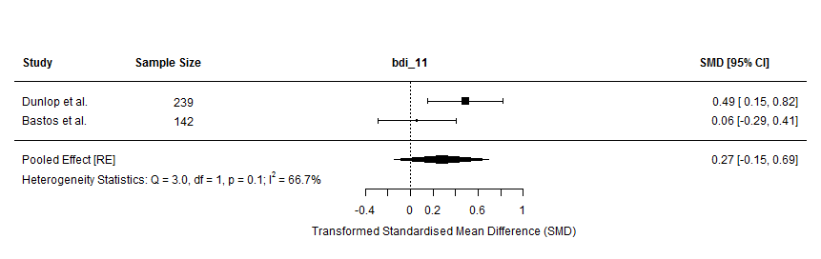
12 | 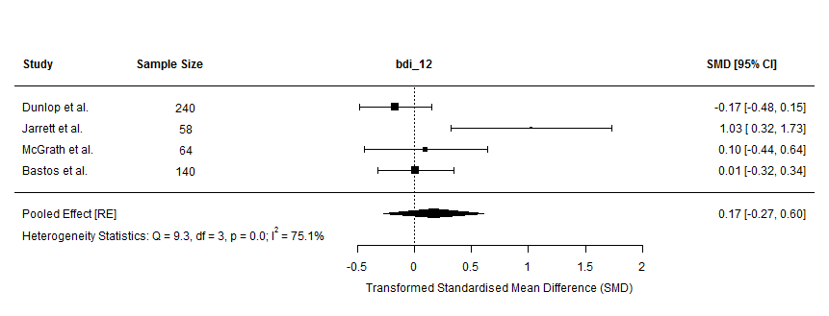
13 | 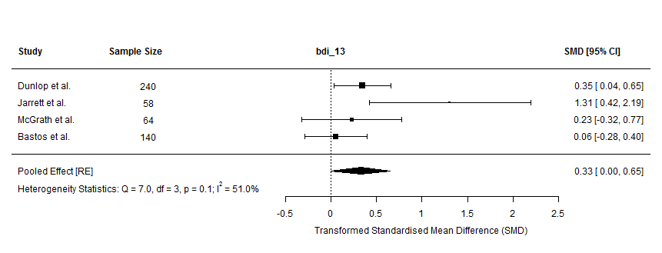
14 | 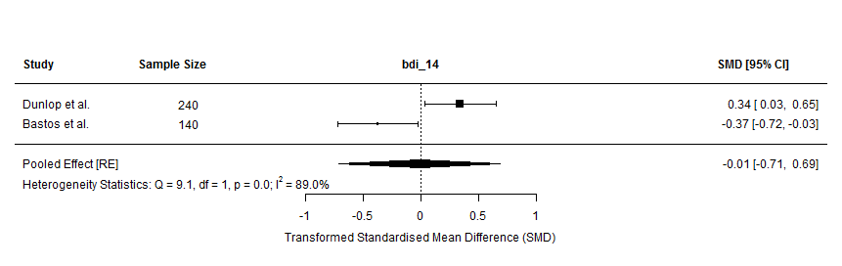
15 | 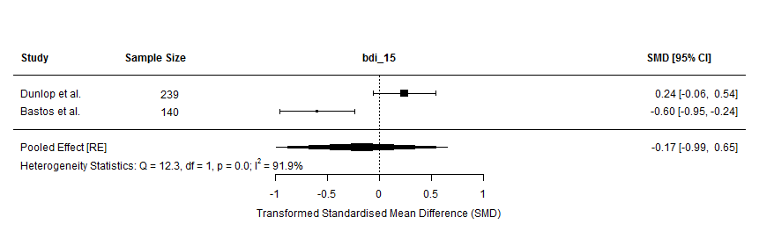
16 | 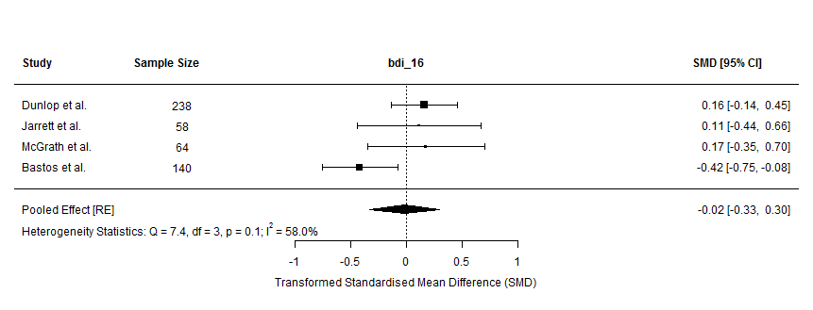
17 | 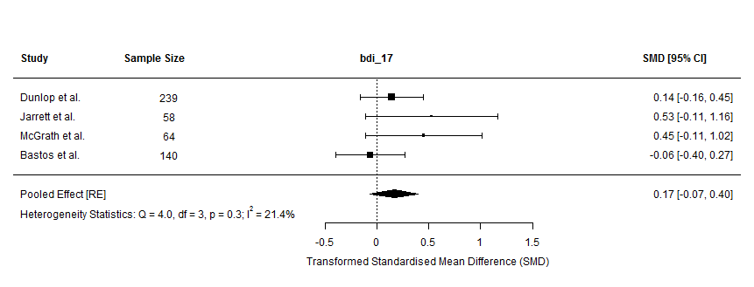
18 | 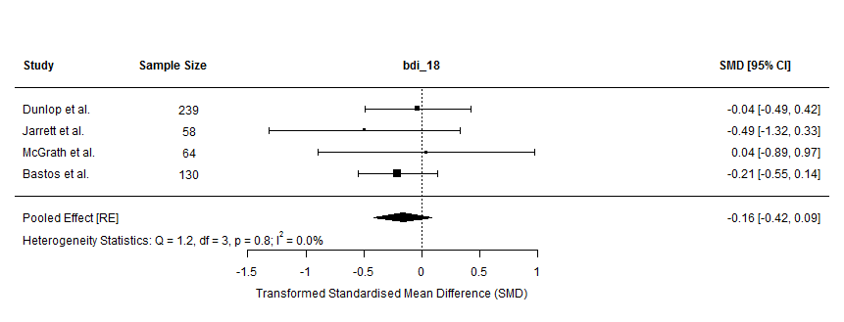
19 | 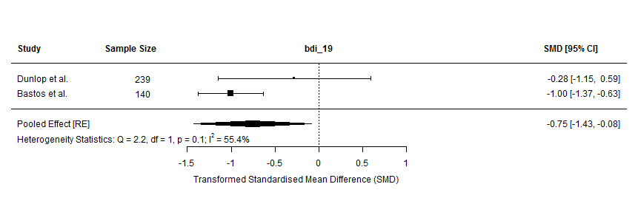
20 | 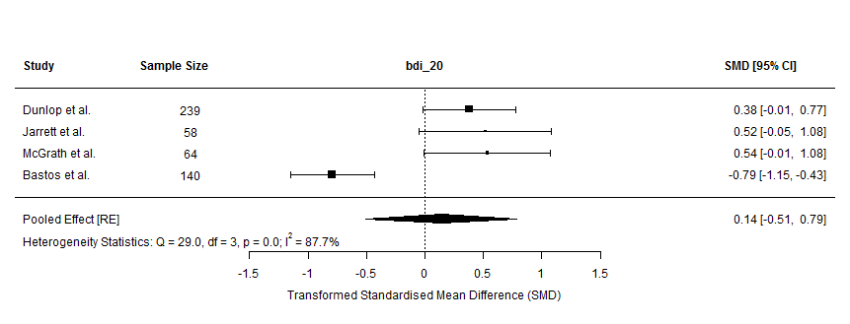
21 | 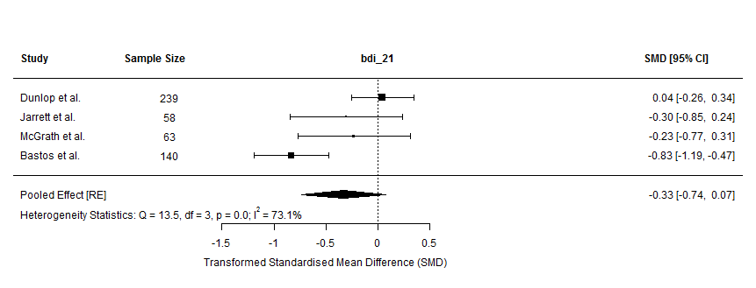

Figure S6: Effect size comparison of HAM-D and BDI per symptom type
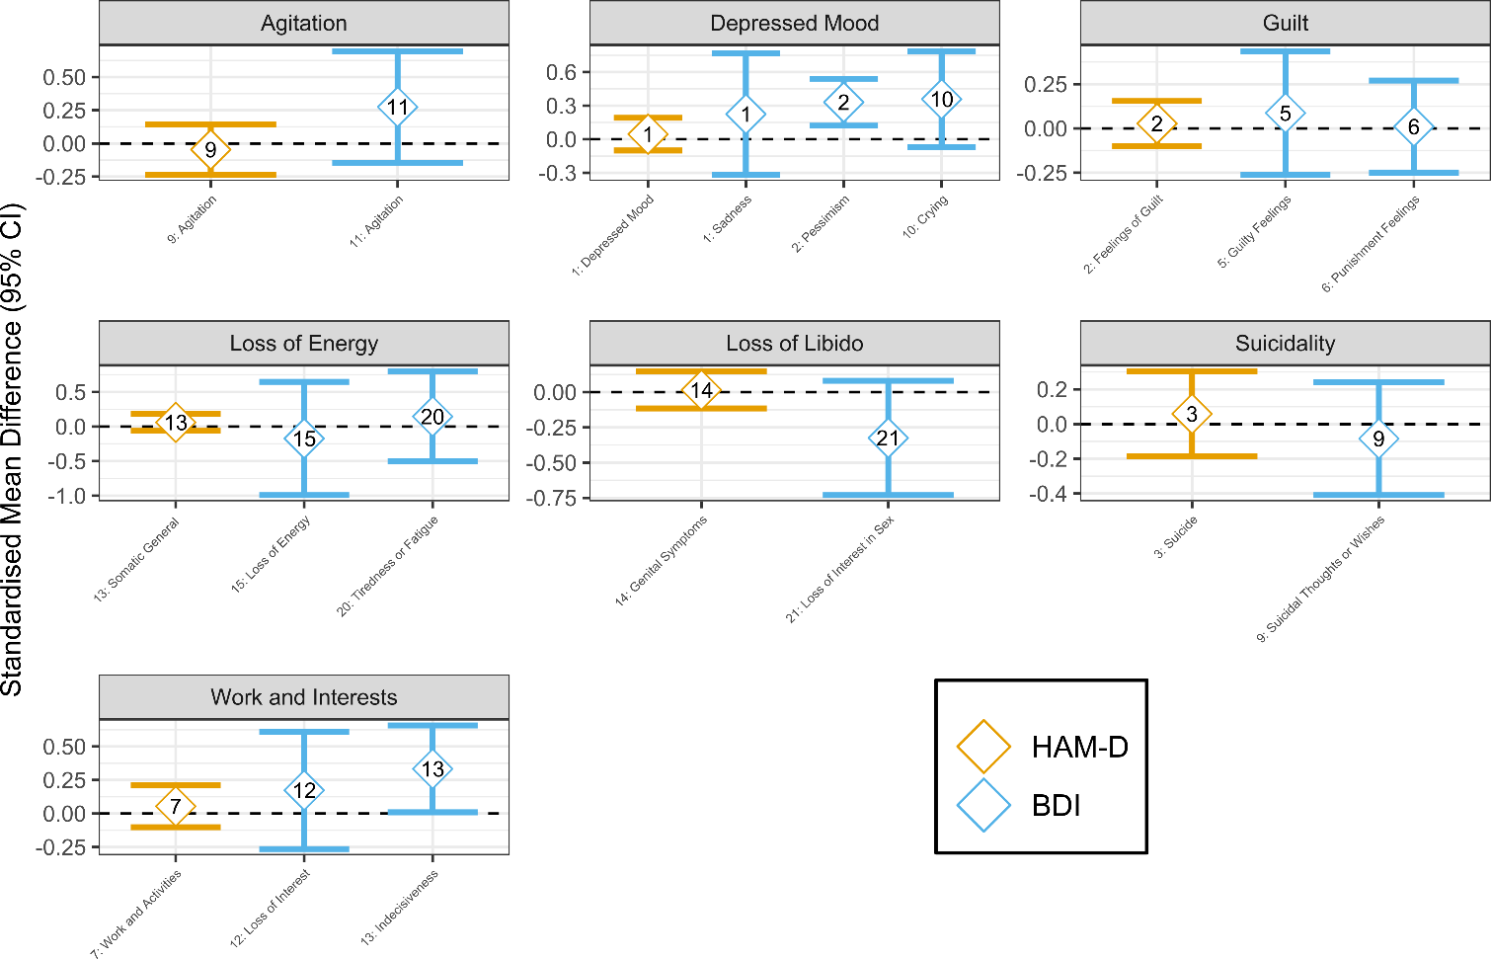

Sensitivity Analyses
“Simple” ORs were computed following median split of each symptom item, setting items to 1 if a patient’s score was greater or equal to the median and scores lower than the median to 0 (if the median was 0, all scores above zero were set to 1).
Figure S7 shows pooled meta-analytic effect sizes for individual symptoms for each effect size metric used in meta-analyses. We also assessed effect size metrics intercorrelations for HAM-D and BDI scales, which were in medium-to-large range (Pearson’s r range: 0.69-0.97) with pORs and ORs being more similar to each other (Pearson’s r range: 0.93-0.97) than both OR-based metrics with SMDs (Pearson’s r range: 0.69-0.96). More detailed results of these sensitivity analyses are presented in Table S10 and Figure S8.

Figure S7: Individual symptom effect sizes per effect size metric used in meta-analyses
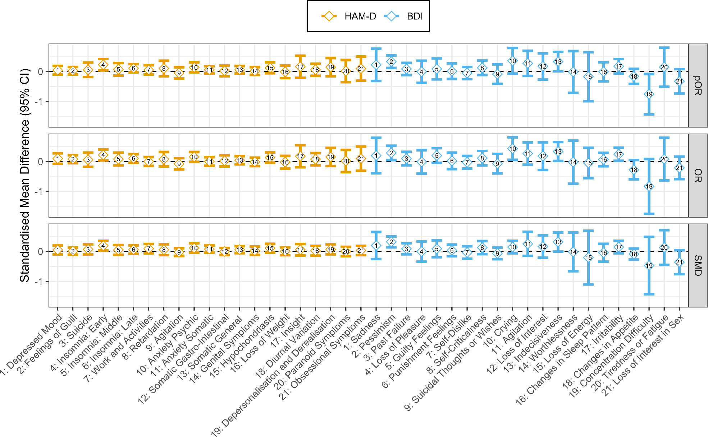

Table S10: Correlations between meta-analytic effect sizes metrics

 |  | HAM-D |  |  | BDI
 | pOR | OR | SMD | pOR | OR | SMD
pOR | 1 |  |  | 1
OR | 0.93 | 1 |  | 0.97 | 1
SMD | 0.83 | 0.69 | 1 | 0.96 | 0.89 | 1
Note: HAM-D=Hamilton Rating Scale for Depression; BDI=Beck Depression Inventory; pOR=proportional Odds Ratio, OR=Odds Ratio; SMD=Standardised Mean Difference.

Figure S8: Associations between meta-analytic effect size metrics
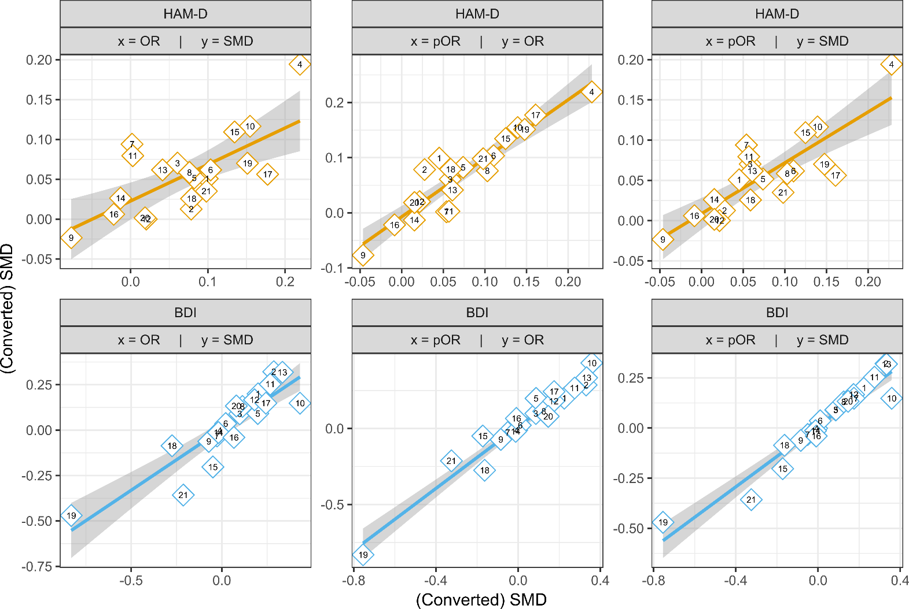

Exploratory Comparison with Boschloo et al.

We performed two sets of exploratory comparisons. First, we correlated our individual HAM-D symptom effect sizes with theirs (cf. Table 2 of Boschloo et al.), which did not indicate an association between effect sizes (Pearson’s r=0.04, df=15, p=0.890; Fig. S9). Next, we repeated our individual symptom meta-analyses for the first 16 HAM-D items and restricted to those four RCTs that assessed CBT as psychotherapy of choice (cf. Additional file 6: Table S6). Although SMDs from these analyses are more closely related to results from Boschloo et al. (Pearson’s r=0.44, df=14, p=0.085; Fig. S10), the correlation is still of small-to-moderate size. A likely reason for this discrepancy is that we only meta-analysed four RCTs with a median of 394 patients per symptom, while meta-analysis of Boschloo et al. reported 1070 patients. This also highlights, however, that individual studies potentially introduce a lot of variability in symptom-specific comparative effectiveness.

Figure S9: Effect size association to Boschloo et al.

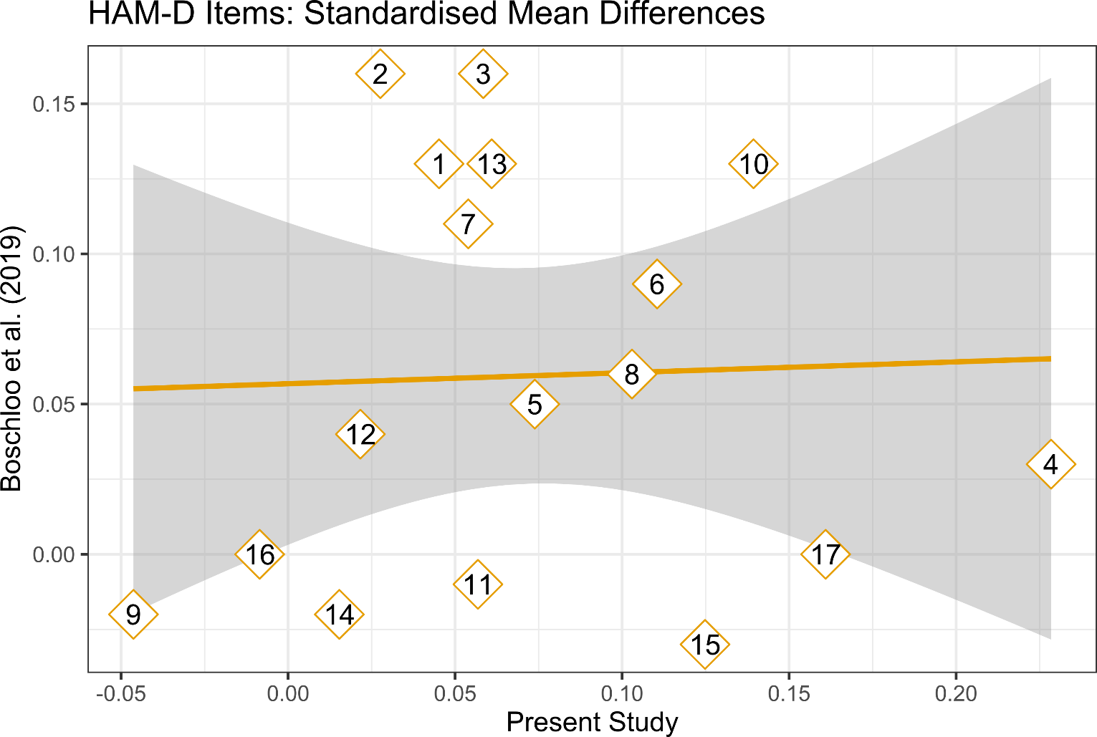

Figure S10: Effect size association to Boschloo et al. for RCTs with CBT only
