Supplementary Figure 1.

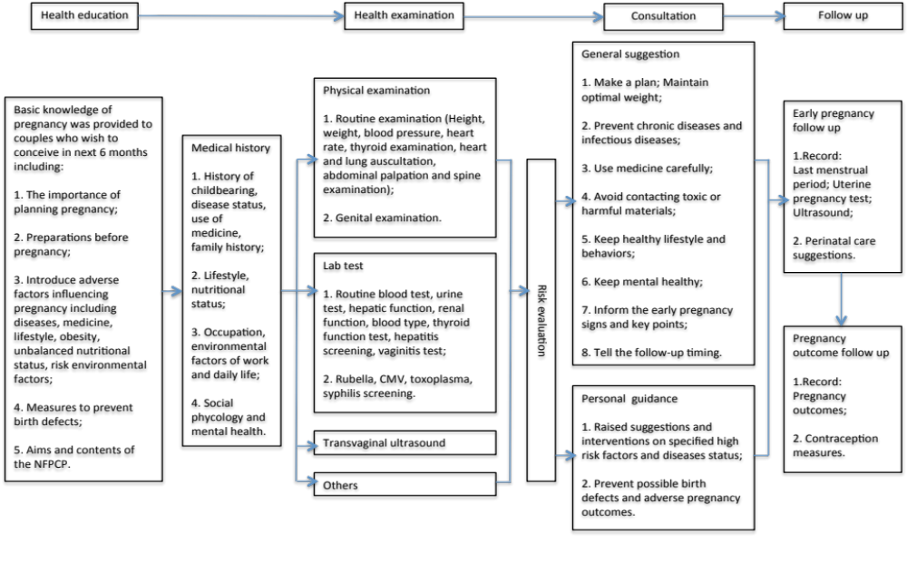
Translated of detailed design, organization, and implementation of the NFPCP (described elsewhere in Chinese). [Zhang S, Wang Q, Shen H. Design of the national free proception health examination project in China. Zhonghua yi xue za zhi. 2015;95(3):162-5.]

