Additional file 1
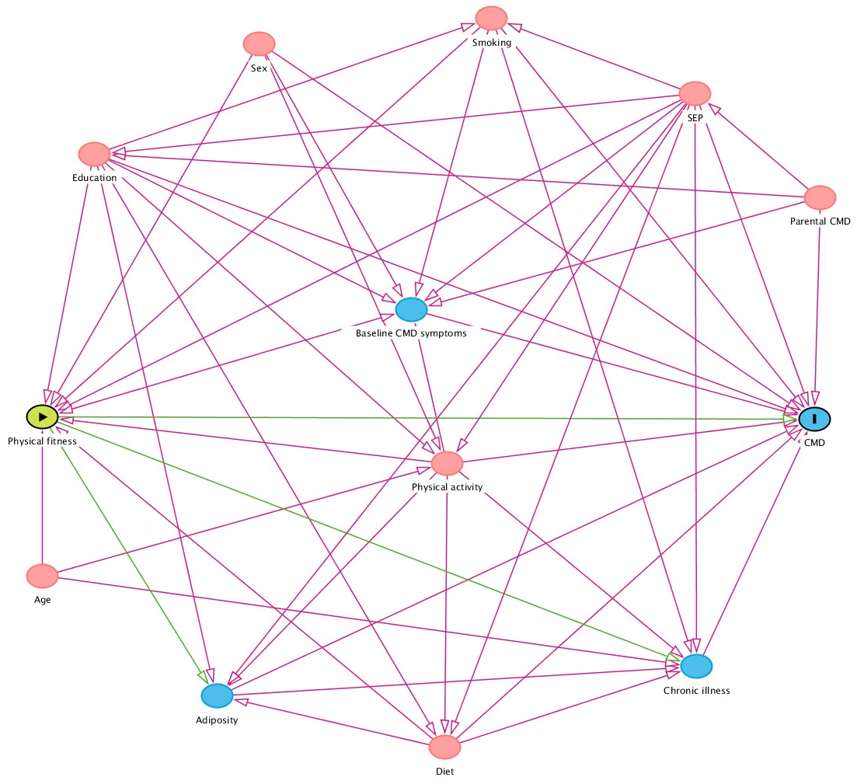
Figure 1. DAG of proposed causal associations between fitness, common mental disorders, and covariates
CMD = common mental disorder; SEP = socioeconomic position
Methodology 1. Multiple imputation models
We ran multiple imputation models by chained equations to generate 50 datasets for 152,978 in the longitudinal analysis. The method uses separate distributions per imputed variable. Non-normally distributed continuous variables were imputed using predictive mean matching. The results from all 50 datasets are pooled together with corrected standard errors according to Rubin’s rule. The multiple imputation model included all variables used in our analysis for the exposure, outcome, and covariates, including those in the sensitivity analysis.

Table 1. Baseline participant characteristics by CRF groupings
 |  |  | CRF (n = 63,372)
Variable |  | All | Low | Medium | High
N |  | 491,278 | 17,952 (28.33) | 20,257 (31.97) | 25,163 (39.71)
Sex (%) | Women | 267,392 (54.43) | 9621 (53.59) | 10991 (54.26) | 13409 (53.29)
 | Men | 223,886 (45.57) | 8331 (46.41) | 9266 (45.74) | 11754 (46.71)
Age | Mean (SD) | 56.559 (8.090) | 57.013 (7.837) | 56.63 (8.10) | 56.20 (8.34)
Ethnicity | White | 463630 (94.72) | 15221 (85.18) | 18524 (91.88) | 23852 (95.13)
 | Mixed | 2884 (0.59) | 174 (0.97) | 180 (0.89) | 202 (0.81)
 | South Asian | 7732 (1.58) | 933 (5.22) | 635 (3.15) | 359 (1.43)
 | Black | 1497 (0.31) | 1086 (6.08) | 484 (2.40) | 274 (1.09)
 | Chinese | 9347 (1.91) | 63 (0.35) | 81 (0.40) | 126 (0.50)
 | Other | 4367 (0.89) | 392 (2.19) | 257 (1.27) | 260 (1.04)
Household income | Less than 18,000 | 95316 (22.86) | 3807 (25.19) | 3340 (19.02) | 3480 (15.62)
 | 18,000 to 30,999 | 106335 (25.50) | 4164 (27.56) | 4399 (25.05) | 5035 (22.60)
 | 31,000 to 51,999 | 108634 (26.06) | 3844 (25.44) | 4773 (27.18) | 5844 (26.23)
 | 52,000 to 100,000 | 84405 (20.24) | 2633 (17.42) | 3881 (22.10) | 5692 (25.55)
 | Greater than 100,000 | 22248 (5.34) | 663 (4.39) | 1165 (6.64) | 2229 (10.00)
Education level | None | 83697 (17.35) | 2701 (13.47) | 2502 (10.00) | 8273 (13.18)
 | College or University degree | 157403 (32.63) | 7090 (35.36) | 10741 (42.94) | 22925 (36.52)
 | A levels/AS levels or equivalent | 54196 (11.24) | 2370 (11.82) | 3096 (12.38) | 7489 (11.93)
 | O levels/GCSEs or equivalent | 103278 (21.41) | 4385 (21.87) | 4881 (19.51) | 13298 (21.18)
 | CSEs or equivalent | 26339 (5.46) | 1124 (5.61) | 1161 (4.64) | 3462 (5.51)
 | NVQ or HND or HNC or equivalent | 32125 (6.66) | 1363 (6.80) | 1380 (5.52) | 4096 (6.52)
 | Other professional qualifications e.g., nursing, teaching | 25310 (5.25) | 1020 (5.09) | 1251 (5.00) | 3232 (5.15)
Parental depression | No | 434749 (91.14) | 15991 (91.73) | 17976 (91.07) | 22204 (90.40)
 | Yes | 42248 (8.86) | 1441 (8.27) | 1762 (8.93) | 2357 (9.60)
Chronic illness or disability | No | 322634 (65.80) | 11236 (62.76) | 14242 (70.39) | 18432 (73.29)
 | Yes | 156670 (31.95) | 6169 (34.46) | 5545 (27.40) | 6294 (25.03)
Body fat % | mean (SD) | 31.458 (8.545) | 34.188 (8.425) | 31.506 (7.958) | 28.696 (7.853)
Grip strength per 5kg | mean (SD) | 6.121 (2.205) | 5.84 (2.105) | 5.978 (2.117) | 6.149 (2.118)
CRF, METs | mean (SD) | 9.951 (2.971) | 7.171 (1.438) | 9.311 (1.519) | 12.452 (2.606)
Daily minutes of physical activity | mean (SD) | 125.429 (145.591) | 114.057 (139.592) | 127.198 (137.176) | 140.215 (139.356)
Daily pieces of fruit and vegetables | mean (SD) | 4.898 (2.751) | 4.793 (2.835) | 4.876 (2.822) | 5.022 (2.747)
Smoking status | Never | 35424 (56.08) | 10415 (58.25) | 11304 (55.97) | 13705 (54.62)
 | Previous | 21964 (34.77) | 6023 (33.68) | 7032 (34.82) | 8909 (35.51)
 | Current | 5779 (9.15) | 1443 (8.07) | 1859 (9.21) | 2477 (9.87)

Table 2. Baseline participant characteristics by CRF groupings
 |  |  | Grip strength (n = 491,108)
Variable |  | All | Low | Medium | High
N (%) |  | 491,278 | 151,300 (30.81) | 165,629 (33.73) | 174,179 (35.47)
Sex (%) | Women | 267,392 (54.43) | 82151 (54.30) | 89563 (54.07) | 95591 (54.88)
 | Men | 223,886 (45.57) | 69149 (45.70) | 76066 (45.93) | 78588 (45.12)
Age | Mean (SD) | 56.559 (8.090) | 56.695 (8.023) | 56.888 (7.853) | 56.12 (8.344)
Ethnicity | White | 463630 (94.72) | 138717 (92.06) | 157700 (95.52) | 167213  (96.27)
 | Mixed | 2884 (0.59) | 922 (0.61) | 878 (0.53) | 1084 (0.62)
 | South Asian | 7732 (1.58) | 2465 (1.64) | 2296 (1.39) | 2971 (1.71)
 | Black | 1497 (0.31) | 665 (0.44) | 505 (0.31) | 327 (0.19)
 | Chinese | 9347 (1.91) | 5850 (3.88) | 2421 (1.47) | 1076 (0.62)
 | Other | 4367 (0.89) | 2054 (1.36) | 1301 (0.79) | 1012 (0.58)
Household income | Less than 18,000 | 95316 (22.86) | 36406  (29.05) | 31196 (22.10) | 27714 (18.41)
 | 18,000 to 30,999 | 106335 (25.50) | 32921 (26.27) | 36302 (25.72) | 37112 (24.66)
 | 31,000 to 51,999 | 108634 (26.06) | 29752 (23.74) | 37150 (26.32) | 41732 (27.73)
 | 52,000 to 100,000 | 84405 (20.24) | 21012 (16.77) | 28828 (20.43) | 34565 (22.97)
 | Greater than 100,000 | 22248 (5.34) | 5214 (4.16) | 7656 (5.42) | 9378 (6.23)
Education level | None | 83697 (17.35) | 31784 (21.46) | 27705  (17.02) | 24208  (14.12)
 | College or University degree | 157403 (32.63) | 43184 (29.16) | 53043  (32.59) | 61176  (35.67)
 | A levels/AS levels or equivalent | 54196 (11.24) | 15741 (10.63) | 18360  (11.28) | 20095  (11.72)
 | O levels/GCSEs or equivalent | 103278 (21.41) | 31392 (21.19) | 35533  (21.83) | 36353  (21.20)
 | CSEs or equivalent | 26339 (5.46) | 8713 (5.88) | 8835 (5.43) | 8791 (5.13)
 | NVQ or HND or HNC or equivalent | 32125 (6.66) | 9750 (6.58) | 10705 (6.58) | 11670 (6.80)
 | Other professional qualifications e.g., nursing, teaching | 25310 (5.25) | 7548 (5.10) | 8562 (5.26) | 9200 (5.36)
Parental depression | No | 434749 (91.14) | 132770 (90.67) | 146749 (91.11) | 155230 (91.58)
 | Yes | 42248 (8.86) | 13667 (9.33) | 14317 (8.89) | 14264 (8.42)
Chronic illness or disability | No | 322634 (65.80) | 86103 (57.04) | 112045 (67.74) | 124486 (71.55)
 | Yes | 156670 (31.95) | 61022 (40.43) | 49588 (29.98) | 46060 (26.47)
Body fat % | mean (SD) | 31.458 (8.545) | 32.12 (8.679) | 31.282 (8.522) | 31.054 (8.421)
Grip strength per 5kg | mean (SD) | 6.121 (2.205) | 4.498 (1.602) | 6.076 (1.709) | 7.575 (2.075)
CRF, METs | mean (SD) | 9.951 (2.971) | 9.722 (2.887) | 9.966 (3.002) | 10.191 (3.002)
Daily minutes of physical activity | mean (SD) | 125.429 (145.591) | 113.267 (141.988) | 126.639 (145.651) | 133.927 (147.834)
Daily pieces of fruit and vegetables | mean (SD) | 4.898 (2.751) | 4.813 (2.925) | 4.883 (2.691) | 4.963 (2.676)
Smoking status | Never | 83297 (55.32) | 83297 (55.32) | 90837 (55.03) | 93694 (53.96)
 | Previous | 50129 (33.29) | 50129 (33.29) | 57063 (34.57) | 62440 (35.96)
 | Current | 17153 (11.39) | 17153 (11.39) | 17159 (10.40) | 17504 (10.08)

 |  | Common mental health disorders
 |  | Adjusted
 |  |  | Depression |  | Anxiety |  | Depression or anxiety
 | Fitness group | N | OR (95% CIs) | P | OR (95% CIs) | P | OR (95% CIs) | P
CRF | Low | 15,363 | 1.75 (1.143, 1.905) | 0.003 | 1.339 (0.964, 1.858) | 0.081 | 1.522 (1.220, 1.900) | < 0.001
CRF | Medium | 15,363 | 1.371 (1.082, 1.736) | 0.009 | 1.120 (0.822, 1.153) | 0.471 | 1.308 (1.062, 1.611) | 0.011
CRF | High | 15,363 | Reference
Grip strength | Low | 97,880 | 1.409 (1.285, 1.545) | < 0.001 | 1.358 (1.196, 1.115) | < 0.001 | 1.393 (1.284, 1.514) | < 0.001
Grip strength | Medium | 97,880 | 1.110 (1.013, 1.215) | 0.0024 | 1.125 (1.115, 1.417) | < 0.001 | 1.134 (1.046, 1.229) | 0.002
Grip strength | High | 97,880 | Reference
Table 3. Longitudinal models with participants with a history of depression or anxiety excluded

Table 4. Longitudinal models adiposity included as a covariate
 |  | Common mental health disorders
 |  | Adjusted
 |  |  | Depression |  | Anxiety |  | Depression or anxiety
 | Fitness group | N | OR (95% CIs) | P | OR (95% CIs) | P | OR (95% CIs) | P
CRF | Low | 23,399 | 1.328 (1.131, 1.559) | 0.001 | 1.180 (0.961, 1.446) | 0.115 | 1.281 (1.110, 1.480) | 0.001
CRF | Medium | 23,399 | 1.044 (0.900, 1.213) | 0.566 | 1.050 (0.876, 1.206) | 0.596 | 1.056 (0.925, 1.203) | 0.423
CRF | High | 23,399 | Reference
Grip strength | Low | 152,853 | 1.366 (1.296, 1.444) | < 0.001 | 1.356 (1.262, 1.456) | < 0.001 | 1.343 (1.278, 1.413) | < 0.001
Grip strength | Medium | 152,853 | 1.112 (1.063, 1.444) | < 0.001 | 1.142 (1.064, 1.224) | < 0.001 | 1.112 (1.058, 1.168) | < 0.001
Grip strength | High | 152,853 | Reference

 |  | Common mental health disorders
 |  | Adjusted
 |  |  | Depression |  | Anxiety |  | Depression or anxiety
 | Fitness group | N | OR (95% CIs) | P | OR (95% CIs) | P | OR (95% CIs) | P
CRF | Low | 23,399 | 1.475 (1.309, 1.660) | < 0.001 | 1.351 (1.159, 1.570) | < 0.001 | 1.485 (1.302, 1.695) | < 0.001
CRF | Medium | 23,399 | 1.195 (1.067, 1.337) | 0.002 | 1.157 (1.002, 1.337) | 0.046 | 1.141 (1.005, 1.296) | 0.041
CRF | High | 23,399 | Reference
Grip strength | Low | 152,853 | 1.354 (1.286, 1.405) | < 0.001 | 1.402 (1.322, 1.486) | < 0.001 | 1.381 (1.315, 1.452) | < 0.001
Grip strength | Medium | 152,853 | 1.116 (1.068, 1.165) | < 0.001 | 1.140 (1.076, 1.207) | < 0.001 | 1.112 (1.061, 1.173) | < 0.001
Grip strength | High | 152,853 | Reference
Table 5. Longitudinal models lower thresholds for defining depression (PHQ ≥8) and anxiety (GAD-7 ≥8) incidence

Fully imputed |  | Common mental health disorders
 |  | Adjusted
 |  |  | Depression |  | Anxiety |  | Depression or anxiety
 | Fitness group | N | OR (95% CIs) | P | OR (95% CIs) | P | OR (95% CIs) | P
CRF | Low | 152,978 | 1.628 (1.436, 1.846) | < 0.001 | 1.256 (1.072, 1.472) | < 0.001 | 1.489 (1.332, 1.664) | < 0.001
CRF | Medium | 152,978 | 1.252 (1.133, 1.384) | < 0.001 | 1.102 (0.982, 1.238) | 0.096 | 1.198 (1.096, 1.307) | < 0.001
CRF | High | 152,978 | Reference
Grip strength | Low | 152,978 | 1.385 (1.312, 1.460) | < 0.001 | 1.356 (1.266, 1.452) | < 0.001 | 1.359 (1.294, 1.426) | < 0.001
Grip strength | Medium | 152,978 | 1.122 (1.064, 1.183) | < 0.001 | 1.140 (1.065, 1.220) | < 0.001 | 1.115 (1.063, 1.170) | < 0.001
Grip strength | High | 152,978 | Reference

Multivariate models
The results of the multivariate linear model indicate that CRF is independently associated with both PHQ-9 and GAD-7 outcomes, following a test of the coefficient across both equations (F(2, 23,399) = 35.36, p < 0.001). Grip strength was also independently associated with each outcome (F(2, 152,853) = 207.09, p < 0.001).

Table 6. Longitudinal models in full cohort with imputed missing data
STROBE Statement

 | Item No | Recommendation | Page No
Title and abstract | 1 | (a) Indicate the study’s design with a commonly used term in the title or the abstract | 1 and 2
Title and abstract | 1 | (b) Provide in the abstract an informative and balanced summary of what was done and what was found
Introduction
Background/rationale | 2 | Explain the scientific background and rationale for the investigation being reported | 4 and 5
Objectives | 3 | State specific objectives, including any prespecified hypotheses | 5
Methods
Study design | 4 | Present key elements of study design early in the paper | 5
Setting | 5 | Describe the setting, locations, and relevant dates, including periods of recruitment, exposure, follow-up, and data collection | 5
Participants | 6 | (a) Give the eligibility criteria, and the sources and methods of selection of participants. Describe methods of follow-up | 5
Participants | 6 | (b) For matched studies, give matching criteria and number of exposed and unexposed
Variables | 7 | Clearly define all outcomes, exposures, predictors, potential confounders, and effect modifiers. Give diagnostic criteria, if applicable | 5 to 7
Data sources/ measurement | 8* | For each variable of interest, give sources of data and details of methods of assessment (measurement). Describe comparability of assessment methods if there is more than one group | 5 to 7
Bias | 9 | Describe any efforts to address potential sources of bias | 7 and 8
Study size | 10 | Explain how the study size was arrived at | 5
Quantitative variables | 11 | Explain how quantitative variables were handled in the analyses. If applicable, describe which groupings were chosen and why | 7 and 8
Statistical methods | 12 | (a) Describe all statistical methods, including those used to control for confounding | 7 and 8
Statistical methods | 12 | (b) Describe any methods used to examine subgroups and interactions
Statistical methods | 12 | (c) Explain how missing data were addressed
Statistical methods | 12 | (d) If applicable, explain how loss to follow-up was addressed
Statistical methods | 12 | (e) Describe any sensitivity analyses
Results
Participants | 13* | (a) Report numbers of individuals at each stage of study—eg numbers potentially eligible, examined for eligibility, confirmed eligible, included in the study, completing follow-up, and analysed | 5 and 8 to 9
Participants | 13* | (b) Give reasons for non-participation at each stage
Participants | 13* | (c) Consider use of a flow diagram
Descriptive data | 14* | (a) Give characteristics of study participants (eg demographic, clinical, social) and information on exposures and potential confounders | Supplementary
Descriptive data | 14* | (b) Indicate number of participants with missing data for each variable of interest
Descriptive data | 14* | (c) Summarise follow-up time (eg, average and total amount)
Outcome data | 15* | Report numbers of outcome events or summary measures over time | 9

Main results | 16 | (a) Give unadjusted estimates and, if applicable, confounder-adjusted estimates and their precision (eg, 95% confidence interval). Make clear which confounders were adjusted for and why they were included | 9 to 10
Main results | 16 | (b) Report category boundaries when continuous variables were categorized
Main results | 16 | (c) If relevant, consider translating estimates of relative risk into absolute risk for a meaningful time period
Other analyses | 17 | Report other analyses done—eg analyses of subgroups and interactions, and sensitivity analyses | 10
Discussion
Key results | 18 | Summarise key results with reference to study objectives | 11
Limitations | 19 | Discuss limitations of the study, taking into account sources of potential bias or imprecision. Discuss both direction and magnitude of any potential bias | 11 and 12
Interpretation | 20 | Give a cautious overall interpretation of results considering objectives, limitations, multiplicity of analyses, results from similar studies, and other relevant evidence | 11 to 13
Generalisability | 21 | Discuss the generalisability (external validity) of the study results | 11 to 13
Other information
Funding | 22 | Give the source of funding and the role of the funders for the present study and, if applicable, for the original study on which the present article is based | 14

*Give information separately for exposed and unexposed groups.

