Supplementary results: Transmission models without considering sequential sexual practices (model 1-3)
Unpublished data from 4888 MSM attending Melbourne Sexual Health Centre for model (model 1-3) calibration
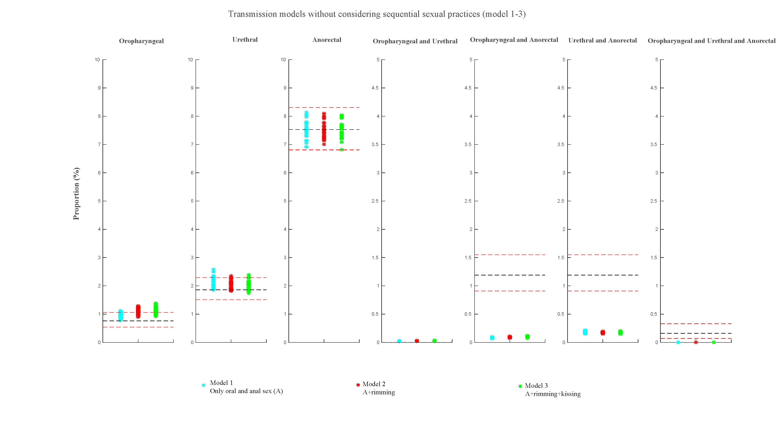
Figure S2a. Estimates of the three models for the percentage of specific anatomical sites positive for Chlamydia trachomatis for the three models (model 1-3) and the 95% confidence intervals for the observed site-specific positivity among 4888 MSM attending Melbourne Sexual Health Centre in 2018 and 2019
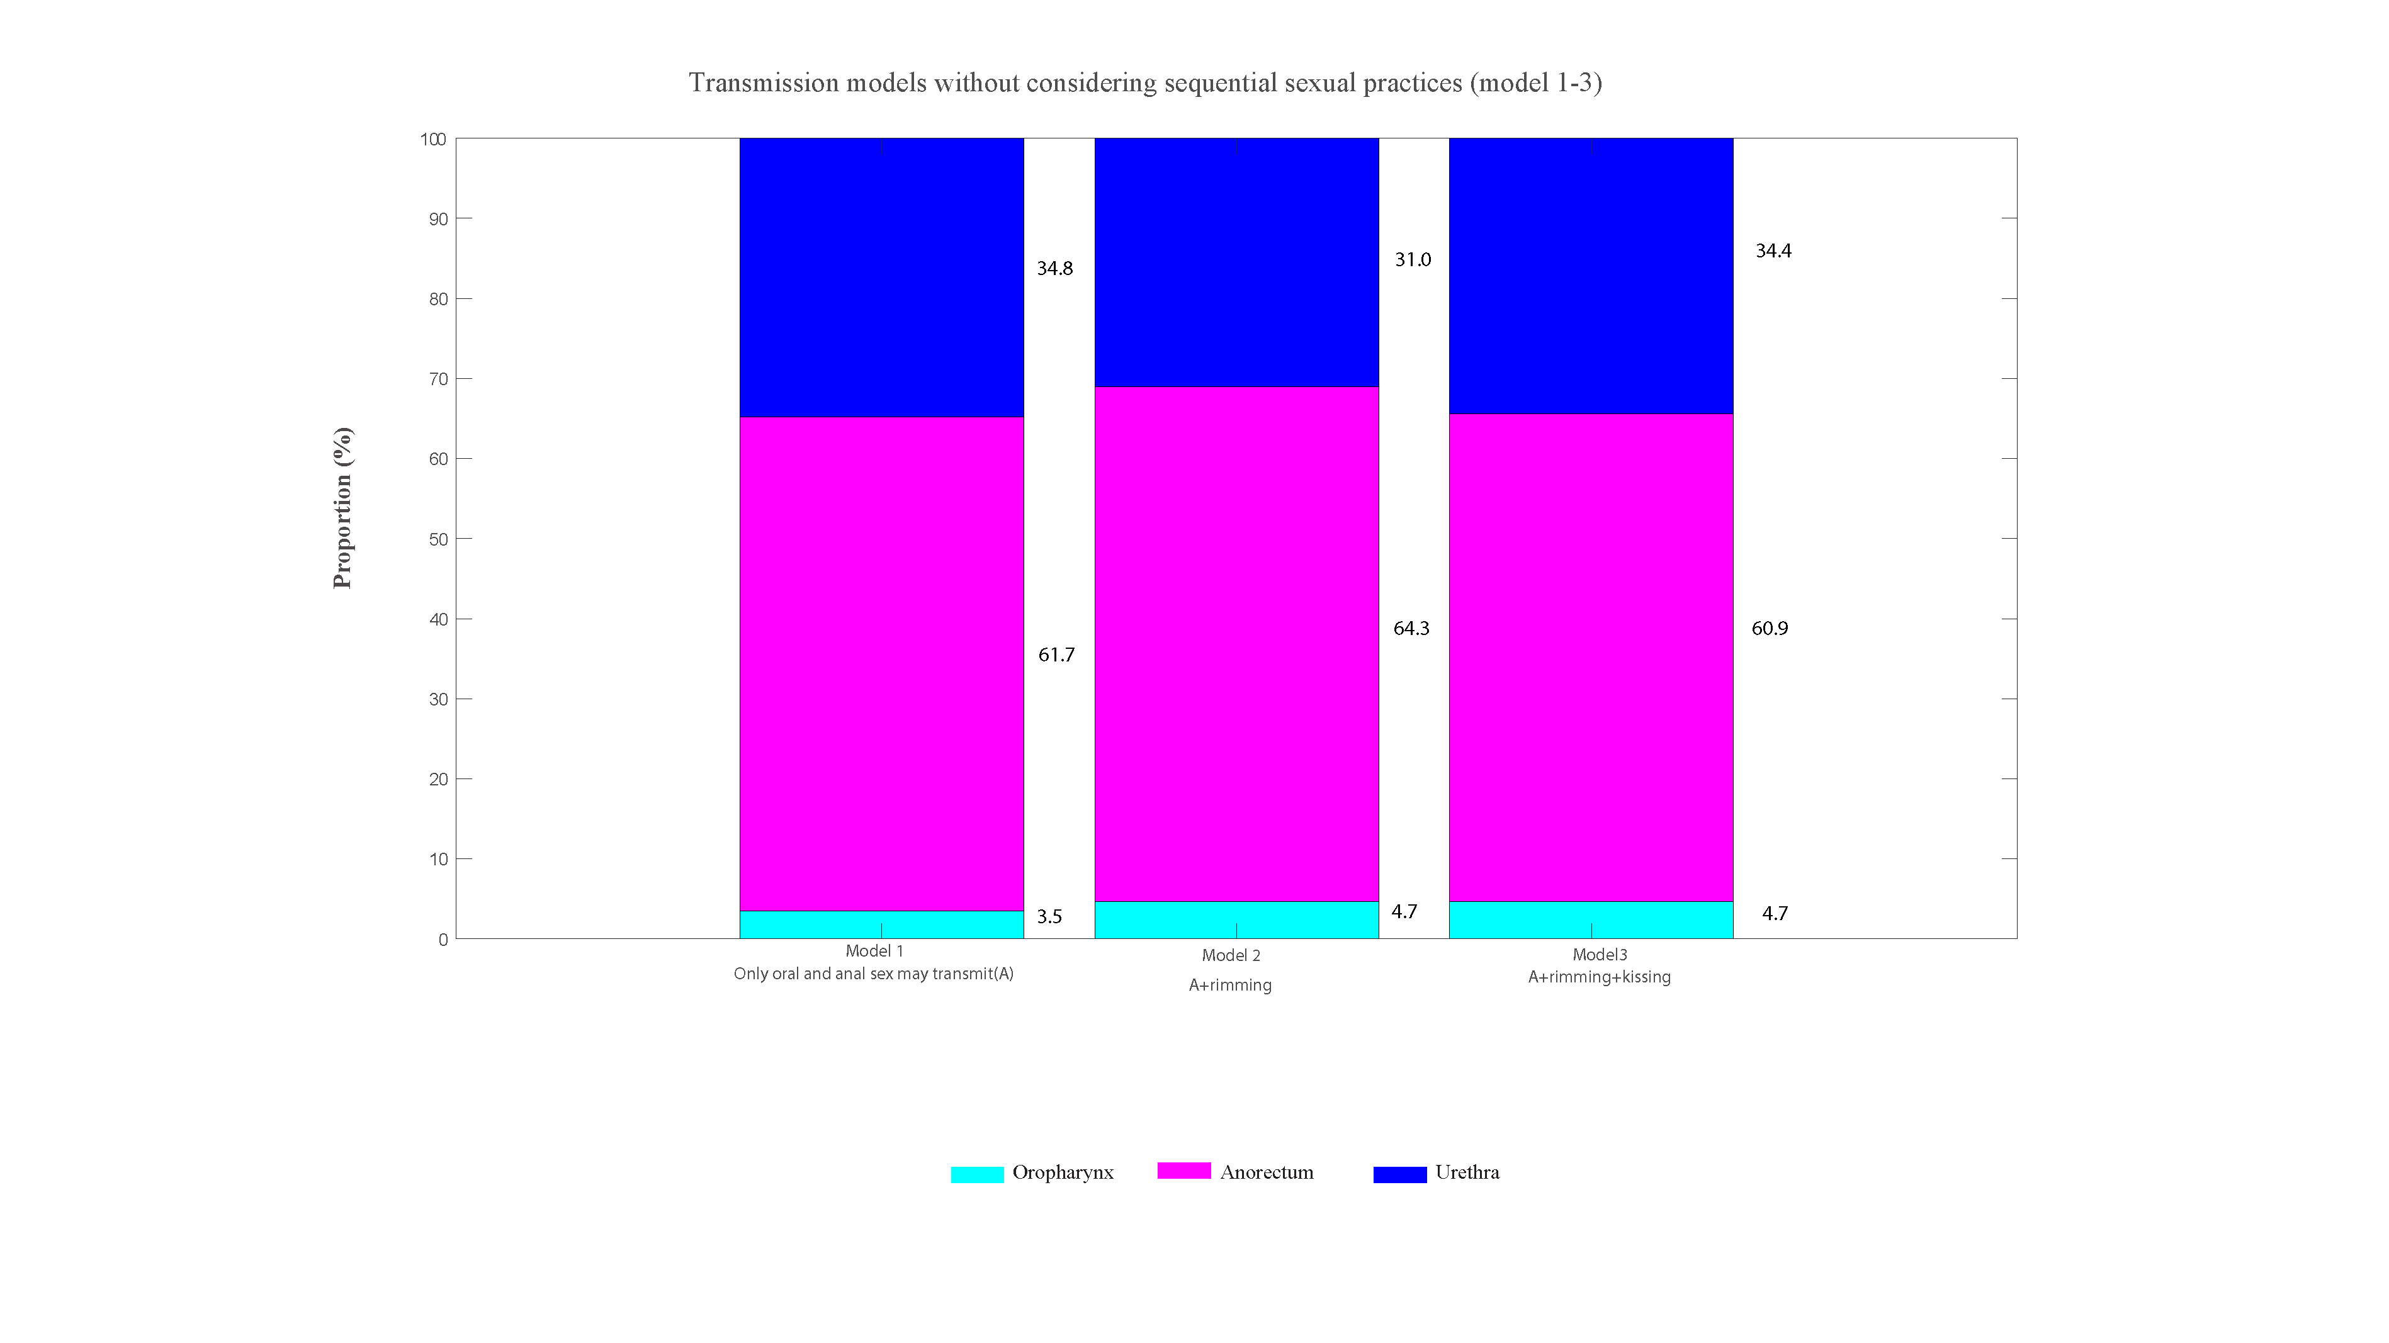
Figure S2b. Estimated proportion of incident Chlamydia trachomatis cases that occur at the oropharynx, anorectum or urethra in MSM from the three models (model 1-3) among 4888 MSM attending Melbourne Sexual Health Centre in 2018 and 2019

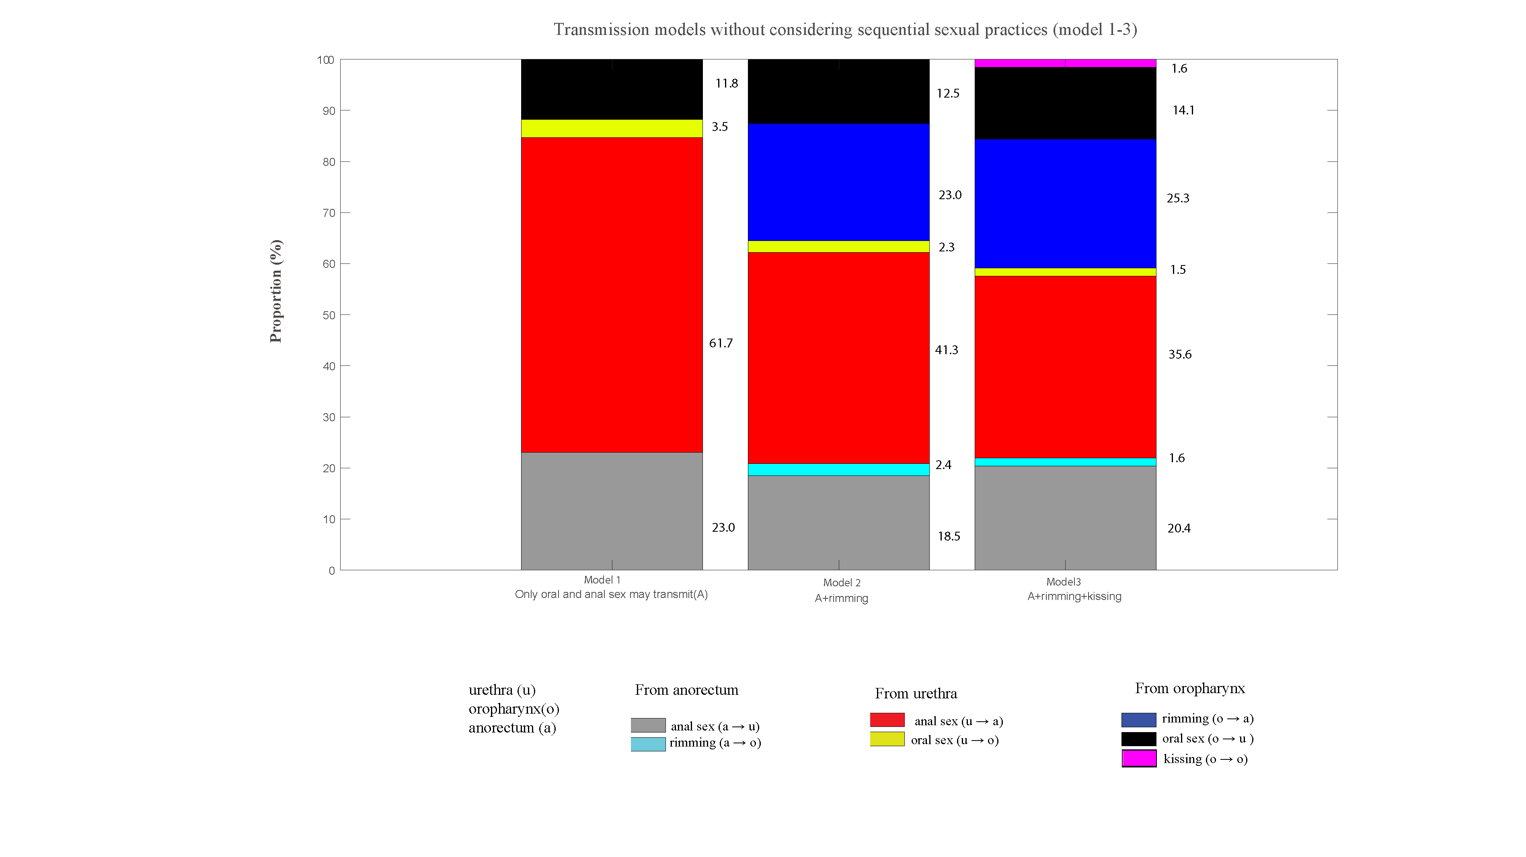
Figure S2c. Estimated proportion of incident Chlamydia trachomatis cases caused by sexual practices in MSM from the three models (model 1-3) among 4888 MSM attending Melbourne Sexual Health Centre in 2018 and 2019
Validation of Results (Dataset 1): Published validation data from 1,011 asymptomatic MSM attending Melbourne Sexual Health Centre

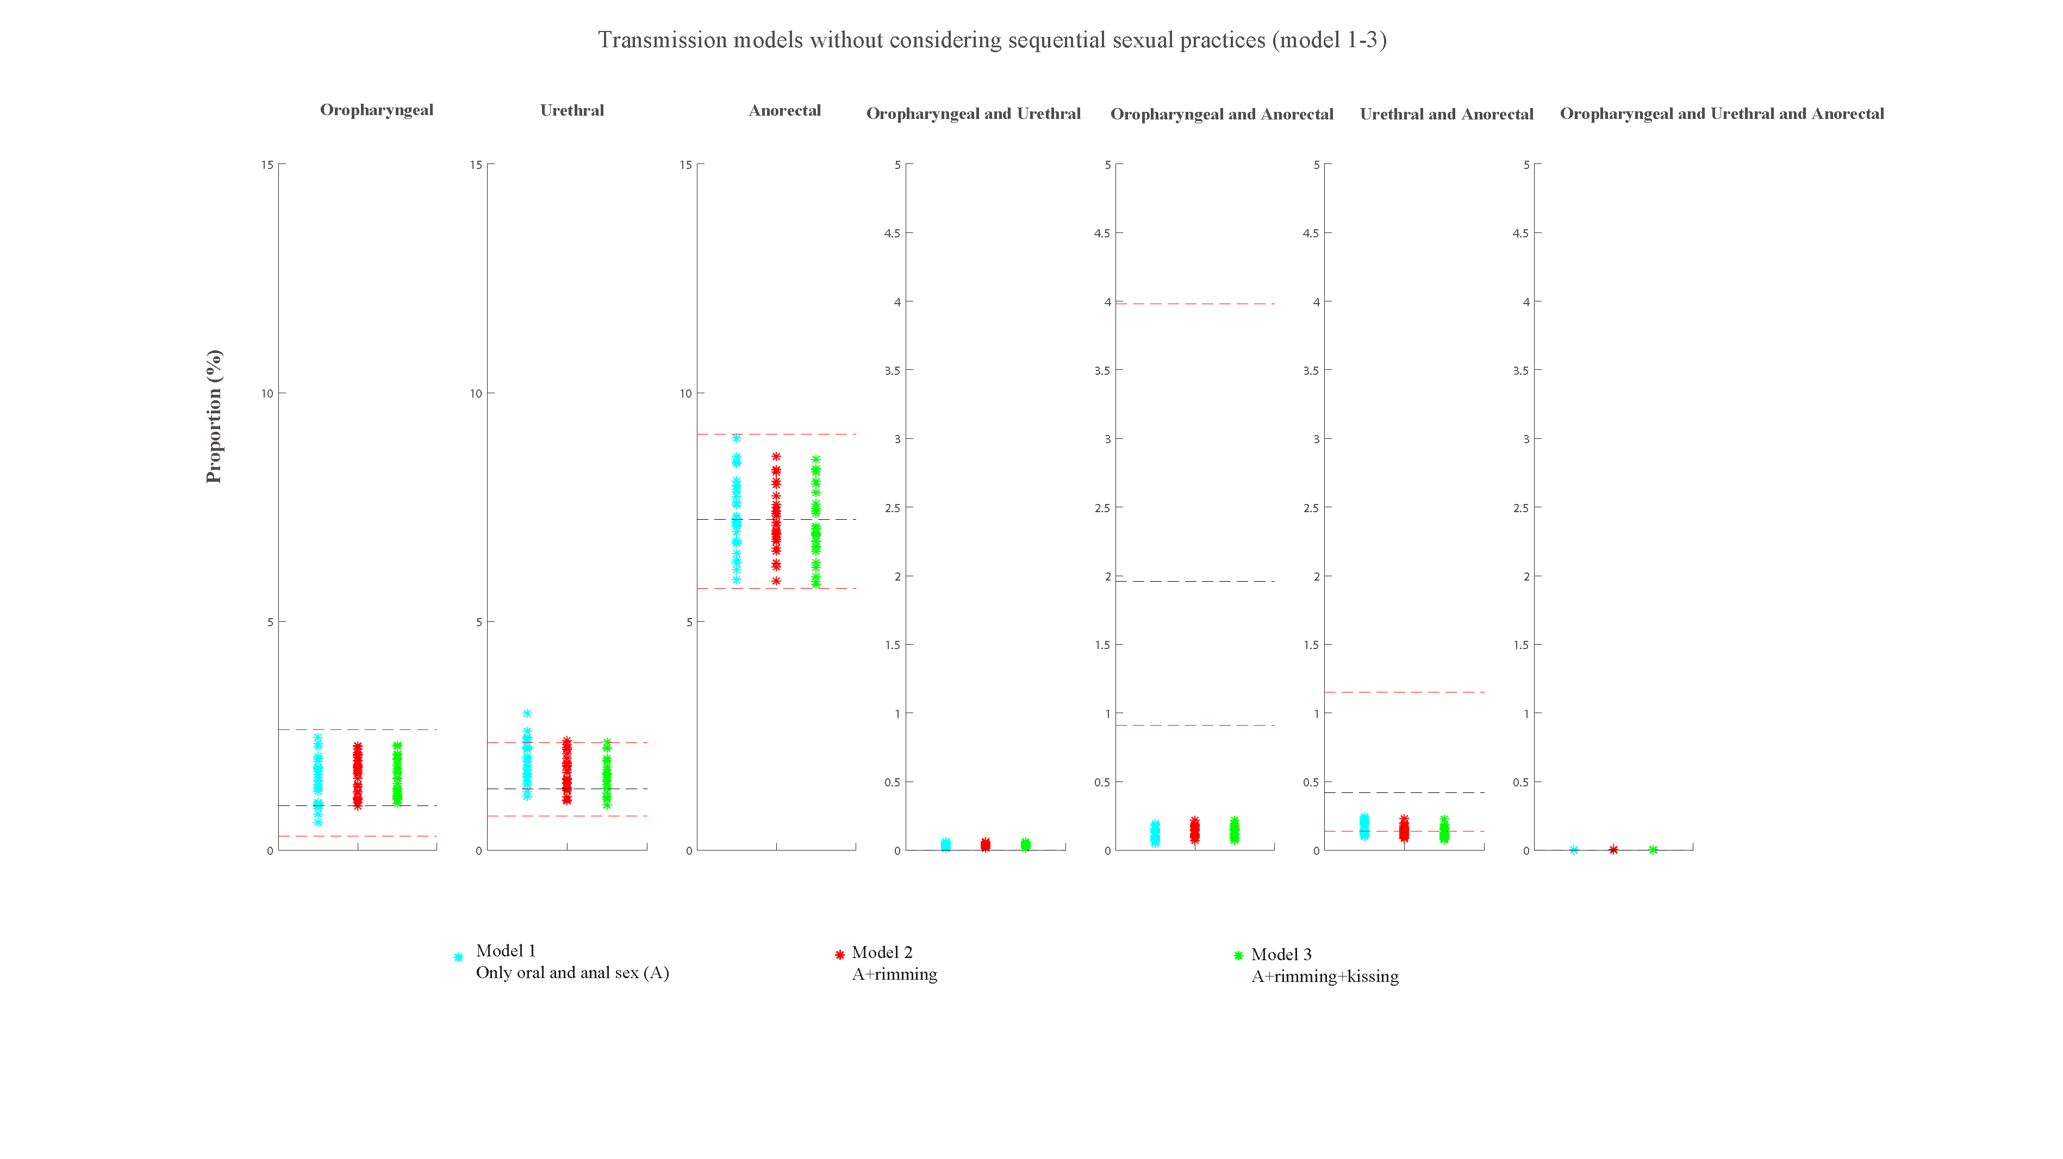
Figure S3a. Estimates of the three models for the percentage of specific anatomical sites positive for Chlamydia trachomatis for the three models (model 1-3) and the 95% confidence intervals for the observed site-specific positivity among 1,011 asymptomatic MSM attending MSHC during 2016–2017
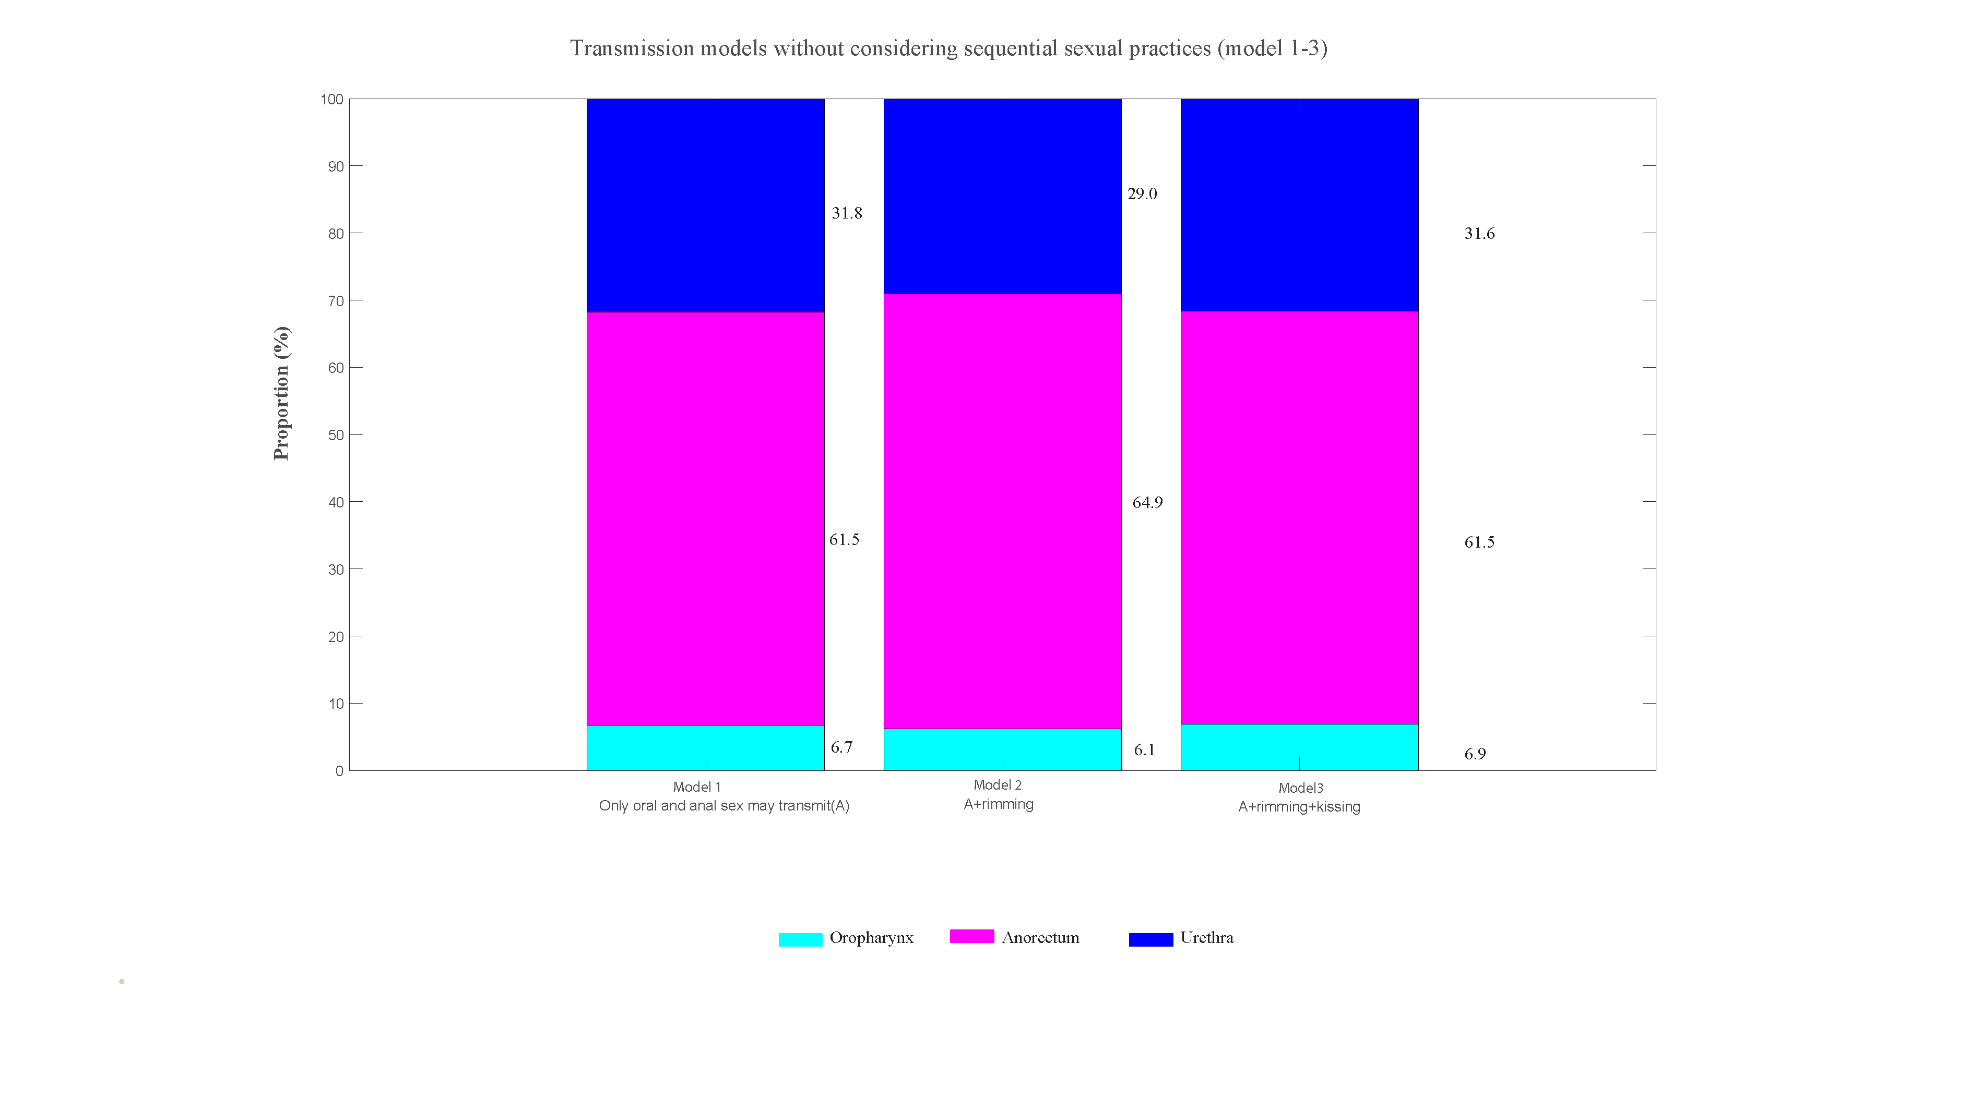
Figure S3b. Estimated proportion of incident Chlamydia trachomatis cases that occur at the oropharynx, anorectum or urethra in MSM from the three models (model 1-3) among 1,011 asymptomatic MSM attending MSHC during 2016–2017

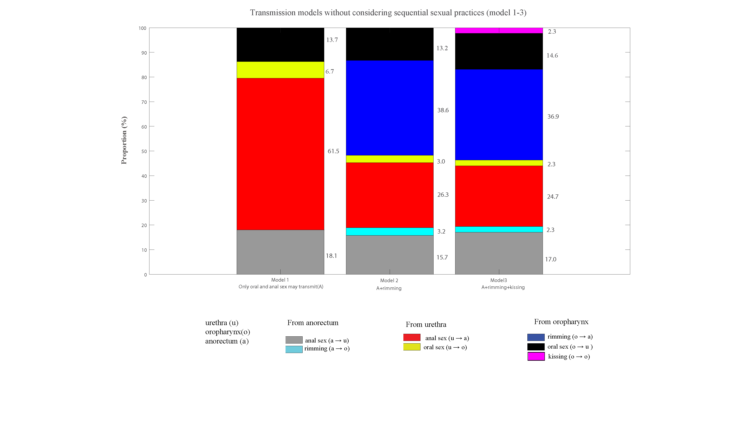
Figure S3c. Estimated proportion of incident Chlamydia trachomatis cases caused by sexual practices in MSM from the three models (model 1-3) among 1,011 asymptomatic MSM attending MSHC during 2016–2017
Validation of Results (Dataset 2): Published validation data from 393 MSM attending STD & HIV care clinics in the USA
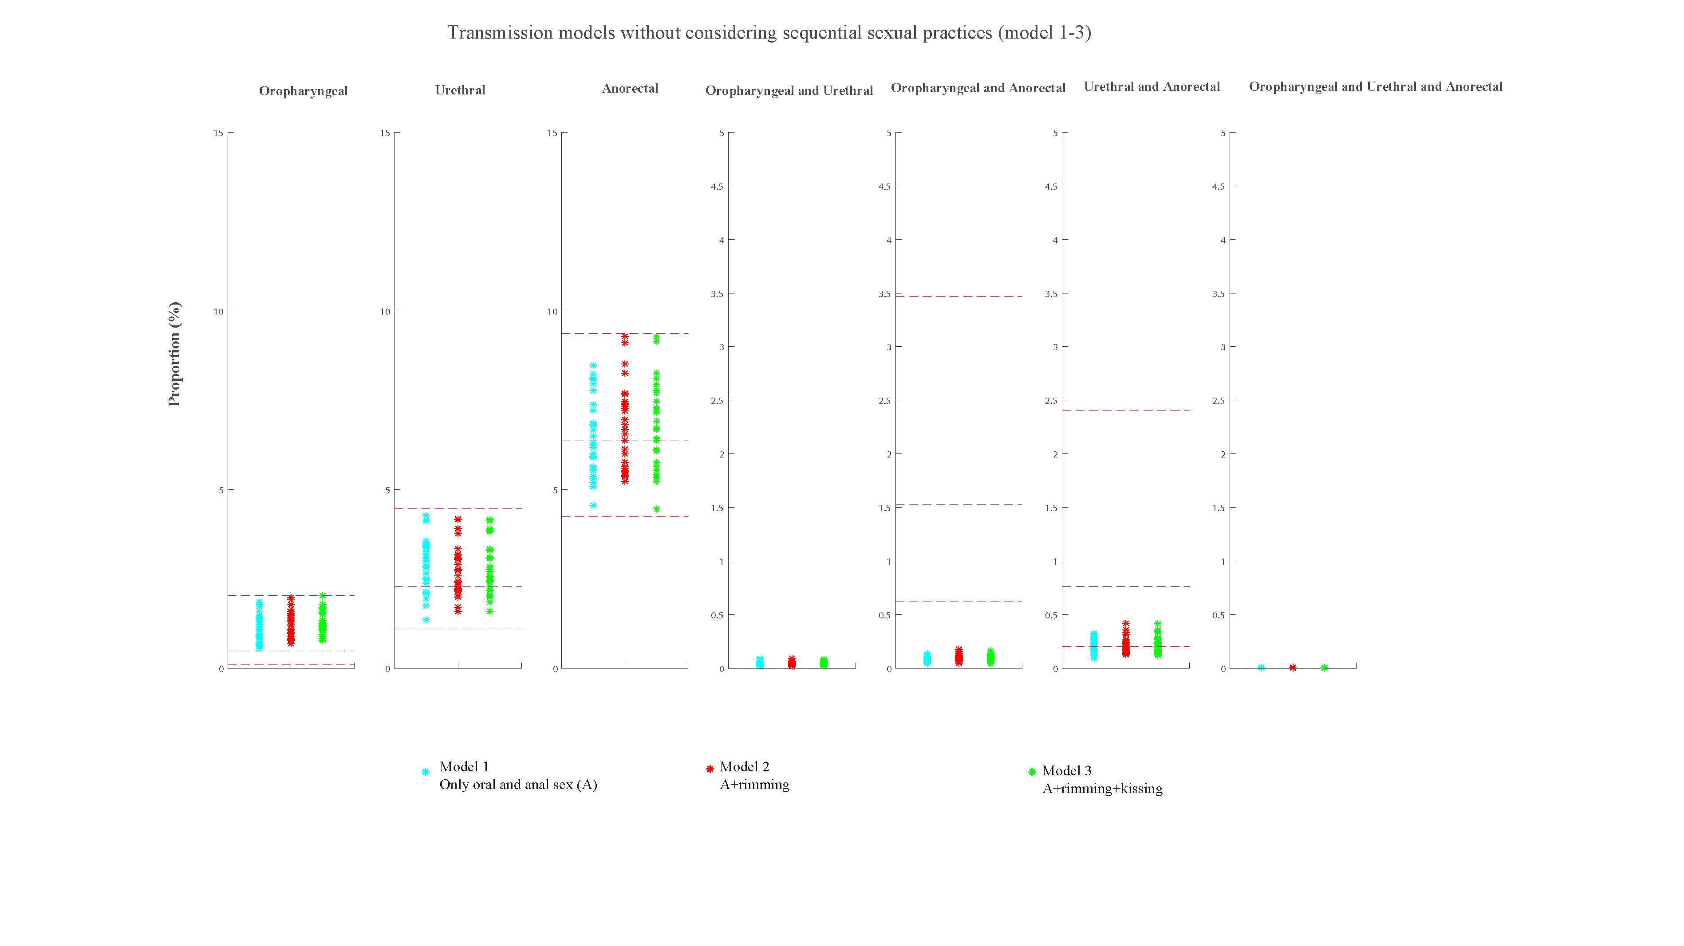
Figure S4a. Estimates of the three models for the percentage of specific anatomical sites positive for Chlamydia trachomatis for the three models (model 1-3) and the 95% confidence intervals for the observed site-specific positivity among 393MSM attending STD & HIV care clinics in the USA

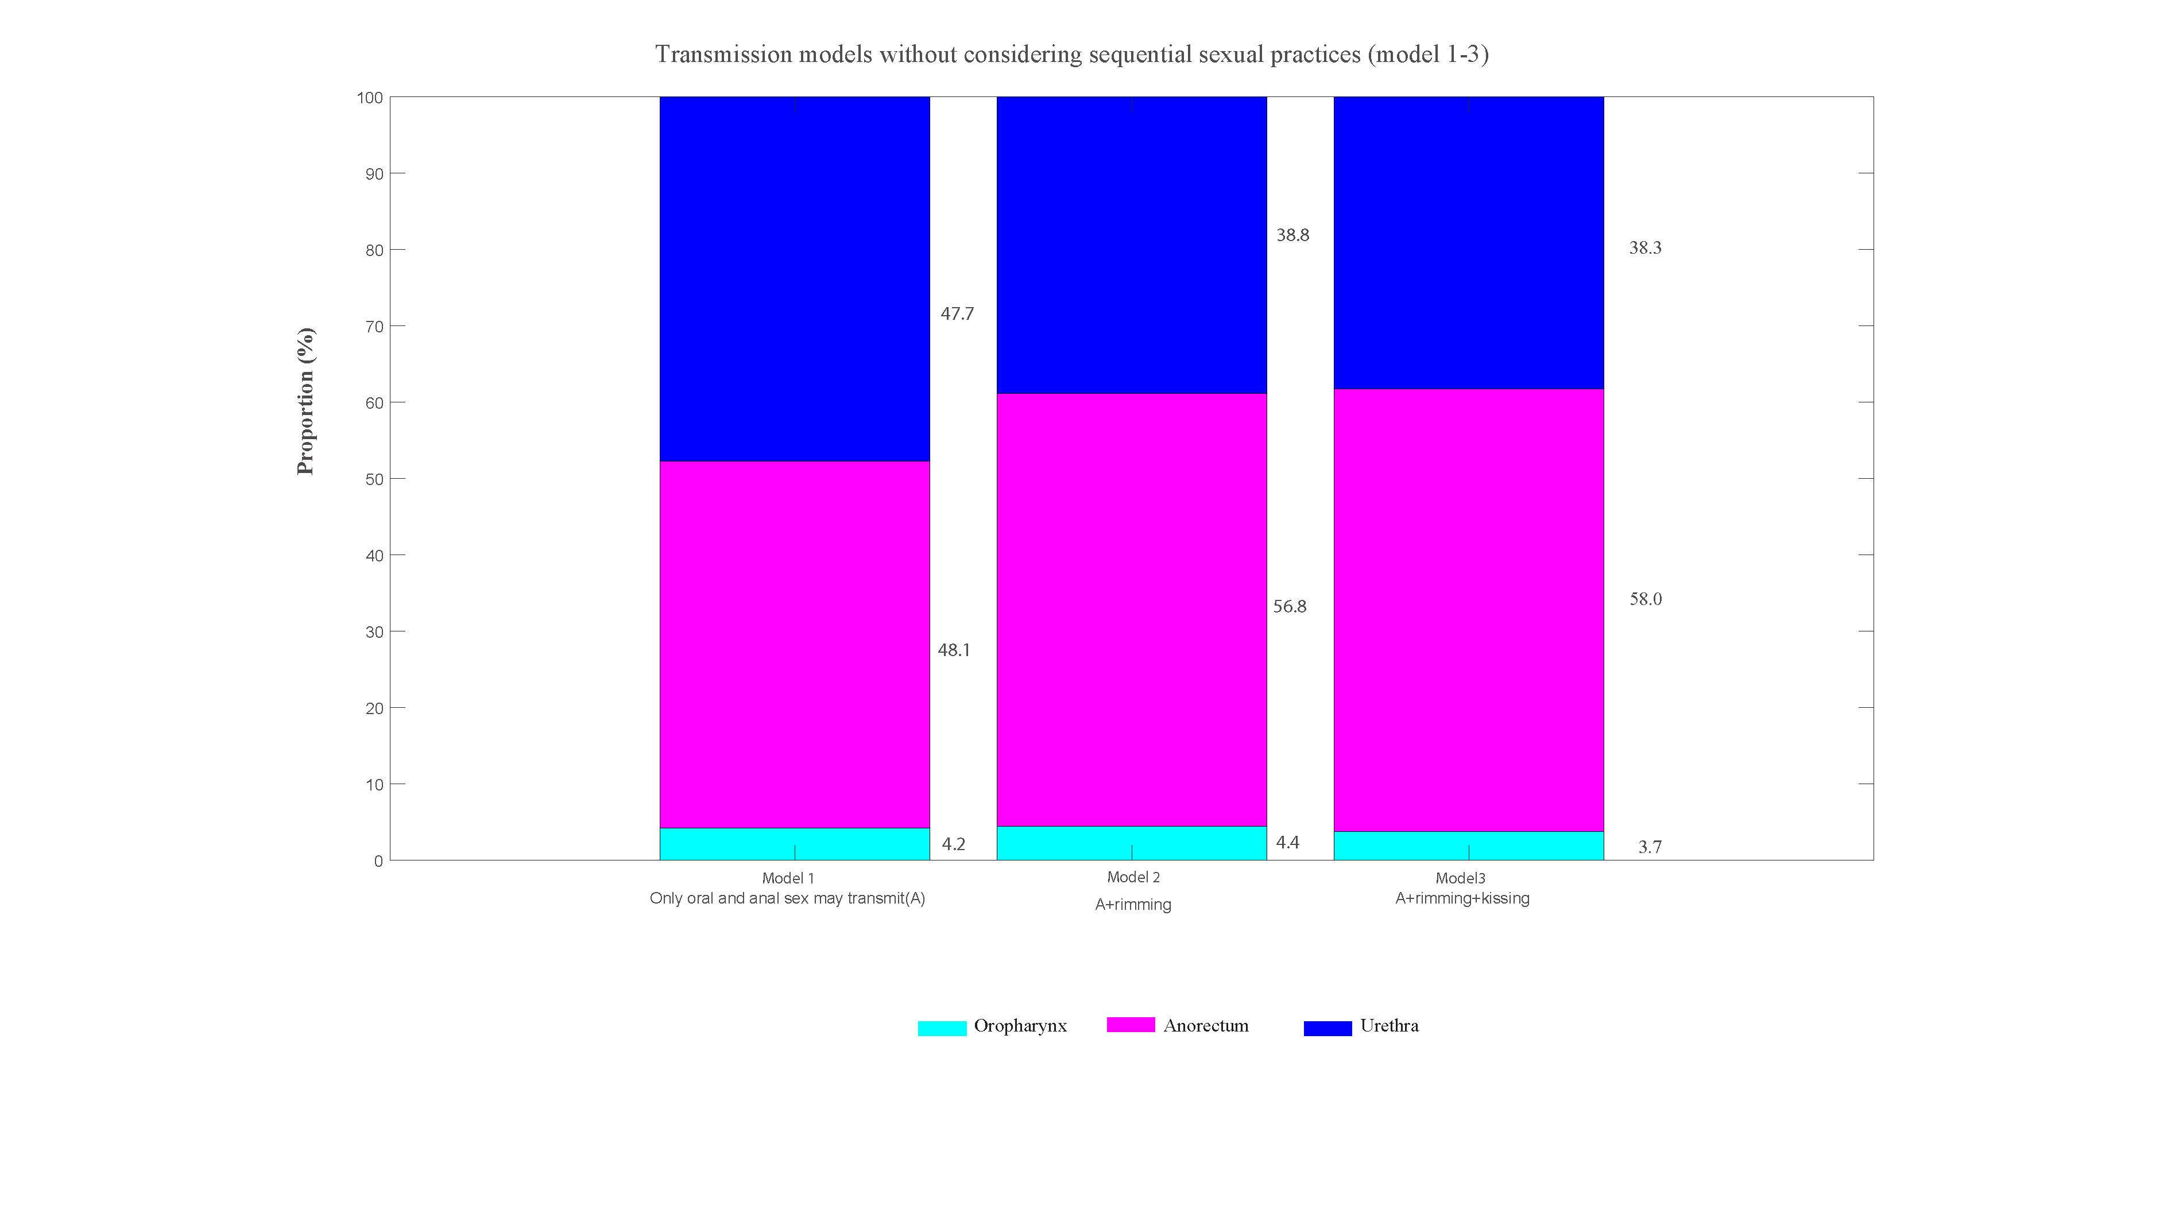
Figure S4b. Estimated proportion of incident Chlamydia trachomatis cases that occur at the oropharynx, anorectum or urethra in MSM from the three models (model 1-3) among 393MSM attending STD & HIV care clinics in the USA

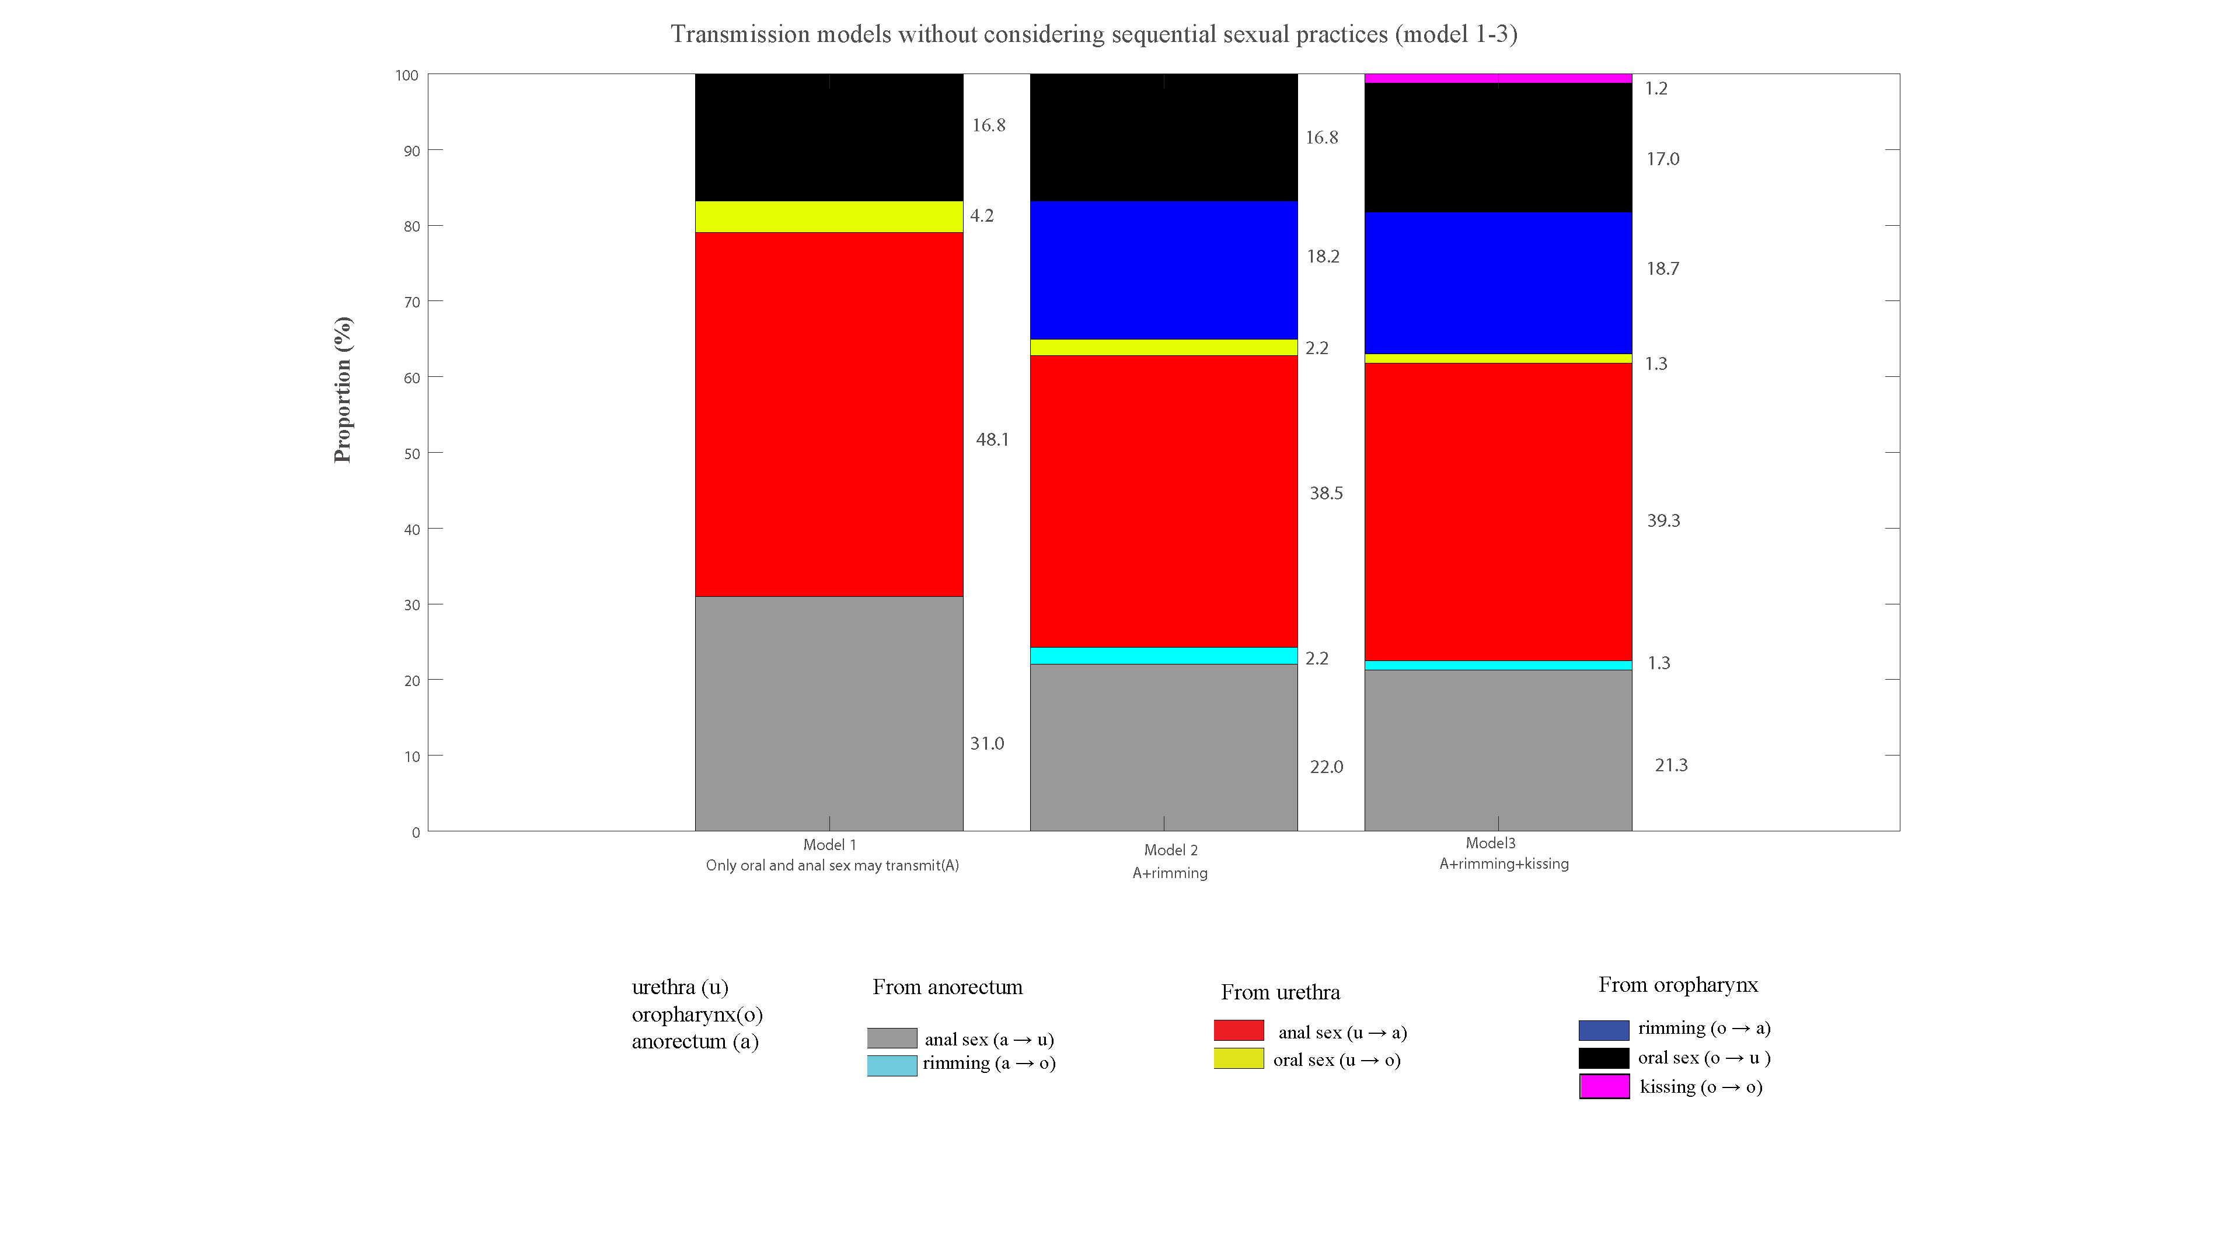
Figure S4c. Estimated proportion of incident Chlamydia trachomatis cases caused by sexual practices in MSM from the three models (model 1-3) among 393MSM attending STD & HIV care clinics in the USA
Validation of Results (Dataset 3): Published validation data from MSM surveillance data of all Dutch STI clinics
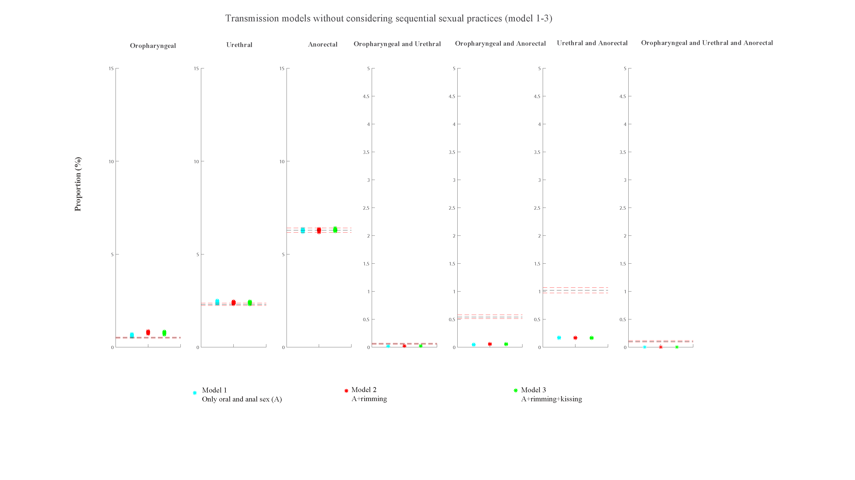
Figure S5a. Estimates of the three models for the percentage of specific anatomical sites positive for Chlamydia trachomatis for the three models (model 1-3) and the 95% confidence intervals for the observed site-specific positivity among MSM surveillance data (271, 242 consultations) from all Dutch STI clinics during 2008-2017

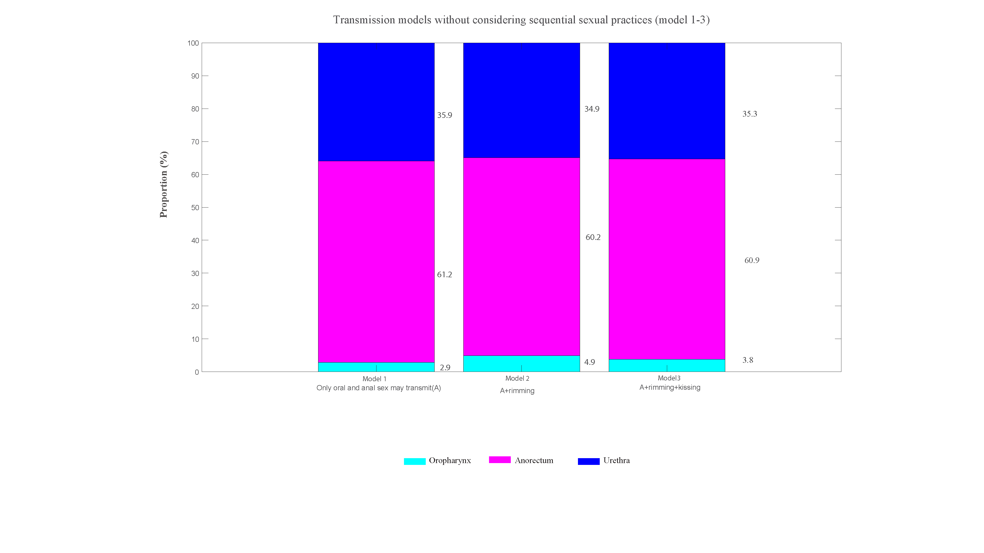
Figure S5b. Estimated proportion of incident Chlamydia trachomatis cases that occur at the oropharynx, anorectum or urethra in MSM from the three models (model 1-3) among MSM surveillance data (271, 242 consultations) from all Dutch STI clinics during 2008-2017

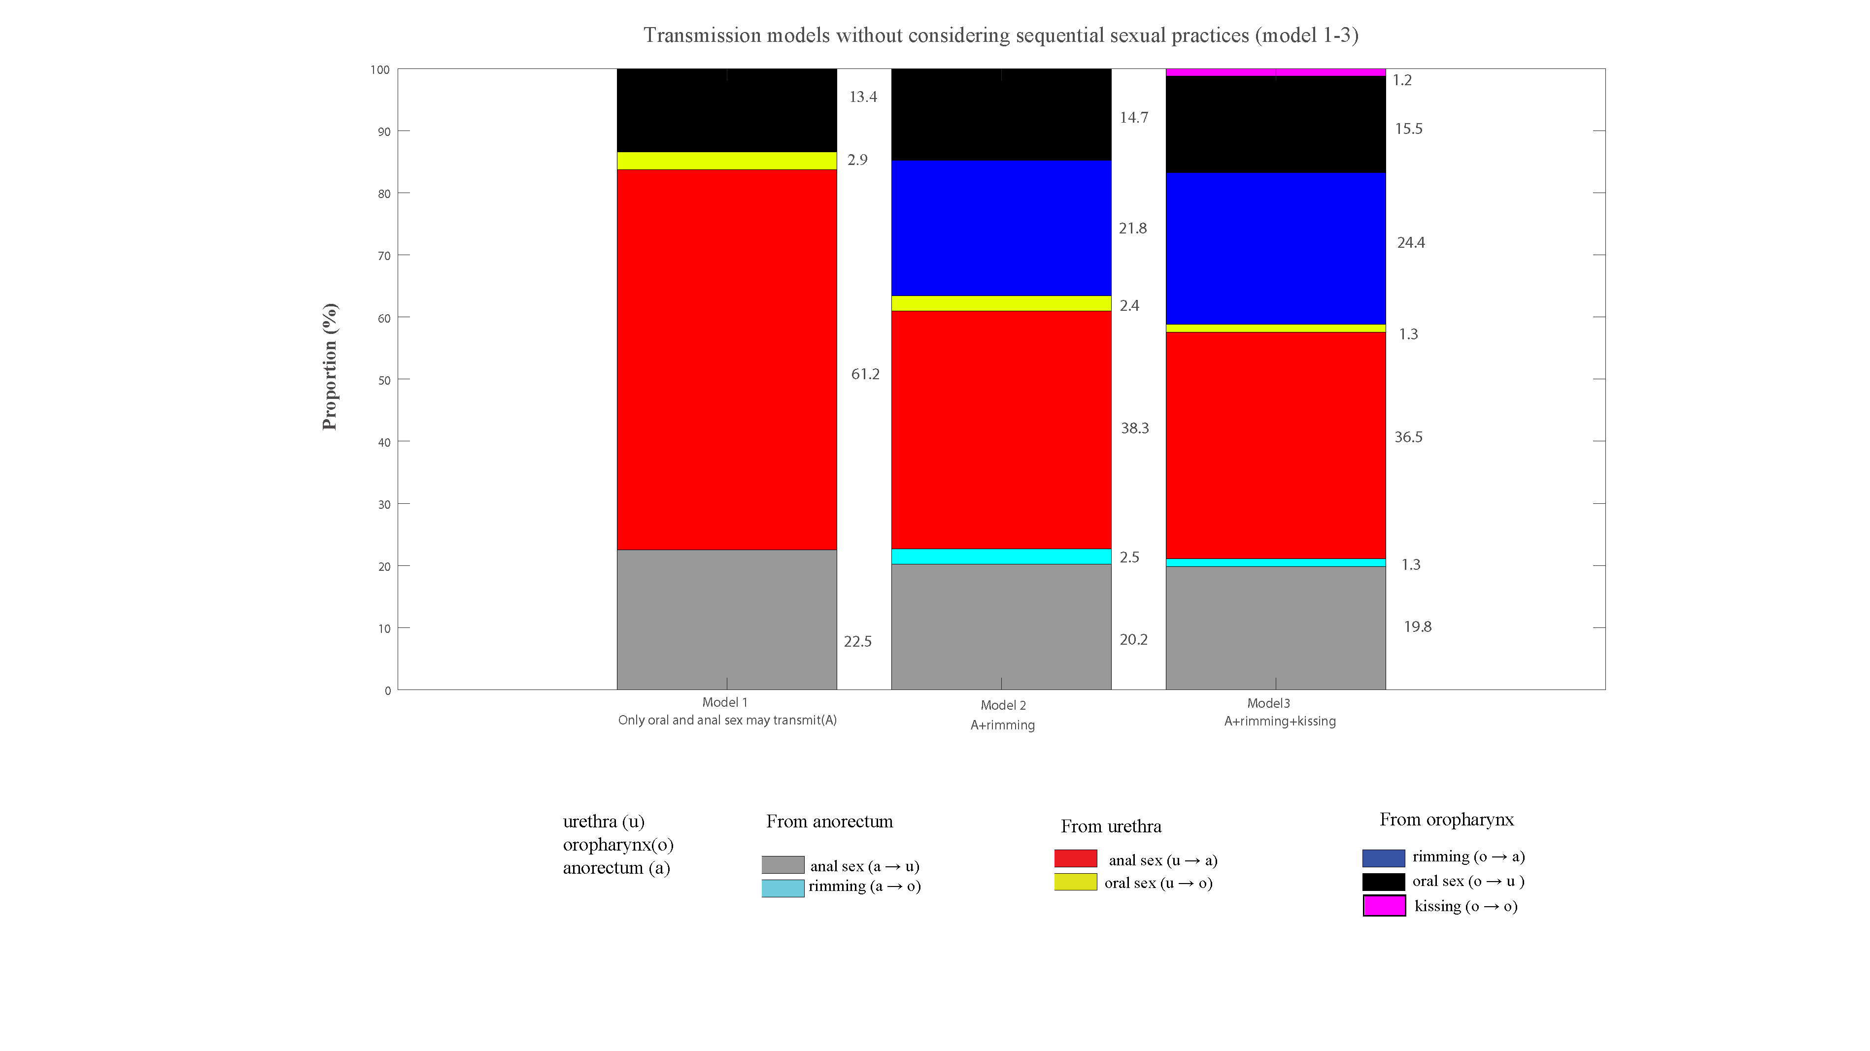
Figure S5c. Estimated proportion of incident Chlamydia trachomatis cases caused by sexual practices in MSM from the three models (model 1-3) among MSM surveillance data (271, 242 consultations) from all Dutch STI clinics during 2008-2017

Validation of Results (Dataset 4): Published validation data from 1,610 community MSM in Thailand
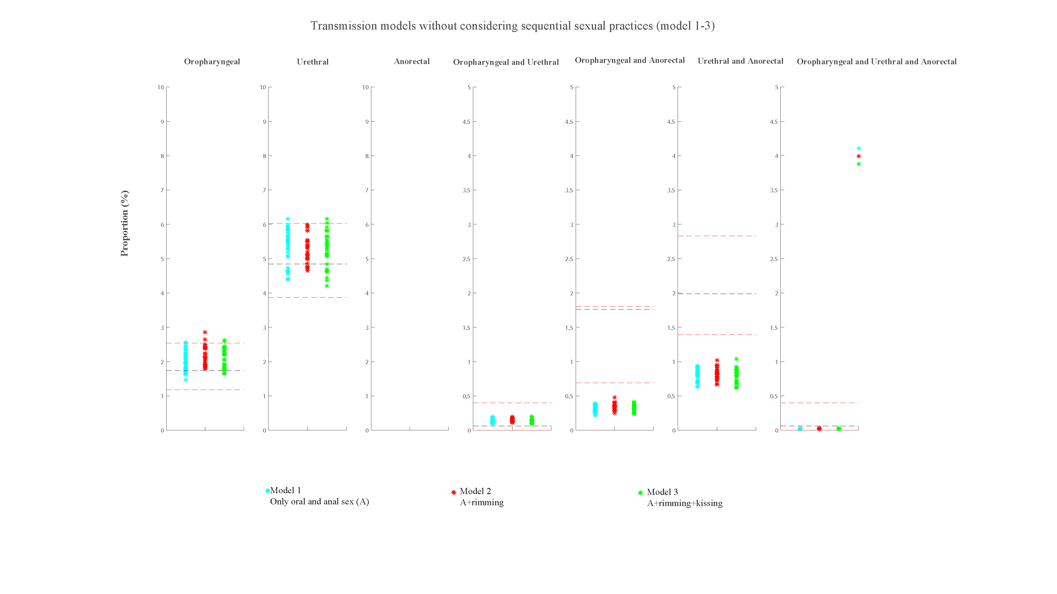
Figure S6a. Estimates of the three models for the percentage of specific anatomical sites positive for Chlamydia trachomatis for the three models (model 1-3) and the 95% confidence intervals for the observed site-specific positivity among 1,610 MSM attending a community-led test and treat cohort in Thailand between October 2015 and October 2016

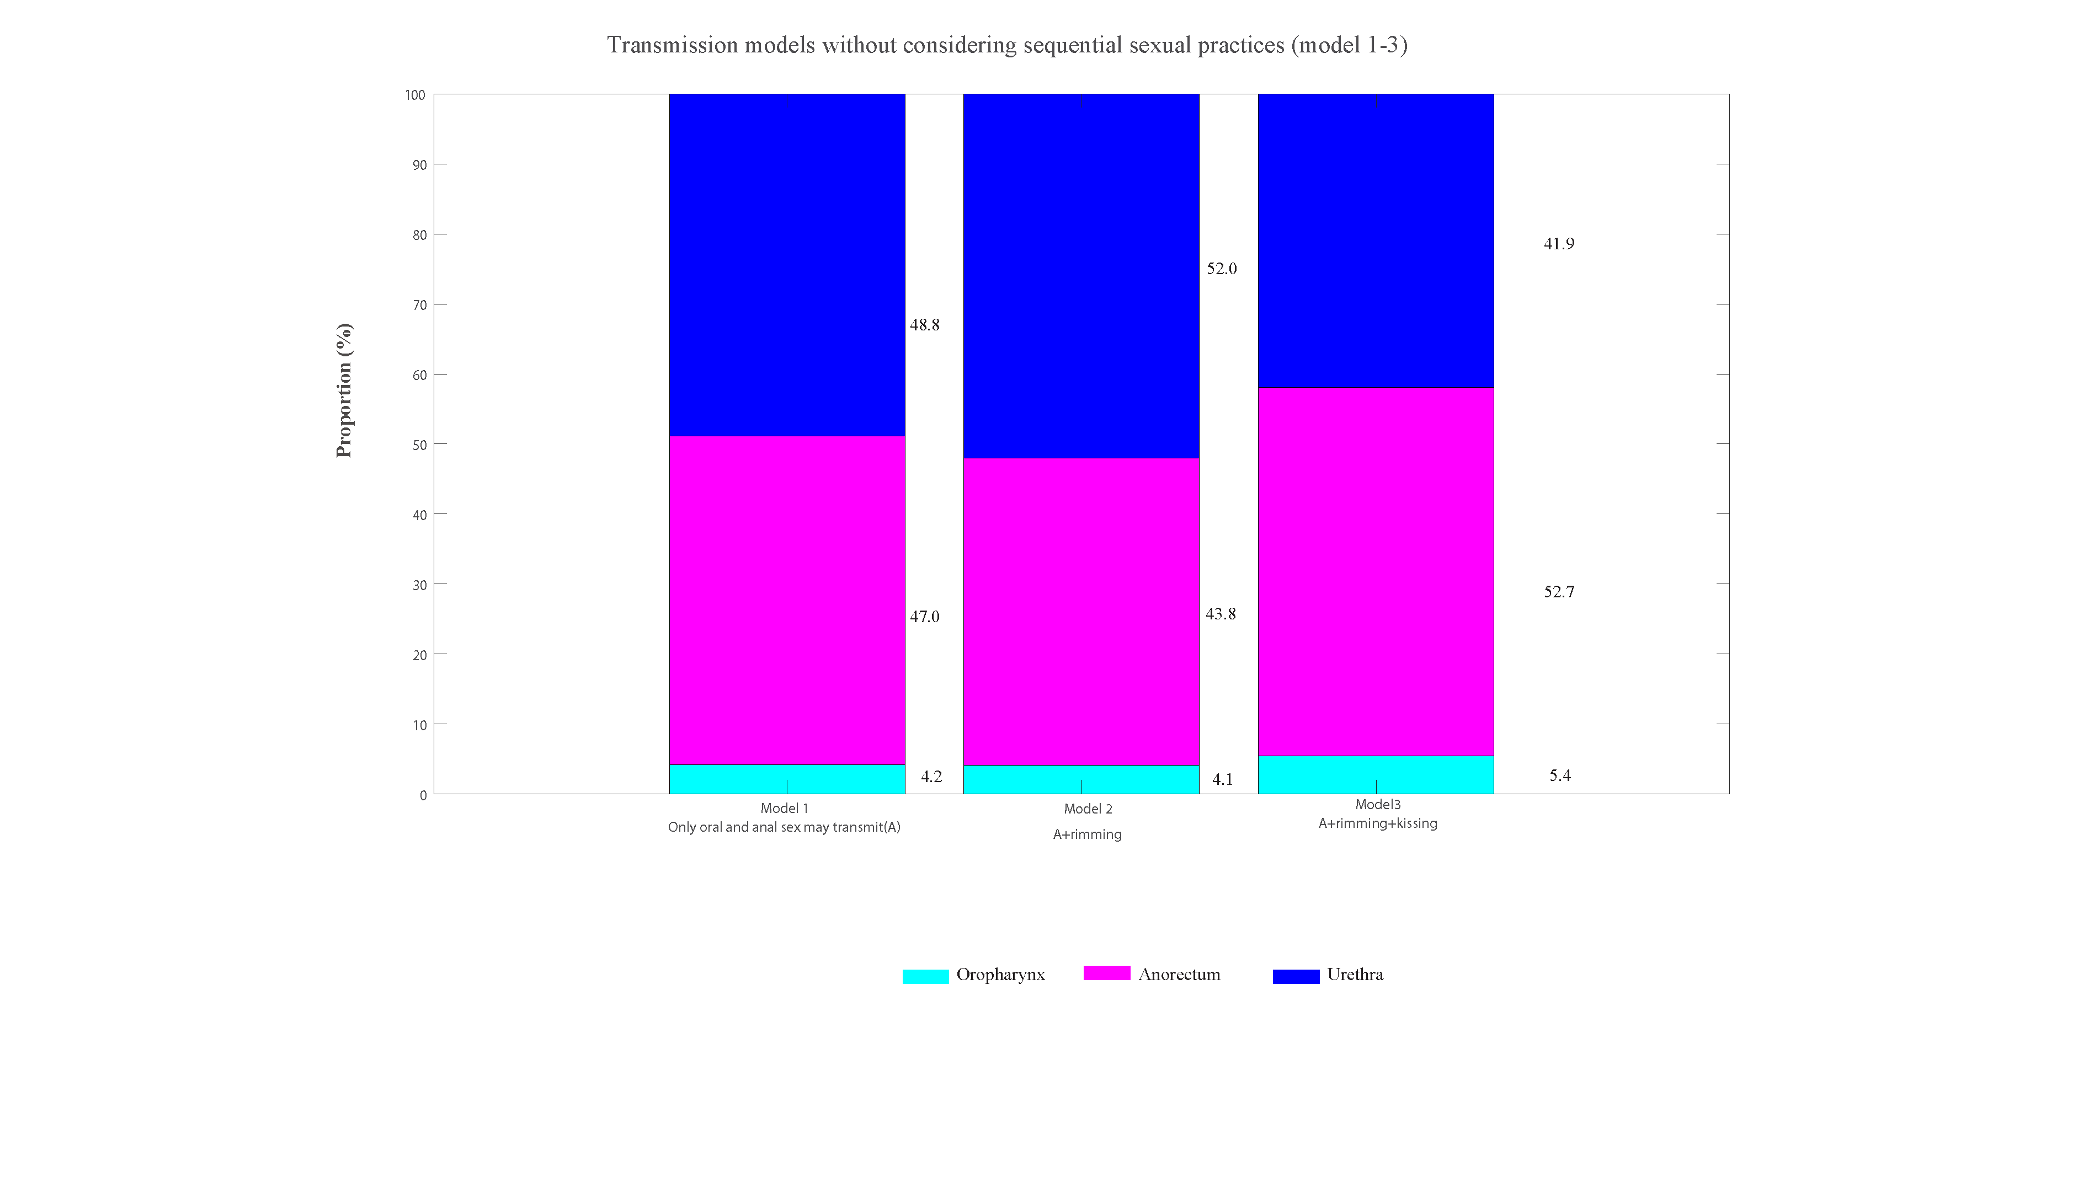
Figure S6b. Estimated proportion of incident Chlamydia trachomatis cases that occur at the oropharynx, anorectum or urethra in MSM from the three models (model 1-3) among 1,610 MSM attending a community-led test and treat cohort in Thailand between October 2015 and October 2016

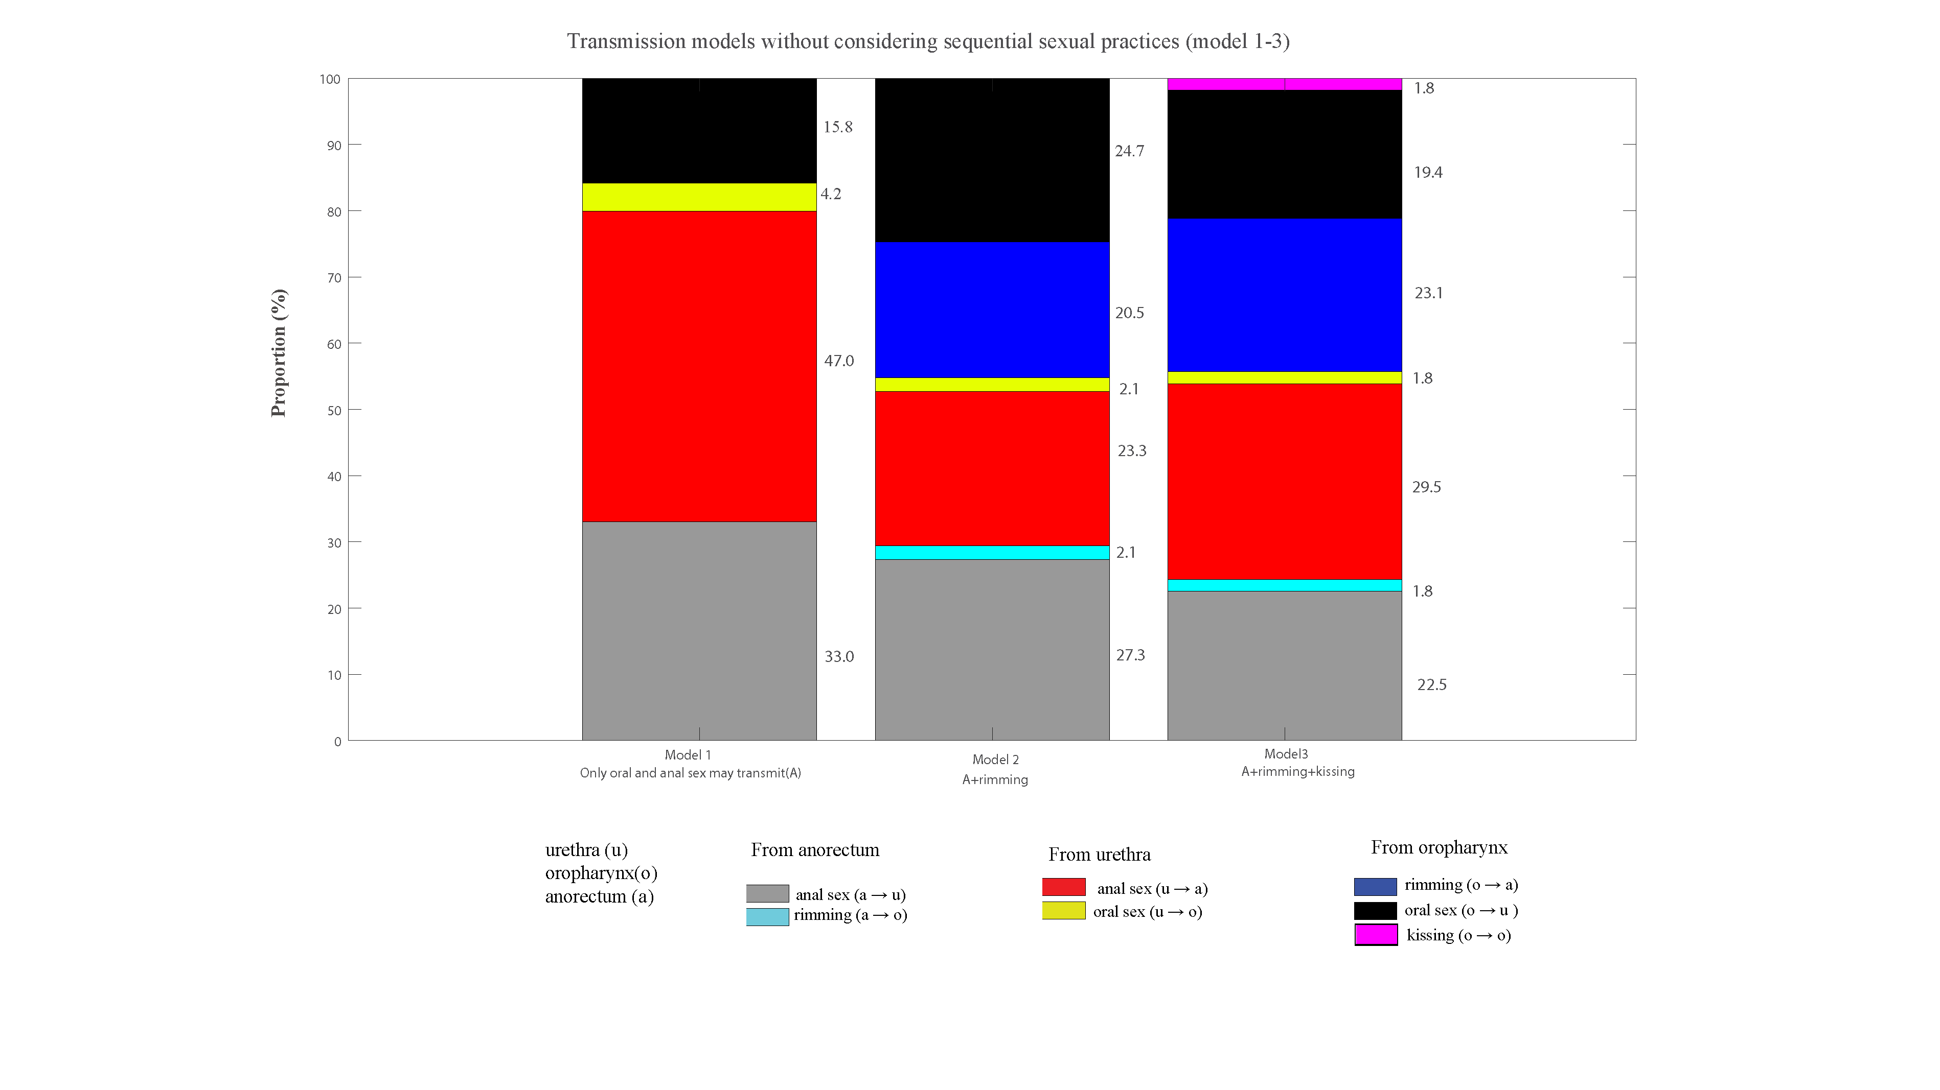
Figure S6c. Estimated proportion of incident Chlamydia trachomatis cases caused by sexual practices in MSM from the three models (model 1-3) among 1,610 MSM attending a community-led test and treat cohort in Thailand between October 2015 and October 2016

Validation of Results (Dataset 5): Published validation data from 179 MSM with HIV in the USA
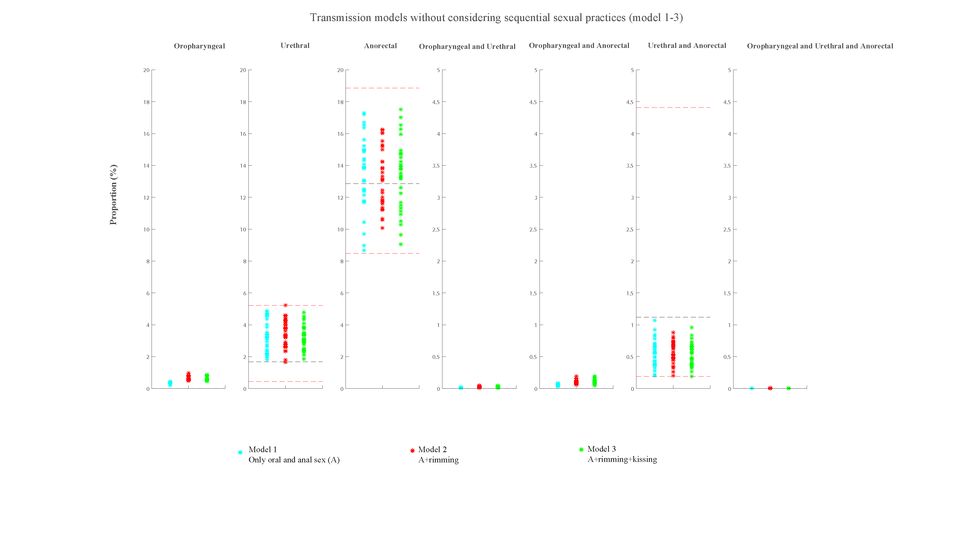
Figure S7a. Estimates of the three models for the percentage of specific anatomical sites positive for Chlamydia trachomatis for the three models (model 1-3) and the 95% confidence intervals for the observed site-specific positivity among179 MSM with HIV

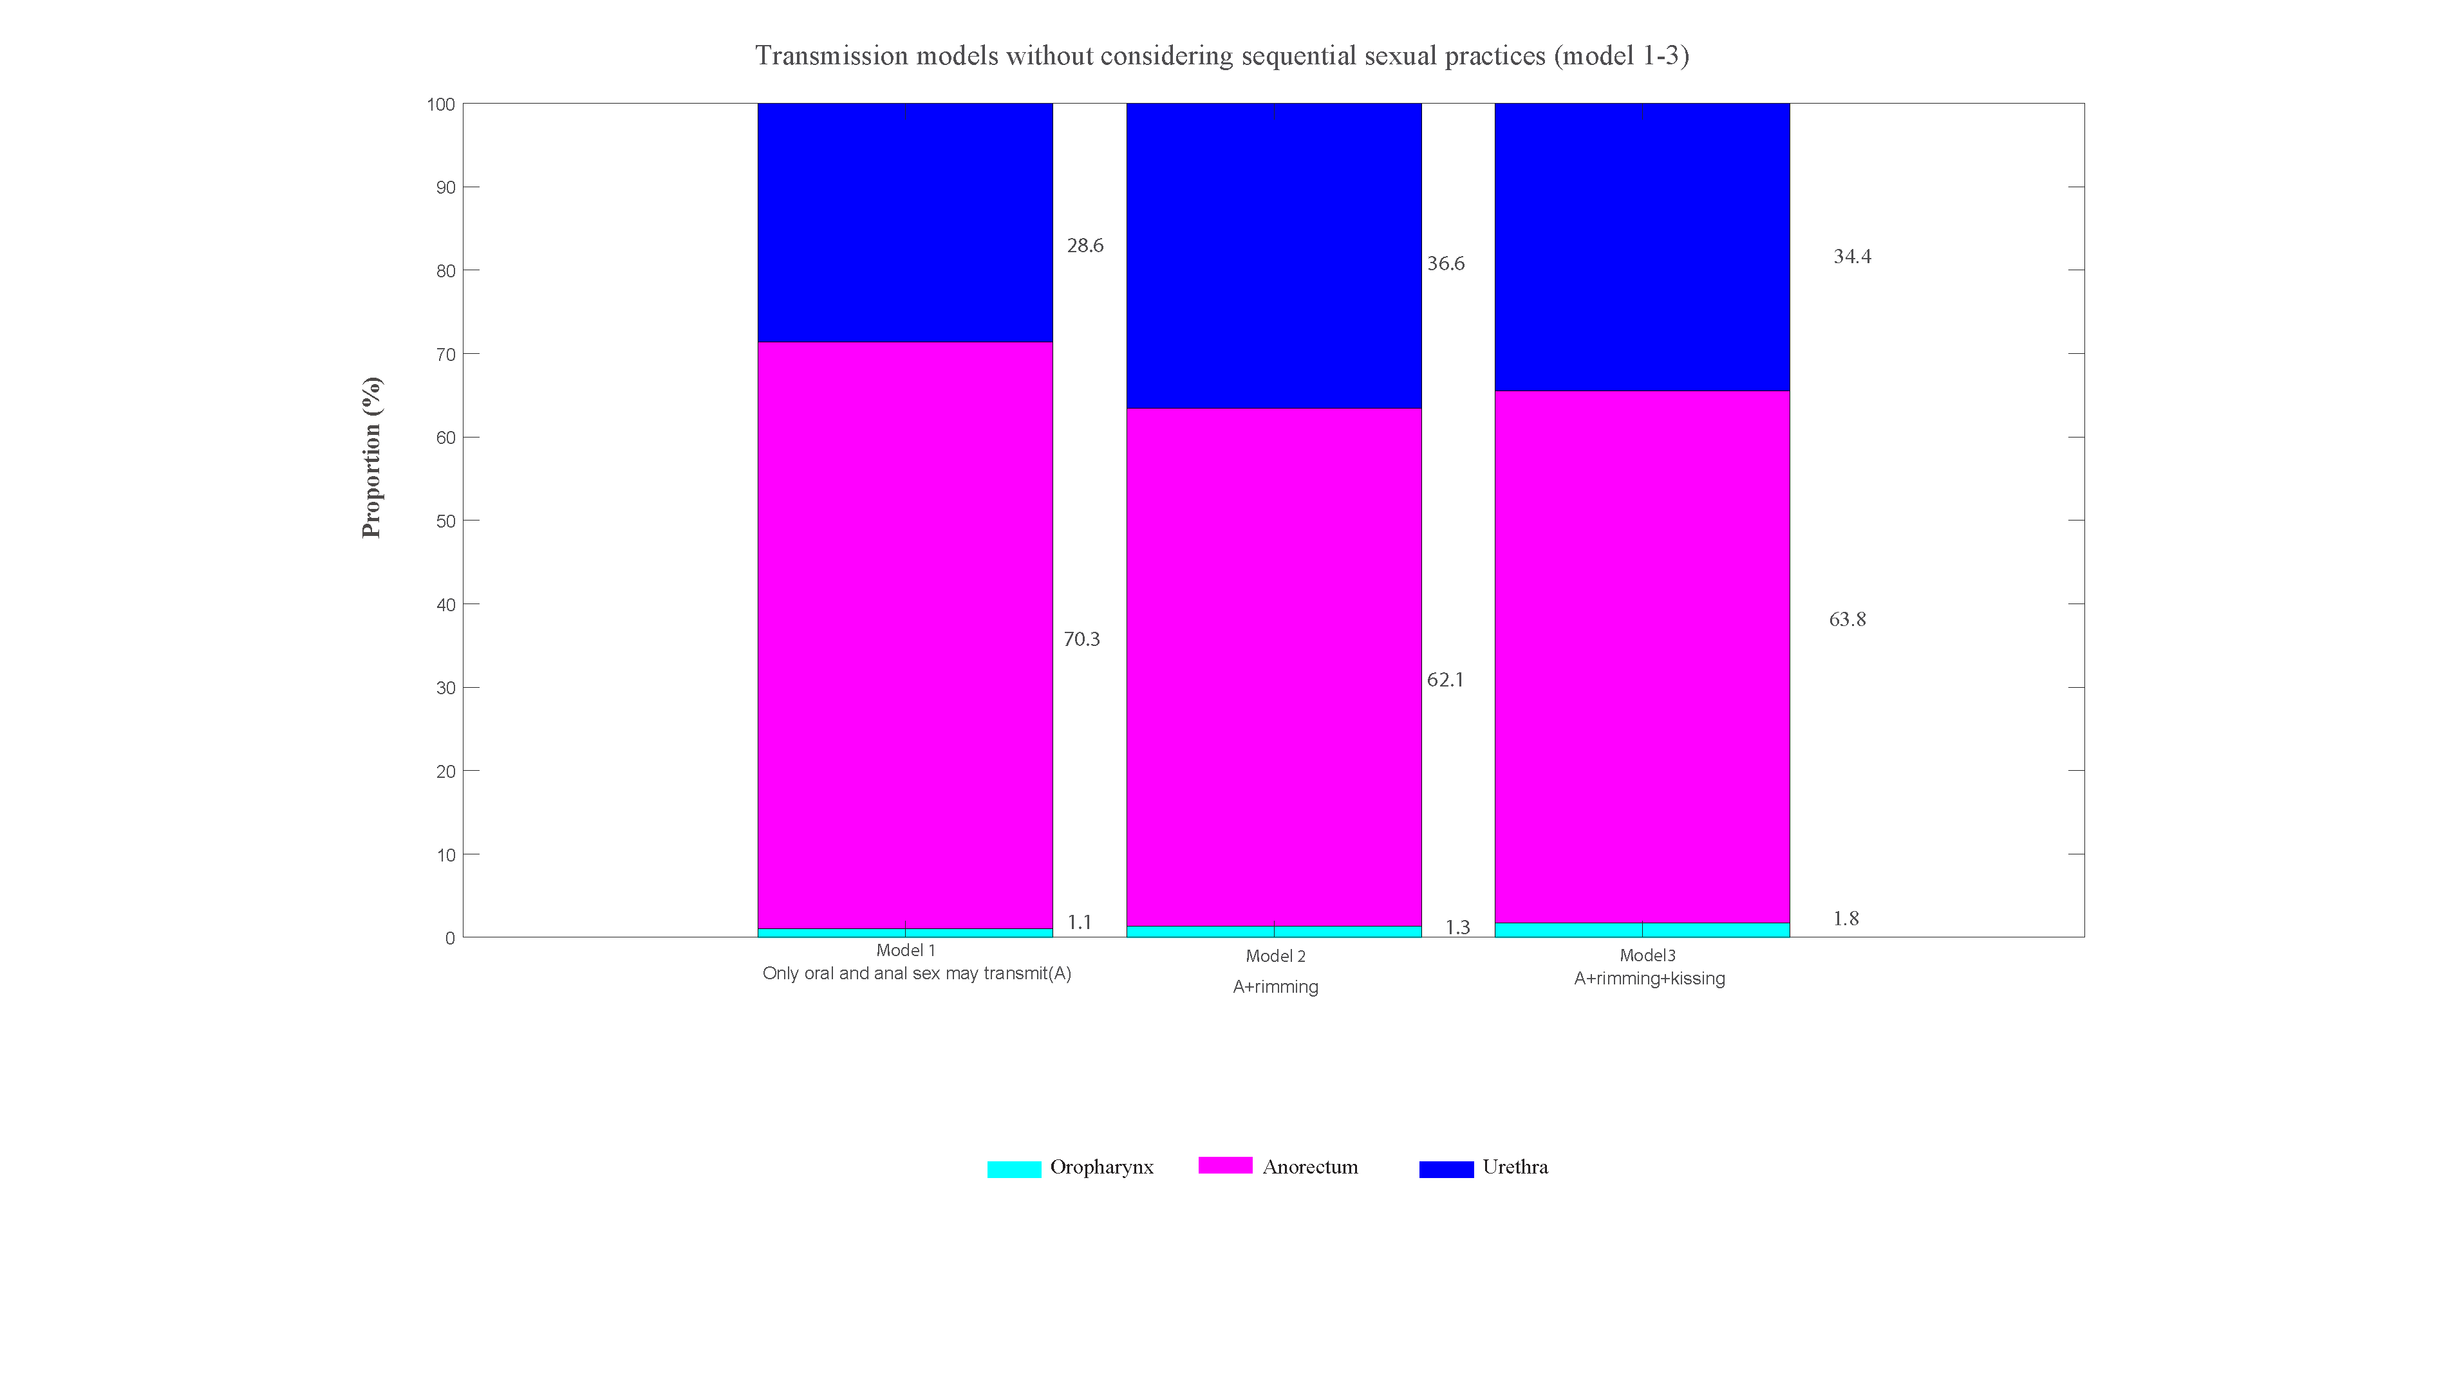
Figure S7b. Estimated proportion of incident Chlamydia trachomatis cases that occur at the oropharynx, anorectum or urethra in MSM from the three models (model 1-3) among179 MSM with HIV

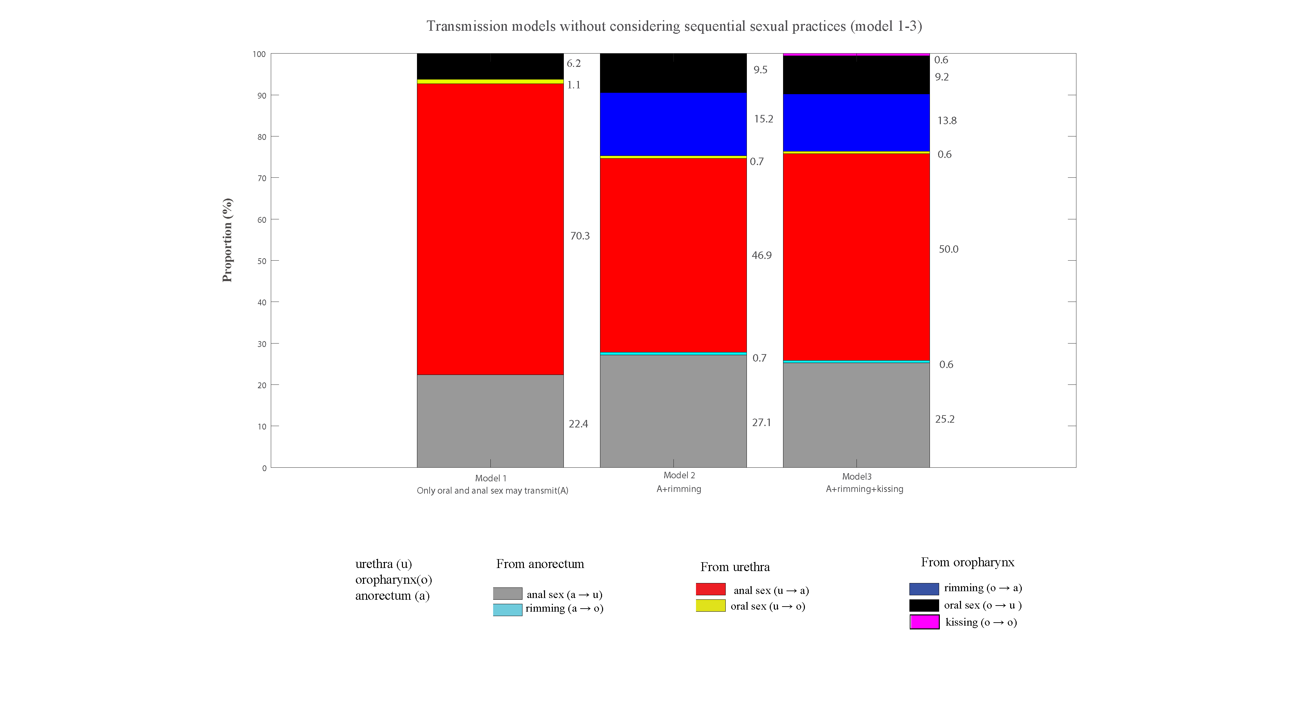
Figure S7c. Estimated proportion of incident Chlamydia trachomatis cases caused by sexual practices in MSM from the three models (model 1-3) among179 MSM with HIV

Supplementary results: ‘Anal sex, oral sex and sequential sexual practices’ transmission models (Model 1, 4-6)
Unpublished data from 4888 MSM attending Melbourne Sexual Health Centre for model (model 1, 4-6) calibration
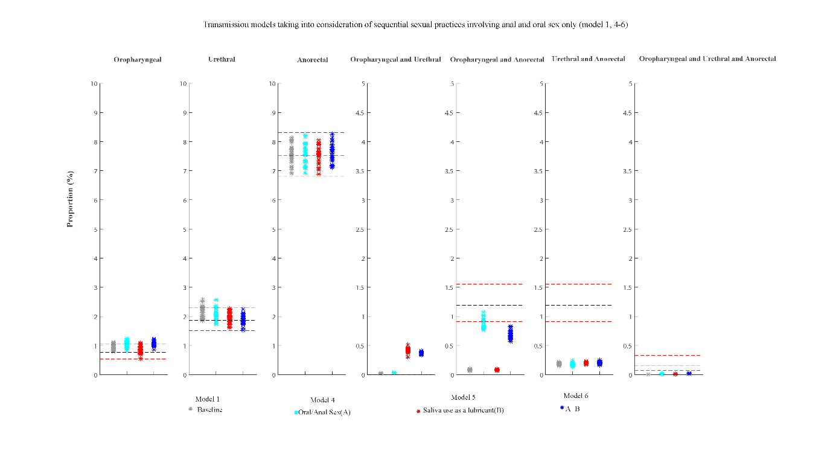
Figure S8a. Estimates of the eight models for the percentage of specific anatomical sites positive for Chlamydia trachomatis for the four models (model 1, 4-6) and the 95% confidence intervals for the observed site-specific positivity among 4888 MSM attending Melbourne Sexual Health Centre in 2018 and 2019

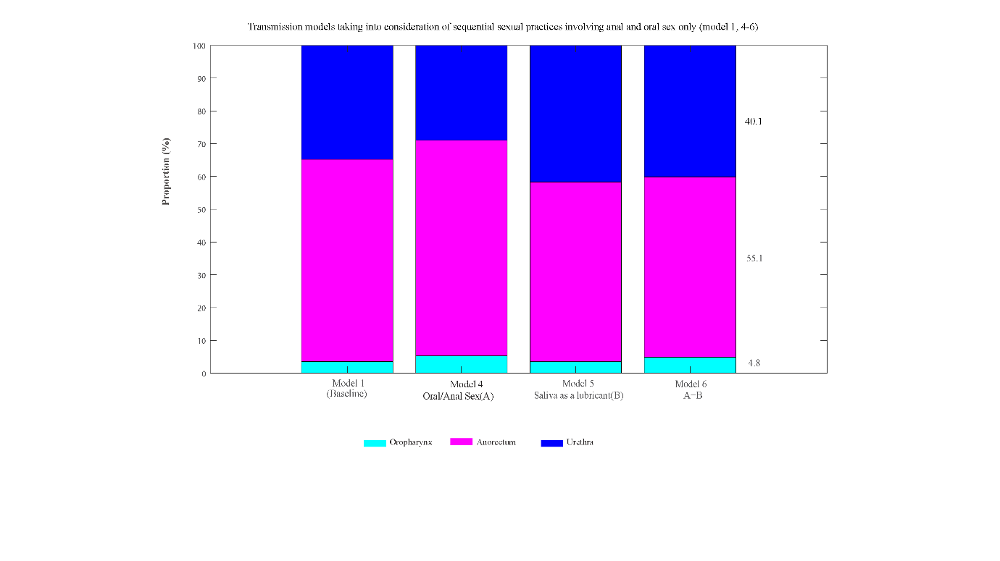
Figure S8b. Estimated proportion of incident Chlamydia trachomatis cases that occur at the oropharynx, anorectum or urethra in MSM from the four models (model 1, 4-6) among 4888 MSM attending Melbourne Sexual Health Centre in 2018 and 2019

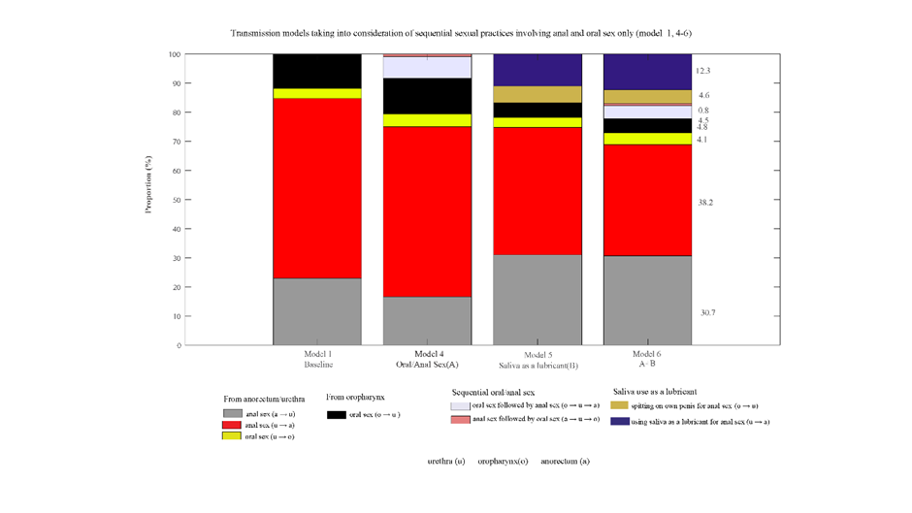
Figure S8c. Estimated proportion of incident Chlamydia trachomatis cases caused by sexual practices in MSM from the four models (model 1, 4-6) among 4888 MSM attending Melbourne Sexual Health Centre in 2018 and 2019

Validation of Results (Dataset 1): Published validation data from 1,011 asymptomatic MSM attending Melbourne Sexual Health Centre
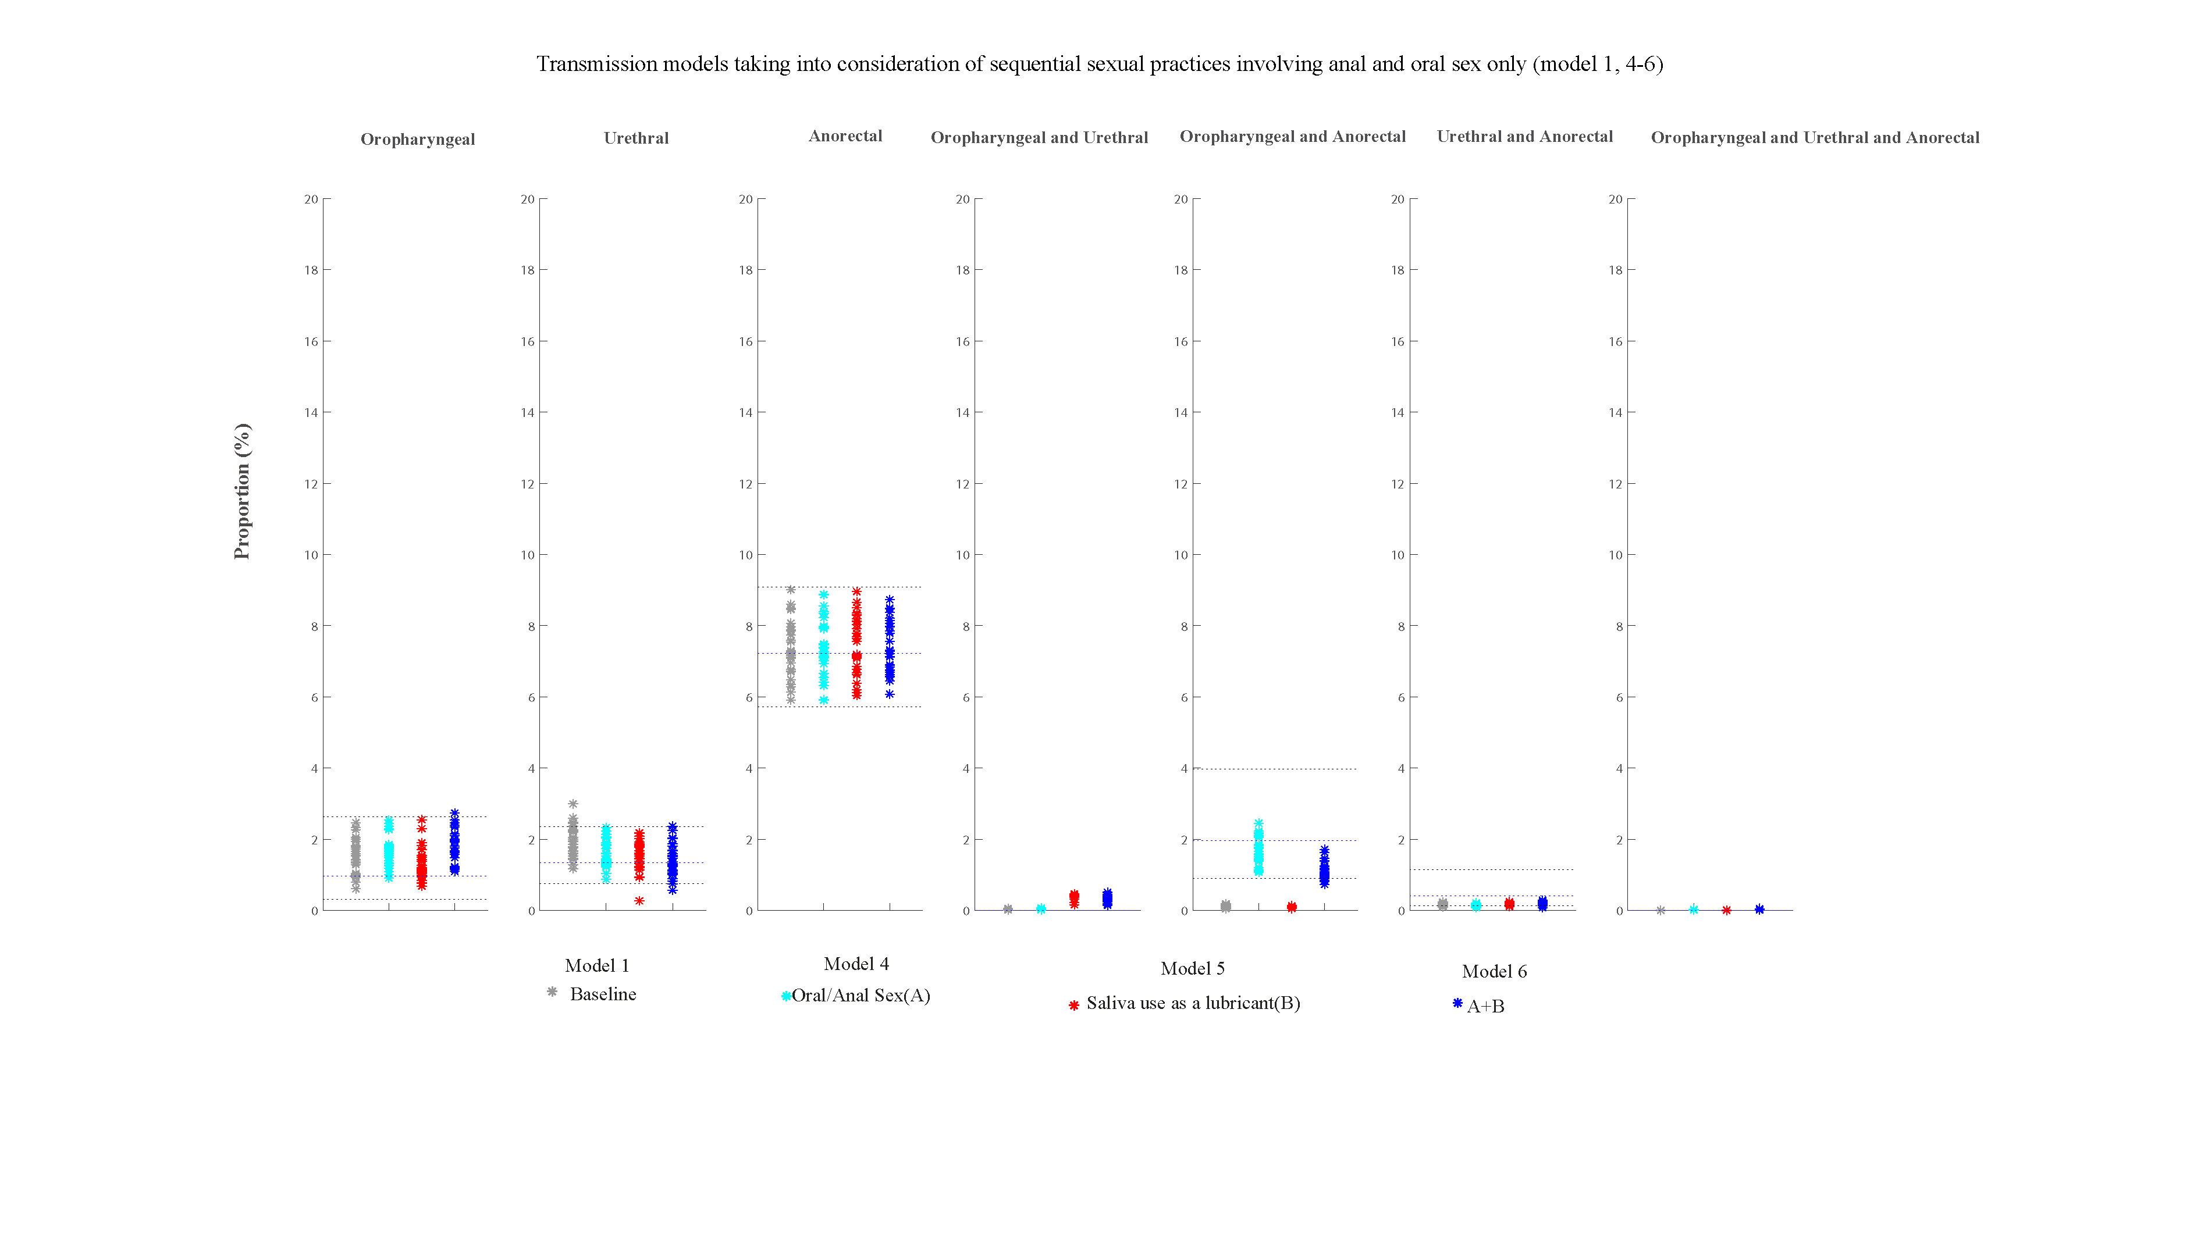
Figure S9a. Estimates of the eight models for the percentage of specific anatomical sites positive for Chlamydia trachomatis for the four models (model 1, 4-6) and the 95% confidence intervals for the observed site-specific positivity among 1,011 asymptomatic MSM attending MSHC during 2016–2017

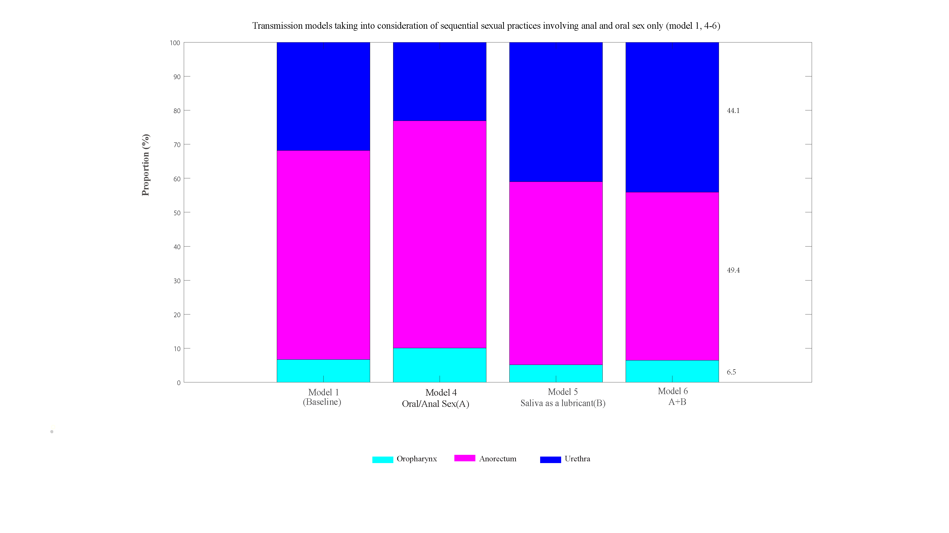
Figure S9b. Estimated proportion of incident Chlamydia trachomatis cases that occur at the oropharynx, anorectum or urethra in MSM from the four models (model 1, 4-6) among 1,011 asymptomatic MSM attending MSHC during 2016–2017
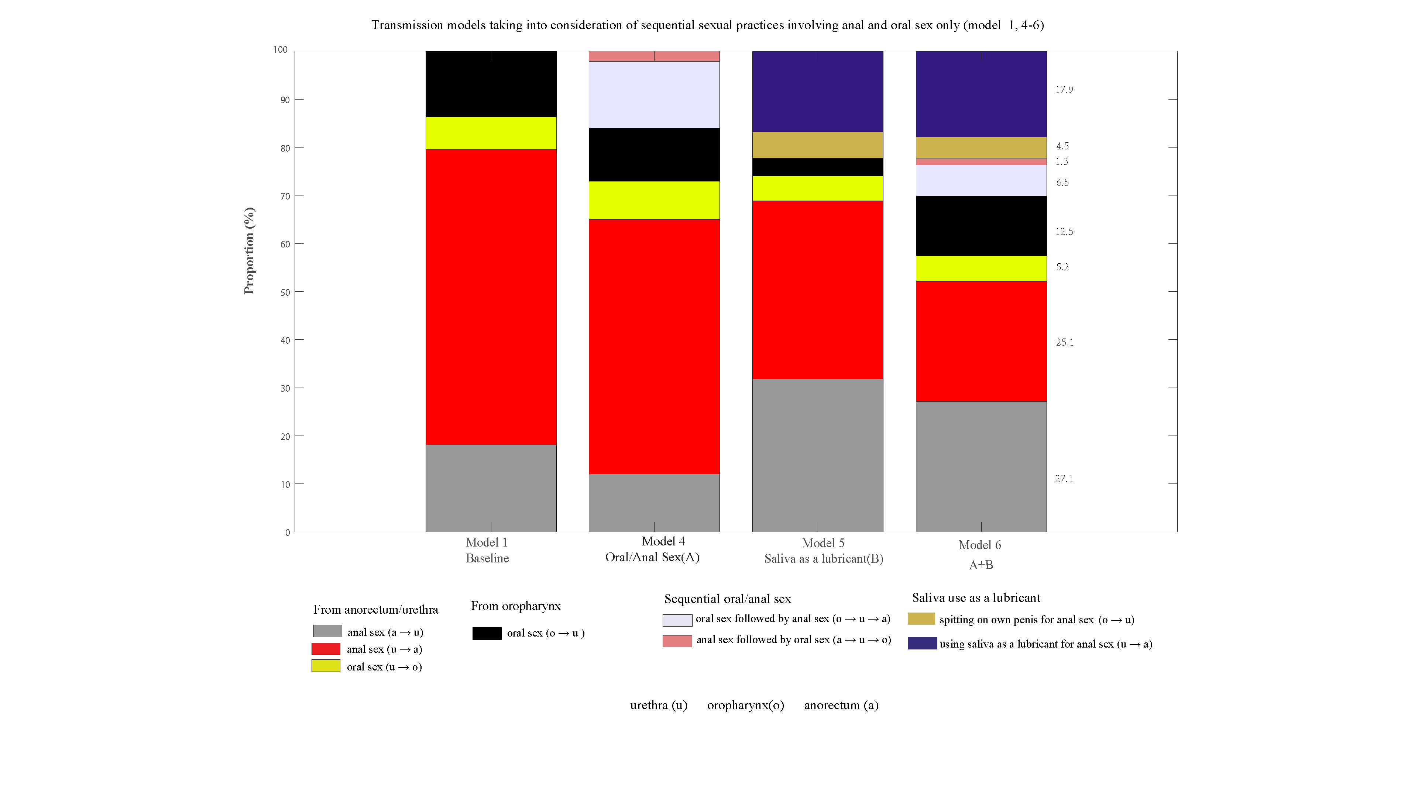
Figure S9c. Estimated proportion of incident Chlamydia trachomatis cases caused by sexual practices in MSM from the four models (model 1, 4-6) among 1,011 asymptomatic MSM attending MSHC during 2016–2017

Validation of Results (Dataset 2): Published validation data from 393MSM attending STD & HIV care clinics in the USA
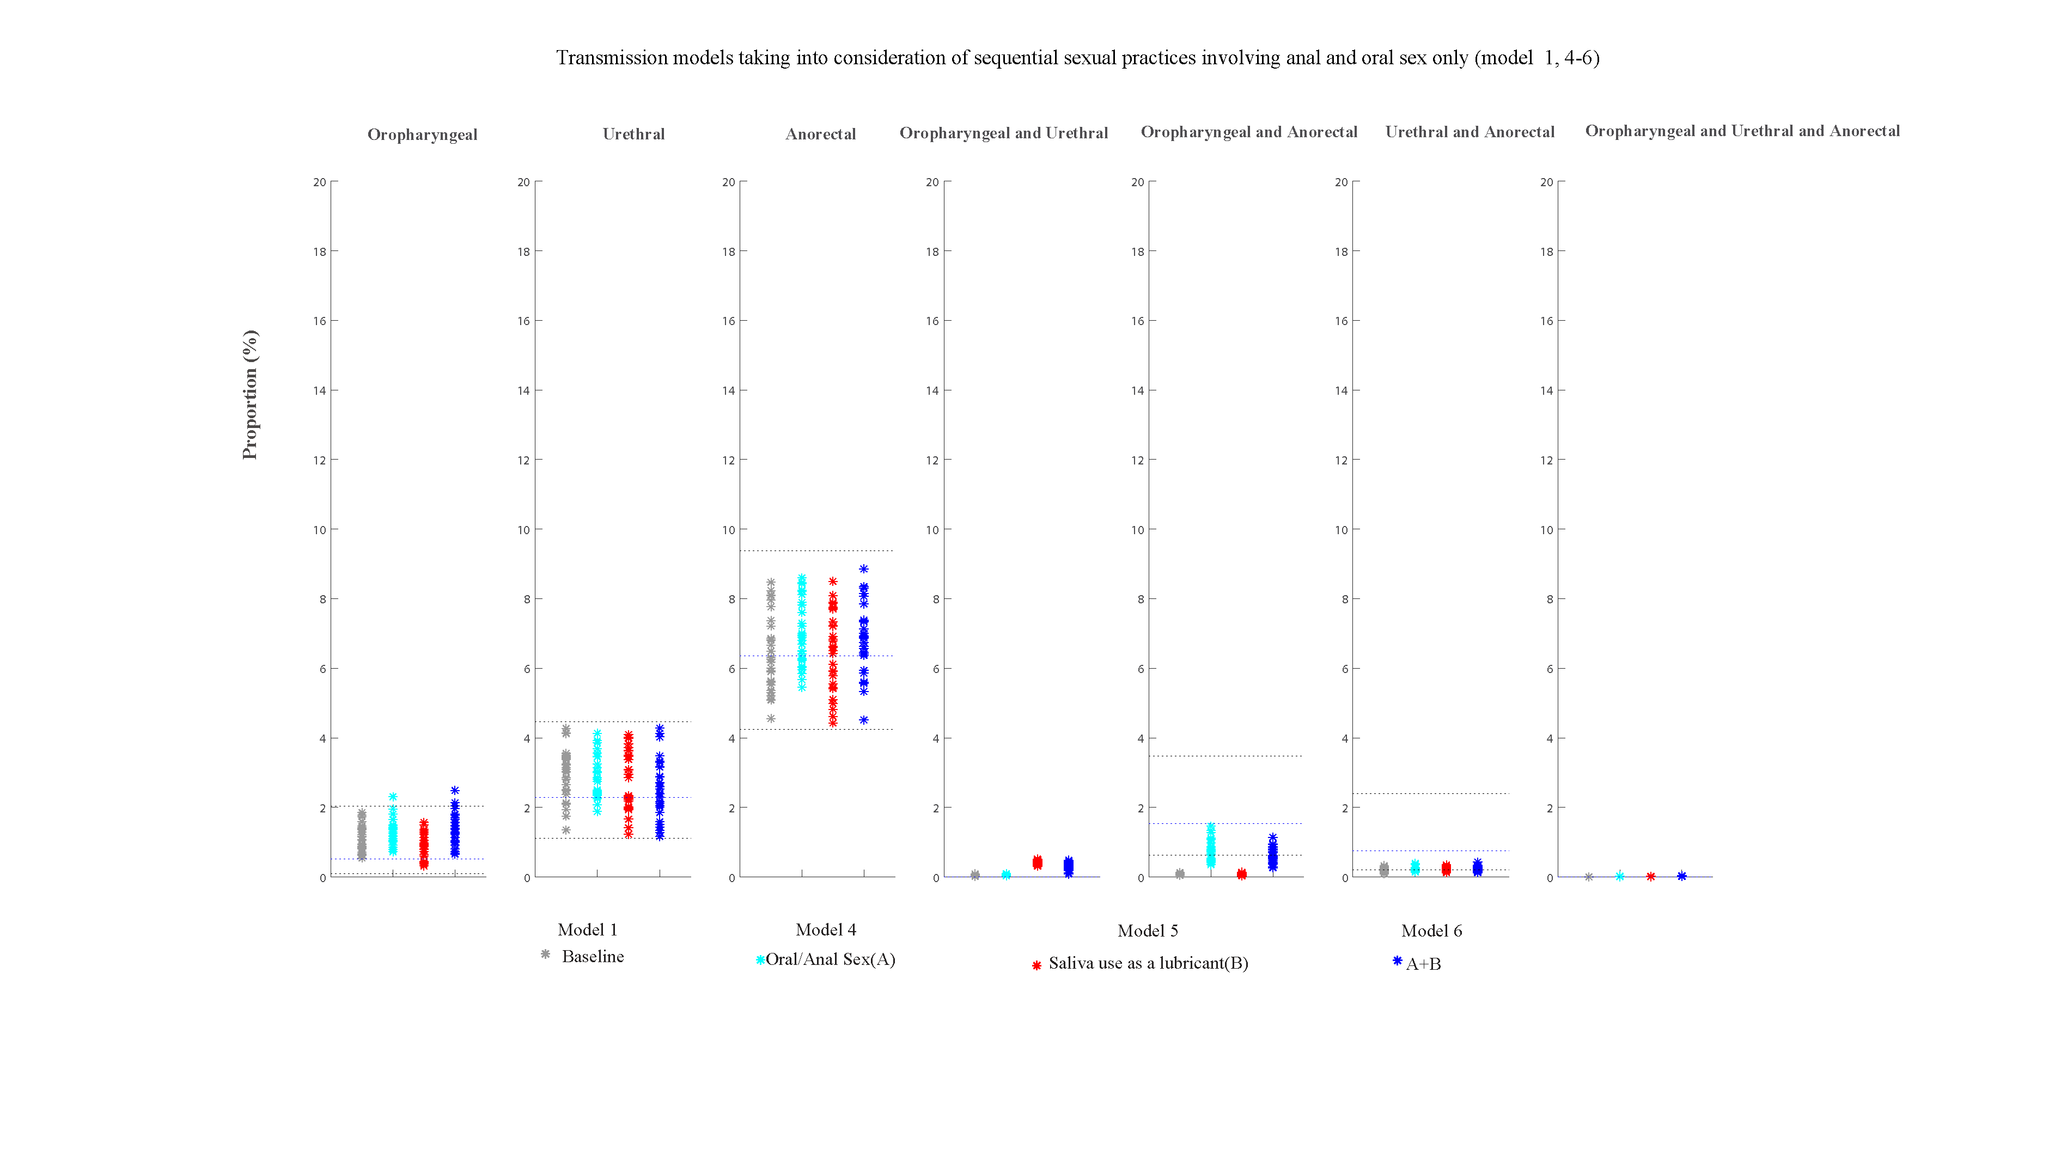
Figure S10a. Estimates of the eight models for the percentage of specific anatomical sites positive for Chlamydia trachomatis for the four models (model 1, 4-6) and the 95% confidence intervals for the observed site-specific positivity among 393MSM attending STD & HIV care clinics in the USA
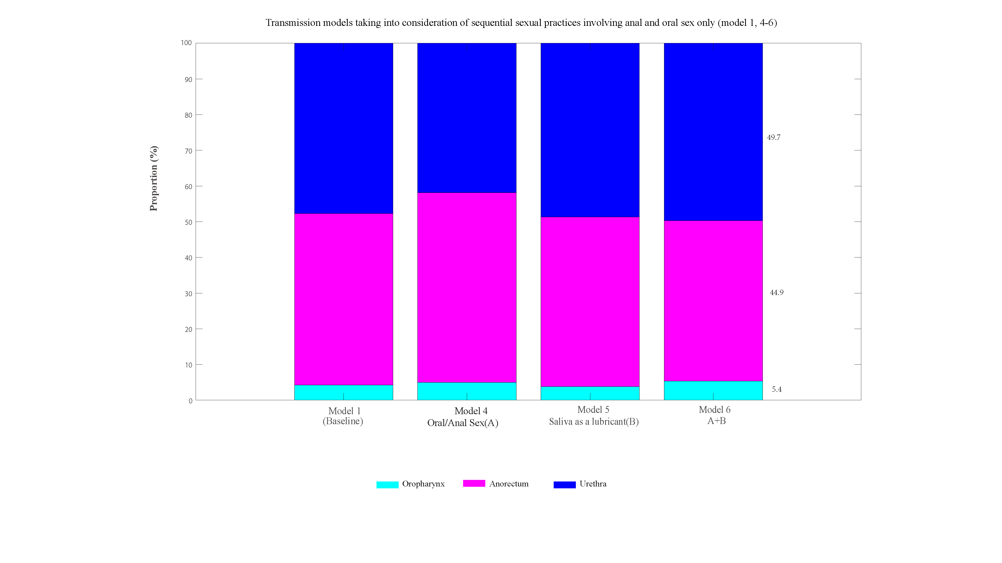
Figure S10b. Estimated proportion of incident Chlamydia trachomatis cases that occur at the oropharynx, anorectum or urethra in MSM from the four models (model 1, 4-6) among 393MSM attending STD & HIV care clinics in the USA
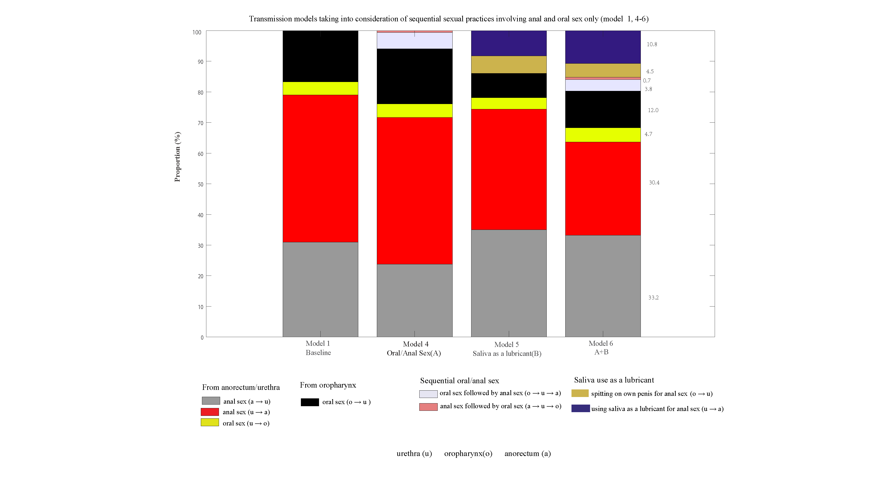
Figure S10c. Estimated proportion of incident Chlamydia trachomatis cases caused by sexual practices in MSM from the four models (model 1, 4-6) among 393MSM attending STD & HIV care clinics in the USA

Validation of Results (Dataset 3): Published validation data from MSM surveillance data of all Dutch STI clinics
Figure S11a. Estimates of the eight models for the percentage of specific anatomical sites positive for Chlamydia trachomatis for the four models (model 1, 4-6) and the 95% confidence intervals for the observed site-specific positivity among MSM surveillance data (271, 242 consultations) from all Dutch STI clinics during 2008-2017
Figure S11b. Estimated proportion of incident Chlamydia trachomatis cases that occur at the oropharynx, anorectum or urethra in MSM from the four models (model 1, 4-6) among MSM surveillance data (271, 242 consultations) from all Dutch STI clinics during 2008-2017

Figure S11c. Estimated proportion of incident Chlamydia trachomatis cases caused by sexual practices in MSM from the four models (model 1, 4-6) among MSM surveillance data (271, 242 consultations) from all Dutch STI clinics during 2008-2017
Validation of Results (Dataset 4): Published validation data from 1,610 community MSM in Thailand
Figure S12a. Estimates of the eight models for the percentage of specific anatomical sites positive for Chlamydia trachomatis for the four models (model 1, 4-6) and the 95% confidence intervals for the observed site-specific positivity among 1,610 MSM attending a community-led test and treat cohort in Thailand between October 2015 and October 2016
Figure S12b. Estimated proportion of incident Chlamydia trachomatis cases that occur at the oropharynx, anorectum or urethra in MSM from the four models (model 1, 4-6) among 1,610 MSM attending a community-led test and treat cohort in Thailand between October 2015 and October 2016
Figure S12c. Estimated proportion of incident Chlamydia trachomatis cases caused by sexual practices in MSM from the four models (model 1, 4-6) among 1,610 MSM attending a community-led test and treat cohort in Thailand between October 2015 and October 2016
Validation of Results (Dataset 5): Published validation data from 179 MSM with HIV in the USA
Figure S13a. Estimates of the eight models for the percentage of specific anatomical sites positive for Chlamydia trachomatis for the four models (model 1, 4-6) and the 95% confidence intervals for the observed site-specific positivity among179 MSM with HIV
Figure S13b. Estimated proportion of incident Chlamydia trachomatis cases that occur at the oropharynx, anorectum or urethra in MSM from the four models (model 1, 4-6) among179 MSM with HIV

Figure S13c. Estimated proportion of incident Chlamydia trachomatis cases caused by sexual practices in MSM from the four models (model 1, 4-6) among179 MSM with HIV

Supplementary results: ‘Anal sex, oral sex, rimming and sequential sexual practices’ transmission models (Model 2, 7-13)
Unpublished data from 4888 MSM attending Melbourne Sexual Health Centre for model (model 2, 7-13) calibration
Figure S14a. Estimates of the eight models for the percentage of specific anatomical sites positive for Chlamydia trachomatis for the 8 models (model 2, 7-13) and the 95% confidence intervals for the observed site-specific positivity among 4888 MSM attending Melbourne Sexual Health Centre in 2018 and 2019

Figure S14b. Estimated proportion of incident Chlamydia trachomatis cases that occur at the oropharynx, anorectum or urethra in MSM from the eight models (model 2, 7-13) among 4888 MSM attending Melbourne Sexual Health Centre in 2018 and 2019

Figure S14c. Estimated proportion of incident Chlamydia trachomatis cases caused by sexual practices in MSM from the eight models (model 2, 7-13) among 4888 MSM attending Melbourne Sexual Health Centre in 2018 and 2019

Validation of Results (Dataset 1): Published validation data from 1,011 asymptomatic MSM attending Melbourne Sexual Health Centre

Figure S15a. Estimates of the eight models for the percentage of specific anatomical sites positive for Chlamydia trachomatis for the 8 models (model 2, 7-13) and the 95% confidence intervals for the observed site-specific positivity among 1,011 asymptomatic MSM attending MSHC during 2016–2017

Figure S15b. Estimated proportion of incident Chlamydia trachomatis cases that occur at the oropharynx, anorectum or urethra in MSM from the eight models (model 2, 7-13) among 1,011 asymptomatic MSM attending MSHC during 2016–2017

Figure S15c. Estimated proportion of incident Chlamydia trachomatis cases caused by sexual practices in MSM from the eight models (model 2, 7-13) among 1,011 asymptomatic MSM attending MSHC during 2016–2017

Validation of Results (Dataset 2): Published validation data from 393MSM attending STD & HIV care clinics in the USA

Figure S16a. Estimates of the eight models for the percentage of specific anatomical sites positive for Chlamydia trachomatis for the 8 models (model 2, 7-13) and the 95% confidence intervals for the observed site-specific positivity among 393MSM attending STD & HIV care clinics in the USA

Figure S16b. Estimated proportion of incident Chlamydia trachomatis cases that occur at the oropharynx, anorectum or urethra in MSM from the eight models (model 2, 7-13) among 393MSM attending STD & HIV care clinics in the USA

Figure S16c. Estimated proportion of incident Chlamydia trachomatis cases caused by sexual practices in MSM from the eight models (model 2, 7-13) among 393MSM attending STD & HIV care clinics in the USA

Validation of Results (Dataset 3): Published validation data from MSM surveillance data of all Dutch STI clinics

Figure S17a. Estimates of the eight models for the percentage of specific anatomical sites positive for Chlamydia trachomatis for the 8 models (model 2, 7-13) and the 95% confidence intervals for the observed site-specific positivity among MSM surveillance data (271, 242 consultations) from all Dutch STI clinics during 2008-2017

Figure S17b. Estimated proportion of incident Chlamydia trachomatis cases that occur at the oropharynx, anorectum or urethra in MSM from the eight models (model 2, 7-13) among MSM surveillance data (271, 242 consultations) from all Dutch STI clinics during 2008-2017

Figure S17c. Estimated proportion of incident Chlamydia trachomatis cases caused by sexual practices in MSM from the eight models (model 2, 7-13) among MSM surveillance data (271, 242 consultations) from all Dutch STI clinics during 2008-2017

Validation of Results (Dataset 4): Published validation data from 1,610 community MSM in Thailand
Figure S18a. Estimates of the eight models for the percentage of specific anatomical sites positive for Chlamydia trachomatis for the 8 models (model 2, 7-13) and the 95% confidence intervals for the observed site-specific positivity among 1,610 MSM attending a community-led test and treat cohort in Thailand between October 2015 and October 2016

Figure S18b. Estimated proportion of incident Chlamydia trachomatis cases that occur at the oropharynx, anorectum or urethra in MSM from the eight models (model 2, 7-13) among 1,610 MSM attending a community-led test and treat cohort in Thailand between October 2015 and October 2016

Figure S18c. Estimated proportion of incident Chlamydia trachomatis cases caused by sexual practices in MSM from the eight models (model 2, 7-13) among 1,610 MSM attending a community-led test and treat cohort in Thailand between October 2015 and October 2016

Validation of Results (Dataset 5): Published validation data from 179 MSM with HIV in the USA
Figure S19a. Estimates of the eight models for the percentage of specific anatomical sites positive for Chlamydia trachomatis for the 8 models (model 2, 7-13) and the 95% confidence intervals for the observed site-specific positivity among179 MSM with HIV

Figure S19b. Estimated proportion of incident Chlamydia trachomatis cases that occur at the oropharynx, anorectum or urethra in MSM from the eight models (model 2, 7-13) among179 MSM with HIV

Figure S19c. Estimated proportion of incident Chlamydia trachomatis cases caused by sexual practices in MSM from the eight models (model 2, 7-13) among179 MSM with HIV

Supplementary results: ‘Anal sex, oral sex, rimming, kissing and sequential sexual practices’ transmission models (Model 3,14-20)

Unpublished data from 4888 MSM attending Melbourne Sexual Health Centre for model (model 3,14-20) calibration

Figure S20a. Estimates of the eight models for the percentage of specific anatomical sites positive for Chlamydia trachomatis for the 8 models (model 3, 14-20) and the 95% confidence intervals for the observed site-specific positivity among 4888 MSM attending Melbourne Sexual Health Centre in 2018 and 2019

Figure S20b. Estimated proportion of incident Chlamydia trachomatis cases that occur at the oropharynx, anorectum or urethra in MSM from the 8 models (model 3, 14-20) among 4888 MSM attending Melbourne Sexual Health Centre in 2018 and 2019

Figure S20c. Estimated proportion of incident Chlamydia trachomatis cases caused by sexual practices in MSM from the 8 models (model 3,14-20) among 4888 MSM attending Melbourne Sexual Health Centre in 2018 and 2019

Validation of Results (Dataset 1): Published validation data from 1,011 asymptomatic MSM attending Melbourne Sexual Health Centre
Figure S21a. Estimates of the eight models for the percentage of specific anatomical sites positive for Chlamydia trachomatis for the 8 models (model 3, 14-20) and the 95% confidence intervals for the observed site-specific positivity among 1,011 asymptomatic MSM attending MSHC during 2016–2017

Figure S21b. Estimated proportion of incident Chlamydia trachomatis cases that occur at the oropharynx, anorectum or urethra in MSM from the 8 models (model 3, 14-20) among 1,011 asymptomatic MSM attending MSHC during 2016–2017
Figure S21c. Estimated proportion of incident Chlamydia trachomatis cases caused by sexual practices in MSM from the 8 models (model 3, 14-20) among 1,011 asymptomatic MSM attending MSHC during 2016–2017

Validation of Results (Dataset 2): Published validation data from 393MSM attending STD & HIV care clinics in the USA
Figure S22a. Estimates of the eight models for the percentage of specific anatomical sites positive for Chlamydia trachomatis for the 8 models (model 3,14-20) and the 95% confidence intervals for the observed site-specific positivity among 393MSM attending STD & HIV care clinics in the USA

Figure S22b. Estimated proportion of incident Chlamydia trachomatis cases that occur at the oropharynx, anorectum or urethra in MSM from the 8 models (model 3,14-20) among 393MSM attending STD & HIV care clinics in the USA

Figure S22c. Estimated proportion of incident Chlamydia trachomatis cases caused by sexual practices in MSM from the 8 models (model 3,14-20) among 393MSM attending STD & HIV care clinics in the USA
Validation of Results (Dataset 3): Published validation data from MSM surveillance data of all Dutch STI clinics
Figure S23a. Estimates of the eight models for the percentage of specific anatomical sites positive for Chlamydia trachomatis for the 8 models (model 3,14-20) and the 95% confidence intervals for the observed site-specific positivity among MSM surveillance data (271, 242 consultations) from all Dutch STI clinics during 2008-2017

Figure S23b. Estimated proportion of incident Chlamydia trachomatis cases that occur at the oropharynx, anorectum or urethra in MSM from the 8 models (model 3, 14-20) among MSM surveillance data (271, 242 consultations) from all Dutch STI clinics during 2008-2017

Figure S23c. Estimated proportion of incident Chlamydia trachomatis cases caused by sexual practices in MSM from the 8 models (model 3, 14-20) among MSM surveillance data (271, 242 consultations) from all Dutch STI clinics during 2008-2017
Validation of Results (Dataset 4): Published validation data from 1,610 community MSM in Thailand
Figure S24a. Estimates of the eight models for the percentage of specific anatomical sites positive for Chlamydia trachomatis for the 8 models (model 3, 14-20) and the 95% confidence intervals for the observed site-specific positivity among 1,610 MSM attending a community-led test and treat cohort in Thailand between October 2015 and October 2016

Figure S24b. Estimated proportion of incident Chlamydia trachomatis cases that occur at the oropharynx, anorectum or urethra in MSM from the 8 models (model 3, 14-20) among 1,610 MSM attending a community-led test and treat cohort in Thailand between October 2015 and October 2016
Figure S24c. Estimated proportion of incident Chlamydia trachomatis cases caused by sexual practices in MSM from the 8 models (model 3, 14-20) among 1,610 MSM attending a community-led test and treat cohort in Thailand between October 2015 and October 2016

Validation of Results (Dataset 5): Published validation data from 179 MSM with HIV in the USA
Figure S25a. Estimates of the eight models for the percentage of specific anatomical sites positive for Chlamydia trachomatis for the 8 models (model 3,14-20) and the 95% confidence intervals for the observed site-specific positivity among179 MSM with HIV
Figure S25b. Estimated proportion of incident Chlamydia trachomatis cases that occur at the oropharynx, anorectum or urethra in MSM from the 8 models (model 3, 14-20) among179 MSM with HIV

Figure S25c. Estimated proportion of incident Chlamydia trachomatis cases caused by sexual practices in MSM from the 8 models (model 3, 14-20) among179 MSM with HIV

Supplementary results: Sensitivity analysis
Sensitivity analysis: half-length of asymptomatic urethral and anal duration

Figure S26a. Estimates of the eight models for the percentage of specific anatomical sites positive for Chlamydia trachomatis for the eight models (model 2, 7-13) and the 95% confidence intervals for the observed site-specific positivity among 4888 MSM attending Melbourne Sexual Health Centre in 2018 and 2019: half-length of asymptomatic urethral and anal duration

Figure S26b. Estimated proportion of incident Chlamydia trachomatis cases that occur at the oropharynx, anorectum or urethra in MSM from the eight models (model 2, 7-13) among 4888 MSM attending Melbourne Sexual Health Centre in 2018 and 2019: half-length of asymptomatic urethral and anal duration

Figure S26c. Estimated proportion of incident Chlamydia trachomatis cases caused by sexual practices in MSM from the eight models (model 2, 7-13) among 4888 MSM attending Melbourne Sexual Health Centre in 2018 and 2019: half-length of asymptomatic urethral and anal duration
Sensitivity analysis: double days of sexual practices
Figure S27a. Estimates of the eight models for the percentage of specific anatomical sites positive for Chlamydia trachomatis for the eight models (model 2, 7-13) and the 95% confidence intervals for the observed site-specific positivity among 4888 MSM attending Melbourne Sexual Health Centre in 2018 and 2019: double days of sexual practices
Figure S27b. Estimated proportion of incident Chlamydia trachomatis cases that occur at the oropharynx, anorectum or urethra in MSM from the eight models (model 2, 7-13) among 4888 MSM attending Melbourne Sexual Health Centre in 2018 and 2019：double days of sexual practices

Figure S27c. Estimated proportion of incident Chlamydia trachomatis cases caused by sexual practices in MSM from the eight models (model 2, 7-13) among 4888 MSM attending Melbourne Sexual Health Centre in 2018 and 2019：double days of sexual practices

Sensitivity analysis: half days of sexual practices
Figure S28a. Estimates of the eight models for the percentage of specific anatomical sites positive for Chlamydia trachomatis for the eight models (model 2, 7-13) and the 95% confidence intervals for the observed site-specific positivity among 4888 MSM attending Melbourne Sexual Health Centre in 2018 and 2019: half days of sexual practices

Figure S28b. Estimated proportion of incident Chlamydia trachomatis cases that occur at the oropharynx, anorectum or urethra in MSM from the eight models (model 2, 7-13) among 4888 MSM attending Melbourne Sexual Health Centre in 2018 and 2019：half days of sexual practices

Figure S28c. Estimated proportion of incident Chlamydia trachomatis cases caused by sexual practices in MSM from the eight models (model 2, 7-13) among 4888 MSM attending Melbourne Sexual Health Centre in 2018 and 2019：half days of sexual practices
Sensitivity analysis: The proportion of sequential sexual practices = 0%
Figure S29a. Estimates of the eight models for the percentage of specific anatomical sites positive for Chlamydia trachomatis for the eight models (model 2, 7-13) and the 95% confidence intervals for the observed site-specific positivity among 4888 MSM attending Melbourne Sexual Health Centre in 2018 and 2019: the proportion of sequential sexual practices = 0%

Figure S29b. Estimated proportion of incident Chlamydia trachomatis cases that occur at the oropharynx, anorectum or urethra in MSM from the eight models (model 2, 7-13) among 4888 MSM attending Melbourne Sexual Health Centre in 2018 and 2019：the proportion of sequential sexual practices = 0%

Figure S29c. Estimated proportion of incident Chlamydia trachomatis cases caused by sexual practices in MSM from the eight models (model 2, 7-13) among 4888 MSM attending Melbourne Sexual Health Centre in 2018 and 2019：the proportion of sequential sexual practices = 0%
Sensitivity analysis: The proportion of sequential sexual practices = 95%
Figure S30a. Estimates of the eight models for the percentage of specific anatomical sites positive for Chlamydia trachomatis for the eight models (model 2, 7-13) and the 95% confidence intervals for the observed site-specific positivity among 4888 MSM attending Melbourne Sexual Health Centre in 2018 and 2019: the proportion of sequential sexual practices = 95%

Figure S30b. Estimated proportion of incident Chlamydia trachomatis cases that occur at the oropharynx, anorectum or urethra in MSM from the eight models (model 2, 7-13) among 4888 MSM attending Melbourne Sexual Health Centre in 2018 and 2019: the proportion of sequential sexual practices = 95%
Figure S30c. Estimated proportion of incident Chlamydia trachomatis cases caused by sexual practices in MSM from the eight models (model 2, 7-13) among 4888 MSM attending Melbourne Sexual Health Centre in 2018 and 2019：the proportion of sequential sexual practices = 95%

Sensitivity analysis: The proportion of sequential sexual practices = 98%
Figure S31a. Estimates of the eight models for the percentage of specific anatomical sites positive for Chlamydia trachomatis for the eight models (model 2, 7-13) and the 95% confidence intervals for the observed site-specific positivity among 4888 MSM attending Melbourne Sexual Health Centre in 2018 and 2019: the proportion of sequential sexual practices = 98%

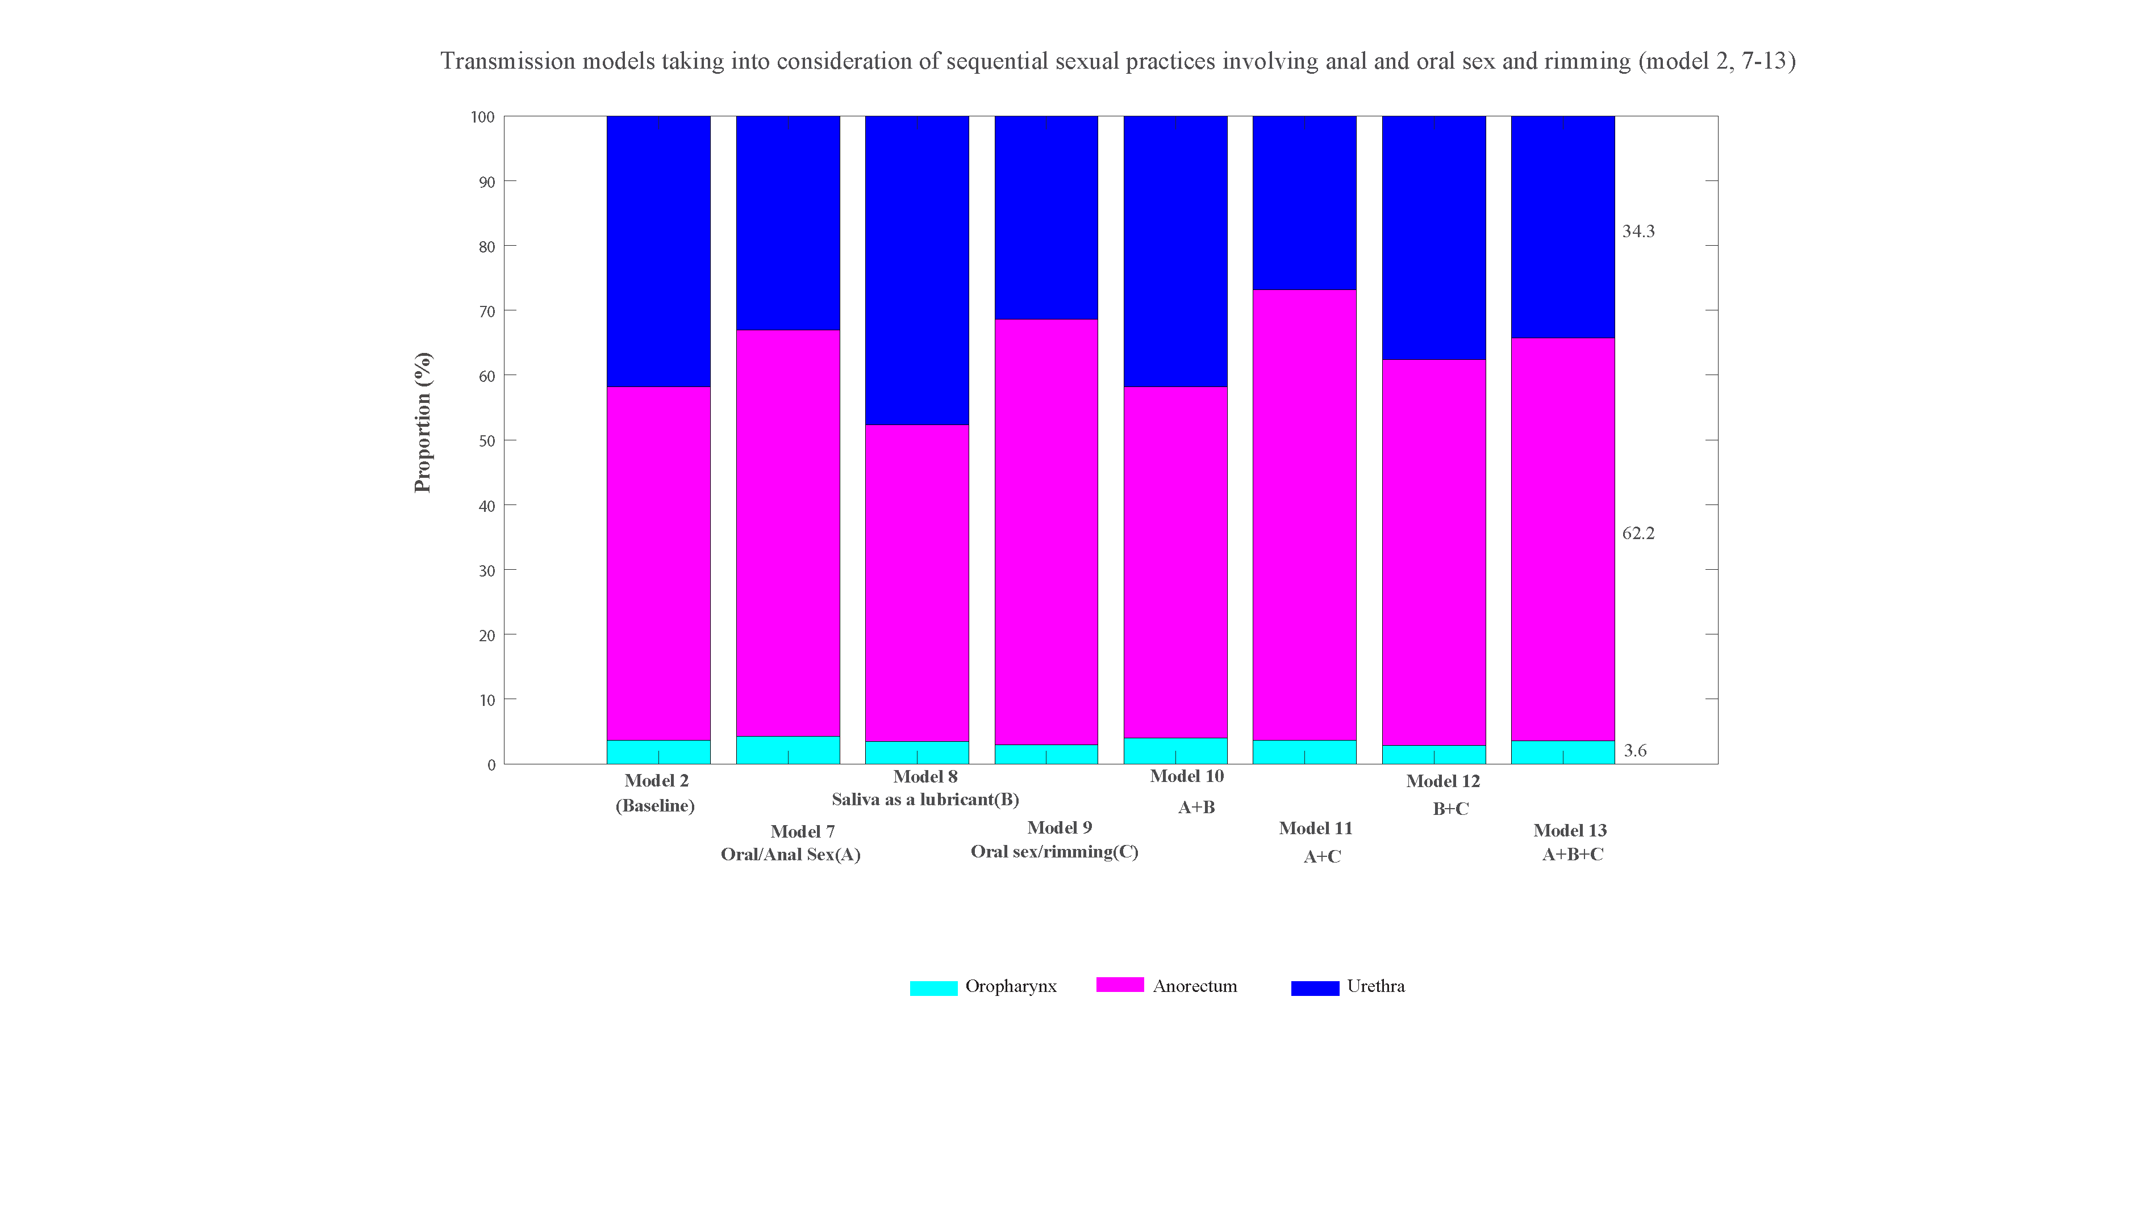
Figure S31b. Estimated proportion of incident Chlamydia trachomatis cases that occur at the oropharynx, anorectum or urethra in MSM from the eight models (model 2, 7-13) among 4888 MSM attending Melbourne Sexual Health Centre in 2018 and 2019: the proportion of sequential sexual practices = 98%

Figure S31c. Estimated proportion of incident Chlamydia trachomatis cases caused by sexual practices in MSM from the eight models (model 2, 7-13) among 4888 MSM attending Melbourne Sexual Health Centre in 2018 and 2019：the proportion of sequential sexual practices = 98%
Sensitivity analysis: The proportion of sequential sexual practices = 100%
Figure S32a. Estimates of the eight models for the percentage of specific anatomical sites positive for Chlamydia trachomatis for the eight models (model 2, 7-13) and the 95% confidence intervals for the observed site-specific positivity among 4888 MSM attending Melbourne Sexual Health Centre in 2018 and 2019: the proportion of sequential sexual practices = 100%

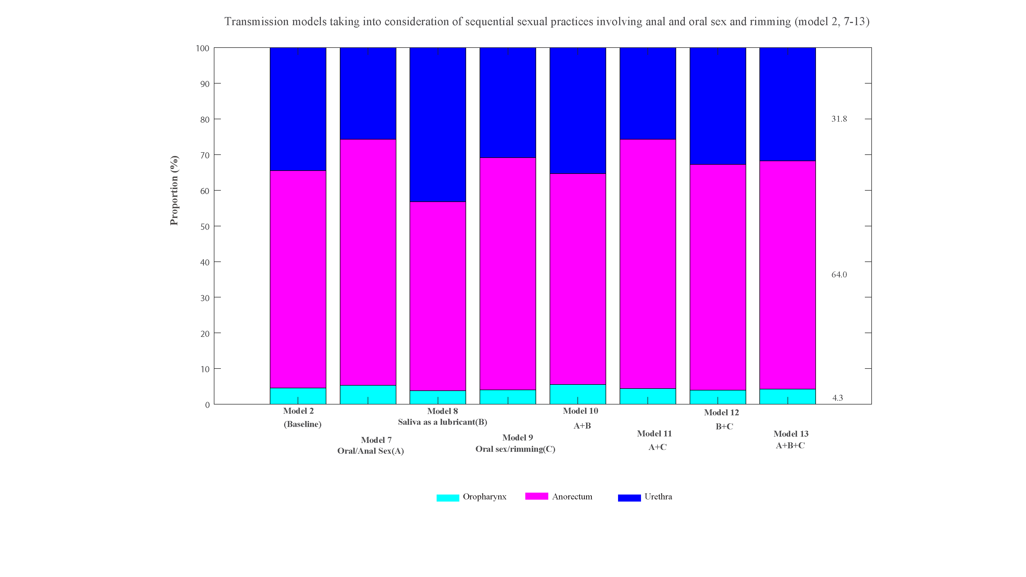
Figure S32b. Estimated proportion of incident Chlamydia trachomatis cases that occur at the oropharynx, anorectum or urethra in MSM from the eight models (model 2, 7-13) among 4888 MSM attending Melbourne Sexual Health Centre in 2018 and 2019：the proportion of sequential sexual practices = 100%

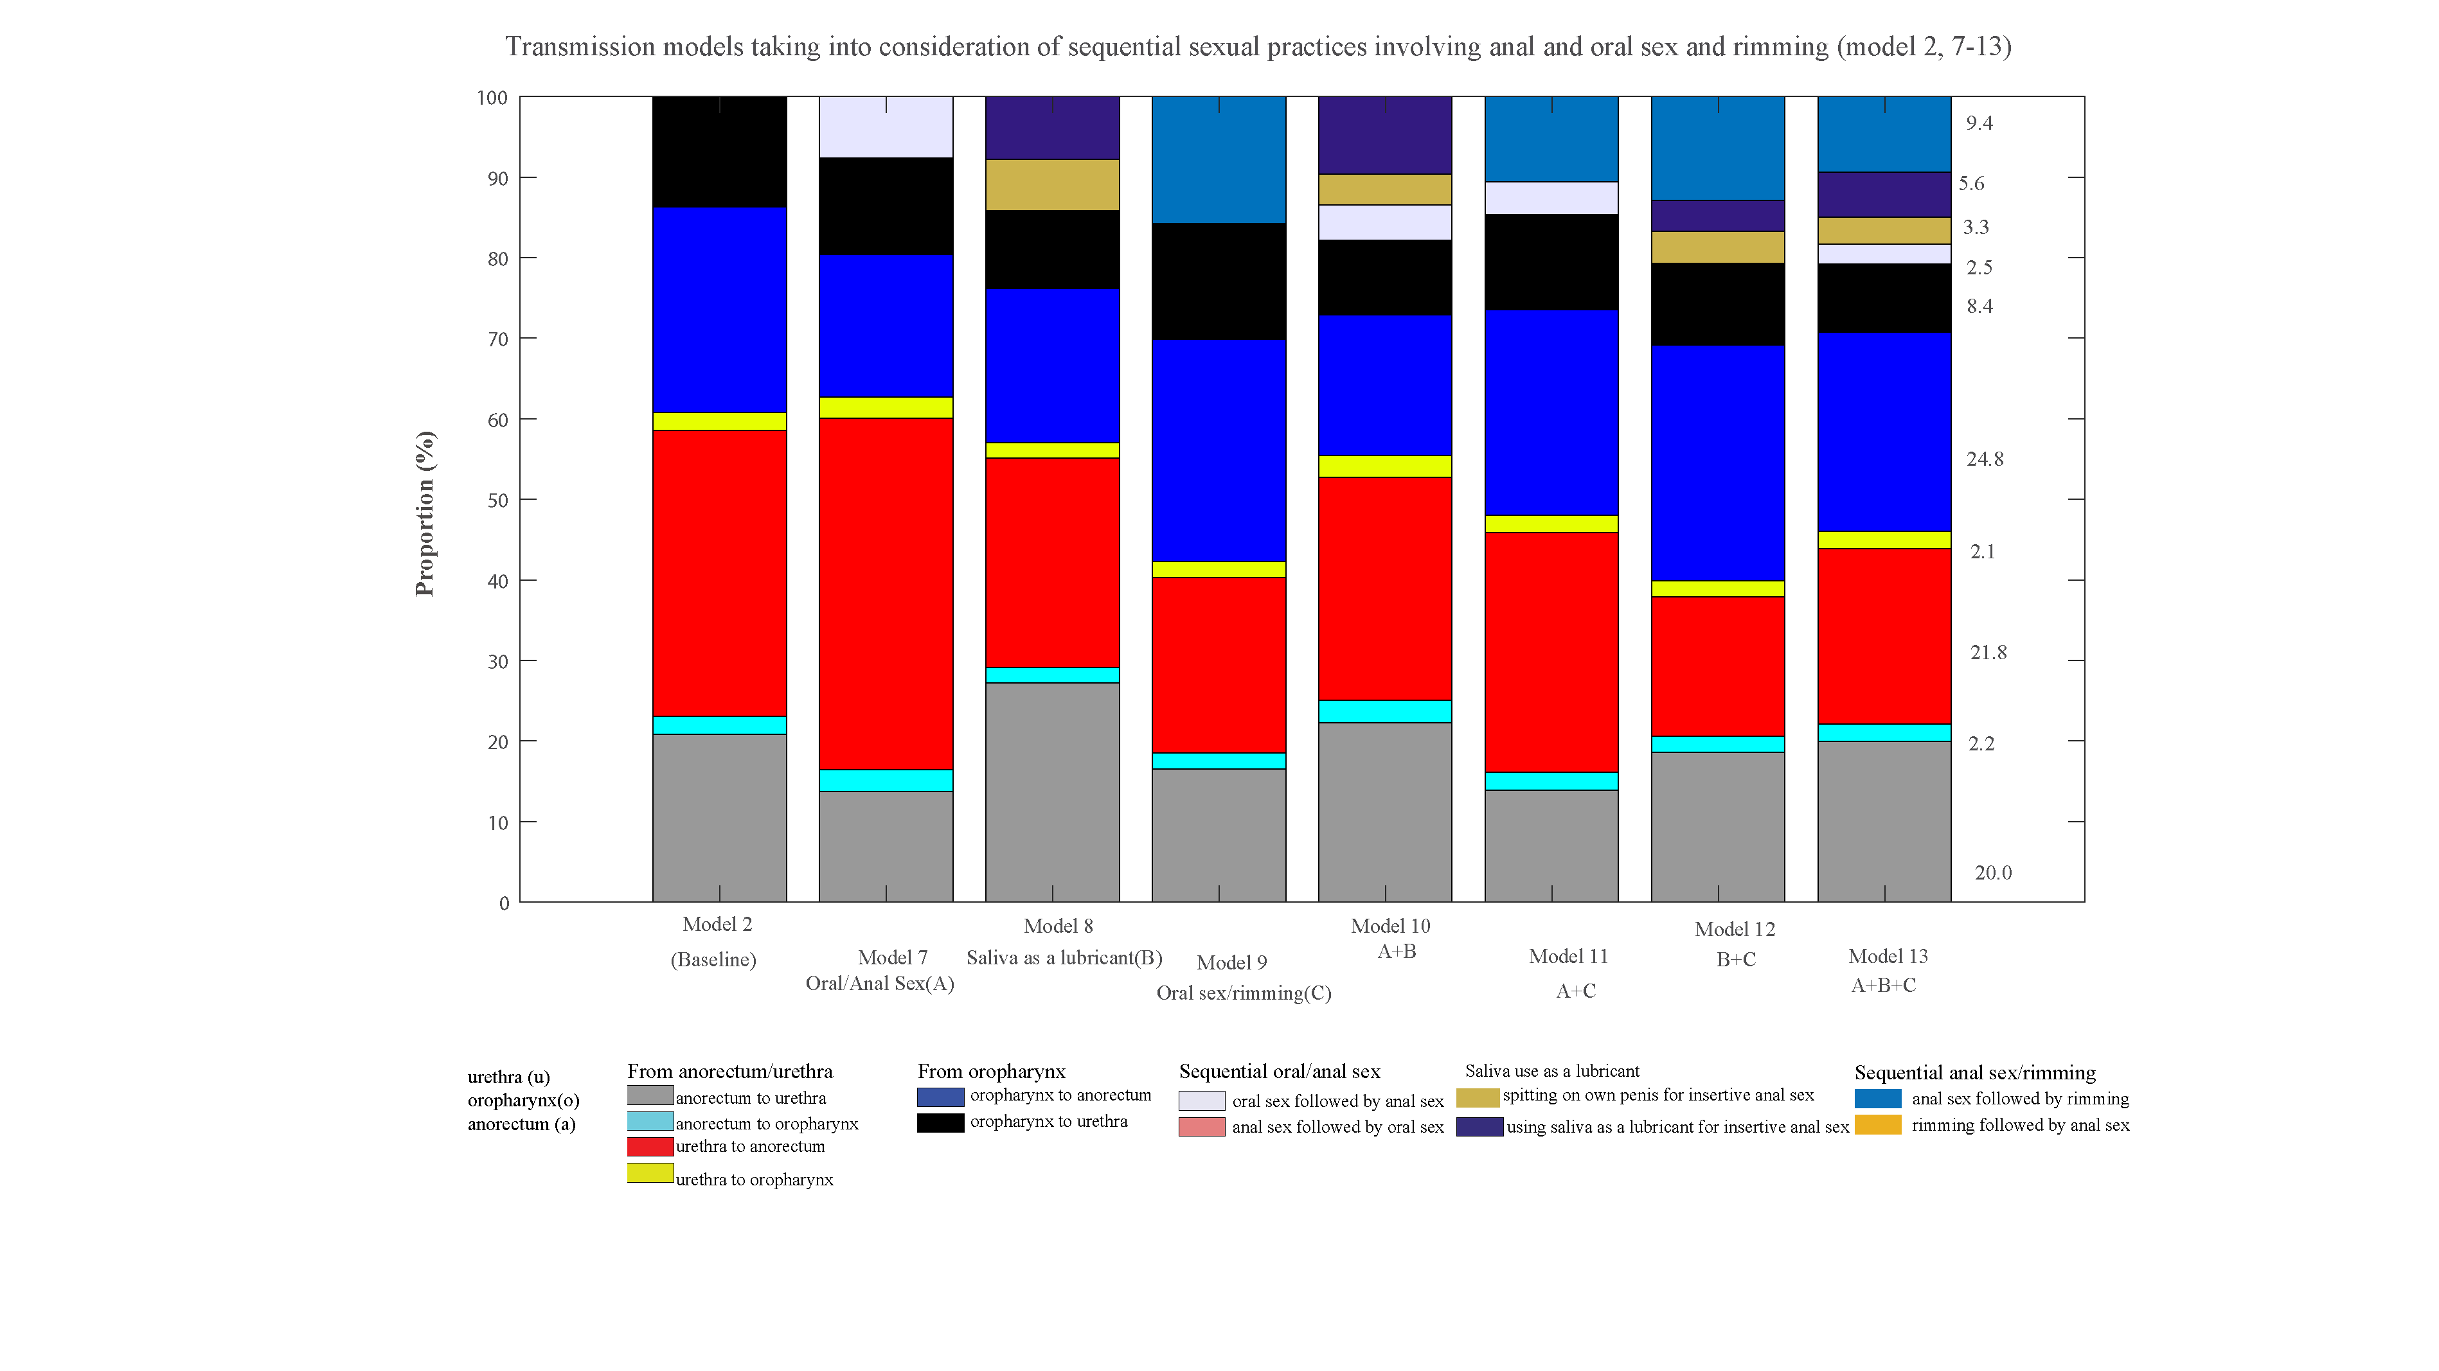
Figure S32c. Estimated proportion of incident Chlamydia trachomatis cases caused by sexual practices in MSM from the eight models (model 2, 7-13) among 4888 MSM attending Melbourne Sexual Health Centre in 2018 and 2019：the proportion of sequential sexual practices = 100%

