Supplementary information
Machine learning approaches classify clinical malaria outcomes based on haematological parameters
Morang’a et al.

Table of Contents
Supplementary tables 2
Table S1. The list of haematological parameters adopted from laboratory procedure manual by the CDC [52]. 2
Table S4. The odds ratio of median categories providing the odd of being diagnosed with either nMI, UM, and SM. The median categories were; low and high levels. 4
Table S5. Performance evaluation of six machine learning models to classify clinical malaria outcomes 5
Supplementary figures 7
Fig. S1. Word cloud of clinical manifestations using clinicians/doctors notes or suspected infections. 7
Fig. S2. Artificial Neural Network Schematic. 8
Fig. S3. Plot for the training and validation history of the ANN. 9
Fig. S4. Case by case analysis of the classification capability of the ML models. 10
Fig. S5. Density estimates of the haematological parameters between nMI and UM cases for sub-sampled data from Kintampo only. 11
Fig. S6. Density estimates of the haematological parameters between nMI, and UM cases for sub-sampled data from Kintampo only, as well limit of children under 4 years of age. 12

Supplementary tables

Table S1. The list of haematological parameters adopted from laboratory procedure manual by the CDC [52].

Cell | Parameter | Measured | Pulse Size | Reported Units
WBC | White Blood Cell Count  This is the number of leukocytes measured directly, multiplied by the calibration constant, and expressed as n x 10³ cells/µL | WBC bath | ≥35 fL | n x 10³ cells/µL
RBC | Red Blood Cell Count  This is the number of erythrocytes measured directly, multiplied by the calibration constant, and expressed as n x 106 cells/µL | RBC bath | 36 to 360 fL | n x 106 cells/µL
Hb | Hemoglobin Concentration  Weight (mass) of hemoglobin determined from the degree of absorbance found through photocurrent transmittance is: Hb (g/dL) = Constant x log10(Reference % T / Sample % T) | WBC bath | 525 nm | g/dL
Hct | Hematocrit  This is the relative volume of packed erythrocytes to whole blood, computed as: Hct (%) = RBC × MCV/10 | Computed | RBC x MCV/10 | % Percent
MCV | Mean Cell Volume  This is the average volume of individual erythrocytes derived from the RBC histogram. | Derived from RBC histogram | # x size of RBC/ Total RBC | fL
MCH | Mean Cell Hemoglobin  This is the weight of hemoglobin in the average erythrocyte count, computed as: Hb / RBC x 10 | Computed | Hb/RBC x 10 | pg
MCHC | Mean Cell Hemoglobin Concentration  This is the average weight of hemoglobin in a measured dilution, computed as: Hb / Hct x 100 | Computed | Hb/Hct x 100 | g/dL
RDW | Red Cell Distribution Width  RDW represents the size distribution spread of the erythrocyte population derived from the RBC histogram. It is the coefficient of variation (CV), expressed in percent, of the RBC size distribution. | Derived from RBC histogram | CV expressed in % of the RBC size distribution | % Percent
Plt | Platelet Count  This is the number of thrombocytes derived from the Plt histogram and multiplied by a calibration constant. This number is expressed as: n x 103 cells/µL | RBC bath | 2 to 20 fL | n x 103 cells/µL
MPV | Mean Platelet Volume  MPV is the average volume of individual platelets derived from the Plt histogram. It represents the mean volume of the Plt population under the fitted Plt curve multiplied by a calibration constant, and expressed in femtoliters. | Derived from Plt histogram | Mean volume of Plt population under the fitted curve x constant | fL
NE% | Neutrophil Percent  The percentages of leukocytes from each category are derived from the scatterplot. | Derived from scatterplot | # cells inside NE area/# cells inside total cell area x 100 | % Percent
NE # | Neutrophil Number  The absolute numbers of leukocytes in each category are computed from the WBC count and the differential percentage parameters. | Absolute number | NE%/100 x WBC Count | 103 cells/µL
LY% | Lymphocyte Percent  The percentages of leukocytes from each category are derived from the scatterplot. | Derived from scatterplot | # cells inside LY area/# cells inside total cell area x 100 | % Percent
LY# | Lymphocyte Number  The absolute numbers of leukocytes in each category are computed from the WBC count and the differential percentage parameters. | Absolute number | Ly%/100 x WBC Count | 103 cells/µL
MO% | Monocyte Percent  The percentages of leukocytes from each category are derived from the scatterplot. | Derived from scatterplot | # cells inside MO area/# cells inside total cell area x 100 | % Percent
MO# | Monocyte Number  The absolute numbers of leukocytes in each category are computed from the WBC count and the differential percentage parameters. | Absolute number | MO%/100 x WBC Count | 103 cells/µL
*PDW - Platelet Distribution Width and Pct - Plateletcrit are NOT for diagnostic use and do not print. Coulter uses the value for PDW is an internal check on the reported platelet parameters. The table outlines the description of the parameters, abbreviation, mode of measurement, pulse size, and the units of reporting.

Table S4. The odds ratio of median categories providing the odd of being diagnosed with either nMI, UM, and SM. The median categories were; low and high levels.

Predict clinical diagnosis of UM | Estimate | S.E | OR | 2.5% | 97.5% | Pr (>Chi)
(Intercept) | 1.73 | 0.45 | 5.62 | 2.34 | 13.49
WBC count - High Levels | -0.1 | 0.2 | 0.90 | 0.60 | 1.34 | ***
RBC count - High Levels | -0.1 | 0.17 | 0.91 | 0.65 | 1.27 | ***
Hb level - High Levels | -0.43 | 0.23 | 0.65 | 0.42 | 1.03 | ***
Hematocrit - High Levels | -0.71 | 0.22 | 0.49 | 0.32 | 0.76 | ***
Platelet count - High Levels | -2.26 | 0.14 | 0.10 | 0.08 | 0.14 | ***
Mean cell volume - High Levels | -0.21 | 0.2 | 0.81 | 0.55 | 1.20
Lymphocytes count - High Levels | -0.77 | 0.19 | 0.46 | 0.32 | 0.67 | ***
Mixed cells % - High Levels | -0.26 | 0.17 | 0.77 | 0.55 | 1.08 | ***
Neutrophils % - High Levels | 0.3 | 0.36 | 1.35 | 0.68 | 2.74 | ***
Mean cell hb conc - High Levels | 0.23 | 0.16 | 1.26 | 0.93 | 1.71 | **
Mean corp hb - High Levels | 0.58 | 0.21 | 1.79 | 1.18 | 2.73 | **
RBC Dist width % - High Levels | 0.7 | 0.16 | 2.02 | 1.48 | 2.76 | ***
Mean platelet vl - High Levels | -0.32 | 0.15 | 0.72 | 0.54 | 0.96 | **
Platelet distr width - High Levels | -0.4 | 0.14 | 0.67 | 0.50 | 0.88 | **
Lymphocytes % - High Levels | -0.29 | 0.35 | 0.74 | 0.38 | 1.49
Mixed cells count - High Levels | -0.23 | 0.19 | 0.80 | 0.55 | 1.16
Neutrophils count - High Levels | 0.34 | 0.2 | 1.40 | 0.94 | 2.09 | .
Predict clinical diagnosis of SM | Estimate | S.E | OR | 2.5% | 97.5% |  | Pr (>Chi)
(Intercept) | 3.87 | 1.03 | 47.79 | 6.75 | 390.36
WBC count - High Levels | -0.46 | 0.59 | 0.63 | 0.20 | 2.00 | ***
RBC count - High Levels | -2.06 | 0.57 | 0.13 | 0.04 | 0.40 | ***
Hb level - High Levels | -2.25 | 0.69 | 0.11 | 0.03 | 0.40 | ***
Hematocrit - High Levels | -1.31 | 0.73 | 0.27 | 0.06 | 1.10 | ***
Platelet count - High Levels | -3.24 | 0.42 | 0.04 | 0.02 | 0.09 | ***
Mean cell volume - High Levels | -1.33 | 0.5 | 0.26 | 0.10 | 0.68 | ***
Lymphocytes count - High Levels | 1.57 | 0.57 | 4.83 | 1.64 | 15.33
Mixed cells % - High Levels | -0.42 | 0.45 | 0.66 | 0.27 | 1.59 | **
Neutrophils % - High Levels | 0.73 | 0.84 | 2.08 | 0.41 | 10.74 | **
Mean cell hb conc - High Levels | 3.97 | 0.54 | 52.89 | 19.25 | 161.79 | ***
Mean corp hb - High Levels | -0.69 | 0.55 | 0.50 | 0.17 | 1.46 | .
RBC Dist width % - High Levels | 1.55 | 0.43 | 4.72 | 2.07 | 11.10 | ***
Mean platelet vl - High Levels | -4.52 | 0.52 | 0.01 | 0.00 | 0.03 | ***
Platelet distr width - High Levels | 3.27 | 0.47 | 26.33 | 10.89 | 70.04 | ***
Lymphocytes % - High Levels | -0.94 | 0.77 | 0.39 | 0.08 | 1.71
Mixed cells count - High Levels | -0.17 | 0.55 | 0.84 | 0.28 | 2.49
Neutrophils count - High Levels | 0.38 | 0.54 | 1.46 | 0.51 | 4.20
OR-odds ratio, S.E – Standard Error, Pr (>Chi) –statistical estimate

Table S5. Performance evaluation of six machine learning models to classify clinical malaria outcomes

 | ANN | UM vs nMI | SM vs nMI
 | Model type | Binary model | Binary model
Data splitting
 | Total data (100%) | n=1681 | n=1504
 | Training & validation data (80%) | n=1345 | n=1204
 | Testing data (20%) | n=336 | n=300
 | Training performance
 | Training accuracy | 0.856 | 0.985
ANN | Testing performance
ANN | Testing accuracy | 0.801 | 0.960
ANN | Kappa | 0.583 | 0.913
ANN | Precision | 0.780 | 0.971
ANN | Recall | 0.717 | 0.918
ANN | F1- Score | 0.747 | 0.944
Logistic Regression | Training performance
Logistic Regression | Training accuracy | 0.817 | 0.962
Logistic Regression | Testing performance
Logistic Regression | Testing accuracy | 0.815 | 0.947
Logistic Regression | Kappa | 0.615 | 0.884
Logistic Regression | Precision | 0.803 | 0.934
Logistic Regression | Recall | 0.734 | 0.917
Logistic Regression | F1- Score | 0.767 | 0.925
Multivariate Adaptive Regression Splines | Training performance
Multivariate Adaptive Regression Splines | Training accuracy | 0.820 | 0.980
Multivariate Adaptive Regression Splines | Testing performance
Multivariate Adaptive Regression Splines | Testing accuracy | 0.786 | 0.973
Multivariate Adaptive Regression Splines | Kappa | 0.542 | 0.942
Multivariate Adaptive Regression Splines | Precision | 0.742 | 0.972
Multivariate Adaptive Regression Splines | Recall | 0.685 | 0.954
Multivariate Adaptive Regression Splines | F1- Score | 0.712 | 0.963
Decision Trees | Training performance
Decision Trees | Training accuracy | 0.794 | 0.937
Decision Trees | Testing performance
Decision Trees | Testing accuracy | 0.777 | 0.930
Decision Trees | Kappa | 0.533 | 0.848
Decision Trees | Precision | 0.704 | 0.899
Decision Trees | Recall | 0.731 | 0.907
Decision Trees | F1- Score | 0.717 | 0.903

 | ANN | UM vs nMI | SM vs nMI
 | Model type | Binary model | Binary model
Random Forest | Training performance
Random Forest | Training accuracy | 0.817 | 0.982
Random Forest | Testing performance
Random Forest | Testing accuracy | 0.815 | 0.960
Random Forest | Kappa | 0.614 | 0.914
Random Forest | Precision | 0.808 | 0.936
Random Forest | Recall | 0.723 | 0.954
Random Forest | F1- Score | 0.765 | 0.945
SVM | Training performance
SVM | Training accuracy | 0.822 | 0.981
SVM | Testing performance
SVM | Testing accuracy | 0.827 | 0.970
SVM | Kappa | 0.650 | 0.936
SVM | Precision | 0.849 | 0.955
SVM | Recall | 0.761 | 0.996
SVM | F1- Score | 0.803 | 0.959

Supplementary figures

Fig. S1. Word cloud of clinical manifestations using clinicians/doctors notes or suspected infections.
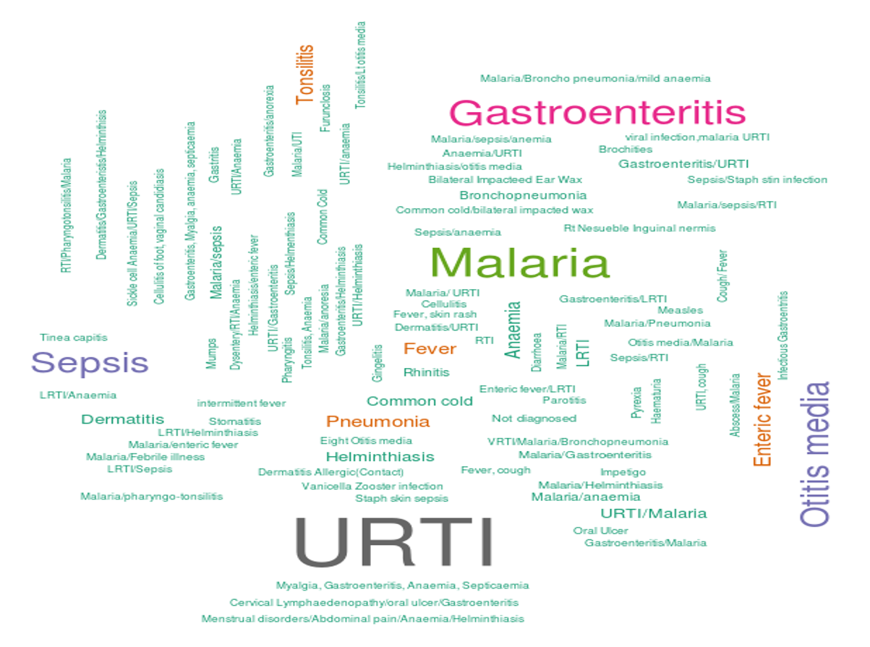
Top 150 infections that were reported; with majority of the people having upper respiratory tract infections (URTI), followed by Malaria, Gastroenteritis, Sepsis, Otitis media, and Fever. The rest of the diagnosis had a frequency less than 2.

Fig. S2. Artificial Neural Network Schematic.
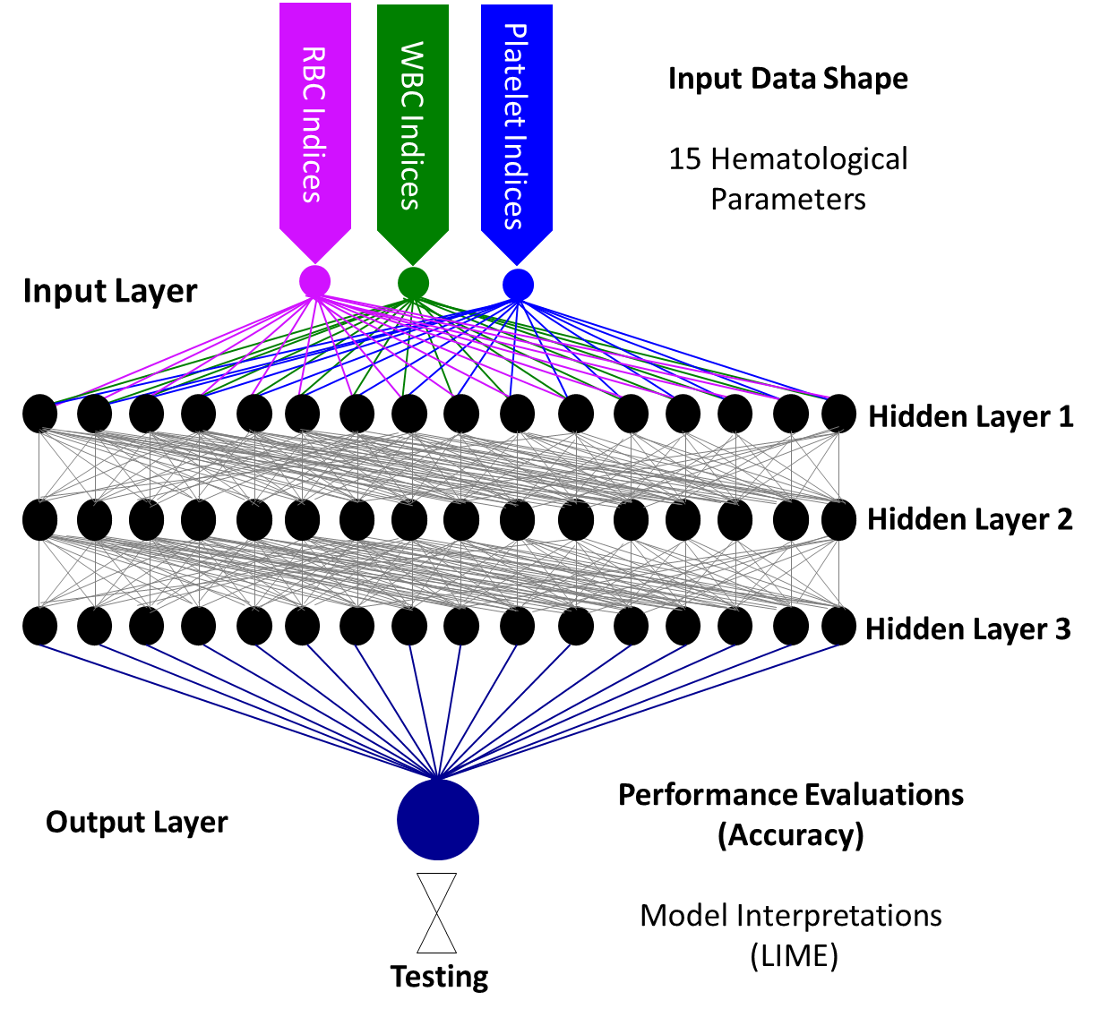
A representative Keras model that is composed of a linear stack of input layers, three hidden layers and one output layer. The input layer composed of an input shape of 15 haematological parameters (RBC parameters, WBC parameters, and Platelet indices). The hidden layers are each composed of a represetative16-stacked unit with ReLU as the activation function. The output layer had sigmoid/softmax function as the activation function and uniform initialization. Interpretations of the model classifications were made using local interpretable model-agonistic explanations (LIME Package in R) [41].

Fig. S3. Plot for the training and validation history of the ANN.
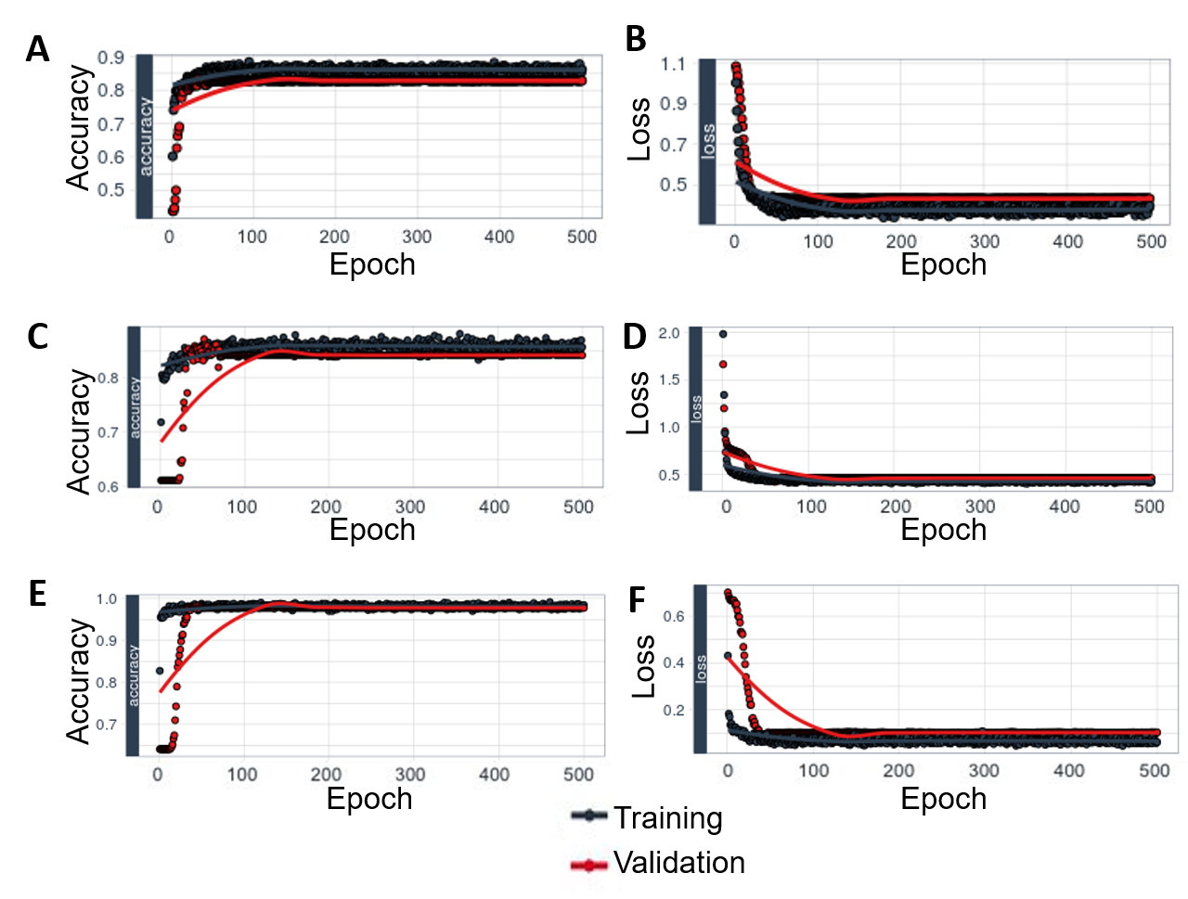 The figure indicates training and validation history of the model, which shows how accuracy and loss are leveling off, as well as the divergence between training and validation accuracy and training and validation loss. (A and B) Multi-classification of (SM vs. UM vs. nMI) accuracy and loss respectively. (C and D) Accuracy and loss respectively for ANN (UM vs. nMI) binary classifier. (E and F) Accuracy and loss respectively for the ANN (SM vs. nMI) binary classifier. The plots show a minimal model gap between training and validation.

Fig. S4. Case by case analysis of the classification capability of the ML models.
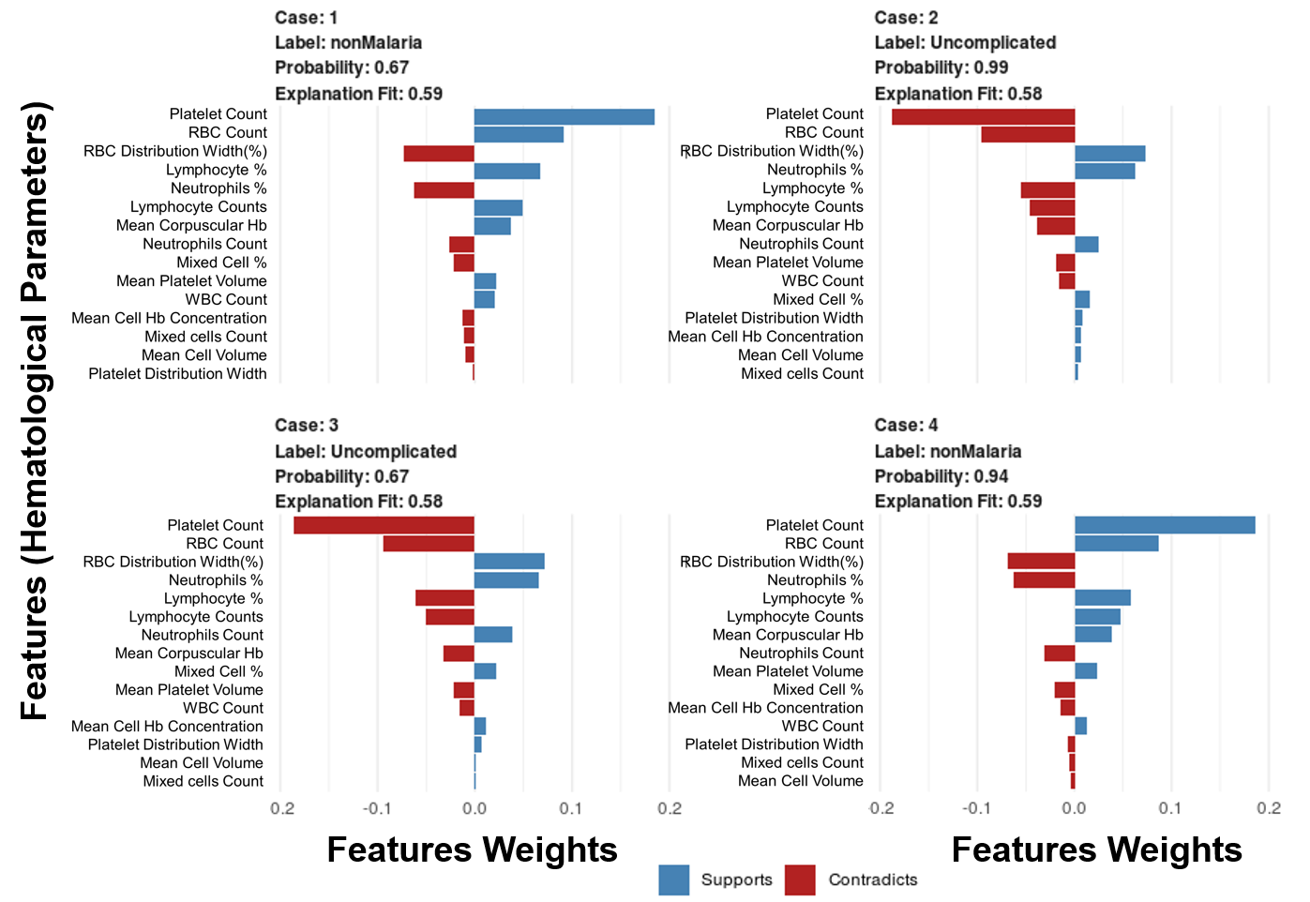
Samples of four cases in the test dataset were selected to indicate the predictions for each case. Case 1 and 4 are nMI patients, while case 2 and 3 are UM patients. The bars indicate the feature weights for each haematological parameter and whether it is a classifier of malaria (supports) or not (contradicts). This figure highlights how the parameters can be used for precision medicine.

Fig. S5. Density estimates of the haematological parameters between nMI and UM cases for sub-sampled data from Kintampo only.

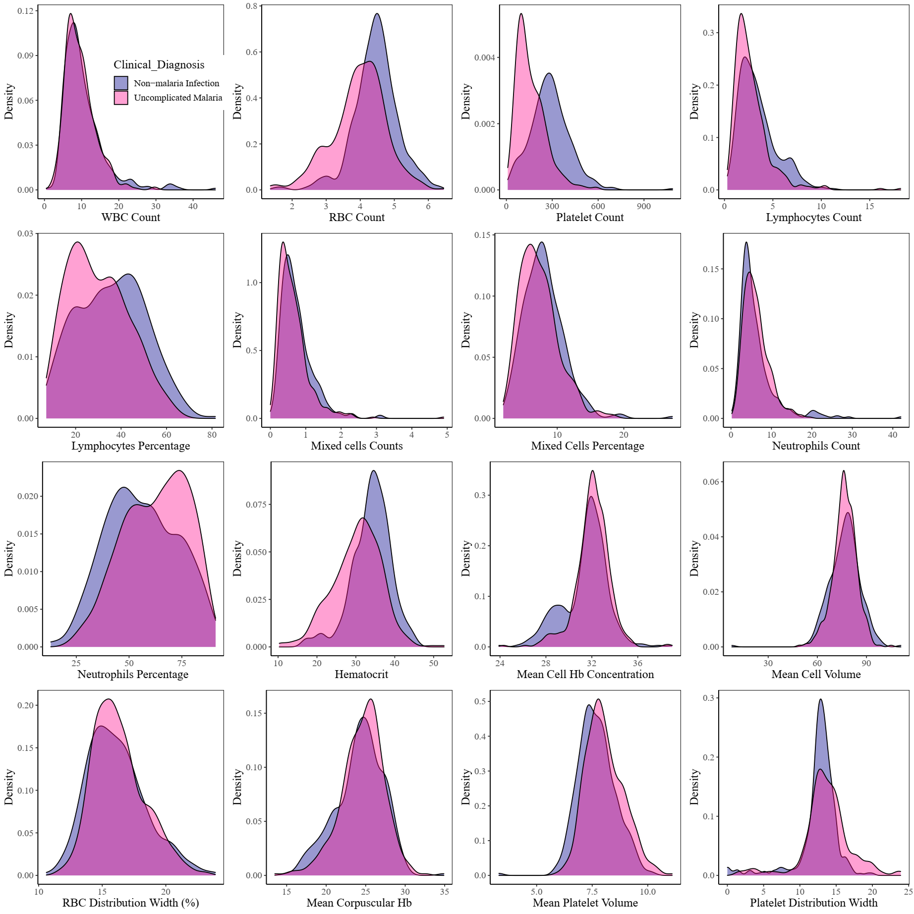

Fig. S6. Density estimates of the haematological parameters between nMI, and UM cases for sub-sampled data from Kintampo only, as well limit of children under 4 years of age.
