Fig S1. Example of search strategy as used in MEDLINE.

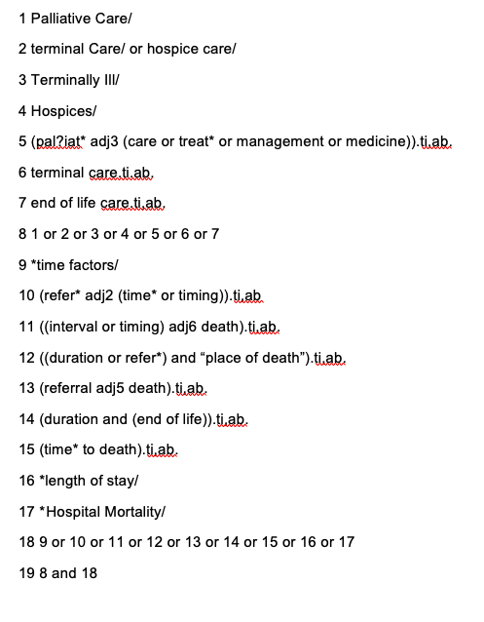

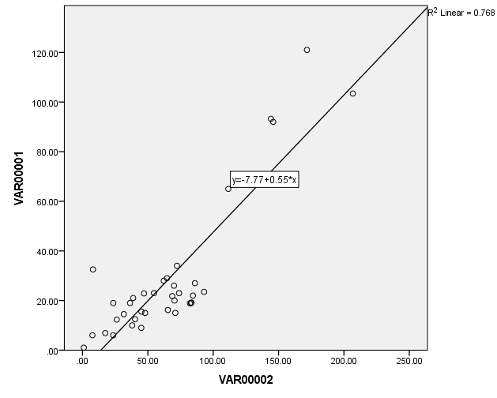
Fig S2. Linear regression model used to compare mean and median values.
Median
Mean

