ADDITIONAL FILE 2: SUPPLEMENTARY TABLES AND FIGURES

Table S1. Number of cases grouped under “other” cancers. 2
Table S2. Prevalence of and age-, sex- and education- adjusted prevalence ratios (PRs) for adverse person-centred outcomes according to joint categories of physical functioning limitations and cancer 3
Figure S1. Prevalence of moderate/high distress by cancer type and time since diagnosis 4
Figure S2. Prevalence of moderate/high distress by cancer type and stage 5
Figure S3. Prevalence of moderate/high distress by cancer type and recent treatment 6
Figure S4. Prevalence of poor/fair self-rated health by cancer type and time since diagnosis 7
Figure S5. Prevalence of poor/fair self-rated health by cancer type and stage 8
Figure S6. Prevalence of poor/fair self-rated health by cancer type and recent treatment 9
Figure S7. Prevalence of poor/fair self-rated quality of life by cancer type and time since diagnosis 10
Figure S8. Prevalence of poor/fair self-rated quality of life by cancer type and stage 11
Figure S9. Prevalence of poor/fair self-rated quality of life by cancer type and recent treatment 12
Figure S10. Prevalence of high psychological distress by cancer type 13
Figure S11. Prevalence of moderate/severe physical functioning limitations by cancer type 14
Figure S12. Prevalence of and age- and sex- adjusted prevalence ratios (PR) for adverse person-centred outcomes by cancer type: analyses restricted to those without severe physical functioning limitations 15

Table S1. Number of cases grouped under “other” cancers.
ICD-10AM Code | ICD-10AM label | n
C00 | Lip | 178
C01-C02 | Tongue | 92
C03-C06 | Mouth | 76
C07-C08 | Salivary glands | 54
C09-C10 | Oropharynx | 65
C11 | Nasopharynx | 23
C12-C13 | Hypopharynx | 12
C14 | Other sites in pharynx | 9
C16 | Stomach | 167
C17 | Small intestine | 70
C21 | Anus | 56
C22 | Liver | 43
C23-C24 | Gallbladder and extrahepatic bile ducts | 47
C25 | Pancreas | 52
C26 | Other digestive organs | 2
C30-C31 | Nose, sinuses, etc | 18
C32 | Larynx | 119
C37-C39 | Other thoracic and respiratory organs | 7
C40-C41 | Bone | 28
C42.1 | Bone Marrow | 1
C45 | Mesothelioma | 25
C46 | Kaposi sarcoma | 11
C48 | Peritoneum | 28
C47, C49 | Other soft tissue | 84
C51 | Vulva | 37
C52 | Vagina | 6
C53 | Cervix | 88
C56 | Ovary | 189
C57-C58 | Other female genital organs and placenta | 14
C60 | Penis | 13
C62 | Testis | 77
C63 | Other male genital organs | 7
C65-C66, C68 | Other urinary organs | 55
C69 | Eye | 64
C71 | Brain | 47
C70, C72 | Other central nervous system | 9
C74-C75 | Other endocrine glands | 8
C76 | Other and ill-defined sites | 4
C80 | Unknown primary site | 121
C81 | Hodgkin's disease | 64
C88 | Immunoproliferative cancers | 8
C90.1-C90.9 | Other plasma cell | 15
C96, D45, D47.1, D47.3-D47.5 | Other cancers of the blood and lymphatic system | 95
D46 | Myelodysplastic syndromes | 74
Total |  | 2262

Table S2. Prevalence of and age-, sex- and education- adjusted prevalence ratios (PRs) for adverse person-centred outcomes according to joint categories of physical functioning limitations and cancer
 | moderate/high distress |  | poor/fair self-rated health |  | poor/fair self-rated quality of life
 | %(n/N) | PR (95% CI) | %(n/N) | PR (95% CI) | %(n/N) | PR (95% CI)
Without cancer | 23.1(45357/196185) | 1 | 12.5(26122/209129) | 1 | 9.4(19478/206394) | 1
With cancer | 22.2(3746/16915) | 1.06(1.02-1.09) | 20.7(3851/18651) | 1.45(1.41-1.50) | 14.0(2579/18444) | 1.30(1.25-1.35)
No cancer and
No limitations | 15.7(11081/70776) | 1 | 2.1(1552/73819) | 1 | 2.6(1897/72689) | 1
Minor limitations | 18.3(10591/57822) | 1.28(1.25-1.31) | 4.5(2754/60606) | 2.24(2.10-2.38) | 3.5(2093/59896) | 1.37(1.29-1.46)
Moderate limitations | 28.5(12860/45149) | 2.12(2.08-2.17) | 16.7(8146/48743) | 8.48(8.03-8.95) | 10.5(5085/48234) | 4.19(3.98-4.42)
Severe limitations | 48.2(10825/22438) | 3.73(3.65-3.81) | 52.7(13670/25961) | 26.47(25.12-27.90) | 40.7(10403/25575) | 15.77(15.02-16.56)
Cancer and
No limitations | 12.1(457/3768) | 0.87(0.80-0.95) | 2.7(108/4012) | 1.28(1.05-1.56) | 2.6(101/3946) | 0.97(0.80-1.19)
Minor limitations | 13.3(634/4765) | 1.11(1.03-1.20) | 5.4(276/5089) | 2.75(2.42-3.12) | 3.6(179/5036) | 1.43(1.23-1.67)
Moderate limitations | 23.6(1231/5213) | 2.08(1.97-2.19) | 21.1(1218/5768) | 10.70(9.91-11.55) | 12.0(686/5714) | 4.84(4.42-5.30)
Severe limitations | 44.9(1424/3169) | 3.99(3.81-4.17) | 59.5(2249/3782) | 29.30(27.43-31.30) | 43.0(1613/3748) | 16.70(15.56-17.92)

Figure S1. Prevalence of moderate/high distress by cancer type and time since diagnosis
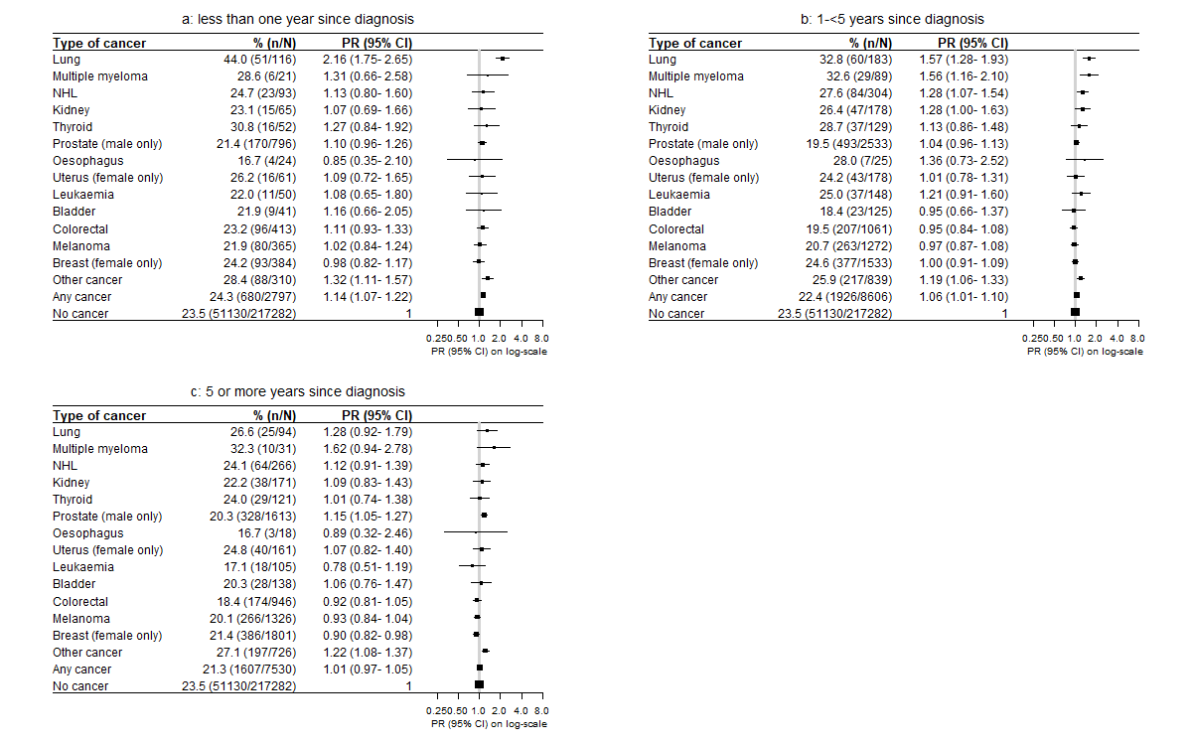
Figure S2. Prevalence of moderate/high distress by cancer type and stage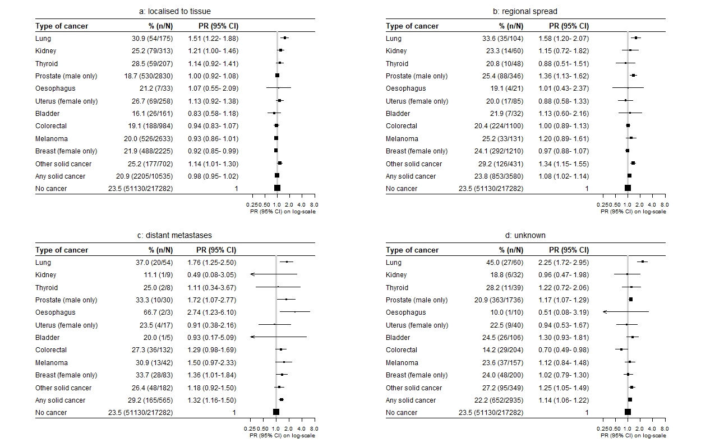

Figure S3. Prevalence of moderate/high distress by cancer type and recent treatment
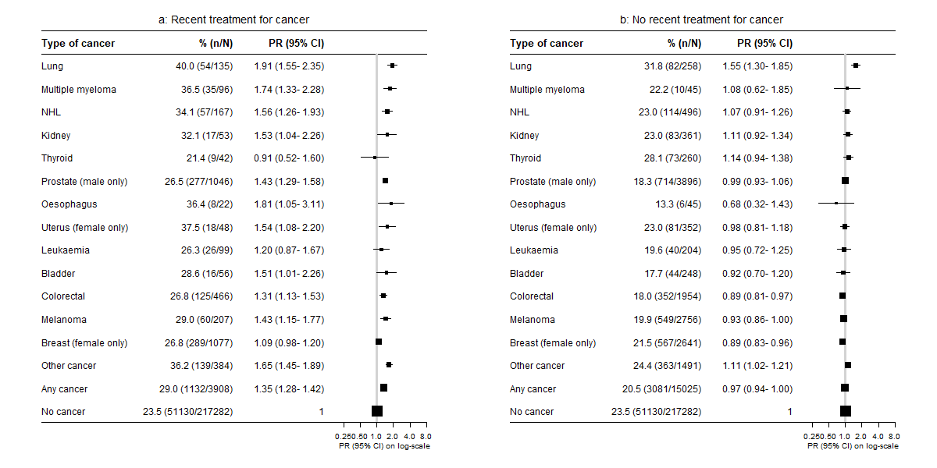
Figure S4. Prevalence of poor/fair self-rated health by cancer type and time since diagnosis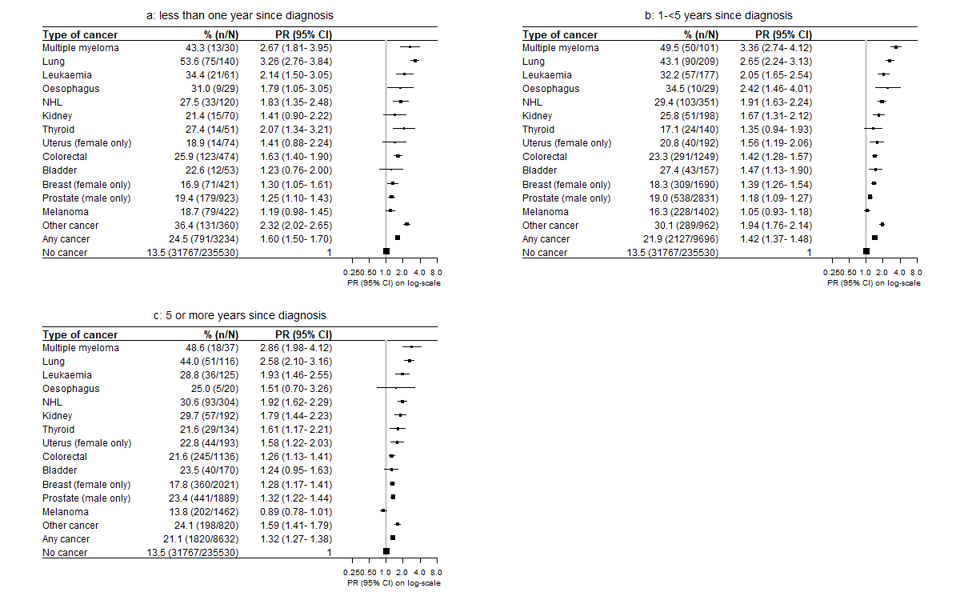

Figure S5. Prevalence of poor/fair self-rated health by cancer type and stage
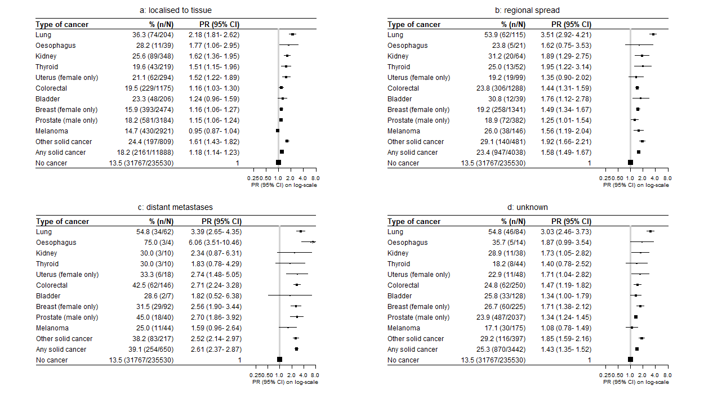

Figure S6. Prevalence of poor/fair self-rated health by cancer type and recent treatment
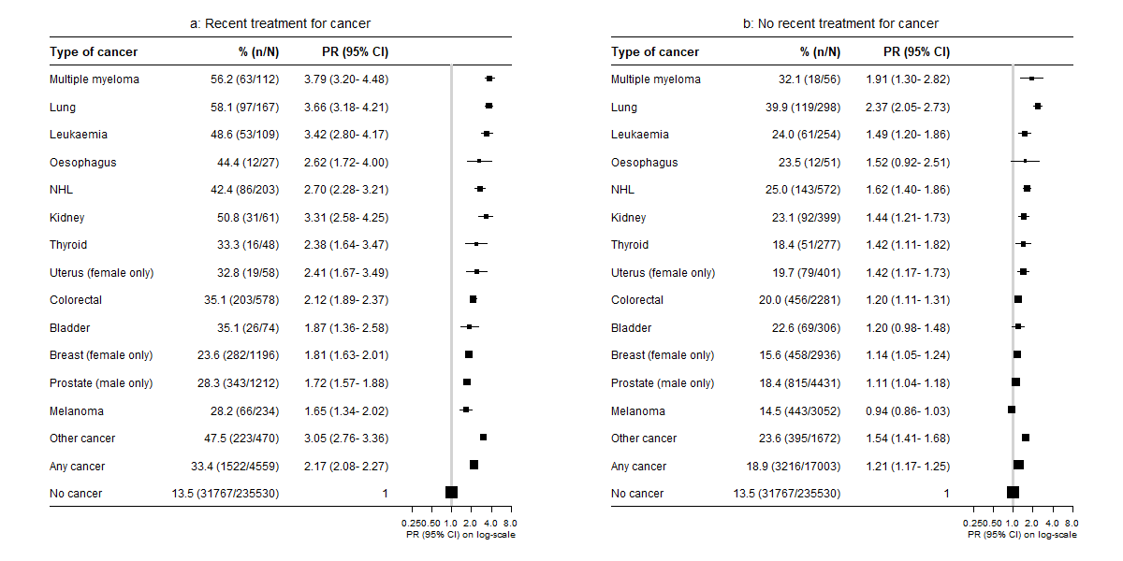

Figure S7. Prevalence of poor/fair self-rated quality of life by cancer type and time since diagnosis
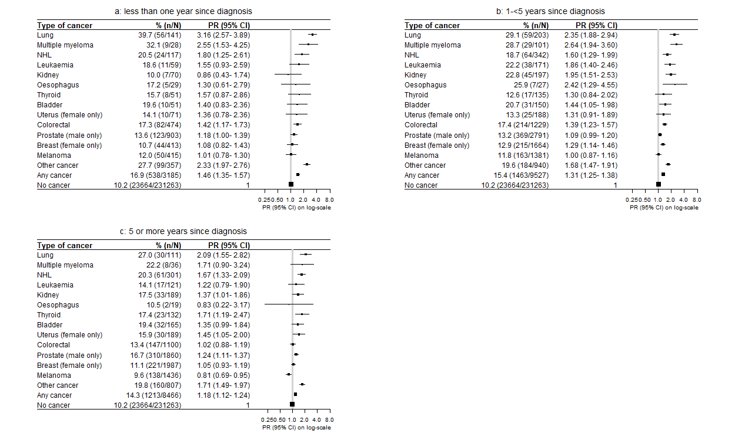
Figure S8. Prevalence of poor/fair self-rated quality of life by cancer type and stage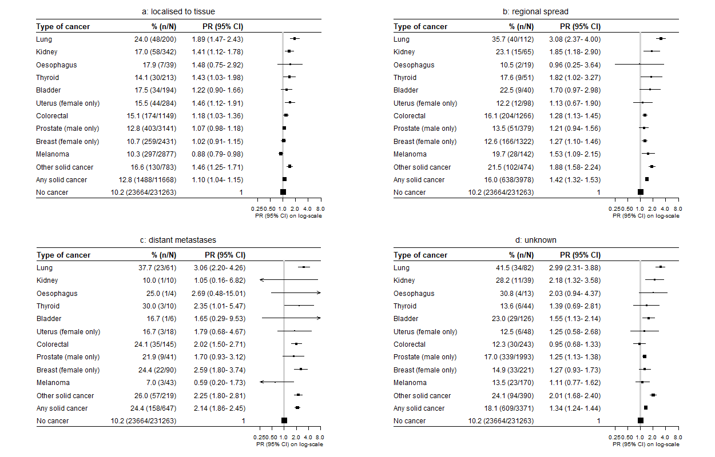

Figure S9. Prevalence of poor/fair self-rated quality of life by cancer type and recent treatment
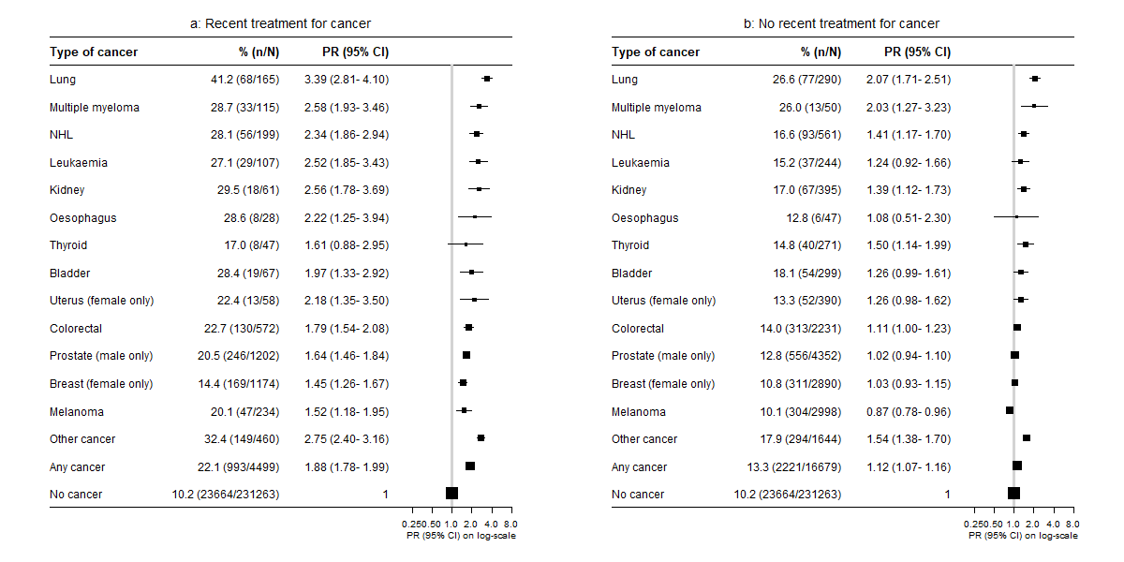

Figure S10. Prevalence of high psychological distress by cancer type
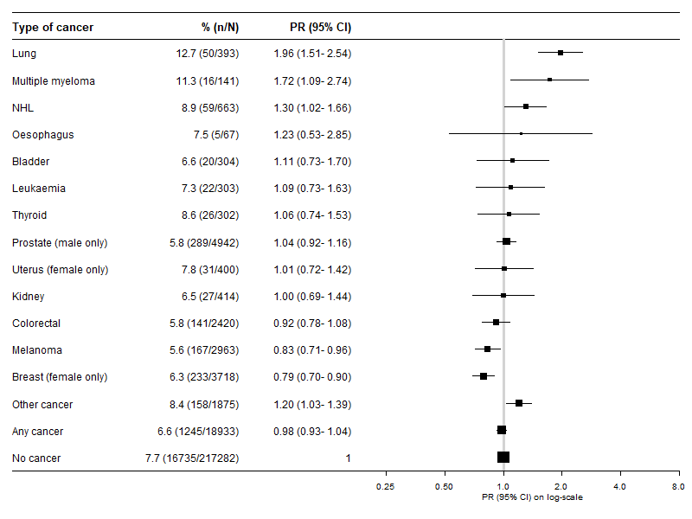

Figure S11. Prevalence of moderate/severe physical functioning limitations by cancer type
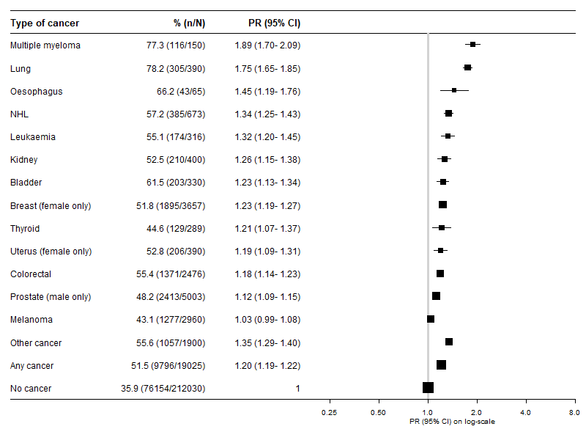

Figure S12. Prevalence of and age- and sex- adjusted prevalence ratios (PR) for adverse person-centred outcomes by cancer type: analyses restricted to those without severe physical functioning limitations
