Additional file 10: Figure S5. Association between CRP and other laboratory tests result
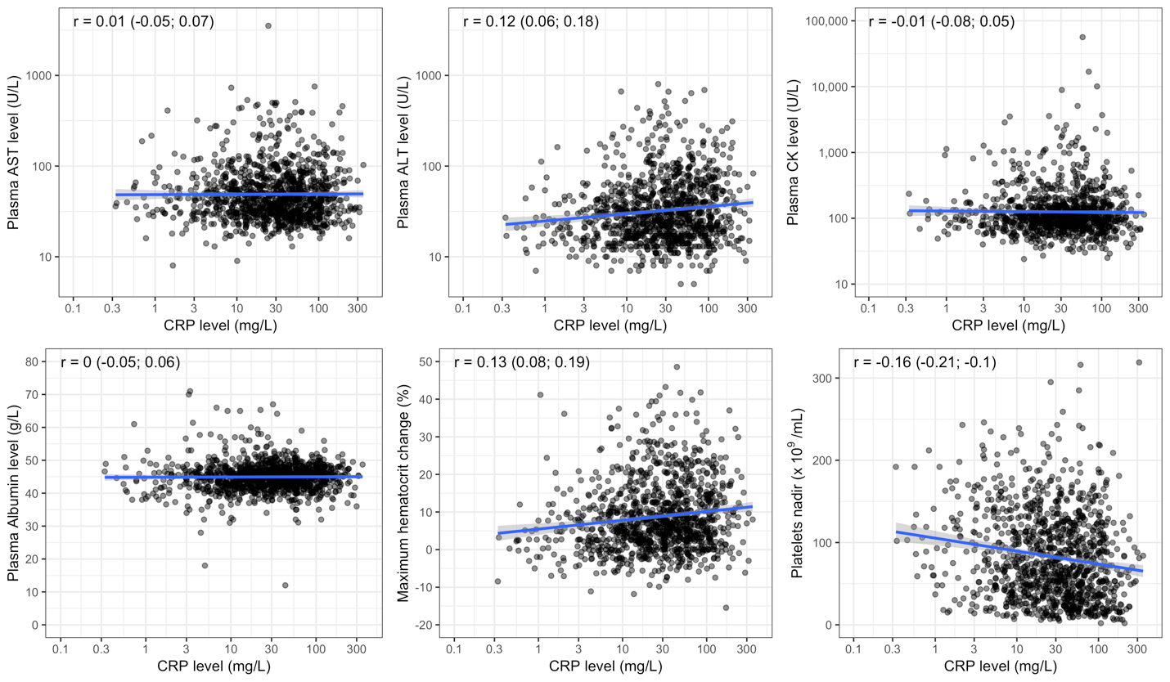

The black point is the actual value for each patient. The blue line is the linear regression line and the grey region is its 95% confidence interval. Pearson’s correlation coefficient and its 95% confidence interval are shown in the top left corner of each plot. The x-axis is transformed using base-2 logarithm.
ALT: Alanine aminotransferase; AST: Aspartate aminotransferase; CK: Creatine kinase; CRP: C-reactive protein

