Additional file 8: Figure S4. Association between CRP level and hospitalization among dengue patients
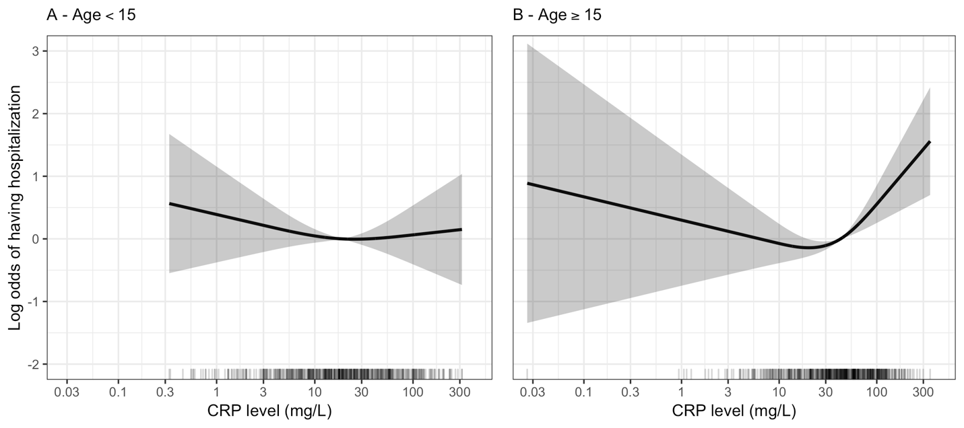
The log odds of having hospitalization (the black line) and its 95% confidence interval (the grey region) were estimated from multivariable logistic regression models allowing for non-linear effect of log 2 of CRP levels using restricted cubic splines and adjusted for age, DOI at enrolment, viremia levels at enrolment, and immune status. P-values of the non-linear effect of CRP levels were 0.443 and 0.005 for A and B, respectively. The rug plot on the x-axis represents the distribution of individual cases.
CRP: C-reactive protein

