Additional file 4
Additional file 4 – Figure 1: Genetically predicted associations of plasma vitamin C with lung cancer in the UK biobank dataset. (A) Forest plot for associations of each vitamin C-related SNP with lung cancer risk. (B) Scatter plot of genetic association with the plasma vitamin C levels and genetic association with lung cancer. The results from the primary approach (random-effects inverse-variance-weighted method) were presented in the plots, while the results from other sensitivity analyses were presented in the tables below the plots.
- (B)

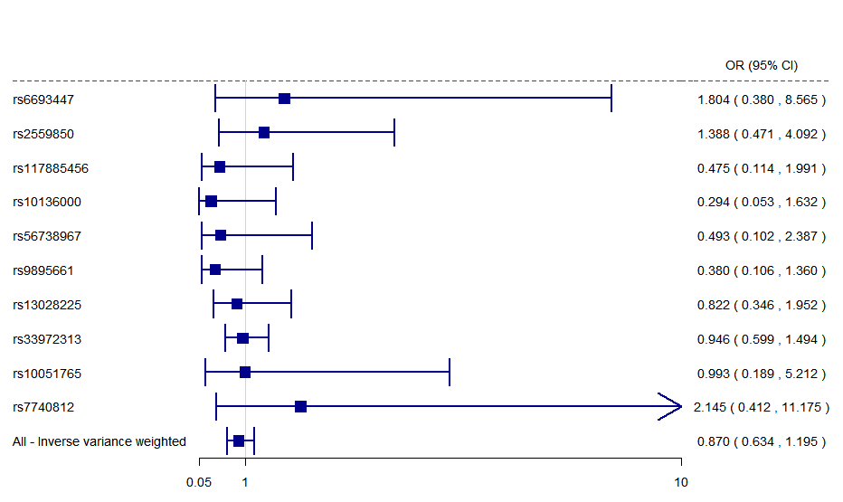 | 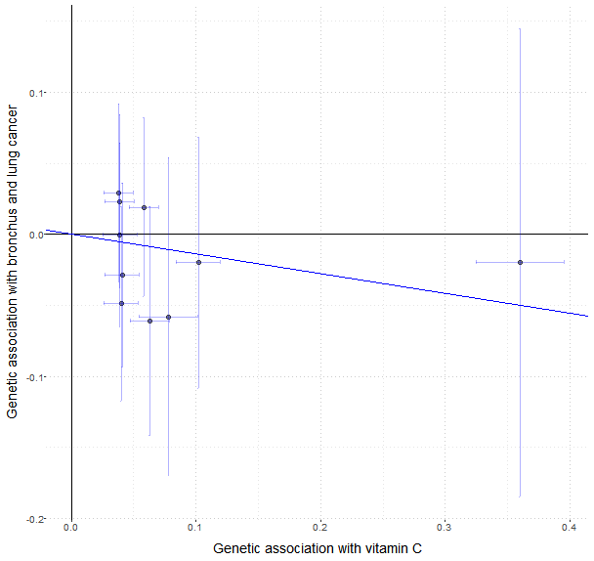

 | OR | 95% CI |  | p | Cochran’s Q test
Inverse-variance weighted | 0.870 | 0.634 | 1.195 | 0.390 | 0.614
MR-Egger | 0.892 | 0.543 | 1.464 | 0.663 | 0.614
Weighted median | 0.922 | 0.612 | 1.388 | 0.696 | 0.614
MR-PRESSO | 0.870 | 0.655 | 1.156 | 0.362 | 0.614
mode-based | 0.943 | 0.617 | 1.440 | 0.785 | 0.614
MR-Robust | 0.875 | 0.712 | 1.075 | 0.202 | 0.614
MR-RAPS | 0.869 | 0.625 | 1.208 | 0.404 | 0.614

Additional file 4 – Figure 2: Genetically predicted associations of plasma vitamin C with breast cancer in the UK biobank dataset. (A) Forest plot for associations of each vitamin C-related SNP with lung cancer risk. (B) Scatter plot of genetic association with the plasma vitamin C levels and genetic association with lung cancer. The results from the primary approach (random-effects inverse-variance-weighted method) were presented in the plots, while the results from other sensitivity analyses were presented in the tables below the plots.
- (B)

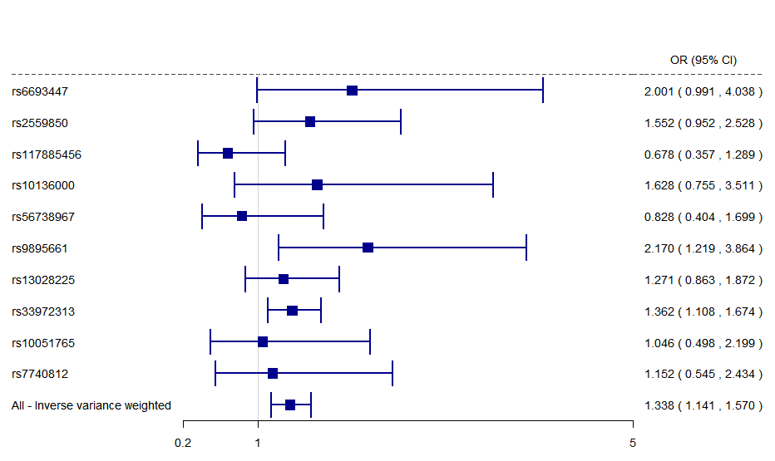 | 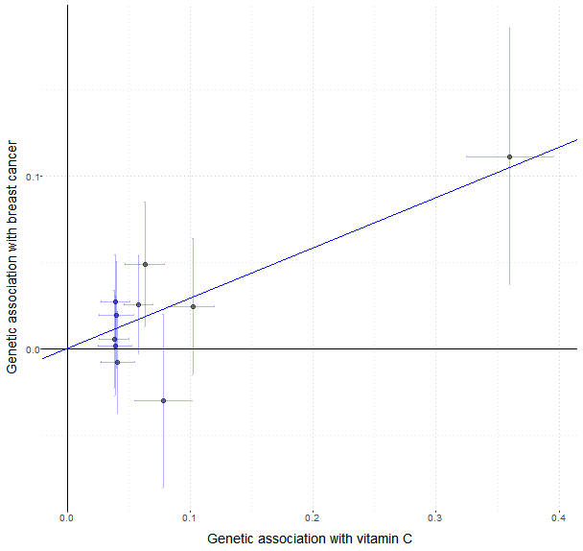

 | OR | 95% CI |  | p | Cochran’s Q test
Inverse-variance weighted | 1.338 | 1.141 | 1.570 | 0.000 | 0.259
MR-Egger | 1.344 | 1.031 | 1.752 | 0.030 | 0.259
Weighted median | 1.349 | 1.125 | 1.617 | 0.001 | 0.259
MR-PRESSO | 1.338 | 1.141 | 1.570 | 0.006 | 0.259
mode-based | 1.359 | 1.121 | 1.648 | 0.002 | 0.259
MR-Robust | 1.344 | 1.214 | 1.489 | 0.000 | 0.259
MR-RAPS | 1.351 | 1.153 | 1.583 | 0.000 | 0.259

Additional file 4 – Figure 3: Genetically predicted associations of plasma vitamin C with prostate cancer in the UK biobank dataset. (A) Forest plot for associations of each vitamin C-related SNP with lung cancer risk. (B) Scatter plot of genetic association with the plasma vitamin C levels and genetic association with lung cancer. The results from the primary approach (random-effects inverse-variance-weighted method) were presented in the plots, while the results from other sensitivity analyses were presented in the tables below the plots.
- (B)

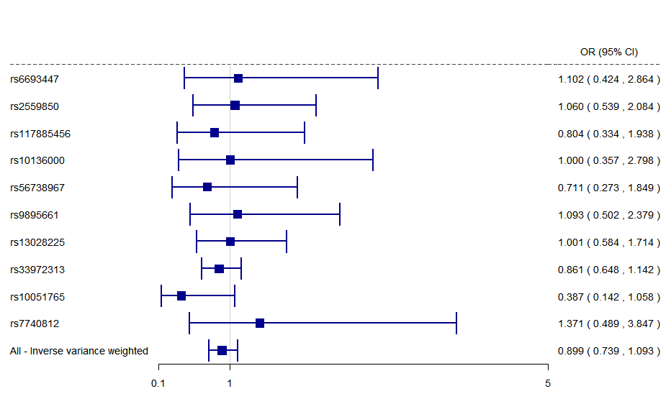 | 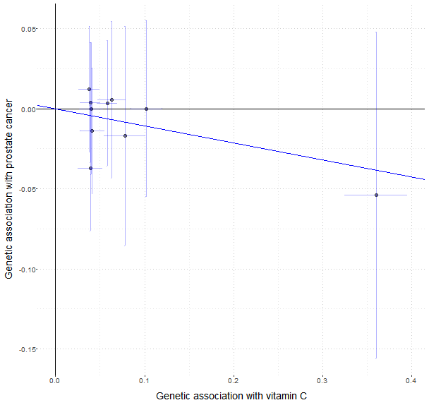

 | OR | 95% CI |  | p | Cochran’s Q test
Inverse-variance weighted | 0.899 | 0.739 | 1.093 | 0.286 | 0.243
MR-Egger | 0.886 | 0.652 | 1.204 | 0.463 | 0.243
Weighted median | 0.931 | 0.726 | 1.195 | 0.574 | 0.243
MR-PRESSO | 0.899 | 0.782 | 1.033 | 0.168 | 0.243
mode-based | 0.885 | 0.682 | 1.148 | 0.358 | 0.243
MR-Robust | 0.913 | 0.752 | 1.109 | 0.360 | 0.243
MR-RAPS | 0.904 | 0.737 | 1.108 | 0.331 | 0.243

Additional file 4 – Figure 4: Genetically predicted associations of plasma vitamin C with colon cancer in the UK biobank dataset. (A) Forest plot for associations of each vitamin C-related SNP with lung cancer risk. (B) Scatter plot of genetic association with the plasma vitamin C levels and genetic association with lung cancer. The results from the primary approach (random-effects inverse-variance-weighted method) were presented in the plots, while the results from other sensitivity analyses were presented in the tables below the plots.
(A) (B)

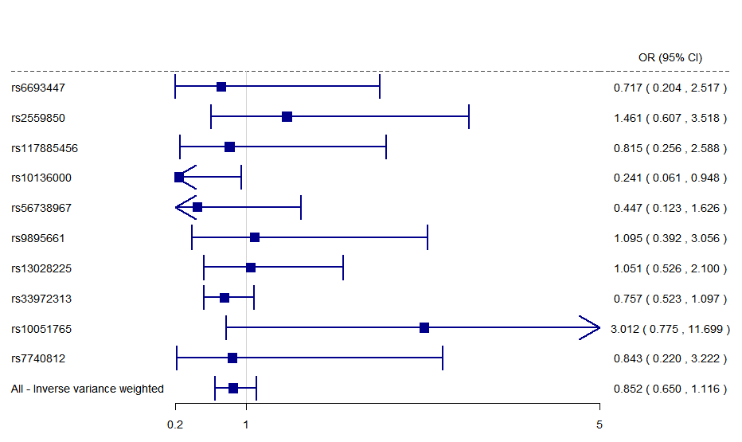 | 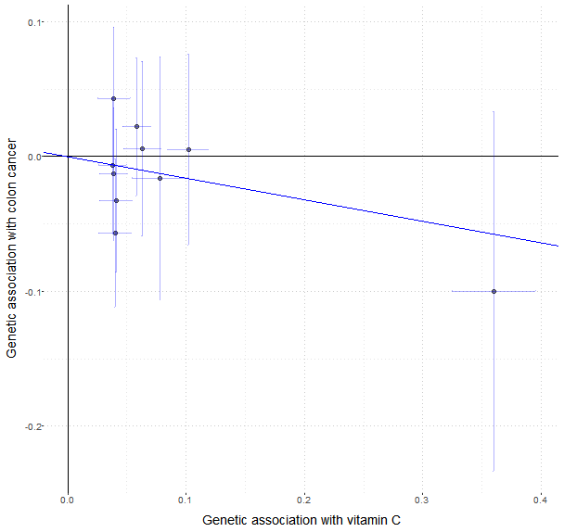

 | OR | 95% CI |  | p | Cochran’s Q test
Inverse-variance weighted | 0.852 | 0.650 | 1.116 | 0.245 | 0.347
MR-Egger | 0.809 | 0.517 | 1.265 | 0.379 | 0.347
Weighted median | 0.789 | 0.569 | 1.094 | 0.155 | 0.347
MR-PRESSO | 0.852 | 0.650 | 1.116 | 0.275 | 0.347
mode-based | 0.793 | 0.559 | 1.123 | 0.191 | 0.347
MR-Robust | 0.849 | 0.687 | 1.048 | 0.128 | 0.347
MR-RAPS | 0.849 | 0.649 | 1.110 | 0.231 | 0.347

Additional file 4 – Figure 5: Genetically predicted associations of plasma vitamin C with rectal cancer in the UK biobank dataset. (A) Forest plot for associations of each vitamin C-related SNP with lung cancer risk. (B) Scatter plot of genetic association with the plasma vitamin C levels and genetic association with lung cancer. The results from the primary approach (random-effects inverse-variance-weighted method) were presented in the plots, while the results from other sensitivity analyses were presented in the tables below the plots.
(A) (B)

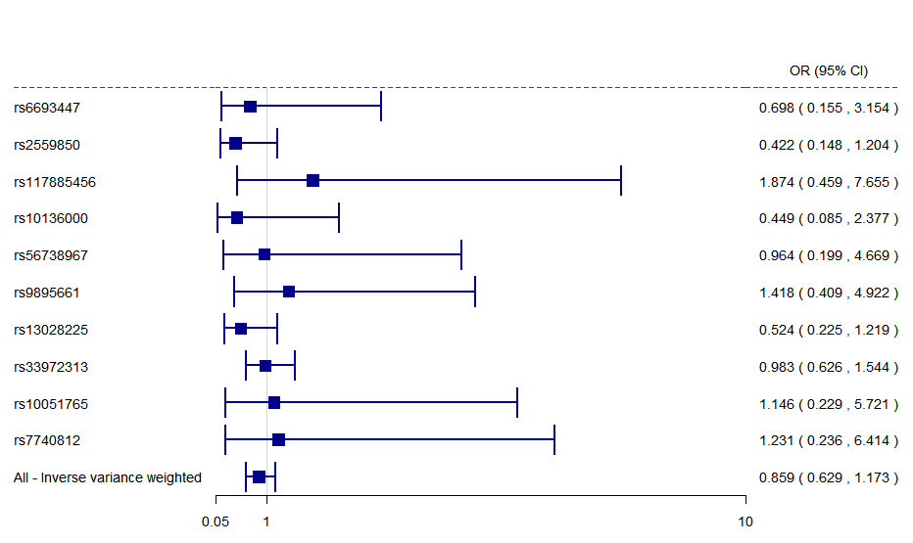 | 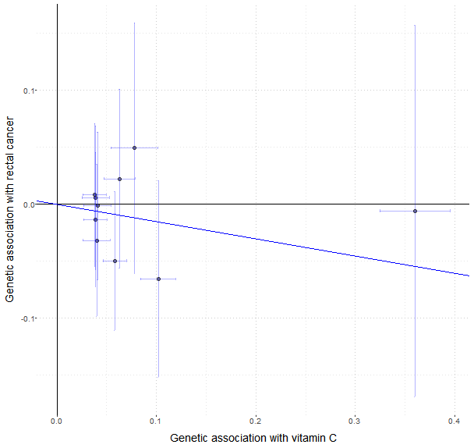

 | OR | 95% CI |  | p | Cochran’s Q test
Inverse-variance weighted | 0.859 | 0.629 | 1.173 | 0.340 | 0.719
MR-Egger | 0.940 | 0.576 | 1.533 | 0.810 | 0.719
Weighted median | 0.977 | 0.648 | 1.473 | 0.913 | 0.719
MR-PRESSO | 0.859 | 0.663 | 1.113 | 0.280 | 0.719
mode-based | 1.000 | 0.640 | 1.561 | 0.999 | 0.719
MR-Robust | 0.874 | 0.633 | 1.206 | 0.412 | 0.719
MR-RAPS | 0.858 | 0.621 | 1.187 | 0.355 | 0.719

Additional file 4 – Figure 6: Genetically predicted associations of plasma vitamin C with lung cancer in the dataset from International Lung Cancer Consortium (ILCCO). (A) Forest plot for associations of each vitamin C-related SNP with lung cancer risk. (B) Scatter plot of genetic association with the plasma vitamin C levels and genetic association with lung cancer. The results from the primary approach (random-effects inverse-variance-weighted method) were presented in the plots, while the results from other sensitivity analyses were presented in the tables below the plots.
(A) (B)

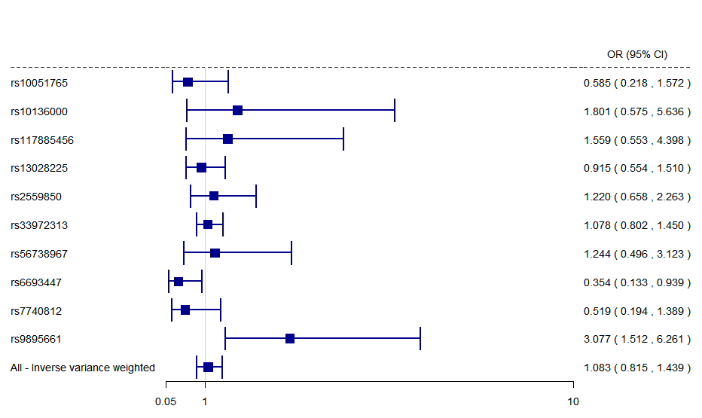 | 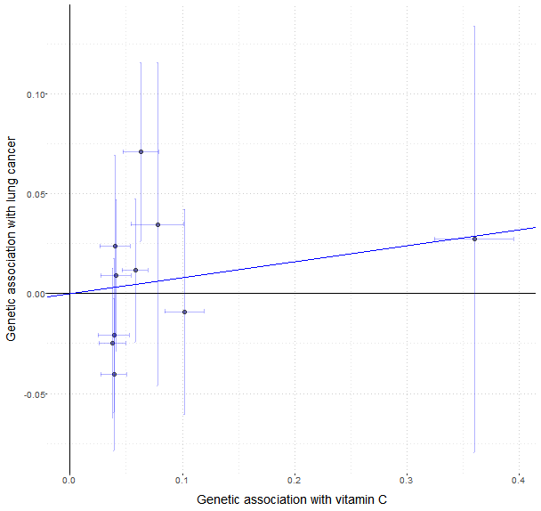

 | OR | 95% CI |  | p | Cochran’s Q test
Inverse-variance weighted | 1.083 | 0.815 | 1.439 | 0.584 | 0.026
MR-Egger | 1.188 | 0.735 | 1.920 | 0.503 | 0.026
Weighted median | 1.081 | 0.845 | 1.382 | 0.535 | 0.026
MR-PRESSO | 1.083 | 0.815 | 1.439 | 0.598 | 0.026
mode-based | 1.082 | 0.834 | 1.403 | 0.554 | 0.026
MR-Robust | 1.066 | 0.891 | 1.276 | 0.483 | 0.026
MR-RAPS | 1.069 | 0.845 | 1.352 |  | 0.026

Additional file 4 – Figure 7: Genetically predicted associations of plasma vitamin C with breast cancer in the dataset from the Breast Cancer Association Consortium (BCAC). (A) Forest plot for associations of each vitamin C-related SNP with lung cancer risk. (B) Scatter plot of genetic association with the plasma vitamin C levels and genetic association with lung cancer. The results from the primary approach (random-effects inverse-variance-weighted method) were presented in the plots, while the results from other sensitivity analyses were presented in the tables below the plots.
(A) (B)
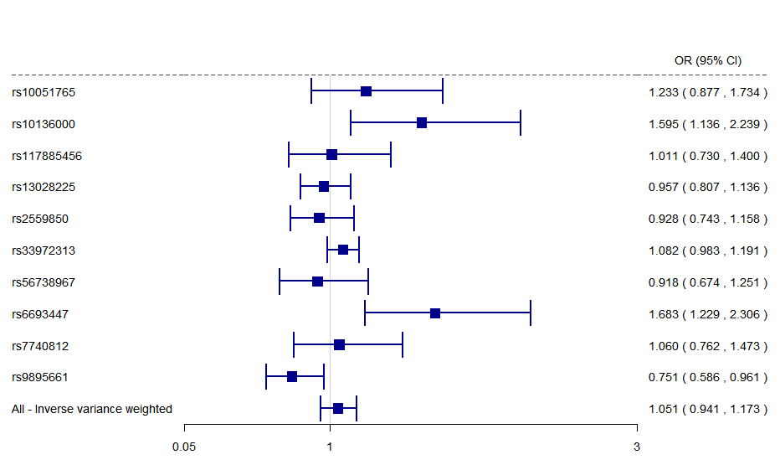 | 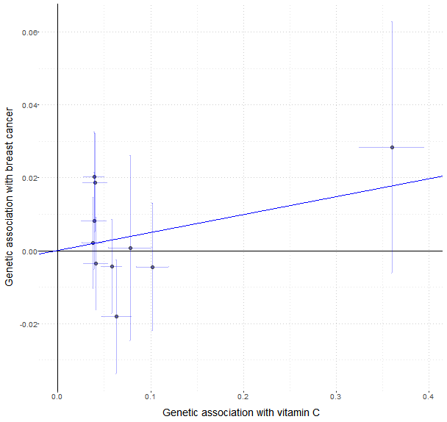

 | OR | 95% CI |  | p | Cochran’s Q test
Inverse-variance weighted | 1.051 | 0.941 | 1.173 | 0.378 | 0.002
MR-Egger | 1.016 | 0.846 | 1.220 | 0.870 | 0.002
Weighted median | 1.068 | 0.978 | 1.166 | 0.144 | 0.002
MR-PRESSO | 1.055 | 0.970 | 1.146 | 0.250 | 0.002
mode-based | 1.043 | 0.954 | 1.141 | 0.353 | 0.002
MR-Robust | 1.048 | 0.966 | 1.138 | 0.256 | 0.002
MR-RAPS | 1.054 | 0.968 | 1.147 | 0.223 | 0.002

Additional file 4 – Figure 8: Genetically predicted associations of plasma vitamin C with prostate cancer in the dataset from the Prostate Cancer Association Group to Investigate Cancer Associated Alterations in the Genome (PRACTICAL). (A) Forest plot for associations of each vitamin C-related SNP with lung cancer risk. (B) Scatter plot of genetic association with the plasma vitamin C levels and genetic association with lung cancer. The results from the primary approach (random-effects inverse-variance-weighted method) were presented in the plots, while the results from other sensitivity analyses were presented in the tables below the plots.
(A) (B)

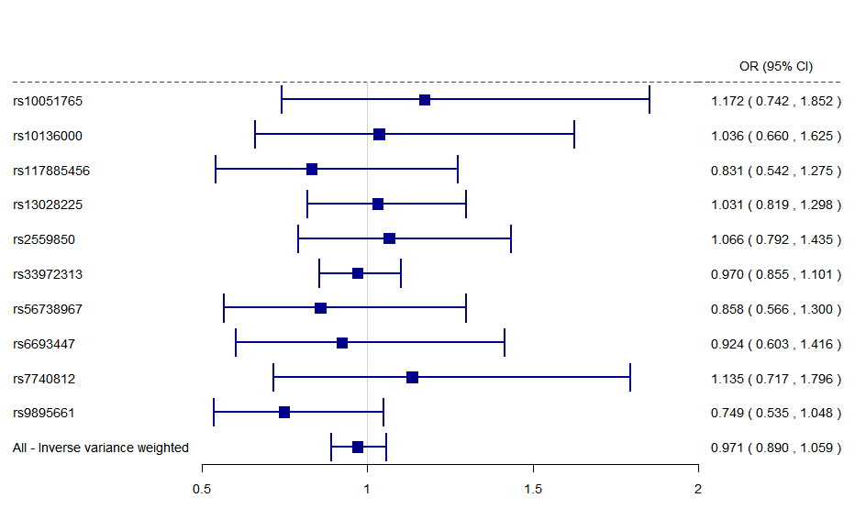 | 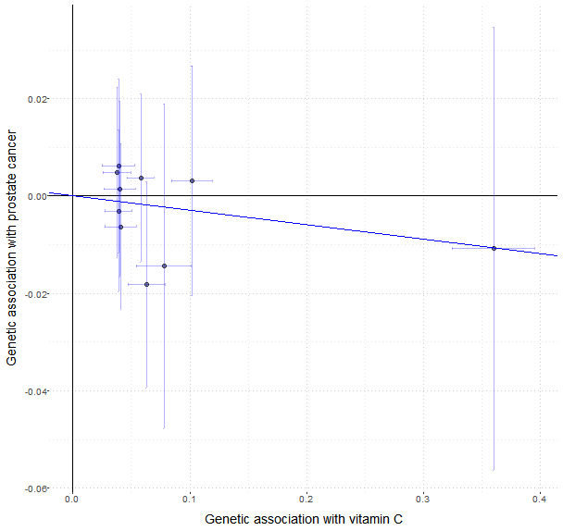

 | OR | 95% CI |  | p | Cochran’s Q test
Inverse-variance weighted | 0.971 | 0.890 | 1.059 | 0.502 | 0.834
MR-Egger | 0.963 | 0.840 | 1.103 | 0.599 | 0.834
Weighted median | 0.985 | 0.880 | 1.102 | 0.785 | 0.834
MR-PRESSO | 0.971 | 0.910 | 1.036 | 0.391 | 0.834
mode-based | 0.989 | 0.879 | 1.113 | 0.857 | 0.834
MR-Robust | 0.975 | 0.922 | 1.030 | 0.368 | 0.834
MR-RAPS | 0.973 | 0.889 | 1.064 | 0.545 | 0.834

