Supplemental Tables and Figures

 |  | Page
Supplemental tables
Table 1. | Crude incidence rates for heart failure diagnosis and isolated loop-diuretic use in patients with no prevalent heart failure or loop-diuretic use at AF diagnosis | 2
Table 2. | Rates of adverse outcomes (>100 days) after AF diagnosis by baseline heart failure status. | 3
Table 3. | Patient characteristics at AF diagnosis by gender. | 4
Table 4. | Rates of adverse outcomes after AF diagnosis by gender and baseline heart failure status. | 6
Table 5. | Risk of adverse outcomes after AF diagnosis, by baseline heart failure status.  Patients with an isolated episode of heart failure classified as no heart failure. | 7
Table 6. | Risk of adverse outcomes after AF diagnosis, by baseline heart failure status.  Including only patients with non-valvular AF | 8
Table 7. | Adverse outcomes after AF diagnosis by baseline heart failure status.  Including outcomes occurring within 100-days of AF diagnosis. | 9
Table 8. | Risk of adverse outcomes after AF diagnosis, by baseline heart failure status.  No censor period after AF diagnosis. | 10
Table 9. | Risk of adverse outcomes after AF diagnosis, by baseline heart failure status.  Increasing the censor period after AF diagnosis to 1 year. | 11
Table 10. | Risk of adverse outcomes after AF diagnosis, by baseline heart failure status.  Excluding loop-diuretic use in the last 12 months of life. | 12
Table 11. | Risk of adverse outcomes after AF diagnosis, by baseline heart failure status.  Restricted to patients with no BMI measurement. | 13
Table 12. | Risk of adverse outcomes after AF diagnosis, by baseline heart failure status.  Re-classifying patients with stage 3 and 4 chronic kidney disease (n=1,257) as having a non-cardiac indication for loop-diuretic therapy (in addition to those with stage 5 and renal replacement therapy). | 14
Table 13. | Risk of adverse outcomes after AF diagnosis by heart failure status at any time during follow-up. Exposure categories defined using a time-dependent approach (i.e., isolated loop-diuretic use or HF diagnosis occurring at any time during follow-up). | 15
Supplemental figures
Figure 1. | Prevalence of diagnosed heart failure and isolated loop-diuretic use at AF diagnosis by study year. Includes heart failure diagnosed before [>3months] and concomitant with [±3months] AF diagnosis. | 17
Figure 2. | Prevalence of diagnosed heart failure and isolated loop-diuretic use at AF diagnosis by gender. A. Women, B. Men. Includes HF diagnosed prior to [>3months] and concomitant with [±3months] AF diagnosis. | 18
Figure 3. | Cumulative incidence of (A) diagnosed heart failure and (B) diagnosed heart failure combined with isolated loop-diuretic use, and the competing risk of death before heart failure, after AF diagnosis. Study cohort comprises patients without heart failure or loop-diuretic use at AF diagnosis. | 19
Figure 4. | Survival after AF diagnosis, stratified by gender and baseline heart failure status. A. Diagnosed heart failure versus no heart failure. B. Diagnosed heart failure or isolated loop-diuretic use versus no heart failure. *excluding a 100-day censor period. | 20

Supplemental Table 1. Crude incidence rates for heart failure diagnosis and isolated loop-diuretic use in patients with no prevalent heart failure or loop-diuretic use at AF diagnosis
Outcome | Overall  n=124,256 | Women  n=58,222 (46·9%) | Men  n=66,034 (53·1%) | p-value (women vs men) | Incidence rate ratio (women/men), 95% CI,  p-value
Incident HF diagnosisª
No. events /No. at risk (%) | 12,182 / 102,255 (11·9) | 5,586 / 48,361 (11·6) | 6,596 / 53,894 (12·2)
Patient-years at risk | 380,639·7 | 175,305·7 | 205,334·0
Crude event rate  /100pt-yrs (95% CI) | 3·2  (3·1-3·3) | 3·2  (3·1-3·3) | 3·2  (3·1-3·3) |  | 0·99  (0·96-1·03)  p=0·656
Standardised event rate^{c} /100pt-yrs (95% CI) | 1·7  (1·7-1·7) | 1·5  (1·5-1·5) | 1·8  (1·7-1·8)
Hospital HF diagnosis,  n (% of all HF) | 3,964  (32·5) | 1,900  (34·0) | 2,064  (31·3) | 0·001
Incident HF diagnosis or isolated loop diuretic use^{b}
No. events / No. at risk (%) | 17,307 / 79,930 (26·9) | 8,226 / 35,111 (23·4) | 9,081 / 44,819 (20·3)
Patient-years at risk | 285,185 | 119,840·9 | 165,344·1
Crude event rate  /100pt-yrs (95% CI) | 6·1  (6·0-6·2) | 6·9  (6·7-7·0) | 5·5  (5·4-5·6) |  | 1·25  (1·21-1·29)  p=<0·00005
Standardised event rate^{c} /100pt-yrs (95% CI) | 3·0  (3·0-3·1) | 3·1  (3·1-3·2) | 2·8  (2·8-2·9)
Time to diagnosed or possible HF from AF diagnosis, yrs | 2·1  (0·8-4·5) | 2·1  (0·8-4·4) | 2·1  (0·8-4·5) | 0·061
Data presented as median (LQ-UQ)
ª Study population includes all patients without prevalent HF at AF diagnosis
^{b} Study population includes all patients without prevalent HF or loop diuretic use at AF diagnosis.
^{c} Standardised according to the distribution of age and gender (overall analysis) or age alone (gender-stratified analyses) of the UK population in CPRD in 2011 (de Jong RG, Gallagher AM, Herrett E, Masclee AA, Janssen-Heijnen ML, de Vries F. Comparability of the age and gender distribution of the UK Clinical Practice Research Datalink and the total Dutch population. Pharmacoepidemiol Drug Saf 2016; 25(12): 1460-4).
Supplemental Table 2. Rates of adverse outcomes (>100 days) after AF diagnosis by baseline heart failure status
Outcome | Total population  n=124,256 | Prevalent heart failure at AF diagnosis?
Outcome | Total population  n=124,256 | No  n=102,255 |  | Yes  n=22,001
Outcome | Total population  n=124,256 | Treated with loop diuretic?
Outcome | Total population  n=124,256 | No  n=79,930 | Yes  n=22,235 | No  n=6,082 | Yes  n=15,919
All-cause mortality
No. events (%) | 32,258 (26.0) | 16,084 (20.1) | 7,842 (35.3) | 1,608 (26.4) | 6,744 (42.4)
Person-years at risk | 444,575.7 | 306,586.7 | 71,736.3 | 19,864.4 | 46,388.3
Crude event rate  per 100pt-yrs (95% CIª) | 7.3  (7.2-7.3) | 5.2  (5.2-5.3) | 10.9  (10.7-11.2) | 8.1  (7.7-8.5) | 14.5  (14.2-14.9)
Standardised event rate^{b}  per 100pt-yrs (95%CIª) | 2.9  (2.9-2.9) | 2.3  (2.2-2.3) | 4.0  (3.9-4.1) | 4.1  (3.9-4.3) | 7.3  (7.1-7.5)
Emergency HF hospitalisation
No. events (%) | 3,064 (2.5) | 1,233 (1.5) | 648 (2.9) | 276 (4.5) | 907 (5.7)
Person-years at risk | 435,943.9 | 303,903.8 | 70,558.5 | 18,420.0 | 43,061.6
Crude event rate  per 100pt-yrs (95% CIª) | 0.7  (0.7-0.7) | 0.4  (0.4-0.4) | 0.9  (0.9-1.0) | 1.5  (1.3-1.7) | 2.1  (2.0-2.2)
Standardised event rate^{b}  per 100pt-yrs (95%CIª) | 0.4  (0.4-0.5) | 0.2  (0.2-0.3) | 0.9  (0.8-1.0) | 1.9  (1.7-2.2) | 2.3  (2.2-2.5)
Ischaemic stroke/TIA
No. events (%) | 11,584 (9.3) | 7,660 (9.6) | 2,128 (9.6) | 531 (8.7) | 1,265 (7.9)
Person-years at risk | 401,043.2 | 275,479.3 | 64,893.4 | 17,899.6 | 42,770.9
Crude event rate  per 100pt-yrs (95% CIª) | 2.9  (2.8-2.9) | 2.8  (2.7-2.8) | 3.3  (3.1-3.4) | 3.0  (2.7-3.2) | 3.0  (2.8-3.1)
Standardised event rate^{b}  per 100pt-yrs (95%CIª) | 1.4  (1.4-1.4) | 1.4  (1.4-1.4) | 1.6  (1.5-1.6) | 1.6  (1.5-1.7) | 2.2  (2.1-2.4)
HF, heart failure; TIA, transient ischaemic attack
ªAssuming a constant incidence rate over time.
^{b}Standardised for the age and gender-distribution of the UK population in CPRD in 2011

Supplemental Table 3. Patient characteristics at AF diagnosis by gender
Characteristic | Total population with incident AF  n=124,256 | Men  N=66,034 (53.1%) | Women  N=58,222 (46.9%) | p-value
Age (y) | 76 (68, 83) | 73 (65, 81) | 79 (71, 85) | <0.0005
Systolic blood pressure (mmHg)  Missing data, n (%) | 133 (120, 145)  1,459 (1.2) | 132 (120, 143)  869 (1.3) | 135 (121, 146)  590 (1.0) | <0.0005
Diastolic blood pressure (mmHg)  Missing data, n (%) | 79 (70, 84)  1,459 (1.2) | 79 (70, 84)  869 (1.3) | 79 (70, 84)  590 (1.0) | 0.588
BMI (kg/m²)  BMI category^{b}, n (%)  Underweight  Normal  Overweight  Obese  Missing data | 28.1±6.2  2,647 (2.1)  26,909 (21.7)  33,401 (26.9)  30,765 (24.8)  30,534 (24.6) | 28.3±5.6  746 (1.1)  13,239 (20.0)  20,427 (30.9)  16,835 (25.5)  14,787 (22.4) | 27.9±6.8  1,901 (3.3)  13,670 (23.4)  12,974 (22.3)  13,930 (23.9)  15,747 (27.0) | <0.0005  <0.0005
Smoking, n (%)  Current smovenomgt  ker  Ex-smoker  Total | 35,106 (28.3)  36,115 (29.1)  71,221 (57.3) | 21,537 (32.6)  44,325 (67.1) | 13,569 (23.3)  26,896 (46.2) | <0.005  <0.005  <0.005
Comorbidities, n (%)
Cardiovascular
Hypertension | 81,137 (65.3) | 40,456 (61.3) | 40,681 (69.9) | <0.0005
Ischaemic heart disease | 37,286 (30.0) | 21,823 (33.1) | 15,463 (26.6) | <0.0005
Prior myocardial infarction | 15,208 (12.2) | 9,983 (15.1) | 5,225 (9.0) | <0.0005
Stroke/TIA | 17,744 (14.3) | 9,011 (13.7) | 8,733 (15.0) | <0.0005
Valvular heart disease | 14,412 (11.6) | 7,135 (10.8) | 7,277 (12.5) | <0.0005
PPM / ICD | 3,008 (2.4) | 1,907 (2.9) | 1,101 (1.9) | <0.0005
Peripheral artery disease | 10,367 (8.3) | 6,241 (9.5) | 4,126 (7.1) | <0.0005
Dyslipidaemia | 32,477 (26.1) | 17,554 (26.6) | 14,923 (25.6) | <0.0005
Respiratory
Asthma | 20,198 (16.3) | 9,851 (14.9) | 10,347 (17.8) | <0.0005
COPD | 14,943 (12.0) | 8,500 (12.9) | 6,443 (11.1) | <0.0005
Interstitial lung disease | 2,776 (2.2) | 1,534 (2.3) | 1,242 (2.1) | 0.024
Obstructive sleep apnoea | 1,464 (1.2) | 1,212 (1.8) | 252 (0.4) | <0.0005
Renal
End-stage kidney disease | 2,286 (1.8) | 1,258 (1.9) | 1,028 (1.8) | 0.068
Nephrotic syndrome | 259 (0.2) | 166 (0.3) | 93 (0.2) | <0.0005
Other
Diabetes | 20,684 (16.7) | 12,031 (18.2) | 8,653 (14.9) | <0.0005
Chronic liver disease | 1,325 (1.1) | 745 (1.1) | 580 (1.0) | 0.024
Malignancy (any)  Malignancy (top 4 causes)^{c} | 21,076 (17.0)  5,438 (4.4) | 11,700 (17.7)  3,126 (4.7) | 9,376 (16.1)  2,312 (4.0) | <0.0005  <0.0005
Depression | 18,565 (14.9) | 7,301 (11.1) | 11,264 (19.4) | <0.0005
CHA₂DS₂-VASc score | 3.3±1.7 | 2.7±1.7 | 4.0±1.5 | <0.0005
Medication, n (%)
ACEI | 64,855 (52.2) | 34,904 (52.9) | 29,951 (51.4) | <0.0005
ARB | 7,435 (6.0) | 3,371 (5.1) | 4,064 (7.0) | <0.0005
ACEI or ARB | 72,290 (58.2) | 38,275 (58.0) | 34,015 (58.4) | 0.101
ARNI | <5 (0.0) | <5 (0.0) | <5 (0.0) | -
MRA | 9,277 (7.5) | 4,991 (7.6) | 4,286 (7.4) | 0.188
Antiarrhythmic drug^{d} | 11,195 (9.0) | 6,725 (10.2) | 4,470 (7.7) | <0.0005
Beta-blocker | 81,591 (65.7) | 42,214 (63.9) | 39,377 (67.6) | <0.0005
Digoxin | 30,309 (24.4) | 13,726 (20.8) | 16,583 (28.5) | <0.0005
Dihydropyridine CCB | 50,994 (41.0) | 25,525 (38.7) | 25,469 (43.7) | <0.0005
Non-dihydropyridine CCB | 16,588 (13.4) | 8,022 (12.2) | 8,566 (14.7) | <0.0005
Anticoagulant therapy | 58,348 (47.0) | 32,762 (49.6) | 25,586 (44.0) | <0.0005
Antiplatelet therapy | 86,018 (69.2) | 45,478 (68.9) | 40,540 (69.6) | 0.004
Loop diuretic (non-cardiac indication) | 1,125 (0.9) | 569 (1.3) | 556 (1.6) | <0.0005
Statin | 65,336 (52.6) | 36,591 (55.4) | 28,745 (49.4) | <0.0005
Data presented as mean (SD), median (LQ, UQ) or frequency (%) as appropriate.
BMI denotes body mass index; COPD, chronic obstructive pulmonary disease; ICD, implantable cardioverter defibrillator; PPM, permanent pacemaker; TIA, transient ischaemic attack.

ª Refers to loop diuretic therapy for a presumed cardiac indication. Patients on loop diuretic therapy with end-stage renal failure, chronic liver disease, or nephrotic syndrome (without a diagnosis of heart failure) were considered to have a non-cardiac indication and therefore included in the ‘no loop diuretic therapy’ category for this analysis. Patients with heart failure and loop diuretic use were assumed to have a cardiac indication.
^{b} BMI was categorised as underweight (<18.5 kg/m²), normal (18.5–24.9 kg/m²), overweight (25–29.9 kg/m²), and obese (≥30 kg/m²).
^{c} Aggregated number of cases of the four most common causes of cancer (lung, breast, bowel, and prostate) as reported by Cancer Research UK in 2015 (Cancer Research UK. Cancer incidence statistics. https://www.cancerresearchuk.org/health-professional/cancer-statistics/incidence; accessed Jun 02, 2021).
^{d} Excluding non-dihydropyridine calcium channel blockers

Supplemental Table 4. Rates of adverse outcomes after AF diagnosis by gender and baseline heart failure (HF) status
Outcome | Women  n=58,222 |  |  |  | Men  n=66,034
Outcome | No heart failure |  | Diagnosed heart failure |  | No heart failure |  | Diagnosed heart failure
Outcome | No loop diuretic  n=35,111 | Isolated loop diuretic use  n=13,250 | No loop diuretic  n=2,407 | Loop diuretic  n=7,454 | No loop diuretic  n=44,819 | Isolated loop diuretic use  n=9,075 | No loop diuretic  n=3,675 | Loop diuretic  n=8,465
All-cause mortality
No. events (%) | 7,464 (21·2) | 4,548 (34·3) | 694 (28·8) | 3,190 (42·8) | 8,600 (19·1) | 3,294 (36·3) | 914 (24·9) | 3,554 (42·0)
Patient-years at risk | 130,640·4 | 42,317·5 | 7,144·9 | 20,869·6 | 175,946·3 | 29,418·8 | 12,719·5 | 25,518·7
Crude event rate  per 100pt-yrs (95% CI) | 5·7  (5·6-5·8) | 10·7  (10·4-11·1) | 9·7  (9·0-10·4) | 15·3  (14·8-15·8) | 4·9  (4·8-5·0) | 11·2  (10·8-11·6) | 7·2  (6·7-7·7) | 13·9  (13·5-14·4)
Standardised event rate  per 100pt-yrs (95%CIª) | 2·3  (2·3-2·4) | 4·3  (4·2-4·5) | 3·7  (3·4-4·0) | 7·3  (7·1-7·6) | 2·1  (2·0-2·1) | 3·8  (3·7-3·9) | 3·8  (3·6-4·1) | 7·0  (6·8-7·2)
Unplanned HF hospitalisation
No. events (%) | 564 (1·6) | 367 (2·8) | 104 (4·3) | 419 (5·6) | 669 (1·5) | 281 (3·1) | 172 (4·7) | 488 (5·8)
Patient-years at risk | 129,460·9 | 41,613·9 | 6,561·4 | 19,403·7 | 177,442·9 | 28,944·6 | 11,858·6 | 23,657·9
Crude event rate  per 100pt-yrs (95% CI) | 0·4  (0·4-0·5) | 0·9  (0·8-1·0) | 1·6  (1·3-1·9) | 2·2  (2·0-2·4) | 0·4  (0·3-0·4) | 1·0  (0·9-1·1) | 1·5  (1·2-1·7) | 2·1  (1·9-2·3)
Standardised event rate  per 100pt-yrs (95%CIª) | 0·2  (0·2-0·2) | 1·1  (0·9-1·2) | 2·5  (2·0-3·0) | 4·2  (3·8-4·7) | 0·2  (0·2-0·3) | 0·8  (0·7-0·9) | 1·8  (1·5-2·1) | 1·9  (1·7-2·0)
Stroke
No. events (%) | 3,652 (10·4) | 1,328 (10·0) | 229 (9·5) | 626 (8·4) | 4,008 (8·9) | 800 (8·8) | 302 (8·2) | 639 (7·5)
Patient-years at risk | 116,430·6 | 38,178·2 | 6,419·6 | 19,070·8 | 159,048·7 | 26,715·2 | 11,479·9 | 23,700·1
Crude event rate  per 100pt-yrs (95% CI) | 3·1  (3·0-3·2) | 3·5  (3·3-3·7) | 3·6  (3·1-4·1) | 3·3  (3·0-3·5) | 2·5  (2·4-2·6) | 3·0  (2·8-3·2) | 2·6  (2·4-2·9) | 2·7  (2·5-2·9)
Standardised event rate  per 100pt-yrs (95%CIª) | 1·5  (1·4-1·5) | 1·6  (1·5-1·7) | 2·3  (2·0-2·6) | 10·4  (9·6-11·3) | 1·3  (1·2-1·3) | 1·5  (1·4-1·6) | 1·5  (1·3-1·6) | 1·5  (1·4-1·7)

HF, heart failure
ªThe 95% CI estimates assume a constant incidence rate over time

Supplemental Table 5. Risk of adverse outcomes after AF diagnosis, by baseline heart failure status. Patients with an isolated episode of heart failure re-classified as no heart failure.
Outcome | Model 1ª | Model 2^{b} | Model 3^{c}
 | HR (95% CI) | HR (95% CI) | HR (95% CI)
All-cause mortality
No HF or LD use | Referent | Referent | Referent
Isolated LD use | 2·08 (2·02-2·14)*** | 1·44 (1·40-1·49)*** | 1·40 (1·35-1·45)***
Diagnosed HF | 1·69 (1·61-1·77)*** | 1·48 (1·40-1·56)*** | 1·43 (1·36-1·51)***
Diagnosed HF + LD use | 2·70 (2·63-2·78)*** | 1·88 (1·81-1·95)*** | 1·71 (1·64-1·78)***
Unplanned HF hospitalisation ^{Δ}
No HF or LD use | Referent | Referent | Referent
Isolated LD use | 1·94 (1·76-2·14)*** | 1·67 (1·48-1·88)*** | 1·64 (1·46-1·85)***
Diagnosed HF | 3·32 (2·94-3·76)*** | 3·00 (2·59-3·42)*** | 2·92 (2·53-3·38)***
Diagnosed HF + LD use | 3·96 (3·63-4·32)*** | 3·18 (2·85-3·54)*** | 3·01 (2·66-3·40)***
Ischaemic stroke ^{Δ}
No HF or LD use | Referent | Referent | Referent
Isolated LD use | 0·98 (0·93-1·03) | 0·85 (0·80-0·90)*** | 0·87 (0·82-0·93)***
Diagnosed HF | 0·96 (0·88-1·04) | 0·96 (0·87-1·05) | 0·99 (0·90-1·09)
Diagnosed HF + LD use | 0·81 (0·76-0·86)*** | 0·72 (0·67-0·78)*** | 0·78 (0·72-0·84)***

HF, heart failure; LD, loop diuretic
*p<0·05 **p<0·005 ***p<0·0005.
^{Δ} Hazard ratios (95% CI) are derived using the method of Fine and Gray, adjusting for death as a competing risk.
ª Model 1 is the unadjusted analysis
^{b} Model 2 adjusts for age, gender, systolic blood pressure, BMI, smoking status, and comorbidities at
AF diagnosis: COPD, diabetes, hypertension, previous MI, previous stroke/TIA.
^{c} Model 3 adjusts for variables in Model 2 + medication use at AF diagnosis (ACEI/ARB, beta-blocker, MRA, digoxin, anticoagulant, antiplatelet, antiarrhythmic drug, non-dihydropyridine CCB, and statin use).
Supplemental Table 6. Risk of adverse outcomes after AF diagnosis by baseline heart failure status. Including only patients with non-valvular AF (n=109,844).
Outcome | Model 1ª | Model 2^{b} | Model 3^{c}
 | HR (95% CI) | HR (95% CI) | HR (95% CI)
All-cause mortality
No HF or LD use | Referent | Referent | Referent
Isolated LD use | 2·14 (2·07-2·20)*** | 1·45 (1·40-1·51)*** | 1·41 (1·37-1·47)***
Diagnosed HF | 1·56 (1·47-1·65)*** | 1·35 (1·27-1·45)*** | 1·32 (1·24-1·42)***
Diagnosed HF + LD use | 2·80 (2·72-2·89)*** | 1·90 (1·83-1·97)*** | 1·76 (1·68-1·83)***
Unplanned HF hospitalisation ^{Δ}
No HF or LD use | Referent – was 3 | Referent | Referent
Isolated LD use | 1·91 (1·72-2·12)*** | 1·61 (1·42-1·82)*** | 1·59 (1·40-1·81)***
Diagnosed HF | 3·53 (3·05-4·09)*** | 3·22 (2·73-3·81)*** | 3·21 (2·71-3·81)***
Diagnosed HF + LD use | 3·70 (3·35-4·08)*** | 2·89 (2·55-3·28)*** | 2·78 (2·41-3·20)***
Ischaemic stroke ^{Δ}
No HF or LD use | Referent | Referent | Referent
Isolated LD use | 0·98 (0·93-1·03) | 0·85 (0·80-0·90)*** | 0·87 (0·82-0·92)***
Diagnosed HF | 0·99 (0·89-1·09) | 1·02 (0·91-1·14) | 1·04 (0·93-1·17)
Diagnosed HF + LD use | 0·80 (0·75-0·86)*** | 0·72 (0·66-0·78)*** | 0·76 (0·70-0·83)***

HF, heart failure; LD, loop diuretic
*p<0·05 **p<0·005 ***p<0·0005.
^{Δ} Hazard ratios (95% CI) are derived using the method of Fine and Gray, adjusting for death as a competing risk.
ª Model 1 is the unadjusted analysis
^{b} Model 2 adjusts for age, gender, systolic blood pressure, BMI, smoking status, and comorbidities at
AF diagnosis: COPD, diabetes, hypertension, previous MI, previous stroke/TIA.
^{c} Model 3 adjusts for variables in Model 2 + medication use at AF diagnosis (ACEI/ARB, beta-blocker, MRA, digoxin, anticoagulant, antiplatelet, antiarrhythmic drug, non-dihydropyridine CCB, and statin use).

Supplemental Table 7. Adverse outcomes after AF diagnosis by baseline heart failure status. Including outcomes occurring within 100-days of AF diagnosis.
Outcome | Total population  n=124,256 | Status at time of AF diagnosis
Outcome | Total population  n=124,256 | No heart failure diagnosis  n=102,255 |  | Diagnosed heart failure  n=22,001
Outcome | Total population  n=124,256 | No loop diuretic  n=79,930 | Isolated loop diuretic use  n=22,235 | No loop diuretic  n=6,082 | Loop diuretic  n=15,919
All-cause mortality
No. events, n (%) | 36,519 (29·3) | 18,204 (22·8) | 8,648 (38·7) | 2,085 (34·3) | 7,582 (47·6)
No. events <100-days of AF diagnosis, n (%) | 4,216 (3·4) | 2,118 (2·6) | 797 (3·6) | 469 (7·7) | 832 (5·2)
Unplanned HF hospitalisation
No. events, n (%) | 4,018 (3·2) | 1,246 (1·6) | 658 (3·0) | 553 (9·1) | 1,561 (9·8)
No. events <100-days of AF diagnosis, n (%) | 935 (0·8) | 8 (0·01) | 5 (0·02) | 272 (4·5) | 650 (4·1)
Ischaemic stroke/TIA
No. events, n (%) | 16,026 (12·9) | 10,686 (13·4) | 2,845 (12·7) | 791 (13·0) | 1,704 (10·7)
No. events <100-days of AF diagnosis, n (%) | 4,403 (3·5) | 3,000 (3·8) | 710 (3·2) | 259 (4·3) | 434 (2·7)

HF, heart failure; TIA, transient ischaemic attack
Supplemental Table 8. Risk of adverse outcomes after AF diagnosis by baseline heart failure status. No censor period after AF diagnosis (i.e. including outcomes occurring within 100 days of AF diagnosis)
Outcome | Model 1ª | Model 2^{b} | Model 3^{c}
 | HR (95% CI) | HR (95% CI) | HR (95% CI)
All-cause mortality
No HF or LD use | Referent | Referent | Referent
Isolated LD use | 2·00 (1·95-2·05) *** | 1·40 (1·36-1·45) *** | 1·39 (1·34-1·43) ***
Diagnosed HF | 1·74 (1·67-1·82) *** | 1·47 (1·40-1·56) *** | 1·46 (1·38-1·54) ***
Diagnosed HF + LD use | 2·67 (2·60-2·75) *** | 1·86 (1·80-1·93) *** | 1·74 (1·68-1·81) ***
Unplanned HF hospitalisation ^{Δ}
No HF or LD use | Referent | Referent | Referent
Isolated LD use | 1·88 (1·72-2·07)*** | 1·70 (1·52-1·90)*** | 1·61 (1·44-1·81)***
Diagnosed HF | 6·28 (5·68-6·95)*** | 5·53 (4·91-6·22)*** | 5·30 (4·69-5·98)***
Diagnosed HF + LD use | 6·53 (6·06-7·03)*** | 5·46 (4·97-6·00)*** | 4·85 (4·36-5·40)***
Ischaemic stroke ^{Δ}
No HF or LD use | Referent | Referent | Referent
Isolated LD use | 0·94 (0·90-0·98)** | 0·82 (0·78-0·87)*** | 0·85 (0·80-0·89)***
Diagnosed HF | 0·99 (0·92-1·06) | 1·03 (0·95-1·13) | 1·06 (0·97-1·16)
Diagnosed HF + LD use | 0·77 (0·73-0·81)*** | 0·72 (0·67-0·76)*** | 0·77 (0·72-0·83)***

HF, heart failure; LD, loop diuretic
*p<0·05 **p<0·005 ***p<0·0005.
^{Δ} Hazard ratios (95% CI) are derived using the method of Fine and Gray, adjusting for death as a competing risk.
ª Model 1 is the unadjusted analysis
^{b} Model 2 adjusts for age, gender, systolic blood pressure, BMI, smoking status, and comorbidities at
AF diagnosis: COPD, diabetes, hypertension, previous MI, previous stroke/TIA.
^{c} Model 3 adjusts for variables in Model 2 + medication use at AF diagnosis (ACEI/ARB, beta-blocker, MRA, digoxin, anticoagulant, antiplatelet, antiarrhythmic drug, non-dihydropyridine CCB, and statin use).

Supplemental Table 9. Risk of adverse outcomes after AF diagnosis by baseline heart failure status. Increasing the censor period to 1 year.
Outcome | Model 1ª | Model 2^{b} | Model 3^{c}
 | HR (95% CI) | HR (95% CI) | HR (95% CI)
All-cause mortality
No HF or LD use | Referent | Referent | Referent
Isolated LD use | 2·12 (2·06-2·19)*** | 1·47 (1·41-1·52)*** | 1·43 (1·38-1·49)***
Diagnosed HF | 1·48 (1·39-1·57)*** | 1·32 (1·23-1·41)*** | 1·29 (1·21-1·38)***
Diagnosed HF + LD use | 2·75 (2·66-2·84)*** | 1·91 (1·84-1·99)*** | 1·77 (1·70-1·85)***
Unplanned HF hospitalisation ^{Δ}
No HF or LD use | Referent | Referent | Referent
Isolated LD use | 1·92 (1·73-2·14)*** | 1·58 (1·39-1·80)*** | 1·57 (1·37-1·79)***
Diagnosed HF | 3·06 (2·62-3·57)*** | 2·68 (2·25-3·19)*** | 2·67 (2·23-3·20)***
Diagnosed HF + LD use | 3·63 (3·28-3·01)*** | 2·83 (2·50-3·21)*** | 2·77 (2·40-3·19)***
Ischaemic stroke ^{Δ}
No HF or LD use | Referent | Referent | Referent
Isolated LD use | 1·00 (0·94-1·06) | 0·86 (0·80-0·92)*** | 0·88 (0·82-0·95)***
Diagnosed HF | 1·01 (0·91-1·12) | 1·00 (0·88-1·12) | 1·03 (0·92-1·16)
Diagnosed HF + LD use | 0·82 (0·76-0·88)*** | 0·72 (0·67-0·79)*** | 0·78 (0·71-0·86)***

HF, heart failure; LD, loop diuretic
*p<0·05 **p<0·005 ***p<0·0005.
^{Δ} Hazard ratios (95% CI) are derived using the method of Fine and Gray, adjusting for death as a competing risk.
ª Model 1 is the unadjusted analysis
^{b} Model 2 adjusts for age, gender, systolic blood pressure, BMI, smoking status, and comorbidities at
AF diagnosis: COPD, diabetes, hypertension, previous MI, previous stroke/TIA.
^{c} Model 3 adjusts for variables in Model 2 + medication use at AF diagnosis (ACEI/ARB, beta-blocker, MRA, digoxin, anticoagulant, antiplatelet, antiarrhythmic drug, non-dihydropyridine CCB, and statin use).

Supplemental Table 10. Risk of adverse outcomes after AF diagnosis by baseline heart failure status. Excluding patients initiated on loop-diuretic therapy in the last 12 months of life.
Outcome | Model 1ª | Model 2^{b} | Model 3^{c}
 | HR (95% CI) | HR (95% CI) | HR (95% CI)
All-cause mortality
No HF | Referent | Referent | Referent
Possible HF | 1.94 (1.89-2.00)*** | 1.39 (1.34-1.43)*** | 1.35 (1.31-1.40)***
Diagnosed HF – loop diuretic | 1.55 (1.47-1.63)*** | 1.38 (1.30-1.46)*** | 1.35 (1.27-1.43)***
Diagnosed HF + loop diuretic | 2.60 (2.52-2.68)*** | 1.86 (1.79-1.92)*** | 1.70 (1.64-1.77)***
Unplanned HF hospitalisation ^{Δ}
No HF | Referent | Referent | Referent
Possible HF | 1.91 (1.74-2.10)*** | 1.63 (1.45-1.83)*** | 1.60 (1.42-1.80)***
Diagnosed HF – loop diuretic | 3.39 (2.97-3.86)*** | 3.04 (2.62-3.53)*** | 3.00 (2.58-3.50)***
Diagnosed HF + loop diuretic | 4.01 (3.68-4.37)*** | 3.22 (2.89-3.59)*** | 3.03 (2.68-3.43)***
Ischaemic stroke ^{Δ}
No HF | Referent | Referent | Referent
Possible HF | 1.00 (0.96-1.05) | 0.87 (0.82-0.92)*** | 0.89 (0.84-0.95)***
Diagnosed HF – loop diuretic | 0.98 (0.90-1.07) | 1.00 (0.90-1.10) | 1.02 (0.92-1.13)
Diagnosed HF + loop diuretic | 0.82 (0.78-0.88)*** | 0.74 (0.69-0.79)*** | 0.79 (0.74-0.86)***

HF, heart failure; LD, loop diuretic
*p<0·05 **p<0·005 ***p<0·0005.
^{Δ}Hazard ratios (95% CI) are derived using the method of Fine and Gray, adjusting for death as a competing risk.
ª Model 1 is the unadjusted analysis
^{b} Model 2 adjusts for age, gender, systolic blood pressure, BMI, smoking status, and comorbidities at
AF diagnosis: COPD, diabetes, hypertension, previous MI, previous stroke/TIA.
^{c} Model 3 adjusts for variables in Model 2 + medication use at AF diagnosis (ACEI/ARB, beta-blocker, MRA, digoxin, anticoagulant, antiplatelet, antiarrhythmic drug, non-dihydropyridine CCB, and statin use).

Supplemental Table 11. Risk of adverse outcomes after AF diagnosis by baseline heart failure status. Restricted to patients with no BMI data available.
Outcome | Model 1ª | Model 2^{b} | Model 3^{c}
 | HR (95% CI) | HR (95% CI) | HR (95% CI)
All-cause mortality
No HF | Referent | Referent | Referent
Possible HF | 2.52 (2.39-2.65)*** | 1.42 (1.34-1.50)*** | 1.39 (1.31-1.47)***
Diagnosed HF – loop diuretic | 1.69 (1.53-1.88)*** | 1.38 (1.24-1.53)*** | 1.33 (1.19-1.47)***
Diagnosed HF + loop diuretic | 3.11 (2.94-3.30)*** | 1.79 (1.68-1.90)*** | 1.64 (1.53-1.76)***
Unplanned HF hospitalisation ^{Δ}
No HF | Referent | Referent | Referent
Possible HF | 2.08 (1.69-2.56)*** | 1.66 (1.33-2.08)*** | 1.59 (1.27-2.00)***
Diagnosed HF – loop diuretic | 3.39 (2.51-4.58)*** | 3.02 (2.22-4.13)*** | 2.89 (2.12-3.95)***
Diagnosed HF + loop diuretic | 4.40 (3.63-5.33)*** | 3.38 (2.73-4.19)*** | 3.06 (2.40-3.94)***
Ischaemic stroke ^{Δ}
No HF | Referent | Referent | Referent
Possible HF | 0.98 (0.87-1.09) | 0.75 (0.66-0.84)*** | 0.74 (0.66-0.84)***
Diagnosed HF – loop diuretic | 1.00 (0.81-1.22) | 0.88 (0.71-1.09) | 0.88 (0.71-1.09)
Diagnosed HF + loop diuretic | 0.89 (0.78-1.03) | 0.68 (0.59-0.79)*** | 0.69 (0.59-0.80)***

HF, heart failure; LD, loop diuretic
*p<0·05 **p<0·005 ***p<0·0005.
^{Δ}Hazard ratios (95% CI) are derived using the method of Fine and Gray, adjusting for death as a competing risk.
ª Model 1 is the unadjusted analysis
^{b} Model 2 adjusts for age, gender, systolic blood pressure, smoking status, and comorbidities at AF diagnosis: COPD, diabetes, hypertension, previous MI, previous stroke/TIA.
^{c} Model 3 adjusts for variables in Model 2 + medication use at AF diagnosis (ACEI/ARB, beta-blocker, MRA, digoxin, anticoagulant, antiplatelet, antiarrhythmic drug, non-dihydropyridine CCB, and statin use).

Supplemental Table 12. Risk of adverse outcomes after AF diagnosis by baseline heart failure status. Re-classifying patients with stage 3 and 4 chronic kidney disease (n=1,257), in addition to stage 5 as per the main analysis, as having a possible non-cardiac indication for loop-diuretic therapy (in addition to those with stage 5 and renal replacement therapy).
Outcome | Model 1ª | Model 2^{b} | Model 3^{c}
 | HR (95% CI) | HR (95% CI) | HR (95% CI)
All-cause mortality
No HF | Referent | Referent | Referent
Possible HF | 1.89 (1.84-1.94) *** | 1.37 (1.32-1.41) *** | 1.34 (1.30-1.38) ***
Diagnosed HF – loop diuretic | 2.24 (2.16-2.32) *** | 1.82 (1.74-1.90) *** | 1.73 (1.65-1.81) ***
Diagnosed HF + loop diuretic | 2.40 (2.33-2.47) *** | 1.74 (1.68-1.80) *** | 1.60 (1.54-1.67) ***
Unplanned HF hospitalisation ^{Δ}
No HF | Referent | Referent | Referent
Possible HF | 2.09 (1.90-2.30)*** | 1.66 (1.48-1.85)*** | 1.57 (1.40-1.77)***
Diagnosed HF – loop diuretic | 8.06 (7.39-8.80)*** | 5.61 (5.05-6.24)*** | 5.23 (4.68-5.84)***
Diagnosed HF + loop diuretic | 7.47 (6.92-8.07)*** | 5.24 (4.76-5.78)*** | 4.66 (4.18-5.20)***
Ischaemic stroke ^{Δ}
No HF | Referent | Referent | Referent
Possible HF | 0.93 (0.89-0.97)** | 0.83 (0.79-0.87)*** | 0.85 (0.81-0.90)***
Diagnosed HF – loop diuretic | 0.95 (0.89-1.01) | 0.92 (0.85-0.99)* | 0.96 (0.88-1.04)
Diagnosed HF + loop diuretic | 0.75 (0.71-0.80)*** | 0.73 (0.69-0.78)*** | 0.79 (0.74-0.85)***

HF, heart failure; LD, loop diuretic
*p<0·05 **p<0·005 ***p<0·0005.
^{Δ}Hazard ratios (95% CI) are derived using the method of Fine and Gray, adjusting for death as a competing risk.
ª Model 1 is the unadjusted analysis
^{b} Model 2 adjusts for age, gender, systolic blood pressure, BMI, smoking status, and comorbidities at
AF diagnosis: COPD, diabetes, hypertension, previous MI, previous stroke/TIA.
^{c} Model 3 adjusts for variables in Model 2 + medication use at AF diagnosis (ACEI/ARB, beta-blocker, MRA, digoxin, anticoagulant, antiplatelet, antiarrhythmic drug, non-dihydropyridine CCB, and statin use).
Supplemental Table 13. Risk of adverse outcomes after AF diagnosis by heart failure status at any time during follow-up. Exposure categories defined using a time-dependent approach (i.e., isolated loop-diuretic use or HF diagnosis occurring at any time during follow-up).
Outcome | Model 1ª | Model 2^{b} | Model 3^{c}
 | HR (95% CI) | HR (95% CI) | HR (95% CI)
All-cause mortality
No HF | Referent | Referent | Referent
Possible HF | 2.12 (2.04-2.19)*** | 1.42 (1.36-1.48)*** | 1.37 (1.31-1.44)***
Diagnosed HF – loop diuretic | 2.03 (1.91-2.16)*** | 1.45 (1.34-1.57)*** | 1.41 (1.30-1.53)***
Diagnosed HF + loop diuretic | 2.86 (2.75-2.97)*** | 1.97 (1.88-2.06)*** | 1.80 (1.71-1.89)***
Unplanned HF hospitalisation ^{Δ}
No HF | Referent | Referent | Referent
Possible HF | 2.32 (2.04-2.64)*** | 1.77 (1.52-2.05)*** | 1.72 (1.48-2.00)***
Diagnosed HF – loop diuretic | 4.41 (3.72-5.22)*** | 3.88 (3.21-4.69)*** | 3.79 (3.13-4.59)***
Diagnosed HF + loop diuretic | 6.13 (5.48-6.86)*** | 4.34 (3.80-4.95)*** | 3.98 (3.45-4.60)***
Ischaemic stroke ^{Δ}
No HF | Referent | Referent | Referent
Possible HF | 1.14 (1.07-1.21)*** | 0.92 (0.86-0.99)* | 0.94 (0.88-1.01)
Diagnosed HF – loop diuretic | 1.07 (0.96-1.19) | 1.07 (0.95-1.20) | 1.09 (0.96-1.23)
Diagnosed HF + loop diuretic | 1.01 (0.94-1.08) | 0.83 (0.76-0.90)*** | 0.87 (0.80-0.95)**

HF, heart failure; LD, loop diuretic
*p<0·05 **p<0·005 ***p<0·0005.
^{Δ}Hazard ratios (95% CI) are derived using the method of Fine and Gray, adjusting for death as a competing risk.
ª Model 1 is the unadjusted analysis
^{b} Model 2 adjusts for age, gender, systolic blood pressure, BMI, smoking status, and comorbidities at
AF diagnosis: COPD, diabetes, hypertension, previous MI, previous stroke/TIA.
^{c} Model 3 adjusts for variables in Model 2 + medication use at AF diagnosis (ACEI/ARB, beta-blocker, MRA, digoxin, anticoagulant, antiplatelet, antiarrhythmic drug, non-dihydropyridine CCB, and statin use).
Supplemental figure legends

Supplemental figure 1. Prevalence of diagnosed heart failure and isolated loop-diuretic use at AF diagnosis by study year. Includes heart failure diagnosed prior to [>3 months] and concomitant with [±3months] AF diagnosis.

Supplemental figure 2. Prevalence of diagnosed heart failure and isolated loop-diuretic use at AF diagnosis by gender. A. Women, B. Men. Includes heart failure diagnosed prior to [>3 months] and concomitant with [±3months] AF diagnosis.

Supplemental figure 3. Cumulative incidence of (A) diagnosed heart failure and (B) diagnosed heart failure and isolated loop-diuretic use combined, and the competing risk of death before heart failure, after AF diagnosis. Study cohort comprises patients without heart failure or loop-diuretic use at AF diagnosis.

Supplemental figure 4. Survival after AF diagnosis, stratified by gender and baseline heart failure status. A. Diagnosed heart failure versus no heart failure. B. Diagnosed heart failure and isolated loop-diuretic use (combined) versus no heart failure. *excluding a 100-day censor period
Supplemental figure 1.

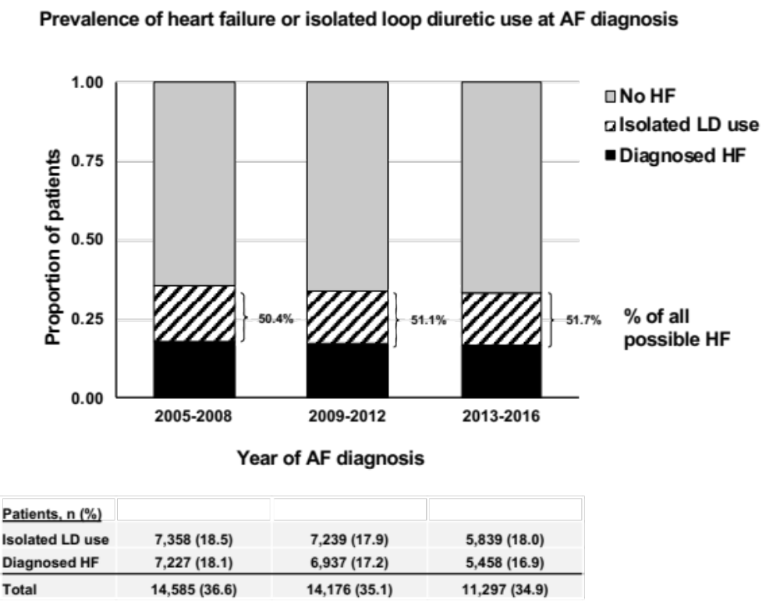

Supplemental figure 2.
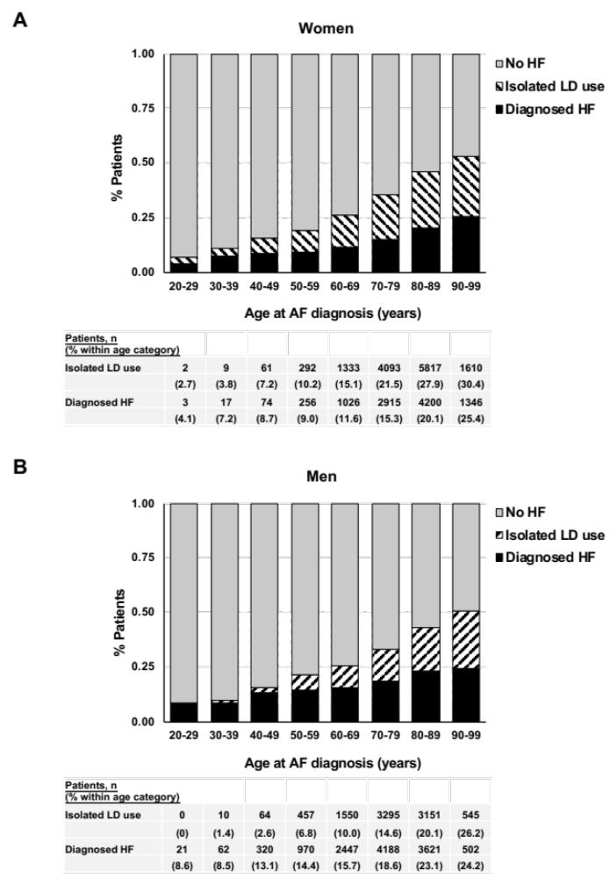
Supplemental figure 3.
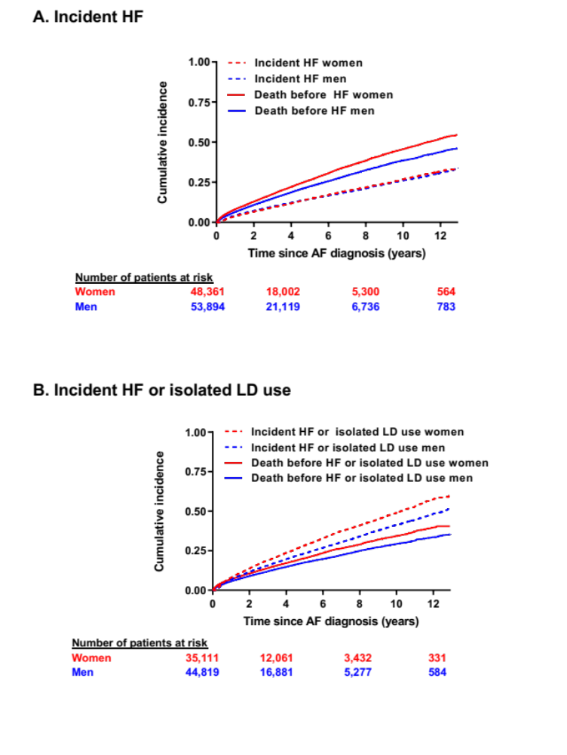
Supplemental figure 4
