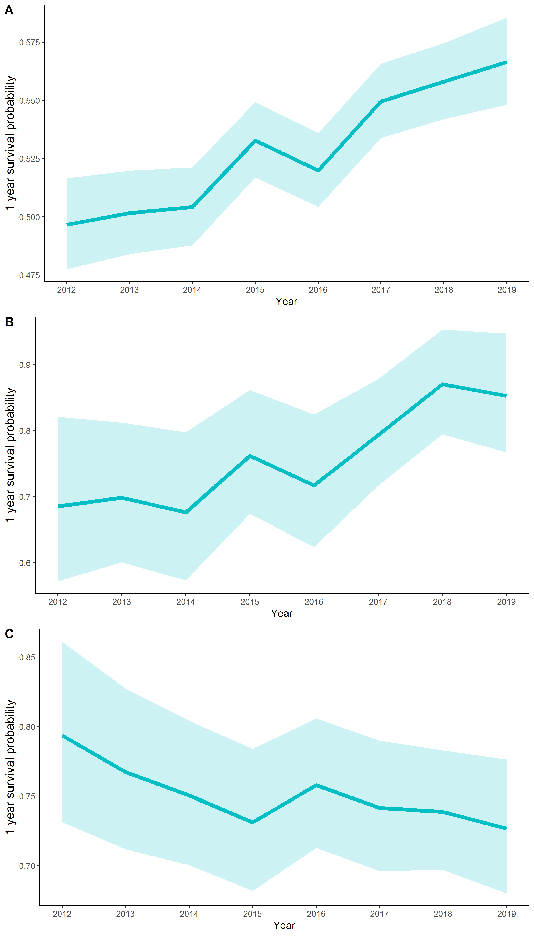
Supplementary Figure 1. One year survival probability among non-oncogene positive (A) advanced and/or metastatic NSCLC (B) ALK-positive and (C) and EGFR-positive patients diagnosed in each year from 2012 to 2019. Shaded area represents 95% confidence intervals.

