Online Additional File

G Qiao, W Zhuang, B Dong et al. Discovery and validation of methylation signatures in circulating cell-free DNA for early detection of esophageal cancer: a case-control study

Contents:
Additional File Tables: 3
Additional File Figure: 1-4
Table S1. Sensitivity and specificity in training set and test set.
Patient Group | Training set |  |  |  |  | Test set
Patient Group | Tested | Positive | Sensitivity (%) | Specificity (%) |  | Tested | Positive | Sensitivity (%) | Specificity (%)
Stage 0 | 3 | 2 | 66.7% (9.4%-99.2%) |  |  | 2 | 1 | 50.0% (1.3%-98.7%)
Stage I | 9 | 7 | 77.8% (39.8%-97.2%) |  |  | 8 | 5 | 62.5% (24.5%-91.5%)
Stage II | 11 | 10 | 90.9% (58.7%-99.8%) |  |  | 16 | 11 | 68.8% (41.3%-89.0%)
Stage III | 12 | 10 | 83.3% (51.7%-97.9%) |  |  | 10 | 9 | 90.0% (55.4%-99.8%)
Stage IV | 8 | 8 | 100.0% (63.1%-100.0%) |  |  | 6 | 6 | 100.0% (54.1%-100.0%)
All cancer | 43 | 37 | 86.0% (72.2%-94.8%) |  |  | 42 | 32 | 76.2% (60.5%-87.9%)
Benign | 5 | 1 | 20.0% (0.5%-71.4%) | 80.0% (28.4%-99.5%) |  | 5 | 1 | 20.0% (0.5%-71.4%) | 80.0% (28.4%-99.5%)
Healthy control | 62 | 3 |  | 95.2% (86.5%-99.0%) |  | 63 | 3 |  | 95.2% (86.7%-99.0%)
All non-cancer | 67 | 4 |  | 94.0% (85.5%-98.3%) |  | 68 | 4 |  | 94.1% (85.7%-98.4%)

Table S2. AUCs stratified by clinical covariates
 | Yes | No | P
Male | 0.968 (0.944-0.991) | 0.902 (0.832-0.972) | 0.08
Age (≥55） | 0.941 (0.901-0.977) | 0.953 (0.907-1.000) | 0.68
ESCC | 0.951 (0.925-0.978) | 0.903 (0.803-1.000) | 0.33
ESCC, Esophageal squamous cell carcinoma; AUC, Area under roc curve.

Table S3. Sensitivity and specificity in the validation set.
Patient Group | Validation set
Patient Group | Tested | Positive | Sensitivity (%) | Specificity (%)
Stage 0 | 10 | 4 | 40.0% (12.2%-73.8%)
Stage I | 14 | 5 | 35.7% (12.8%-64.9%)
Stage II | 27 | 21 | 77.8% (57.8%-91.4%)
Stage III | 14 | 14 | 100.0% (76.8%-100.0%)
Stage IV | 18 | 18 | 100.0% (81.5%-100.0%)
All cancer | 83 | 62 | 74.7% (64.0%-83.6%)
Healthy control | 98 | 4 |  | 95.9% (89.9%-98.9%)

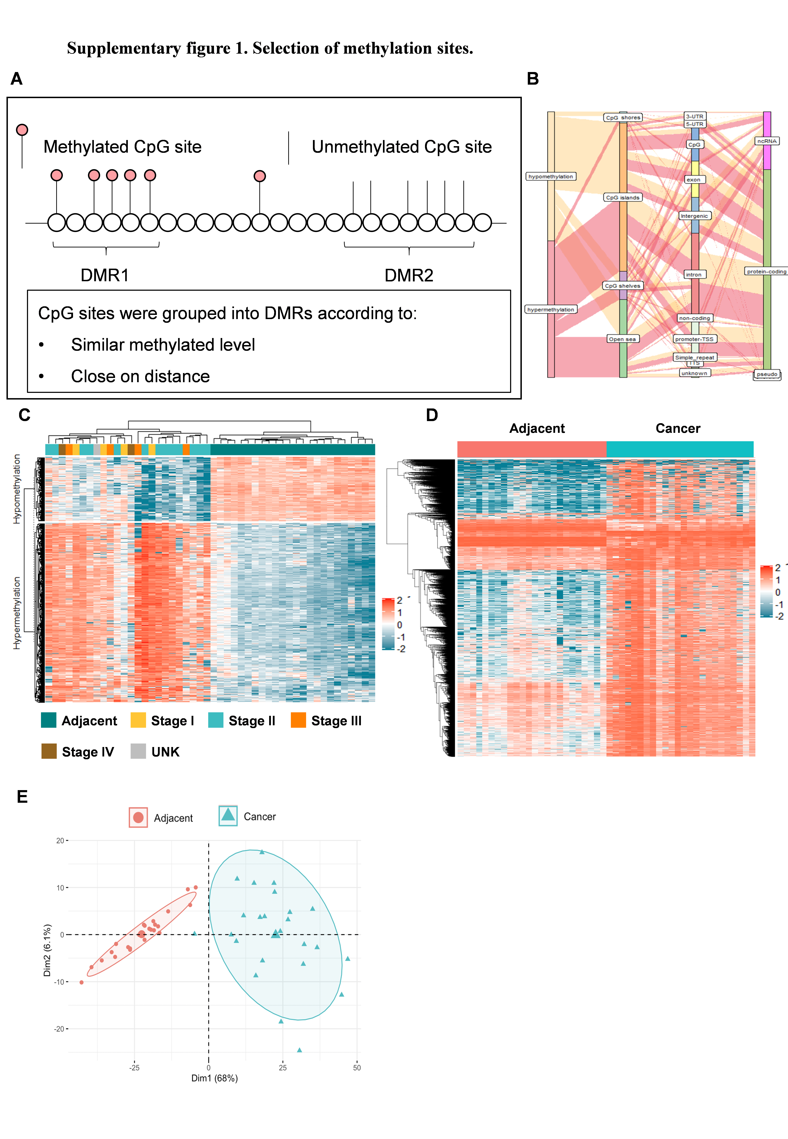
Figure S1. Selected methylation sites.
(A). Definition of DMRs. (B). Sankey plot of the ESCA -specific DMRs. (C). Heatmap illustrating the hypermethylated and hypomethylated DMRs between ESCA tissues and adjacent tissues by unsupervised clustering. (D). Heatmap illustrating the differentiated CpG sites in the DMRs between ESCA tissues and adjacent tissues. (E). Principal component analysis of the DMRs between ESCA tissues and adjacent tissues. Abbreviations: DMR, differentially methylated region; ESCA, esophageal cancer.

Figure S2. Early detection model development. Receiver operating characteristic curves by 5-fold cross validation in the training set.

Figure S3. Performance of the early detection classifier in the total matched population.
(A). Positive ratios in healthy controls, benign esophageal diseases and ESCA with different clinical stages in the total matched population. (B). Predicted probabilities of healthy controls, benign esophageal diseases and ESCA stratified by different clinical covariates in total matched population. * P<0.05 (compared with healthy controls). Abbreviations: ESCA, esophageal cancer.

Figure S4. Performance of the early detection model in the validation cohort. Predicted probabilities of healthy controls, benign esophageal diseases and ESCA stratified by different clinical covariates in the validation cohort. * P<0.05 (compared with healthy controls). Abbreviations: ESCA, esophageal cancer.

