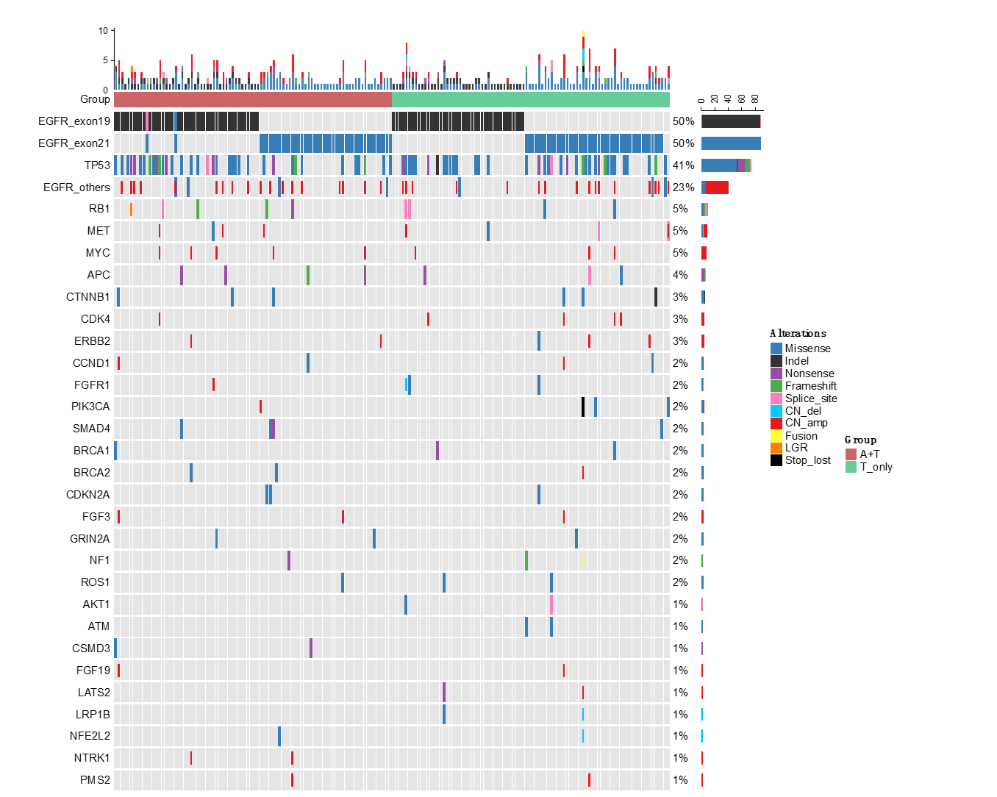
Figure S1. Baseline mutational profile of Training cohort A. The patients were grouped according to the treatment received; A+T, EGFR-TKI with bevacizumab; T, single-agent EGFR-TKI.

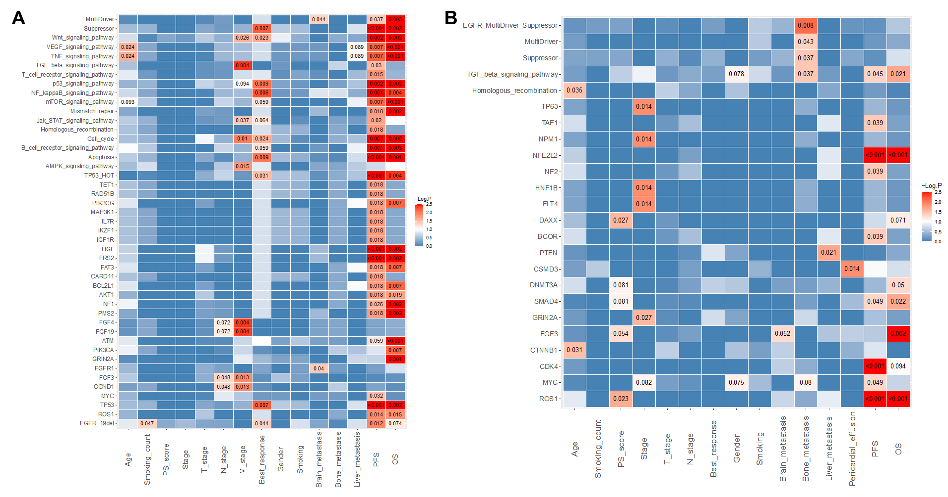
Figure S2. Heat map illustrating the association between gene mutation or pathway (y-axis) and clinical characteristics, progression-free survival (PFS), and overall survival (OS) (x-axis) for single-agent EGFR-TKI group (A) and EGFR-TKI plus bevacizumab group (B). Blue indicates no statistical difference. The intensity of red color indicates the level of statistical significance with corresponding p-values indicated.

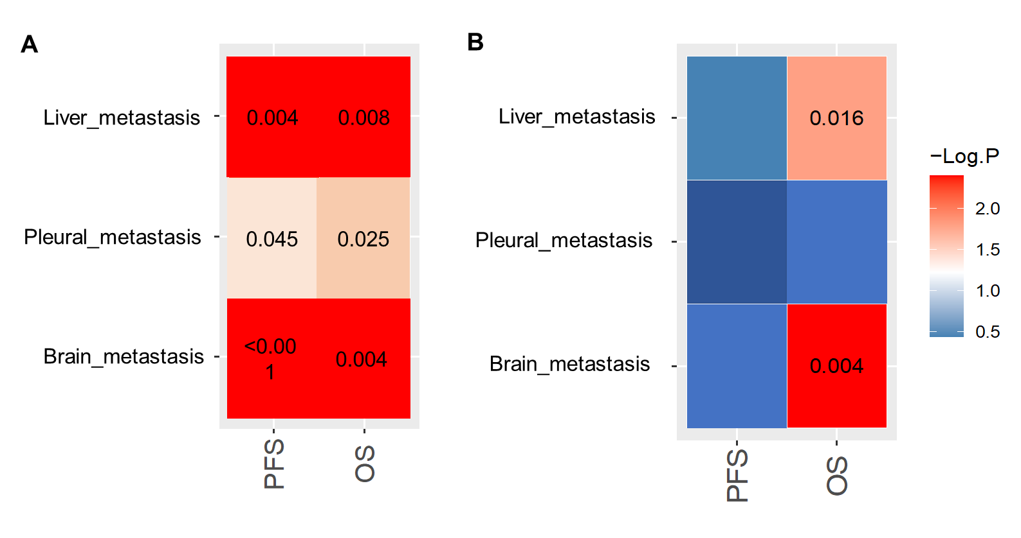
Figure S3. Patients in cohort A with brain, liver, or pleural metastasis had significantly shorter progression-free survival (PFS) and overall survival (OS) with single-agent EGFR-TKI (A) but not on EGFR-TKI plus bevacizumab combination (B).

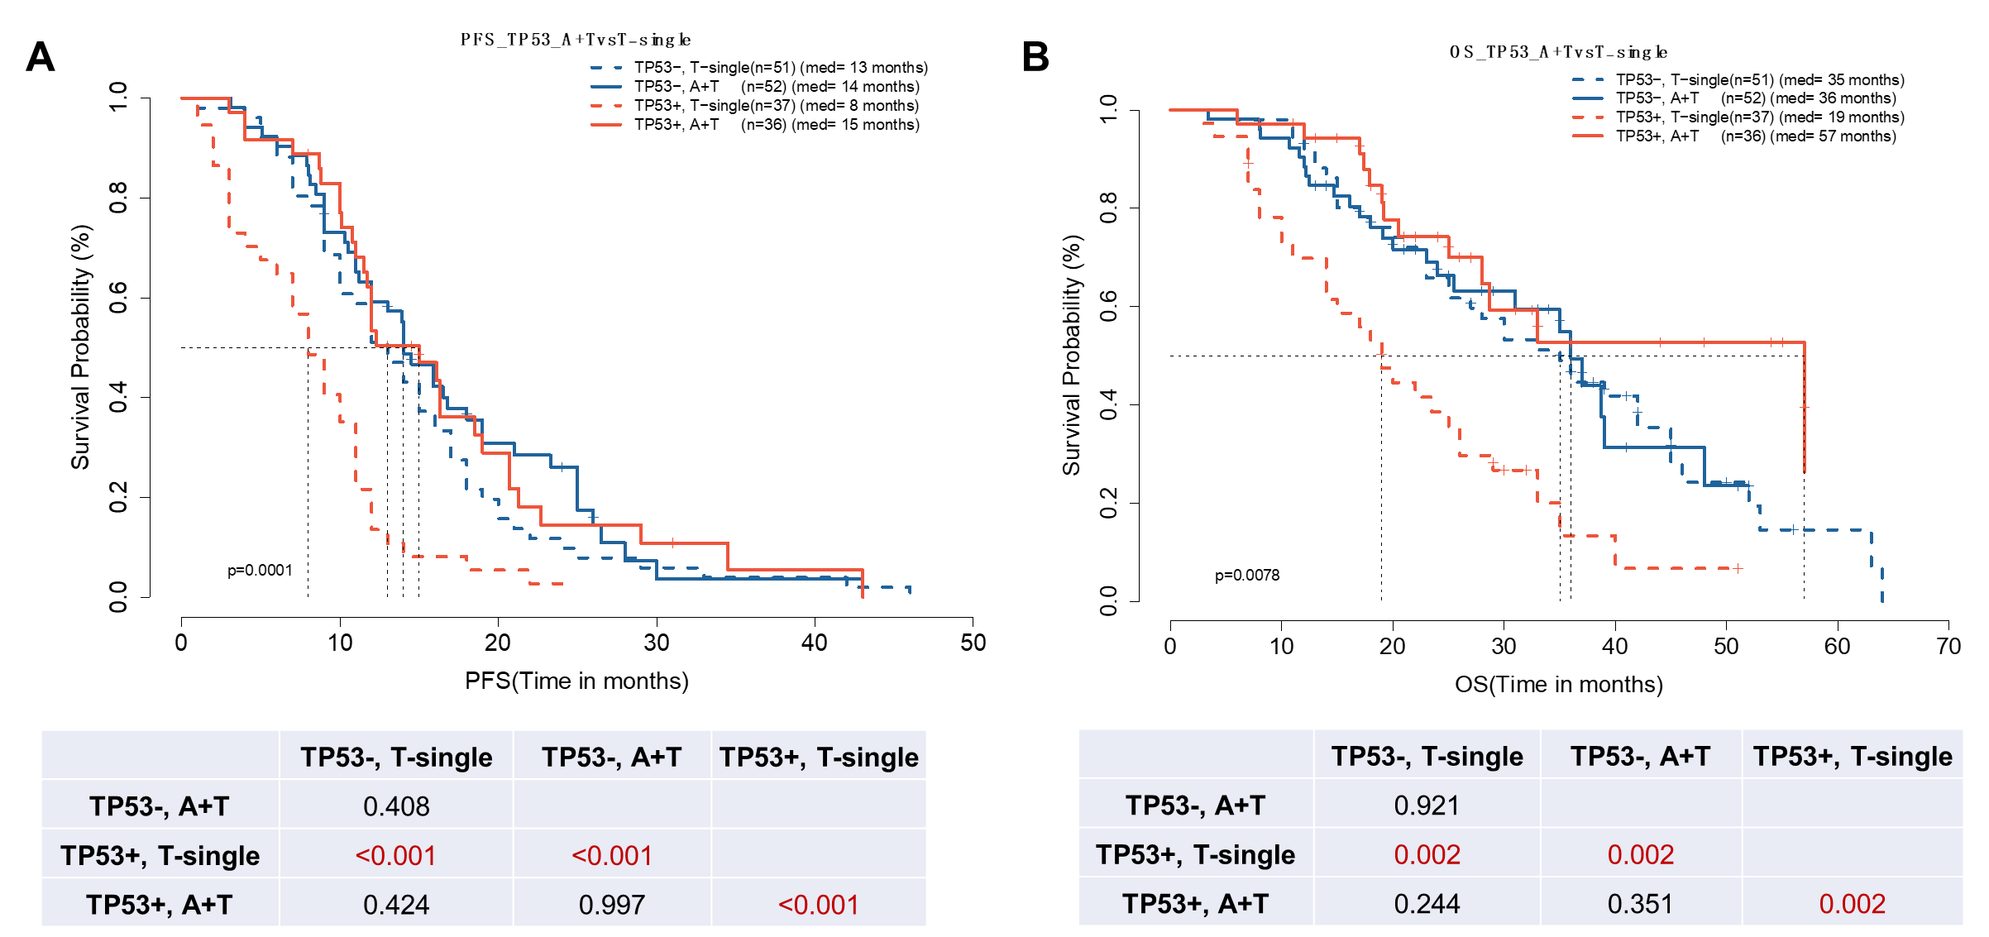 Figure S4. Patients with concomitant TP53 mutation had significantly longer progression-free survival (PFS) and overall survival (OS) with EGFR-TKI plus bevacizumab combination. Kaplan-Meier curves for PFS (A) and OS (B) of patients with EGFR-mutant advanced NSCLC with concurrent TP53 mutations (TP53+, red color) or wild-type TP53 (TP53-, blue color) treated with either EGFR-TKI with bevacizumab (A+T, solid lines) or EGFR-TKI monotherapy (T-single, dashed lines). The table below summarizes the p-values.
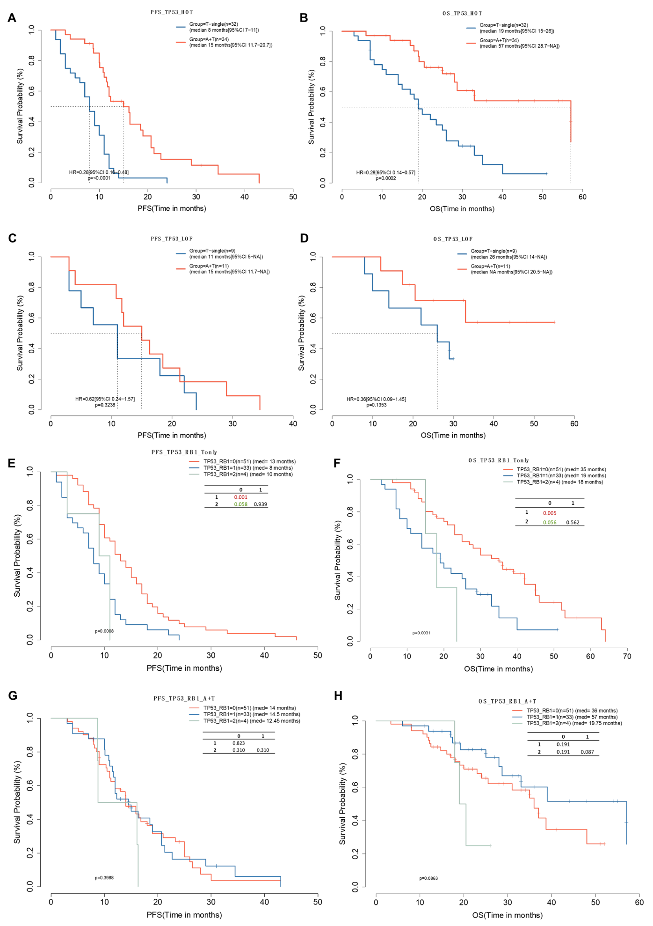
Figure S5. Patients with concomitant TP53 mutations located in exons 5-8 had significantly longer progression-free survival (PFS) and overall survival (OS) with EGFR-TKI plus bevacizumab combination. Kaplan-Meier curves for PFS (A, C) and OS (B, D) of patients with EGFR-mutant advanced NSCLC with or without concurrent TP53 mutations located between exon 5-8 (TP53_hot; A-B) or mutations that result in loss-of-function (TP53_LOF; C-D) and were treated with either EGFR-TKI with bevacizumab (A+T) or EGFR-TKI monotherapy (T-single). Kaplan-Meier curves for PFS (E, G) and OS (F, H) of patients with concomitant TP53 and RB1 mutations who were treated with either T-only (E, F) or A+T (G, H).

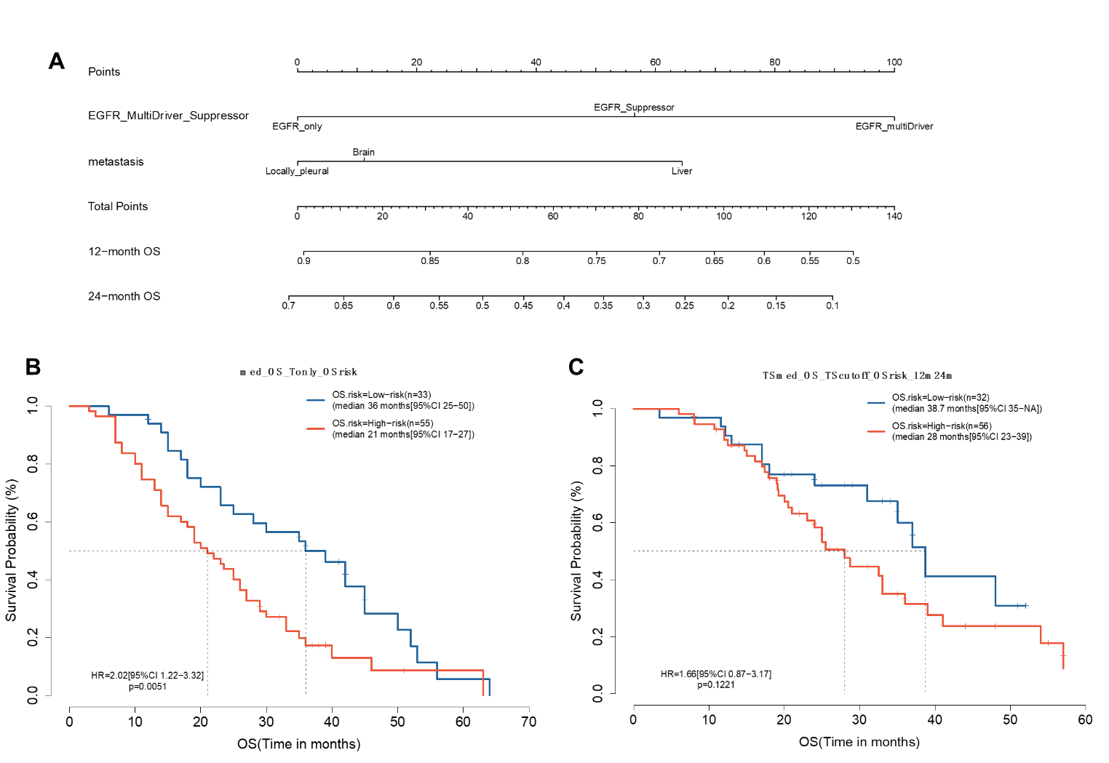
Figure S6. Nomograms were constructed for predicting the risk of 12-month and 24-month overall survival (OS) (A). Survival analysis of the training cohort A was performed using Kaplan-Meier curves to compare the OS of patients in the T group (B) or A+T (C) group, which were further subgrouped according to the median score into low-risk (< median score) and high-risk (≥ median score).

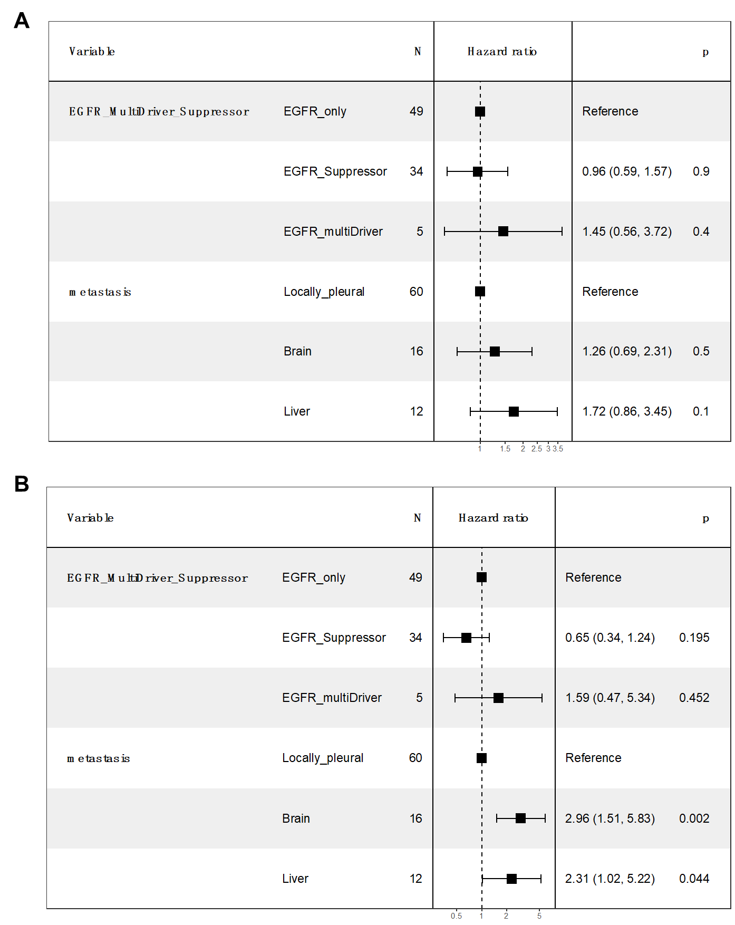
Figure S7. Tabulated summary of the hazard ratios for each molecular and clinical features calculated for the patients treated with EGFR-TKI with bevacizumab (A+T) using Cox multivariable analysis for progression-free survival (A) and overall survival (B).

