Additional file 3: Figure S1. Radar charts of saliva antibodies by visit. Overall median antibody levels in the first and last visit (A), in the last visit comparing individuals who increased, decreased (≥3 fold-change [FC]) or maintained (<3 FC) responses (B), in the first versus the last visit in individuals who decreased (C) or increased (D) responses. FC in median antibody levels between first and last visit (E). Groups were compared through Mann-Whitney test. * p ≤ 0.05, ** p ≤ 0.01, *** p ≤ 0.001.
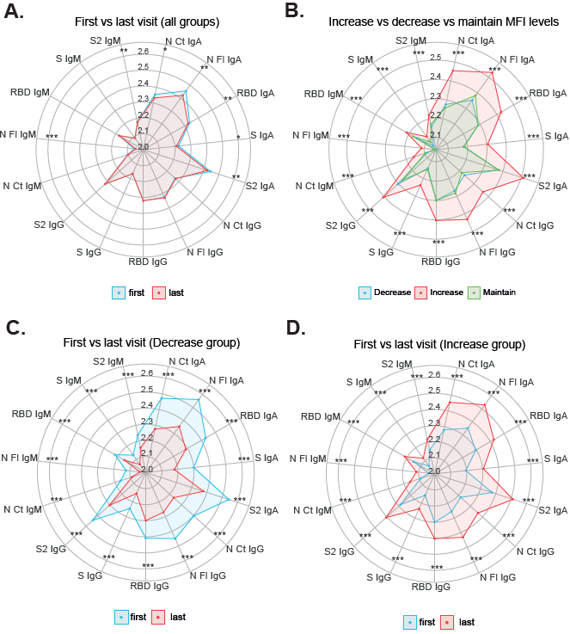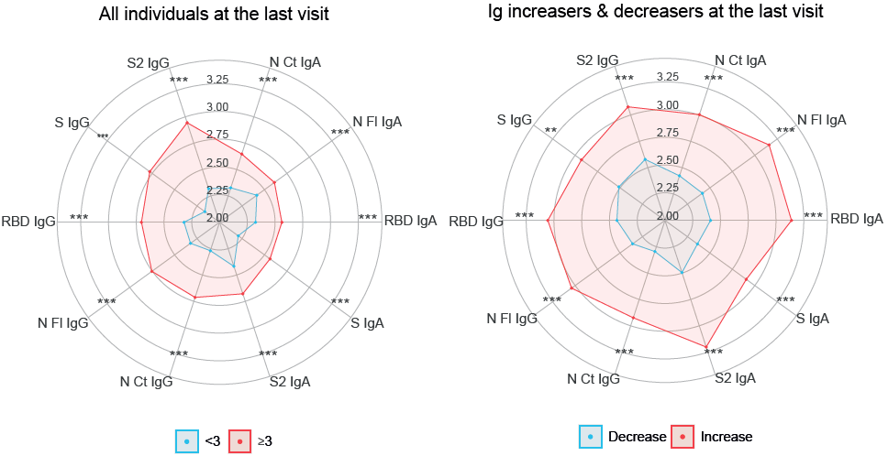
E.

