Additional file 7: Figure S4. Antibody levels by age. Antibody levels by age category groups in the last and single visits (A) and by age and sex (B), compared by Mann-Whitney statistical test, and correlations of antibody levels with age (C). * p ≤ 0.05, ** p ≤ 0.01, *** p ≤ 0.001, NS = not significant.
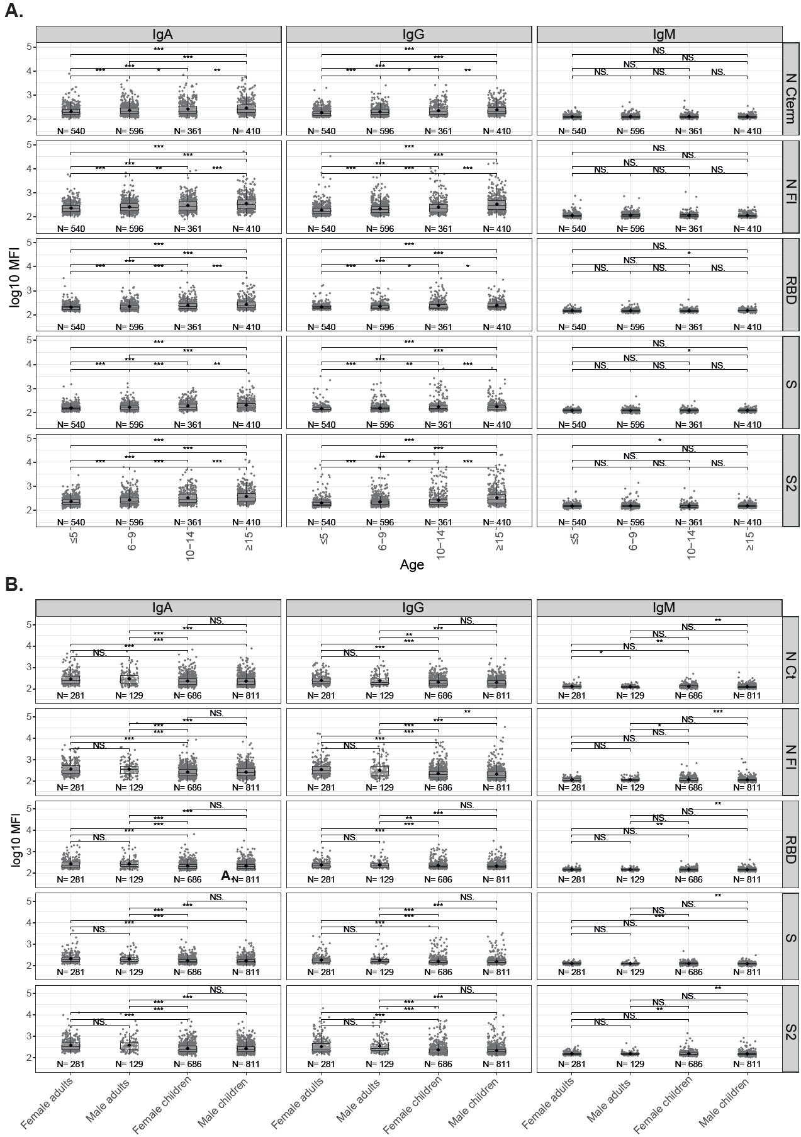
C.

