Additional file 3: Figures S1-6
Supplement to: B. Li, Z. Qiu, Y. Xu, et al. Common DNA methylation changes of biliary tract cancer identifies subtypes with different immune characteristics and clinical outcomes.

TABLE OF CONTENTS
Supplemental Figures 2
Supplemental Fig. S1. Consensus clustering of the EHSH cohort. 2
Supplemental Fig. S2. Feature selection using the LASSO algorithm for a prognostic model. 3
Supplemental Fig. S3. Association between mutational rate and TNM stage. 4
Supplemental Fig. S4. Consensus clustering of the TCGA-CHOL cohort. 5
Supplemental Fig. S5. Overlap of greater infiltration of CD8⁺ T cell and higher angiogenesis signature clustering in the TCGA-CHOL cohort. 6
Supplemental Fig. S6. Associations of the methyl-risk with the signatures of naïve, effector, and exhausted CD8 T cells in the TCGA-CHOL cohort. 7

Supplemental Figures

Supplemental Fig. S1. Consensus clustering of the EHSH cohort.
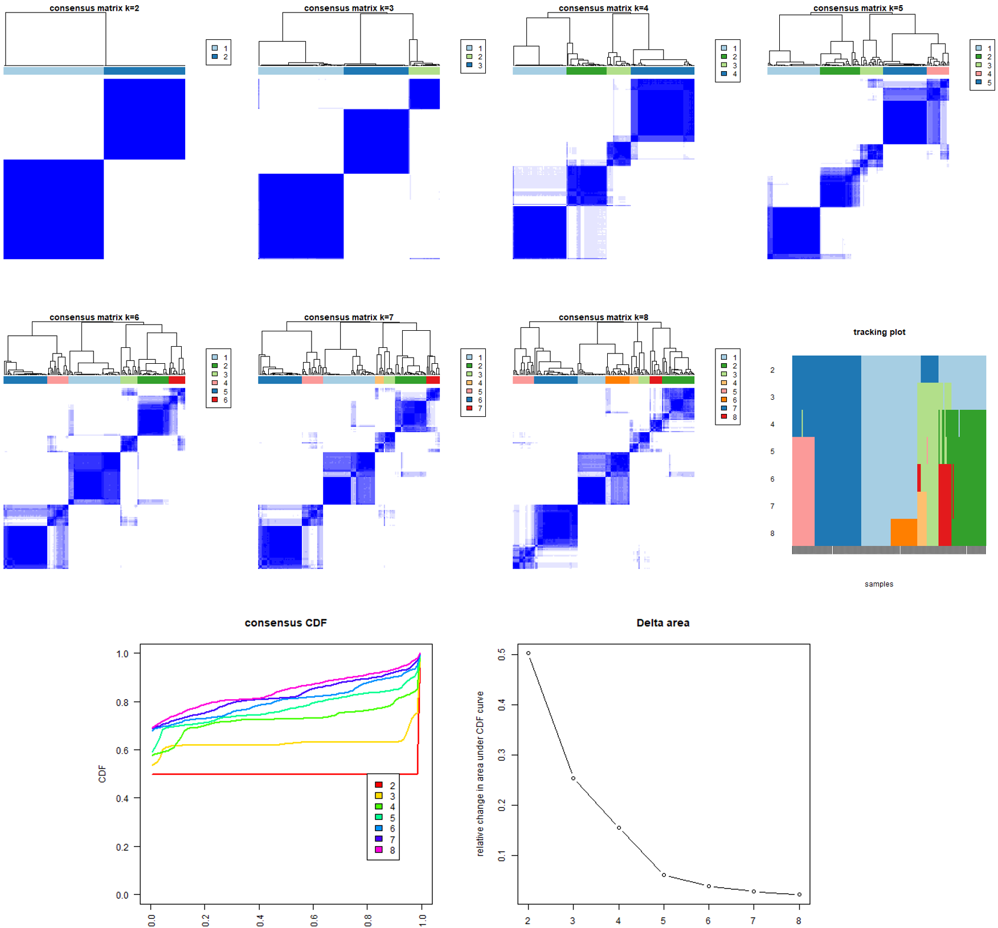
Consensus matrix of non-supervised clustering of methylation signatures by K-means method (K=2-8) and delta plot assessing change in consensus cumulative distribution function area. Abbreviations: CDF=cumulative distribution function.

Supplemental Fig. S2. Feature selection using the LASSO algorithm for a prognostic model.
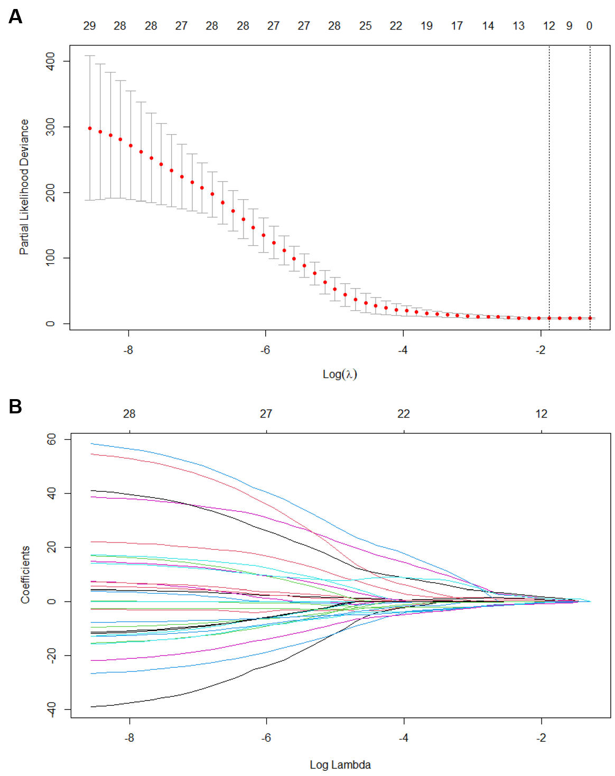
A. The optimal tuning parameter (Lambda) in the LASSO model was selected using 3-fold cross-validation. B. LASSO coefficient profiles of the 12 features.

Supplemental Fig. S3. Association between mutational rate and TNM stage.
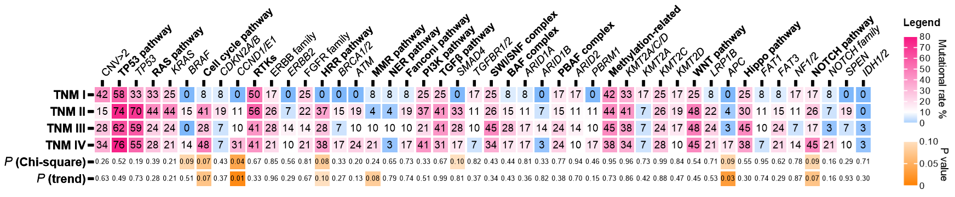

Supplemental Fig. S4. Consensus clustering of the TCGA-CHOL cohort.
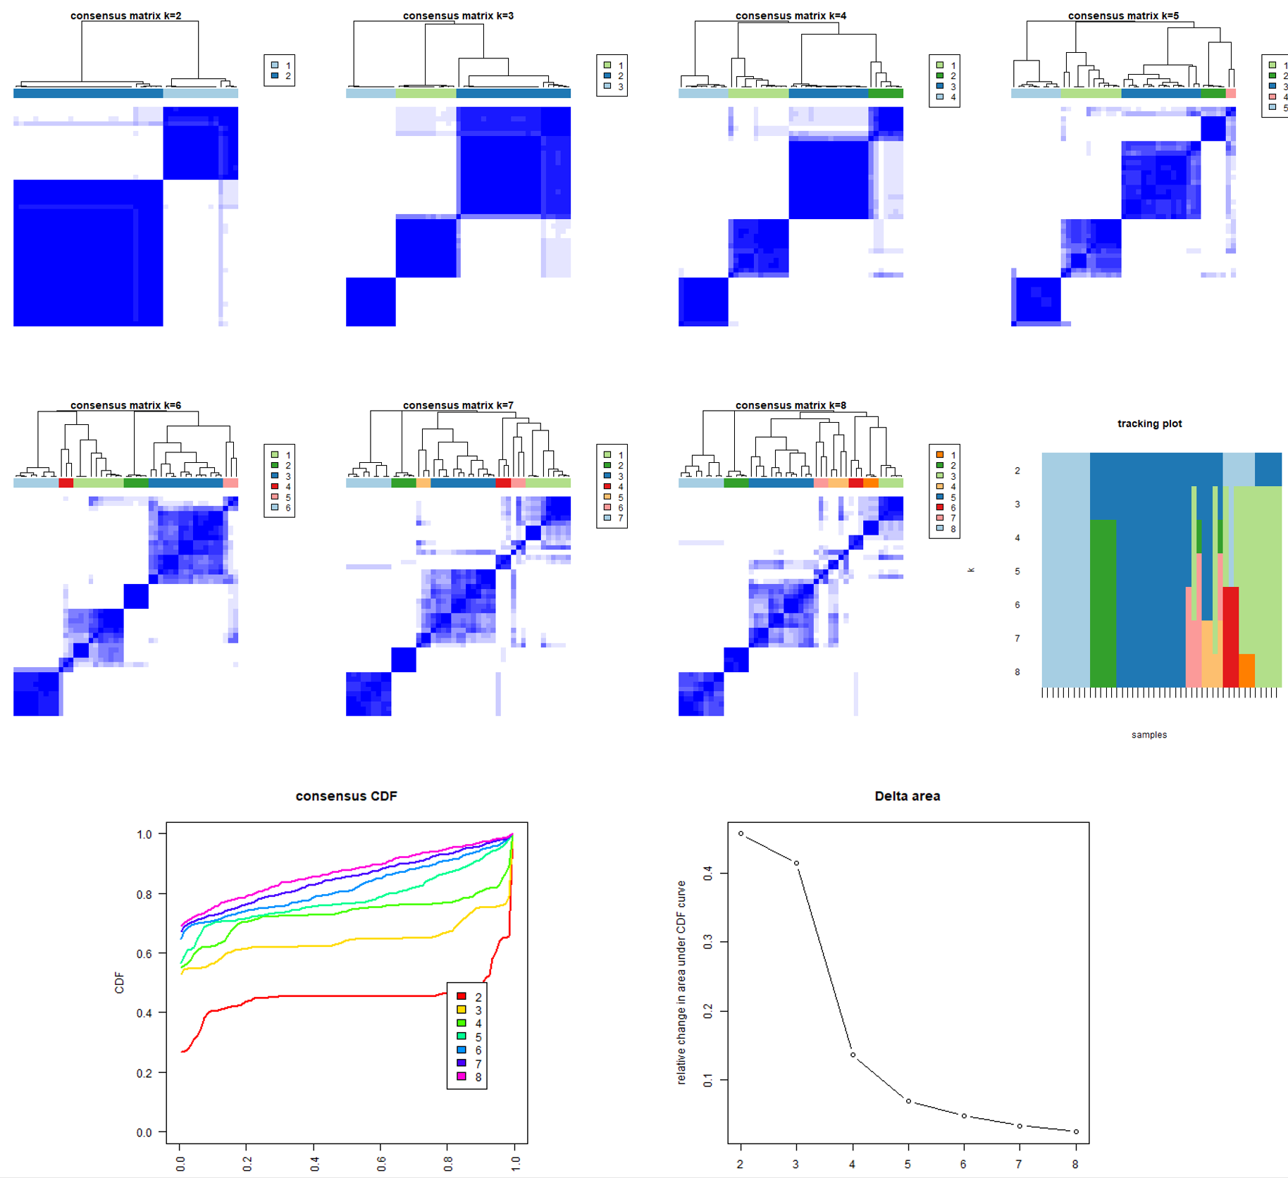
Consensus matrix of non-supervised clustering of methylation signatures by K-means method (K=2-8) and delta plot assessing change in consensus cumulative distribution function area.

Supplemental Fig. S5. Overlap of greater infiltration of CD8⁺ T cell and higher angiogenesis signature clustering in the TCGA-CHOL cohort.
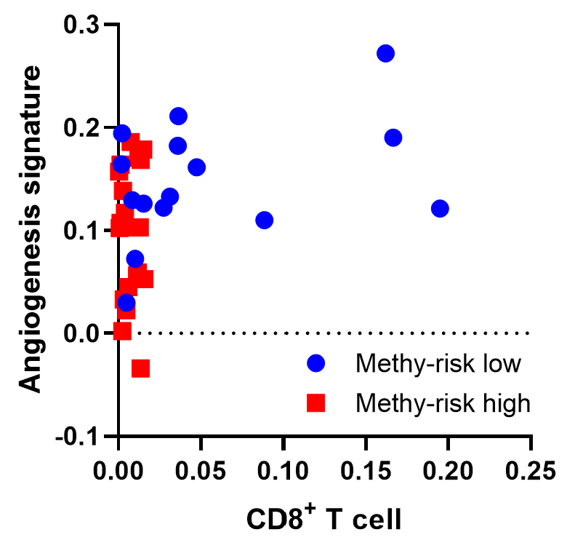
Scatter plot illustrating the infiltration of CD8 T cell and the score of angiogenesis signature in the methyl-risk high and the methyl-risk low groups.

Supplemental Fig. S6. Associations of the methyl-risk with the signatures of naïve, effector, and exhausted CD8 T cells in the TCGA-CHOL cohort.
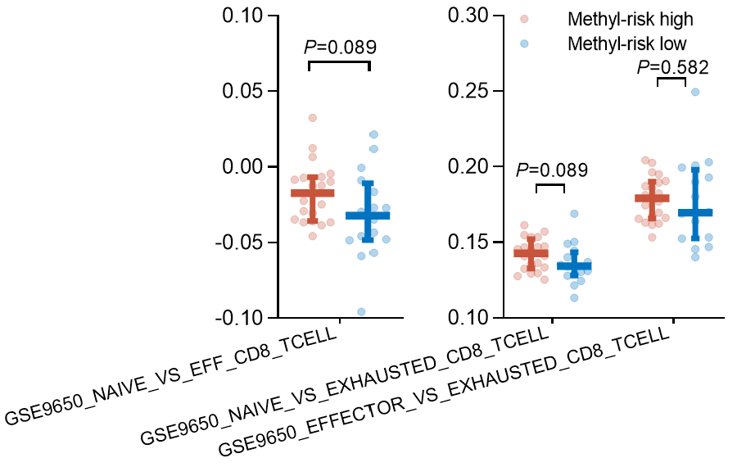
Comparisons of the signatures concerning naïve vs. effector, naïve vs. exhausted, and effector vs. exhausted between the two subgroups defined by the methyl-risk in the TCGA-CHOL cohort.

